

**ITS66404 Software Engineering**

**ASSIGNMENT 2**

**Project Based Learning (PBL) with Purpose Learning**

**HAND OUT DATE: 8th May 2023 (Monday)**

**HAND IN DATE: 7th June 2023 (Wednesday)**

**WEIGHTAGE: 30%**

**Instructions to students:**

* The assignment should be attempted in groups of 4-5 students.
* Complete this cover sheet and attach it to your assignment – this should be your first page.

|  |  |
| --- | --- |
| **Student declaration:** | |
| ***I declare that:***   * ***I understand what is meant by plagiarism*** * ***The implication of plagiarism has been explained to us by our lecturer***   ***This project is all our work and I have acknowledged any use of the published or unpublished works of other people.*** | |
| **Names of Group Members** | |
| **Name** | **Student ID** |
| 1. **Dev Mani Maharjan** | 0355610 |
| 1. Alina Khatri | 0355498 |
| 1. Rebica Shrestha | 0355545 |
| 1. Romik Shreshta | 0355468 |
| 1. Rosy Maharjan | 0355478 |

Contents

Use Case Diagram: 3

Modified Use Case Diagram: 4

Use case diagram differences after mod 5

Class Diagram: 6

Modified class Diagram: 7

class diagram differences after mod 8

Interface Design Proposal for E-learning Platform 9

Test Plan: E-Learning Platform Website 11

Sequence Diagram 13

Modified Sequence Diagram 14

Activity Diagram 15

State Diagram 17

Modified State Diagram 18

Design Rationale: 19

Alternative Design Ideas: 20

Group Analysis: 21

# Use Case Diagram:

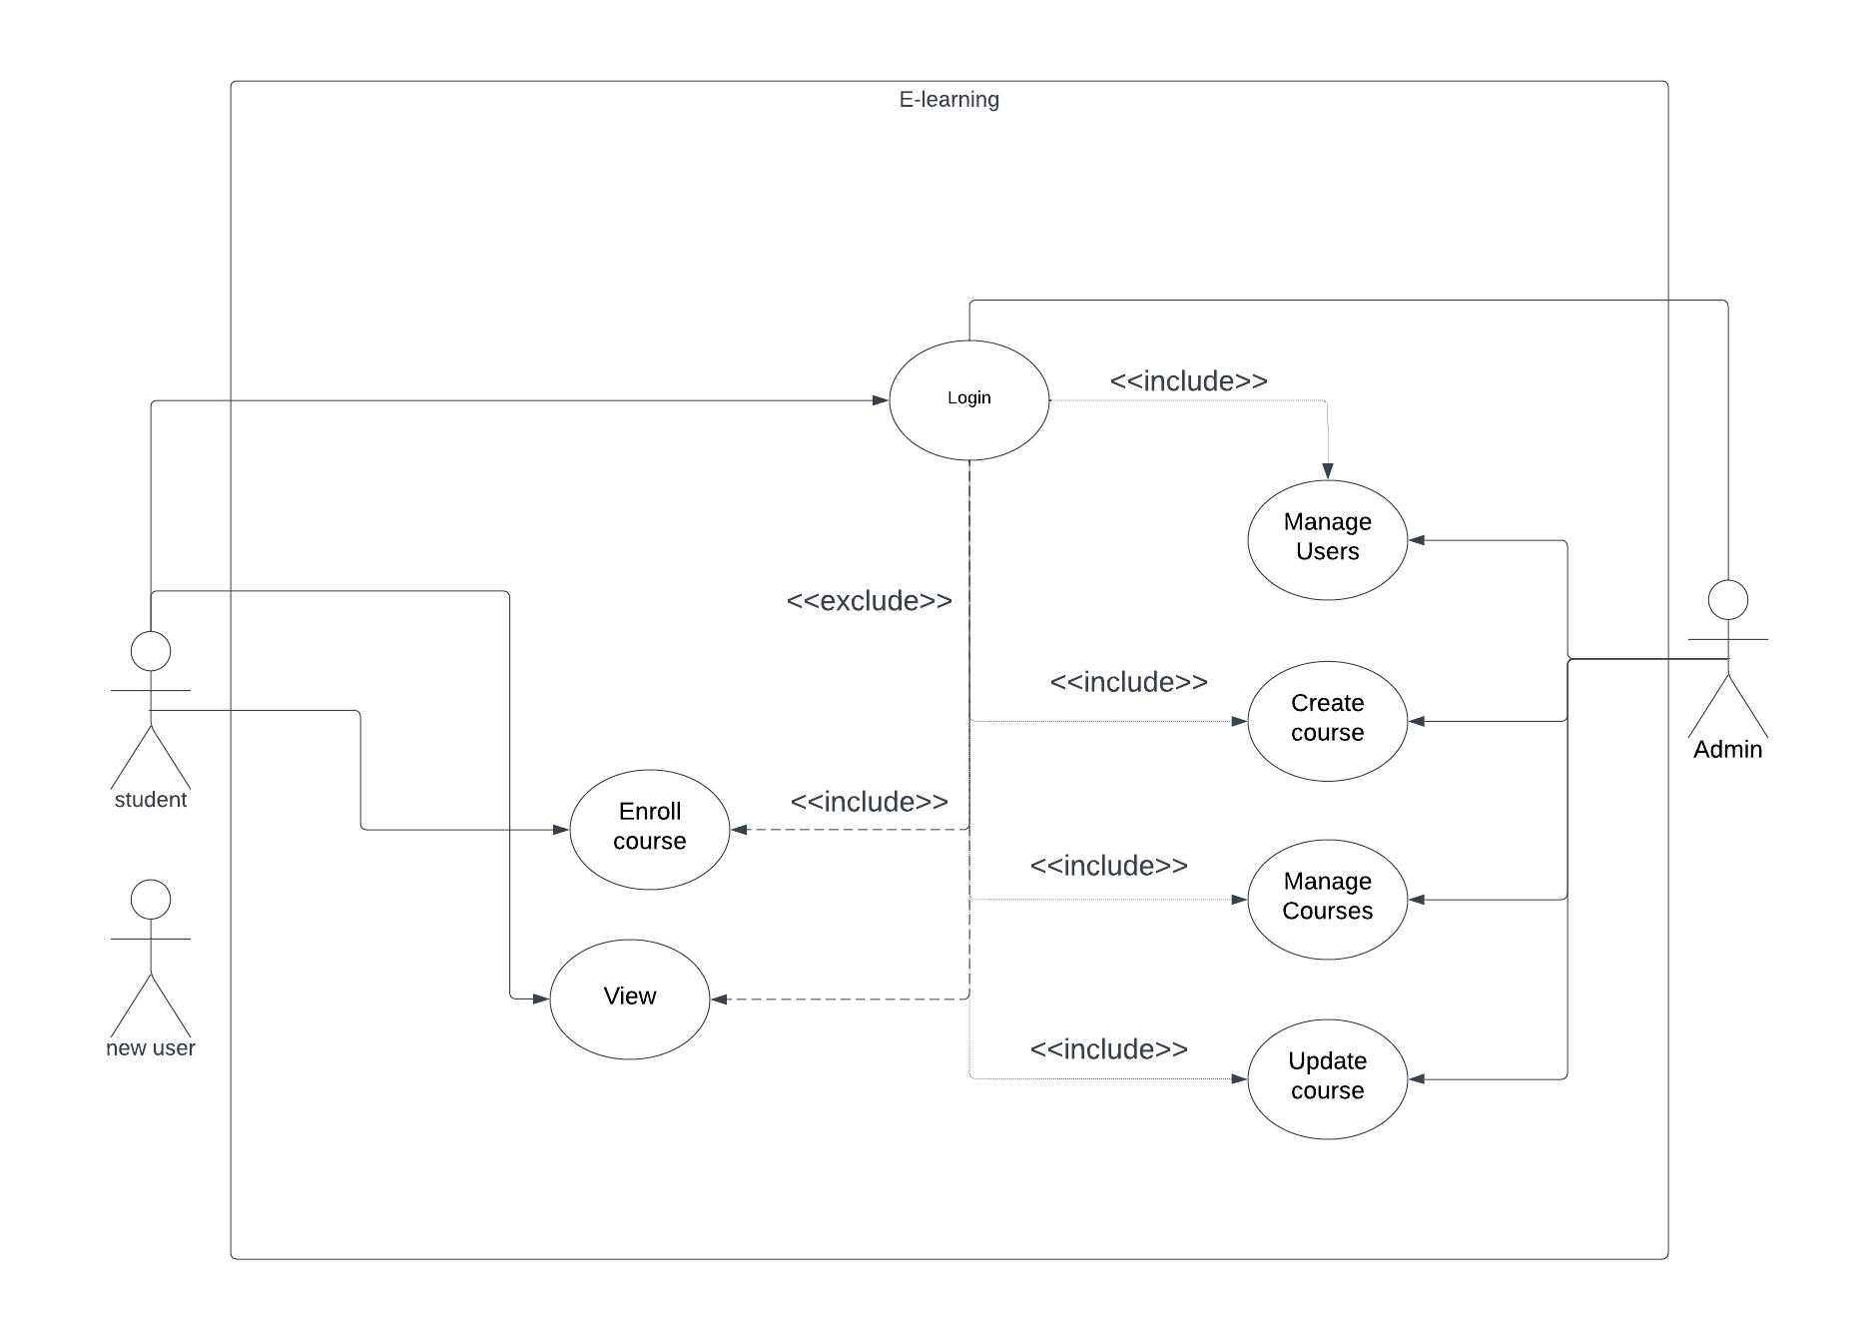

# Modified Use Case Diagram:

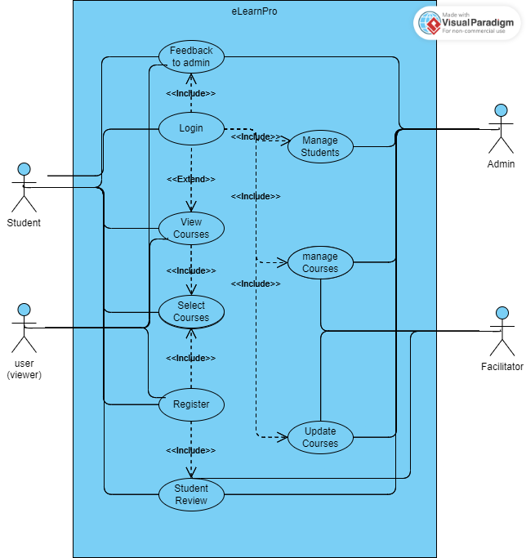

Use case diagram differences after mod

In the modified version of the use case diagram, several changes have been made compared to the old version. The new use case diagram includes additional actors and modifies the functionalities of existing actors. The changes are as follows:

1. Actors:

a. Student: This actor remains the same in both the old and new use case diagrams. The student can enroll in courses, login to the system, and view courses.

b. User (Viewer): This is a new actor introduced in the new use case diagram. The user can only view the courses and does not have the ability to enroll, provide feedback, or review courses.

c. Admin: This actor remains the same in both versions. The admin has the authority to manage students, manage courses, and update courses.

d. Facilitator: This is a new actor added in the new use case diagram. The facilitator has the ability to manage and update courses, as well as read students' reviews.

2. Functionalities:

a. Student:

- Old Use Case: The student can enroll in courses, login, and view courses.

- New Use Case: The student must register to become a student first. After registration, the student can login, view courses, select and enroll in courses, give feedback to the admin, and review the courses.

b. User (Viewer):

- New Use Case: The user can only view the courses and does not have the ability to enroll, provide feedback, or review courses.

c. Admin:

- Old Use Case: The admin can manage students, manage courses, and update courses.

- New Use Case: The admin retains the same functionalities, which include managing students, managing courses, and updating courses.

d. Facilitator:

- New Use Case: The facilitator has the ability to manage and update courses, as well as read students' reviews.

These changes in the use case diagram reflect the addition of a new actor (User/Viewer) and the modification of existing actor functionalities (Student). The introduction of the Facilitator actor represents a new role that interacts with the system. Overall, these changes enhance the functionality and capabilities of the system by involving more actors and allowing for additional interactions and operations.

# Class Diagram:

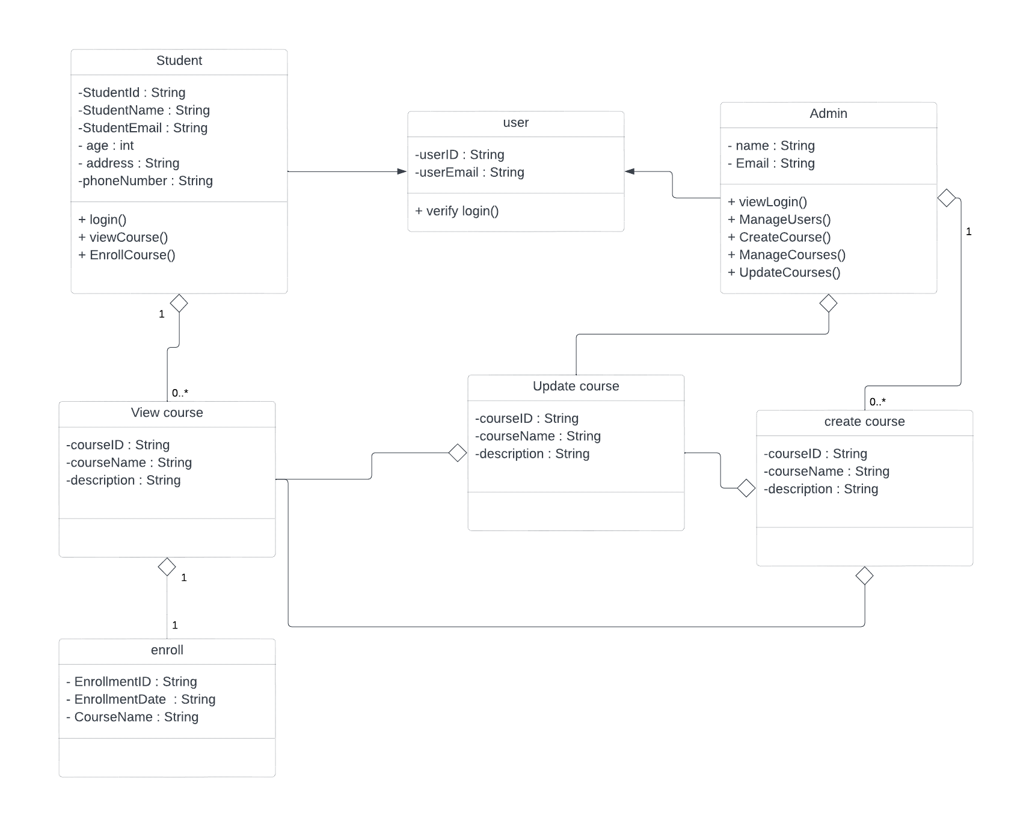

# Modified class Diagram:

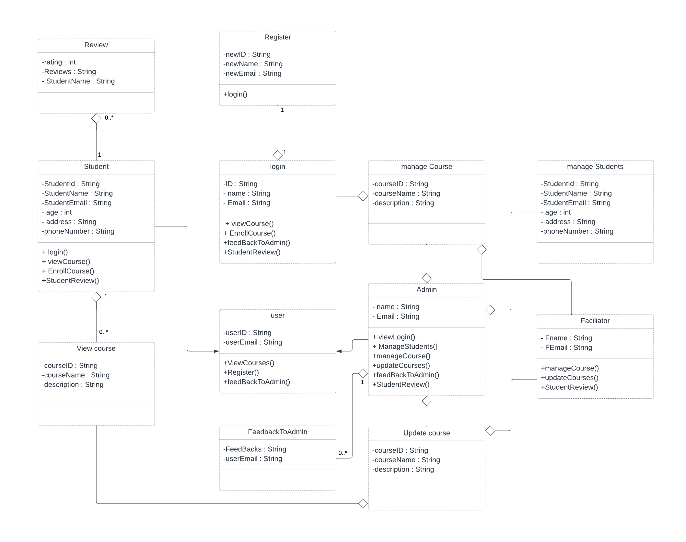

# class diagram differences after mod

In comparing the old and new class diagrams, several modifications can be observed. The following is a detailed account of the changes made:

1. Removal of "enroll" and "create course": In the new class diagram, the concepts of "enroll" and "create course" have been eliminated. These functionalities are no longer represented as distinct entities in the updated system.

2. Addition of "review" and "register": The new class diagram introduces two new elements, "review" and "register." These represent additional functionalities that have been incorporated into the system. The "review" feature likely pertains to providing feedback or evaluations for courses or other system components, while "register" implies the act of creating a new user account.

3. Introduction of "facilitator": The new class diagram introduces a new entity called "facilitator." This suggests the inclusion of a user role that is distinct from the "student," "user," and "admin" roles. The role of the facilitator may involve managing or assisting with course activities.

4. Inclusion of "login" and "feedback to admin": The new class diagram includes "login" as a separate concept. This signifies that the act of authentication and accessing the system has been explicitly represented. Additionally, the introduction of "feedback to admin" implies a mechanism for users to provide feedback directly to the system administrator.

5. Refinement of existing entities: The class diagram also presents some refinements to the existing entities. The "user" entity remains but may have undergone modifications to accommodate the "register" and "login" functionalities. Similarly, the "student" and "admin" entities persist but may have additional associations or attributes associated with them.

6. Introduction of "manage students" and "manage course": The new class diagram includes two new functionalities, namely "manage students" and "manage course." These additions suggest that the system has extended its capabilities to allow for administrative tasks related to student management and course administration.

Overall, the new class diagram demonstrates modifications and additions to the existing system's functionalities and entities. It reflects the inclusion of new features such as "review," "register," "facilitator," "login," "feedback to admin," "manage students," and "manage course," while removing "enroll" and "create course" from the previous design.

# Interface Design Proposal for E-learning Platform

1. Introduction and Project Overview: This interface design idea is provided by ELearnPro for the creation of an e-learning platform. The platform seeks to give students, teachers, and educational institutions a seamless and interesting learning experience. Our proposal highlights the essential design factors, elements, and goals needed to produce an understandable and efficient interface.

2. Objectives and Goals:

- Create a user-friendly interface that encourages accessibility and simple navigation.

- Produce an eye-catching and captivating design to increase user interest and motivation in the learning process.

- Make sure your user interface is responsive and fluid across all platforms and screen sizes.

- Deliver a customized learning experience by taking into account user preferences and monitoring advancement.

- Make it possible for students and teachers to collaborate and communicate effectively.

3. Target Audience:

Students, teachers, and educational institutions make up the main target market for the e-learning platform. The platform offers educational opportunities for students in K–12 through higher education.

4. User Research and Insights:

In-depth user research has been done to learn more about the wants and preferences of the target market. Key findings from surveys, interviews, and usability tests include the following:

- Students want an interface that is aesthetically appealing and stimulating and keeps them motivated.

- To handle courses, exams, and student relationships, teachers need simple tools.

For students who like to learn while on the go, mobile compatibility is essential.

5. Design Principles and Guidelines:

The following rules will guide our interface design:

- Simplicity: Maintain a clear, uncluttered, and intuitive user interface for simple navigation.

- Consistency: Keep the platform's visual language, typography, and interaction styles uniform.

- Accessibility: Make that the user interface complies with accessibility standards, including having enough contrast and being compatible with screen readers.

- Responsiveness: To ensure a consistent user experience, optimize the design for all devices and screen sizes.

6. Wireframes and Mockups:

You will find wireframes and mockups that show the suggested interface design attached to this project. The design features a simple, modern layout, easy navigation, and eye-catching components. The design carefully incorporates the user profile, communication features, progress monitoring, and course structure.

7. Key Features and Functionality:

A simple way to create, organize, and manage courses, lessons, and learning resources is through course management.

b. Interactive learning: Including interactive components like quizzes, tasks, and multimedia material.

Real-time progress tracking helps students and teachers to keep track of learning objectives.

d. Individualization: Possibilities for modifying the learning experience in accordance with personal preferences.

Communication channels that are seamless, such as message boards and discussion forums.

f. Collaboration: Tools for student teamwork and group projects.

8. Technical Considerations:

- The platform will be created utilizing cutting-edge web technologies, guaranteeing responsive design and cross-browser compatibility.

- Integration, if necessary, with current Learning Management Systems (LMS) or APIs.

- Taking into account scalable architecture and future integration with tools or services from third parties.

# Test Plan: E-Learning Platform Website

1. Introduction:

The website for the e-learning platform is a web-based platform that strives to give students a convenient and effective learning experience. The strategy, scope, objectives, and activities for testing the website for an e-learning platform are described in this test plan.

2. Test Objectives:

- Check the website of the e-learning platform for accessibility and functioning properly.

- Assure a smooth user experience for students, users, administrators, and facilitators on the website.

- Verify the authenticity and dependability of the features for course enrolment, feedback, and reviews.

- Recognize and fix any system flaws or problems.

3. Test Scope:

In-Scope:

- Course enrollment: Examining the capacity of learners for effectively enrolling in courses.

- Login/Logout: Checking that all user roles can successfully log in and out.

- Course Viewing: Examining how well courses are presented and made accessible to users and students.

- Feedback Submission: Confirming students' capacity to provide feedback to the admin.

- Student and Course Management: Ensuring that the administrative staff manages student and course records in an appropriate manner.

4. Test Approach:

The e-learning platform website will be tested using a combination of manual and automated testing approaches. To assure the system's quality, functional, usability, and security testing will be carried out. The use cases mentioned in the system requirements will serve as the basis for the test scenarios.

5. Test Environment:

- Hardware: Common desktop and portable gadgets.

- Software: The supported operating systems and web browsers include Windows, macOS, iOS, and Android.

- Any desired tool for test management, such as JIRA.

- Selenium WebDriver or another chosen tool for testing browsers.

6. Test Deliverables:

- Test Cases: Extensively described test cases developed from use case scenarios.

- Test Scripts: Automation scripts for tests (if necessary).

- Test Reports: Records test outcomes, including flaws and their current condition.

- Defect Reports: Comprehensive summaries of found flaws.

7. Test Schedule:

- Test Preparation: Week 1

- Test Execution: Weeks 2-4

- Test Reporting: Week 5

8. Test Cases:

- Create detailed test cases that cover every feature of the website's e-learning platform.

- Implement boundary value analysis, error handling instances, and positive and negative test scenarios.

- Connect each test case to the appropriate use case.

9. Test Data:

- Specify the test information needed to run the test cases.

- Provide examples of user accounts, courses, reviews, and feedback.

- Make sure there are many data sets to account for various circumstances.

10. Test Execution:

- Carry out test cases in accordance with the planned timeline.

- Follow the test scripts while conducting manual testing, then record the outcomes.

- When conducting automated testing, execute the automation scripts and contrast the outcomes with what was anticipated.

# Sequence Diagram

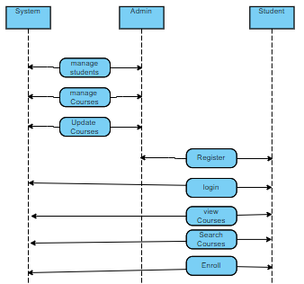

# Modified Sequence Diagram

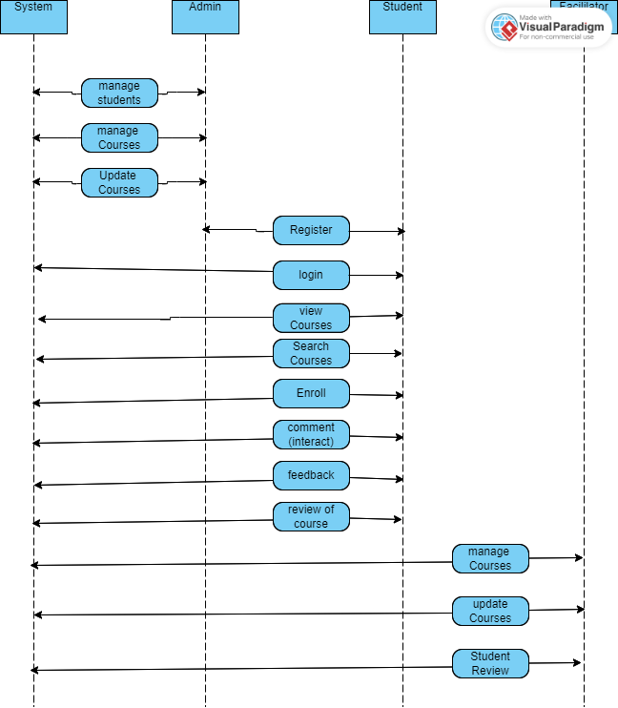

# Activity Diagram

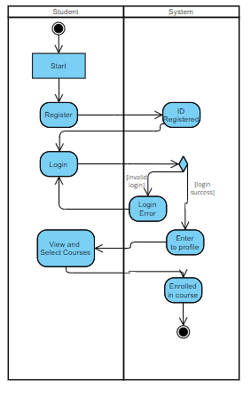 Modified Activity Diagram

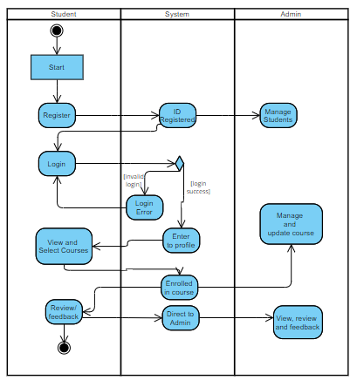

# State Diagram

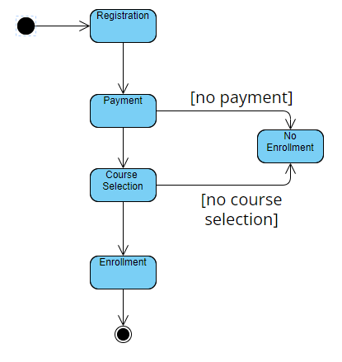

# Modified State Diagram

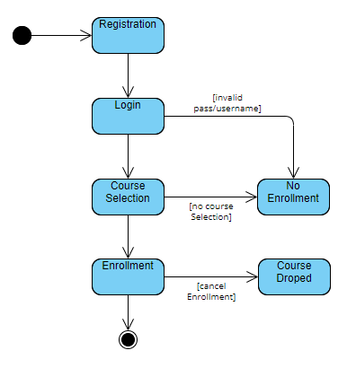

# Design Rationale:

Strengths and Weaknesses of the Final Design:

The final design of our eLearning website offers various advantages that center on offering a variety of courses and allowing user feedback. The large course catalog's breadth of subject matter and topics is one of its key advantages. To accommodate varied interests and learning requirements, we intended to develop a platform that offers a wide range of courses. We provide people the chance to study new fields of knowledge and improve their abilities across a range of disciplines by providing a large variety.

Our design's user-friendly interface and simple navigation are other assets. We placed a high priority on maintaining a smooth user experience, making it simple for consumers to explore and search for courses they are interested in. Users may identify suitable courses easily thanks to clear categorization, filters, and a powerful search tool. We also included user accounts and progress tracking so that students could keep track of their finished courses, accomplishments, and certificates. These elements increase user interaction and provide users a feeling of success and advancement.

Our design's user-friendly interface and simple navigation are another asset. We placed a high priority on maintaining a smooth user experience, making it simple for consumers to explore and search for courses they are interested in. Users may identify suitable courses easily thanks to clear categorization, filters, and a powerful search tool. We also included user accounts and progress tracking so that students could keep track of their finished courses, accomplishments, and certificates. These elements increase user interaction and provide users a feeling of success and advancement.

Our design does, however, also have flaws and recognized problems that need to be addressed. The lack of a mobile-responsive layout is one obvious flaw. It is essential to make sure the website is accessible and suited for different screen sizes and devices in today's mobile-centric society. We can provide users on smartphones and tablets with a smooth learning experience by designing a responsive design, enabling them to access courses and participate in the platform with ease.

The classes' meager level of interaction is another flaw. While we concentrated on offering top-notch information, such as movies, readings, and quizzes, we could have improved the interactive components even more. More interactive and collaborative learning experiences might be facilitated by including discussion boards, live webinars, or interactive assignments. These interactive elements would foster user interaction, information sharing, and a sense of community among users.

We may think about adding personalized learning routes and recommendations to the eLearning website to make it even better. We can provide personalized course recommendations and learning routes to assist people in achieving their unique learning objectives by looking at users' preferences, learning histories, and performance. This tailored approach would increase user satisfaction and guarantee that students are exposed to material that is useful and pertinent.

In conclusion, there are areas for development even if the final design of our eLearning website effectively offers a varied course library, user-friendly layout, and a feedback system. We can give users a more customized and engaging learning experience by fixing flaws like responsiveness and restricted interaction, as well as by adding individualized learning routes and suggestions.

## Alternative Design Ideas:

We examined other concepts to further improve the functionality and user experience of our eLearning website as it was being designed. One of these suggestions was to include a feature for a virtual classroom that would allow for live video lectures, in-person conversations, and interactive sessions with lecturers. This online classroom would replicate a regular classroom setting and encourage face-to-face communication between teachers and students. But because of time restrictions and technological challenges, we chose to concentrate on other crucial project components.

The use of gamification components inside the classes was a different concept we looked at. Badges, points, leaderboards, and prizes are examples of gamification approaches that can improve student engagement and motivation. Learners would be more motivated to finish courses, hit milestones, and compete with their peers if there were game-like features included. However, given the size and schedule of the project, we decided to give other essential functionality and content creation priority.

Despite the fact that we didn't use these other designs

# Group Analysis:

Our team, which was made up of five committed individuals, worked together to create our eLearning website. We were able to handle a wide variety of tasks and produce a high-quality output since each member contributed their special set of talents and knowledge. Our team was prepared to tackle the project's different facets thanks to our members' specializations in web development, design, content generation, and marketing.

Collaboration and effective communication were essential to our team's success. We understood the importance of preserving a unified process and making sure everyone was in agreement with the project objectives. We developed open channels using online collaboration tools, held frequent meetings to discuss difficulties, and provided progress reports in order to encourage effective communication. We were able to remain on course and get things done by working together.

Although the fact that two people carried most of the effort, the support and contributions of the full team must be recognized. Throughout the development process, each team member offered insightful comments and input that helped the project as a whole. We were able to make the most of each team member's talents and develop a well-rounded eLearning website by establishing a collaborative environment and promoting open communication.

However, after considering our team dynamics, we understand the need for a more equitable job distribution and greater team participation. In retrospect, we could have used a more organized job distribution approach to make sure that duties were assigned fairly and made the most of each team member's knowledge and abilities. This strategy would have promoted a better feeling of shared ownership and given each team member the chance to grow and develop.

We have discovered areas where our team's methodology needs to be improved going future. To guarantee a fair distribution of duties, we will put building a more transparent and equal job allocation procedure as a priority. We may encourage inclusion and equitable engagement among team members by doing this. In order to build a collaborative environment and value different viewpoints, we will also encourage active participation from every team member during the brainstorming and decision-making processes.

In conclusion, the successful creation of our eLearning website was made possible by the different skill sets of our team and their good communication. Despite some room for improvement, we acknowledge the contribution each team member made to the project. We will continue to improve our team relationships and produce outstanding results on future projects by adopting a more equitable task distribution and cultivating a culture of inclusion and cooperation.