Library Management System

SQL Project Report

Prepared by: Student of B.Sc. IT (2nd Year)

# 1. Introduction

The Library Management System is a database project developed using MySQL. It helps in maintaining the records of books, authors, members, and borrowings. The system automates the borrowing and returning process and provides useful reports.

# 2. Objectives

- To store and manage library data efficiently.  
- To automate the borrowing and returning of books.  
- To maintain member details.  
- To generate reports such as borrowed books and overdue books.

# 3. ER Diagram

The Entity-Relationship diagram of the Library Management System is shown below:

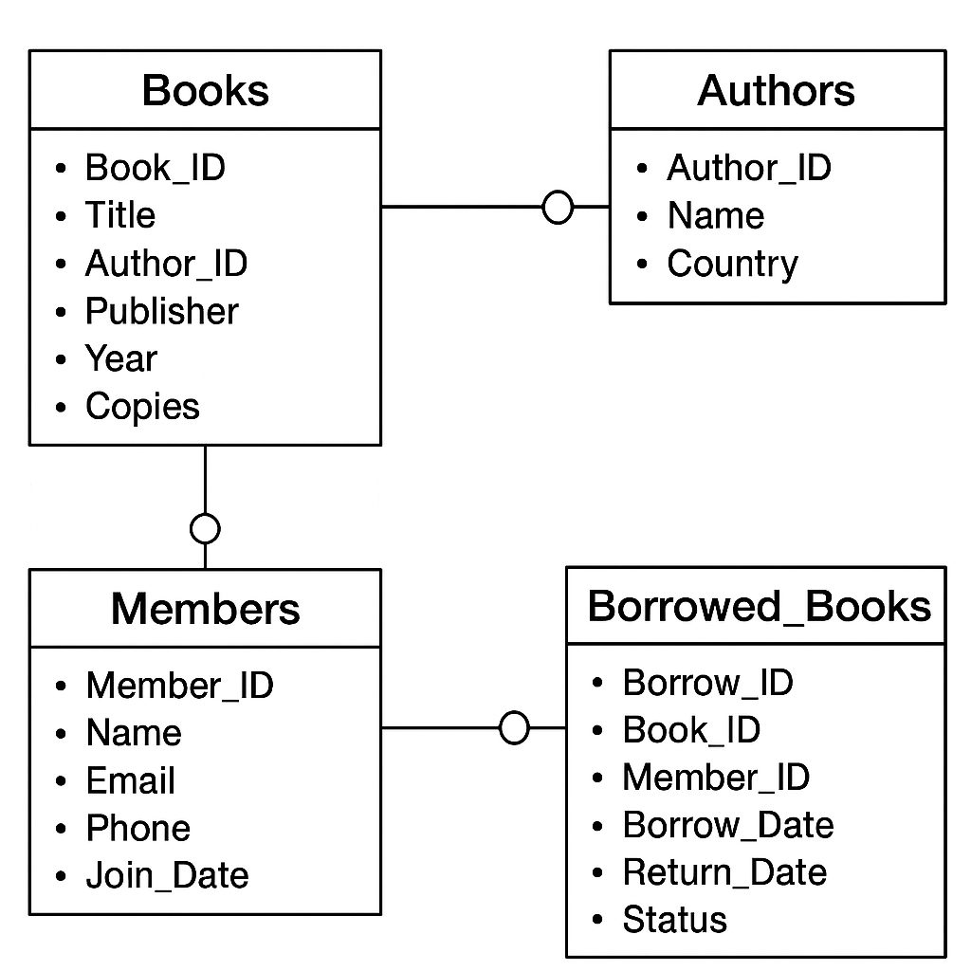

# 4. Database Schema

Tables created in the project:  
  
1. Authors(AuthorID, Name, Country)  
2. Books(BookID, Title, AuthorID, Publisher, PubYear, TotalCopies, AvailableCopies)  
3. Members(MemberID, Name, Email, Phone, JoinDate)  
4. Borrowings(BorrowID, BookID, MemberID, BorrowDate, DueDate, ReturnDate, Status)

# 5. SQL Implementation

The following SQL code was used to create and manage the database.

Example:

CREATE TABLE Authors (  
 AuthorID INT AUTO_INCREMENT PRIMARY KEY,  
 Name VARCHAR(100) NOT NULL,  
 Country VARCHAR(50)  
);

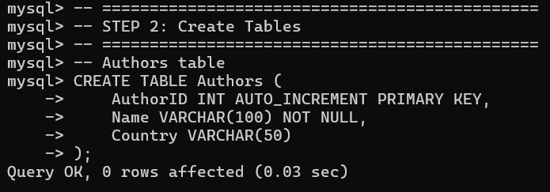

# 6. Sample Queries and Reports

Example Queries:

1. List all borrowed books:  
 SELECT * FROM v_current_loans;

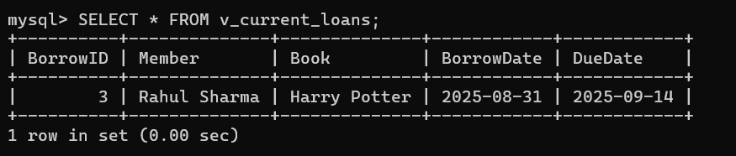  
  
2. Find the most borrowed book:  
 SELECT b.Title, COUNT(*) AS BorrowCount  
 FROM Borrowings br  
 JOIN Books b ON br.BookID = b.BookID  
 GROUP BY b.Title  
 ORDER BY BorrowCount DESC LIMIT 1;

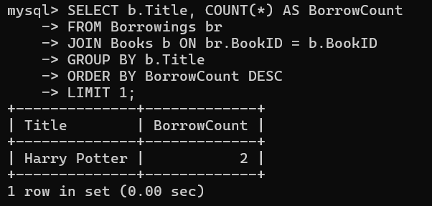  
  
3. Members who borrowed more than 1 book:  
 SELECT m.Name, COUNT(br.BookID) AS BooksBorrowed  
 FROM Members m  
 JOIN Borrowings br ON m.MemberID = br.MemberID  
 GROUP BY m.Name  
 HAVING COUNT(br.BookID) > 1;

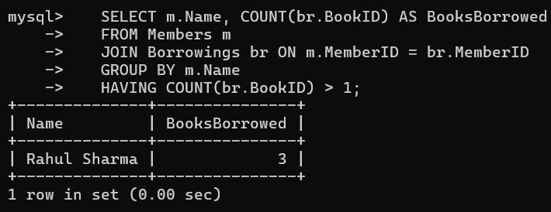

# 7. Conclusion

The Library Management System successfully manages books, authors, and members. It ensures proper tracking of borrowings and returns. This project demonstrates how SQL can be applied to real-world database management.