Prerequisite -
hadoop-1.2.1 , hive-0.12.0 AND hbase-0.94.5
Create a folder named auxlib in Hive root directory and put the following jars in it. The jars can be found in HBase lib directory. Hive-HBase handler is present in Hive lib directory.
Guava
Hive-Hbase handler
HBase
Zookeeper

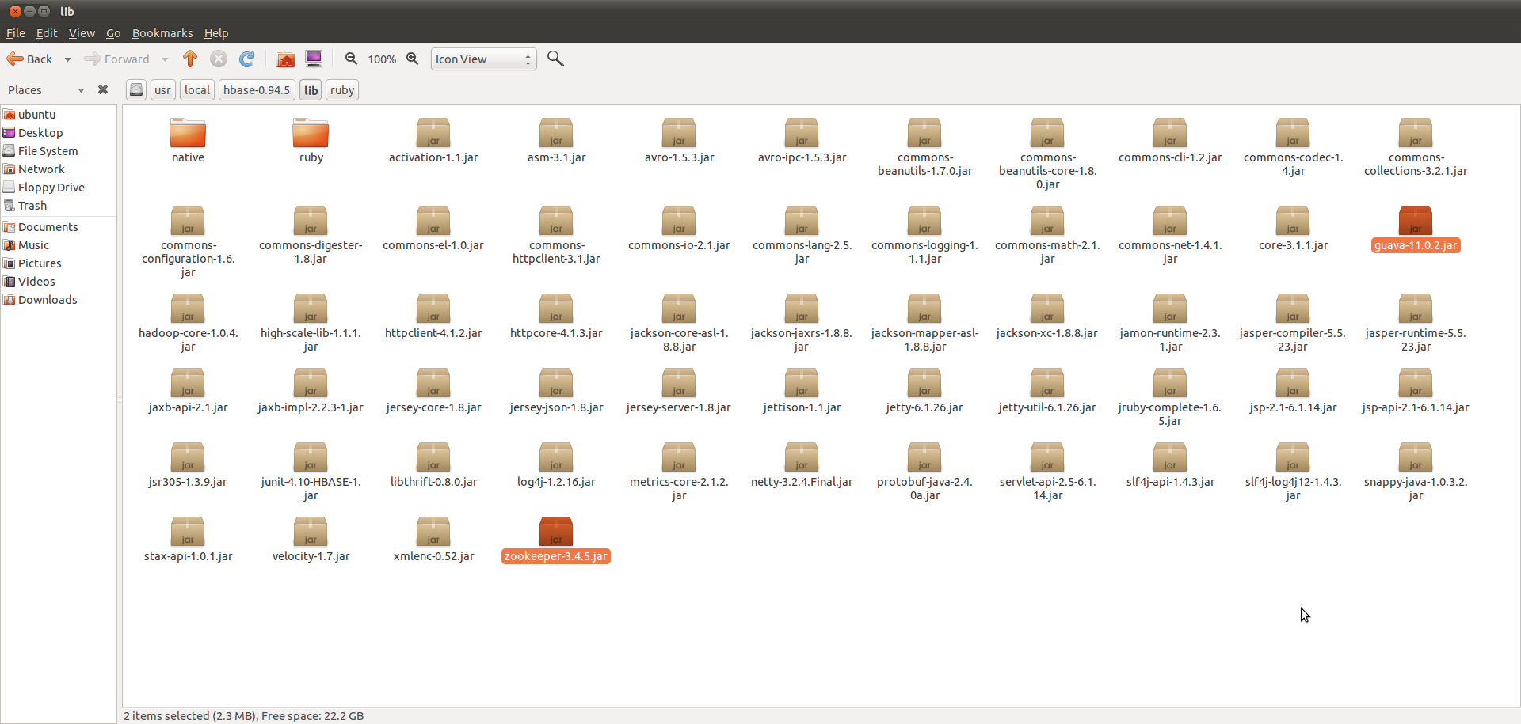

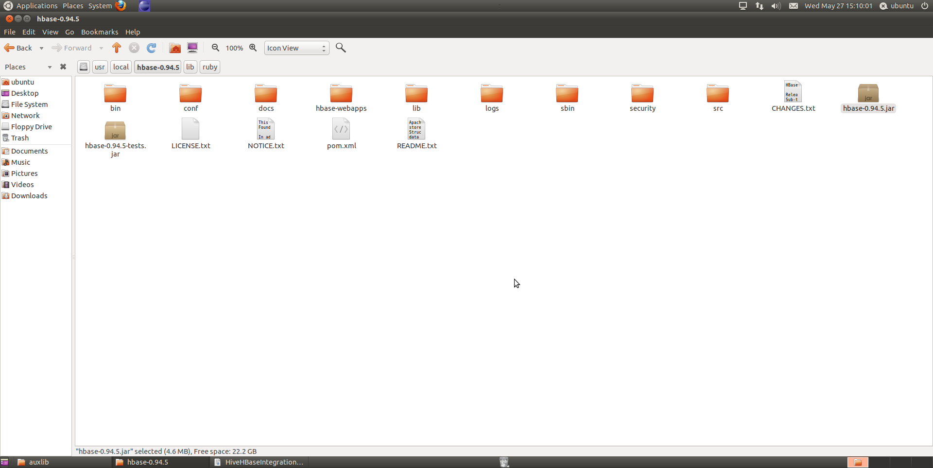

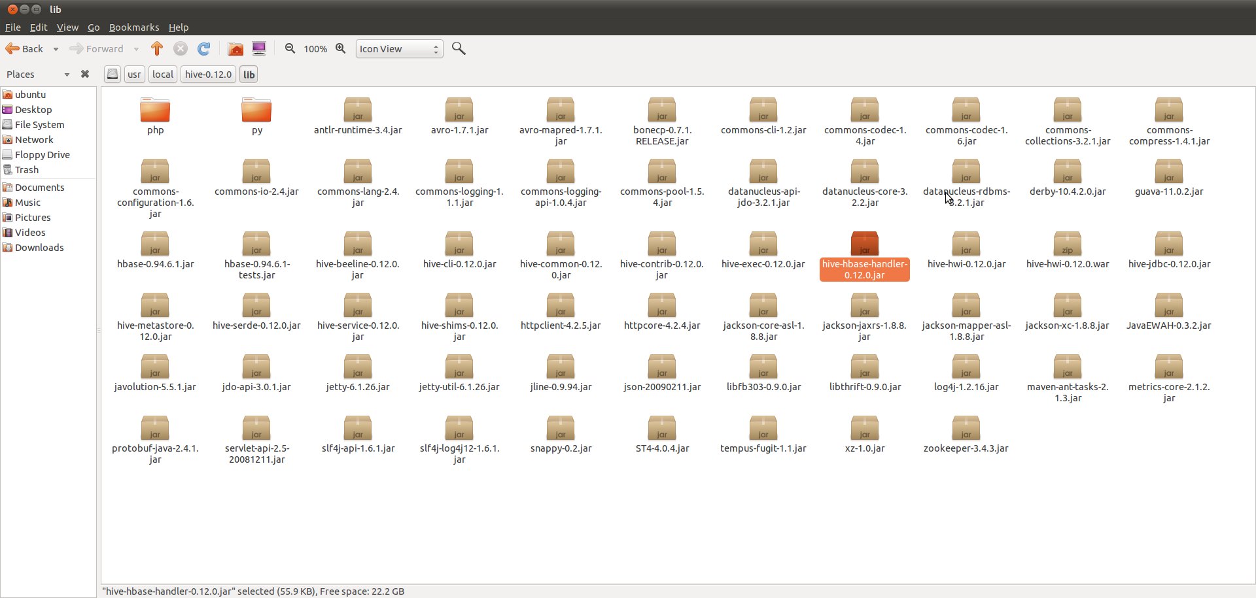

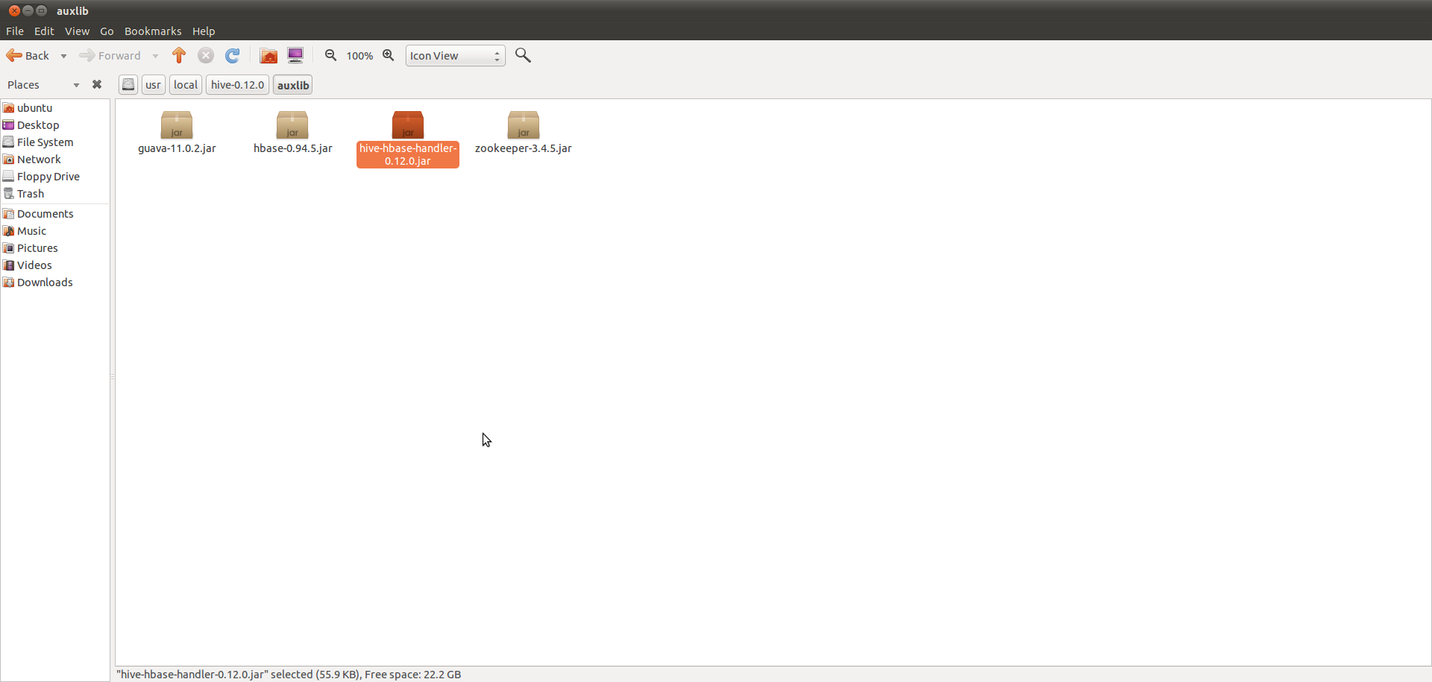
Start hadoop(ubuntu@ubuntu:~$ start-all.sh
)
Start hive (ubuntu@ubuntu:~$ hive
)
Start hbase(ubuntu@ubuntu:/usr/local/hbase-0.94.5$ bin/start-hbase.sh
ubuntu@ubuntu:/usr/local/hbase-0.94.5$ bin/hbase shell
)

Create Hbase Table ::
******************
create 'hivehbase', 'ratings'
put 'hivehbase', 'row1', 'ratings:userid', 'user1'
put 'hivehbase', 'row1', 'ratings:bookid', 'book1'
put 'hivehbase', 'row1', 'ratings:rating', '1'

put 'hivehbase', 'row2', 'ratings:userid', 'user2'
put 'hivehbase', 'row2', 'ratings:bookid', 'book1'
put 'hivehbase', 'row2', 'ratings:rating', '3'

put 'hivehbase', 'row3', 'ratings:userid', 'user2'
put 'hivehbase', 'row3', 'ratings:bookid', 'book2'
put 'hivehbase', 'row3', 'ratings:rating', '3'

put 'hivehbase', 'row4', 'ratings:userid', 'user2'
put 'hivehbase', 'row4', 'ratings:bookid', 'book4'
put 'hivehbase', 'row4', 'ratings:rating', '1'

hbase(main):015:0> scan 'hivehbase'

ROW COLUMN+CELL
row1 column=ratings:bookid, timestamp=1432720017695, value=book1
row1 column=ratings:rating, timestamp=1432720025048, value=1
row1 column=ratings:userid, timestamp=1432720006553, value=user1
row2 column=ratings:bookid, timestamp=1432720042368, value=book1
row2 column=ratings:rating, timestamp=1432720049559, value=3
row2 column=ratings:userid, timestamp=1432720035412, value=user2
row3 column=ratings:bookid, timestamp=1432720066011, value=book2
row3 column=ratings:rating, timestamp=1432720075514, value=3
row3 column=ratings:userid, timestamp=1432720057269, value=user2
row4 column=ratings:bookid, timestamp=1432720095287, value=book4
row4 column=ratings:rating, timestamp=1432720103092, value=1
row4 column=ratings:userid, timestamp=1432720087655, value=user2

4 row(s) in 0.0250 seconds

Since we want the data to be fetched from HBase we would need to create an external table for Hive.

CREATE EXTERNAL TABLE hbasehive_table
(key string, userid string,bookid string,rating int)
STORED BY 'org.apache.hadoop.hive.hbase.HBaseStorageHandler'
WITH SERDEPROPERTIES
("hbase.columns.mapping" = ":key,ratings:userid,ratings:bookid,ratings:rating")
TBLPROPERTIES ("hbase.table.name" = "hivehbase");
Note : the first column must be the key column which would also be same as the HBase’s key column. Also if you have some numeric data columns you can use the ratings:rating#b in the HBase column mappings.

hive> select * from hbasehive_table;

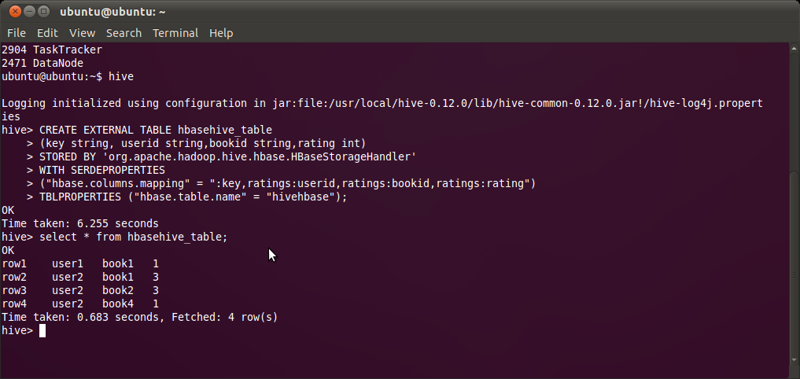
Few exceptions Along the path

java.lang.NoClassDefFoundError: com/google/protobuf/Message
java.lang.NoClassDefFoundError: Could not initialize class org.apache.hadoop.hbase.io.HbaseObjectWritable
The above two issues occur when Hive is unable to find required jars in its path. Adding above 4 jars in the auxlib directory fixes this issue.

java.lang.NegativeArraySizeException
SELECT COUNT(*) FROM hbasehive_table; fails

