Download solr jar.
tar -vxf solr-4.6.1.tgz
sudo mv solr-4.6.1 solr

sudo mv solr /opt/

//Goto Solr example folder & execute chomod command . If you are in example folder only use start.jar not //entire path
sudo chmod -R 777 /opt/solr/example/start.jar

java -jar start.jar

//Ctrl+z then write bg so that server runs in background
ubuntu@ubuntu:/opt/solr/example$ bg

//Execute ps command to see the processes
ubuntu@ubuntu:/opt/solr/example$ ps

PID TTY TIME CMD

2086 pts/0 00:00:00 bash

2726 pts/0 00:00:04 java

2950 pts/0 00:00:00 ps

//Goto /opt/solr/example/exampledocs folder & there you can see some sample files for indexing & post.jar to post the //files to Jetty server .Now that Solr is running, you can index some documents by running java -jar post.jar *.xml //from exampledocs directory. Then select collection1 from the left drop-down at http://localhost:8983/solr
java -jar post.jar *.xml

Now goto webconsole -
Run http://localhost:8983/solr to see the Solr running.
Now select Collection1

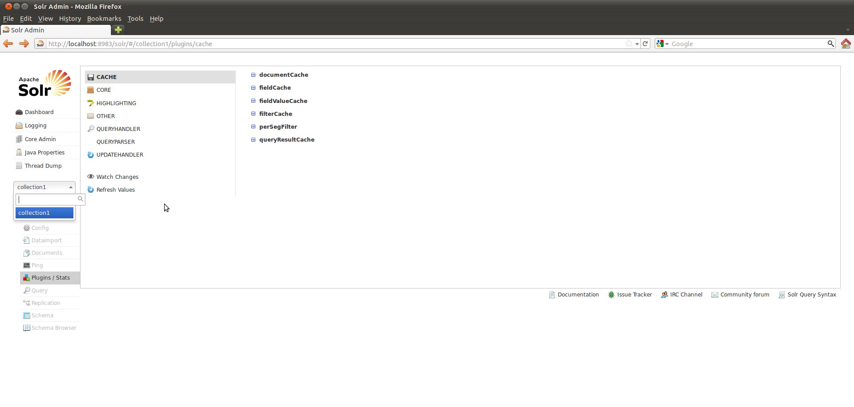
From the above, various queries can be run whose syntax is as follows:
http://localhost:8983/solr/collection1/select?
q=USB& (Main query which will get documents containing the word USB)
fq=manu:Canon& (Filter Query that filters obtained results, selecting those where manu is Canon)
sort=price asc& (Sorts by price in ascending order)
fl=id,name,price,score& (Specifies the fields to obtain from the query)
wt=json& (Specified the format of results. XML/CSV can also be specified)
indent=true& (Flag to indent results or not)
start=0&rows=10 (For pagination)

For a complete guide on the query syntax, see the lucene site

In solr console you can search -

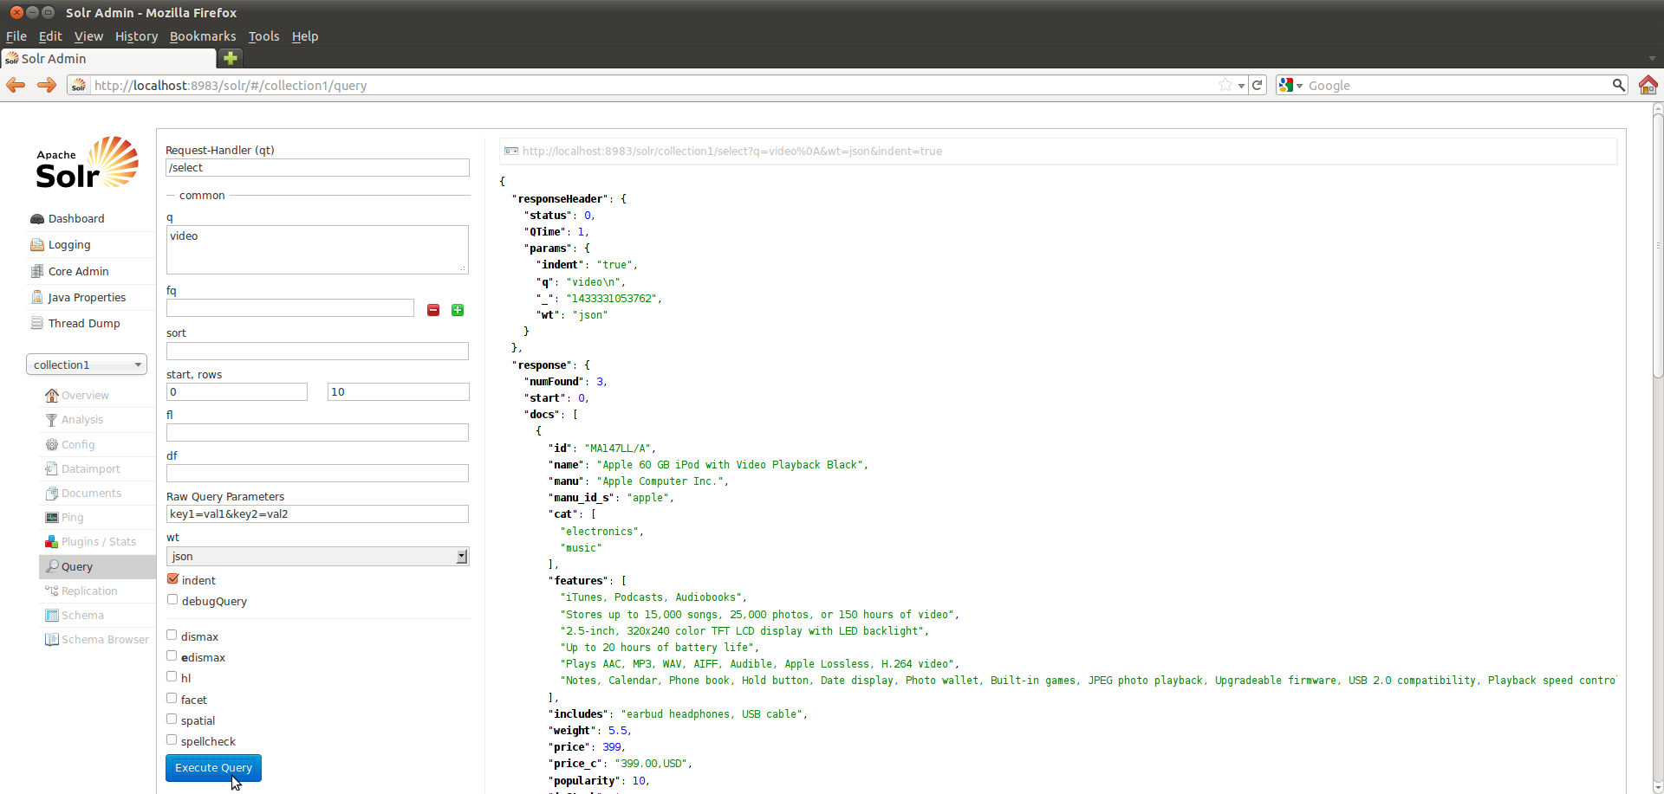

You can directly also check -
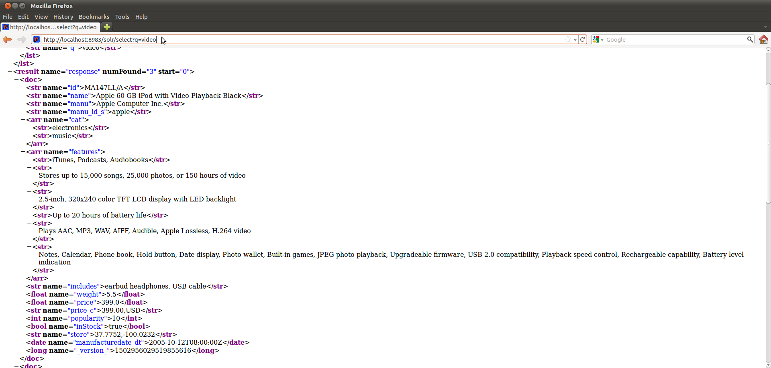

For update -

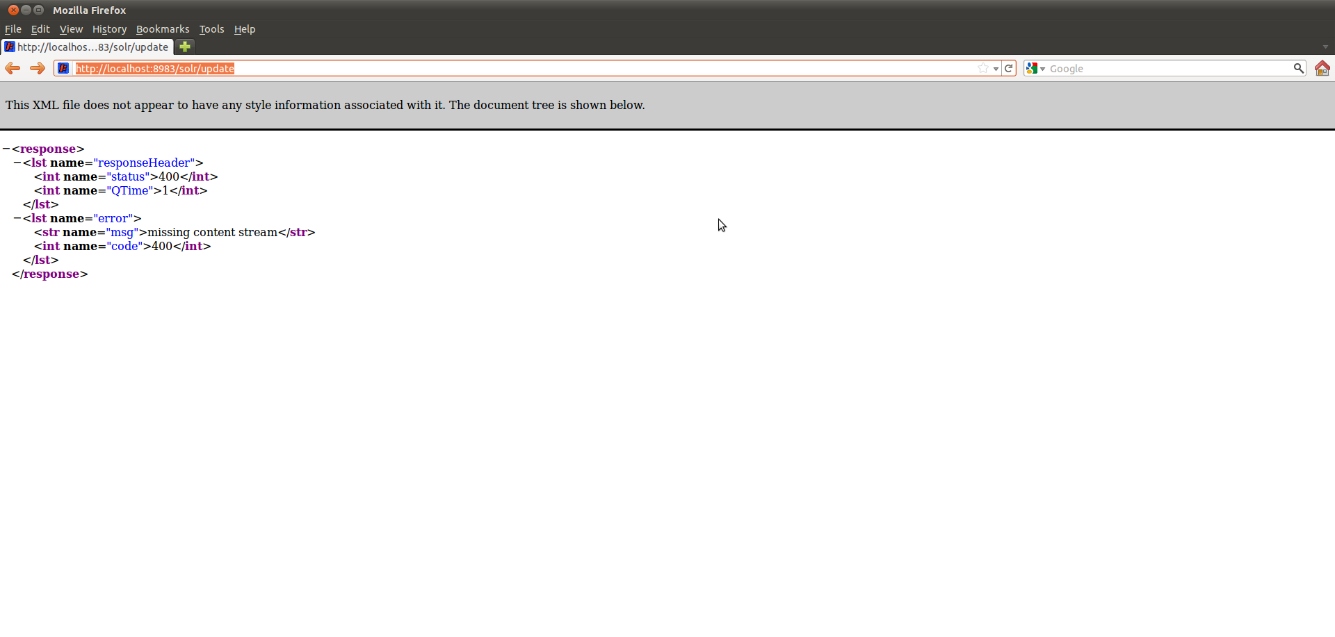
To stop solr write ps in command promt
then excute kill command for java process - “kill 2726”

ubuntu@ubuntu:/opt/solr/example$ lsof -i :8983

COMMAND PID USER FD TYPE DEVICE SIZE/OFF NODE NAME

firefox-b 2570 ubuntu 55u IPv4 86376 0t0 TCP localhost:38793->localhost:8983 (ESTABLISHED)

firefox-b 2570 ubuntu 65u IPv4 86378 0t0 TCP localhost:38794->localhost:8983 (CLOSE_WAIT)

firefox-b 2570 ubuntu 66u IPv4 86379 0t0 TCP localhost:38795->localhost:8983 (CLOSE_WAIT)

firefox-b 2570 ubuntu 67u IPv4 86380 0t0 TCP localhost:38796->localhost:8983 (CLOSE_WAIT)

firefox-b 2570 ubuntu 72u IPv4 86381 0t0 TCP localhost:38797->localhost:8983 (CLOSE_WAIT)

firefox-b 2570 ubuntu 75u IPv4 86382 0t0 TCP localhost:38798->localhost:8983 (CLOSE_WAIT)

java 3062 ubuntu 130u IPv4 82719 0t0 TCP *:8983 (LISTEN)

java 3062 ubuntu 131u IPv4 86377 0t0 TCP localhost:8983->localhost:38793 (ESTABLISHED)

ubuntu@ubuntu:/opt/solr/example$ ps

PID TTY TIME CMD

2086 pts/0 00:00:00 bash

3062 pts/0 00:00:03 java

3116 pts/0 00:00:00 ps

ubuntu@ubuntu:/opt/solr/example$
kill -9 3062

************************************

