**MUBEEN**

Jr. Software Developer

**Basic Information**

**Email:**

mr.mubeenbhatti@gmail.com

**Phone:**

+92 305 5352778

**Skype:**

live:mr.mubeenbhatti

**Location:**

Faisalabad.

**Nationality:**

Pakistan.

**Personal Skills**

* Communication
* Team Work
* Creativity
* Dedication
* Confidence
* Leadership

**Career Vision**

Seeking a challenging, responsible and dynamic position in renowned organization where all my energies, knowledge and experience can be effectively utilized for benefit of the organization and enhancement of my career.

**Professional Skills**

|  |  |
| --- | --- |
| * HTML/HTML5 * Twitter Bootstrap * PSD to HTML * jQuery (Basic) * Ng-zorro (Basic) * Git/SVN * GitHub, GitLab | * CSS/CSS3 * SASS, Compass * JavaScript (Basic) * Angular (Basic) * C++ * NPM * Jira |

**Working**

**Zepto System PVT Ltd. 2020 - 2021**

Js. Software Developer *Faisalabad*.

* Developed new template from scratch using HTML/CSS3 and Bootstrap.
* Define navigation. User workflows and layouts focusing on usability.
* Developed intuitive and engaging experiences for the product.
* Produced high-quality user interfaces and visual designs from concept to launch on web and mobile applications.
* Created and optimized complex user flows
* Read and understand requirements and specifications and records are correct.
* Create and optimized user flows.

**Zepto System PVT Ltd. 2020 - 2020**

Internship *Faisalabad*.

* Fulfill tasks set out by supervisors from several departments.
* Reports on progress on daily basis or as required.
* Perform research at a supervisor's request.
* Write well-designed, testable code.
* Assess new application ideas
* Execute full software development life cycle (SDLC)
* Develop flowcharts, layouts and documentation to identify requirements and solutions

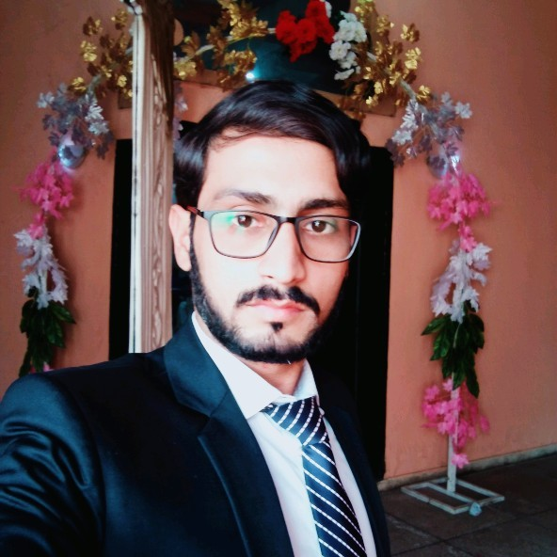

**Communication**

Excellent skills of Reading, Writing, Listening & Speaking in;

* English
* Urdu
* Punjabi

**Education**

2016 - 2020 BS (CS) GC University Fsd

2012 - 2014 B.Com (IT) Punjab University Lhr

2010 - 2012 Intermediate P.B.T.E Lahore

2007 - 2009 Matric (Science) B.I.S.E Faisalabad

**Activities & Interests**

* Learning New Skills
* Computing
* Designing Web Pages
* Traveling
* Painting
* Photography

**Reference**

Reference would be served on demand.