Protein Sequence implementation using visual c#.net

Table of Contents

1. Introduction 2

2. Environment 2

3. C# and .Net Framework 2

4. Flow Chart 3

5. Code 4

6. Snapshots 6

7. References 7

1. Paper1 7

2. http://www.rcsb.org/pdb/home/home.do#Subcategory-download_sequences 7

# Introduction

The paper focuses on to create a Graphical User Interface (GUI) which enables the user to determine the similarity between two protein sequences.

It provides the platform to the user to enter any two protein sequences and the algorithm will determine the similarity status of those two sequences. Application will work fine for Protein Sequences up to 10^12 in length.

# Environment

Microsoft Visual Studio 2012(Project style: Windows Forms Application)

# C# and .Net Framework

.Net is a powerful programming platform with integrated visualization programming environment. C# is designed for .Net platform. C# is simple, modern, object oriented and type safe programming language that combines the high productivity of rapid application development languages with raw power of C and C++. C# provides friendly interface, fast execution speed , high security with creating EXE files and can be run with .net framework instead of entire software.

C# could create simple client applications of Windows, XML Web services, distributed component, C/S applications, database applications, etc. Through CLR (Common Language Runtime) ，the program compiled by C# will run steadily on computers with **.Net Framework**. Application developers normally need not be concerned with using processors or Language. Tools described herein will run on it so long as with .Net Framework.

#### Reference: https://msdn.microsoft.com/en-IN/library/z1zx9t92.aspx

#### Reference: https://msdn.microsoft.com/en-us/library/ms973898.aspx

# Flow Chart

start

Enter value in textbox1

Enter value in textbox2

Check textbox are empty

True

False

Check for equal length

False

True

Processing

OUTPUT

END

# Code

using System;

using System.Collections.Generic;

using System.ComponentModel;

using System.Data;

using System.Drawing;

using System.Linq;

using System.Text;

using System.Threading.Tasks;

using System.Windows.Forms;

namespace proteinSequence

{

public partial class Form1 : Form

{

string[,] a = new string[,]

{

{"A","ACGILMFPSV"},

{"R","REQHK"},

{"N","NDCEQHMPST"},

{"D","NDEQH"},

{"C","ANCLMFS"},

{"E","RNDEQHK"},

{"Q","RNDEQHKMS"},

{"G","AGLMPSV"},

{"H","RNDEQHKWY"},

{"I","AILMFPV"},

{"L","ACGILMFPV"},

{"K","REQHK"},

{"M","ANCGILMFPWV"},

{"F","ACILMFPWYV"},

{"P","ANGILMFPWV"},

{"S","ANCQGSTY"},

{"T","NST"},

{"W","HMFWY"},

{"Y","HFSWY"},

{"V","AGILMFPV"}

};

public Form1()

{

InitializeComponent();

}

private void label1_Click(object sender, EventArgs e)

{

}

private void button1_Click(object sender, EventArgs e)

{

try

{

int flag = 0;

String outputStr1 = System.Text.RegularExpressions.Regex.Replace(textBox1.Text, @"[^a-zA-Z//]", "").ToUpperInvariant();

String outputStr2 = System.Text.RegularExpressions.Regex.Replace(textBox2.Text, @"[^a-zA-Z//]", "").ToUpperInvariant();

char[] ch1 = (outputStr1).ToCharArray();

char[] ch2 = (outputStr2).ToCharArray();

if (ch1.Length == ch2.Length)

{

for (int i = 0; i < ch1.Length; i++)

{

if(ch1[i] == ch2[i])

{

flag ++;

}

else

{

for (int j = 0; j < 20; j++)

{

if (ch1[i] == Convert.ToChar(a[j, 0]))

{

char[] ch3 = a[j,1].ToCharArray();

for (int k = 0; k < ch3.Length; k++)

{

if(ch2[i] == ch3[k])

{

flag++;

}

}

}

}

}

}

if (flag == ch1.Length)

{

MessageBox.Show("true");

MessageBox.Show(Convert.ToString(a.Length));

}

else

{

MessageBox.Show("false");

}

}

else

{

MessageBox.Show("enter equal length protein sequences!");

}

}

catch (Exception ex)

{

MessageBox.Show(ex.Message.ToString(), "Error!");

}

}

}

}

# Snapshots

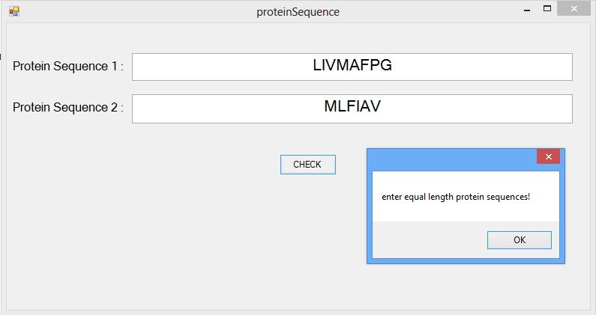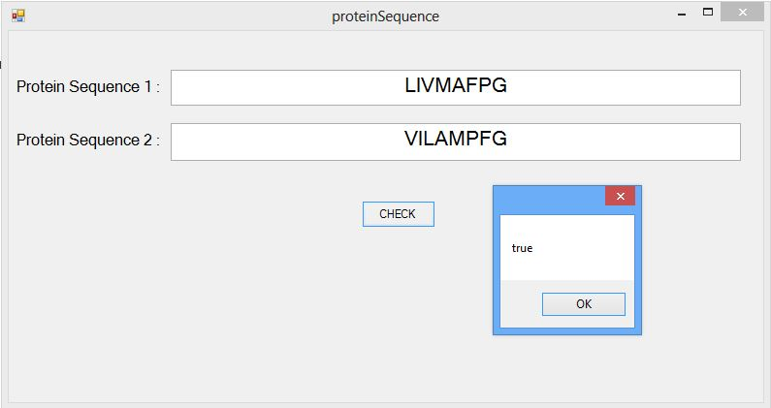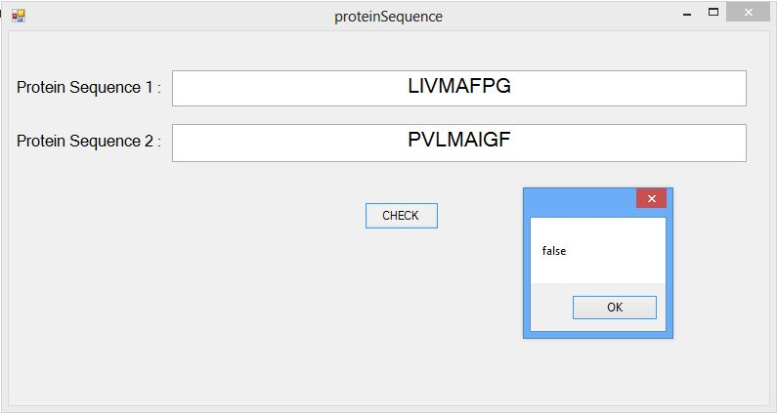

# References

## Paper1

## <http://www.rcsb.org/pdb/home/home.do#Subcategory-download_sequences>

(FOR EXAMPLES OF PROTEIN SEQUENCES USED IN SNAPSHOTS!)