**Text Analysis Demo,** deployed on http://edge.innovaccer.com/text_analysis

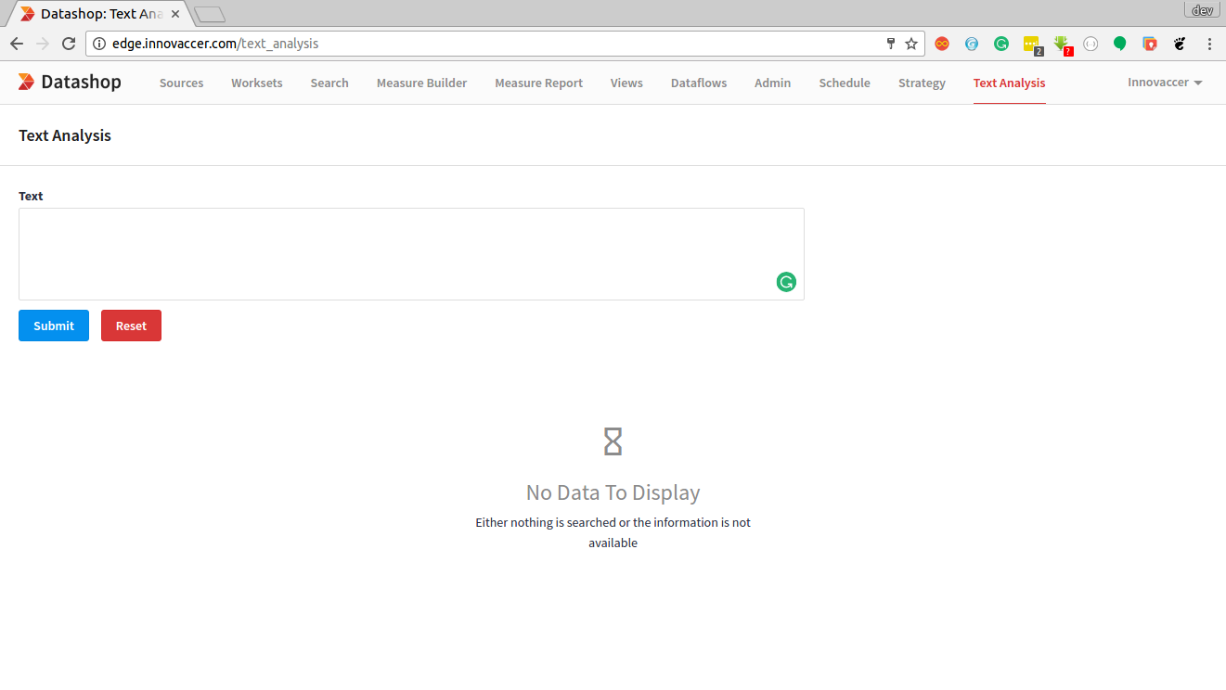

**- Enter The Clinical Text in the Text Field**

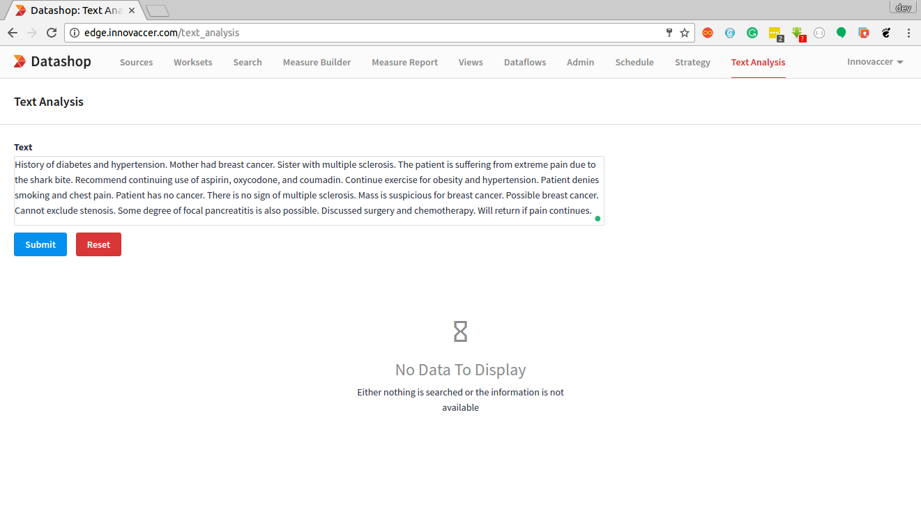

**- Submit button is used to generate th result an Reset button is used to clear the Text Field**

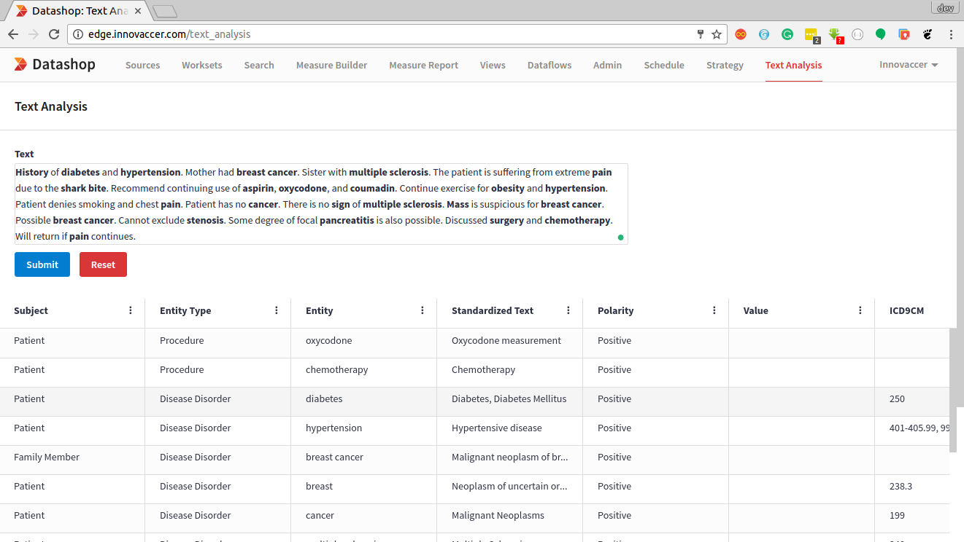

**- After Clinical Text is generated the analyzed keywords get bold on Text Field and after clicking on the particular entity (row), the respective entity will highlight in Text Field.**

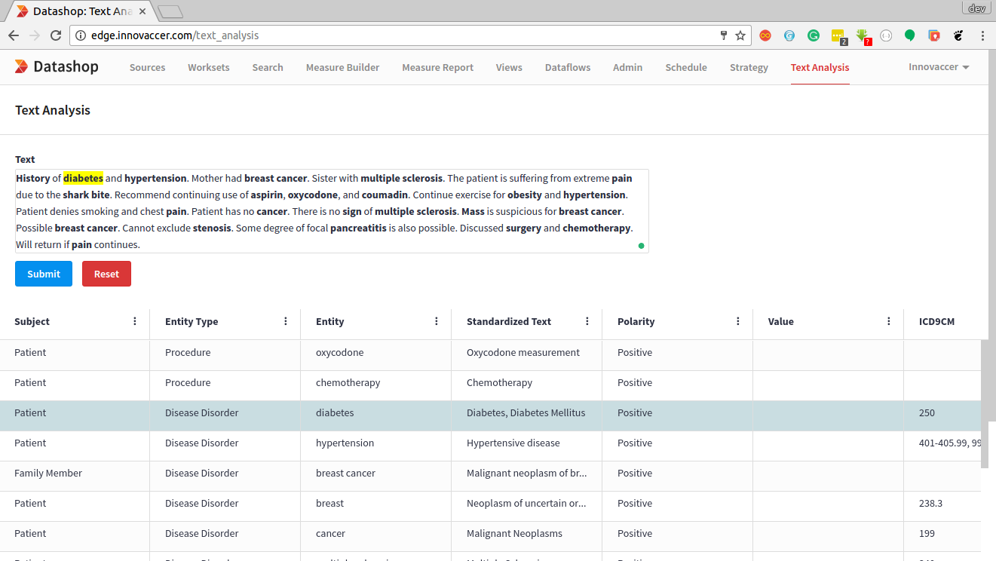

**Glossary:**

**Entity:** Keyword for which analysis took place and procedure or medication codes are generated.

**Entity Type:** Type of Keyword Selected. can be Procedure, Disease Disorder, Medication, Sign Symptom or Entity(Other).

**Subject:** Refers to the person related to the analyzed entity. can be Patient, Family Member or Other.

**Standardized Text:** Gives Preferred Terms and Medical Terms for the analyzed entity.

**Polarity:** Is a Boolean Value, for a particular entity. If the subject corresponds to the analyzed entity, Polarity is Positive else Negative.

**Value:** Numerical Value associated with the particular entity

**ICD9CM:** ICD9CM codes generated for the analyzed entity are placed in this column in a comma separated fashion.

**ICD10CM:** ICD10CM codes generated for the analyzed entity are placed in this column in a comma separated fashion.

**CPT:** CPT codes generated for the analyzed entity are placed in this column in a comma separated fashion.

**HCPCS:** HCPCS codes generated for the analyzed entity are placed in this column in a comma separated fashion.

**LOINC:** LOINC codes generated for the analyzed entity are placed in this column in a comma separated fashion.

**RXNORM:** RXNORM codes generated for the analyzed entity are placed in this column in a comma separated fashion.