**A MAJOR PROJECT REPORT**

**ON**

**EXCELBOT: YOUR SMART DATA PARTNER**

**Submitted to**



**UNIVERSITY INSTITUTE OF TECHNOLOGY RGPV SHIVPURI (M.P.)**

**In Partial Fulfillment of the Degree of**

**BACHELOR OF TECHNOLOGY**

**IN**

**COMPUTER SCIENCE & ENGINEERING**

**Submitted By**

**Monika Namdev (0967CS201041)**

**Under the supervision of**

**Mrs. Bhavya Shukla**

**Head of Department of Computer Science & Engineering**



**UNIVERSITY INSTITUTE OF TECHNOLOGY, RGPV, SHIVPURI (M.P.)**

**DEPARTMENT OF COMPUTER SCIENCE AND ENGINEERING**

**CERTIFICATE**

This is to certify that the Project entitled “***ExcelBot: Your Smart Data Partner”*** is the record of bonafide work done by Monika Namdev under our guidance for the partial fulfillment of the requirements for the award of the degree of “Bachelor of Technology.” To the best my knowledge, this project is an original work and has not been submitted anywhere for the award of any degree.

Date: Mrs. Bhavya Shukla

(HOD, CSE Department)



**UNIVERSITY INSTITUTE OF TECHNOLOGY, RGPV, SHIVPURI (M.P.)**

**DEPARTMENT OF COMPUTER SCIENCE AND ENGINEERING**

**CERTIFICATE OF APPROVAL**

The foregoing project entitled *ExcelBot: Your Smart Data Partner* is hereby approved as a creditable study of an engineering subject carried out and presented in a manner satisfactory to warrant its acceptance as a pre-requisite to the degree for which it is submitted. It is understood that by this approval, the undersigned do not necessarily endorse any conclusion or opinion therein, but approve the project for the purpose for which it was submitted.

|  |  |
| --- | --- |
| (Internal Examiner) | (External Examiner) |
| DIRECTOR | HOD/AHOD |

**Acknowledgment**

We are always thankful to our college Director Dr. Rakesh Singhai, who endorsed us throughout this project.

Our heartfelt thanks to HOD Mrs. Bhavya Shukla, Professor at University Institute of Technology RGPV, Shivpuri, for the prompt and limitless help in providing the excellent infrastructure to do the project and to prepare the thesis. Also, we express our deep sense of gratitude to our HOD , for her invaluable support and guidance, and encouragement for the successful completion of this project. Her vision and spirit will always inspire and enlighten us.

We thank all the faculty members of The Department of Computer Science and Engineering for their valuable help and guidance. We are grateful to our family and friends for their constant support and encouragement. We thank the almighty whose showers of blessings made this project a reality.

*Index*

## Abstract .................................... 07

## Introduction .................................... 08

* 1. Project Overview .................................... 08
  2. The Need for ExcelBot .................................... 09
  3. Key Features of ExcelBot .................................... 10
  4. The Future of ExcelBot .................................... 10

## Project Structure .................................... 11

* 1. Directory Structure .................................... 11
  2. Key Components .................................... 13
  3. Technology Stack .................................... 14

## Key Features .................................... 15

* 1. File Upload .................................... 15
  2. Tabular Data Display .................................... 16
  3. Natural Language Query .................................... 17
  4. Integration with OpenAI API .................................... 18
  5. Answer Display .................................... 10

## Technology Stack .................................... 20

* 1. Frontend .................................... 20
  2. Backend .................................... 21
  3. Natural Language Processing (NLP) .................................... 22

## API Endpoints .................................... 24

* 1. User Query API .................................... 24
  2. OpenAI Integration API .................................... 25

## User Interface .................................... 27

* 1. Design Overview .................................... 27
  2. Wireframes/Mockups .................................... 28

## Deployment .................................... 30

* 1. Hosting Platform .................................... 30
  2. Deployment Process .................................... 32

## Workflow of ExcelBot .................................... 35

* 1. User Accesses the Web Application .................................... 35
  2. Uploading a CSV File .................................... 35
  3. Viewing CSV Data in Tabular Form .................................... 36
  4. Asking a Query .................................... 37
  5. Query Sent to Server via API .................................... 38
  6. Displaying the Answer .................................... 39

## Testing .................................... 40

* 1. Testing Strategy .................................... 40
  2. Unit and Integration Tests .................................... 40

## Security .................................... 44

* 1. Security Measures .................................... 44
  2. Data Protection .................................... 45

## Future Improvements .................................... 47

## Conclusion .................................... 49

## Reference .................................... 51

Abstract

***ExcelBot: Your Smart Data Partner*** is a game-changing web application poised to revolutionize how we interact with Excel spreadsheets and conduct data analysis. In an age where data shapes crucial decisions, ExcelBot serves as an intelligent companion, bridging the gap between raw data and actionable insights.

Its primary objective is to empower users with an intuitive and efficient tool that simplifies the process of uploading, analysing, and querying data in Excel files. Harnessing the power of Python, Django, and natural language processing, ExcelBot enables users to converse with their data using plain language questions. Users can effortlessly upload Excel files, view data in an organized tabular format, and obtain instant answers to their queries through natural language interactions. Beneath the surface, Python libraries ensure precise data analysis, while OpenAI integration enhances the application's capabilities for accurate responses.

ExcelBot is set to streamline data analysis for professionals, students, and data enthusiasts, eliminating the need for labour-intensive, error-prone manual data manipulation.

It is not just a project; it is a vision for the future of data analysis, where data becomes a wellspring of knowledge rather than a challenge. Welcome to the data-driven future with ExcelBot—a smarter, more efficient way to unlock insights from your Excel files.

Introduction

## Project Overview:

In an age where data reigns supreme, the power to harness its potential is the key to unlocking insights, making informed decisions, and driving productivity. Enter ***ExcelBot, your intelligent companion for Excel file***s – a revolutionary web application designed to simplify the process of data analysis, answer your questions, and transform your static Excel spreadsheets into dynamic sources of actionable information.

ExcelBot is your gateway to effortless data-driven decision-making. In a world awash with data, it offers an innovative solution that bridges the gap between traditional data analysis and cutting-edge artificial intelligence. Through a seamless fusion of Python's Django web framework, the natural language processing prowess of OpenAI, and a user-friendly interface, ExcelBot redefines the way you interact with your Excel documents.

ExcelBot is a cutting-edge project that marries the worlds of data analysis, natural language processing, and user-friendly web interfaces. This intelligent companion was meticulously crafted to address the challenges faced by professionals, analysts, students, and anyone who seeks swift and accurate insights from their Excel files. With ExcelBot, the days of arduous data hunting and manual analysis are left behind, making room for a seamless and intuitive solution that promises to redefine how we interact with spreadsheet data.

Imagine a single, user-friendly web page where you can effortlessly upload your Excel files and ask questions in plain language. No more cumbersome, time-consuming data hunting. With ExcelBot, the era of manual data sifting and number crunching becomes a distant memory. Instead, you gain quick, accurate answers that unveil the true potential of your Excel documents.

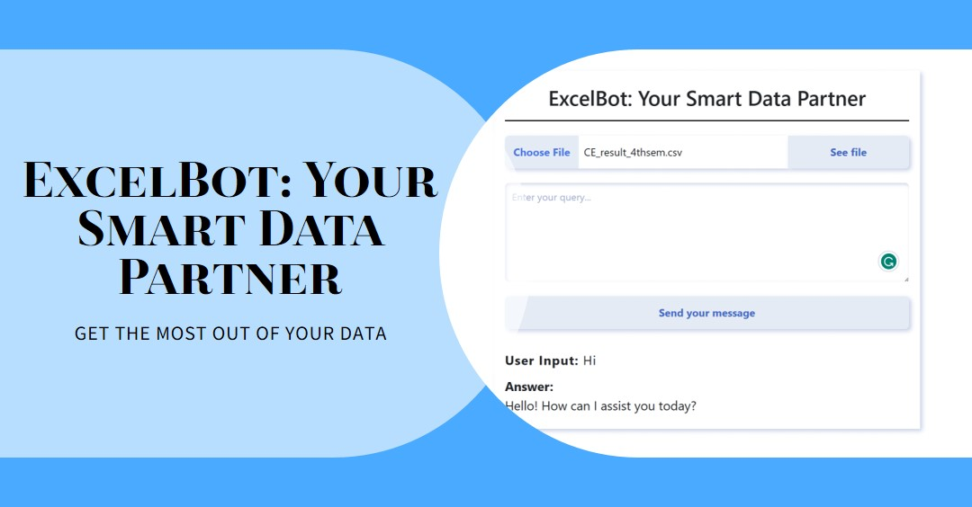At the heart of ExcelBot lies a robust tech stack, leveraging Python as the primary language for Django development, Django as the powerful web framework for building our application, and JavaScript for enhancing the user interface and interactivity..

## The Need for ExcelBot:

Data analysis is no longer a niche activity; it is a ubiquitous requirement in today's information-centric landscape. As the reliance on data-driven decisions grows, so does the demand for tools that simplify the process of transforming data into actionable insights. While spreadsheet software is widely used for data organization, the human effort required to locate, filter, and analyse specific pieces of information within these files can be arduous and error-prone.

ExcelBot was conceived as a response to these challenges. It is designed to cater to a diverse range of users, from professionals seeking quick business insights to students requiring streamlined academic research tools. By bridging the gap between Excel spreadsheets and intelligent data analysis, ExcelBot liberates users from the shackles of manual data manipulation and liberates their time for more valuable pursuits.

## Key Features of ExcelBot:

ExcelBot boasts a robust set of features that sets it apart as an exceptional solution for data analysis and insights:

* **Seamless File Upload:** Users can easily upload their Excel spreadsheets, eliminating the complexities associated with file conversion or data extraction.
* **Intuitive Data Visualization:** The application transforms raw data from uploaded Excel files into visually appealing, user-friendly tabular formats for swift data comprehension.
* **Natural Language Interaction:** ExcelBot embraces natural language processing, allowing users to ask questions in plain language, enabling an effortless communication channel with the application.
* **Efficient Data Analysis:** Behind the scenes, ExcelBot leverages the power of Python libraries such as Pandas and OpenPyXL to execute data analysis operations with precision and speed.
* **OpenAI Integration:** Excel Bot’s integration with the OpenAI API enhances its capabilities, enabling the application to generate insightful answers to user queries.
* **User-Friendly Interface:** A well-crafted user interface ensures a seamless and enjoyable experience, even for those with minimal technical expertise.

## The Future of ExcelBot:

ExcelBot is more than just a project it is a vision for the future of data analysis. As we continue to expand its capabilities and refine its interface, ExcelBot is poised to evolve into a sophisticated, indispensable tool for a multitude of industries and use cases. In an era where data reigns supreme, ExcelBot is poised to be the guiding light for those who seek to harness the true power of their data, ultimately transforming the way we approach data analysis, enabling individuals and organizations to make informed decisions that are based on data-driven insights.

Project Structure

## Directory Structure:

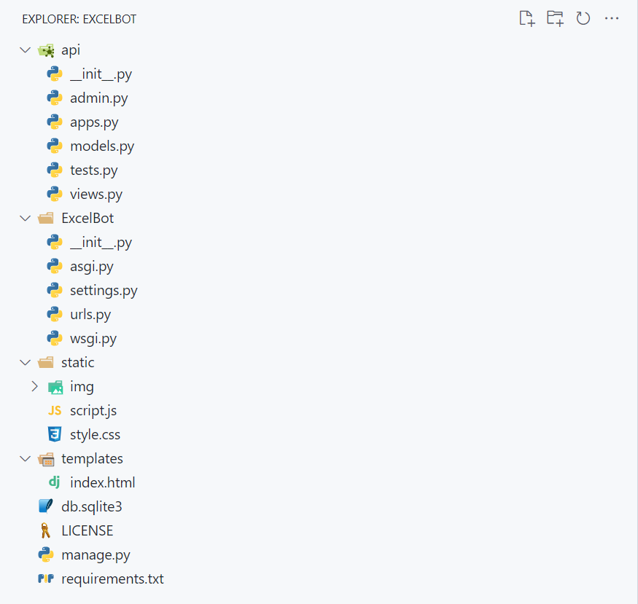The project follows a well-organized directory structure to ensure modularity and clarity. Here is an overview of the key directories:

**Directory Structure of project**

* **ExcelBot/:** The root directory of the project.
* **ExcelBot** /: This directory contains the core configuration files for the Django project.
  + __init__.py: App initialization.
  + settings.py: Django project settings.
  + urls.py: URL routing configuration.
  + wsgi.py: WSGI configuration for deployment.
  + asgi.py: ASGI configuration for asynchronous support.
* **Api/:** This is the main Django app for your project.
  + __init__.py: App initialization.
  + admin.py: Configuration of the Django admin panel.
  + apps.py: App configuration.
  + models.py: Database models.
  + tests.py: Unit tests for the app.
  + views.py: Views for the app.
* **static/:** Static files like CSS, JavaScript, and images.
  + Style.css: CSS styles.
  + Script.js: JavaScript scripts.
  + img/: Image assets.
* **templates/:** HTML templates.
  + index.html: Template for the main page.
* **db.sqlite:** database file
* **manage.py:** A Django management script that provides command-line tools for common tasks like running the development server, creating migrations, and managing the database.
* **requirements.txt:** A text file listing the Python packages and dependencies required for your project. You can use this file to install all necessary packages with a single command.

## Key Components:

## **1. Django Backend**

## **Description**: The heart of the project, the Django backend, is responsible for managing user accounts, handling file uploads, and providing API endpoints for data analysis.

## **Key Features**: User authentication, file handling, and API development.

## **2. Frontend Development**

## **Description**: The frontend component of ExcelBot is responsible for creating a user-friendly interface for uploading files, asking questions, and viewing results.

## **Key Features**: HTML, CSS, JavaScript for web page creation. (Consider utilizing a front-end framework for enhanced interactivity.)

## **3. Data Analysis and Processing**

## **Description**: This component utilizes Python libraries like Pandas and OpenPyXL to efficiently process and analyse data extracted from uploaded CSV files.

## **Key Features**: Data extraction, transformation, and analysis.

## **4. Natural Language Processing (NLP)**

## **Description**: NLP techniques are integrated to interpret and process plain language questions from users, allowing for intuitive interactions.

## **Key Features**: Language understanding, query processing.

## **6. User Interface (UI)**

## **Description**: The UI component focuses on designing user-friendly and responsive web pages, making it easy for users to interact with the application.

## **Key Features**: Web page design, usability.

## **7. API Endpoints**

## **Description**: API endpoints are created to enable communication between the frontend and backend, facilitating data analysis and OpenAI API integration.

## **Key Features**: API development, communication with other components.

## Technology Stack:

ExcelBot leverages a powerful technology stack to deliver a seamless and feature-rich experience for its users. The chosen technologies and frameworks contribute to the project's efficiency, security, and functionality:

* **Frontend:**
  + **HTML, CSS, JavaScript:** The fundamental trio for building interactive web interfaces.
* **Backend:**
  + **Python:** The primary programming language that powers the project's backend logic. Python's versatility and ease of use make it an ideal choice for developing the core functionality of ExcelBot.
  + **Django:** A high-level Python web framework that streamlines web application development. Django offers built-in features for user authentication, URL routing, database modelling, and more, facilitating rapid development.
* **Natural Language Processing (NLP):**
  + **OpenAI API:** ExcelBot integrates with the OpenAI API, leveraging state-of-the-art natural language processing models to understand and answer user queries accurately. This powerful API enhances the application's ability to interpret plain language questions and provide insightful responses.

The selected technology stack aligns with ExcelBot's mission to provide a user-friendly, efficient, and secure environment for working with Excel data and obtaining valuable insights. It blends Python's versatility, Django's development efficiency, and NLP capabilities to create an innovative and valuable tool for users.

Key Features

## File Upload:

***Overview:***

File Upload is a fundamental feature of ExcelBot, enabling users to seamlessly import their Excel files into the application for analysis. This feature simplifies the data ingestion process, eliminating the need for manual data entry and reducing the risk of errors. With File Upload, users can swiftly transition from their local Excel files to a user-friendly web-based environment for data analysis.

***Functionality:***

* **Easy Upload Process:** ExcelBot provides an intuitive interface for users to select and upload their Excel files. The upload process is straightforward and user-friendly, making it accessible to users of all technical backgrounds.
* **Wide Format Compatibility:** ExcelBot supports a variety of Excel file formats, ensuring compatibility with both older and newer Excel versions, such as .CSV
* **Error Handling:** The system is equipped with error-checking mechanisms to handle common issues during the upload process, ensuring a smooth user experience.
* **Automatic Data Extraction:** Once a file is uploaded, ExcelBot automatically extracts and organizes the data, presenting it in a user-friendly tabular format. This step simplifies the data visualization process, reducing the need for manual data formatting.
* **Data Validation:** The application validates the uploaded data to ensure its integrity, reducing the chances of working with corrupted or unreliable data.
* **Security Measures:** ExcelBot incorporates security measures to protect user data during the upload process, maintaining the confidentiality and integrity of sensitive information.

*Benefits:*

File Upload is a pivotal feature that streamlines the initial step of the data analysis process. By facilitating the effortless import of Excel files, users can quickly transition from data preparation to analysis, saving time and reducing the risk of errors associated with manual data entry. This feature sets the stage for further data exploration and insights within the ExcelBot ecosystem.

## Tabular Data Display:

One of the pivotal features of ExcelBot is its intuitive and user-friendly tabular data display. This feature addresses the fundamental need for users to visualize and understand the data contained within their uploaded Excel files seamlessly. ExcelBot's tabular data display offers several notable benefits:

1. **Visual Clarity:** ExcelBot presents the data from uploaded Excel files in a visually organized and structured tabular format. This enables users to grasp the data's layout and structure briefly, improving overall data comprehension.
2. **Effortless Navigation:** Users can easily scroll through and navigate large datasets using the intuitive interface. This feature ensures that users can explore extensive data sets with ease, locating specific information swiftly.
3. **Responsive Design:** The tabular data display is designed to be responsive and adaptable to various screen sizes, ensuring an optimal viewing experience on both desktop and mobile devices.
4. **Column Sorting and Filtering:** ExcelBot allows users to sort and filter columns, empowering them to rearrange data according to their preferences and extract relevant information efficiently.
5. **Data Enrichment:** Users can explore data rows to access additional information or drill down into specific data points, enabling them to make more informed decisions.
6. **Customization:** Users have the flexibility to customize the display based on their preferences, tailoring the tabular view to their specific needs.
7. **Data Export:** ExcelBot enables users to export tabular data to various formats (e.g., CSV, Excel, PDF) for further analysis or reporting.

ExcelBot's tabular data display serves as a pivotal component in its mission to streamline data analysis. By offering users an efficient and user-friendly way to interact with their data, ExcelBot empowers individuals and organizations to unlock the insights hidden within their Excel files, fostering data-driven decision-making and efficiency in data analysis processes.

## Natural Language Query

The "Natural Language Query" feature in ExcelBot represents a transformative approach to data interaction. It recognizes that not everyone is well-versed in complex data querying languages or data analysis tools. With natural language query, users can communicate with ExcelBot in everyday language, just as they would with a human colleague. Users simply input questions, and ExcelBot understands and interprets their queries, returning precise and contextually relevant responses.

This feature leverages advanced Natural Language Processing (NLP) techniques, allowing users to ask questions about their data without the need for specific technical or query language knowledge. It is the bridge between human intent and machine execution. Whether you are seeking sales trends, product insights, or financial data summaries, the "Natural Language Query" feature in ExcelBot makes data analysis accessible to all.

With ExcelBot, data becomes a conversation. Users can ask questions like "What were our sales figures for Q3 2022?" or "Show me the top-performing products," and ExcelBot will swiftly generate answers, presenting the results in a clear and easily digestible format.

This powerful feature not only enhances accessibility but also significantly boosts productivity, making data analysis a seamless and intuitive process for professionals, students, and anyone seeking answers within their datasets. ExcelBot's "Natural Language Query" is not just a feature; it is a revolution in how we approach and interact with data, making data analysis more inclusive, efficient, and user-friendly.

## Integration with OpenAI API

ExcelBot leverages the power of natural language processing (NLP) through its seamless integration with the OpenAI API. This integration is at the core of the application's ability to generate insightful and accurate answers to user queries. By combining the capabilities of ExcelBot with the advanced language models provided by OpenAI, users can pose questions in plain language and receive timely responses that help them make informed decisions based on data-driven insights.

The OpenAI integration enhances ExcelBot's functionality by:

1. **Enabling Natural Language Queries:** Users can interact with ExcelBot using everyday language, making it accessible to a wide range of users, regardless of their technical background.
2. **Delivering Precise Responses:** The OpenAI API's language models provide nuanced and context-aware answers, ensuring that users receive accurate information that matches their query's intent.
3. **Supporting a Variety of Use Cases:** From business data analysis to academic research, the OpenAI integration broadens ExcelBot's utility, making it a versatile tool for multiple industries and scenarios.
4. **Streamlining Data-Driven Decision-Making:** By swiftly providing answers to user queries, ExcelBot empowers users to make faster, more informed decisions, reducing the time and effort required for data analysis.

The integration with the OpenAI API positions ExcelBot as a cutting-edge solution for those seeking to extract actionable insights from their data while simplifying the process of interacting with complex datasets. This key feature opens the door to a new era of efficient and intelligent data analysis.

## Answer Display

One of the fundamental capabilities of ExcelBot is its ability to present answers in a user-friendly manner through the "Answer Display" feature. This feature is a pivotal component of the application, ensuring that users can readily access and comprehend the responses generated by the system.

Key aspects of the "Answer Display" feature include:

1. **Clarity and Readability:** ExcelBot's response is presented in a clear and legible format, making it easy for users to understand the information provided.
2. **Contextual Presentation:** The application ensures that answers are displayed within the context of the user's query, enhancing comprehension and relevance.
3. **Structured Layout:** The answer display is organized, making it effortless for users to extract the exact information they need from the response.
4. **Multi-Modal Support:** The feature accommodates various forms of answers, including text, charts, tables, and more, depending on the nature of the query and the data involved.
5. **User Interaction:** Users can interact with the displayed answer, facilitating further exploration or refinement of their queries based on the information presented.

Technology Stack

## Frontend:

The frontend of the ExcelBot project plays a crucial role in providing a user-friendly and intuitive interface for users to interact with the application. It encompasses a range of technologies and tools to ensure a seamless user experience. Key components of the frontend technology stack include:

1. **HTML (Hypertext Markup Language):** HTML forms the foundation of web pages, defining the structure and content of the user interface.
2. **CSS (Cascading Style Sheets):** CSS is used to enhance the visual design of the web pages, including layout, fonts, colours, and responsive design to ensure compatibility with various devices.
3. **JavaScript:** JavaScript is a fundamental programming language for adding interactivity to web pages. It is utilized for dynamic content updates and user interactions, enabling a smoother user experience.
4. **Responsive Design:** Responsive design techniques ensure that the web application adapts to various screen sizes and devices, providing a consistent experience for users on desktops, tablets, and mobile phones.
5. **User Experience (UX) Design:** A focus on UX design principles helps create an intuitive and user-friendly interface, optimizing the user's interaction with the application.

The frontend technology stack is a critical component of ExcelBot, as it directly influences how users interact with and navigate the application. A well-crafted frontend ensures that users can easily upload their CSV files, view data in a tabular format, input queries, and receive answers in a seamless and efficient manner

## Backend

The backend of the ExcelBot project plays a pivotal role in managing data, user interactions, and communication with external APIs. It encompasses a range of technologies and frameworks, each serving a specific purpose in the overall functionality of the application. Here is an overview of the backend technology stack:

1. **Python:**
   * Python is the core programming language driving the backend of ExcelBot. It offers simplicity, readability, and a wide array of libraries, making it an ideal choice for data processing, web development, and integration with external services.
2. **Django:**
   * ExcelBot relies on the Django web framework for its backend development. Django provides a robust and scalable architecture, making it easier to handle user authentication, data processing, and API endpoints. It follows the Model-View-Controller (MVC) architectural pattern, simplifying development and ensuring security best practices.
3. **Django REST Framework:**
   * To facilitate API development, Django REST Framework is integrated into the project. It streamlines the creation of RESTful APIs, allowing for smooth communication between the frontend and backend components. With RESTful APIs, ExcelBot efficiently manages user queries and interactions.
4. **Security Measures:**
   * Various security measures are implemented within the backend to protect user data and application integrity. These measures include data encryption, authentication, access control, and handling user inputs securely.

The ExcelBot backend serves as the engine that powers the application, processing data, managing user interactions, and orchestrating communication with the external OpenAI API. This technology stack is chosen to ensure reliability, security, and scalability, enabling ExcelBot to fulfil its mission as an intelligent companion for data analysis and natural language interaction.

## Natural Language Processing (NLP) in ExcelBot: Transforming Language into Insights

Natural Language Processing, often abbreviated as NLP, is a groundbreaking field of artificial intelligence that ExcelBot leverages to facilitate human-computer communication, enabling users to interact with the application in a more intuitive and natural manner. NLP empowers ExcelBot to interpret, process, and respond to user queries expressed in plain language, thus bridging the gap between raw data and actionable insights.

At its core, NLP equips ExcelBot with the ability to comprehend the subtleties of human language. This means that users can pose questions, seek information, and provide instructions to the application without the need for rigid and structured commands. ExcelBot, equipped with NLP capabilities, can understand not only the syntax but also the semantics, context, and nuances of human language.

The key components of NLP in ExcelBot include:

1. **Tokenization:** ExcelBot's NLP engine breaks down user input into smaller units, or tokens. This process helps the application understand the individual words and their relationships within the sentence.
2. **Part-of-Speech Tagging:** NLP identifies the grammatical categories of words within a sentence, such as nouns, verbs, adjectives, and adverbs. This information is crucial for understanding the roles of words in a sentence.
3. **Named Entity Recognition:** ExcelBot can identify entities in text, such as names of people, places, dates, and more. This capability aids in contextual understanding and information extraction.
4. **Syntax Parsing:** The NLP engine parses the grammatical structure of sentences, helping ExcelBot understand the relationships between words and phrases within a sentence.
5. **Semantic Analysis:** NLP goes beyond syntax to understand the meaning of words in context. It enables ExcelBot to comprehend the intent behind user queries and extract actionable data from them.
6. **Sentiment Analysis:** ExcelBot can also assess the sentiment expressed in user input, helping to gauge the emotional tone and context of the query.
7. **Machine Learning Models:** ExcelBot employs machine learning models to continuously improve its NLP capabilities. These models learn from user interactions and adapt to provide more accurate and relevant responses over time.

The integration of NLP into ExcelBot not only enhances the user experience but also extends the application's usefulness across various domains. Users can communicate with ExcelBot as if they were conversing with a human, making data analysis more accessible and user-friendly. NLP serves as a bridge between the complex world of data analysis and the natural language that humans use to express their data-related questions and requirements.

In summary, Natural Language Processing is the bedrock of ExcelBot's ability to transform language into actionable insights. It is the intelligent layer that enables users to effortlessly engage with their data and receive meaningful answers, thereby making data analysis more approachable, efficient, and accessible to a wider audience. ExcelBot's incorporation of NLP represents a significant step forward in the realm of data analysis tools, aligning technology with the way humans naturally communicate and inquire about their data.

API Endpoints

## User Query API:

The User Query API is a core component of ExcelBot, serving as the bridge between the user interface and the backend processing. This API facilitates user interactions, allowing users to input natural language questions related to their data within Excel spreadsheets. Here is a breakdown of the User Query API:

* **Endpoint:** https://excel-bot.onrender.com/
* **HTTP Method:** POST
* **Request Data:** JSON object containing the user's query in plain language.
* **Processing:** Upon receiving the user's query, the User Query API leverages the natural language processing (NLP) capabilities of the system to interpret the user's intent and question.
* **Data Interaction:** The API interfaces with the data analysis engine to extract relevant data from uploaded Excel files and process the query.
* **Response:** The API returns a structured response to the user, which may include the answer to the query or additional information for further analysis.

## Code:

        // Create a data object to send to the API

        const requestData = {

            csv_data: csvData,

            user_input_message: userInput,

        };

        // Send the data to the API endpoint

        fetch("https://excel-bot.onrender.com/", {

            method: "POST",

            headers: {

                "Content-Type": "application/json",

            },

            body: JSON.stringify(requestData),

        })

            .then((response) => response.json())

            .then((data) => {

                // Show the user input and the API response

                document.getElementById("response").innerHTML = "<span>Answer: </span>" + marked.parse(data.answer);

## OpenAI Integration API:

The OpenAI Integration API extends the capabilities of ExcelBot by integrating with the OpenAI GPT-3 API, providing advanced natural language understanding and response generation. This API is responsible for enhancing the system's ability to generate detailed and insightful answers to user queries. Here are the key details:

* **Endpoint:** https://excel-bot.onrender.com/
* **HTTP Method:** POST
* **Request Data:** JSON object containing the user's query, context, and additional parameters.
* **Integration:** This API forwards user queries to the OpenAI API for advanced natural language understanding and response generation. It includes context from the Excel data and user input.
* **Request to OpenAI:** The API sends a request to the OpenAI API with the user's query and context, requesting an answer or response.
* **Response Handling:** The API receives the response from the OpenAI API and processes it for presentation to the user through the User Query API.
* **Response:** The API returns the answer generated by OpenAI along with any additional contextual information for the user's reference.

These two APIs are pivotal components of ExcelBot, working in tandem to provide a seamless and powerful user experience. The User Query API serves as the entry point for user interactions, while the OpenAI Integration API enhances the system's ability to understand and respond to complex natural language queries with accurate, insightful answers. Together, they empower users to effortlessly extract knowledge from their Excel data, turning the application into a true intelligent companion for data analysis.

## Code:

def get_ai_response(conversation):

    print("Received a request to get AI response.")

    try:

        # Use the provided conversation in the OpenAI API request.

        completion = openai.ChatCompletion.create(

            model="gpt-3.5-turbo",

            messages=conversation

        )

        response_text = completion.choices[0].message["content"]

        # time.sleep(3)

        # response_text = "hi how can i help you.."

        print("AI response received.")

        return response_text

    except openai.error.OpenAIError as e:

        # Handle OpenAI API errors and provide specific error message.

        response_data = {

            'error': f'OpenAI API error: {str(e)}'

        }

        print(f"OpenAI API error: {str(e)}")

        return response_data

User Interface

## Design Overview:

The user interface (UI) of ExcelBot plays a pivotal role in the overall user experience and the project's success. It is the bridge between the user and the underlying functionality of the application, ensuring that the user can seamlessly interact with their data, ask questions, and obtain meaningful insights. In this section, we delve into the design principles and considerations that underpin ExcelBot's UI.

1. **User-Centric Approach**: The UI of ExcelBot is driven by a user-centric approach. We prioritize user needs, ease of use, and a clean, intuitive design. This ensures that users, regardless of their technical expertise, can effortlessly navigate and leverage the application's capabilities.
2. **Responsive Design**: In an age where users access applications from a myriad of devices and screen sizes, ExcelBot's UI is designed to be responsive. It adapts to different screen sizes, providing a consistent and enjoyable user experience on desktops, tablets, and smartphones.
3. **Data Visualization**: A fundamental aspect of ExcelBot is presenting data in a visually comprehensible format. The UI is designed to transform raw data from uploaded Excel files into clear, organized, and interactive tabular displays. This visualization approach helps users quickly grasp the data's structure and identify areas of interest.
4. **Natural Language Interaction**: The UI includes an input field for users to input questions in plain language. The natural language processing capabilities enable users to have human-like interactions with the application, making the experience more conversational and user-friendly.
5. **Intuitive Navigation**: The navigation elements within the UI are designed to guide users through the application seamlessly. Clear menus, buttons, and links make it easy for users to perform actions such as uploading files, asking questions, and viewing results.
6. **Colour Scheme and Branding**: ExcelBot's UI is characterized by a well-thought-out colour scheme that aligns with the project's branding. The colour choices are not only visually appealing but also help convey a sense of professionalism and trustworthiness.

## Wireframes/Mockups:

Wireframes and Mockups serve as the blueprints for ExcelBot's UI. They provide a visual representation of how different elements of the application will be arranged, ensuring that the design aligns with the project's objectives and user expectations. Here, we outline some key aspects of the wireframes and Mockups used in the UI design process:

1. **Homepage**: The wireframe for the homepage sets the tone for the application. It includes elements such as the project logo, navigation menu, and a prominent file upload area, encouraging users to get started.
2. **Data Visualization**: Mockups depict how data from Excel files will be displayed in a tabular format. The layout is clean, with clear column headers, sorting options, and pagination controls to handle larger datasets.
3. **Natural Language Query Interface**: Wireframes illustrate the user interface for inputting questions. This area includes an input field and a submit button, making it straightforward for users to interact with the application using plain language.
4. **Results Display**: Mockups show how the answers generated by ExcelBot will be presented to the user. The design ensures that answers are clearly visible, and additional context or explanations are available when needed.
5. **Mobile and Desktop Views**: Wireframes and Mockups are created for both mobile and desktop views, demonstrating how the UI adapts to different screen sizes. This guarantees a consistent and delightful user experience across devices.
6. **Colour and Typography**: Design choices for colour palettes and typography are outlined in the wireframes, ensuring that the visual identity of ExcelBot is cohesive and aligned with the project's branding.

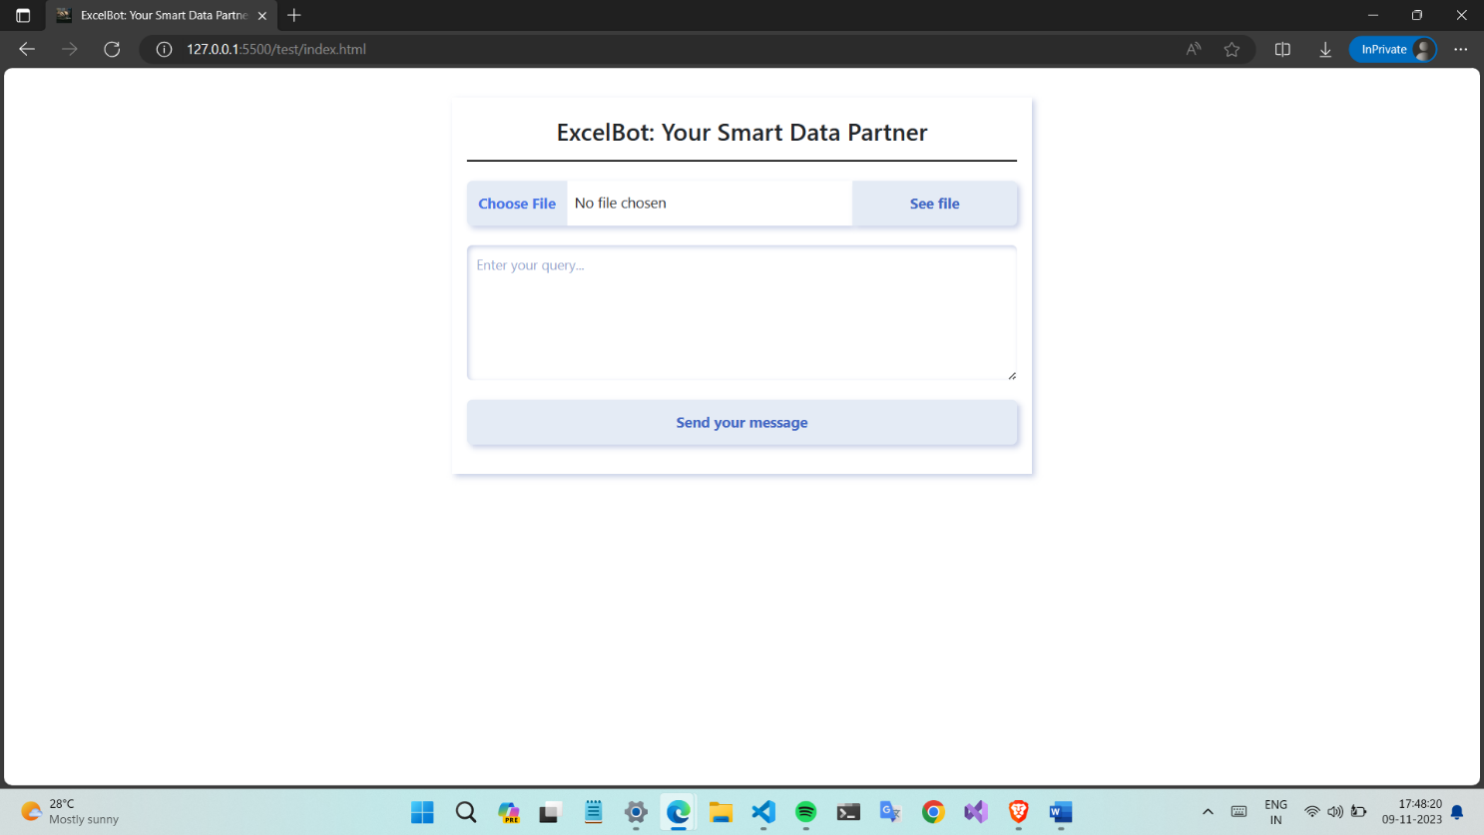

In summary, the design of ExcelBot's user interface is grounded in a user-centric approach that prioritizes ease of use, responsiveness, and effective data visualization. Wireframes and Mockups serve as the visual roadmap, ensuring that the design aligns with the project's goals while providing a foundation for the development of a visually appealing and functional interface.

Deployment

## The Hosting Platform: Render

In the ever-evolving landscape of web development and application deployment, the choice of a hosting platform plays a pivotal role in the success of a project. For ExcelBot, the decision to host the application on Render proves to be a strategic one, owing to Render's user-friendly approach, scalability, and robust feature set that caters to modern web applications. Below, we discuss the significance of Render as the hosting platform for your ExcelBot project.

**User-Friendly Deployment:**

Render is renowned for its user-friendly approach to deploying web applications. For developers and project teams, this means less time spent on complex configurations and more time focused on crafting exceptional applications. When deploying your Django-based ExcelBot, Render streamlines the process, allowing you to effortlessly bring your application to life. The intuitive dashboard, straightforward setup, and built-in support for popular technologies, such as Python and Django, ensure a seamless experience from code to deployment.

**Git Integration:**

The marriage of Git repositories and hosting platforms is a game-changer in modern development, and Render excels in this regard. By linking your GitHub repository to Render, you establish a seamless integration that automates deployment, enabling every code push to be effortlessly reflected in the live application. For ExcelBot, this not only simplifies the deployment process but also ensures that the application remains up to date with the latest code changes. This integration facilitates collaborative development and provides a version-controlled environment where developers can coordinate their efforts while maintaining a clear history of changes.

**Environment Configuration:**

In the realm of web applications, environment configuration can be a complex task, often requiring careful handling of dependencies, libraries, and specific runtime environments. Render simplifies this process by offering customizable environment configuration. For ExcelBot, this translates into the ability to define essential environment variables for database connections, API keys, and other project-specific settings. This feature ensures that ExcelBot is equipped with the necessary resources to function optimally.

**Custom Domain Support:**

For a polished and professional appearance, custom domains are often desirable. Render facilitates this by offering support for custom domains. By associating your custom domain with ExcelBot, you ensure that users can access your application via a branded URL. This feature not only enhances your application's aesthetics but also builds trust and reinforces your brand identity.

**Continuous Integration (CI/CD):**

Continuous Integration and Continuous Deployment (CI/CD) pipelines are essential for maintaining code quality and automating the deployment process. By combining Render with GitHub, you can set up CI/CD pipelines using tools like GitHub Actions. This approach enables automatic testing, building, and deployment of your application whenever changes are pushed to the specified branch. It ensures that ExcelBot remains stable and reliable, with each code update rigorously tested before reaching production.

**Monitoring and Insights:**

Application performance and user experience are paramount. Render provides monitoring and insights tools, such as Render Insights, that allow you to keep a watchful eye on the health of your application. By monitoring key metrics and setting up alerts, you can promptly address any issues that may affect ExcelBot's performance. This proactive approach ensures that users have a smooth and uninterrupted experience while using the application.

In conclusion, the choice of Render as the hosting platform for ExcelBot is a decision rooted in practicality, efficiency, and reliability. By leveraging Render's user-friendly deployment process, Git integration, customizable environments, database support, scalability, custom domain capabilities, CI/CD pipelines, and monitoring tools, your ExcelBot project is poised for success. Render not only simplifies the deployment process but also equips you with the tools and resources necessary to deliver a polished, responsive, and reliable application. This hosting platform stands as a cornerstone in the architecture of ExcelBot, providing a robust foundation for a data analysis companion that empowers users and reshapes the way we interact with data.

## Deployment Process for ExcelBot on Render with GitHub Integration

**Step 1: Preparing Your Project**

Before diving into deployment, ensure that your ExcelBot project is in good shape for hosting. This includes:

* Thoroughly testing your project to catch and resolve any issues.
* Securing any sensitive information such as API keys or database credentials using environment variables.
* Verifying that your project is well-structured with proper configuration and dependencies.

**Step 2: Create a Render Account**

If you do not already have a Render account, you need to sign up for one:

1. Visit the Render website ([https://render.com](https://render.com/)) and sign up for a free account.
2. Follow the on-screen instructions to create your account.

**Step 3: Setting Up a New Web Service on Render**

1. Log in to your Render account.
2. In your Render dashboard, click on the "New" button and select "Web Service" to create a new service.
3. Give your service a name, which can be the name of your project (e.g., ExcelBot).

**Step 4: Linking to Your GitHub Repository**

1. In the "Git Repo" section, choose "GitHub" as your repository type.
2. Connect your Render account to your GitHub account. Render will ask for the necessary permissions to access your GitHub repositories.
3. Select the GitHub repository where your ExcelBot project is hosted.
4. Choose the branch you want to deploy from (typically, this is your main or production branch).

**Step 5: Configuring Your Deployment Settings**

1. Under the "Environment" section, you can add environment variables. These variables are used to store sensitive data such as your Django secret key, database credentials, and API keys. Make sure to configure these according to your application's requirements.
2. In the "Build Environment" section, select the build environment you need for your Django project. This usually involves specifying the Python version required.

**Step 6: Custom Domain Setup (Optional)**

If you have a custom domain for your ExcelBot project, you can set it up in the Render dashboard for a more professional appearance.

1. Go to the "Domains" section in your Render dashboard.
2. Follow the instructions to add and configure your custom domain.

**Step 6: Deployment**

Once you have configured all the necessary settings, Render will automatically build and deploy your Django project. This deployment process includes:

* Building your application from the specified GitHub branch.
* Installing project dependencies using **requirements.txt**.
* Running your Django application using the specified Python version.

**Step 7: Deployment Verification**

After deployment is complete, verify that your ExcelBot application is up and running by accessing the provided Render URL. You should be able to access your application and interact with it in your web browser.

**Step 8: Continuous Integration:**

Consider setting up a Continuous Integration (CI) pipeline on GitHub. Services like GitHub Actions can automatically build, test, and deploy your project whenever changes are pushed to the specified branch. This enhances project quality and streamlines deployment.

**Step 9: Monitoring and Alerts**

It is crucial to implement monitoring and alerting for your deployed application. You can use tools like Render Insights to monitor application performance and set up alerts to ensure your application is performing as expected.

By following this deployment process, you can confidently host your ExcelBot project on Render, integrate it with GitHub for version control, and ensure that your application is accessible to users with high availability and performance.

Workflow of ExcelBot

## User Accesses the Web Application:

* **Step 1:** The process begins with the user accessing the ExcelBot web application through a standard web browser. They enter the web address or click on a provided link to reach the application's landing page.

This step is the entry point for users, where they first encounter the ExcelBot application and its capabilities.

## Uploading a CSV File:

* **Step 2:** After successfully accessing the web application, the user proceeds to the file upload section. This section is designed to enable users to easily upload their CSV files.
* **Step 3:** The user selects a CSV file stored on their local device and uploads it by following the on-screen instructions and prompts.

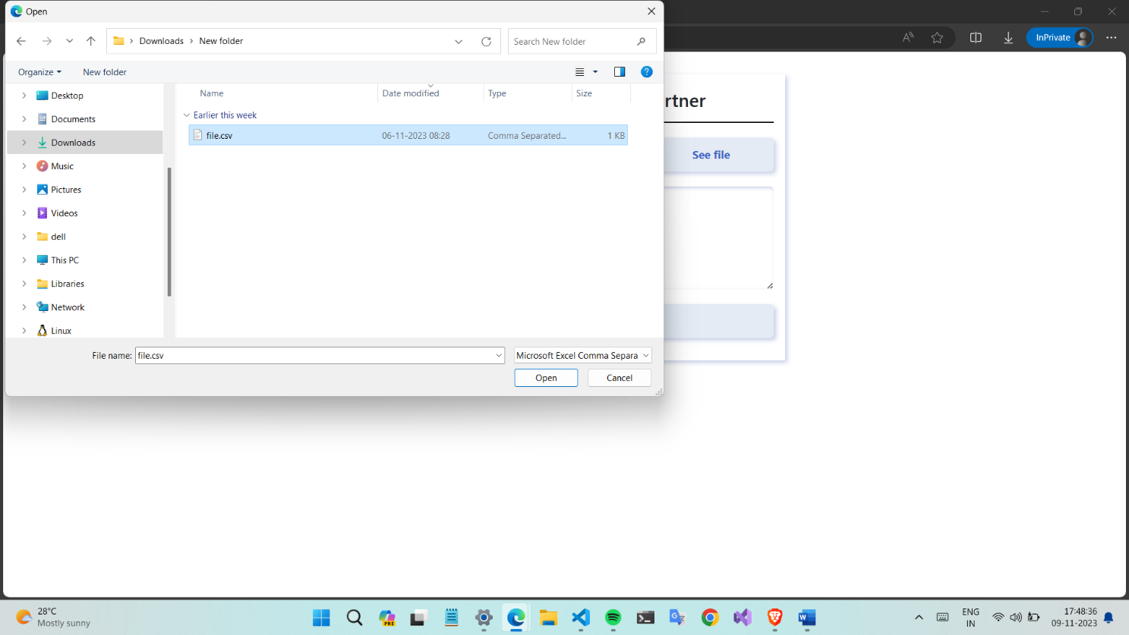

Uploading a CSV file is the fundamental action that provides the application with the data it needs to process and analyse. This step simplifies the process of incorporating user data into the analysis.

## Viewing CSV Data in Tabular Form:

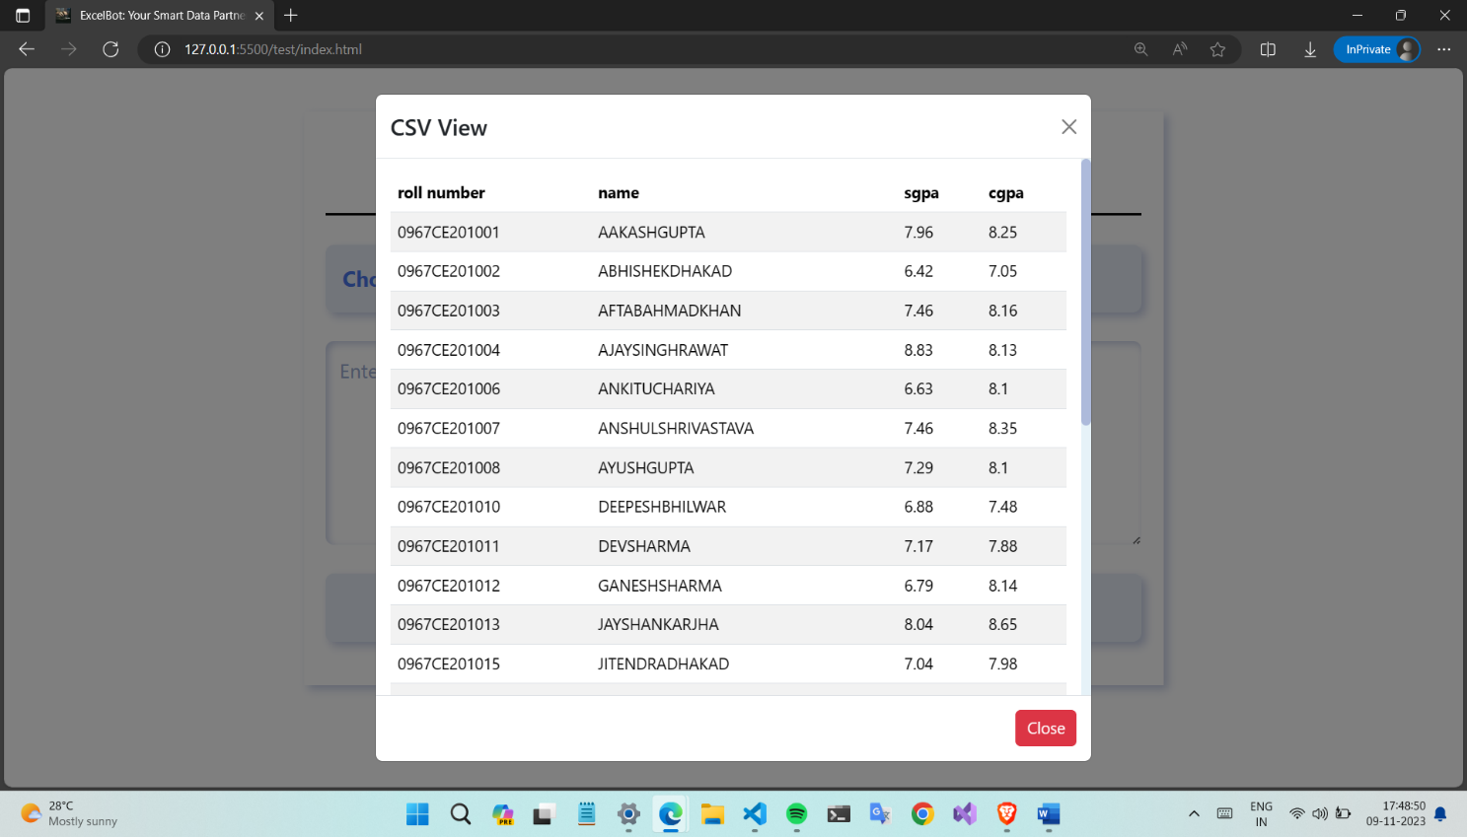

* **Step 4:** Upon successful file upload, the application processes the uploaded CSV file. It performs necessary data parsing and formatting operations.
* **Step 5:** The processed data is then presented to the user in a structured and user-friendly tabular format on the web page. Users can visually inspect and explore the content of their CSV file in this format.

This step transforms raw data into an accessible format, allowing users to understand their data more easily. It is a pivotal part of the user experience, making data exploration straightforward.

## Asking a Query:

* **Step 6:** To facilitate a more interactive experience, users have the option to ask questions or queries related to the data they see in the tabular form. They can do this by accessing the query input field on the web page.
* **Step 7:** The user enters their query into the provided text field. This query should be formulated in plain language, as the system is designed to understand and process natural language input.

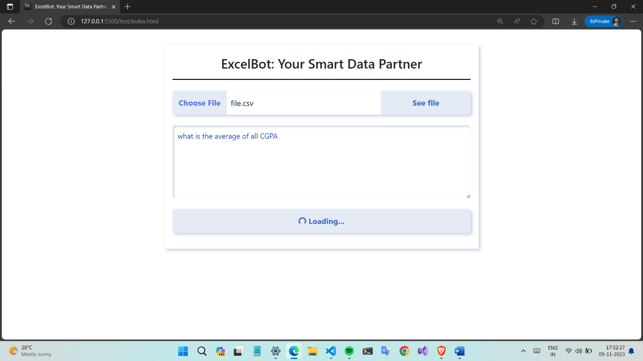

Enabling users to ask questions in plain language enhances the accessibility of the application and ensures that users can interact with their data in a way that feels intuitive and conversational.

## Query Sent to Server via API:

* **Step 8:** After entering their query, the user submits it by clicking a relevant button or invoking a command on the web page.
* **Step 9:** The user's query is then sent to the server via an API (Application Programming Interface) endpoint. The server is responsible for processing user queries and facilitating communication with external services like the OpenAI API.
* **Step 10:** The server processes the user's query and communicates with the OpenAI API, which specializes in natural language processing and can provide detailed responses based on the given input.

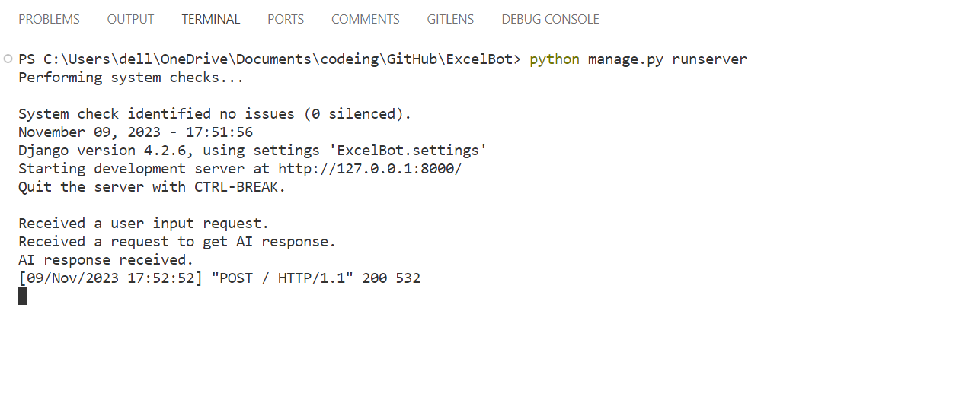

This step involves the backend processes of query handling, where user requests are transformed into structured data that can be sent to external services for analysis.

## Displaying the Answer:

* **Step 11:** The server, after sending the query to the OpenAI API, awaits a response.
* **Step 12:** Once the response is received, the server displays the generated answer on the web page, providing the user with valuable insights and information related to their query.

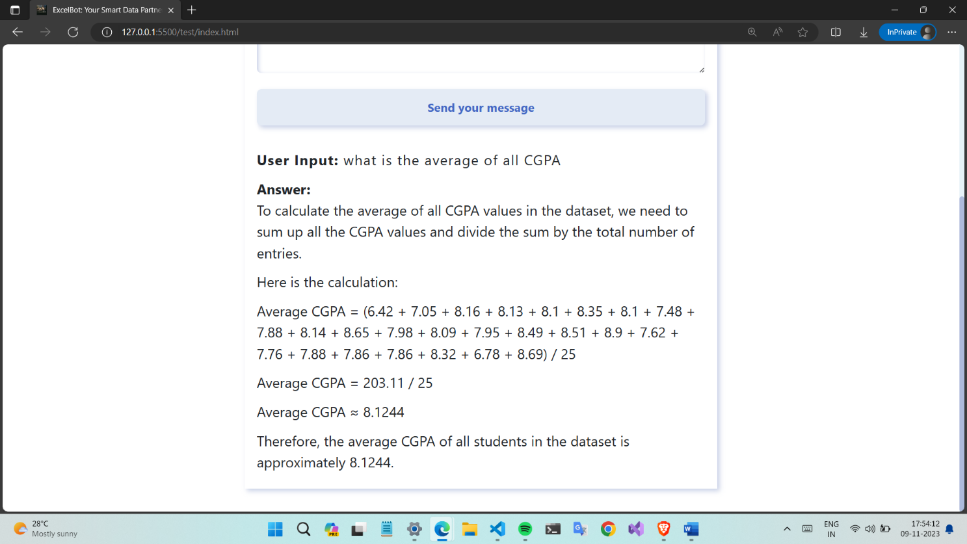

This final step is where the user receives the fruits of their interaction with the application, as the answer to their query is presented, facilitating data-driven decision-making and insights.

Testing

## Testing Strategy for ExcelBot: Ensuring Reliability and Quality:

Testing is an integral aspect of software development, an essential process that guarantees an application's reliability, functionality, and the quality of the user experience. ExcelBot, a powerful data analysis tool, is no exception to this rule. In fact, it places a premium on a comprehensive testing strategy to ensure that it delivers on its promise of providing efficient and precise data analysis capabilities. This testing strategy encompasses various layers of evaluation, including unit and integration testing, all with the primary goal of verifying the application's stability and robustness.

**Unit Testing: Building the Foundation of Quality**

Unit testing is the bedrock of any testing strategy, especially for complex software like ExcelBot. It revolves around the examination of individual components, functions, or methods in isolation, with a focus on their ability to perform their designated tasks correctly. The importance of unit testing in ExcelBot is multi-fold:

* **Precision and Accuracy:** Unit tests scrutinize the smallest building blocks of the application. In the context of ExcelBot, these blocks can be functions or methods responsible for data processing, conversion, or any other specific task. Ensuring that these components operate with precision and accuracy is essential for reliable data analysis results.
* **Early Error Detection:** By conducting unit tests as early as possible during development, ExcelBot's developers can identify and rectify errors before they propagate to higher-level components or, worse, make their way into the production application. This proactive approach significantly reduces the likelihood of critical bugs affecting the application's users.
* **Regression Testing:** ExcelBot is a dynamic project that is bound to evolve over time. As new features and functionalities are added, unit tests act as a protective barrier against the introduction of new issues. By frequently running unit tests, developers can promptly catch and address problems that may arise due to code changes.
* **Modularity Validation:** ExcelBot's architecture is based on modularity, where different components work cohesively but are designed to be independent. Unit tests ensure that these modules function in isolation and collaborate seamlessly, adhering to the principles of encapsulation and separation of concerns.
* **Maintainability:** In the ever-changing landscape of software development, maintaining and enhancing the application is inevitable. Unit tests provide a form of documentation for how individual components are intended to function. This documentation not only aids in code maintenance but also eases the onboarding of new team members to the project.

**Integration Testing: Ensuring Holistic Functionality**

While unit tests focus on the micro-level functionality of ExcelBot, integration testing takes a more macro-level perspective. It evaluates how various components or modules interact with each other in a more comprehensive manner, simulating real-world scenarios and assessing the application's end-to-end functionality. Integration testing holds immense importance for ExcelBot:

* **End-to-End Validation:** Integration tests simulate real-world scenarios by examining how multiple components work together. This is crucial for verifying that ExcelBot operates cohesively, ensuring that every step in the user's journey, from data upload to query generation and answer display, proceeds seamlessly.
* **User Experience Assurance:** The ultimate measure of ExcelBot's worth is the user experience it provides. Integration testing confirms that all user-facing and back-end components function harmoniously, resulting in a smooth and efficient user experience. It is not just about functionalities working; it is about delivering an exceptional user journey.
* **Data Flow Validation:** ExcelBot is all about data processing, and the validation of data flow is at the core of integration testing. It ensures that data traverses through various stages as intended, from file upload to answer generation, and follows the prescribed path.
* **Compatibility Checks:** ExcelBot is built using a stack of technologies, including Python, Django, JavaScript, and potentially third-party APIs like OpenAI. Integration tests help identify and resolve any discrepancies that may arise due to interactions between these components. Ensuring compatibility between the various technologies is essential for a smooth user experience.
* **Scalability Assessment:** As ExcelBot's user base grows, it needs to be prepared for increased traffic and usage. Integration tests confirm that the application can scale effectively, anticipating and addressing potential bottlenecks to ensure that ExcelBot remains responsive even under heavy usage.

**Result: Trust through Testing**

ExcelBot's users rely on the application to provide them with accurate and timely data analysis. Trust is the currency of the software world, and testing is how trust is earned. ExcelBot's comprehensive testing strategy, which includes unit testing for precision and early error detection, and integration testing for end-to-end validation and user experience assurance, is the bedrock upon which this trust is built.

It is a testament to ExcelBot's commitment to delivering a superior data analysis experience, free from critical errors and backed by rigorous testing practices. As ExcelBot continues to evolve and improve, this testing strategy remains instrumental in upholding ExcelBot's promise of excellence in data analysis and ensuring that it continues to be a trusted and reliable tool for all users.

## Code:

import json

from django.test import TestCase

from django.urls import reverse

from unittest.mock import patch

from api.views import get_ai_response  # Import your view functions

class ExcelBotTest(TestCase):

    def test_valid_user_input(self):

        # Define a valid user input in JSON format.

        valid_input = {

            'csv_data': 'your_csv_data_here',

            'user_input_message': 'your_user_input_message_here',

        }

        # Use the reverse function to get the URL for your view.

        url = reverse('user_input')  # Replace 'user_input' with the actual view name.

        # Mock the get_ai_response function to avoid external API calls.

        with patch('api.views.get_ai_response', return_value='Your expected response'):

            # Send a POST request with valid user input data.

            response = self.client.post(url, json.dumps(valid_input), content_type='application/json')

        # Check if the response status code is 200 (OK).

        self.assertEqual(response.status_code, 200)

    def test_missing_required_fields(self):

        # Define invalid user input with missing fields.

        invalid_input = {

            'csv_data': 'your_csv_data_here',

            # 'user_input_message': 'your_user_input_message_here',  # Commenting out a required field.

        }

        # Use the reverse function to get the URL for your view.

        url = reverse('user_input')  # Replace 'user_input' with the actual view name.

        # Send a POST request with invalid user input data.

        response = self.client.post(url, json.dumps(invalid_input), content_type='application/json')

        # Check if the response status code is 400 (Bad Request) because of missing fields.

        self.assertEqual(response.status_code, 400)

Security

Security is a paramount concern in the development and deployment of any web application, and ExcelBot is no exception. In an age where data privacy and the protection of sensitive information have taken centre stage, ExcelBot is committed to ensuring the highest level of security for its users. This section explores the security measures in place and the data protection strategies employed within ExcelBot.

## Security Measures: Defending Against Threats:

ExcelBot employs a multi-faceted approach to security, encompassing various measures and protocols to safeguard both the application and its users. These measures include:

1. **Authentication and Authorization:** User authentication is a fundamental aspect of ExcelBot's security. Robust mechanisms are in place to verify user identities and control access to various parts of the application. User roles are defined, ensuring that only authorized individuals can perform specific actions, such as uploading files or accessing sensitive data.
2. **Data Encryption:** Data transmission and storage are secured through encryption protocols. Sensitive information, including user credentials, is encrypted to prevent eavesdropping during communication or potential data breaches.
3. **Regular Updates:** ExcelBot keeps its software and libraries up to date to mitigate vulnerabilities that can be exploited by attackers. Patches and updates are applied promptly to address known security issues.
4. **Cross-Site Request Forgery (CSRF) Protection:** Measures are in place to protect against CSRF attacks, which could trick users into performing unauthorized actions on their behalf.
5. **Cross-Site Scripting (XSS) Prevention:** Input validation and output encoding techniques are applied to prevent XSS attacks, where malicious scripts are injected into web pages viewed by other users.
6. **Server Security:** Server-side security is paramount. Access to the server and its configuration is tightly controlled, and best practices are followed to prevent unauthorized access or data leakage.
7. **Regular Audits and Penetration Testing:** Periodic security audits and penetration testing are conducted to identify vulnerabilities and assess the system's resistance to potential attacks. Any identified issues are addressed promptly.
8. **Password Policies:** ExcelBot enforces strong password policies to ensure that user accounts are protected with robust passwords, reducing the risk of unauthorized access.
9. **Rate Limiting:** Rate limiting is implemented to prevent abuse or misuse of the application's resources. This helps protect against denial-of-service (DoS) attacks and ensures fair resource allocation among users.

## Data Protection: Safeguarding User Information:

ExcelBot is deeply committed to protecting user data and ensuring the utmost data privacy. Data protection strategies employed within ExcelBot include:

1. **User Data Encryption:** User data, including uploaded Excel files and any sensitive user information, is encrypted at rest. This provides an additional layer of security, even if a breach occurs.
2. **Data Retention Policies:** ExcelBot follows data retention policies that determine how long user data is stored. This helps in complying with data protection regulations and reducing the risk of data exposure.
3. **User Consent:** Users are informed about data collection practices, and their consent is obtained for any data processing activities. This transparency ensures that users have control over their data.
4. **Data Minimization:** ExcelBot only collects and stores data that is necessary for its intended purposes. Unnecessary data is not retained.
5. **GDPR Compliance:** ExcelBot adheres to the principles of the General Data Protection Regulation (GDPR) to protect user data, offer data portability, and ensure transparency.
6. **Secure File Handling:** Excel files uploaded by users are processed with the utmost care. Security measures are in place to prevent data leaks or unauthorized access to the uploaded files.
7. **Incident Response Plan:** ExcelBot maintains an incident response plan to address data breaches or security incidents promptly and effectively, reducing potential harm to users.

In conclusion, security and data protection are integral components of ExcelBot's mission to provide a safe and trusted environment for users to upload, analyse, and query their data. The comprehensive security measures and data protection strategies ensure that user information remains confidential, while the application itself remains resilient to potential threats and vulnerabilities. ExcelBot's commitment to security underscores its dedication to safeguarding user data and application integrity.

Future Improvements

ExcelBot is designed to be an agile and evolving solution for data analysis and natural language interaction with Excel spreadsheets. As we look forward to ExcelBot's future, we have identified several potential enhancements that can further enrich its functionality and usability. These improvements aim to meet the changing needs of our users and to stay at the forefront of technology. Some of the key areas for future improvements include:

**1. Enhanced Data Visualization**

While ExcelBot currently offers a user-friendly tabular data display, the next step is to enhance data visualization. We plan to integrate advanced charting libraries such as Plotly or D3.js to allow users to create interactive charts, graphs, and visual representations of their data. These visualizations will provide a more in-depth understanding of data trends and patterns.

**2. Collaboration and Sharing**

Collaboration is a crucial aspect of modern data analysis. We are working towards implementing features that will enable users to collaborate with team members or share their analysed data, visualizations, and queries. This will make ExcelBot an even more valuable tool in a collaborative work environment.

**3. Custom Data Analysis Plugins**

To provide users with maximum flexibility and adaptability, we plan to introduce a plugin system that allows users to write and integrate custom data analysis scripts in Python or other compatible languages. This will empower users to design tailored data processing workflows that cater to specific business or research requirements.

**4. Multiple File Type Support**

ExcelBot currently focuses on Excel files, but we intend to broaden its horizons by supporting a wider range of file formats, including CSV, JSON, and database connections. This expansion will make ExcelBot a versatile platform for data analysis regardless of the data source.

**5. Advanced AI Integration**

Our commitment to harnessing the latest AI technologies means we are exploring advanced AI integration beyond OpenAI. Machine learning models for predictive analytics, sentiment analysis, and other advanced AI capabilities will provide users with deeper insights into data trends and patterns.

**6. Mobile Application**

We recognize the need for mobile accessibility. Developing a mobile application for ExcelBot will allow users to access and interact with their data on the go, ensuring they can stay productive even outside the office.

**7. Customizable Dashboards**

We plan to introduce customizable dashboards that enable users to create personalized data displays, emphasizing the most relevant data and insights. This feature will streamline decision-making and reporting.

**8. Internationalization and Multilingual Support**

To expand ExcelBot's reach and appeal to a global audience, we aim to provide support for different languages and locales. Multilingual support will make ExcelBot accessible and relevant to users worldwide.

**9. Offline Mode**

The introduction of an offline mode will allow users to work with their data and perform basic operations without an internet connection. This feature will enhance ExcelBot's accessibility and reliability.

**10. Performance Optimization**

Continuous performance optimization is a priority. We will regularly update and enhance the application's performance, responsiveness, and scalability to ensure a smooth user experience, even with large datasets.

Conclusion: ExcelBot - Transforming Data Analysis

In the era of data, where decisions of all scales are increasingly reliant on information-driven insights, ExcelBot emerges as a transformative force, simplifying the intricate realm of data analysis. Our journey through this project has been one of innovation, design, and empowerment, with ExcelBot as the beacon leading the way.

ExcelBot was conceived out of a pressing need: the need to bridge the gap between data stored within Excel spreadsheets and the insights they conceal. The manual process of data analysis often proves cumbersome, time-consuming, and fraught with the risk of human error. With ExcelBot, we aimed to mitigate these challenges, ensuring that every individual, regardless of their technical background, could effortlessly harness the true potential of their data.

Our endeavour to empower users with a comprehensive tool for data analysis has yielded a project laden with features that redefine the landscape of data interaction:

1. **Seamless File Upload:** Users can effortlessly upload their Excel files, transforming a once cumbersome process into a simple, user-friendly task.
2. **Intuitive Data Visualization:** The application takes raw data from uploaded Excel files and presents it in an engaging, tabular format, promoting efficient comprehension of the dataset.
3. **Natural Language Interaction:** Users can engage in a dynamic conversation with their data, transcending the technical barriers that often inhibit effective communication.
4. **OpenAI Integration:** Our collaboration with OpenAI introduces an exciting dimension to ExcelBot. The integration with OpenAI's language models elevates the application's capabilities, facilitating the generation of insightful and accurate answers to user queries.
5. **User-Friendly Interface:** A well-crafted user interface ensures that regardless of technical familiarity, users can interact with ExcelBot effortlessly. The user experience is seamless and enjoyable, promoting both efficiency and user satisfaction.
6. **Enhanced Productivity:** ExcelBot optimizes data analysis processes, accelerating information retrieval, and empowering users to make informed decisions swiftly. Productivity soars as ExcelBot liberates time for more meaningful pursuits.

ExcelBot is not just a project; it is a vision for the future of data analysis. As we look ahead, the potential of ExcelBot unfolds on multiple horizons:

* **Transformative Impact:** ExcelBot has the potential to transform the way individuals and organizations approach data analysis.
* **Continuous Evolution:** ExcelBot is not a static solution but a dynamic entity poised for ongoing improvement.
* **Empowerment Through Data:** Our ultimate objective is to empower users to become data-driven decision-makers..

In a world where data reigns supreme, ExcelBot stands as a beacon guiding us towards a future where data analysis is no longer a challenge but an opportunity. It is more than an application; it is the key to unlocking the hidden potential within your Excel files. ExcelBot is the future of data analysis—a smarter, more efficient way to extract valuable insights from your data.

Say goodbye to the arduous process of manual data hunting and analysis, and say hello to a new era of data interaction with ExcelBot. Welcome to a future where data becomes your ally, and knowledge is at your fingertips.

References

* <https://blog.enterprisedna.co/excel-formula-bot/>
* <https://gpt3demo.com/apps/excel-formula-bot>
* <https://en.wikipedia.org/wiki/Artificial_intelligence>
* <https://www.techtarget.com/searchenterpriseai/definition/AI-Artificial-Intelligence>
* <https://www.ibm.com/topics/artificial-intelligence>
* <https://www.investopedia.com/terms/a/artificial-intelligence-ai.asp>
* <https://www.w3schools.com/python/>
* <https://www.programiz.com/python-programming/online-compiler/>