**User Profile**

The application will be used at exhibitions stand by different companies, at the moment we have Cisco but in the future it could be companies like Microsoft, HP, Nike etc.

Before an exhibition employees should download a app from one of the stores to their mobile device, this could be a android, apple, Microsoft etc tablet. Once they have the application on the Tablet they can then download an xml and file folder that will add the customised design and the required questions and file. (a teh sart we can install this over the developer account)

The employees will then do the survey at the boots at a exhibition, it could be up to 100 employees making the survey and when they are online the information they have collected should be uploaded to the server. As it may take time till they have an internet connection for example the whole day. the answers for all the questions should be saved locally on the native app and uploaded later.

**Design requirements**

As the design of the application has to be changed for the different companies this information has to be in the xml and folder information. The design has been kept easy to help this process. The elements that should be changed are the

* Background image
* Fonts and font colour
* Buttons
* Pullout menu colour
* Question layer background

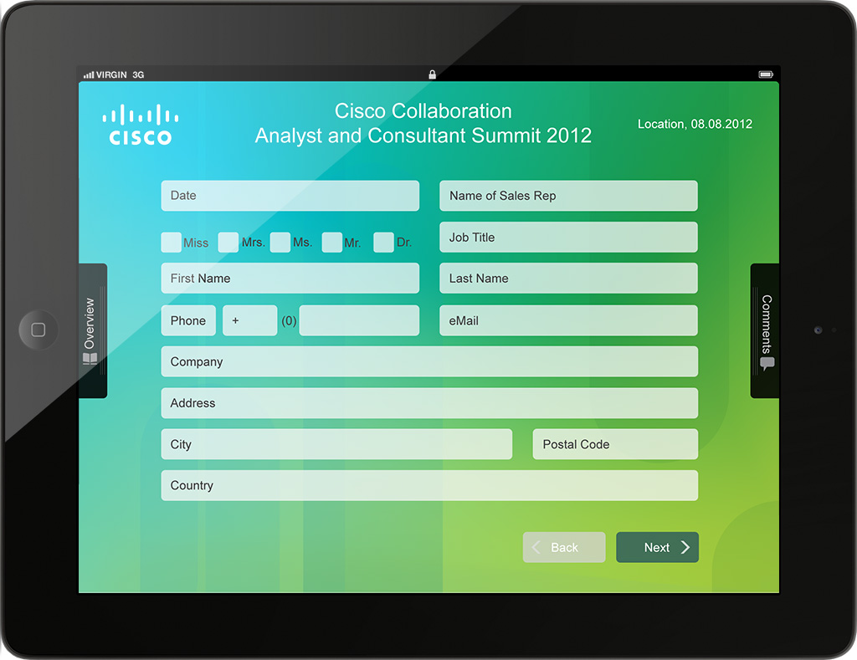

Above is background images with the questions over this in a layer with 2 pullout menus. The title at the top **Cisco Collaboration Analyst and Consultant summit 2012** and the date can either come over the xml and system or for teh start just be in the background image.

**Cisco application requirements**

Till now you have received a word doc with the whole requirement for the application in over the next couple of months. The big question is what we need for the Cisco example. For this we need the design which you have received. This has to be done in a way that the design and the questions can be changed over the xml.

**In the Overview tab**

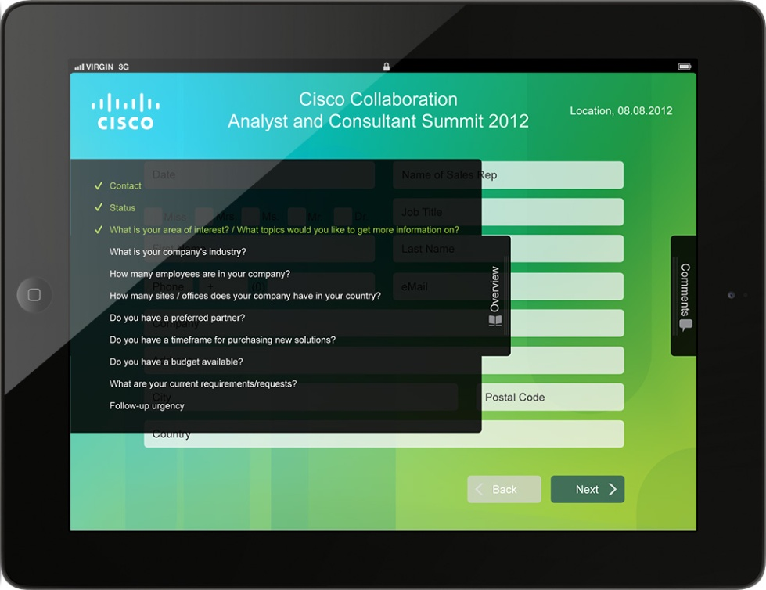

One should be able to pull this tab out and sees the different questions and also which ones have been answered or not. It should be possible to click on a question and jump to this (Quick jump button). If the question has been answered one will see this. For example the first three have been completed in this screen. If there is more questions than can be viewed within the tab a scroll bar should appear. I do not think we have this problem for Cisco but later it could be the case.

**Comments tab.**

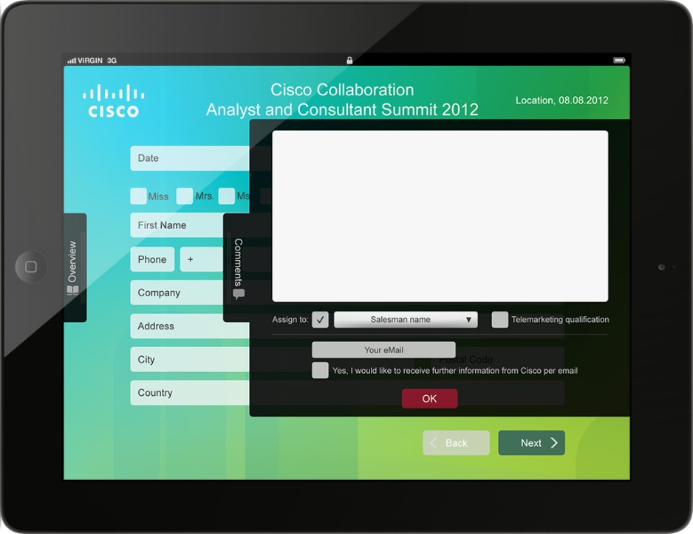

Again this a pullout menu, and one can add a comments and also the name of the sales person that should be taking care of the person. This will be in a dropdown and should also come over the xml. The email address of the person answering eh survey should be added as well as the opt in for further communication (In the future the field other then the comment field may change here, we worry about this later)

**Questions Types**

The question types for cisco will be mainly the ones in the pdf **leadform-cisco-generic-v10-120621_A4_portrait_EN.pdf** which you have received. As this is just a standard questionnaire we will also add around three more question to this. You will receive these over the next couple of days. Within the extra questions we should the possibility to add logic to the questions, open a file and add a chart. Not only will you receive the questions but also the designs as we have to define the icons for the attachments for example PowerPoint, word, pdf, video etc

**Export to server**

**External databases**

In the app builder (comes later) it will be the possibility to set up your own SQL server as database. Therefore the customer has to create a database and a user with specific rights in advance. After that a routine of our server is setting up the necessary tables and stores the access information in the XML. There will be a test function which ensures that the external server is correctly set up. - Just the client would be able to use one of his existing databases, just genereatas a table with a "dump file" - - Than he just enters HIS Database login information -. @Dev , would that work?

What we would need for Cisco is the information/answers in a csv file and this files would be saved on a server