**Lab 5: Two Stack-based Recursive Graphics [30 points, Due 2/15]**

**Last name:**

**First name:**

**ID#:**

1. Before designing your recursive graphics using Processing review the following topics/examples ([link 1](https://processing.org/examples/tree.html), [link](https://processing.org/examples/recursion.html) 2, [link 3](http://learningprocessing.com/examples/chp13/example-13-08-recursion), [link 4](https://natureofcode.com/book/chapter-8-fractals/)). To design two different works of recursive shapes different from the samples (more realistic found in nature), you must incorporate [pushMatrix()](https://www.processing.org/reference/pushMatrix_.html) , [popMatrix(),](https://www.processing.org/reference/popMatrix_.html) and [ArrayList](https://processing.org/reference/ArrayList.html) along with both mouse and key interactivities (e.g., mouse movement to change shape, color change through pressing different keys ) for your recursive graphics. To get a full mark, your work should show uniqueness simulating recursvie pattern in nature (or product) in addition to technical excellency different from examples ([Tree](https://processing.org/examples/tree.html), [circles](https://processing.org/examples/recursion.html)) based on your research. Do not copy other’s work (You will receive ‘0’; [plagiarism](http://libguides.kpu.ca/academicintegrity/plagiarism)).

* Recursion basic examples: [Tree](https://processing.org/examples/tree.html), [circles](https://processing.org/examples/recursion.html)
* [pushMatrix()](https://www.processing.org/reference/pushMatrix_.html)
* [popMatrix().](https://www.processing.org/reference/popMatrix_.html)
* [ArrayList](https://processing.org/reference/ArrayList.html)
* [Fractals](http://natureofcode.com/book/chapter-8-fractals/)

2. Find some reference images showing recursive patterns in nature. Try some keywords; pattern, flower, skin, tree, wave, people etc. Briefly explain the reason you choose those images for your two examples. You must add your reference image with web link below.

|  |  |  |
| --- | --- | --- |
| #1 |  |  |
|  | [Image result for pattern tree](https://www.etsy.com/au/listing/101766880/tree-cross-stitch-pattern-pdf) | Briefly explain the reason why you choose this image |
| Link | <https://www.etsy.com/au/listing/101766880/tree-cross-stitch-pattern-pdf> |  |

|  |  |  |
| --- | --- | --- |
| #2 |  |  |
|  | [Image result for pattern crowd stick figure](https://www.dreamstime.com/stock-illustration-unique-stick-figure-crowd-illustration-image68466276) | Briefly explain the reason why you choose this image |
| Link | <https://www.dreamstime.com/stock-illustration-unique-stick-figure-crowd-illustration-image68466276> |  |

1. **Name your Processing files as recursiveA_yourLastname_firstnameInitial.pde and recursiveB_yourLastname_firstnameInitial.pde.**
   1. **Describe your design rules showing the breakdown of your first recursive design (similar example shown below)**

[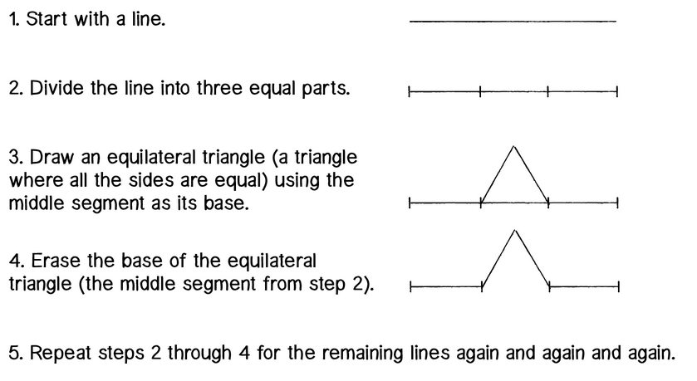](http://natureofcode.com/book/chapter-8-fractals/)

* Attach minimum two screen shots of your work showing interactive change.
  1. **Describe your design rules showing the breakdown of your second recursive design (similar example shown below)**

[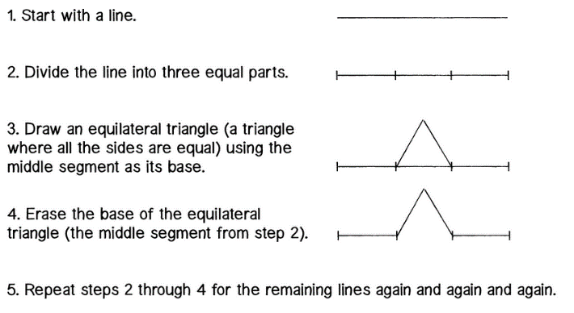](http://natureofcode.com/book/chapter-8-fractals/)

* Attach minimum two screen shots of your work showing interactive change.

**Submit one zip file (lab05_yourLastname_firstnameInitial.zip) showing two Processing pde files along with this MS Word document.**