**Lab 06 Reference image + Rendering of 3D environments**

**Last name:** Mehta

**Fist name:** Arnav

**ID:** 300196365

1. Find a reference image (from movie. video game, famous painting, animation, drama, or your own photo etc.). Attach a reference image with web link ([APA style](https://libguides.kpu.ca/c.php?g=713337&p=5086514)). Explain the reason why you chose this image.

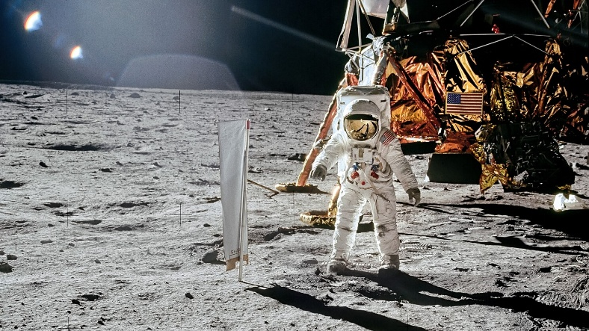Buder, Sarah. “50th Anniversary of Apollo 11 Moon Landing: See Photos from NASA Archives.” AFAR Media, AFAR, 8 July 2019, [www.afar.com/magazine/50th-anniversary-of-apollo-11-how-the-moon-landing-changed-our-world. Accessed 17 Dec. 2019](http://www.afar.com/magazine/50th-anniversary-of-apollo-11-how-the-moon-landing-changed-our-world.%20Accessed%2017%20Dec.%202019).

I chose this image because it looks cool. I found some lunar 3d models and I wanted to use them. It looked like it would be difficult to copy the moon lighting conditions so I wanted to try it.

1. Attach a few images of your work (both 6a and 6b) showing different camera shots. Explain your lighting strategy, scene composition, and program structure (e.g., number of lights, 3d geometry construction, camera angle etc,) for both 6a and 6b (indoor and outdoor environments). Also, if using any 3D file from website, please reference it.

## Program structure

Both files contain the same base scene. The only difference between both is the camera angles and the placement and types of lights.

Lab 6a contains 5 functions in addition to the setup, draw and mousePressed. I created separate functions to draw the scene (ground, astronaut and lunar module), 2 functions to draw each buttons that switch the position of the camera and change the lighting to default respectively.

Lab 6b contains similar functions with just one less button function and no camera setup function. The lighting function also has 3 lights (2 point lights and a spotlight) but they are placed differently than lab 6a.