- When creating case file: responsible lawyer should be by default the lawyer that is logged in.

- When creating a case file with jurisdiction “Liability Law”, please add a tab with “Date of accident”.

- When creating a relationship you can only choose from client and counter party. Please add the option to select something different. Because we also have courts, bailiffs, hospitals, banks etc. So I think there should be a third option for other type of parties.

- When creating a relationship, please add the email address on the general tab page.

- Dates should be mentioned the European continental way: day, month, year. Please see below for example:

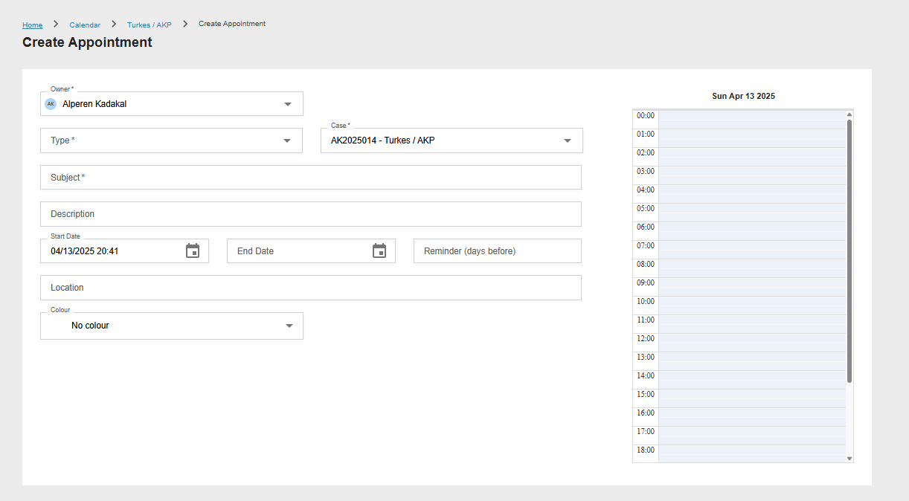
- Relationship: medische behandelaars

- At the bulk timesheets tab, I cannot choose from the whole list of “type”. Please see below:

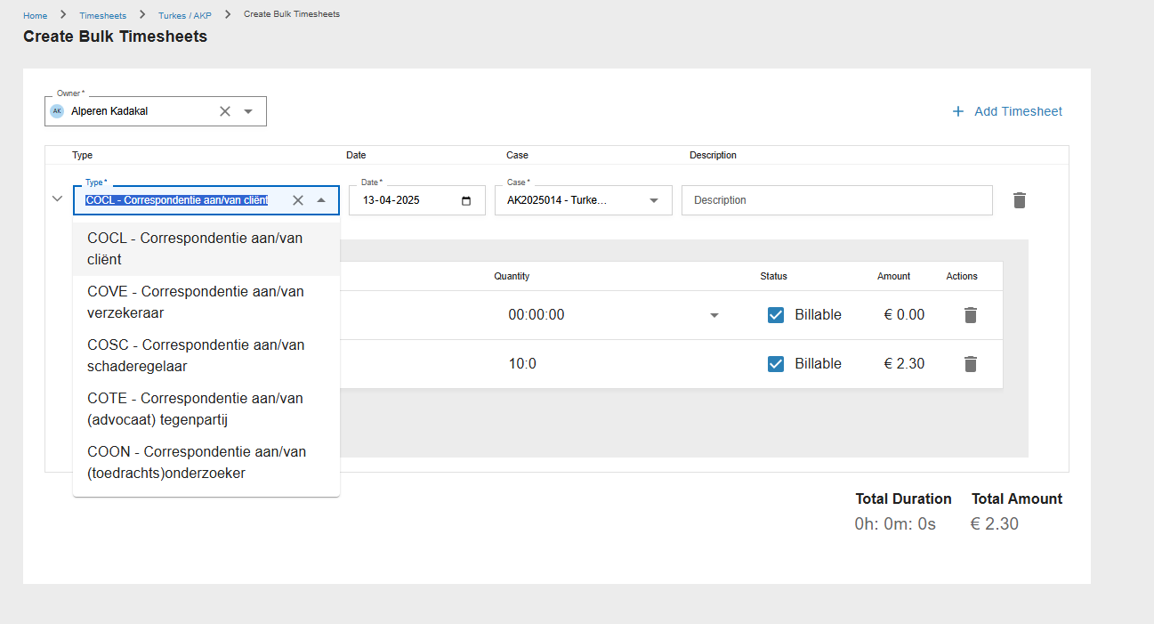

- At the bulk timesheets tab, when i want to add kilometers it is not possible to add more than 10 kilometers. Please see below:
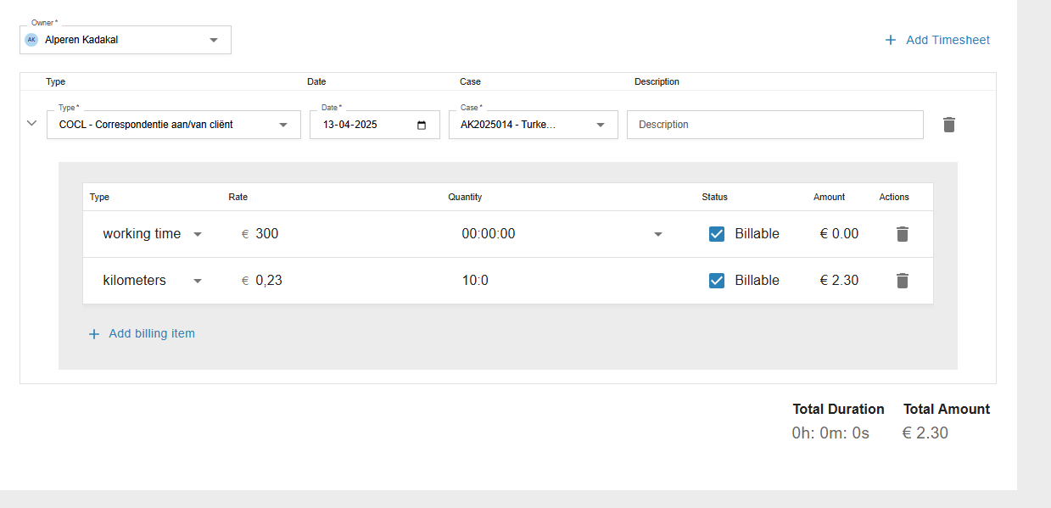

- At the timesheets tab, it isn’t possible to add disbursements.

- At the timesheet overview I would like to be able to make changes in everything. For example, type, owner, date, description and time. Please see below:

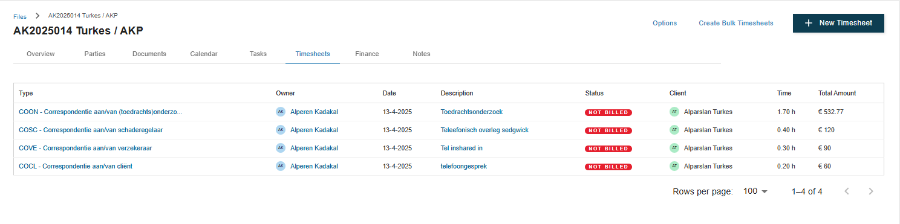

- At the finance tab in the new case file i made i do not see the hours and also not at the sales documents the billable hours are not seen back. Please see below:
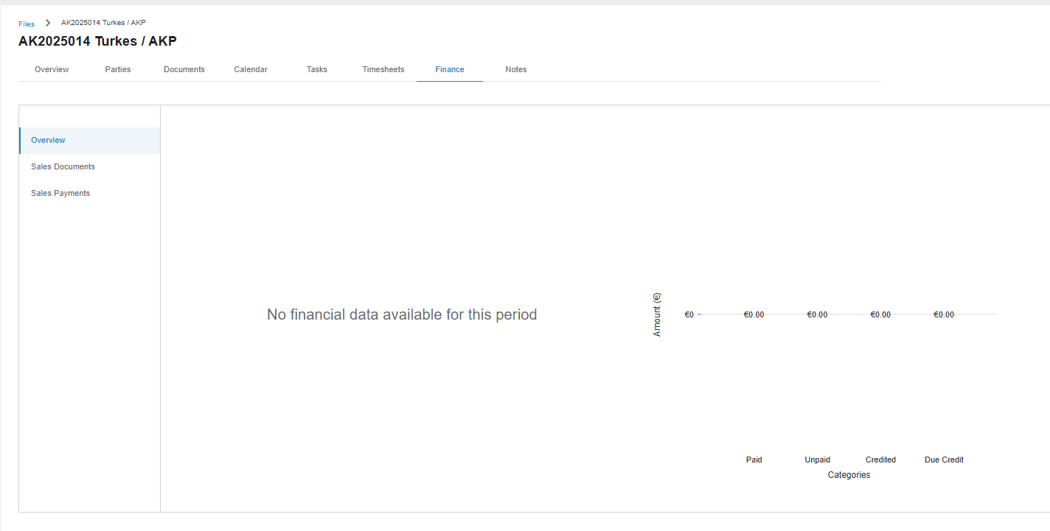

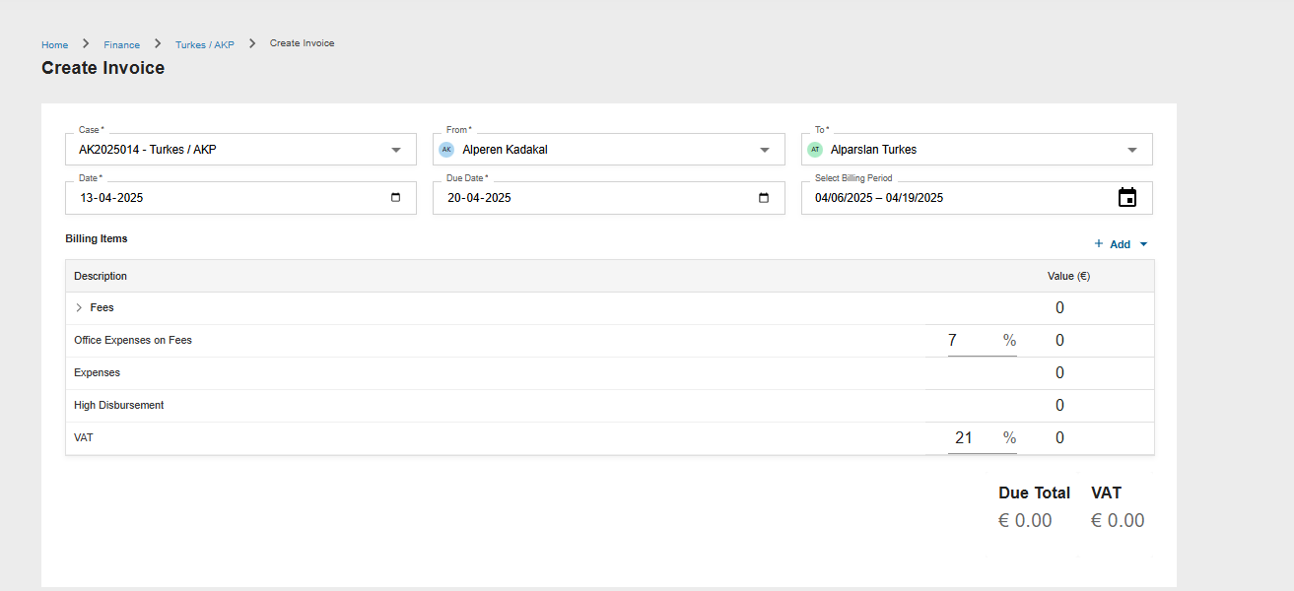

- On the Relationships and files overview page it is possible to filter by status active / inactive. Please also add the option for both active AND inactive.

- At the timesheet overview of every case, there should be a total of hours and amounts. Here on this page I mean, see below:

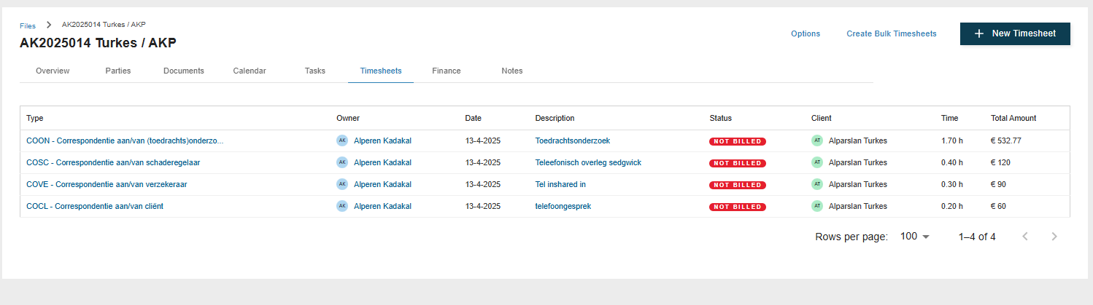

This is how Kleos has it:

