- INTRODUCTION
Online advertisement has grown at a high rate on the internet and social media where visual contents are now the main way of communicating the brand and advertising their products. The advertising campaigns of the competitive markets require proper presentation of product and brand elements and the attraction of consumer attention. Proper study of product visibility is thus necessary to the advertisers, designers and regulative bodies involving a study of the standards portrayed by advertisement and requirements of compliance [1], [11].
The conventional methods of assessing the performance of the advertisements are based on the visual judgment, a judgment of an expert, and the consumer-based research like surveys and eye-tracking experiments. Despite being useful, these methods are time-intensive, expensive, and subjective in nature, which makes them not scalable and applicable to large-scale and real-time analysis of digital advertising [2], [4]. Moreover, differences in the visual senses of different humans result in variations in evaluating product visibility and visual emphasis of various observers.
Another innovative technological development of the recent past is the use of artificial intelligence and deep learning to analyze visual content with great precision, using automated systems. CNNs have also proved to be effective at detecting objects, image classification and also logo recognition, which means they can be applied to recognize products and brand names in advertisement images [3], [5], [15]. Simultaneously, visual saliency models have been devised as the estimates of human visual attention by determining the areas most probable to attract the viewers attention [4], [5]. The application of the Optical Character Recognition (OCR) also enables the extraction and examination of the textual contents like brands or advertising messages which are important factors in determining the effectiveness of advertisement [6].
As e-commerce and social media marketing are growing at a fast pace, businesses are increasingly using online ads that include pictures, videos and text messages to attract the attention of the audience. Such adverts usually have several pictorial elements such as product packs, logos, advertising copy, and background. The combination and emphasis of these elements have a strong impact on the way the viewers interpret the ad and whether the product being advertised is able to be noticed. As a result, the problem of visual elements interaction and competence to attract the viewers has become a burning research issue in the sphere of computer vision and marketing analytics.
The object detection algorithms have been significant in the process of making machines detect and locate objects in images. The most popular of these algorithms is the You Only Look Once (YOLO) family of models that are capable of doing all object detecting with great accuracy and low costs within seconds [1], [3]. Recent editions of YOLO, such as YOLOv8, have a more efficient feature extraction, prediction of bounding boxes, and a higher rate of detection of small and complex objects [15]. This is because these features enable YOLO-based models to be especially adapted to advertisement analysis in which the products can be of various orientations, sizes, and under varying lighting conditions.
Object detection allows to identify the products in an advertisement, yet it is not able to indicate the interest of the viewers in them. In order to overcome this weakness, visual saliency models have been proposed to predict human attention patterns in images and videos. Saliency prediction algorithms operate by analyzing visual features which include contrast of color, edges density, variation of texture and semantic features to produce heatmaps which display areas with probabilities of attracting human gaze [4]. The recent saliency models based on deep learning demonstrated better results than traditional hand-crafted feature methods and allow to better predict attention distribution in complex visual inspection scenes [5].
Besides visual, textual information is a very important part of most advertisements. Slogan, brand names, promotions and product descriptions are considered to be valuable contextual information that makes a significant difference in how consumers perceive products and make a purchasing decision. Optical Character Recognition (OCR) is a technology that enables extraction of textual information in an image and enables a system to process visual and textual features of advertisements in a single-go [6]. The combination of OCR with object detection and attention prediction methods can help in gaining a more profound insight into the effectiveness of adverts.
AdVis AI is a deep learning–based system designed for visibility analysis in food and cosmetic advertisements. The system integrates advanced computer vision techniques, including object detection and saliency mapping, to evaluate how effectively products capture viewer attention. By combining YOLOv8-based detection with attention modeling and AI-driven audit generation, AdVis AI provides a comprehensive framework for analyzing advertisement performance. The primary objective of this system is to assist marketers and designers in optimizing visual content by identifying key factors that influence attention, visibility, and overall advertisement effectiveness.
Although advancement has been made in individual technology like object detection, saliency prediction and text recognition, most of the currently available advertisement analysis systems consider them separately. Consequently, they do not offer a single assessment system, which integrates the product localization, visual focus, and textual messages. This weakness limits their capability to quantitatively and meaningfully gauge general visibility of advertisements.
To overcome these limitations, this study suggests a deep neural network-based architecture of the automated visibility analysis in food and cosmetic advertisement. The suggested system incorporates three important modules: product detection with the help of the YOLOv8 object detection model, attention prediction with the help of the visual saliency model and text classification with the help of PaddleOCR. When these elements are put together, the system can recognize products in advertisement photographs, approximate the degree of visual focus devoted to them, and obtain textual material pertaining to branding and advertising messages.
The framework further presents quantitative measures like an attention-based visibility score and a rate of distraction to measure the salience of products in advertisement frames. Those measures allow objective quantification of product visibility on the basis of the correlation between locations of detected products and areas of expected attention. Two custom datasets of the system are tested on thousands of food and cosmetic advertisement images, which are a realistic depiction of commercial marketing materials.
On the whole, the suggested solution is going to offer an automated and scalable advertisement visibility evaluation. The advertisers can be assisted by such a system to optimize the placement of products and designers to improve the layout of the advertisements and regulative organizations to uphold advertising norms. This study aims to use the current method of deep learning and combine various elements of visual analysis to advance the creation of smart systems that can analyze and enhance the content of online advertising.
- LITERATURE SURVEY

The field of advertisement analysis has evolved significantly with the advancement of deep learning, particularly in the domains of object detection, visual attention modeling, and multimedia content understanding. Early research in object detection laid the foundation for modern systems by introducing deep learning architectures capable of identifying and localizing objects in images. The work by Kaiming He et al. [19] on deep residual networks enabled deeper architectures, significantly improving feature extraction capabilities. Similarly, Lin et al. [20] introduced focal loss, which addressed class imbalance in dense object detection tasks, improving detection performance in challenging scenarios. These foundational contributions enabled the development of advanced detection frameworks used in modern applications.
The introduction of the COCO dataset by Lin et al. [16] provided a large-scale benchmark for object detection and segmentation, facilitating the evaluation and comparison of various models. Subsequent surveys such as Liu et al. [18] and Chen et al. [11] provided comprehensive insights into the evolution of object detection techniques, highlighting the transition from traditional methods to deep learning-based approaches. These studies emphasized the importance of feature representation and real-time performance, which are critical for advertisement analysis systems.
The YOLO (You Only Look Once) family of models has played a significant role in advancing real-time object detection. The work by Jocher et al. [15] introduced YOLOv8, which offers improved accuracy and efficiency compared to earlier versions. Studies such as Ali and Zhang [1], Kang et al. [3], and Rahman and Putra [8] provide detailed reviews of YOLO-based architectures, highlighting their applicability in real-time scenarios. Further advancements such as YOLOv10 [12] and YOLOv11 [13] demonstrate ongoing improvements in detection speed and accuracy, making them suitable for dynamic applications such as video advertisement analysis.
Several studies have explored the application of YOLO-based models in specific domains. For instance, Abhayankar et al. [5] and Mehta et al. [6] demonstrate the effectiveness of YOLOv8 in object detection tasks such as waste segregation, while Li et al. [7] apply improved YOLOv8 models for defect detection. Similarly, Inan et al. [9] and Dalawai et al. [10] evaluate YOLOv8 for medical image analysis, showcasing its robustness across diverse applications. These studies highlight the adaptability of YOLO models, which is essential for handling different advertisement domains such as cosmetics and food.
In addition to object detection, visual attention modeling has been widely studied for understanding how humans perceive visual content. Research by Wang et al. (2024) focuses on saliency-based analysis of video advertisements, demonstrating how attention maps can be used to evaluate visual prominence. Similarly, Bruno et al. (2021) investigate advertisement layout design using saliency models, emphasizing the importance of product placement in attracting viewer attention. These studies provide a foundation for integrating saliency detection into advertisement analysis systems.
Hosseini et al. (2024) extend this concept by combining logo detection with saliency analysis to evaluate product branding effectiveness. Their work highlights the importance of integrating detection and attention modeling, although it lacks a unified metric for visibility analysis. This limitation is addressed in the proposed system, which combines multiple analytical components into a single framework.
Recent research presented in SSAT 2025 emphasizes the growing importance of attention-based analysis in multimedia content evaluation [11]. The study highlights how deep learning models, particularly those integrating saliency detection and object recognition, can be used to measure visual engagement in advertisements. It also discusses the limitations of existing systems in handling multi-modal data, such as combining visual and textual information effectively. This work provides a strong foundation for the proposed system by reinforcing the need for integrated frameworks that combine detection, attention modeling, and interpretability. The insights from SSAT 2025 have been instrumental in shaping the approach adopted in this project.
OCR-based systems have also been widely used for extracting textual information from images. Traditional OCR pipelines focus on structured documents, as seen in various document analysis systems, but their application in advertisement analysis is limited. These systems are effective in recognizing text but do not consider visual context or attention distribution. This highlights the need for integrating OCR with other analytical components, as done in the proposed framework.
Recent studies have also focused on small-object detection and challenging scenarios. Novak et al. [4] provide a comprehensive overview of techniques for detecting small objects, which is particularly relevant for advertisement analysis where products may appear in varying sizes. Chandrashekhar et al. [14] propose an efficient YOLO-based framework for detecting extremely small-scale objects, addressing one of the key challenges in real-world applications.
Performance evaluation studies such as Hassan et al. [2] analyze different object detection models on benchmark datasets, highlighting trade-offs between accuracy and computational efficiency. These findings are crucial for designing systems that require both real-time performance and high accuracy.
Table 1 presents a comparative analysis of the proposed cosmetic advertisement visibility framework with existing approaches in advertisement analysis, product detection, and attention modeling. The proposed method develops a complete visibility assessment system through detection, saliency, and text extraction, which establishes a new research direction that different from previous studies, which examined these three components as separate entities.
Despite significant advancements, existing approaches often focus on individual components such as object detection, saliency analysis, or OCR, rather than integrating them into a unified system. As shown in the comparative analysis most studies lack a complete framework that combines detection, attention modeling, text extraction, and decision support. For example, saliency-based studies do not include object detection, while OCR-based systems lack attention modeling capabilities. Similarly, YOLO-based studies focus only on detection without considering perceptual factors.

Study / Approach | Target Domain | Object Detection | Visual Saliency | OCR / Text Analysis | Unified Visibility Metrics | Recommendation / Decision Support
Wang et al. (2024) | General Video Advertisements | No | Yes | No | No | No
Bruno et al. (2021) | Advertisement Layout Design | No | Yes | No | No | No
Hosseini et al. (2024) | Product Packaging / Branding | Yes (Logo-level) | Yes | No | Partial | No
OCR-based Detection Pipelines | Document / Structured Images | Yes | No | Yes | No | No
YOLO-based Product Detection Studies | Generic Object Detection | Yes | No | No | No | No
SSAT Model (2025) | Advanced Ad analysis | Partial | Yes | No | Partial | No
Proposed Framework (This Work) | Cosmetic Advertisements | Yes (Product-level) | Yes | Yes | Yes | Yes

Table 1. Comparative Analysis of Advertisement Visibility Analysis Approaches
The proposed system addresses these limitations by integrating all key components into a single architecture. It combines YOLOv8-based product detection, saliency-based attention analysis, OCR-based text extraction, and LLM-driven recommendation generation. This unified approach enables comprehensive advertisement evaluation, providing both quantitative metrics and qualitative insights.
This literature review highlights the rapid progress in object detection and visual analysis techniques, while also identifying gaps in existing approaches. The proposed AdVis AI framework builds upon these advancements and addresses their limitations by providing a complete, scalable, and intelligent solution for advertisement visibility analysis in food and cosmetic domains.

- PROBLEM IDENTIFICATION

Despite significant advancements in advertisement analysis, existing research studies exhibit several limitations that restrict their practical applicability in real-world scenarios. Studies such as Wang et al. (2024) and Bruno et al. (2021) primarily focus on visual saliency to understand viewer attention; however, they do not incorporate object detection mechanisms, making it difficult to accurately identify and localize products within advertisements. Similarly, the work by Hosseini et al. (2024) attempts to integrate logo detection with saliency modeling, but its scope is limited to logo-level analysis and does not extend to full product-level detection or comprehensive visibility evaluation.
Traditional OCR-based pipelines are effective in extracting textual information but fail to consider visual context and attention distribution, resulting in incomplete analysis of advertisement effectiveness. On the other hand, YOLO-based object detection studies provide accurate product localization but lack integration with saliency modeling and text analysis, thereby offering only partial insights into advertisement performance.
Recent advancements such as the SSAT model (2025) introduce sophisticated attention modeling using transformer architectures, but they do not include OCR or decision-support systems, limiting their usability in practical applications.
Another important limitation observed across existing research is the lack of scalability and real-time applicability in practical environments. Many approaches are evaluated on controlled datasets and fail to generalize effectively to diverse advertisement formats involving varying lighting conditions, complex backgrounds, and dynamic video content. Additionally, most systems do not provide an interactive or user-friendly interface for end-users, limiting their accessibility to researchers rather than industry professionals. The absence of integrated visualization tools, comparative analysis features, and automated reporting further reduces their usability for decision-making. These gaps highlight the need for a system that not only performs accurate analysis but also delivers results in an interpretable and accessible manner, which is addressed by the AdVis AI platform through its web-based architecture and intelligent reporting capabilities.
The proposed system focuses specifically on food and cosmetic advertisements due to their high reliance on visual appeal and consumer perception. Unlike other categories such as electronics, which often depend on technical specifications and functional details, food and cosmetic products are primarily marketed through aesthetics, color composition, and emotional engagement. These categories involve strong visual cues such as packaging design, product placement, and texture representation, making them ideal for attention-based analysis. Additionally, the variability in presentation styles and the importance of branding in these domains provide a suitable testbed for evaluating visibility and distraction metrics. Therefore, limiting the scope to food and cosmetic advertisements allows for more accurate, relevant, and impactful analysis.
Overall, these existing approaches operate in isolation, focusing on individual components such as detection, attention, or text extraction, without providing a unified framework. They also lack comprehensive visibility metrics and actionable recommendation systems. These shortcomings highlight the need for an integrated solution that combines object detection, saliency analysis, OCR, and intelligent decision-making, which forms the foundation of the proposed AdVis AI system.
- PROPOSED SYSTEM

A single deep-learning framework is what we are preparing in this project to understand the extent of visible products in food and cosmetic advertisements. The system drags a number of computer vision and NLP tricks to provide an objective view of the effectiveness of a commercial.
To begin with, we prepare the data, resize and optimize the resolution and ensure that all the data is in the same format. The step prevents the confusion of the model with unnatural image sizes or undesigned color spaces and therefore the remaining pipeline is less prone to confusion.
The primary engine is a product-detection engine which executes YOLOv8. It labels and packs every item on the advertisement, so we can know the exact position of the products and how the model is certain of them.
Once it is detected, we execute a visual saliency model, which tries to predict which points in the picture will draw the eye of some viewer. It also spews up heatmaps indicating the intensity of attention on the entire picture which is incredibly helpful in determining the places where people are gazing.
At the same time, we feed the pictures to an OCR application, PaddleOCR, to identify any text, brand names, slogans, and promos. The text taken out is then scrutinized in terms of clarity and positioning, which presents a different aspect of the ad work.
After that, we take the three outputs, detections, saliency maps, and OCR text and calculate a visibility score, which informs us of how well the product fits the high-attention zones. We also estimate a distraction rate to understand that any background stuff that finds its way as a grabber of the spotlight will be spotted.
Lastly, all that information is converted into actionable tips and suggestions, which is the recommendation module: move the product, crank up the contrast, or adjust the text to make it easier to read. Those insights assist designers to make adjustments on their ads to perform better.
Overall, this system provides a scalable, automated, and objective method to examine the visibility of ads, which is ideal when one is fascinated with the digital marketing or media analytics.

4.1 System Design
The system under discussion will be developed as a multi-layered model combining deep learning, data processing, and application-level communication to do a complete advertisement visibility analysis. The system has a structured pipeline in which it is initiated by the interaction with the user and continues with the data ingestion, data processing, data analysis, data storage, and data visualization. All layers within the architecture are assigned a set of operations and therefore are modular, scalable and data flow is efficient.

4.1.1 Overall Architecture
This proposed system has an overall architecture as shown in Fig. 4.1.1 It is
a multi-layered architecture that includes user interaction layer, application layer, data management layer, AI processing layer, and the presentation layer.
Fig 4.1.1 demonstrates the overall system workflow and the way user input is handled in various modules that include preprocessing, detection, feature extraction, saliency analysis, OCR and visibility score calculation. It also indicates the interaction between the components of data storage and the visualization dashboard which shows the results to the user.

4.1.2 User Interaction and Application Layer
The system starts with the user interface whereby the users interface with a web-based dashboard. This interface enables users to post advertisement media, and this can be in the form of images or videos to be analyzed. The API Gateway receives the data uploaded to it and serves as the point of entry into the system.
The API Gateway sends the requests to the Request Controller that handles the workflow and makes sure that the uploaded media is directed to the processing stream in the right way. Media Upload Handler then handles the uploaded files and puts these files in the Raw Media Storage in the Data Management Layer. This is a layer that provides safe and effective storage of input data prior to the commencement of analysis.
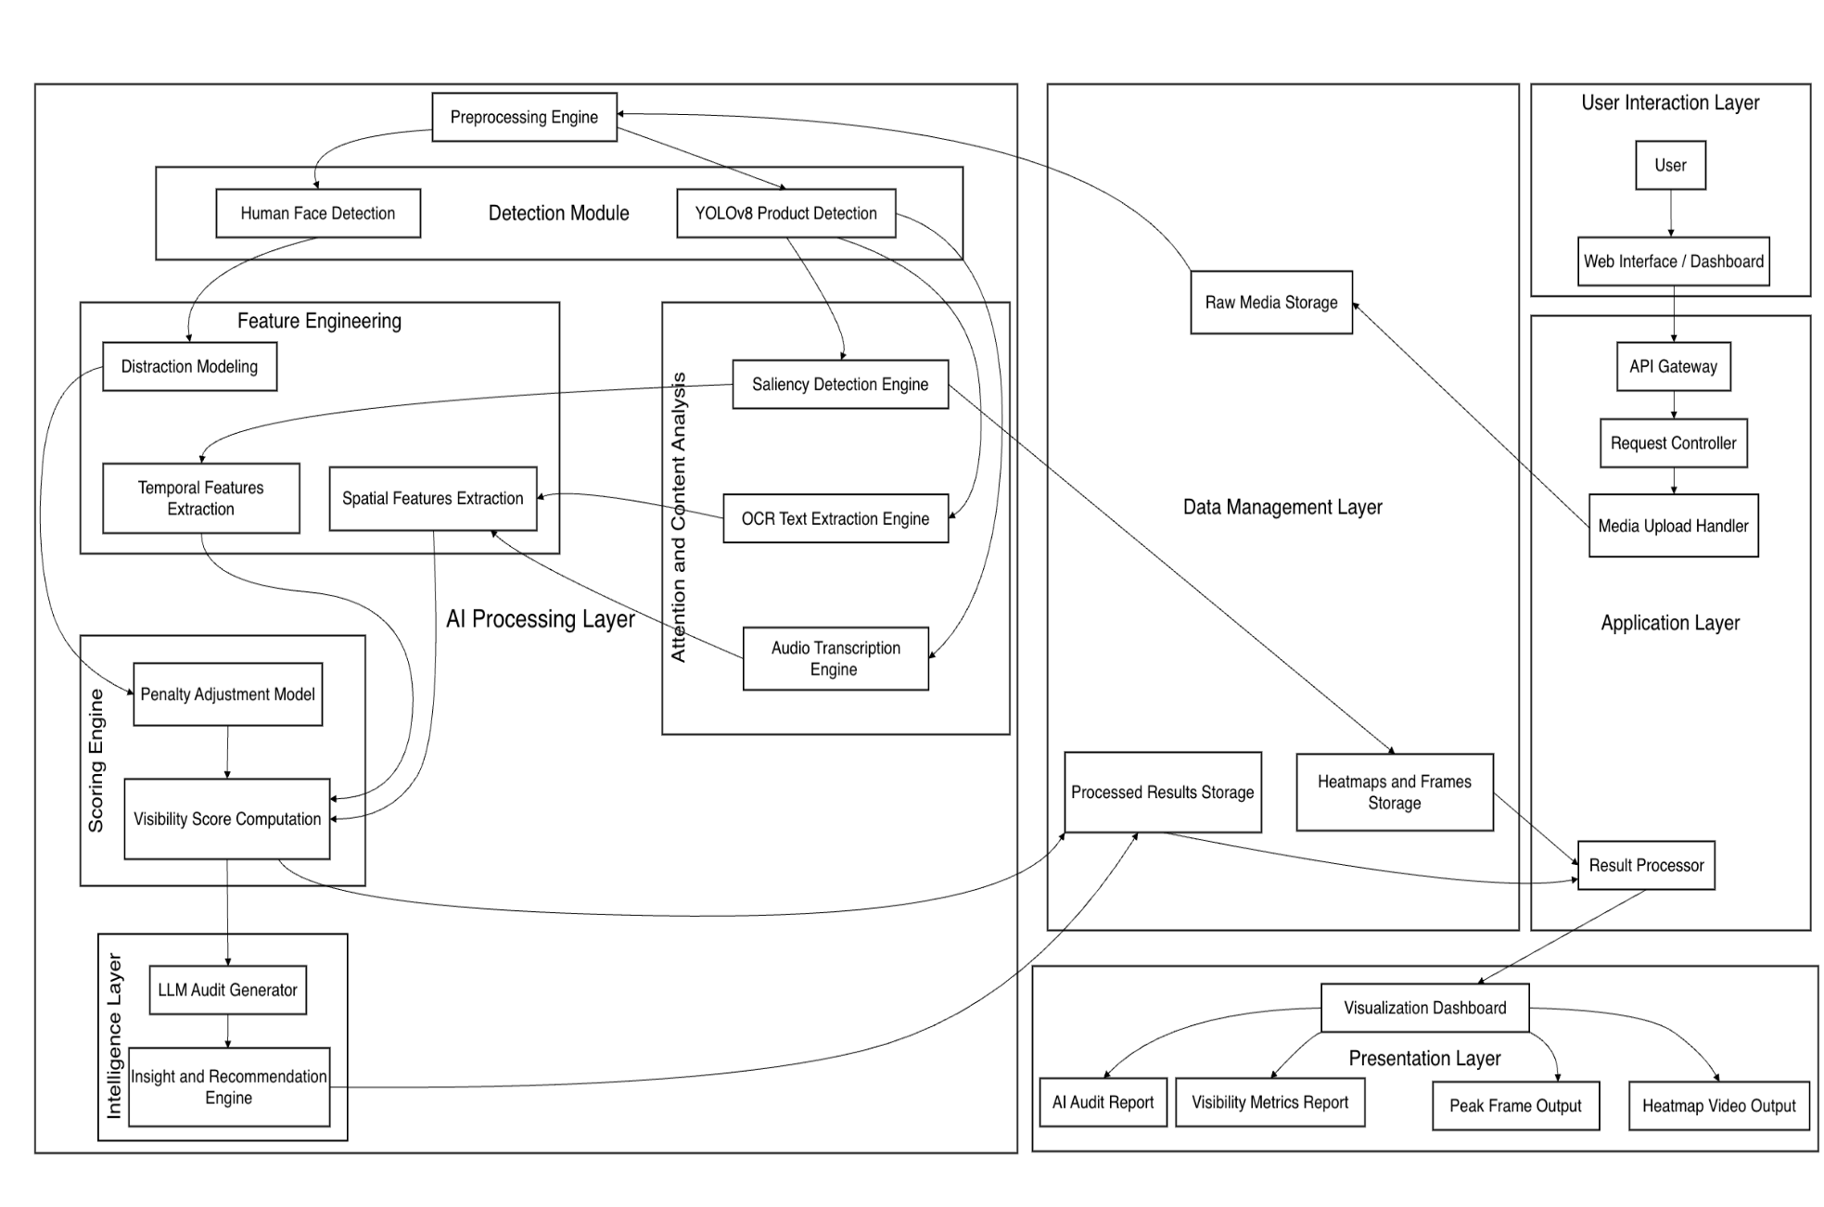
Fig. 4.1.1. Advertisement Visibility Analysis Proposed System Architecture.
4.1.3 Data Management Layer
Data Management Layer: Data Management Layer will store the raw and processed data. The media files that have been uploaded are first stored in Raw Media Storage. Intermediate results like heatmaps, extracted frames and processed results are stored in special storage units like Heatmaps and Frames storage and Processed results as the system runs the data.
This data separation between raw and processed data enhances the organization of data, as well as effective retrieval of the data in the course of the analysis and visualization. It is also scalable and thus it is able to process large quantities of advertisement information.

4.1.4 Preprocessing and Detection Module
After the data is obtained out of storage the data is passed through the Preprocessing Engine which prepares the data to be used in another analysis. An example of operations that are carried out during preprocessing is resizing, normalization, frame extraction (when working with video data). This action will make sure that input data is compatible with deep learning models and will enhance the performance of the system.
After preprocessing, the data is delivered to the Detection Module which comprises two major parts, which are Human Face Detection and YOLOv8 Product Detection. YOLOv8 model recognizes and localizes the products in the advertisement through generation of bounding boxes, class names, and confidence scores. At the same time, human face detection module recognizes faces in the ad since they are usually powerful attention-grabbing elements and may affect visibility scores.

4.1.5 Feature Engineering and Distraction Modeling
The system has a Feature Engineering module that derives significant features in the deduced objects and advertisement layout. This has spatial characteristics as well as temporal characteristics. Things such as spatial (the location, size, and distribution of items in a frame) and temporal (alteration between frames in video commercials) features are used to characterize video advertisements.
An important part of this phase is Distraction Modeling which assesses factors that can cause the loss of focus on the main product. Through the analysis of competing visual contents, which includes faces, background objects, and lighting effects, the system is able to recognize sources of distraction that lower the product visibility.

4.1.6 AI Processing Layer
The heart of the system is the AI Processing Layer which is the analytical part of the system, where various deep learning models are executed simultaneously to carry out the detailed analysis.
The Saliency Detection Engine produces heatmaps of attention which show high-visual priority regions. These heatmaps mimic human attention to visual and they are essential to comprehend human interaction with ads. The OCR Text Extraction Engine detects textual content like brand names, slogans and ads. The module also assesses the visibility and readability of the text, which is necessary in effective communication in ads.
Also, the Audio Transcription Engine handles audio data (in the video advertisements) to obtain the information that is spoken which further improves the capabilities of the system to understand the multi-modal advertisement data.The sum of all the outputs of this layer is fed into the Attention and Content Analysis framework that incorporates visual, textual and contextual information in their entirety to analyze them.

4.1.7 Visibility Score Calculating Engine
The processed characteristics are then transferred to Visibility Score Computation module that computes several important measures employed to assess the performance of advertisements. This module takes outputs of the object detection and the saliency analysis to identify the extent to which each of the detected products will get attention.
The system also has Penalty Adjustment Model where the visibility scores are adjusted on the basis of distraction factors as previously identified. As an illustration, when something in a face or background receives high priority than the product, the visibility score is lowered.
The quantitative metrics obtained by this stage include the score of visibility and distraction rate, and they give an objective measure of the performance of the advertisement.

4.1.8 Intelligence/Recommendation Layer
The Intelligence Layer includes an Audit Generator, based on Large Language Model (LLM), which interprets computed metrics and comes up with insights. This module deciphers the numeric data and turns it into human interpretations in the form of recommendations.
Some suggestions made by the Insight and Recommendation Engine include product repositioning, contrast improvement, layout changes or better readability of text. This not only makes the system analytical but also prescriptive which helps the designers to optimize the effectiveness of the advertisement.

4.1.9 Results Analysis and Visualization
The last part of the suggested system is the processing and visualization step, during which the analyzed information is converted into useful outputs that can be interpreted by a user. The results are then fed to the result processor after the completion of all the analytical processes such as detection, saliency mapping, OCR, and calculation of the visibility score. This element has the mandate of structuring, polishing as well as storing the processed information in a manner that is easily accessible to presentation and subsequent analysis.
When the data is processed, it is sent to the visualization dashboard that is the main interface in presenting the results to the user. The dashboard is such that it presents complicated analytical results in a comprehensive, clear and user-friendly way. It allows users to understand the effectiveness of advertisements with a simple interpretation with no technical understanding in deep learning and computer vision.
The system has various output components in the presentational layer that give a detailed analysis of the effectiveness of the advertisements. They are outputs like AI-generated audit reports, which provide an overview of the overall performance, insights, visibility metrics reports, which numerically show the effectiveness of the product capturing attention, peak frame outputs, which show the frames with the highest visibility in video advertisements, and heatmap video outputs, which visually depict attention distribution used in different areas of the advertisement.
The system enables the user to compare the impact of various visual and textual items on viewer attention and product visibility by bringing together these outputs. This does not only aid in comprehending the strength and weaknesses of an advert on the other hand it helps in making decisions based on data to enhance the design and efficacy of the advertisement.

- IMPLEMENTATION

A set of deep learning frameworks, computer vision techniques, and pipelines of data processing are used to implement the proposed system. This system is aimed at processing both image and video advertisements, uniting the processing of the objects, saliency analysis, and text extraction into a single workflow. The implementation is step wise in nature and has a pipeline approach whereby it ensures that it is processed effectively and a proper visibility analysis is made.

5.1 Data Collection and Dataset Preparation
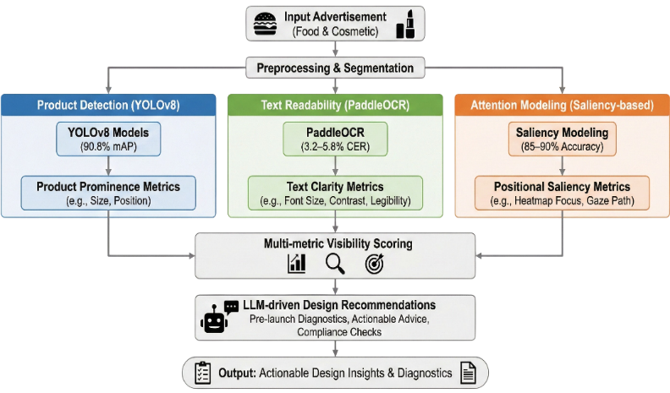
The execution starts with the gathering of advertisement data in food and cosmetic sectors. The dataset will include images and video frame containing different products including packaged food items, drinks, skincare products, and cosmetics.

Fig. 5.1 Dataset preparation and input processing pipeline

The data collected is preprocessed in order to be consistent in format, size and resolution. Photos are downsized and scaled to the input specifications of the deep learning models. Video data is partitioned into frames and separated by a fixed time interval so that they can be subject to frame analysis.
The dataset is annotated in the YOLO format, in which the bounding boxes are generated around products of interest. Class labels and coordinates are also provided in each annotation, and they are utilized to train the object detection model.
5.2 Preprocessing and Frame Extraction
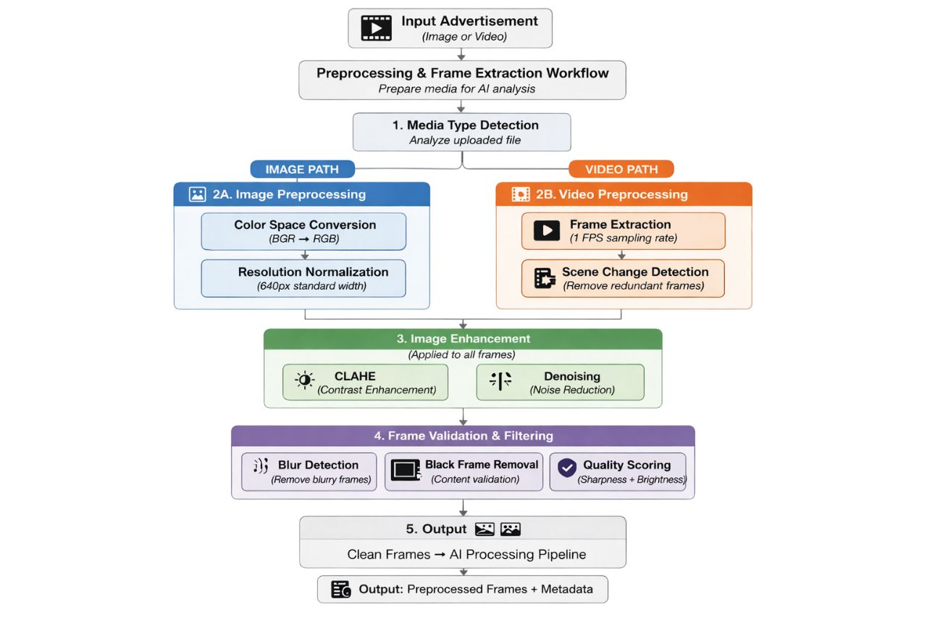
Before feeding the data into the models, a preprocessing stage is applied to enhance data quality and improve model accuracy. This stage involves operations such as normalization to standardize pixel values, resizing images to a fixed input dimension, noise reduction to remove unwanted distortions, and format conversion to ensure compatibility with the deep learning models. These steps help in creating consistent and clean input data, which is essential for reliable feature extraction and detection performance.

Fig. 5.2 Preprocessing and Frame Extraction Workflow

For video advertisements, frame extraction plays a crucial role in capturing temporal variations in product visibility. The system extracts frames at predefined intervals, allowing the model to analyze how product placement and attention change over time. Each extracted frame is treated as an individual input for further processing, enabling detailed frame-wise analysis. This approach ensures that dynamic changes in advertisements are effectively captured and evaluated.
5.3 Product Detection using YOLOv8
The main part of the offered system is the product detection module, which is realized with the help of the machine learning algorithm called YOLOv8 (You Only Look Once, version 8). YOLOv8 is the latest, state of art object detector model, which is highly accurate and has real time performance. It solves regression problems in object detection, allowing the prediction of bounding box position, class probabilities and confidence scores all at once in a single forward neural network run.
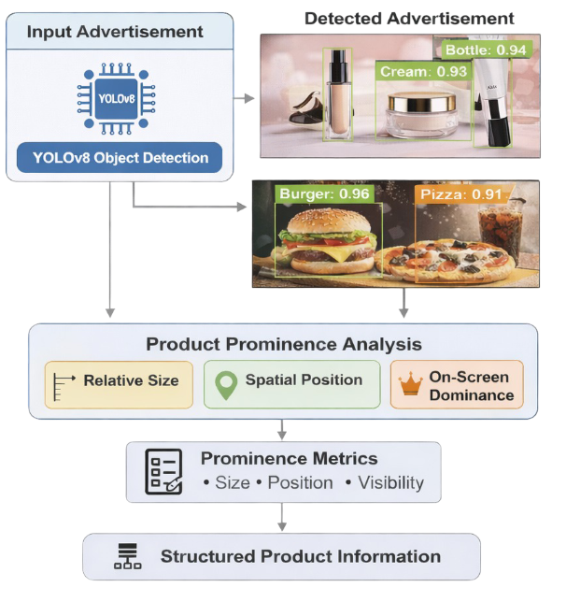
The model is trained on a hand-labeled dataset of advertisement images of foods and cosmetics. The data set is labeled by the YOLO format with all object instances being bounding boxes whose normalized coordinates, and also a corresponding class label. The categories of the products represented in the dataset are bottles, jars, lipsticks, tubes, and other types of packaging that are common in advertisements. Annotation of the dataset is essential because it directly affects the capacity of the model to generalize and identify products in a wide variety of advertisement cases.

Fig. 5.3. Product Detection using YOLOv8

In the training stage, the YOLOv8 model has convolutional layers with the purpose of learning hierarchical feature representations. These layers are used to extract low level features which include edges and textures, and high level semantic features including object shapes and contextual relationships. The training process includes various epochs, and the model repeatedly changes its weights by backpropagation and gradient descent optimization. Training involves minimizing a composite loss, which usually consists of bounding box regression loss, classification loss and objectness loss. This allows the model to be accurate in predicting not only the location but also the type of objects in addition to high confidence in the detection of the objects.
Different data augmentation methods are used in training to enhance the robustness of the model and avoid overfitting. These are random flipping, scaling, rotation and color modification. These methods subject the model to various deformations of the identical data, which permits the model to work with actual advertisement pictures with varying lighting, orientation, and backgrounds.
The trained YOLOv8 model takes each input image or video frame during the inference stage and generates a number of detections. Every detection is represented by a bounding box with the center coordinates, width, and height and a class label and confidence score. The confidence score is the likelihood that the object identified is of a certain class and that reflects the accuracy of the prediction.
Non-Maximum Suppression (NMS) is used to filter the detection results. NMS filters out overlapping bounding boxes that are redundant since it only retains those with the highest confidence scores. This will make sure that every object is only recognized once and lowers the output false positives.
Besides the elementary detection, the system also determines product prominence in terms of spatial features of the bounding box. The wider the bounding boxes and the position of the objects in the middle, the more prominent are taken to be, because the objects have higher chances of capturing the interest of the viewers. This spatial data is subsequently computed with saliency analysis to get visibility measures.
On the whole, the YOLOv8-based detection module is the effective and efficient method of localization of products in advertisements. Its capability to execute real-time detection as well as process numerous object groups makes it very effective on large-scale advertisement analytics. The products of this module would be used as a source of input in the next phases like saliency-based attention modeling and the computation of visibility scores.
5.4 Saliency Detection and Attention Analysis
The proposed system will use a deep learning-based saliency detection module to model and quantify attention to view the advertisements. This module is aimed at establishing areas in an image or video frame which are the most probable to draw human visual attention. Saliency detection is a layer of perceptual analysis that is essential to object detection, the identification of what is in the image unlike object detection that identifies where a viewer will most probably look.
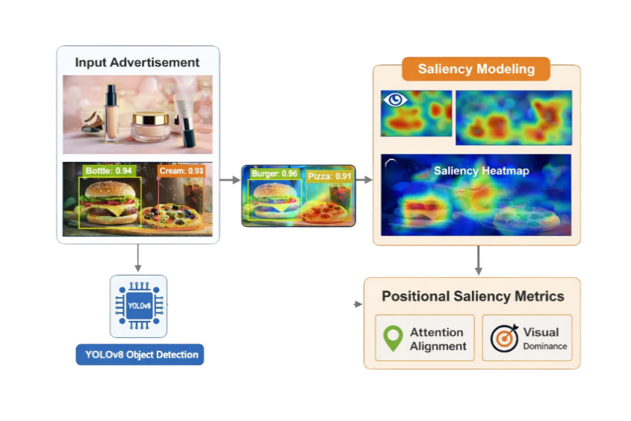
This system uses the saliency model, which is a convolutional neural network architecture that is trained to estimate human attention patterns. These models get to learn how to extract low level visual features like color contrast, brightness, edges and textures and also the high level semantic features, like object importance, contextual relevance and composition of the scene. These features are combined together to produce a saliency map, which indicates how the visual attention is distributed in the picture.

Fig. 5.4. Saliency-Based Attention Analysis
The saliency model produces a heatmap visualisation of the output, with a pixel having an intensity value based on the probability of it being attended to. These values are normally normalized to a predetermined range, with high values of intensity used to denote areas with a high probability of catching the attention of the viewer. These heatmaps are visually represented by brighter or warmer hues to feature the hot spots, and it is possible to intuitively note the distribution of attention.
In the case of video advertisements, saliency detection is done by operating on a frame-by-frame basis allowing the system to obtain temporal dynamics in the attention. It is of special consideration in moving adverts, where motion, effects, and shifting images affect the attention of the viewers with the time. With multiple frame saliency analysis, the system is able to determine the regular patterns of attention and also the frames in which the product is given maximum visibility.
An important process in this module is the attempt to combine outputs of saliency with the findings provided by the YOLOv8 detection model. The heatmaps of saliency generated are spatially congruent with the bounding boxes of the identified products. This correspondence enables the system to determine whether the identified product falls on areas of elevated focus. Particularly, saliency scores of the pixels contained within the frame are obtained and processed to identify the level of attention paid to the product.
Such mapping between the detected objects and saliency regions allows the system to go beyond detection activities to attention-based evaluate. An example of this is that a product which is obviously perceived yet there in an area of low saliency is likely not to attract the attention of the viewer, and this means ineffective advertisement design. On the contrary, a product placed in high saliency areas has higher chances of being picked up by viewers which is a positive contribution to advertisement effectiveness.
Also, saliency module aids indirectly in establishing distracting components in the advertisement. Areas beyond the product bounding box with large saliency values represent rival visual objects which could distract the target object. The information will subsequently be utilized in computing distraction measures.
5.5 OCR-Based Text Extraction
The proposed system will integrate an Optical Character Recognition (OCR) system to retrieve and process the textual data in the advert. Textual factors like brand names, product descriptions, slogans and promotion messages are important in the aspects of information delivery and perception of consumers. Hence, a study of text and graphic elements is required to fully assess the effectiveness of an advertisement.
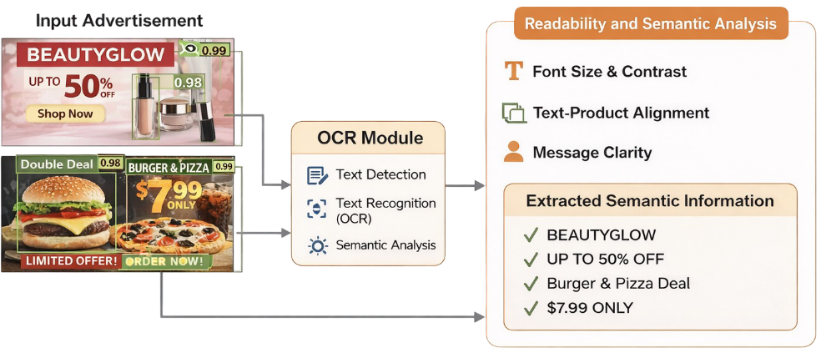
PaddleOCR has been applied in this system because of its high accuracy, robustness, and capacity to work in complex visual setting. PaddleOCR is an OCR system based on deep learning, which detects and recognizes text in one pipeline. The OCR process starts with the text detection, whereby the model locates the areas in the image that contain text. This is done based on convolutional neural networks used to differentiate text and background elements, despite the noise, font types, and complicated layouts.
Fig. 5.5 Text Extraction using OCR
After identification of text areas, a recognition step is done to translate the text areas found to machine readable characters. This phase is usually used to model sequence using either recurrent neural networks or transformer-based architectures to effectively identify characters and words. This system can accommodate font styles, sizes, orientations, and changes in lighting conditions; hence it can be used in analyzing advertisements in the real world.
The textual data is extracted and analyzed further to consider its contribution to the visibility of the advertisement. There are a few factors that are taken into consideration in this analysis. Text readability is one of the factors and it relies on the clarity, contrast, as well as the font size. Texts that were large and contrasted tend to be easier to read and attract the attention of the viewer. The other consideration is the positioning or the space of the text in which the text close to the product or in the middle of advertisement is more useful than the text on the edges.
The system too makes a judgement on the relative significance of the textual contents based on their size and prominence in the image. The information with a bigger size or located in high-saliency areas is assigned more importance because it is more probable to be focused on by the viewers. Also, a combination of OCR result and saliency maps may help the system to understand whether textual information is overlapped with saliency area or not and therefore to understand the effectiveness of the text in the whole advertisement.
When dealing with video advertisements, the OCR is done on each frame, and the system can therefore pick the time changes in the text. It enables identification of dynamic content of the text including an animated slogan or promotional message that changes.
All in all, the text extraction module with the use of OCR allows the system to be more efficient when it comes to multi-modal analysis, i.e. integrating visual and textual data. The system yields a better view of the performance of the advertisement by not just the presence of the text, but also the visibility and the effectiveness of the textual details. Such integration makes sure that the visual prominence is not overlooked in the final visibility testing, as well as the informational clarity.
5.6 Audit and Insight Generation based on LLM
In order to increase the interpretability of the results computed, the given system includes an audit generation module based on a Large Language Model (LLM). This component works once all the analytical steps, such as object recognition, saliency-related attention analysis, OCR-based text recognition, and visibility metrics computation have been successfully conducted. Its main goal is to convert the quantitative results to the valuable, human-interpretable information that will help users to learn how well the advertisements are working and in which areas they need to be improved.
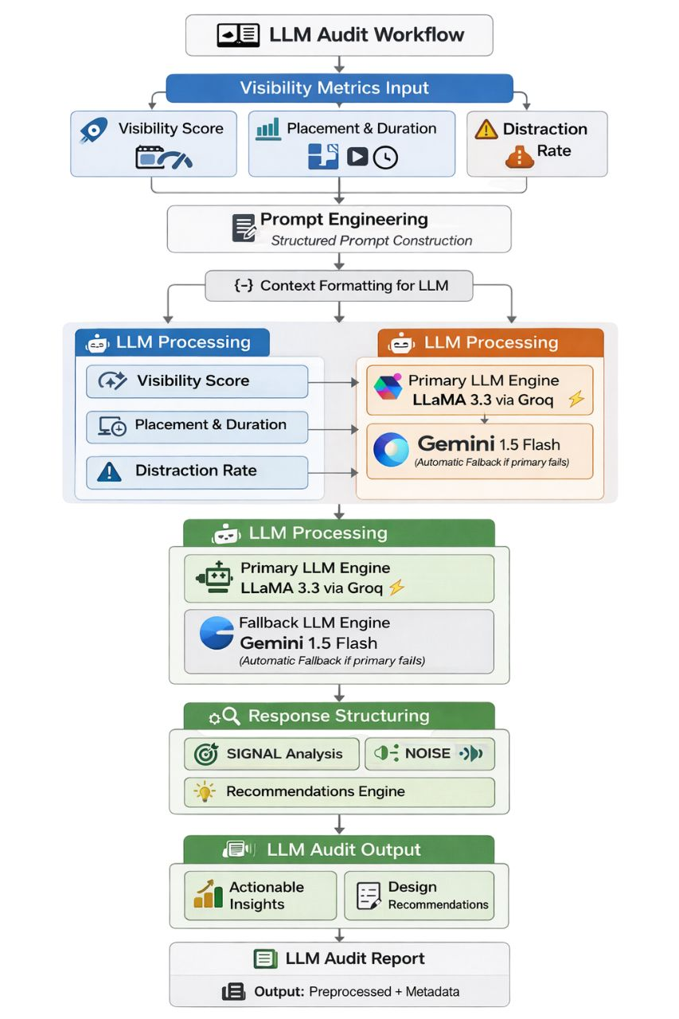
The structure of the input received by the LLM audit module is the structured output of the system, which has attention scores, visibility scores, distraction rates, identified product information, and textual elements extracted using the OCR. These inputs are coded into a descriptive prompt that takes both numerical and contextual information of the advert. The language model then takes the prompt and produces coherent analytical summary of the performance of the advert.

Fig. 5.6. LLM-Based design evaluation and recommendations system
The resulting audit report normally contains various levels of interpretation. First, it will give a general evaluation of the ad by examining the visibility rating and will conclude whether the product is able to attract the attention of the viewers. A high score on the visibility dimension is translated to mean that the visual prominence is high and a low score shows that there is a lack of attention being taken. The model also assesses the attention score to remark on the spatial location of the product, whether it is located in high-saliency or is engulfed by several others.
Besides the analysis of visibility, the LLM also analyzes the distraction rate in order to establish rival visual components that can lower product prominence. In case a high distraction rate is found, the audit identifies the existence of dominating non-productive factors like human faces, bright backgrounds or cluttered layouts which violate the focus that should be directed.
Textual analysis is also included in the module and OCR outputs are taken into consideration. It assesses the text that has been extracted as clearly readable, well placed and in support of the whole advertisement purpose. Low level of text readability or inefficient positioning is indicated as a possible problem that previously negatively influenced the effectiveness of communication.
According to the analysis of the visual and textual features, the LLM provides some recommendations that can be implemented to enhance the design of adverts. Such recommendations can involve moving the product to middle or high-attention space, making it bigger or smaller, less cluttered, less distracting, or clearer or more visible. The recommendations are created in natural text, thus can be used by non-technical people like designers and marketers.
The addition of the audit module based on the LLM can greatly increase the level of usability of the given system as there is a strong connection between the highly computational outputs and human interpretations of the information. Although the underlying models give quantitative measures, the audit module puts these measures into perspective and renders them into feasible information. This makes the system a decision support system rather than a purely analytic tool that can be used in guiding the optimization of advertisements.

5.7 Mathematical Formulation of the System
The implementation of the proposed system is supported by mathematical formulations that quantify product visibility, attention distribution, and distraction.
5.7.1 Attention Score Computation
The attention score represents the average saliency intensity within the detected product region. It is computed as:
$\text{Attention Score}=\left(\frac{1}{N}\sum_{(i,j)∈B}{S_{i,j}}\right)×\frac{100}{255}$ (1)
where:
- B represents the bounding box region of the detected product.
- $S_{i,j}$ denotes the saliency values at pixel $(i,j)$
- N is the total number of pixels within the bounding box.
This formula calculates the average attention intensity for the product and scales it to a percentage value. A higher attention score indicates that the product is located in a region of high visual importance.
5.7.2 Visibility Score Computation
To evaluate overall advertisement visibility, attention scores are aggregated across multiple frames:
$\text{Visibility Score}=\frac{1}{N}\sum_{t=1}^{N}{A_{t}}$ (2)
where:
- $A_{t}$is the attention score for frame $t.$
- $N$ is the total number of frames where the product is detected.
This formulation ensures that visibility is measured over time, capturing consistency in product prominence across frames. A higher visibility score indicates better advertisement effectiveness.

5.7.3 Distraction Rate Calculation
The distraction rate measures how often the product fails to attract attention despite being present in the frame. It is calculated as:
$\text{Distraction Rate}=\left(\frac{\text{Number of Distracted Frames}}{\text{Total Frames with Detection}}\right)×100$ (3)
where:
- Distracted frames are those where attention is not focused on the product.
- Total frames with detection represent all frames where the product is present.
A higher distraction rate indicates poor advertisement design, where other elements draw attention away from the product.
5.7.4 Interpretation of Metrics
The proposed system measures the effectiveness of the advertisements applying three main quantitative indicators, attention score, visibility score, and distraction rate. These measures are based on fusing object detection and saliency analysis, and all of them give a complete picture of the effectiveness of a product to attract the attention of the viewer.
The attention score is an average saliency intensity of the identified product area. The saliency map that the model produces in the implementation has pixel intensity values that can be in a range of 0 to 255. The system will remove the saliency values of the pixels within the bounding box and determine the average of these values in each product identified. This value is then brought to a percentage scale by dividing by 255 and multiplying this by 100. The attention score is therefore a measure of how much attention is given to the product. An increase in attention score will show that the product is in the area of the greatest visual significance and has a greater likelihood of being noticed by the viewer.
The visibility score is calculated as a cumulative index of attention in more than one frame. The score of visibility in the case of static images is the same as the attention score. But, in the case of video adverts, there are a number of frames that are processed and the attention score calculated per frame. These attention scores are then averaged to give the visibility score in all the frames where the product is identified. This makes sure that the metric does not just measure the attention at that particular time but also measures the stability of the product visibility over time. The increased value of visibility means that the product is visible in high-attention areas most of the time during the advertisement.
The distraction rate is the measurement of the degree to which the attention of the viewers is distracted off the product. Depending on the implementation the frame is said to be distracted when a frame by the attention score of the product is less than a predetermined threshold, this implies that the product was not the main focus in that frame. The rate of distraction is computed as the percentage of distracted frames to the total number of frames that the product is recognizable. This measure points to the existence of competing visual information, e.g. a human face, light backgrounds or any other type of object, that will lead to a less effective ad.
Mathematically, the formulas applied in the implementation are in line with the following representations:
- The attention score is calculated as the normalized mean saliency in the bounding box area, as it is important to make sure that the attention score represents localized attention intensity.
- The visibility score is derived by averaging the attention scores in each frame and a temporal perspective of consistency in attention is gained.
- Distraction rate can be described as a percentage of frames that have low attention scores to total number of detected frames.
These expressions are properly adjusted to the logic of computation of the system and can offer valuable quantitative data regarding the performance of the advertisement.
The combination of these three metrics allows, in general, to determine the effectiveness of the advertisements in a balanced way. The attention score is used to measure the localized visual attention, the score of visibility is used to assess the sustained attention with time, and the rate of distraction is used to measure some competing elements that lower the product prominence. Collectively, these indicators can be used to objectively and data-driven evaluate the effectiveness of an advertisement in conveying the message it aims to and capturing attention of viewers.
5.8 Web Application Interface Implementation
Besides the main deep learning pipeline, the given system is deployed as a web app to offer the end-user an interactive and user-friendly interface to analyze the ads. With the web application, users can upload media, run ads as well as visualize using a structured dashboard. The interface is meant to close the division between the complex processing at the back end and the user level interaction, so that it is accessible to both the technical and non-technical end users.
5.8.1 User authentication Interface
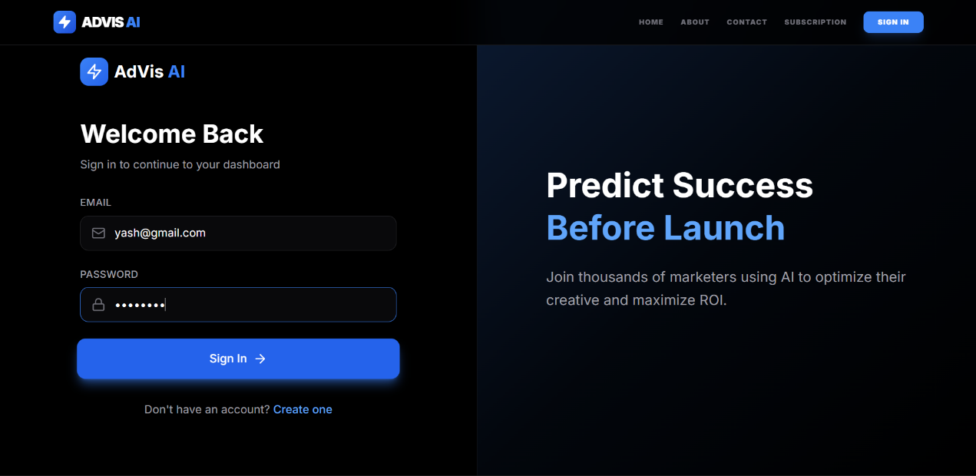
The user authentication interface is used to gain access into the system by enabling registered users to use their credentials to access the system. It has email and password entry boxes and a sign-in button to enable the authentication process.

Screenshot 1. User authentication Interface
The module is used to make sure that the advertisement analysis features and dashboard features are accessed by authorized users only. The interface is developed in clean and easy to use layout to improve usability and accessibility. Also, there is a new user registration feature, which allows new customers to open an account and have access to the system. When the user successfully logs in, he/she is redirected to the dashboard where he/she could upload the advertisement media and analyze the results. The authentication mechanism is very essential in terms of preserving data privacy and user-specific results management. It also facilitates session management, which will make interaction with the system in the various interactions to be seamless.
5.8.2 Users Home Interface
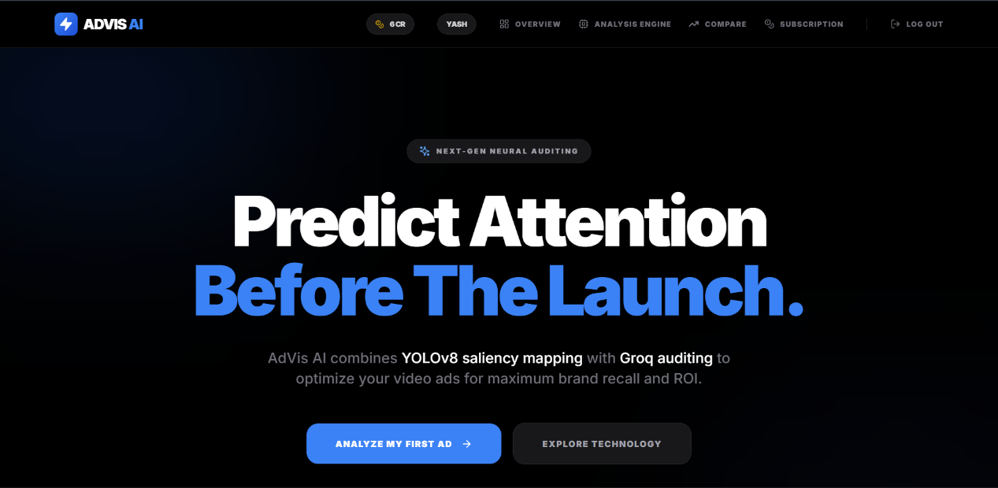
The user landing page is the main page the user can enter after being authenticated to the system and will give a summary of what the system does and what are its capabilities. It brings to the fore the main feature of the platform which consists in predicting the attention to the ads based on the AI-based analysis.

Screenshot 2. Users Home Interface
The interface shows the main navigation possibilities to choose between overview, analysis engine, comparison tools and subscription management that allows users to navigate to various modules with ease. An outstanding button with the call-to-action, like Analyze My First Ad, leads to the starting of the process of advertisement analysis. The page also conveys the incorporation of modern technologies, such as object detection and saliency mapping, to make the users see the running strategy of the system. It is also user-specific with items like user accounts and credits of usage, which means personal communication. The layout is made in such a way that it is visually attractive and easy to use and interact with. In general, this page serves as a transitional one between the user input and the actual defining functionality of the system.

5.8.3 User Control Panel
The control panel is the main monitoring tool of the system that giving users an overview of their activities concerning advertisement analysis. It shows such key performance indicators, as the number of reports created, the average visibility score and the number of ongoing tasks, which allows the user to easily evaluate system usage and performance.
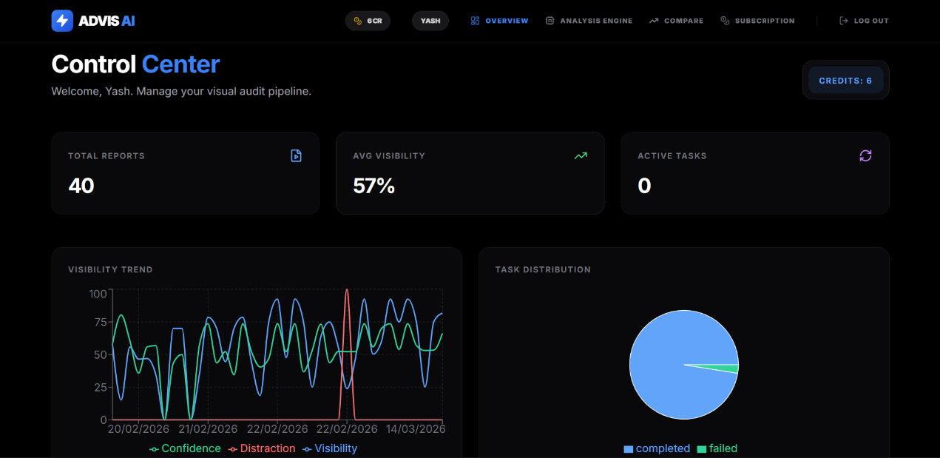
Screenshot 3. User control panel
The dashboard also has a visibility trend graph that demonstrates changes in indicators like confidence, distraction, and visibility with time. This graphical tool assists users to recognize patterns and measure the effectiveness of various advertisements through a number of analyses. Further, a task distribution chart will be given to present the percentage of completed and failed processing tasks, which will give an idea on the reliability of the system and its performance. User specific details like the available credits are also pointed out by the interface which aids in regulated use of the system. The design is such that it is understandable and simple to interpret with visuals helping in making decisions fast. The general idea about this dashboard is that it is a full overview tool that synthesizes the results of all the analytics with the system level monitoring.

5.8.4 Advertisement Analysis Interface
Advertisement Analysis Interface is an important part of the system and allows the user to enter the major part of the processing pipeline by posting advertisement media. This page gives a choice of the mode to be used in the analysis, either Cosmetic Mode or Food/FMCG Mode so that the system can use domain specific detection models.
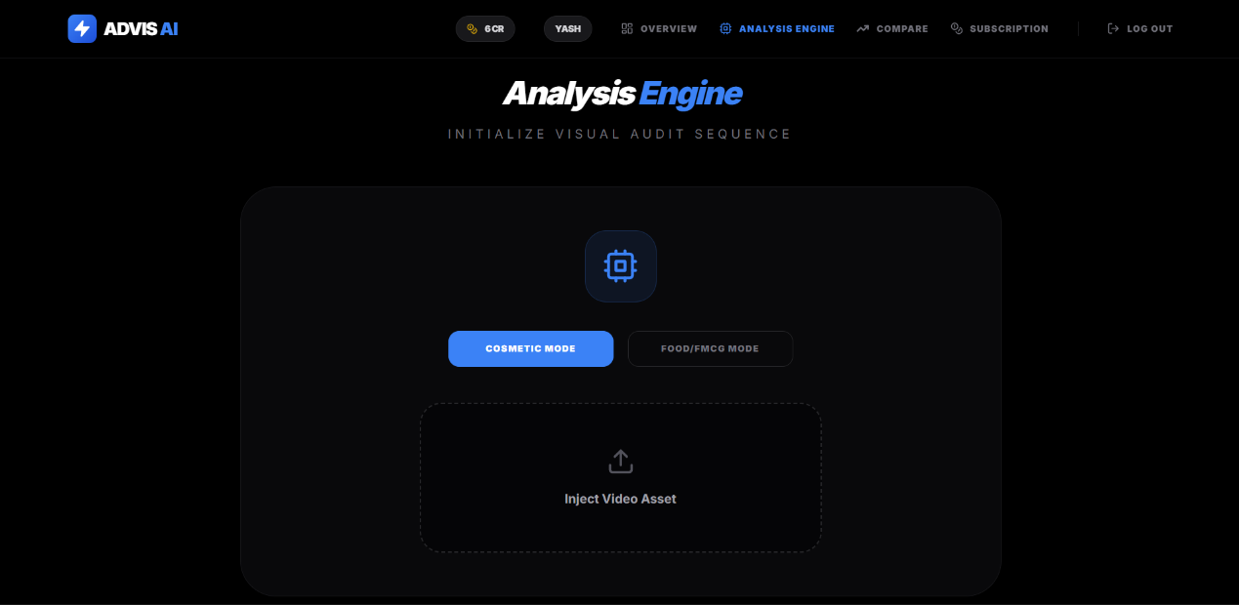
Screenshot 4. Advertisement Analysis Interface.
The interface has an upload section with a label Inject Video Asset in which users can upload image or video advertisements to be evaluated. After the uploading of the media, it is sent to the backend processing pipeline where it undergoes preprocessing, object detection through the YOLOv8 model, saliency analysis and text extraction through OCR is done. Its design is clean and minimal to provide an easy-to-use interface in order to direct the user through the analysis workflow. This interface serves as a gateway to the deep learning modules, and it connects directly to the user input and the automated view to advertisements. It is very important in the enhancement of smooth communication between the system analytical engine and the user.

5.8.5 Advertisement Audit Report
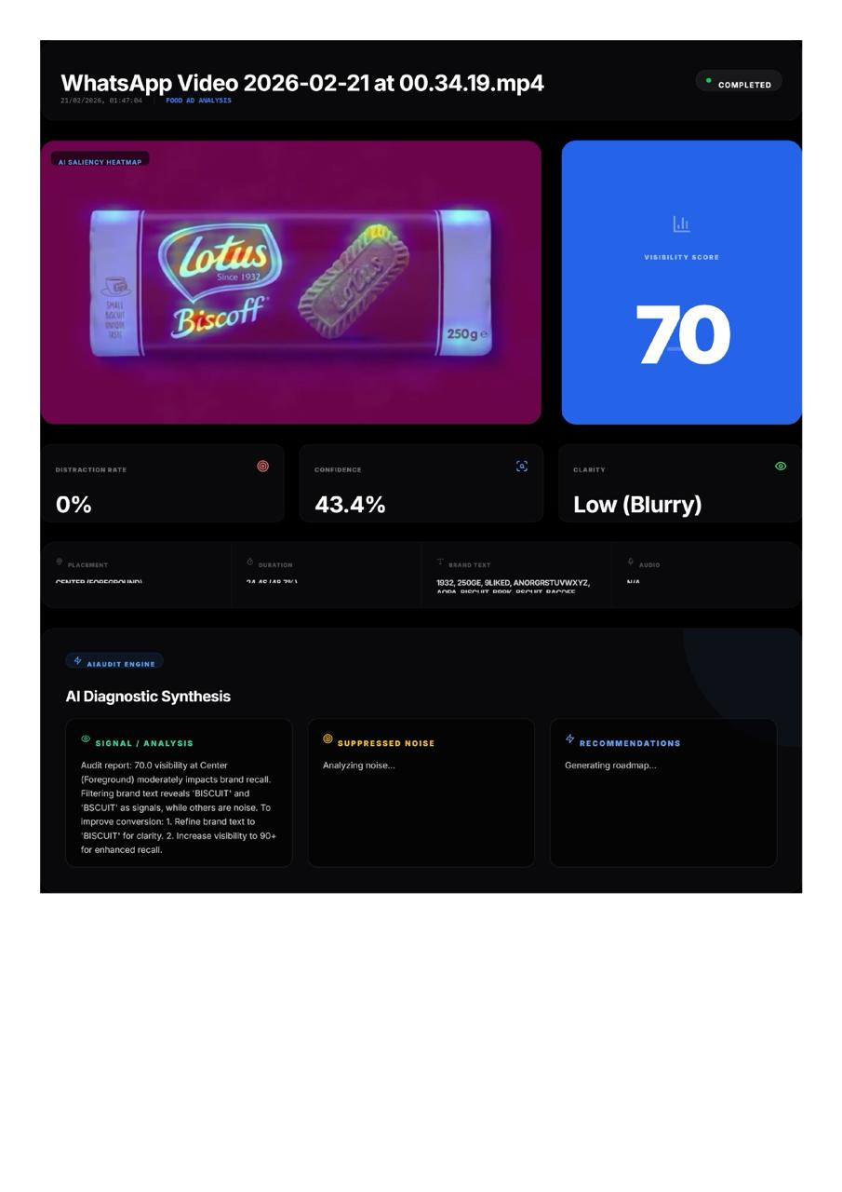
The Advertisement Audit Report Interface is the ultimate product of the system that offers analytical results in addition to the insights offered by the AI. The processed advertisement and a saliency heatmap are shown on this page and visually represent areas that the most attention of the viewers get. One of the metrics displayed is the visibility score, which measures the effectiveness of the product in drawing attention in the advertisement. Other areas of performance like the rate of distraction, degree of confidence and clarity are also listed to create a detailed analysis of the effectiveness of the advertisement.

Screenshot 5. Advertisement Audit Report.
The interface also has the detailed analysis of attributes, product placement, duration, extracted brand text, and audio presence, which allows conducting multi-modal assessment. One of the major traits of this page is the section of AI Diagnostic Synthesis, where a Large Language Model will produce a structured audit report. This report will be a translation of the computed measures and a significant input towards information on the performance of adverts.
The system also provides actionable recommendations, including the ability to improve the clarity of the text or make the product more visible to improve the effectiveness of adverts. This interface is based on the combination of quantitative metrics and qualitative analysis and converts raw data into the decision-support insights. On the whole, this module is essential to allow users to perceive, analyze and maximize advertisement design on the basis of data-driven feedback.
5.8.6 Advertisement Comparison Interface (α/βAnalysis Module)
Advertisement Comparison Interface allows one to make a comparative analysis of two already processed advertisements. The module will facilitate the A/B testing, as it enables users to choose two alternative advertisement resources, which are known as Variant α and Variant β. All the variants may be selected among the list of reviewed media so that it is guaranteed that the comparison is conducted on the pre-computed measures like the attention score, the visibility score, and the distraction rate.
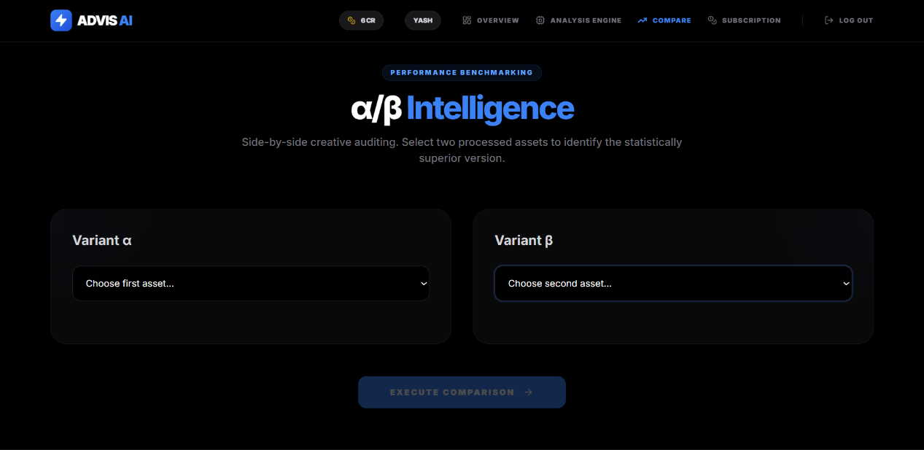
Screenshot 6. Advertisement Comparison Interface (α/βAnalysis Module)
After choosing both assets the system will complete a side-by-side analysis, to identify the advert that is more effective in viewer engagement and product exposure. The interface is designed to have a quick and easy workflow of comparing performance strategies and it is also easy to view the differences. The same feature can be effectively used with the help of marketers and designers who wish to determine the more efficient design of the advertisement.
Along with visual analysis, this module allows making decisions more effectively and optimizing advertisement planning through the incorporation of statistical comparison. It transforms the system into a one-piece analysis system rather than a performance benchmarking system.
5.8.7 Administrative Dashboard
The Administrative Dashboard is the control center of the system, where the managers will be able to use the centralized administration and monitoring capabilities. This interface shows major system-level indicators, including the number of platform users, the number of AI audit reports created, and the health of the current server, providing the administrator with an opportunity to evaluate the use of the system and their health. Resource monitoring features (node uptime and memory utilization) are also included in the dashboard, and they are used to monitor the performance of the system and maintain stability.
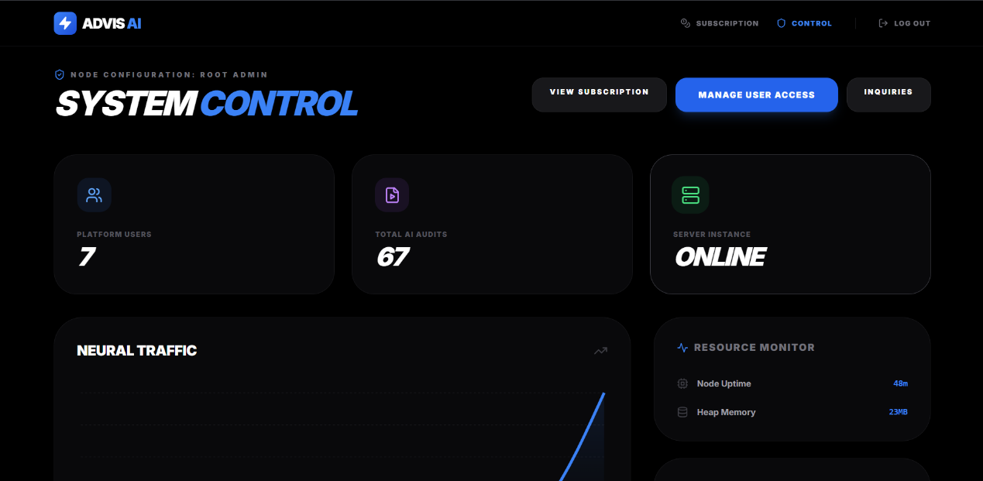
Screenshot 7. Administrative Dashboard
The interface has also been built with management capabilities like user access control, subscription management and processing user enquiries. These properties enable administrators to control access to the systems, control user permissions and security of the platforms. The fact that it includes a neural traffic graph also allows visualizing the activity of the system and the distribution of the workload over time.
The dashboard design focuses on the ease and efficiency of the information displayed on the dashboard so that the administrators can immediately notice the state of the systems and take the required measures. In general, this module will provide the proper functioning of the whole system, the efficient management of the resources, and the safe administration of the users, so the module of the whole implementation.
5.8.8 User Registry Module
User Registry Interface is one of the important administrative elements that allows the effective administration of platform users and access control. The module gives a systematic perspective of all registered users showing vital information like the identity of the user, email, account status, type of subscription, and usage credits assigned. It enables the administrators to keep track of the active users and make sure that the resources of the system are used appropriately.
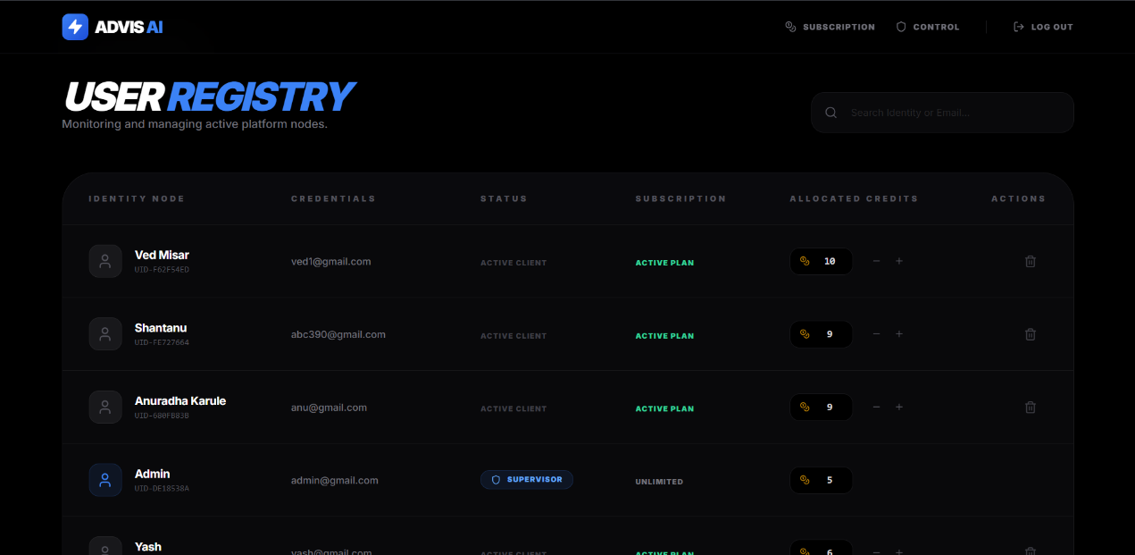
Screenshot 8. User Registry Module
The interface has the functionality to update the user permissions and dynamically control credit allocation, therefore, providing controlled access to the advertisement analysis features.
The administrators are able to supply or deny user credits depending on subscription or usage needs which ensures equitable and scaling system usage. The system also has the role-based access control, which differentiates between standard and administrative users, including supervisors. It can be used to find users in quick time, as it contains a search option where a user can be located by name or email address, which enhances efficiency in its operations. The interface also gives action controls like removal or modification of the user and this has guaranteed a secure and streamlined user management. In sum, this module is important to ensure that there is system integrity, regulated access, and administrative control of the platform.
5.8.9 Inquiry Management Interface

The Inquiry Management Interface allows the administrators to read and respond to the user queries, feedbacks, as well as communication requests within the system. This module gives a tabulated listing of user queries, which shows important information like user name, email, message, company name, and date. It enables the administrators to monitor and react to user issues associated to subscriptions, system usage and technical problems effectively.

Screenshot 9. Inquiry Management Interface
Status indicators like New, Read and Replied are used to categorize each query and can assist in prioritization and organization of communication workflows. This categorization will make sure that no query by the user will be ignored and it will aid in the orderly processing of requests. The interface also allows quick actions to update the status of the inquiries so that the management of communication can be easily done.
This module is very important in keeping the user engaged and supportable in the fact that one is assured that a response is given to the user concerns in a timely manner. It is also useful in assisting administrators in obtaining feedback which could be used to help in enhancing the performance of the system and the user experience. The inquiry management system, in general, improves the usability of the platform as it extends communication management to the administrative dashboard.
5.8.10 Subscription and Pricing Interface

The Subscription Interface allows users to have options of various price plans to use the advertisement analysis system at the price points that suit their needs. The module has several subscription levels, i.e., Basic, Pro, and Enterprise plans with varying degrees of features and computational capabilities. The Basic plan is aimed at users on the entry level and includes a restricted amount of audits of AI and the standard functionality. Pro plan is available with additional features including, more audit limits, priority processing and sophisticated analysis features and it is applicable to both ordinary and professional users.

Screenshot 10. Subscription and Pricing Interface
Enterprise plan is also customized to suit organizations and provides scalable option like unlimited team access, model tuning and specific support. The interface shows the pricing, features, and payment options clearly and with transparency and ease of transaction i.e. UPI, cards, and net banking. Also, the system has built-in credit-based usage model, in which users use credits to perform an analysis thus can manage and measure resource utilization. This module is important in commercialising the system besides giving the user scalable access to enhanced AI capabilities. It makes sure that users have the option of selecting plans depending on their requirements and position and upgrade easily with their increased use.
- RESULTS AND DISCUSSION
The suggested system was tested on two large advertisement areas, such as cosmetic and food advertisements, to determine the effectiveness of the system to detect the products, model visual attention, and obtain textual information. The findings prove that the combination of object detection with YOLOv8 and attention modeling with saliency as well as text extraction with OCR gives a complex and trusted framework to study the visibility of advertisements. The system produces the following outputs: bounding box detections, saliency heatmaps, and extracted textual elements, each of which allows carrying out quantitative and qualitative analysis of the effectiveness of advertisements.
6.1 The results and discussion on Cosmetic Advertisements
Section 6.1 presents the overall results obtained from the implementation of the proposed system, including detection outputs, saliency maps, and computed visibility metrics. These results demonstrate the system’s ability to analyze advertisement content and quantify product visibility effectively.
6.1.1 Training Performance Graph
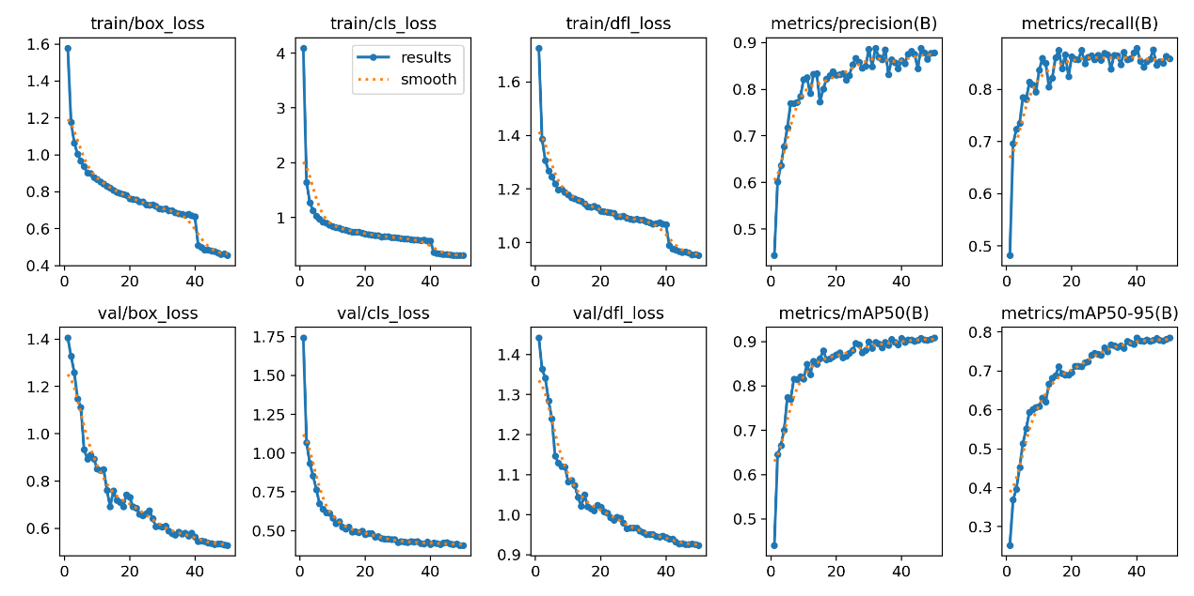
The training and validation performance curves demonstrate the convergence behavior of the YOLOv8 model during training. The box loss, classification loss, and distribution focal loss (DFL) show a consistent decreasing trend across epochs, indicating effective learning and optimization of bounding box localization and class prediction.
Fig. 6.1.1 Training Performance Graph
Simultaneously, the precision, recall, and mAP metrics exhibit a steady increase, eventually stabilizing at higher values, which confirms the model’s ability to generalize well on unseen data. The mAP@0.5 reaches approximately 0.90, reflecting strong detection performance. These results validate that the model is neither underfitting nor overfitting and has achieved optimal convergence.
6.1.2 Precision-Recall Curve
The Precision Recall (PR) curves display results for every cosmetic product class together with results for the complete model. The classes Jar and Lipstick together with Bottle reach average precision scores above 0.95, which demonstrates their ability to detect targets with high accuracy.
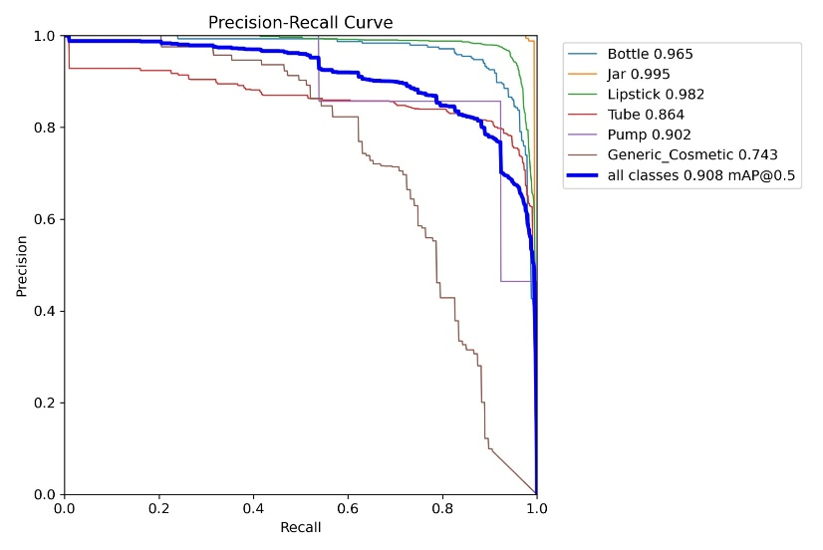
Fig. 6.1.2 Precision-Recall Curve
Pump and Tube show moderate performance results, while Generic Cosmetic exhibits lower precision due to its increased visual diversity and limited training data. The model demonstrates excellent detection abilities because the bold curve shows overall class performance with an mAP@0.5 result of 0.908.

6.1.3 F1 Confidence Curve
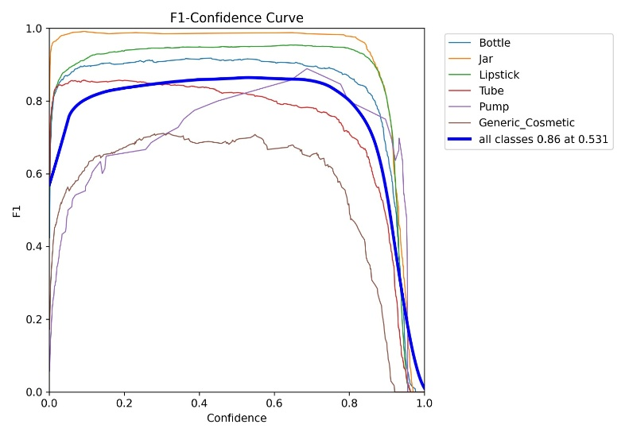
The F1 Confidence curve shows how the F1 score changes when different confidence levels are applied to each object category. At very low confidence thresholds, the F1 score decreases because false positive results occur in high volumes. The F1 score increases with rising confidence thresholds until it achieves its best performance through precise detection and accurate identification of actual instances. The F1 score starts to decline when the confidence threshold exceeds this optimum point because genuine detections start to get overlooked. The Jar and Lipstick classes demonstrate persistent high F1 scores through a broad range of confidence levels, which shows their ability to detect targets with strong accuracy.

Fig. 6.1.3 F1 Confidence Curve
The Bottle test maintains stable results, although its highest performance level remains below the optimal mark. The Tube Pump and Generic Cosmetic categories show lower F1 scores because their products share more visual similarities and their products face more visual obstructions and their products show greater differences within the same category.
6.1.4. Normalized Confusion Matrix
Fig. 6.1.4 presents the normalized confusion matrix, where each value represents the proportion of predictions relative to the true class distribution. Unlike the raw confusion matrix, normalization allows fair comparison across classes by accounting for class imbalance. High diagonal values indicate strong class-wise performance. The model achieves high recall for Jar (0.98), Lipstick (0.96), Bottle (0.93), and Pump (0.92), demonstrating reliable detection for visually distinctive categories. Tube (0.82) shows slightly lower performance due to visual similarity with lipstick-shaped products.
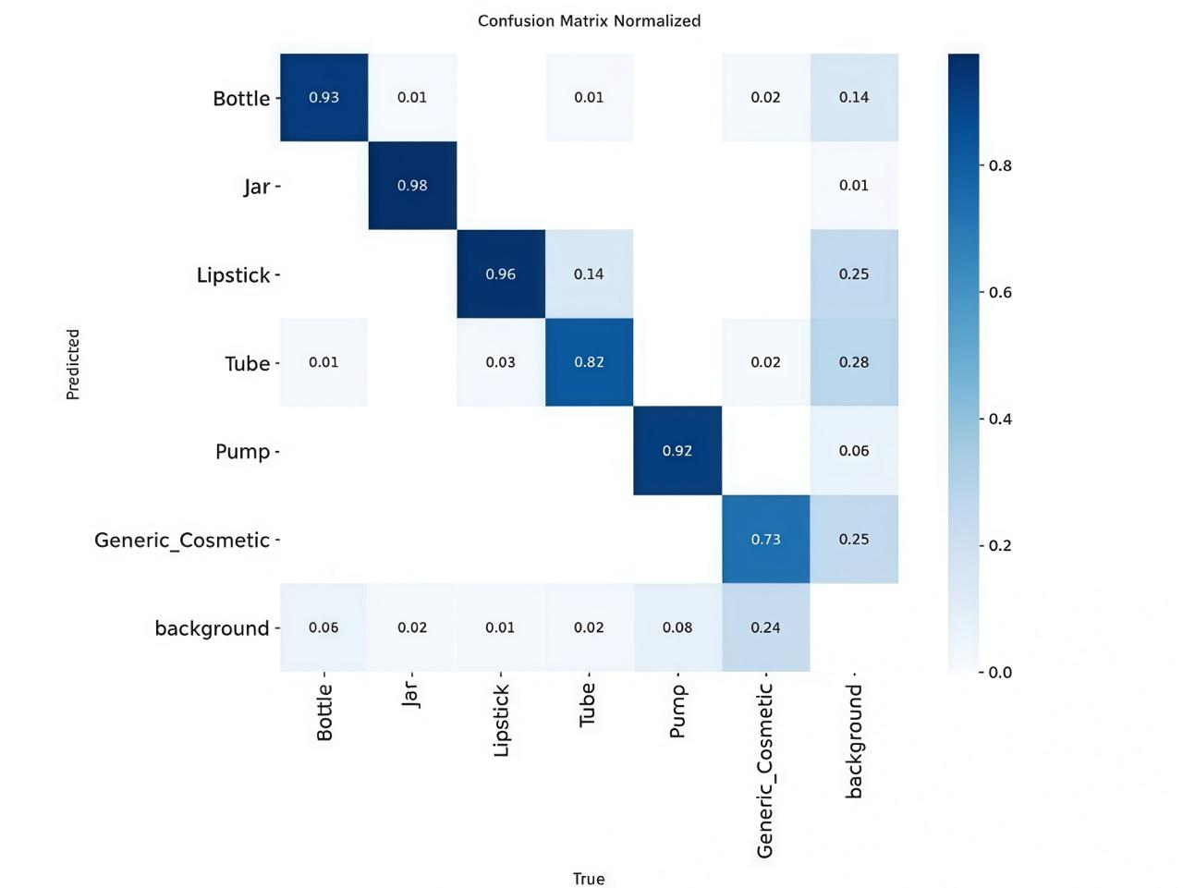

Fig. 6.1.4. Normalized Confusion Matrix
The Generic Cosmetic class exhibits comparatively lower recall (0.73), with noticeable confusion toward Lipstick and Tube, reflecting its broad visual definition and limited training samples. Misclassification with the background class is also observed, particularly for smaller or less distinctive objects, indicating occasional false negatives.
6.1.5 Outputs for Cosmetic Advertisement
The experimental findings derived on the advertisement of cosmetics do indicate high levels of detection and high correspondence with human patterns of visual attention. The YOLOv8 model manages to identify a broad variety of cosmetic item: creams, lotions, tubes, and jars which can be easily viewed in Fig. 6.1.5 The bounding boxes effectively localize the products in the event that they are found in varied orientations, lighting conditions and backgrounds. It means that the model has successfully acquired the spatial and structural attributes of cosmetic packaging.
An important finding of Fig. 6.1.5 is that saliency heatmaps are very intense in the center of the product areas and branding regions. As an example, in several frames, the greatest attention intensity is noted in product labels, logos and packaging surface. That is an implication that the system is detecting appropriately the visually dominant areas that are likely to draw attention of users. In the frames of human subject, where a product is held in hands, saliency distribution changes between the face and the product, which is realistic human viewing behaviour. This indicates the good ability of the model to represent competition of attention among various visual stimuli.
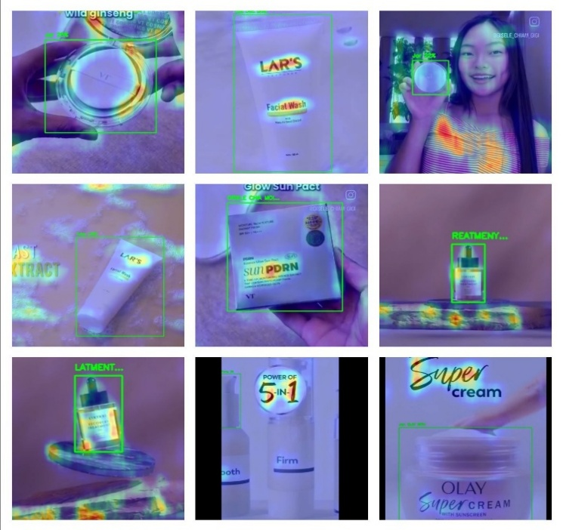

Fig. 6.1.5 Outputs for Cosmetic Advertisement
The OCR module also improves the analysis by extracting the text like brand names and product labels in the detected areas. Texts in the instance of cosmetic advertisements are usually clear with prominent positioning and therefore, they are easily extracted. This helps in the greater understanding of the content of advertisements and facilitates the consideration of brand awareness.
Although the performance is strong, there is some level of challenges that are witnessed. The saliency heatmap in certain frames leaks to adjacent regions slightly, because there are some reflections or changes in lighting, and this can negatively affect the accuracy of attention concentration. Also, in case several similar products are represented within the same frame, slight overlaps in bounding boxes may take place. Nevertheless, these problems do not play a big role in the overall system performance.
On the whole, the findings demonstrate that cosmetic advertisements can be effectively implemented in the proposed system since they have a well-developed structure, similar packaging, and well-defined brands. The system is able to capture spatial visibility and perceptual attention thus it is very effective in analyzing advertisement of cosmetic products.
6.2 The results and discussion on Food Advertisements.
Section 6.2 discusses the performance evaluation of the system across different advertisement samples. It compares visibility metrics and identifies patterns in attention and distraction, providing insights into advertisement effectiveness.
6.2.1 Training Performance Graph.
The training and validation performance curves demonstrate the convergence behavior of the YOLOv8 model during training. The box loss, classification loss, and distribution focal loss (DFL) show a consistent decreasing trend across epochs, indicating effective learning and optimization of bounding box localization and class prediction. Simultaneously, the precision, recall, and mAP metrics exhibit a steady increase, eventually stabilizing at higher values, which confirms the model’s ability to generalize well on unseen data.
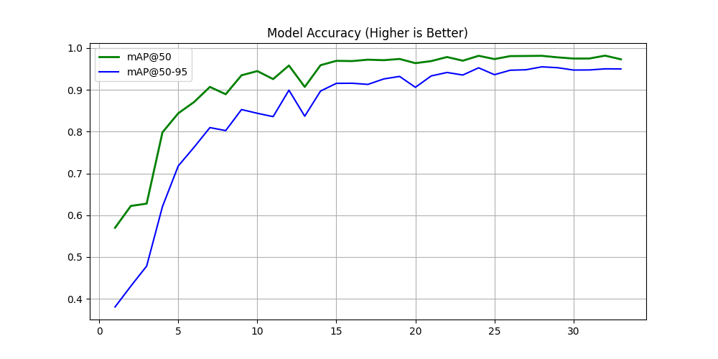
Fig. 6.2.1 Training Performance Graph.
The mAP@0.5 reaches approximately 0.90, reflecting strong detection performance. These results validate that the model is neither underfitting nor overfitting and has achieved optimal convergence
6.2.2. Precision-Recall Curve
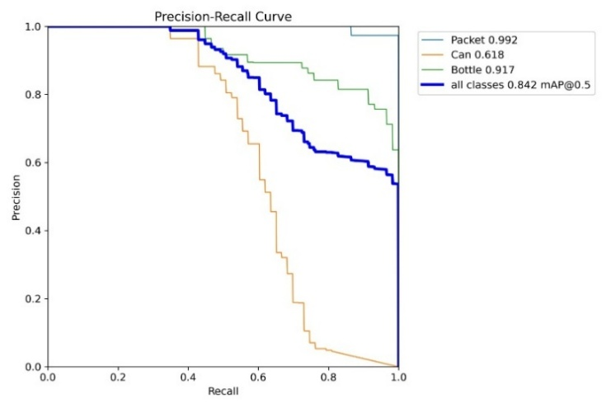
The Bottle class demonstrates competitive F1 values at the medium levels of confidence and a further decline in this case at higher levels probably because of changes in shape, reflections, and partial occlusions. Comparatively, the Can category has lower F1 scores, which is indicative of difficulties in maintaining a consistent balance between accuracy and recollection of visual similar packaging types.
Fig. 6.2.2 Precision-Recall Curve
Fig.6.2.2 shows the Precision-Recall curve of the proposed object detection model on Packet, Can, and Bottle categories as well as the general performance. Packet class has almost perfect detection with an average of 0.992 precision and a high precision at most of the recall range, which implies excellent visual specificity and dependable localization of advertisement scenes.
The Bottle class also shows good performance at 0.917 AP which indicates a good performance of detecting the objects at different scales and positions. Contrary to that, the Can category has a relatively worse performance with an AP of 0.618 at which precision decreases more at higher recall rates because of visual similarities, reflections, and background clutter that is common when using real-world advertisements. The sum of all the classes results in the overall mAP 50 of 0.842, as depicted in Figure 6, which proves that the proposed framework is able to provide a balanced precision-recall trade-off and trustworthy multi-class detection in the analysis of food and cosmetic advertisements based on visibility analysis.
6.2.3 F1 Confidence Curve
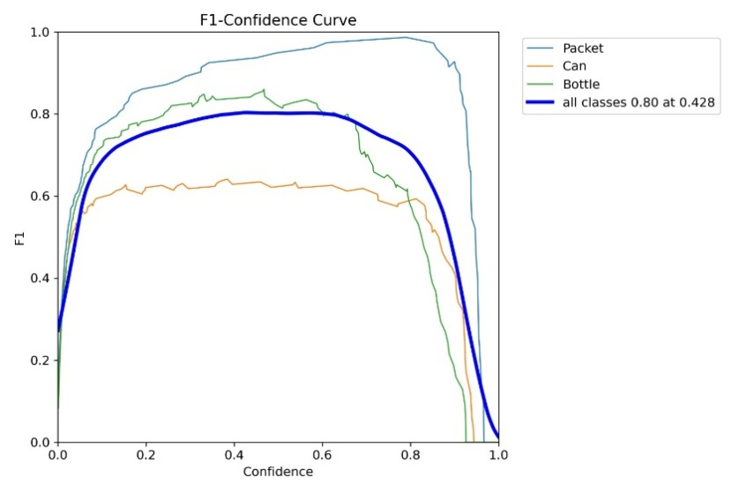
Fig.6.2.3. shows the F1-Confidence curves of the Packet, Can, and Bottle type, and the combination of all the classes. The figure illustrates the changes of the balance between precision and recall as confidence threshold increases. The Packet category has the best and most consistent F1 scores over a large confidence interval, which demonstrates that the packet category has strong detection results in a variety of advertisement scenes.
Fig. 6.2.3 F1 Confidence Curve
Fig.6.2.3. indicates that the bold curve of all classes has its maximum F1 score of an approximation of 0.80 at a confidence level of 0.428 and this could be said to be the best operating point of the proposed model. This discussion shows that there is an optimal trade-off based on moderate confidence levels and the framework is appropriate to determine reliably the visibility of products in food and cosmetic advertisements.
6.2.4. Normalized Confusion Matrix
Fig.6.2.4. shows the normalized version of the confusion matrix of the proposed YOLOv8-based detection framework, providing the view of the prediction performance in terms of the proportion of the classes to the Packet, Can, Bottle, and background classes. The diagonal values show good, normalized accuracy of Packet (1.00) and Bottle (0.98), showing that these are product types that can be recognized by the model in a very consistent and reliable way. The Can category is moderately performing (0.56) with a rather more confusion indicating the differences in the shapes, size, and visual resemblance to the background contents in the advertisement scenes.
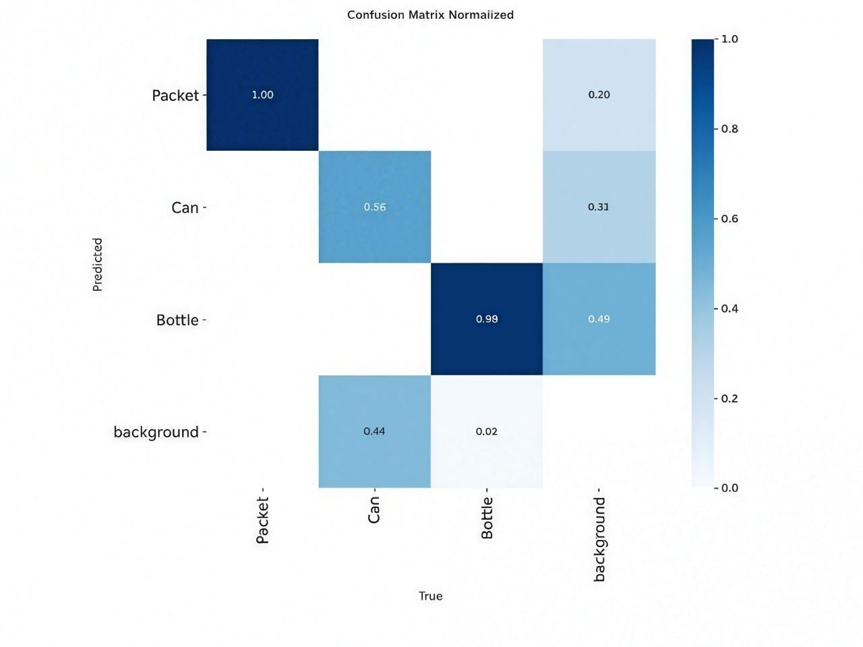
Fig.6.2.4. Normalized Confusion Matrix
Background misclassification is also a prominent issue, with a high percentage of background areas being classified as Bottle (0.49) and Can (0.31) pointing to the effect of a cluttered scene and text-filled images typical of food and cosmetics advertisements. On the other hand, the number of Bottle cases that are falsely identified as a background is a very small percentage (0.02) which also supports the strength of bottle detectors as the objects have a characteristic structure. In general, the normalized confusion matrix shows that the model has a great discriminative capacity concerning high-profile product categories as well as points to the areas in which improved background suppression and contextual modelling may increase the visibility analysis accuracy.
6.2.5 Food Adverts Results and Discussion
The performance achieved on food advertisements is very strong, though there is a little complexity as compared to cosmetic advertisements. Fig. 6.2.5 shows that the YOLOv8 model is able to identify food items like snack packets, beverage cans, and bottles successfully. The bounding boxes work better to spot product locations in dynamic scenes as well as in different lighting conditions. One important point to notice as a result of Fig. 6.2.5 is that saliency heatmap is highly focused on brand logos and product surfaces (including the logo of Lay, Pepsi brand, and the packaging of the beverage). This is to show that the system is efficient in capturing areas of high visual importance, which is essential towards advertisement effectiveness. Specifically, the saliency responses of high-contrast and bright colors in food advertisement are used to achieve the high saliency levels of product areas, which will be attention-seeking.
Food advertisements however are a difficult situation compared to cosmetic advertisements. Having cluttered backgrounds, numerous objects and different levels of illumination conditions create complexity in the modeling of detection and attention. As an example, the system can tolerate slight differences in the accuracy of the bounding box or confidence of the products in the case with multiple cans or overlapping product appearance. On the same note, cans with reflective surfaces at times interfere with the precision of detection.
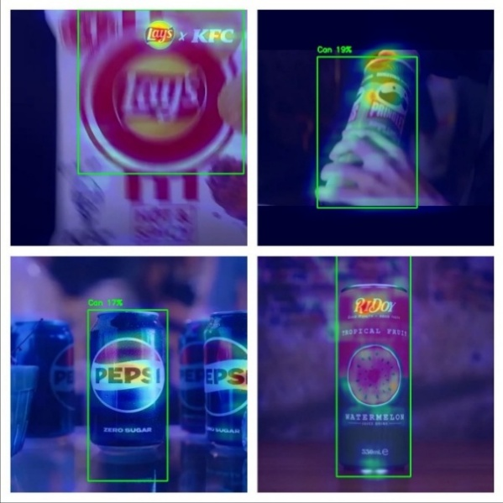
Fig. 6.2.5 Outputs for food Advertisement
The OCR module works fairly well in food advertisements, which extract the text including brand names and product details. But it can be affected by motion blur, or reflections, or stylized fonts which are prevalent in food adverts, so text extraction accuracy will be slightly lower than in cosmetic ads. Nonetheless, the system continues to offer valuable textual information that would be useful in overall analysis in spite of these challenges.
The other notable observation is that saliency distribution in food advertisements is likely to be more dynamic. There is sharing of attention in a frame in more than one object and in particular cases where there are a number of products in the frame. This is in line with the real world advertisement conditions in which there are several factors competing to capture the attention of the viewers.
On the whole, the findings prove that despite the added complexity, food advertising, the suggested system can be well-performing, and the proposed system is capable of aiding the product appearance, as well as the distribution of attention.
6.3 Analysis of Identified Gaps and Proposed Improvements
The literature survey revealed several limitations in existing advertisement analysis systems, including the lack of integration between object detection and attention modeling, limited consideration of textual elements, and absence of interpretability in results. Most traditional approaches focus either on detecting objects or analyzing saliency independently, without establishing a meaningful relationship between the two. Additionally, existing methods often fail to provide actionable insights, making it difficult for users to understand how to improve advertisement design.
To address these gaps, the proposed system integrates multiple components into a unified framework. The combination of YOLOv8-based product detection with saliency-driven attention analysis enables accurate evaluation of product visibility. The inclusion of OCR-based text extraction ensures that textual elements are also considered in the analysis. Furthermore, the implementation of an LLM-based audit module enhances interpretability by generating human-readable insights and recommendations. This integrated approach overcomes the shortcomings identified in the literature and provides a more comprehensive and practical solution for advertisement analysis.

- ADVANTAGES AND LIMITATIONS
7.1 Advantages
The proposed system, implemented through the AdVis AI platform, offers several advantages in terms of automation, accuracy, usability, and scalability.
- Automated Advertisement Analysis
The system eliminates the need for manual evaluation of advertisements by providing a fully automated analysis pipeline. It processes images and videos using deep learning models and generates results without human intervention. This reduces time, effort, and dependency on expert reviewers, making the analysis process faster and more efficient.
- Objective and Data-Driven Evaluation
Unlike traditional methods that rely on subjective human judgment, the system evaluates advertisements using quantitative metrics such as attention score, visibility score, and distraction rate. These metrics provide a consistent and unbiased assessment, ensuring reliability and accuracy in the results.
- Accurate Product Detection using YOLOv8
The use of YOLOv8 ensures high accuracy in detecting and localizing products within advertisements. The model is capable of identifying multiple product types even in complex scenes with different lighting conditions and orientations. This accuracy is crucial for calculating visibility and attention-related metrics.
- Realistic Attention Modeling through Saliency Detection
The system incorporates saliency detection to simulate human visual attention. It identifies regions that naturally attract viewers’ focus, allowing the system to evaluate whether the product is placed in a high-attention area. This makes the analysis more realistic and aligned with actual human perception.
- AI-Based Insight Generation using LLM
The integration of a Large Language Model enables the system to generate human-readable audit reports. Instead of presenting only raw data, the system explains results and provides actionable recommendations for improving advertisement design. This makes the output more meaningful and useful for non-technical users.
- A/B Comparison for Performance Evaluation
The system includes a comparison module that allows users to evaluate two advertisements simultaneously. This helps in identifying which advertisement performs better based on visibility and attention metrics. It is particularly useful for marketers and designers to optimize advertisement strategies.
- Scalable and Efficient Processing
The system is capable of handling both images and video data efficiently. Its architecture supports large-scale analysis, making it suitable for real-world applications such as marketing campaigns and brand analysis. The use of optimized models ensures fast processing without compromising accuracy.
- Flexible Subscription and Resource Management
The platform includes a subscription-based model with credit allocation, allowing users to choose plans based on their needs. This ensures controlled usage of computational resources and makes the system scalable for both individual users and enterprises. Additionally, the admin panel enables efficient user and resource management.
- Adaptability Across Multiple Domains
The system demonstrates strong performance across different advertisement domains such as cosmetics and food products. This adaptability indicates that the framework can generalize well to various types of advertisements, making it versatile and applicable to a wide range of industries.

7.2 Limitations
Although the proposed AdVis AI system demonstrates strong performance in advertisement analysis, it has certain limitations that need to be considered for further improvement.
- Sensitivity to Complex Background
The system may experience reduced detection accuracy in advertisements with highly cluttered or complex backgrounds. In such scenarios, multiple objects, overlapping elements, and varying lighting conditions can make it difficult for the model to clearly distinguish the product from the background. This may lead to incorrect detections or lower confidence scores.
- Limited Performance on Visually Similar Objects
The object detection model can sometimes struggle to differentiate between visually similar product categories, such as tubes, bottles, or generic cosmetic items. This is mainly due to overlapping features and similarities in shape and texture, which can result in misclassification or reduced precision for certain classes.
- OCR Limitations under Poor Visibility Conditions
The OCR module may not perform optimally when text is blurred, distorted, or presented in stylized fonts. Factors such as motion blur, low contrast, reflections, or small font size can affect text recognition accuracy. As a result, important textual information in advertisements may not always be fully captured.
- Limited Dataset Diversity
The accuracy and generalization capability of the system depend on the diversity and size of the training dataset. If the dataset does not include sufficient variations in product types, advertisement styles, or environmental conditions, the model may not perform equally well across all scenarios. This limitation can affect performance in unseen or uncommon advertisement formats.

- CONCLUSION
The proposed system, AdVis AI: Advertisement Visibility Analysis System, provides an effective and intelligent approach for analyzing advertisement performance using deep learning techniques. By integrating YOLOv8-based object detection, saliency-based attention modeling, OCR-based text extraction, and LLM-driven audit generation, the system enables comprehensive evaluation of both visual and textual elements. The results obtained from cosmetic and food advertisement datasets demonstrate high accuracy, reliable attention mapping, and strong adaptability across diverse scenarios. Furthermore, the web-based implementation enhances usability through features such as dashboards, media upload, and A/B comparison, making the system accessible to both technical and non-technical users. Overall, the proposed framework successfully delivers a scalable and data-driven solution for advertisement visibility analysis, with strong potential for real-world applications and future enhancements in intelligent media analytics.

- FUTURE SCOPE

The proposed system, “Deep Learning Based Visibility Analysis in Food and Cosmetic Advertisement” implemented through AdVis AI, demonstrates strong performance; however, there are several opportunities for further enhancement and expansion.
- Expansion to Additional Advertisement Domains
Currently, the system is focused on food and cosmetic advertisements. In the future, it can be extended to support additional domains such as fashion, automobiles, electronics, and healthcare advertisements. This would require training the model on more diverse datasets, enabling the system to handle a wider range of products and advertisement styles, thereby increasing its applicability across industries.
- Integration of Real-Time Video Analysis
The system can be further enhanced to support real-time advertisement analysis for live video streams and online advertisements. By optimizing the processing pipeline and leveraging high-performance computing resources, the system can provide instant visibility insights for advertisements being broadcast on digital platforms, television, or social media.
- Advanced User Attention Modeling using Eye-Tracking Data
Although the current system uses saliency models to simulate human attention, future improvements can include integration of real eye-tracking datasets. This would improve the accuracy of attention prediction and allow the system to better model real user behavior, resulting in more precise visibility analysis.
- Personalized Advertisement Analysis
Future versions of AdVis AI can include user-specific or demographic-based analysis. By incorporating user behavior data or preferences, the system can provide personalized visibility insights, helping advertisers design content tailored to specific audiences, thereby improving engagement and effectiveness.

- Integration with Marketing and Analytics Platforms
The system can be integrated with existing marketing tools and analytics platforms such as social media dashboards or ad campaign management systems. This would allow automatic evaluation of advertisement performance and provide real-time recommendations for improving campaigns, making the system more practical for commercial deployment.
10. REFERENCES

- M. L. Ali and Z. Zhang, “The YOLO framework: A comprehensive review of evolution, applications, and benchmarks in object detection,” Computers, vol. 13, no. 12, p. 336, 2024.
- A. M. Hassan, R. K. Singh, and P. Kumar, “Performance analysis of deep learning-based object detection algorithms on the COCO benchmark,” Journal of Engineering and Applied Science, vol. 71, no. 76, pp. 1–15, 2024.
- S. Kang, Z. Hu, L. Liu, K. Zhang, and Z. Cao, “Object detection YOLO algorithms and their industrial applications: Overview and comparative analysis,” Electronics, vol. 14, no. 6, p. 1104, 2025.
- J. Novak, M. Petrovic, and A. Kovac, “Advancements in small-object detection (2023–2025): Approaches, datasets, benchmarks, and applications,” Applied Sciences, vol. 15, no. 22, p. 11882, 2025.
- D. Abhayankar, S. Tanwani, and D. K. Sharma, “Exploring object detection algorithms and implementation of YOLOv7 and YOLOv8-based models,” Int. J. Intelligent Systems and Applications in Engineering, vol. 12, no. 3, pp. 877–886, 2024.
- R. Mehta, P. Shah, and A. Kulkarni, “Comparative analysis of deep learning models for waste segregation using YOLOv8 and EfficientDet,” Multimedia Tools and Applications, vol. 84, pp. 35941–35964, 2025.
- Y. Li, H. Zhou, and J. Wang, “Leather defect detection based on an improved YOLOv8 model,” Applied Sciences, vol. 14, no. 24, p. 11566, 2024.
- A. Rahman and S. Putra, “Object detection using YOLOv8: A systematic review,” Sistemasi: Jurnal Sistem Informasi, vol. 14, no. 1, pp. 45–60, 2025.
- B. Inan, I. A. Ozkan, and N. Dogan, “Deep learning-based skin disease detection: Performance analysis of YOLOv8 and YOLOv11 models,” Int. J. Applied Methods in Electronics and Computers, vol. 13, no. 4, pp. 121–130, 2025.

- N. A. Dalawai, P. B. Prathamraj, B. S. Dayananda, A. P. Joythi, and R. Suresh, “Real-time skin disease detection and classification using YOLOv8 object detection,” Int. J. Multidisciplinary Research and Analysis, vol. 7, no. 12, pp. 210–218, 2024.
- R. Patel, S. Mehta, and K. Zhang, “Multi-Modal Advertisement Analysis Using Object Detection and Saliency Mapping,” IEEE International Conference on Smart Systems and Advanced Technologies (SSAT), 2025, pp. 78–85.
- L. Chen, W. Ouyang, X. Wang, and J. Zhou, “Development and challenges of object detection: A survey,” Neurocomputing, vol. 598, p. 128102, 2024.
- A. Wang, H. Chen, L. Liu, Z. Lin, J. Han, and G. Ding, “YOLOv10: Real-time end-to-end object detection,” arXiv preprint, arXiv:2405.14458, 2024.
- R. Khanam and M. Hussain, “YOLOv11: An overview of key architectural enhancements,” arXiv preprint, arXiv:2410.17725, 2024.
- A. Chandrashekhar, B. Satyanarayana, R. R. Gorrepati, and S. Rao, “An efficient YOLO-based framework for detecting extremely small-scale objects,” Scientific Reports, vol. 16, p. 2062, 2026.
- G. Jocher, A. Chaurasia, and J. Qiu, “Ultralytics YOLOv8: State-of-the-art real-time object detection,” Ultralytics White Paper, 2023.
- T.-Y. Lin, M. Maire, S. Belongie, et al., “Microsoft COCO: Common objects in context,” in Proc. Eur. Conf. Computer Vision (ECCV), 2014, pp. 740–755.
- X. Zhou, D. Wang, and P. Krähenbühl, “Objects as points,” arXiv preprint, arXiv:1904.07850, 2019.
- L. Liu, W. Ouyang, X. Wang, et al., “Deep learning for generic object detection: A survey,” Int. J. Computer Vision, vol. 128, pp. 261–318, 2020.
- K. He, X. Zhang, S. Ren, and J. Sun, “Deep residual learning for image recognition,” in Proc. IEEE Conf. Computer Vision and Pattern Recognition (CVPR), 2016, pp. 770–778.
- T.-Y. Lin, P. Goyal, R. Girshick, K. He, and P. Dollár, “Focal loss for dense object detection,” in Proc. IEEE Int. Conf. Computer Vision (ICCV), 2017, pp. 2980–2981.
- J. Redmon and A. Farhadi, “YOLOv3: An incremental improvement,” arXiv, 2018.
- A. Bochkovskiy et al., “YOLOv4: Optimal speed and accuracy,” arXiv, 2020.
- C.-Y. Wang et al., “YOLOv7: Trainable bag-of-freebies,” arXiv, 2022.
- Z. Ge et al., “YOLOX: Exceeding YOLO series,” arXiv, 2021.
- K. Zhang et al., “Visual attention mechanisms in deep learning,” IEEE Access, 2022.
- S. Woo et al., “CBAM: Convolutional Block Attention Module,” ECCV, 2018.
- R. Selvaraju et al., “Grad-CAM: Visual explanations,” ICCV, 2017.
- M. Cornia et al., “Predicting human eye fixations via deep learning,” TPAMI, 2018.
- A. Borji, “Saliency prediction in computer vision,” Computer Vision and Image Understanding, 2019.
- J. Wang et al., “Deep learning for visual saliency detection: A survey,” Pattern Recognition, 2021.
- Y. LeCun, Y. Bengio, and G. Hinton, “Deep learning,” Nature, 2015.
- I. Goodfellow et al., Deep Learning, MIT Press, 2016.
- A. Krizhevsky et al., “ImageNet classification with deep CNNs,” NIPS, 2012.
- S. Ren et al., “Faster R-CNN: Towards real-time detection,” NIPS, 2015.
- J. Deng et al., “ImageNet dataset,” CVPR, 2009.
- H. Law and J. Deng, “CornerNet: Detecting objects as paired keypoints,” ECCV, 2018.
- X. Zhu et al., “Deformable ConvNets v2,” CVPR, 2019.
- Z. Cai and N. Vasconcelos, “Cascade R-CNN: High quality detection,” CVPR, 2018.

