**Problem 1**:

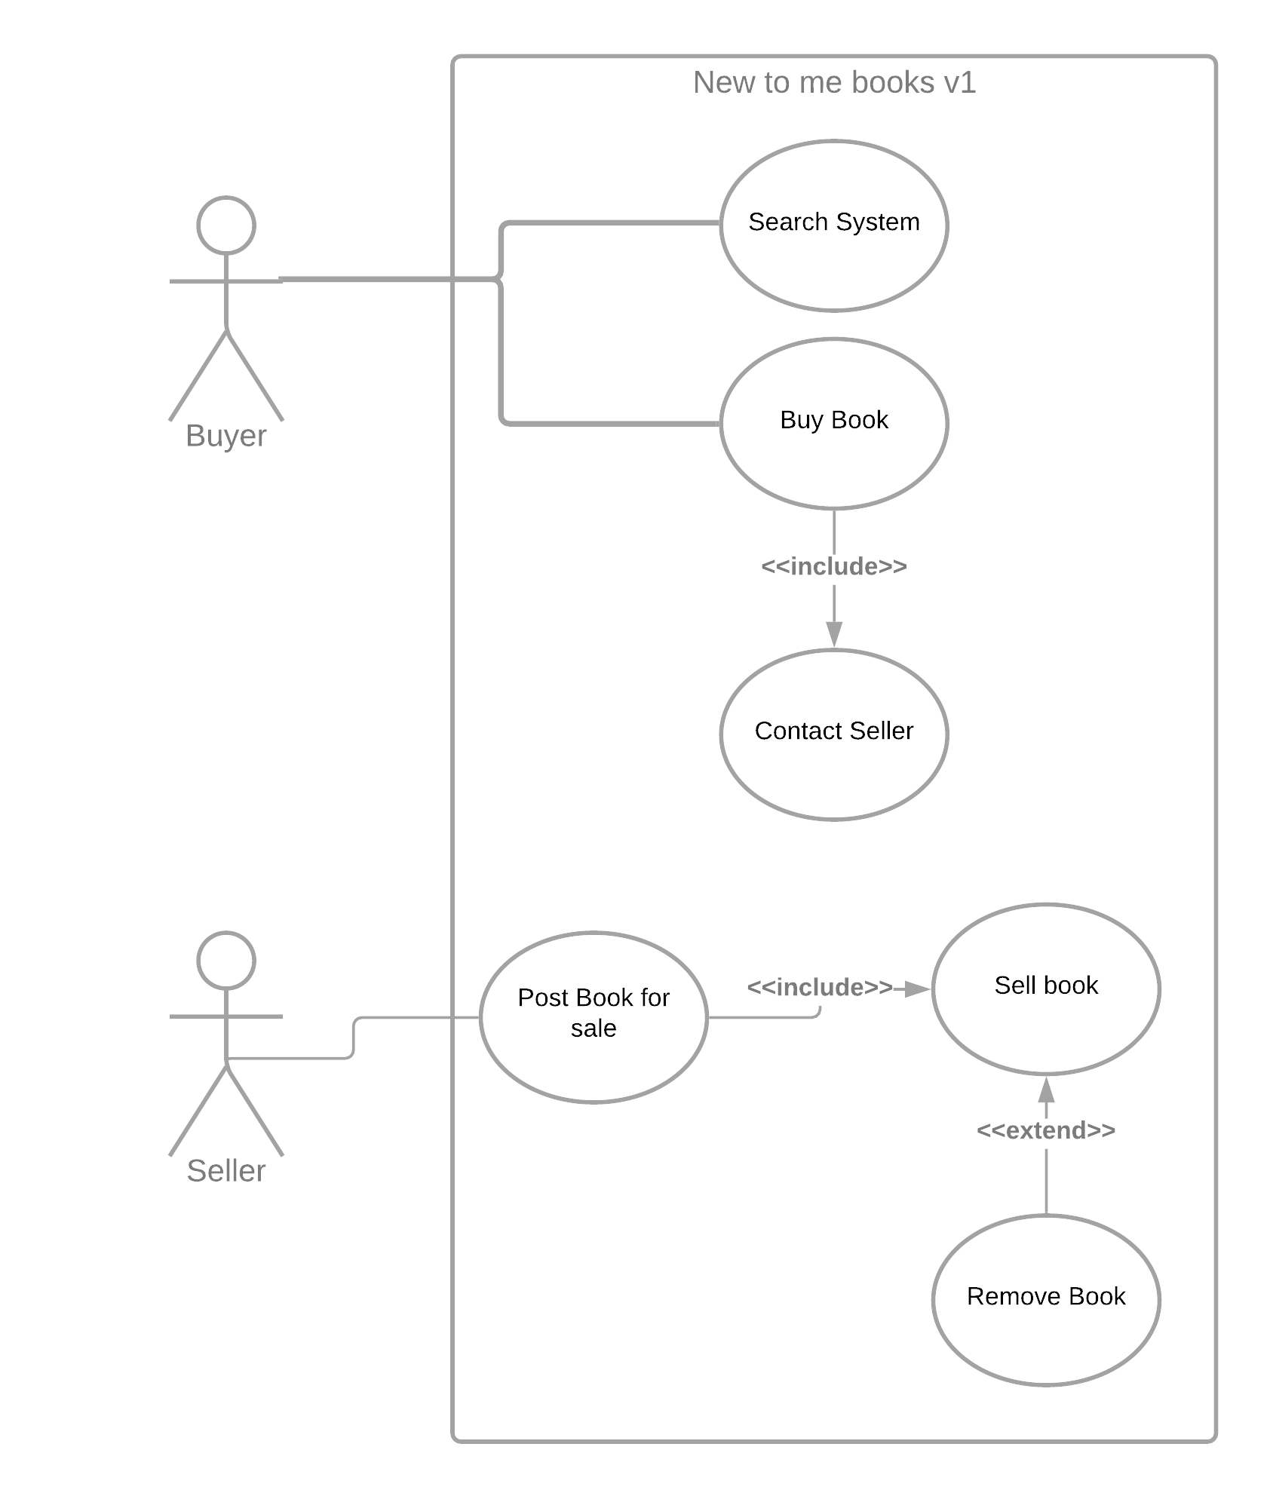

As a buyer, I want to search for books and buy books

As a seller, I want to put books up for sale and sell books

**Problem 2:**

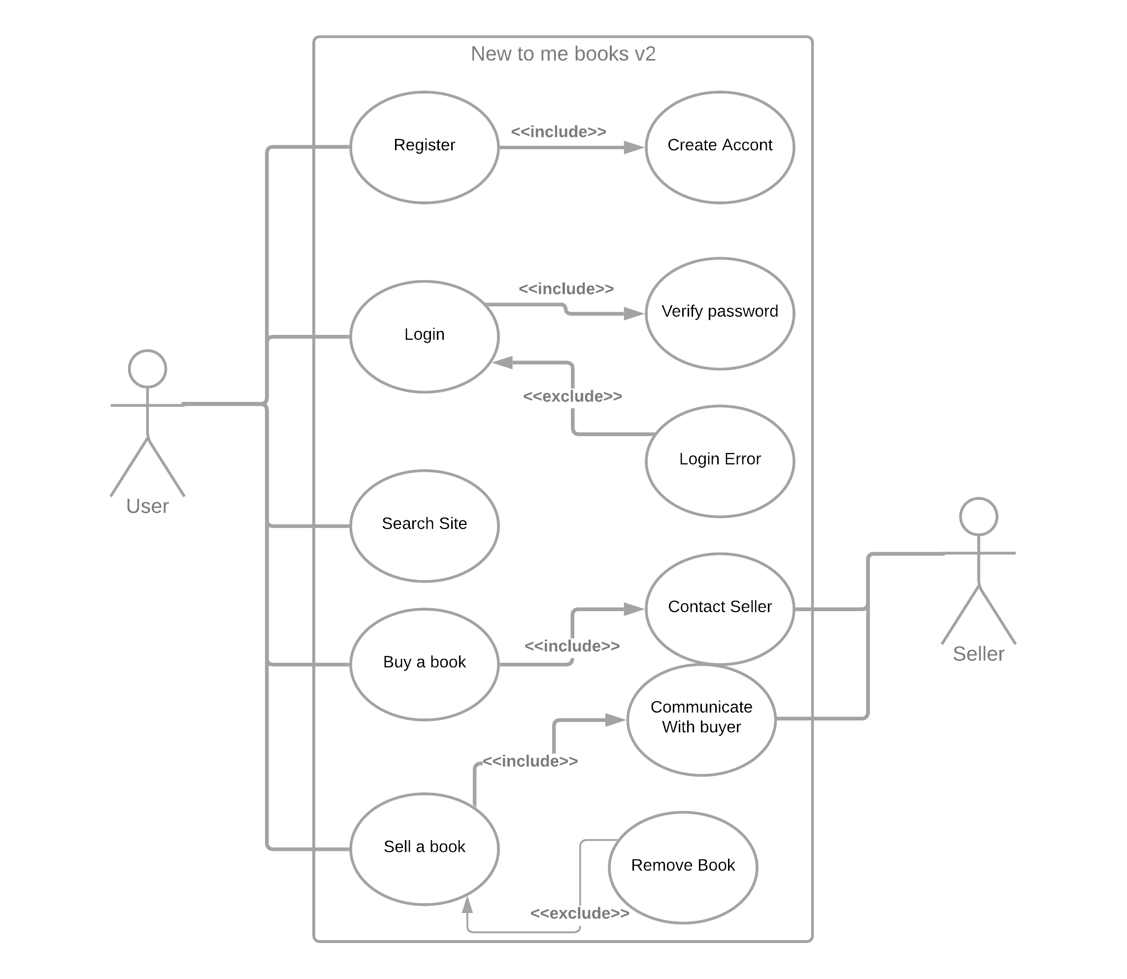

As a user I want to create an account or login, Search the site, buy a book and contact the seller, or post a book for sale.

As a seller, I want to post a book for sale, contact the buyer, and remove the book from the site