Deven Pile

CSE360

Assignment 3

1.

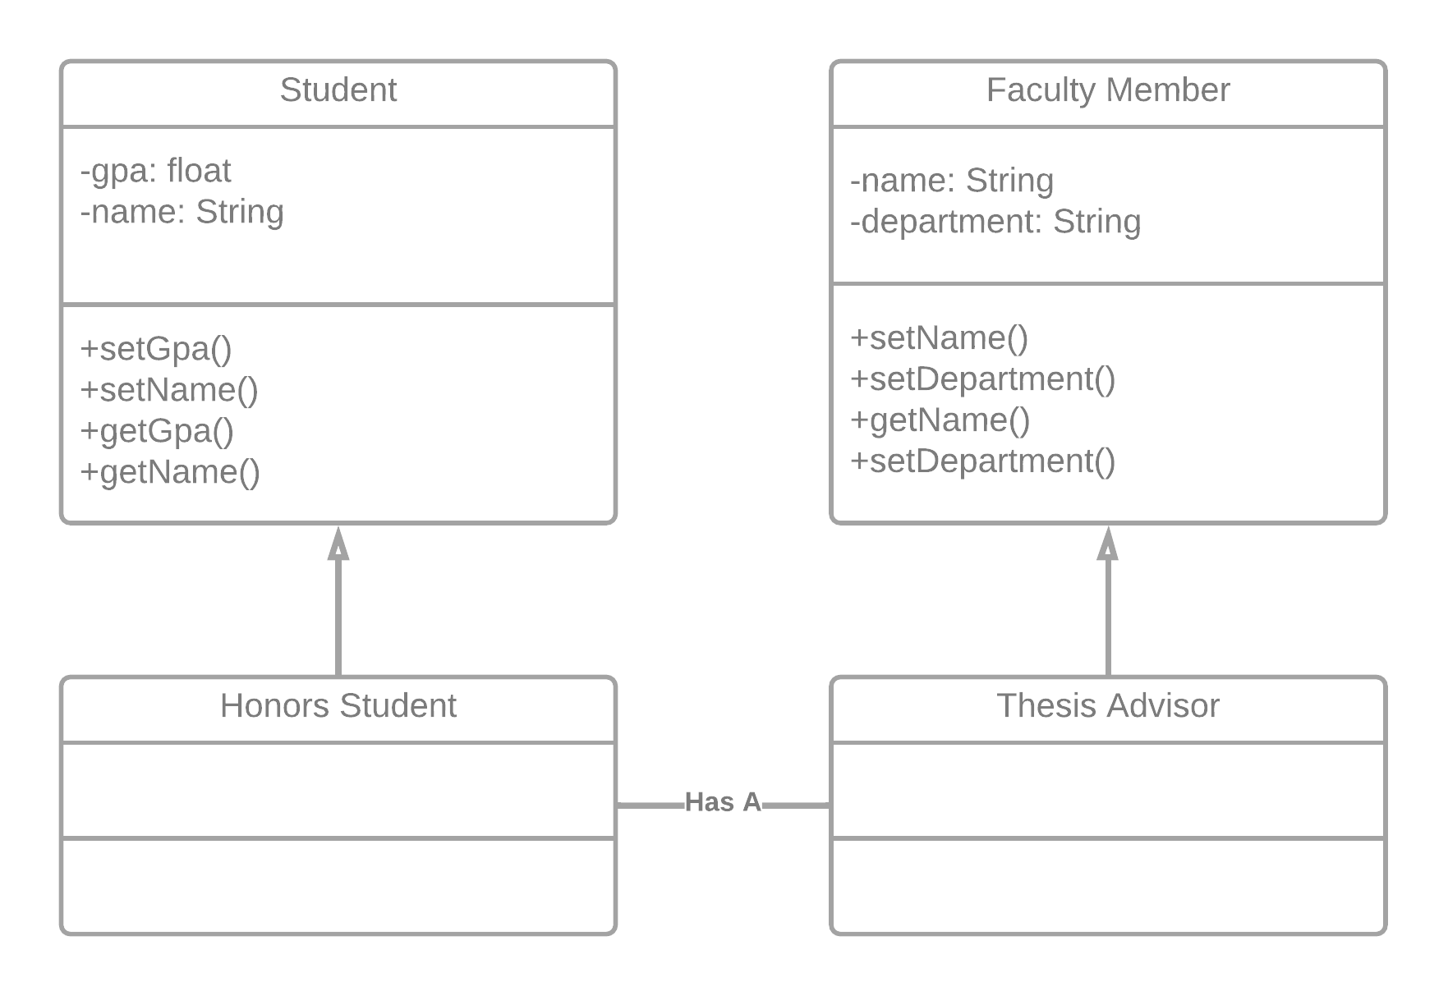

2.

Diagram:

Code Output:

3

4-5

5-6