Biathlon Toy Shooting Range Targets

For Nerf gun

# Introduction

Watching the biathlon world cup events on tv and sensing the thrill and excitement when the athletes enter the shooting range, focusing on the small targets 50 meters away, knowing that their performance will for sure determine the final result in this competition.

It is this part of the biathlon competition that has the potential of being a party game without the dangerous firearms, but instead using children’s toy guns for the purpose of hitting a similar target arrangement as for the biathlon competition.

The biathlon Toy Targets shooting range arrangement for nerf gun, was born.

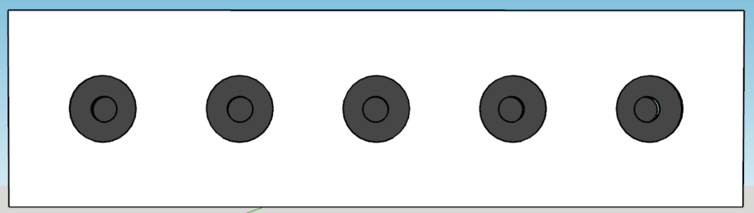

So, how to make this toy biathlon shooting range targets that can detect a nerf gun dart bullet hit?

What technology could be used to register a nerf gun dart bullet hit and what level of precision is needed?

The next thing the toy shooting range target arrangement will need a way to tell the shooter if she or he has hit the target or not – for the real biathlon shooting range target, this is done by mechanically masking / covering the target hit with a white surface, hiding the targets black surface.

In general, Piezoelectric elements are used to generate / produce sound waves when a dc voltage is applied to the Piezo element’s terminals – usually, a high, hearable, frequency sound.

Piezoelectric elements will also accumulate / generate electric charge flow when exposed to mechanical stress of a certain amount. It is this effect that can be used to register a nerf gun dart hit on a plane target surface if the piezo element is mounted on this same target surface.

Several simple experiments have shown that the signals from the piezoelectric elements are sufficient for detecting the impulse a nerf gun dart hit.

The following will describe the electronic and mechanical design for a Biathlon Toy Target row, emulating the behaviour of the automatic target hit indicator. Target hit indicator and reset function will be remote monitored and controlled.

# Target hit indicator

A Nerf-gun dart bullet weighs about 1 g and have a max speed of ~20 m/s. Guessing that the maximum speed will be some few milli seconds after “firing” the Nerf-gun and thereafter the Nerf-gun dart bullet speed will decline rapidly – a function that describe this would be nice.

The speed of the Nerf-gun dart bullet immediately before it hits the target will determine the power of impact it will cause on the target plate.

Without doing any advanced analysis of the physics involved, it is easy to make a similar knock impact on a plane surface as if the same surface was hit by a nerf gun dart bullet. For example, using a foot long ruler or a medium size screwdriver, and hitting the plane surface with the end of the ruler used as a drumstick.

Now, how should the hit sensor piezoelectric element be used? We need to know more about the electrical characteristics of the piezoelectric element and to learn about this, we’ll inspect its electrical behaviour by use of an oscilloscope, when tapping it lightly, for example with end of a pencil.

## Electrical properties of the piezoelectric element

The piezoelectric element used for this simple test / experiment, was a 1x1x1 cm in size and has two polarized SMD (surface mounted device) terminals.

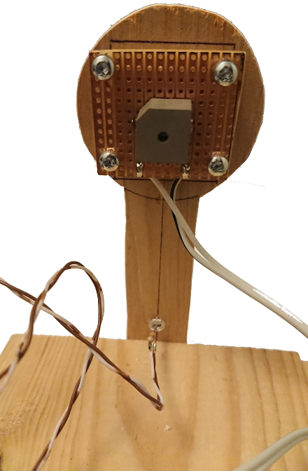

Figure : The piezoelectric element soldered to 3x3 cm Vero-board.

As seen in Figure 1, the terminals are connected to two wires, making it easy to connect to the oscilloscope-probe. The Vero-board is mounted on a small plywood contour as a 4.5 cm target to imitate a target for nerf gun dart bullets. The target contour is screwed onto the edge of a board for mechanical support.

When connected to the oscilloscope probe and taping the target contour lightly with the one foot ruler, the following pulse train appeared on the oscilloscope.

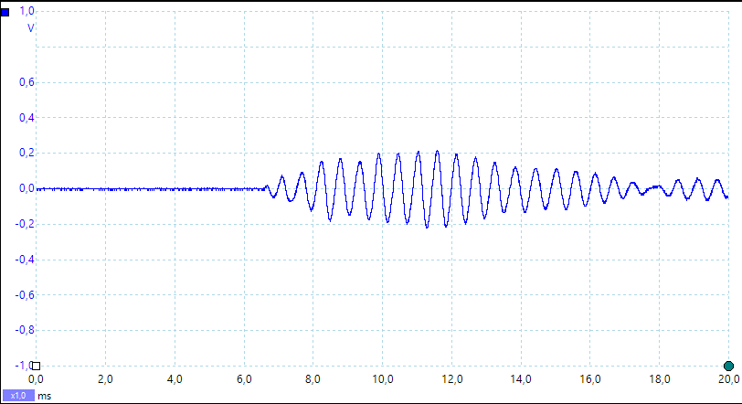

Figure 2: Piezo element mount and the pulse train developed by a medium knock on the mount board.

The signal generated by the piezoelectric element show that it has an alternating behaviour and for this impact it variates between –200mV and +200mV. If the physical impact is greater, larger swing can be expected. Harder impacts can generate up to 4 V peak-to-peak signal. The maximum swing is not explored.

If the raw output from this piezoelectric element were to be used to trigger an event, like an interrupt in a microcontroller, this output signal will certainly challenge any microcontroller General Purpose IO interface and even cause permanent damage to the interface.   
One trick to avoid this, would be to interconnect a 3v Zener-diode between the piezoelectric element and the microcontroller GPIO interface, but then the impact must be quite substantial to excide the logical threshold for the GPIO interface, and must always be at the same level of impact. This simple solution is unsuited for a system that needs to detect a wide range of target hit impacts to allow for various types of nerf-guns and variable shooting range.

So, to make use of piezoelectric element as target hit sensor, the output must be refined and amplified, to comply with the requirement of trigger a wide range of target hit impacts.

## Sensor circuit

Since the piezoelectric element produces an alternating signal, the signal needs to be rectified and smoothened so that it represents a single positive pulse. This signal manipulation is usually called “peak detection”, which is a method to find the highest pulse value among a series of variable sized pulses.

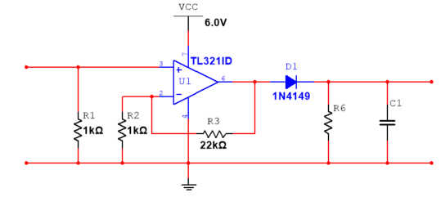

AC Sig. in

DC Sig. out

Figure : Simple peak detector using an Operational Amplifier.

As this piezoelectric signal will need to be amplifies, it is sensible to use an Operational Amplifier together with the circuit elements (D1, C2 & R6) that make the peak detector.

Since the microcontrollers GPIO interface in general accepts only positive voltages and uses 0V as ground reference, it is most practical to use a single supply Operational Amplifiers and use supply voltage for the OpAmps suitable for the MCUs GPIOs.

To detect target hit with variable impact, the rectified and smoothened signal from the piezoelectric element is forwarded to a level comparator. The comparator will output Vcc if the input signal from the peak detector is higher than a reference level, and output 0V if the input signal is lower than this reference level.

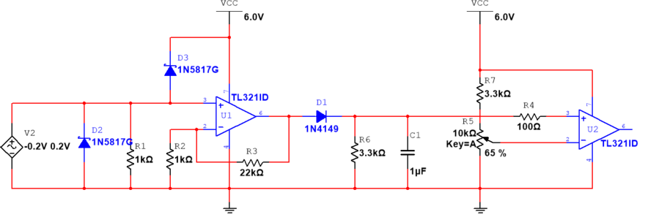

Simulating

the Piezo element

To be connected

to a GPIO pin

on the MCU (PA6)

Comparator

Peak Detector

Figure : Super simple peak detector followed by a mid-level comparator to produce a 5V hit trigger/interrupt signal (max outupt is VCC – 1V = 5V according to the data sheet for TL321).

The target hit detector is simple and can be implemented on a small, printed circuit board, which is easily mounted on the backside of a piece of 4 to 6 mm plywood, where the frontside of the plywood piece, is the target to hit.

The impact on the target plate will propagate to the piezoelectric element soldered onto the PCB, which will produce a single pulse that can trigger an event on an MCU.

# Detector Hardware solution

The Nerf gun bullet dart hit detector circuit design is manufactured as a 30x30mm PCB by use of the free CAD tool KiCad. The PCB design documents are part of the BiathlonToyTargets git repository.

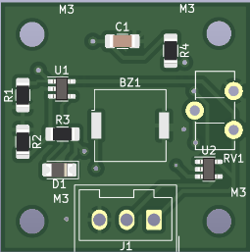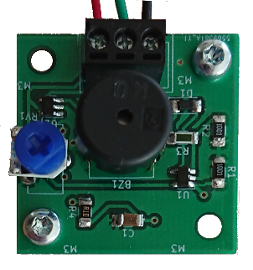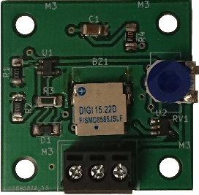

Figure : PCB for the target hit detector. The rightmost uses a surface mounted piezo element.

# Target hit indication

The shooting range biathlon targets indicate immediately if one is hit, by covering the black surface that represents the target. To imitate this functionality, a small servo motor will rotate a circle shaped 3 mm MDF plate, called the Cover-plate, between the target surface and the front plate.

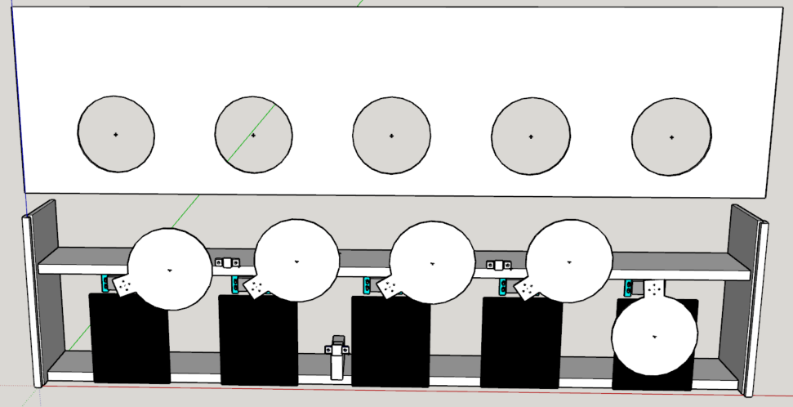

Cover plate in none hit position

Front plate (elevated to show the target front surface and the hit indication cover plates)

3 mm plywood Target front surface

Servo motor

Cover plate in HIT position

Figure : The construction of the biathlon toy target stand.



Figure : The biathlon toy targets with one hit indication - the rightmost target surface is covered by its cover plate.

## Shooting range biathlon toy targets construction

The biathlon toy targets stand with cover plates for hit indication, is a simple construction made from 16 mm floorboards of fir tree and a 6 mm plywood target stand cover with 5 circular formed “windows” exposing the biathlon toy target surfaces.

From Figure 5, two floorboards form as top end bottom of the construction, providing support for both the target surface for the nerf gun dart bullets (the lower floorboard), and for mounting the servo motors for each hit indicator cover plate. The cover plate is attached to the servo motors spine shaft by a spine socket fixture to rotate it to cover the target “window”.

## Servo motor requirements

The servo motor must be able to rotate the target cover, meaning that it has to provide sufficient torque for this operation. The size and weight of the target cover determines the necessary torque needed.   
As the biathlon standing target diameter is 11.5 cm, the target cover must have a slightly larger diameter and a diameter of 13 cm will probably be a practical size. Alternative materials can be used, but for the current prototype, 3 mm MDF board will be used. This material’s density is approximately 820 kg/m3, which gives that MDF target cover described above will weigh approximately …..

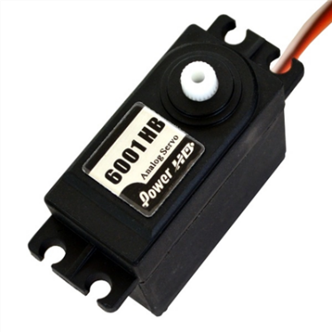

∽80 mm

3 mm MDF

130 mm

Servo Spline **socket**

Servo Spline **shaft**

Figure 8: Servo motor (<https://www.elefun.no/p/prod.aspx?v=15938>) to move the target cover. The 6 mm plywood target cover can and will be replaced with 3 mm MDF material.

The volume of the target cover = d·πr2 = 0.003 m · π · (0.065 m)2 = 12.68 · 10-6 m3

* The total weight of the target cover is approximately **33 grams**.
* Centre of mass relative to servo shaft (13 cm/2 + 1 ∽ **7.5 cm**)
* Required servo torque = 33g * 7.5 ~ **0,25 kg/cm**

So, using an analogue that outputs a torque of 6.7 kg / cm would certainly be more than sufficient, which the Power HD-6001HB will do.

## Servo motor control and operation

In general, servo motors are controlled by a 50 Hz PWM signal, usually provided by a microcontroller. The servo motor’s interface contains of 6V and Ground connection in addition to the PWM signal wire.

# Solution infrastructure

The biathlon toy target solution infrastructure is shown in …

MCU

10 I/O

PWM

Int

5V

GND

Hit sensor

Servo to move target cover

Figure 9: Biathlon toy target hardware infrastructure for automatic hit detection and indication.

# Wiring plan

Every target will need power and two signal leads. The power will be distributed from a 6V battery pack onto a power bus that is connected (some daisy chained) five individual connection panels.

Each of these connection panels will then provide power to both target sensor elements and the servo motor. The signal leads from the sensor and to the servo will also be connected this connection panel and wired to the proper GPIO on the MCU.

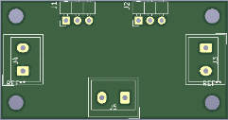

servo detector

50 mm

26 mm

Power bus

Connection panel

PWM signal  
to servo

Detector   
interrupt

servo detector

servo detector

servo detector

servo detector

MCU

Figure : Power and signal distribution.

Important to supply each power connection with an appropriated sized capacitor for stable power source for the hit sensor circuits.

# Microcontroller considerations

The construction of the prototype Biathlon Toy Targets with automatic hit detection and indication, will so far need a microcontroller that has at least 10 General Purposed IO ports for handling the shooting situation. The Biathlon Toy target system must also have a way of resetting the target covers, preferable from a distance, in addition to reading the hit results digitally and forward these to another device or computer. A possible option for this last requirement could be to use a simple UART, which is often included in microcontrollers.

## Interrupt driven operation for hit detection

Since there are 5 targets that can be hit in any order, the hit sensor should trigger on an interrupt that reads the signal status on all targets simultaneously to determine which has been hit. This functionality will require that 5 of GPIOs, in the selected MCU, used for hit-detection, must have the ability to trigger an interrupt based on a signal level change.

## PWM driver for hit indication

The servo motor will tbd

## Wireless and/or wired communication for reset, collecting results and test functions

The easiest way of implementing a communication channel between the MCU and a PC is to use the legacy serial port operation, since this is based on the UART functionality, which is also often found integrated in many microcontrollers.

Implementing the bi-directional operation of this functionality, commands can be given from a remote terminal, like reset target covers, and feedback can be received for both hit results and debugging needs.

# Microcontroller used for the Biathlon Toy Target prototype

The MCU used for the Biathlon Toy Target is a 8-bit mcu Attiny 1634 from Microchip. This is tiny device with 18 programmable IO pins, 16k flash memory and 1k random access memory, which is more than sufficient to implement the necessary software operations for the prototype Biathlon Toy Targets with automatic hit detection and indication.

## Integrated Development Environment – Atmel Studio 7.0

Programmer and debugger… Atmel Ice

# Remaining work on the prototype.

1. Arranging all loose wires onto the target structure by use of cable clips or glue.
2. Make passage for the wires in wood structure.
3. Glue spacer (3 mm MDF) onto the centre of the target cover servo mount point…
4. Clue spacer (4 or 3 mm MDF) onto the centre of the back of the target cover for mechanical support it shot at when it covers an already hit target.
5. Make an open panel for mounting power jack for charging the battery pack, a toggle switch for power on/off the unit.
6. Make a Veroboard for connecting the power jack and power switch the MCU and battery pack.
7. Solder a 10µF capacitor to all sensor and servo power distribution boards.
8. Test functionality with a new improved front board centre “clamping” (this is to make the front board as straight as possible)
9. IMPROVEMENT: Use the analogue input to measure the battery voltage and show it through a terminal command.