**Political Alignments and Civil Society: Examining NGO Influence on Electoral Patterns in Istanbul's Neighborhoods**

**Mehmet Boran Göksel**

**Introduction**

In recent years, studies on non-governmental organizations (NGOs) in Turkey have begun to increase. While many NGOs continue to operate in the manner we are familiar with, focusing on delivering benefits, a portion of them frequently make statements supporting the government and engage in activities that adopt and support the government's policies[1][2][3]. Additionally, it is known that politicians and political circles, including primarily the children[4][5][6] of the AK Party leaders, are founders or supporters of various civil society organizations.

This emerging trend in the NGO sector in Turkey points to a potential shift in the traditional role of NGOs. Traditionally seen as independent entities driven by altruistic and humanitarian goals, some NGOs in Turkey are now perceived as being aligned with specific political ideologies and agendas. This alignment raises questions about the influence of political entities on NGOs and, conversely, the potential impact of NGOs on political processes and outcomes.

For many years, the AK Party has been criticized for conducting social aid programs with the objective of gathering votes and is referred to as the 'pasta party'. This image has been further solidified in recent times due to scandals of favoritism that have come to light in front of cameras, as well as lists mentioning various associations and significant political figures as references.

**Literature**

This relationship between the AK Party and NGOs did not receive a lot of scholarly attention. NGOs play an important role in democracy, The Bureau of International Information Programs' 'Principles of Democracy' website delineates the dynamics of the interplay between non-governmental organizations (NGOs) and the state as follows:

*Governments and NGOs frequently work as partners. NGOs may provide local and regional expertise and personnel on the ground for implementation of government-funded projects. NGOs may be politically unaffiliated, or they may be based on partisan ideals and seek to advance a particular cause or set of causes in the public interest. In either model the key point is that NGOs should operate under minimal political control of states.[7]*

The breach of this rule not only shakes the public's trust in non-governmental organizations but also turns donations and aids made in good faith, and even resources transferred to NGOs by state funds, into an implicit election campaign budget. Köse coins the term indirect political patronage (IPP) to address the role of religious NGOs that work to consolidate the government in Turkey.

*In the social assistance relevant to political patronage, some intermediary actors were mentioned above (…) Religious NGOs played a similar role between the state and the public and, therefore, were utilized by the state in a way that can be described as IPP. Indirectness is related to the lack of transparency by the state and a lack of autonomy by civil society in the AK Party period (Koray and Çelik, 2015: p. 21), where the government provided benefits and state resources to religious NGOs that had similar missions and worldviews as itself.[8]*

**Methodology**

**Data Acquisition**

NGOs Dataset

The dataset pertaining to Non-Governmental Organizations (NGOs) was sourced from the General Directorate of Relations with Civil Society's website, a public domain. Due to the website's limited user interface, which allows only 50 entries to be viewed per page without direct download capabilities, the data collection process involved utilizing the website's underlying API. Through the 'Inspect' function of the web browser, API requests were identified and executed via the INSOMNIA tool to render the data in a readable format. A Python script was then developed to automate the sending of requests to the server, resulting in the procurement of a comprehensive dataset comprising approximately 101,000 entries (with 23,119 entries specifically from Istanbul), across 12 distinct data columns. These columns included essential information such as the names of the NGOs, their main and sub-areas of activity, and physical addresses. The addresses were subsequently converted into geolocations through Python scripts employing Google's Geocoding API, and categorized by their respective province, district, and neighborhood.

2023 General Elections Dataset

Election-related data was obtained from the Supreme Election Council's website, where it is available for public download. The dataset is initially organized at the individual ballot box level and was manually compiled into a single file for each district. The data was then aggregated to reflect neighborhood-level results.

Data Cleaning

The next step involved synchronizing the neighborhood-level data with corresponding geographical polygons to enable visual representation. The necessary polygon data was sourced from the "geojsons-of-turkey" repository on GitHub, contributed by Izzetkalic. The QGIS software's "join attributes by location" function was employed to merge the NGO and 2023 Elections datasets with the polygon data, allowing for the association of neighborhood results with their geographical representations.

However, discrepancies in neighborhood nomenclature across the datasets posed a challenge. For instance, "Burgazadası" in the NGO dataset was listed as "Burgazada" in the election dataset. The 'fuzzywuzzy' Python library was utilized to automate the harmonization process, providing a similarity score between two strings to aid in the identification and merging of similar neighborhood names. Following the automated cleaning, the data underwent a manual review process to correct any encoding errors and to refine the remaining inconsistencies.

**Data Analysis**

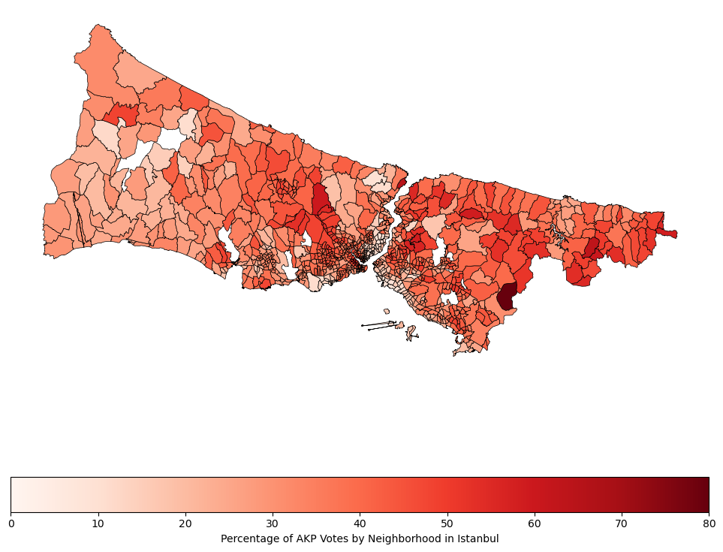

This map displays the percentage of votes received by the AK Party in each neighborhood. It provides a visual representation of the party's electoral support across Istanbul, with color intensity indicating the proportion of AK Party votes in each neighborhood.

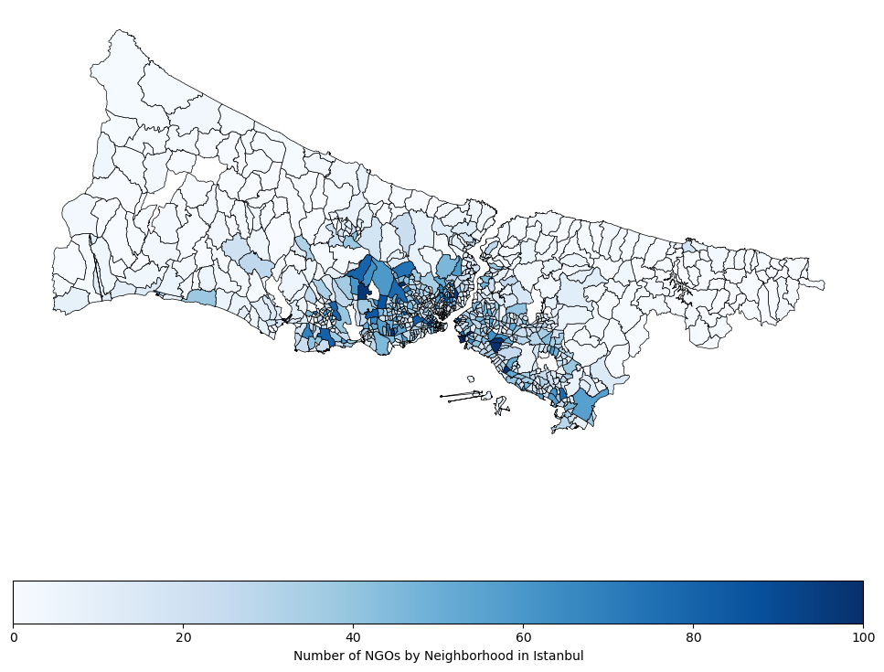

This map illustrates the distribution of NGOs across the neighborhoods of Istanbul. We observe two prominent clusters: the first is centered around the Bağcılar, Esenler, Başakşehir, and Fatih districts, while the second is located between Kadıköy, Ataşehir, Maltepe, and Üsküdar. However, the rest of Istanbul appears to have a sparse presence of NGOs.

**Linear Regression**

To investigate whether the count of various types of NGOs in Istanbul's neighborhoods influences the voting patterns for the AK Party, linear regression was employed as the primary analytical method. This approach allows for a nuanced exploration of how the presence of different NGO categories might correlate with the percentage of votes garnered by the AK Party. Linear regression is particularly suitable for this analysis as it quantifies the strength and direction of the relationship between the independent variables (NGO counts) and the dependent variable (AK Party's vote percentage). It provides a structured way to assess the potential impact of NGO presence on electoral outcomes, which is central to understanding the dynamics between civil society and political preferences. Since we’re interested in neighborhoods that has NGOs, we excluded the ones that don’t have any.

The regression model was fitted with the dependent variable being the percentage of votes for the AK Party and twenty-one independent variables representing different categories of NGOs.

The R-squared value of 0.247 suggests that about 24.7% of the variance in the AK Party's vote percentage is explained by the model. The Adjusted R-squared value of 0.229 accounts for the number of predictors in the model, indicating a modest yet significant fit.

OLS Regression Results

==============================================================================

Dep. Variable: AK PARTİ R-squared: 0.247

Model: OLS Adj. R-squared: 0.229

Method: Least Squares F-statistic: 13.25

No. Observations: 869 Prob (F-statistic): 9.06e-40

Df Residuals: 847 Log-Likelihood: -3212.9

AIC: 6470.

BIC: 6575.

Df Model: 21

Covariance Type: nonrobust

========================================================================================

The F-statistic is 13.25, and the associated Prob (F-statistic) is 9.06e-40, indicating that the model is statistically significant.

Coefficients with p-values less than 0.05, such as 'dini hizmetlerin gerçekleştirilmesine yönelik faaliyet gösteren dernekler' and 'sağlik alaninda faaliyet gösteren dernekler', are statistically significant. This suggests that these categories of NGOs have a meaningful impact on the voting patterns.

The Durbin-Watson statistic of 1.407 suggests the residuals are independent. The Omnibus and Jarque-Bera tests indicate the residuals are normally distributed, supporting the assumptions of linear regression.

The results provide insights into how different NGO types correlate with political preferences in Istanbul. Notably, religious and educational NGOs show a positive influence on AK Party's vote share, whereas thought-based and environmental NGOs exhibit a negative correlation. These findings underscore the diverse roles that civil society organizations play in shaping political landscapes.

**Conclusion**

This report has explored the evolving landscape of NGOs in Turkey, particularly in relation to their interactions and alignment with the political sphere, epitomized by the AK Party. Our findings reveal a nuanced and complex picture of the interplay between non-governmental organizations and political processes. While NGOs traditionally function as independent and altruistic entities, there is a growing trend in Turkey where certain NGOs are perceived as aligning with specific political ideologies and agendas, notably those of the AK Party.

The regression analysis conducted in this study underscores the significant correlation between the presence of certain types of NGOs and the voting patterns for the AK Parti in Istanbul's neighborhoods. Notably, NGOs focusing on religious and educational activities exhibited a positive correlation with increased votes for the AK Parti, while those associated with environmental and thought-based initiatives showed a negative correlation. These findings suggest that the type and nature of NGO activities can have a considerable impact on local political preferences.

Moreover, the study highlights concerns about the potential breach of the traditional role of NGOs, where political patronage and favoritism could overshadow the primary objectives of these organizations. The concept of indirect political patronage, especially in the context of religious NGOs, emerges as a critical factor in understanding the dynamics at play in Turkey's current socio-political environment.

**References**

Çelik, Nihat, and Emre İşeri. 2016. “Islamically Oriented Humanitarian NGOs in Turkey: AKP Foreign Policy Parallelism.” Turkish Studies 17 (3): 429–48. <https://doi.org/10.1080/14683849.2016.1204917>.

@corum.bel.tr, Mehmet Halim COŞKUN- mehmet.coskun. n.d. “STK’lardan Erdoğan’a Destek Mesajı.” Çorum Belediyesi. Accessed December 2, 2023. <https://www.corum.bel.tr/haberler/stk-lardan-erdogan-a-destek-mesaji>.

“STK’lardan Erdoğan’ın Açıklamalarına Destek.” n.d. www.aa.com.tr. Accessed December 2, 2023. https://www.aa.com.tr/tr/turkiye/stklardan-cumhurbaskani-erdoganin-aciklamalarina-destek/1088888.

“Vakıf Meclisi | TÜRGEV.” n.d. Www.turgev.org. Accessed December 2, 2023. https://www.turgev.org/tr/kurullar/vakif-meclisi.

“Ekibimiz - TÜGVA.” 2023. TÜGVA. November 28, 2023. <https://tugva.org/ekibimiz/>.

“İnsan ve İrfan Vakfı | Human and Irfan Foundation.” n.d. İnsan ve İrfan Vakfı | Human and Irfan Foundation. Accessed December 2, 2023. <https://insanveirfan.org/mutevelli-heyetiyonetim-kurulu>.

Bureau of International Information Programs (IIP), U.S. Department of State. (n.d.). The role of Nongovernmental Organizations. Principles of Democracy. <https://www.principlesofdemocracy.org/ngos-dem>

Arslan Köse, S. Faith-based organizations in Turkey as indirect political patronage tools. Palgrave Commun 5, 88 (2019). https://doi.org/10.1057/s41599-019-0301-2

1. Çelik, Nihat, and Emre İşeri. 2016. “Islamically Oriented Humanitarian NGOs in Turkey: AKP Foreign Policy Parallelism.” Turkish Studies 17 (3): 429–48. https://doi.org/10.1080/14683849.2016.1204917.
2. @corum.bel.tr, Mehmet Halim COŞKUN- mehmet.coskun. n.d. “STK’lardan Erdoğan’a Destek Mesajı.” Çorum Belediyesi. Accessed December 2, 2023. https://www.corum.bel.tr/haberler/stk-lardan-erdogan-a-destek-mesaji.
3. “STK’lardan Erdoğan’ın Açıklamalarına Destek.” n.d. www.aa.com.tr. Accessed December 2, 2023. https://www.aa.com.tr/tr/turkiye/stklardan-cumhurbaskani-erdoganin-aciklamalarina-destek/1088888.
4. “Vakıf Meclisi | TÜRGEV.” n.d. Www.turgev.org. Accessed December 2, 2023. https://www.turgev.org/tr/kurullar/vakif-meclisi.
5. “Ekibimiz - TÜGVA.” 2023. TÜGVA. November 28, 2023. https://tugva.org/ekibimiz/.
6. “İnsan ve İrfan Vakfı | Human and Irfan Foundation.” n.d. İnsan ve İrfan Vakfı | Human and Irfan Foundation. Accessed December 2, 2023. https://insanveirfan.org/mutevelli-heyetiyonetim-kurulu.
7. Bureau of International Information Programs (IIP), U.S. Department of State. (n.d.). The role of Nongovernmental Organizations. Principles of Democracy. https://www.principlesofdemocracy.org/ngos-dem
8. Arslan Köse, S. Faith-based organizations in Turkey as indirect political patronage tools. Palgrave Commun 5, 88 (2019). https://doi.org/10.1057/s41599-019-0301-2