5.1 (a) 2.5 pts. (b): 2.5pts. (c): 2.5pts. (d):2.5pts.
(a) On the assumption that we add collisions to the end of the list (which is the easier way if a hash
table is being built by hand), the separate chaining hash table that results is shown here.
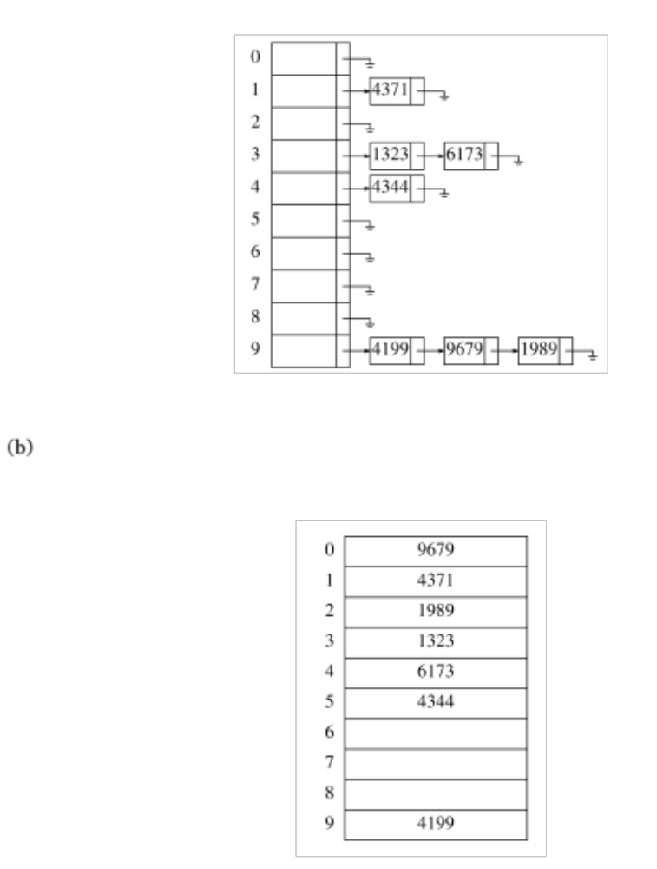
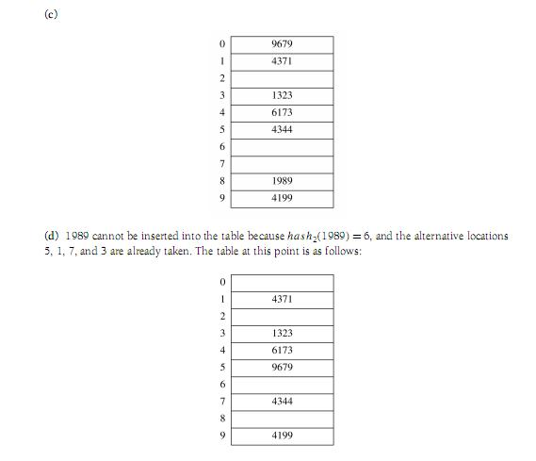
2. (5 pts.) If the list is implemented using an array, successful search: O(logn) where n is the size of the sorted list. Other operations still have worse case cost O(n). So, it does not help much.
If the list is implemented using a linked-list, binary search won’t work and thus the successful search will still be O(n). Other operations still have worst-case cost O(n). So, it does not help much either.

3. (5pts.)
Separate chaining hashing requires the use of links, which costs some memory, and the standard
method of implementing calls on memory allocation routines, which typically are expensive. Linear
probing is easily implemented, but performance degrades severely as the load factor increases because
of primary clustering. Double probing is only slightly more difﬁcult to implement and gives
good performance in practice. An insertion can fail if the table is half empty, but this is not likely.
Even if it were, such an insertion would be so expensive that it wouldn’t matter and would almost
certainly point up a weakness in the hash function. Double probing eliminates primary and secondary
clustering, but the computation of a second hash function can be costly. Gonnet and Baeza-Yates
compare several hashing strategies; their results suggest that double probing is the fastest method.

4. a) 5 pts. B) 5 pts
a) Use radix-128 integer conversion method. Thus, f(A_{i+1}A_{i+2}…A_{i+k}) = 128*(f(A_{i}A_{i+1}…A_{i+k-1}) – A_{i}*128^(k-1))+A_{i+k}. This takes constant time.
b) refer to the notes.

5. You can try using different p (such as 2,3,…). Given the particular choice of m and the method of converting a string into an integer, you should observe the same result for all permutations of the same string.
Hint: You can prove this by assuming that the ascii code of A be xm+y and then replace ascii codes of A, C, and G in a similar fashion. For example h(ACG)= (xm+y) (m+1)^2 + ….
(xm+y)(m+1)^2 = xm^3 + (2x+y)m^2 + (2y+x)m + y. What are the results of this equation % m?

