Rochester Institute of Technology

CMPE-240

Lab 3

Devon Bagley

[dxb4606@rit.edu](mailto:dxb4606@rit.edu)

4/27/2017

Lab Requirements:

This is the Stop and go (SAG) traffic hardware section implementing this feature of the engine controller.

1. A stop event is defined as the vehicle has come to a complete stop for one second.
2. This system continuously monitors the speed of the vehicle.
3. The SAG records the time of day for the last three stop events.
4. If the earliest of these three is within 5 minutes of the current time of day the SAG system output is set to TRUE. Under all other conditions the SAG system output is FALSE. e.g. if there were only two events in last five minutes the output is FALSE.
5. Once per second the SAG checks the most recent stop events (if any) and updates the SAG output.

The requirements define the stop and go traffic hardware as it would work in a real situation although this circuit will be treating the vehicle speed as a boolean input for simplicity. Also for requirement 3 the circuit will simply acknowledge that a change was made within the last 300 seconds since the events must occur within 5 minutes of each other to cause the stop and go traffic state to be true.

Design:

The logisim circuit takes in a single boolean input signaling the vehicle stopping in traffic. This single stop event is recorded using a d flip flop which is also connected to a counter which will begin to count up to 300 seconds. This d flip flop will remain high until the timer is done counting signaling that the stop event has been removed since it has been past the time required. If there has already been one stop event in the past within the 5 minutes a second d flip flop with a counter will be activated to track the additional stop event. The same goes for a third stop event which will also trigger a third counter in case one of the other stop events runs out of time. Once all three stop events are active and clocks are running, the circuit will output true for being in stop and go traffic.

State Machine Diagram:

This circuit’s focus is to provide one of the deciding inputs for the automatic restart of a engine. To reduce the wear and tear on the system it needs to determine if its is in stop and go traffic by tracking the how many times it had to stop within a short period of time. The circuit must constantly track the time since the last stop event individually until it can determine to disable this requirement of the auto restart system. 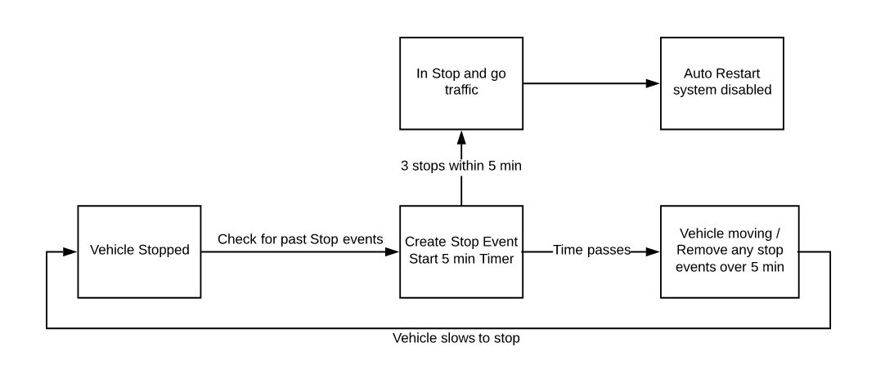

Test suite:

The vehicle coming to a stop causes the change of input. The variable for testing the circuit will be based on number of stops and the time between them. A stop event is defined as the vehicle has come to a complete stop for one second. If the earliest of these three is within 5 minutes of the current time of day the SAG system output is set to TRUE. Under all other conditions the SAG system output is FALSE.

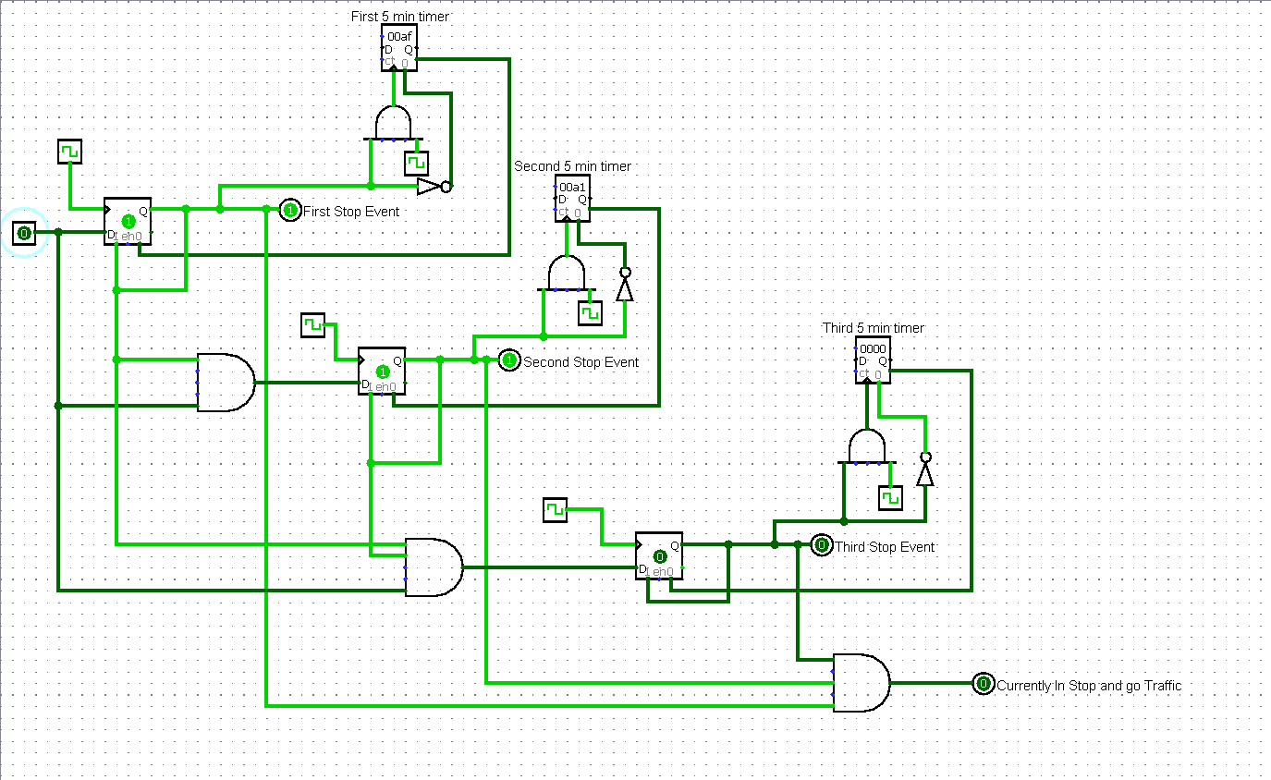

1. The vehicle comes to a single stop within 5 minutes. Output = false.
2. The vehicle comes to a stop twice within 5 minutes of the first stop event. Output = false.
3. The vehicle comes to a stop twice within 5 minutes of the first stop event, Then stops a third time outside the 5 minute time limit. Output = false.
4. The vehicle comes to a stop three times within 5 minutes. Output = true.
5. The vehicle comes to a stop four times within 5 minutes. Output = true but will ignore the fourth event and already be outputting the stop and go traffic.

The tests 1-4 will cover the requirements for the stop and go detection of the vehicle.

Reflection:

This assignment was a good way of covering many of the topics we had focused on during the year by being broken down into separate parts. The c code provided along with the documentation provided a clear demonstration of how this system would work while also testing our ability to incorporate hardware with the code we are writing. The logisim program is simple to use even though the hardware designs may take quite a bit of thought to design. Overall the diagrams and information provided gave me a great understanding of the assignment which helped further my comprehension of the lecture material from class.