Project 3 – Network Data Plan (P4)

The purpose of this assignment is to demonstrate your ability to program a network data plane using the P4 language and understand the P4Runtime.

Write a P4 program that allows switches to forward standard IPv4 traffic. Additionally, the switch should serve as an ARP proxy, providing responses to ARP queries for the hosts directly connected to it.

1. Using the image below and the provided folder “triangle-topo”, complete the runtime files for switch 2 (s2) and switch 3 (s3). Save each file as “s2-runtime.json” and “s3-runtime.json”, respectively. The runtime file for s1 (“s1-runtime.json”) is provided.

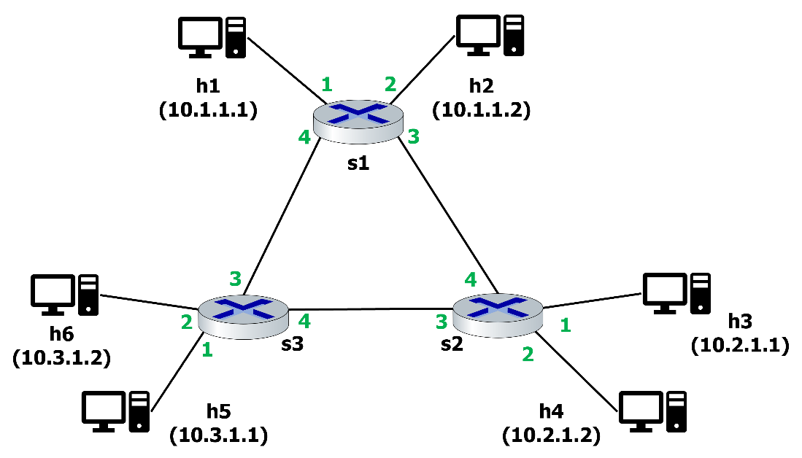

1. Complete the P4 program in the file titled “arp_proxy.p4”. The program should allow each switch to act as an ARP proxy for the hosts connected to it. Therefore, if switch 1 (s1) receives an ARP request for h2’s MAC address, it should respond for h2.
   1. There are multiple TODO sections in the file. Specifically, you need to complete code in the “MyParser” control, “MyIngress” control, and “MyDeparser” control.
   2. If you are unfamiliar with ARP, it is recommended you capture some ARP requests and responses. In Windows, this can be done by running Wireshark, then opening a PowerShell window in administrator mode, and then running the command “arp -d”. This should clear the ARP cache, triggering an ARP request / response interaction for the default gateway.
   3. You can use the files “request.py” and “send.py” to test your “arp_proxy.p4” program. To deploy your P4 program and test it, call the command “make run” from your proj3 directory.