Devon Callanan Pattern Recognition Professor Can
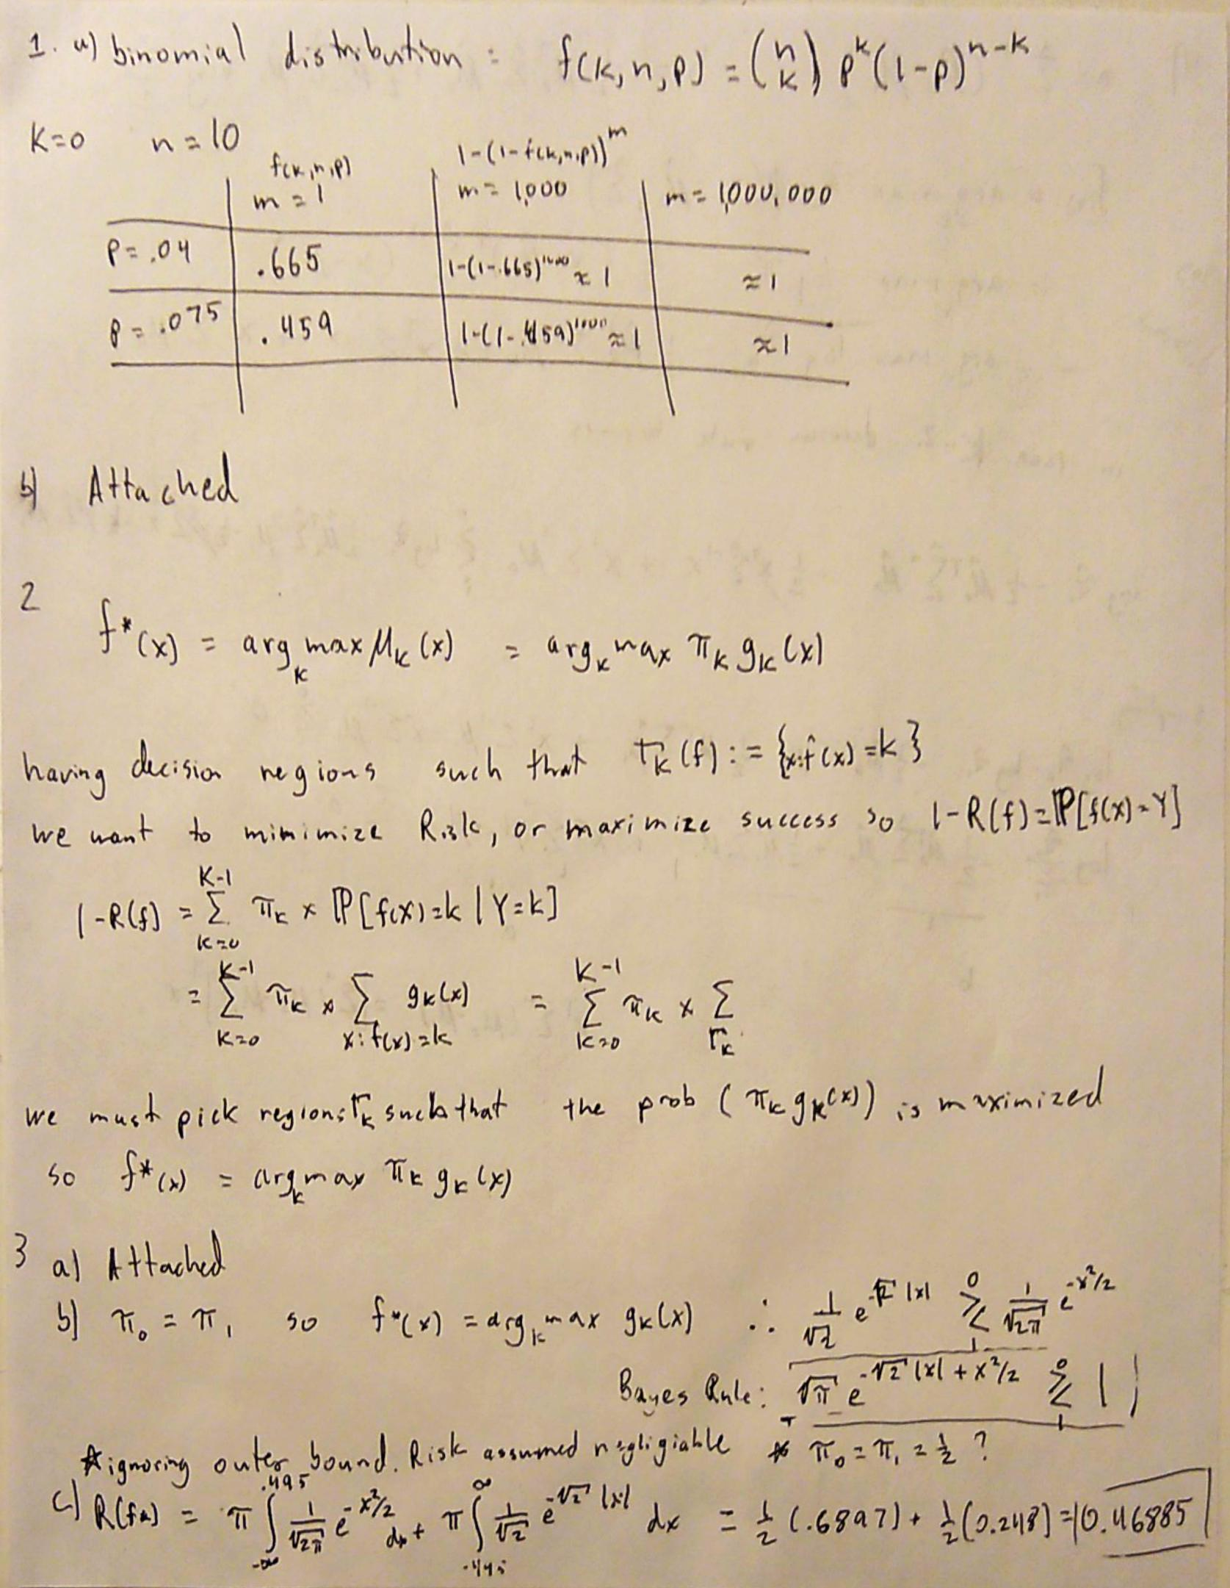

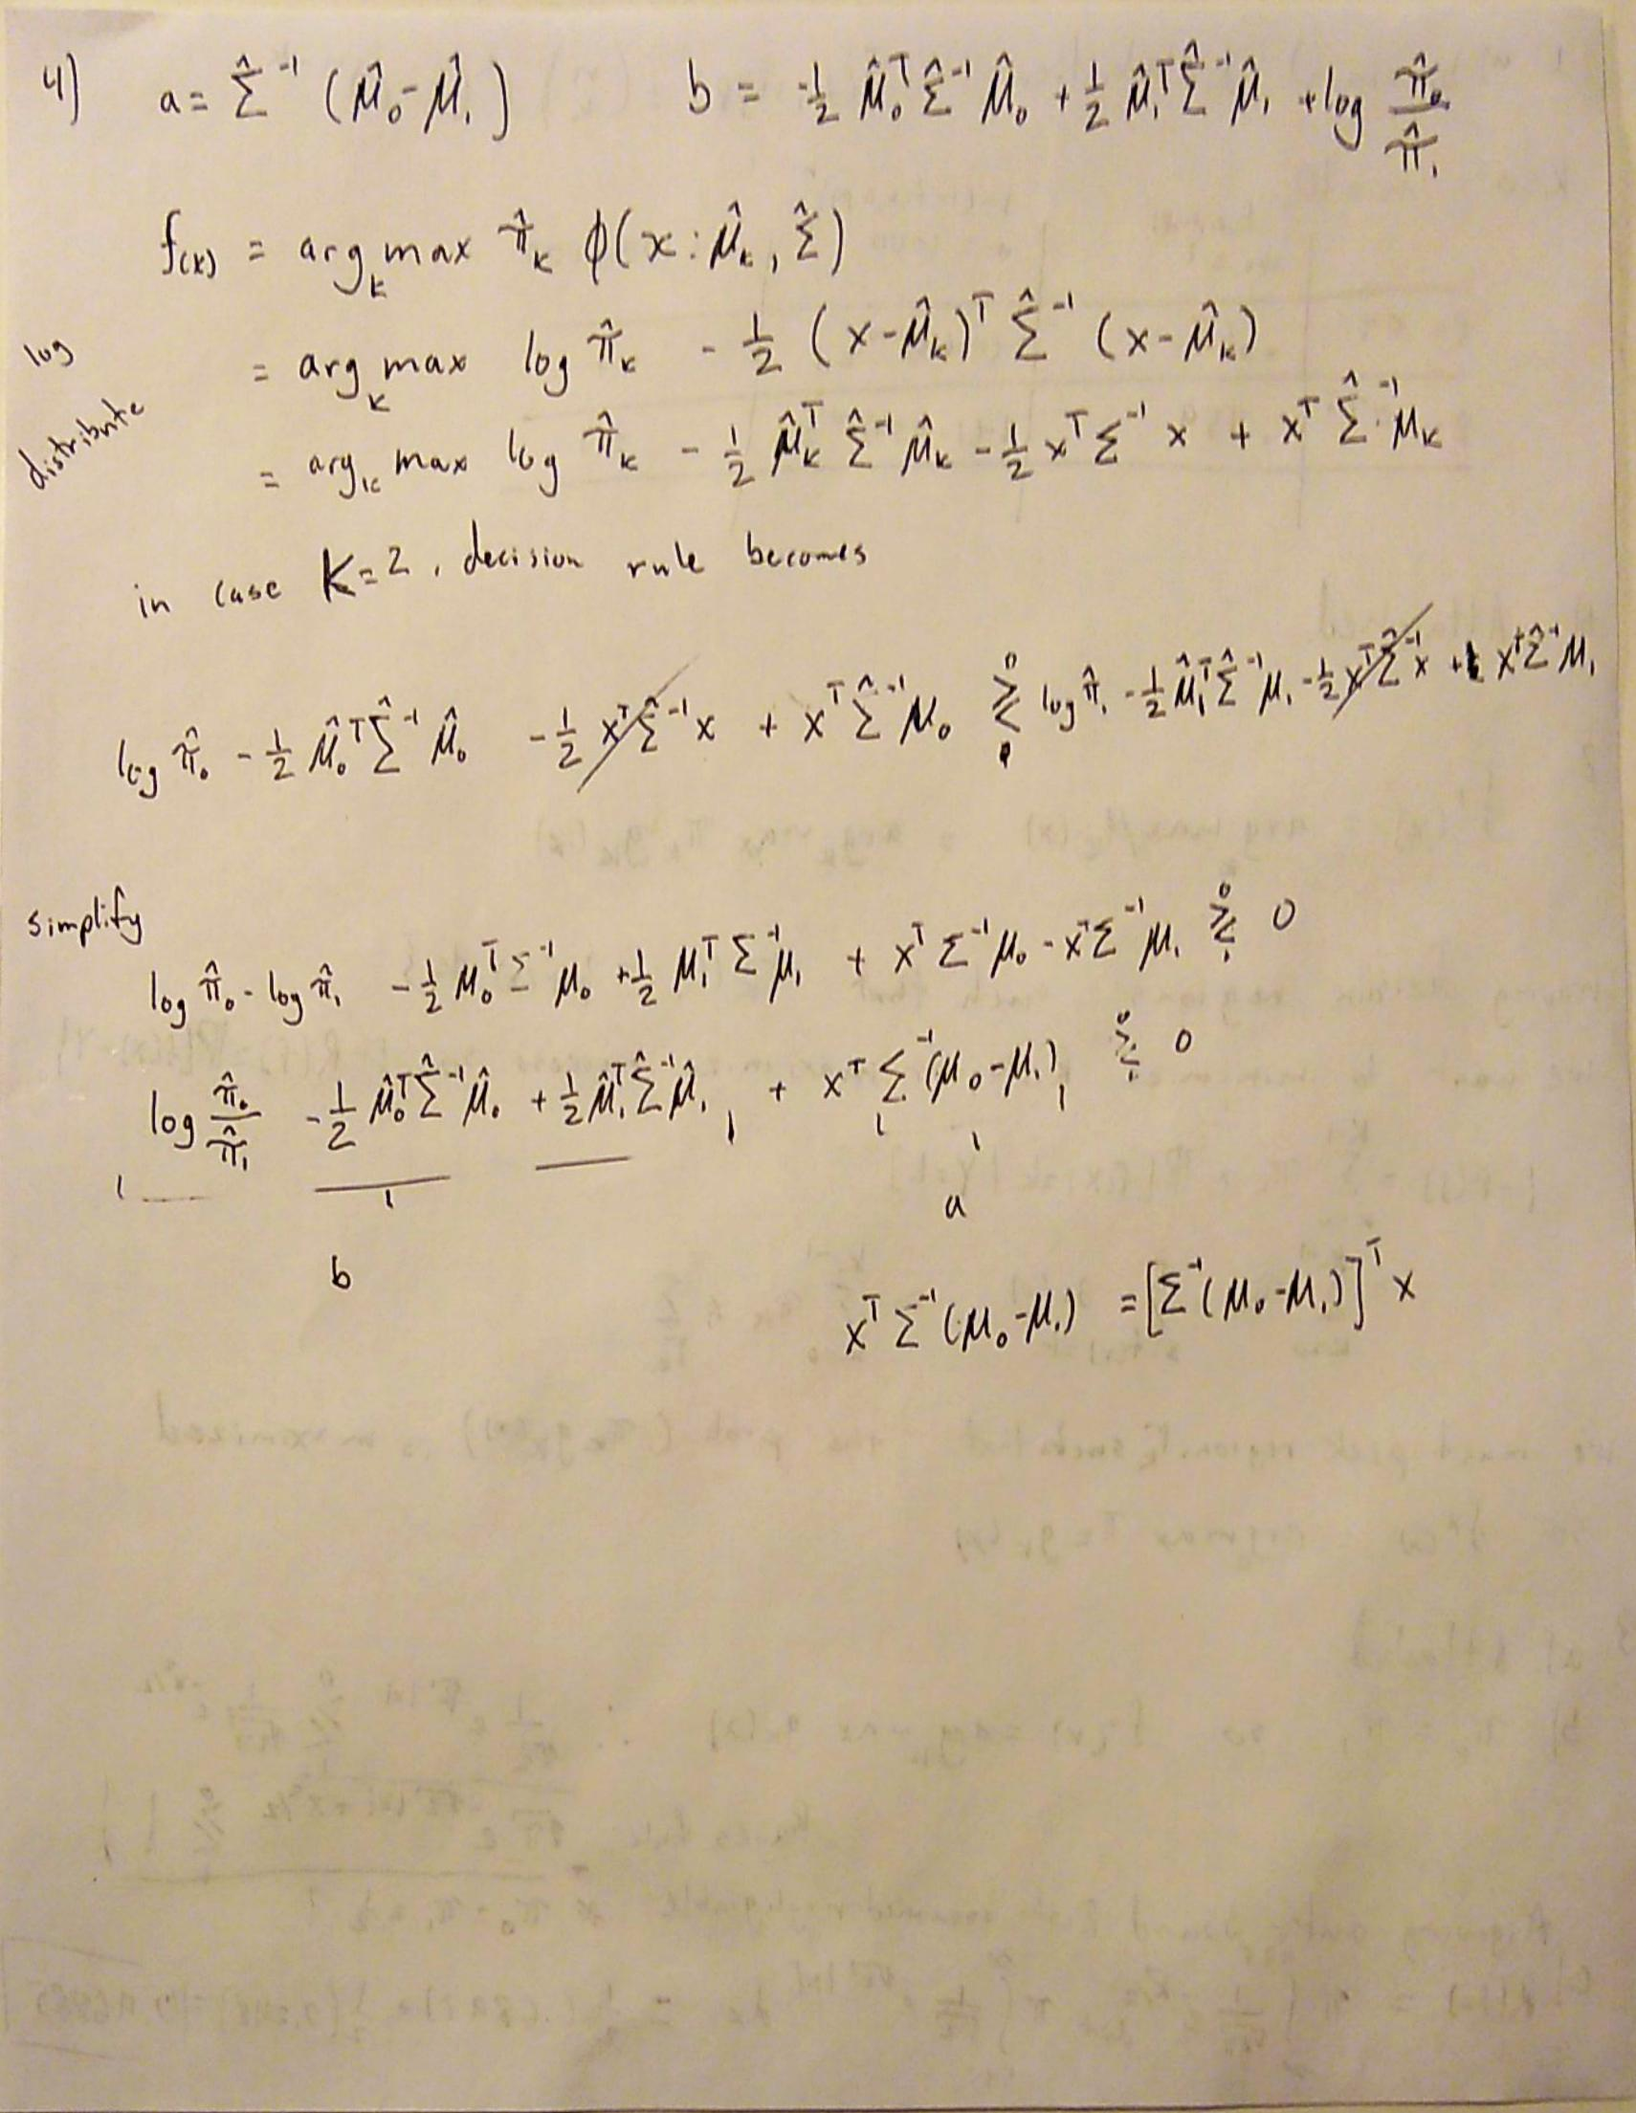

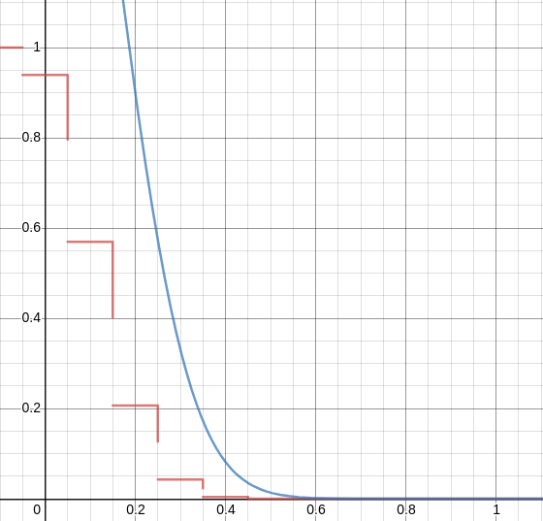
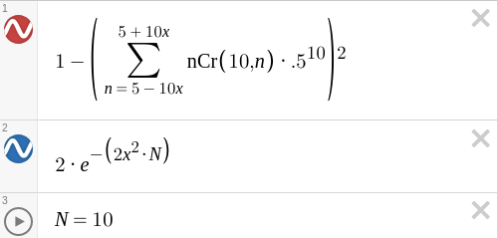
1. b)

3. a)

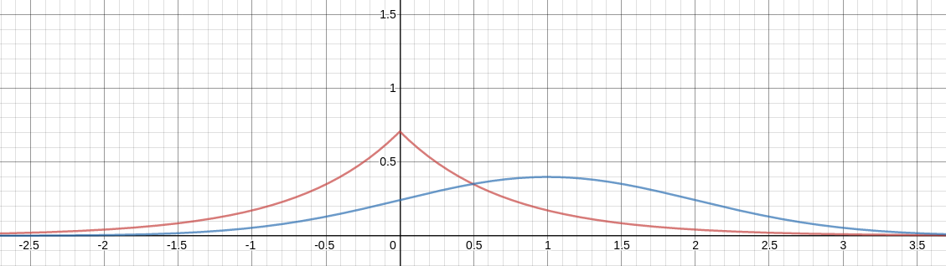

5.

 | Synthetic 1 | Synthetic 2 | Synthetic 3 | Synthetic 4 | Real
Normal | 0.995 | 0.99 | 0.78 | 0.75 | 0.7
Modified | 1 | 0.99 | 0.7 | 0.75 | 0.67

The modified co-variance strategies has a beneficial effect on some, but not all, of the data sets. The performance of LDA is strongly coupled with the separability of the data. Groupings with tight co-variance and strong inter group variance perform best. The diagrams bellow help shed light on the performance statistics shown above.

Plots of data sets and decision rules:
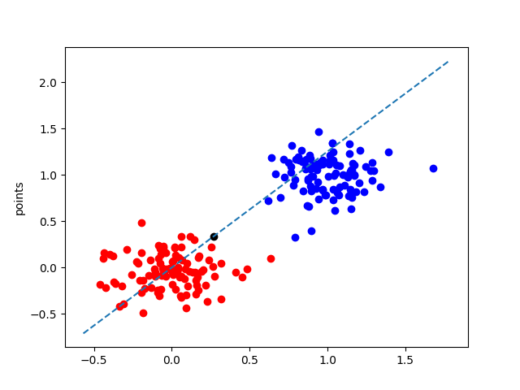
1.

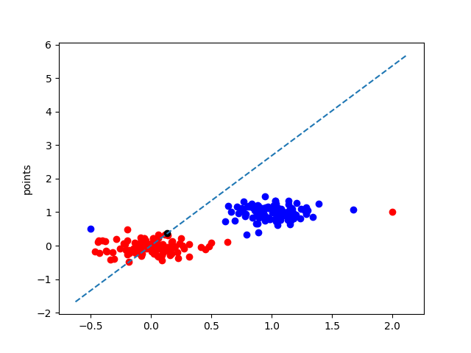
2.

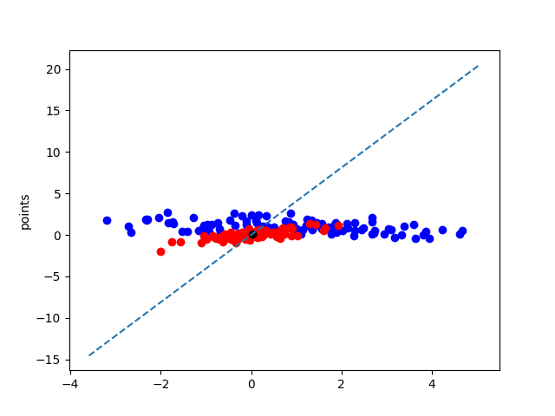
3.

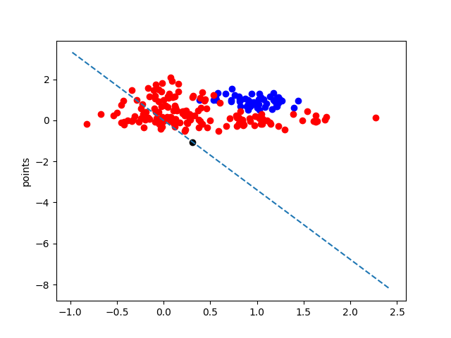
4.

