**Supplemental Information for:**

Bats at the beach, library, or barn: spatial and temporal variation in New Hampshire bat diets

Devon O’Rourke, Nicholas P. Rouillard, Katy L. Parise, Jeffrey T. Foster

**Table of Contents:**

|  |  |
| --- | --- |
| **Figure S1** | Page 2 |
| **Figure S2** | Page 3 |
| **Figure S3** | Page 4 |
| **Figure S4** | Page 5 |
| **Figure S5** | Page 6 |
| **Figure S6** | Page 7 |

**Figure S1.** Dietary richness for a single site (Fox State Forest in Hillsboro, NH, USA) in 2016 among samples collected in six time periods: sampling windows span 37 day periods, beginning in Window 3 (March 16 to April 22) and ending in Window 8 (September 17 through October 24). Richness shown for three metrics: observed OTUs (SR), Shannon’s entropy (H), and Faith’s phylogenetic diversity (PD).

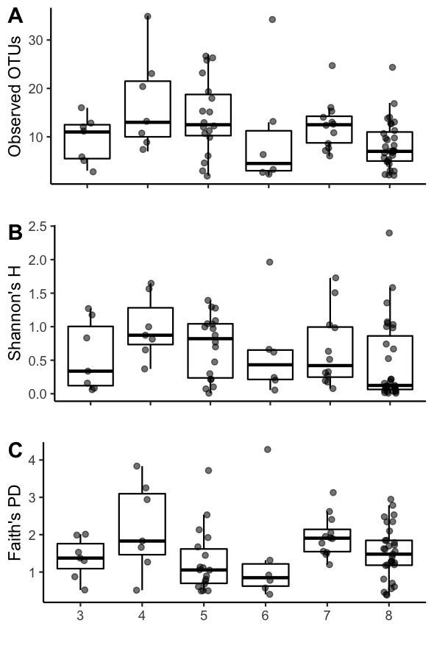

**Figure S2.** Pairwise differences of dietary richness values at a single site (Fox State Forest in Hillsboro, NH, USA) in 2016 among samples collected in six time periods: sampling windows span 37 day periods, beginning in Window 3 (March 16 to April 22) and ending in Window 8 (September 17 through October 24). Post hoc Dunn’s test results shown without multiple significance correction (A) and with correction (B) for each dietary richness test: observed OTUs (SR), Shannon’s entropy (H), and Faith’s phylogenetic diversity (PD).

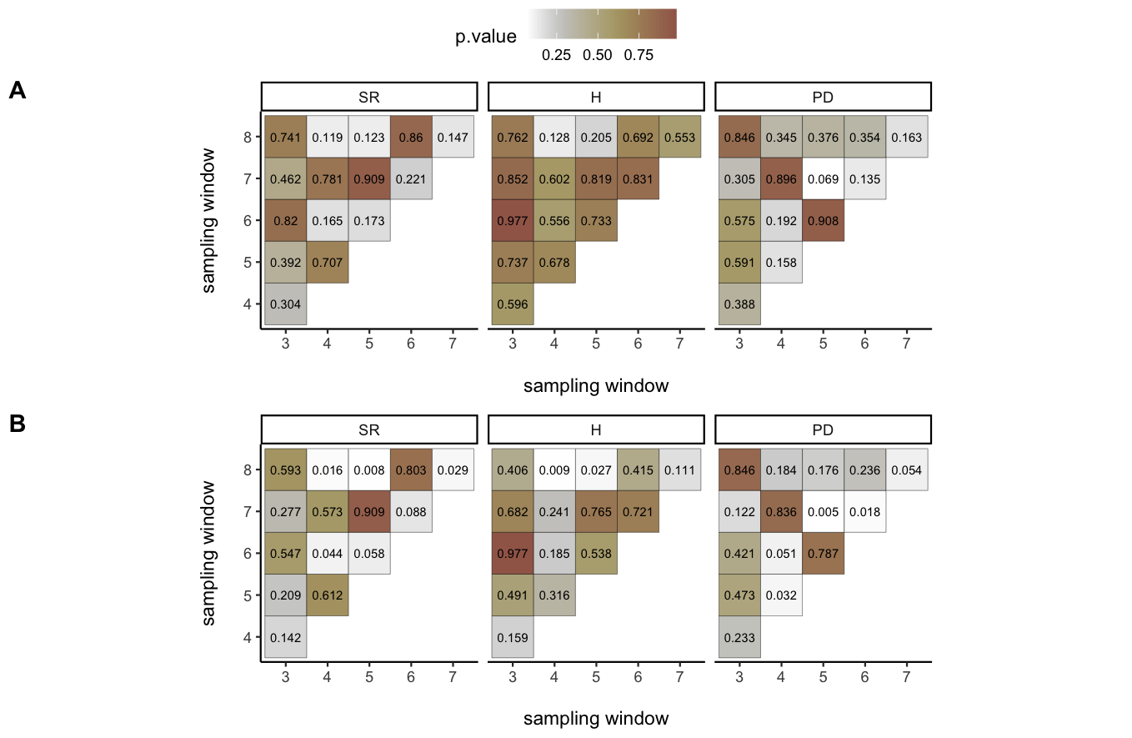

**Figure S3.** Dietary richness among samples collected at one of six sites in 2016 during three sampling windows beginning on Window 4 (April 23 to May 29) and ending on Window 6 (July 5 to August 11). Richness shown for three metrics: observed OTUs (SR), Shannon’s entropy (H), and Faith’s phylogenetic diversity (PD). Pairwise significant differences between each site+date group indicated by distinct letters above each group.

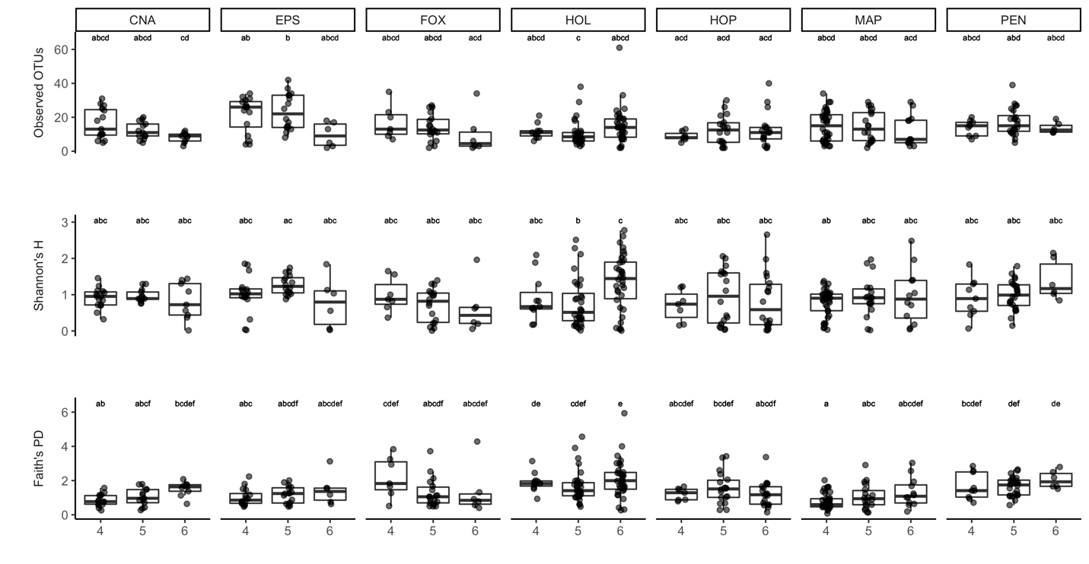

**Figure S4.** Pairwise differences of dietary richness among samples collected at one of six sites in 2016 during three sampling windows beginning on Window 4 (April 23 to May 29) and ending on Window 6 (July 6 - August 8). Post hoc Dunn’s test results shown with multiple significance correction for each dietary richness test: observed OTUs (SR), Shannon’s entropy (H), and Faith’s phylogenetic diversity (PD).

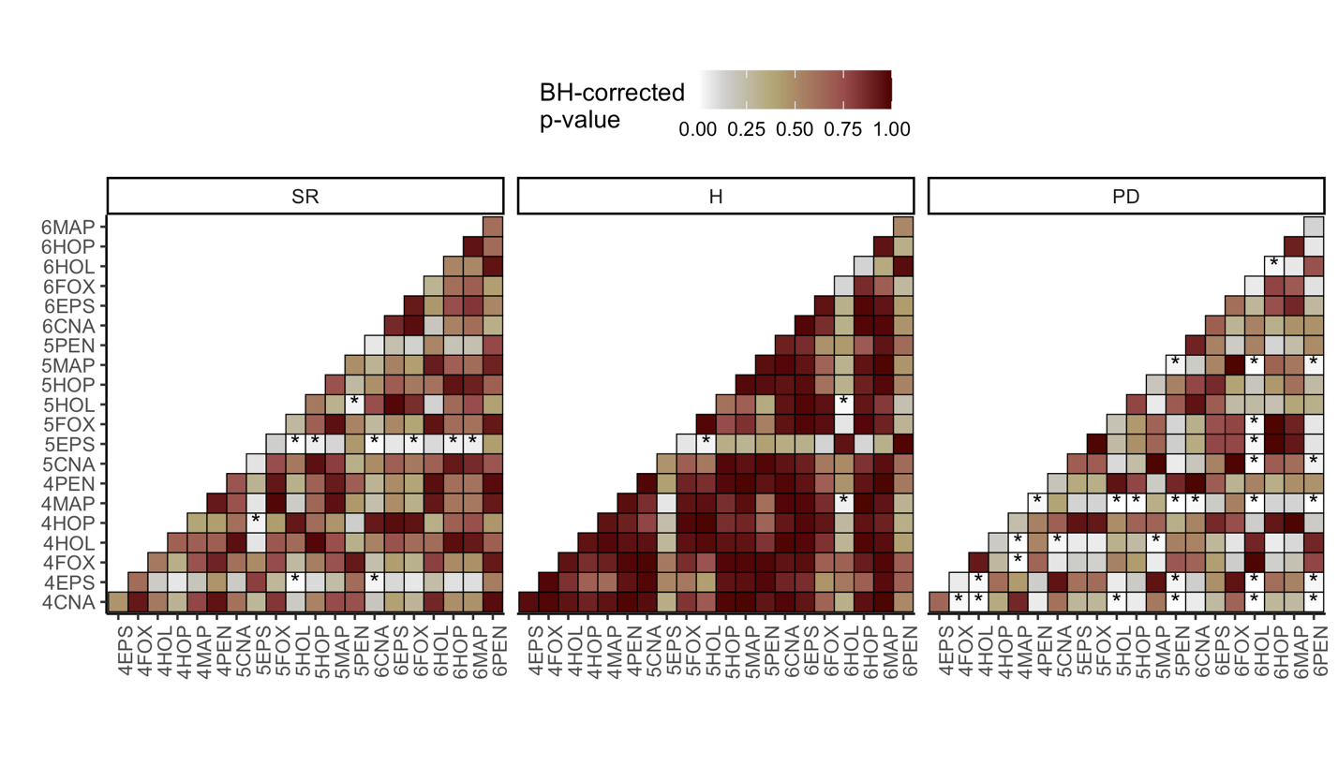

**Figure S5.** Indicator species analysis among samples collected at one of six sites in 2016 during three sampling windows beginning on Window 4 (April 23 to May 29) and ending on Window 6 (July 5 to August 11). Analysis to identify particular diet items distinguishing a group conducted separately for sites only, sampling windows only, and for site+window groups.

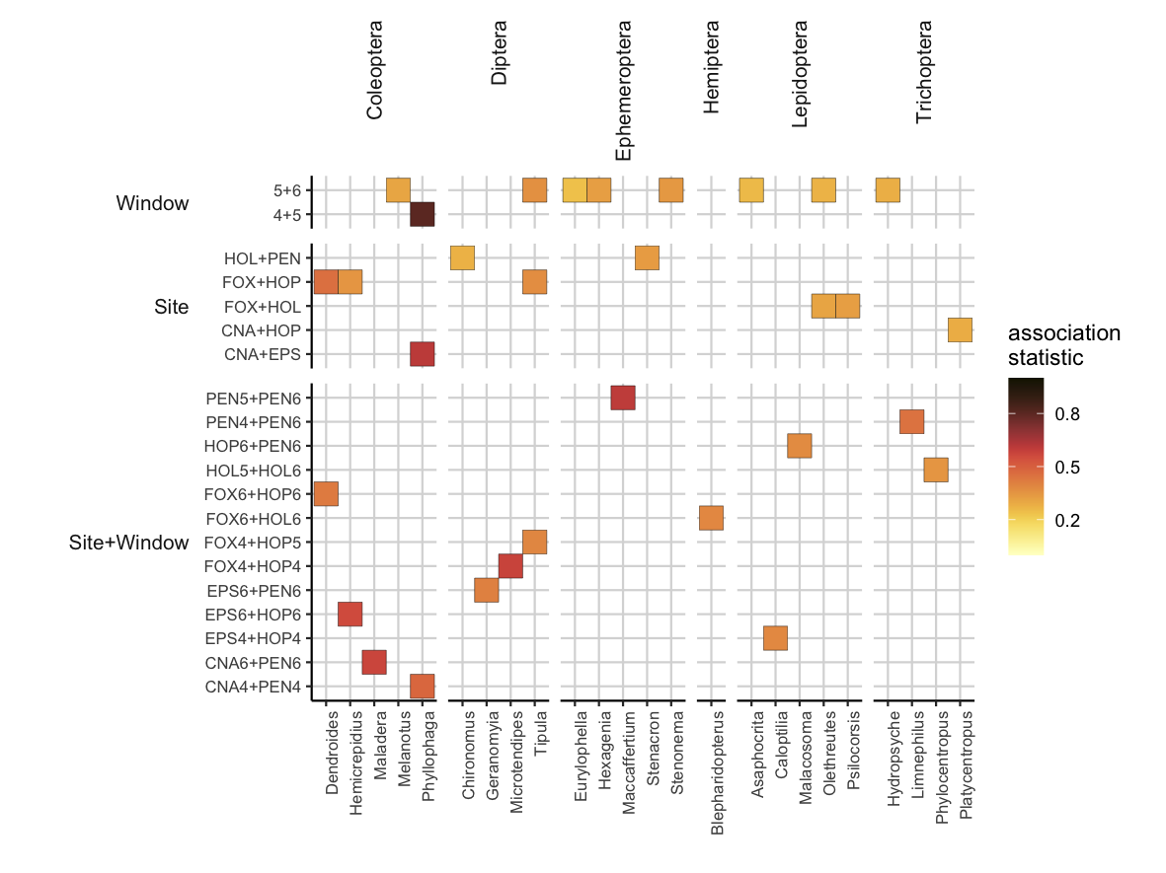

**Figure S6.** Dietary richness among samples collected at one of three sites in both 2015 and 2016 during a single sampling window: Window 6 (July 5 to August 11). Richness shown for three metrics: observed OTUs (SR), Shannon’s entropy (H), and Faith’s phylogenetic diversity (PD).

