The Fresh Protocol: A Decentralized Architecture for Trust Measurement and Validation
Devon Shigaki (ORCID: 0009-0003-8977-8010)
The FreshCredit Lab — Independent Research
Correspondence: freshcredit.xyz
Version 4.0 — October 2026

Abstract
Institutions that measure trust — identity providers, platforms, data brokers, credentialing systems — do so through centralized, expropriative architectures whose observation of users distorts the very behavior being measured. This paper specifies The Fresh Protocol (TFP), a domain-agnostic, decentralized architecture for trust measurement: a five-layer stack that implements the companion theory’s stability law ($ΔS_{t}=λ(V_{t}−E_{t})$, with $ε_{t}=V_{t}−E_{t}$ the signed validation-minus-expectation mismatch) as a live computational process, in which any verifiable interaction — a transaction, a credential check, an API call, a device attestation — functions as a validation event that updates a user-owned record: trust measurement where genuine vulnerability is at stake; verification/reputation measurement otherwise (§1.1). The stack combines W3C decentralized identifiers with selective-disclosure credentials (SD-JWT, IETF RFC 9901), database-per-tenant edge storage (libSQL; single-writer in production), a Substrate settlement and audit layer (143,343 batch transactions per second measured on 23 of 100 Kusama cores in the December 2024 “Spammening” stress test; ordinary peer-to-peer transfers peaked at 10,920 TPS), light-client verification (Smoldot), and x402 micropayment rails (Coinbase-incubated, May 2025; 169M payments in year one (memecoin-inflated; sub-cent settlement is the claim); zero protocol fees; sub-cent settlement). TFP contains no domain logic: an application is constructed by configuring the protocol’s estimator interface for a domain-specific event stream and loading matrix (the financial application is specified in a separate financial application preprint; no financial content appears in this paper beyond minimal pointers). The protocol’s defining design constraint is measurement-theoretic: centralized observation measurably distorts the observed (chilling effects; demand characteristics), so measurement must be user-owned, locally verifiable, and minimally expropriative. Two boundaries are stated up front and defended in the body: (i) user-owned measurement reduces observation salience but does not eliminate distortion — the protocol’s own measurement still perturbs the mismatch process ($ψ→ψ_{min}<0$, not 0; §4); and (ii) database-per-tenant custody converts rare-catastrophic loss into frequent-small loss — a variance reduction whose expected-loss advantage is conditional on endpoint hygiene and client integrity, quantified in §3.9. All performance figures are measurements of existing external systems cited to source, or clearly labeled simulations; cost, speed, and security figures are printed as frozen snapshots, with the live versioned calculator at freshcredit.xyz/cost maintained as a supplementary tool, not a reference.
Keywords: trust measurement; decentralized identity; verifiable credentials; Substrate; x402; chilling effects; edge computing Contents
. Introduction: Trust Measurement as Infrastructure
2. Design Principles from the Theory
3. Architecture
4. Observation Distortion as an Engineering Constraint
5. Protocol Evolution and Benchmarking
6. Discussion
7. Conclusion

1. Introduction: Trust Measurement as Infrastructure

1.1 The problem
Every digital interaction of consequence passes through a measurement — proving identity, establishing reputation, presenting a credential, demonstrating a history — that is trust measurement where genuine vulnerability is at stake; verification/reputation measurement otherwise. The incumbent measurement infrastructure shares a common architecture — centralized custodianship of behavioral data — and a common failure profile:
- Compromise at scale. In 2021, 23.9 million U.S. residents ($∼$9% of the population age 16+) experienced identity theft . U.S. data breaches generated 1.367 billion victim notices in 2024 (the restated figure; the Identity Theft Resource Center revised its initial 1.73 billion estimate downward after de-duplication), still up more than 300% year over year, with six “mega-breaches” — four of them preventable with MFA/passkeys — accounting for the large majority . Centralized behavioral databases are single points of catastrophic failure by construction; the canonical quantification is Equifax 2017 — 147.9 million records, 44% of the U.S. population, one unpatched server, total costs exceeding $1.4B . In the language this paper develops below, a mass breach is an extreme injection of observation noise and expropriation into the measurement channel: the records of millions are observed by an adversary who was never a party to the measurement.
- Attestation failure. Centralized attestation is expensive and still does not verify reliably: the strongest cost accounting comes from financial-services studies — $5.75 in total cost per $1 of fraud losses . Synthetic-identity fraud — fabricated identities “seasoned” with months-to-years of manufactured payment history before a bust-out — is documented qualitatively in the Federal Reserve’s three-part white-paper series as among the fastest-growing financial crimes in the U.S. (A widely circulated claim that “95% of synthetic identities pass onboarding undetected,” attributed to Thomson Reuters across vendor blogs, has no locatable primary source, methodology, or date; we treat it as an unverifiable industry statistic and do not rely on it.)
- Observation distortion. Awareness of surveillance measurably changes measured behavior: after the June 2013 surveillance revelations, traffic to privacy-sensitive Wikipedia articles fell by a statistically significant $∼$19% immediately, with a persistent downward trend change (interrupted time-series design; ). Experimental demand characteristics show heterogeneous, bidirectional participation effects with frequent nulls — 12 of 19 studies positive, 5 clear nulls; the review concludes little is securely known about conditions, mechanisms, or magnitudes . A measurement system that frightens its subjects measures their fear.
- Stale feedback. Institutional trust records update on custodial schedules — monthly, quarterly, or upon dispute — so the measurement systematically describes the past.
A scope boundary is stated up front: vulnerability-free verifiable events (credential checks, device attestations) yield a verification/reputation state, not trust dynamics in the theory’s sense (companion theory preprint, §1.2b, Rousseau boundary: no genuine vulnerability, no trust dynamics); the trust reading applies only where risk and interdependence are present.

1.2 The theoretical diagnosis
The companion theory preprint identifies the parameter that governs how expensive trust is to maintain: the corrective bandwidth $μ$, the rate at which expectation–validation mismatches $ε_{t}=V_{t}−E_{t}$ are dissipated by honest, immediate feedback. In the theory’s $(S,ε)$ dynamics, the phase volume of the mismatch flow contracts uniformly at rate $μ$ (the divergence of the stated flow is the constant $−μ$; no critical point or bifurcation exists in the single-agent dynamics, and none is claimed). Centralized custodians minimize $μ$ — feedback is slow, opaque, and adversarial — so mismatch accumulates: the stationary variance of the mismatch process is $σ^{2}/2μ$, and low-$μ$ regimes carry a permanently noisier alignment. And because their observation is expropriative and unaccountable, they trigger the measurement-dependence that the theory formalizes through the observation-salience-dependent dissipation coefficient $ψ$ (defined precisely in §4 below): the act of measuring lengthens the memory of mismatch (autocorrelation time $1/(μ+ψ)$) and inflates its stationary variance ($σ^{2}/(2(μ+ψ))$). The architectural remedy is motivated by the model rather than derived from it — the $ψ$ model contains no term that ranks user-owned over accountable-centralized observation: measurement should be user-owned, locally verifiable, immediately fed back, and minimally expropriative — with the quantified caveat, developed in §4, that this minimizes $ψ$ but does not drive it to zero.
Two failure registers should be distinguished explicitly, because they have different remedies. The instrumental (logical) failures of the incumbent stack — error rates, stale updates, custody concentration — are correctness problems, addressable by better instruments. The behavioral (psychological) failure — observation distortion — is not a correctness problem: no improvement in accuracy removes it, because its mechanism is the subject’s awareness of being measured, not the measurer’s error. The incumbent failure profile above therefore decomposes into instrumental failures (compromise, attestation, staleness) that better engineering could in principle mitigate, and a behavioral failure (distortion) that only an architectural change — non-expropriative, accountable, user-owned observation — can address. TFP is specified against both registers, but the second is the one the incumbent architecture cannot retrofit.

1.2.1 Historical placement: what the protocol’s primitives make possible
The protocol sits at a specific point in the engineering lineage of the web, and the placement is definitional rather than rhetorical. Each regime of the web is individuated by the operation primitive it adds. Web1 provided read: access to published data. Web2 added write: users authored content, with the platform retaining custody of what they wrote. The third regime adds store: user-side persistence of state, held by the user and anchored against retroactive alteration, outside any platform’s custody (read / write / store). The operative definition of the third regime — independent of any asset class or product built on top of it — is therefore operational, not ideological: it names a new primitive in the vocabulary of what a participant can do with data, not a slogan. In particular, “ownership” is not the primitive; ownership is the functional consequence of the store primitive — of who holds the state and who holds the means to alter or revoke it — and it obtains only where the primitive is actually implemented. What distinguishes store from an ordinary local file is the anchoring guarantee: consensus mechanisms, whether more or less centralized in operation, must guarantee that stored state cannot be retroactively altered. Decentralization is one instrument for securing that guarantee; it is the guarantee itself that constitutes the capability shift. The historical analogy is asymmetric-key cryptography: RSA did not create any new class of application — communication, commerce, and identity all predated it — but it made those applications securable without a shared secret, and every secure channel since is built on that unlock. User-side anchored storage occupies the same position for measurement infrastructure: it adds no new domain capability, but it makes an existing one — continuous, high-resolution trust measurement — possible without custodial exposure, which is the precondition for everything this paper specifies. The placement also counters a recurring industry narrative that conflates capability with scale: the read $→$ read/write $→$ read/write/store progression is a capability sequence, and the decisive step is store (anchored, user-held state), not any increment of throughput. Scale is an engineering consequence of execution architecture (§3.4); capability is what the primitive unlocks. This distinction is why the choice of chain is load-bearing rather than cosmetic.

1.3 Scope: the protocol, not an application
TFP is deliberately agnostic about what is being validated. It supplies: identity primitives, user-owned data topology, a validation compute layer applying the stability law, a settlement/audit substrate, and governance-by-design (user-owned custody, accountable access logging, open standards — see §3.5 for what this does and does not include). It does not contain scoring models, credit logic, financial regulations, or any domain-specific decision rules. Applications consume the protocol’s validation stream and impose their own domain semantics; the financial application preprint (specified separately) applies this protocol to finance, including all credit-pull, bureau, and scoring content. This separation is architectural hygiene: the protocol’s claims must stand on infrastructure evidence, not on any one application’s regulatory or predictive record.

1.4 Hypotheses and proof obligations
The hypothesis below matches the tested design (§3.6) and is the registered form (specified and timestamped in the Supporting Document; an OSF registration of the same design filed with the deposit (DOI: [insert]) prior to any pilot data collection).
Null hypothesis (H0). Feedback coupling has no effect on population-level trust-field coherence (the Kuramoto order parameter R stays at the finite-size incoherent floor $≈$ $1/\sqrt{N}$ at all coupling strengths), observation leakage has no effect on coherence at fixed coupling, and edge architecture does not reduce the marginal cost of engagement.
Alternative hypothesis (H1). Three legs, stated in the direction actually tested:
- Coupling produces coherence. Under protocol feedback coupling at sufficient strength K, the agent population self-organizes above the coherence threshold (target: order parameter $R>0.7$); the isolated control ($K=0$) remains at the incoherent floor (target: $R<0.3$). Coherence is a property of the coupling — of the feedback composition — not of isolated stores.
- Observation leakage degrades coherence. At fixed K, R decays monotonically as the observation-leakage parameter $ℓ$ rises (operationalized exactly in §3.6). The architectural content of the privacy claim lives here: non-expropriative measurement is what keeps $ℓ$ below the fragility threshold at which coherence collapses.
- Edge architecture reduces marginal cost. Edge compute plus per-event micropayment settlement achieves a marginal cost per validation event far below incumbent marginal per-query costs, stated as a conditional (incumbent marginal price $>$ $0.05/query) against printed frozen figures; the reduction factor itself is not printed (§3.6, Sim P3; §5.2).
The protocol’s proof obligations: (1) an agent-based simulation of coupled vs. isolated conditions — run and reported in §3.6 against pre-registered criteria, with an OSF registration of the same design filed with the deposit (DOI: [insert]) prior to any pilot data collection — with coherence differences evaluated at $p<0.001$; (2) the leakage-graded desynchronization arm — R(K, $ℓ$) mapped over a (K, $ℓ$) grid, run and reported in §3.6 (Sim P1b); (3) the coherence threshold itself (leg 1); (4) cost — edge compute plus x402-class settlement at near-zero marginal per-validation cost, with the comparison restricted to like-for-like marginal quantities and frozen figures printed in §5.2. Obligations (1), (2), and (3) are now discharged in silico in §3.6, with an honest null on the quantitative threshold: leg 1 is supported ($R=0.739$ $±$ 0.029 coupled vs. $0.040±0.001$ isolated — the verification re-run values; the isolated arm sits at the $1/\sqrt{N}$ $≈$ 0.045 finite-size floor); leg 2 is supported qualitatively (R decays monotonically in $ℓ$ at every K tested — mechanism demonstrated in silico under a stated operationalization whose attenuation component is definitional; §3.6) but the zero-leakage operating point $K=4.5$ is fragile — R falls below the 0.7 target within the leakage band $ℓ$* $∈$ [0.02, 0.10] (a 9-seed fine scan at $K=4.5$ gives R $≈$ 0.69–0.74 across $ℓ$ $∈$ [0, 0.10], first below-0.7 reading at $ℓ=0.08$; the exact crossing is not resolvable at seed noise $±0.02–0.03$), so robust $R>0.7$ requires either stronger coupling or a lower coherence target — at $K=6$ coherence survives to $ℓ≈0.22\text{–}0.28$ and at $K=8$ to $ℓ≈0.30\text{–}0.40$ (ranges span two independent seeded re-renders; point precision is not resolvable at these N). Obligation (4) is restated in like-for-like form and maintained against printed frozen figures plus the supplementary versioned calculator; it is not asserted as a deployed result.

1.5 Epistemic posture
All quantitative figures in this paper are (a) measurements of existing external systems, cited to source; (b) labeled simulations over synthetic data; or (c) frozen benchmark snapshots printed in §5.2, with the live, versioned calculator at freshcredit.xyz/cost maintained as a supplementary tool — the print figures, not the live page, are the canonical reference for this paper’s claims. No achieved end-to-end performance is claimed for deployed applications of the protocol. Claims carry the stack’s epistemic labels: [DERIVED] (follows from stated assumptions), [STANDARD] (textbook results derived for self-containment), [ANALOGY], [HOMOLOGY], [EMPIRICAL], [HYPOTHESIS], [SIMULATION].

2. Design Principles from the Theory
Three principles follow from the theory and biology layers of the stack (the companion theory and biological-instantiation preprints):
- Interactions as validations (theory layer). Any event with a recorded expectation and a recorded outcome can drive the stability update. Stack-wide, the update is the master law
$$\begin{aligned}S_{t+1}=​&S_{t}+λ^{+}max(ε_{t},0) r_{t}+λ^{−}min(ε_{t},0) r_{t} \\ &−δ_{S} (S_{t}−S_{base}), ε_{t}=V_{t}−E_{t},\end{aligned}$$
- with $λ^{+}$, $λ^{−}$ $≥0$ the confirmation/betrayal sensitivities, $r_{t}$ $∈$ [0,1] the recognition gate, $δ_{S}$ $≥0$ the retention leak, and $S_{base}$ the baseline; $ε$ is dimensionless after per-domain normalization ($\tilde{ε}$ = (V $−$ $E)/s_{d}$, $s_{d}$ the RMSE of the domain’s expectation distribution, companion theory preprint, Def. 2a). The named layer presets are: the physics layer ($r=1,$ $δ_{S}=0,$ $λ^{+}=λ^{−}=λ$ — the Rescorla–Wagner limit, reducing exactly to $ΔS_{t}=λ(V_{t}$ $−$ $E_{t}$)); the biological layer (gating $r_{t}$, baseline-restoring leak $δ_{S}>0,$ $S_{base}$ the homeostatic prior); and the TFP protocol layer ($λ^{−}>λ^{+}$ — break/build asymmetry: betrayal updates faster than confirmation accrues — as an explicitly labeled extension), with $r_{t}≡1$ and $δ_{S}$ $≥0.$ The protocol therefore treats validation as a primitive: a typed, timestamped, attributable event with an expectation field and an outcome field. Domains differ only in what fills those fields.
- The five-channel measurement (biology). Interaction streams — behavioral, transactional, physiological — are measurement layers on the same latent trust process, scored against the frozen biological stage mapping (D–O–C–A–S). The protocol records streams; the companion biology experiment interprets them; applications decide which streams they consume and for what. Streams with decision-ethical sensitivity (e.g., physiological data) are sequestered at the schema level from application decision paths.
- Distortion-minimizing observation (measurement theory). Data minimization (selective disclosure), ownership locality (database-per-tenant), local verification (light clients), and accountable observation (user-visible, on-chain access logs) are the engineering responses to the documented chilling and demand-characteristic distortions of §1.1. Stated against the now-defined $ψ$ (§4): these four responses drive observation salience m toward its floor, and hence $ψ→ψ(m_{min})$ — which the theory and the $ψ$ battery (§4) both say is negative and nonzero: the protocol’s own measurement still distorts, and §4 applies a Campbell’s-law caution to the protocol’s own metrics accordingly.

3. Architecture
The components are existing, production-grade open systems; the contribution is their composition into a trust-measurement loop. Figure 1 summarizes the reference architecture as a five-layer stack of mathematical objects, with the core flow and the cross-cutting population-level objects drawn outside the layers because no single layer owns them.
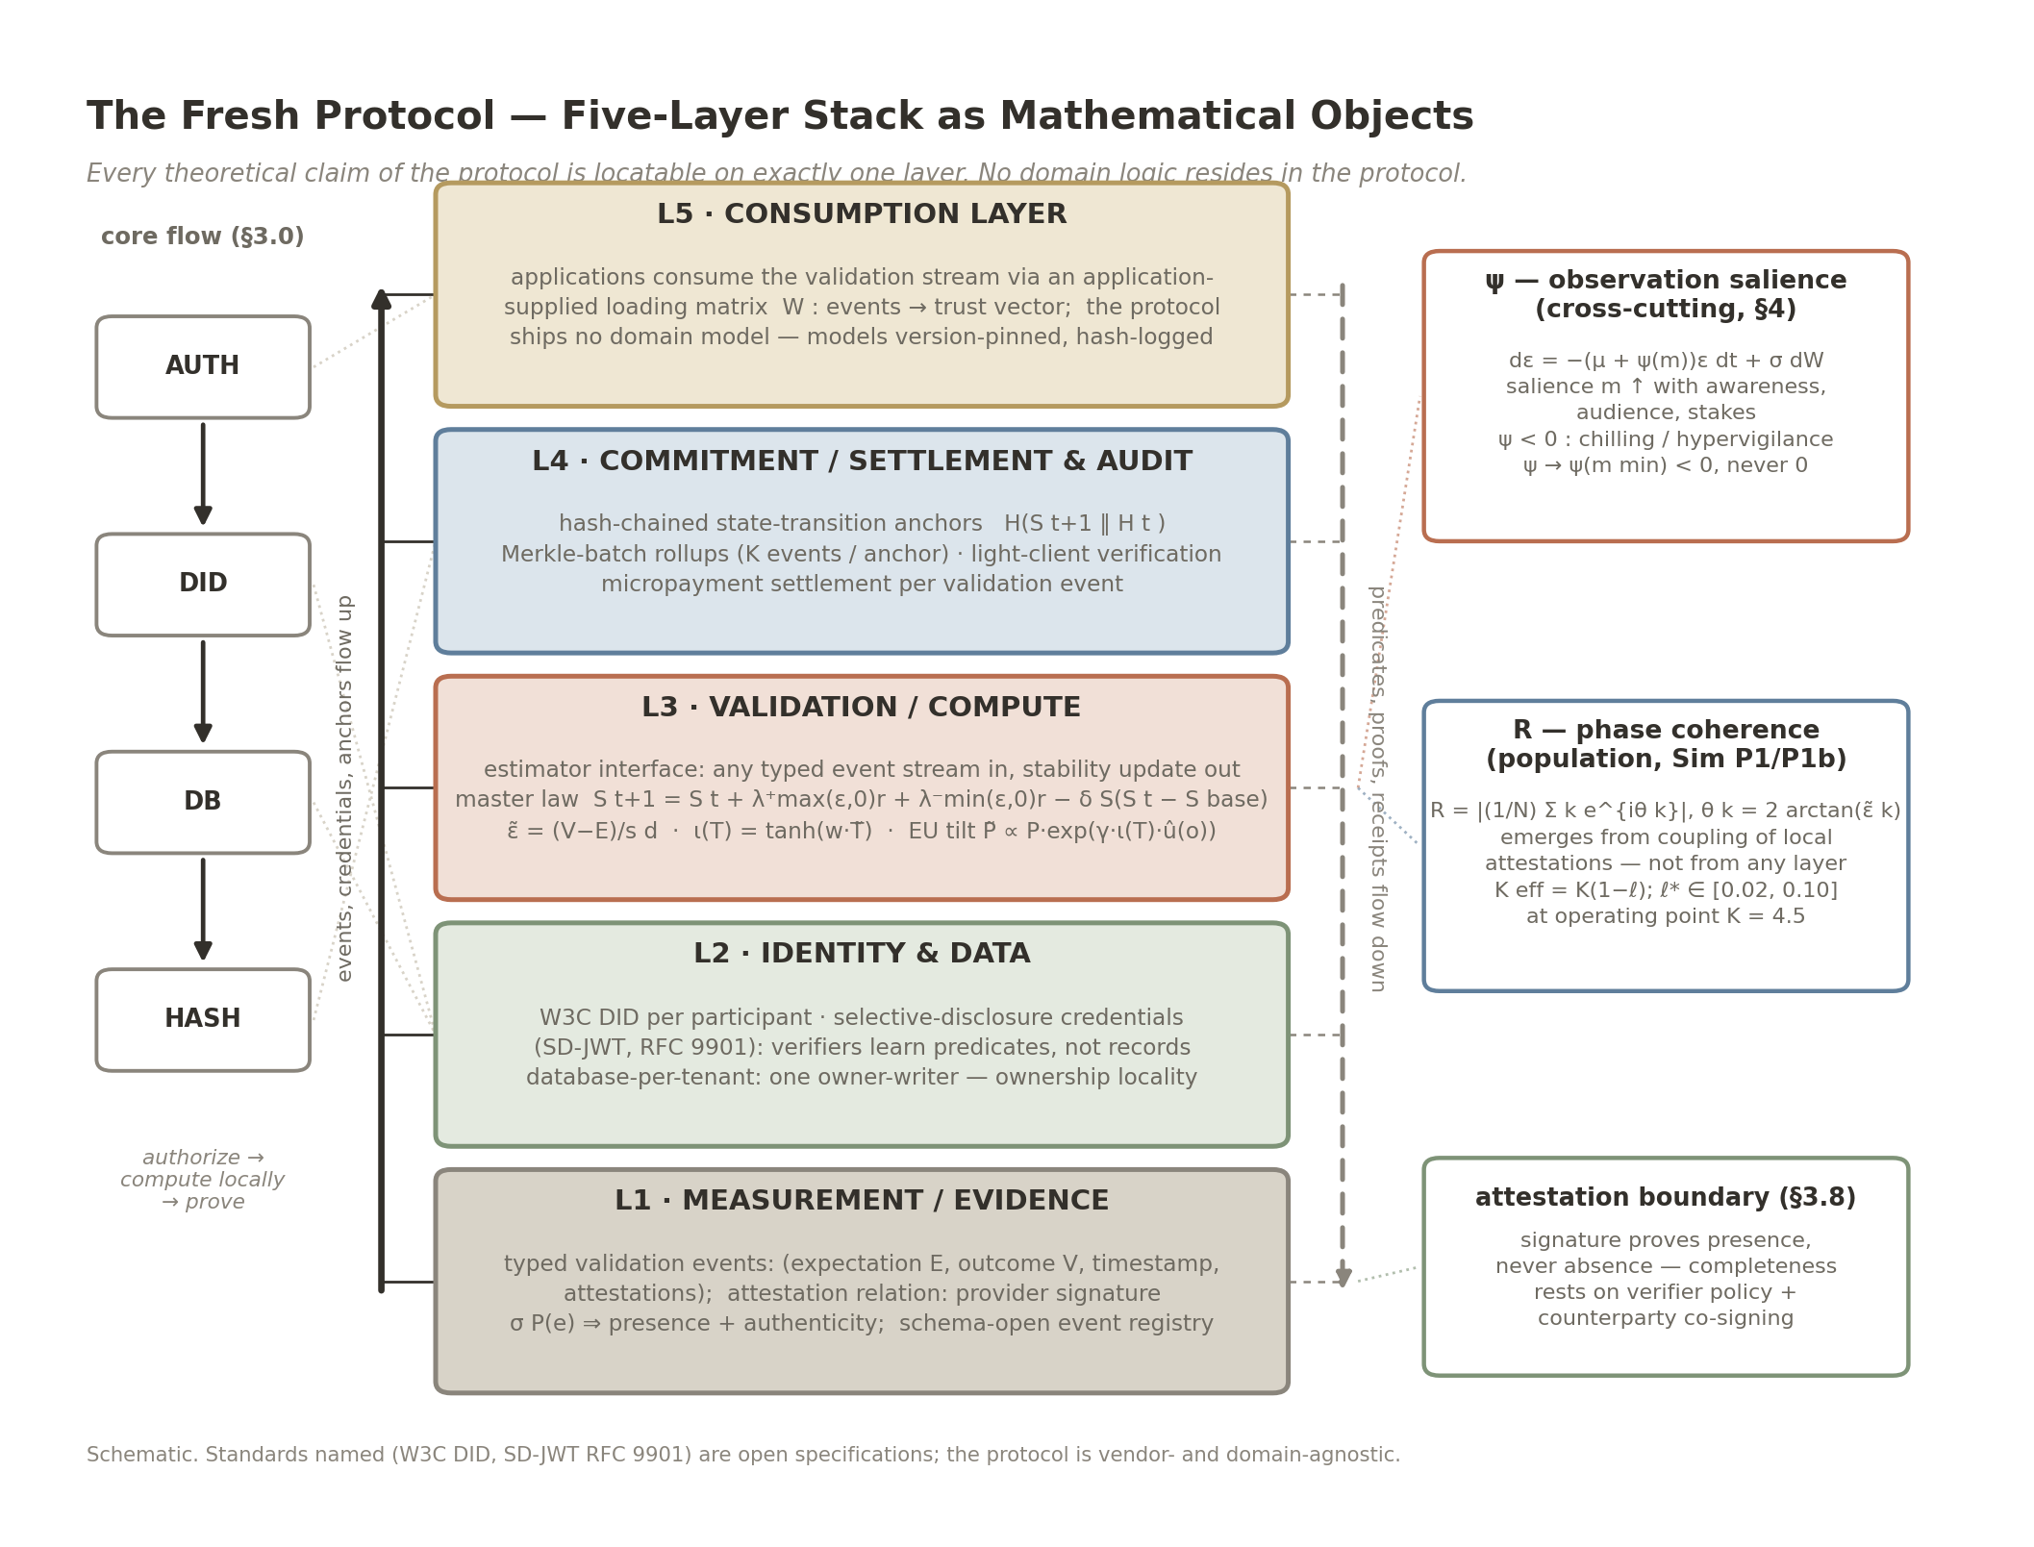
Figure 1. The Fresh Protocol as a five-layer stack of mathematical objects (§3 opening). L1 measurement/evidence: typed validation events ($E$, $V$, timestamp, attestations) and the provider-signature attestation relation (presence + authenticity). L2 identity & data: W3C DIDs, selective-disclosure credentials (SD-JWT, RFC 9901 — predicates, not records), database-per-tenant ownership locality. L3 validation/compute: the estimator interface, the master law (TFP preset $λ^{−}>λ^{+}$), $\tilde{ε}$ normalization, the $ι(T)$ trust index and the bounded exponential-tilt $EU(a∣T)$. L4 commitment/settlement & audit: hash-chained state-transition anchors, Merkle-batch rollups, light-client verification, per-event micropayment settlement. L5 consumption: applications via an application-supplied loading matrix; no domain logic in the protocol. The core flow AUTH $→$ DID $→$ DB $→$ HASH (left rail) and the cross-cutting/population-level objects $ψ$ (observation salience), $R$ (phase coherence), and the attestation boundary (right rail) are drawn outside the layers because no single layer owns them.

3.0 The core flow
Every interaction with the protocol traverses a single sovereign pipeline:
AUTH $→$ DID $→$ DB $→$ HASH
AUTH — the participant authenticates to their own edge environment (device-held keys); no custodial account exists to be breached. DID — the participant’s decentralized identifier scopes the interaction; credentials are presented by selective disclosure (predicates, not records). DB — the validation event is written to the participant’s own database-per-tenant store; the stability update $ΔS=λ(V$ $−$ E) (TFP preset: $λ^{−}>λ^{+}$ asymmetric form, §2) is computed at the edge, so raw data never leaves the participant’s control. HASH — the resulting state transition is hashed to the audit chain, giving the participant — and only parties they authorize — a light-client-verifiable proof of record integrity. The pipeline is the architectural negation of the custodial flow it replaces: where the incumbent pattern is collect $→$ centralize $→$ expose, the protocol’s is authorize $→$ compute locally $→$ prove. Figure 2 renders the expectation–validation loop the pipeline carries — one signed mismatch per event driving one state update, closed through the trust index — and where the audit and observation terms attach.
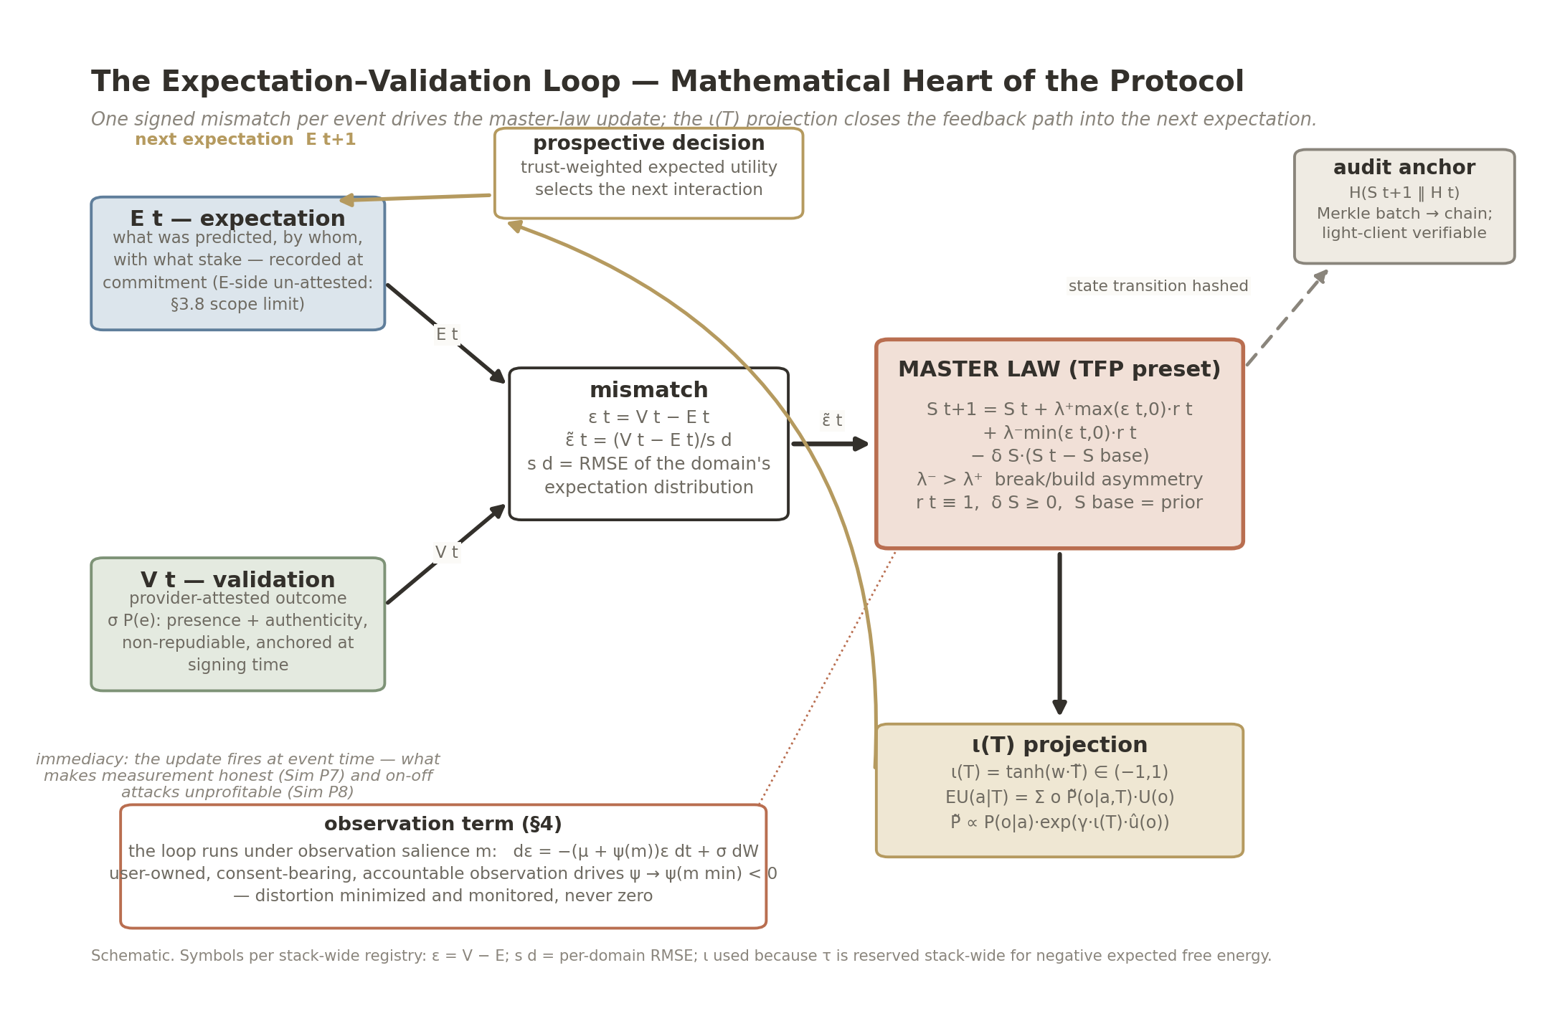
Figure 2. The expectation–validation loop (§3.0–3.3). A recorded expectation $E_{t}$ and a provider-attested outcome $V_{t}$ form the normalized mismatch ${\tilde{ε}}_{t}=(V_{t}−E_{t})/s_{d}$, which drives the master-law update $S_{t+1}=S_{t}+λ^{+}max(ε,0)r+λ^{−}min(ε,0)r−δ_{S}(S_{t}−S_{base})$ with the TFP preset $λ^{−}>λ^{+}$ (break/build asymmetry), $r≡1$, $δ_{S}≥0$. The state projects through $ι(T)=tanh(w⋅\tilde{T})$ into trust-weighted expected utility (exponential tilt $\tilde{P}∝P⋅exp(γ ι(T) \hat{u}(o))$), which selects the next interaction and thereby the next expectation — the feedback path. Every state transition is hashed to the audit anchor. The observation term ($dε=−(μ+ψ(m))ε dt+σ dW$) is annotated as the regime the loop runs under; the $E$-side is marked un-attested (§3.8 scope limit).

3.1 Measurement layer
Validation events enter as typed records: expectation (what was predicted, by whom, with what stake), outcome (what occurred), timestamp, and attestations. Sources are arbitrary: signed API responses, credential presentations, device attestations, settlement receipts, consented wearable streams. The layer is schema-open — new domains register event types without protocol changes. Attestation is the load-bearing integrity and completeness mechanism of this layer; §3.8 states precisely what a provider-signed event proves (presence and authenticity) and what it cannot prove (absence of omitted events), and what the protocol does about the gap. The scope boundary of §1.1 binds the layer’s outputs: vulnerability-free verifiable events (credential checks, device attestations) yield a verification/reputation state, not trust dynamics in the theory’s sense (companion theory preprint, §1.2b, Rousseau boundary: no genuine vulnerability, no trust dynamics); the trust reading applies only where risk and interdependence are present.

3.2 Identity and data layer
Each participant holds a W3C decentralized identifier (DID; ); attestations are verifiable credentials presented by selective disclosure — verifiers learn predicates (“over 18”, “credential unrevoked”, “no failed obligations in window w”), not records. Production DID ecosystems demonstrate the pattern: KILT Protocol — a Substrate-based blockchain operating as a Polkadot parachain — provides production issue-hold-verify credential flows (verifiable, revocable, selectively disclosable credentials anchored by on-chain hashes) documented since its 2019 whitepaper . The standards layer has since matured from draft to regulated default: the Verifiable Credentials Data Model 2.0 reached full W3C Recommendation status in May 2025 , and the selective-disclosure JWT format is standardized as SD-JWT (IETF RFC 9901, a finished Standards-Track specification; ); its credential profile SD-JWT VC — still an IETF Internet-Draft, not yet an RFC — is mandated (alongside ISO mdoc) in the EU’s eIDAS 2.0 wallet architecture. (For the unlinkable-presentation case, BBS cryptosuites exist but are W3C Candidate Recommendation Drafts, not yet Recommendations; the stack does not depend on them.) Selective disclosure is no longer a research construct; it is the direction regulation is pulling.
Data live in a database-per-tenant topology (libSQL; ): each participant’s trust record is an independent encrypted edge database whose durability is provided by cloud backups or offline backups under the participant’s control. One engine fact is stated precisely because the ecosystem’s naming invites confusion: the production libSQL engine (the C fork of SQLite that powers Turso Cloud today) inherits SQLite’s single-writer model; MVCC concurrent writes are a feature of Turso’s ground-up Rust rewrite of SQLite, currently in beta, not of the production engine. Nothing in this architecture requires concurrent writers per tenant — each database has exactly one owner-writer — so the production engine suffices; the beta rewrite is noted for trajectory only. The topology yields local-latency I/O (vendor benchmarks report $∼3×$ improvement over centralized round-trips) and, more importantly, ownership locality: the record is the participant’s, licensed to queries, rather than a custodian’s asset. Aggregation APIs that permission data at the source (Plaid, Stripe, and equivalents) demonstrate the consent-bearing query pattern at production scale — the protocol generalizes it beyond finance.
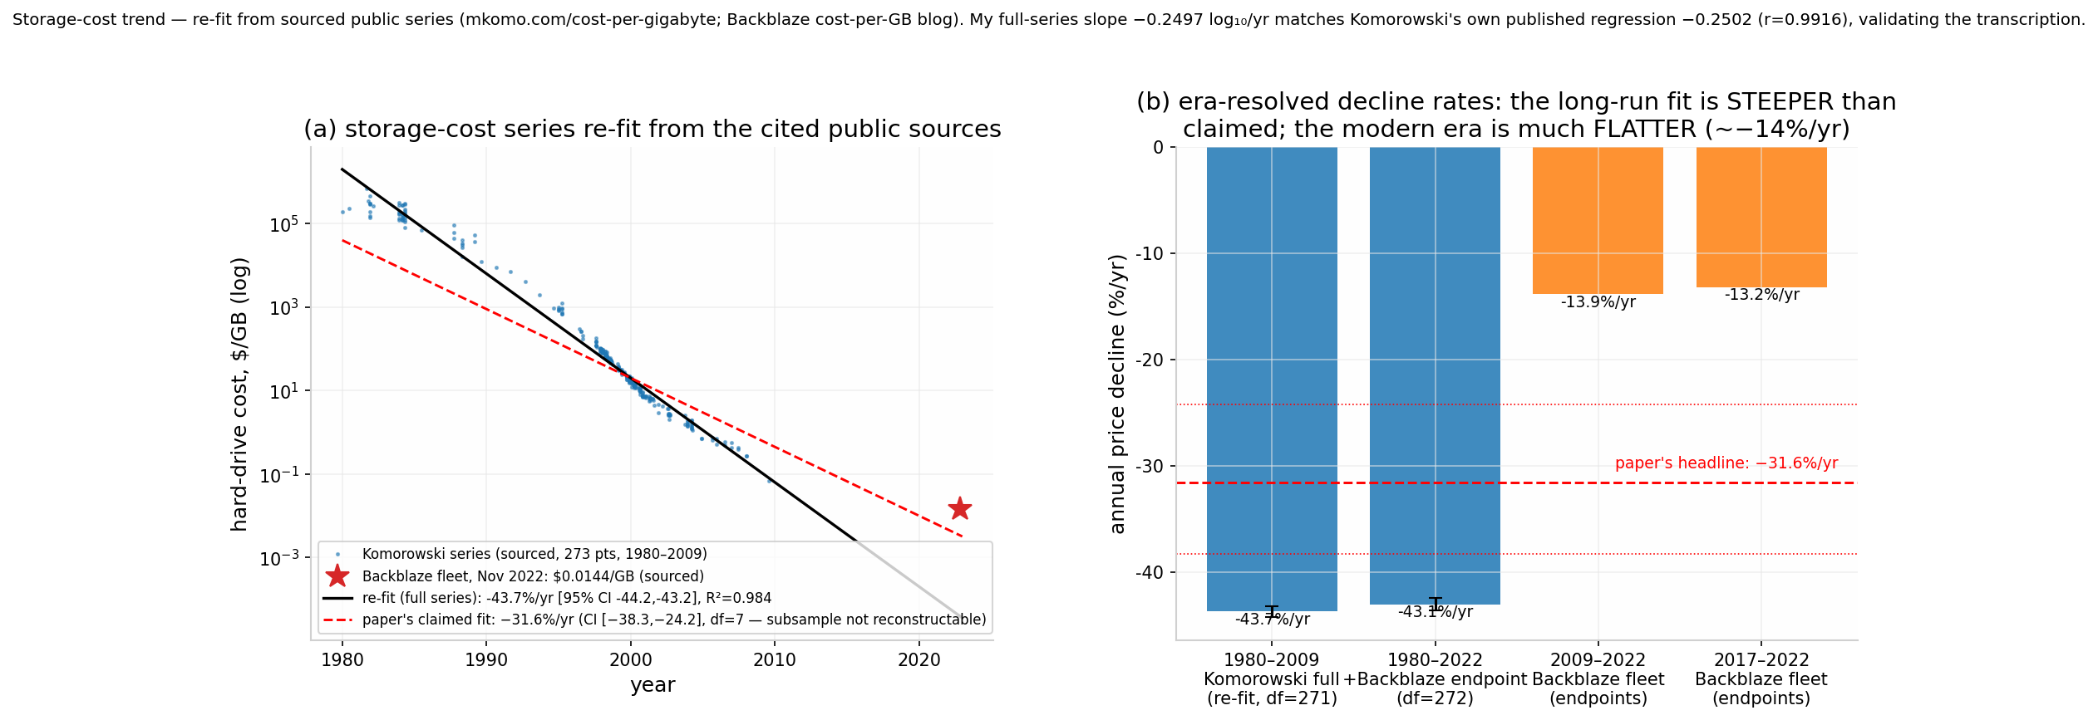
Figure 3. Storage-cost trend, era-split (§3.2): the full sourced Komorowski table (273 drive-price points, 1980–2009) re-fit log-linearly at $−43.7$%/yr (95% CI $[−44.2,−43.2]$, $R^{2}=0.984$), matching Komorowski’s own published regression; Backblaze fleet endpoints extend the series to $0.0144/GB (November 2022) and give the much flatter modern era of $≈−14$%/yr. A $−31.6$%/yr fit (df $=7$) on a small subsample is unreconstructable from the cited series and is not used.
Two properties of this layer are stated with their evidence. First, the cost curve is measured, not asserted, and the trend is era-split (Figure 3): a re-fit on the full sourced Komorowski table (273 transcribed drive-price points, 1980–2009) gives a log-linear decline of $−43.7\%/year$ (95% CI [$−44.2$, $−43.2$]; $R^{2}=0.984$; halving every 1.2 years), matching Komorowski’s own published regression of the same series ($−0.250$ $log_{10}/yr$; ), while the modern era is much flatter — fleet endpoints give $≈$ $−14\%/year$ over 2009–2022 ($0.114/GB in 2009 to $0.0144/GB in November 2022, an 87% drop). A $−31.6\%/year$ fit on a small subsample (df = 7) is unreconstructable from the cited series — its 1980 anchor of “roughly $20,000/GB” conflicts with the sourced Komorowski 1980 rows ($152K–$700K/GB) — and is not used; the re-fit above is the claim, with the caveat that the 2025–26 NAND shortage reversed SSD pricing (enterprise +257%) while HDDs continued the trend (+35%) — a 46-year pattern, not a law (storage-cost study, Supporting Document §S.4). Declining storage cost is what makes database-per-tenant durable history economically ordinary rather than exotic. Second, distribution removes the incentive, not just the breach: a centralized custodian is a honeypot whose compromise is worth $4.44M on average globally and $10.22M in the U.S. per incident . Perimeter scaling answers this with more cameras and higher walls around an ever-more-valuable target; database-per-tenant architecture deletes the target — there is no aggregate vault whose breach amortizes an attacker’s cost across millions of records. The expected-loss counterpart of this static argument — what distribution does to the probability side of the risk equation — is quantified, with its failure modes, in §3.9.
A note on zero-knowledge proofs, stated precisely because the argument is often made badly. A ZK predicate proof over a signed credential is definitive for the predicate it proves (a range proof on an attested date of birth conclusively establishes “not under 21”); what it does not establish is the truth of the underlying attestation, which lives outside the proof — nor the completeness of the attested set (§3.8). The practical limitation is expressivity, not soundness: predicate proofs disclose binary answers, and heterogeneous credential logic — professional licensure, composite standing, conditional eligibility — is general computation, not a fixed predicate. On-chain general-purpose runtimes (§3.4) evaluate such verification programs directly, with ZK reserved for the disclosure-minimizing cases where it is strictly the right tool. Selective disclosure (SD-JWT) and predicate proofs are complementary instruments in the stack, not rivals.

3.3 Validation / compute layer
An edge-compiled evaluation engine applies the theory’s two operations to each event: the trust-weighted expected utility for prospective decisions, and the stability update for completed ones. Both are stated as derived in the companion theory preprint (§2.3, Eq. (2); §M3 of the stack’s Technical Appendix — the simulation batteries and mathematical development cited throughout this paper, bundled in the pending Supporting Document deposit; cited below as “Technical Appendix, §M” and “Technical Appendix, Sim-Battery A/B, Study N”):
- Stability update (completed events): the master-law TFP preset, $S_{t+1}=S_{t}+λ^{+}ε_{t}^{+}+λ^{−}ε_{t}^{−}−δ_{S}(S_{t}−S_{base})$ with $ε_{t}=V_{t}−E_{t}$ dimensionless after per-domain normalization and $λ^{−}>λ^{+}$ (break/build asymmetry, explicitly labeled extension). Participant-level $λ^{+}$, $λ^{−}$ are estimated separately from positive- and negative-$ε$ subsamples of the event history under the state-space estimators specified in the companion theory preprint, §6 (Kalman/EM; Bayesian hierarchical). The population-mean target for the symmetric sensitivity is pre-registered in the companion theory preprint as $μ_{λ}=0.61$ with corridor [0.46, 0.76] — a target hypothesis whose corridor half-width is a pre-registered smallest effect size of interest (SESOI), not a derived constant and not a claim of this paper.
- Trust-weighted expected utility (prospective decisions):
EU(a∣T)=o​P(o∣a,T) U(o),
- where the trust index $ι(T)=tanh(w \tilde{T})∈(−1,1)$ distorts outcome probabilities by a bounded exponential tilt
$$\tilde{P}(o∣a,T)∝P(o∣a) exp\left(γ ι(T) \hat{u}(o)\right)$$
- (companion theory preprint, §2.3; the symbol $ι$ is used because $τ$ is reserved stack-wide for negative expected free energy). At neutral trust ($ι=0$) this is exactly standard expected utility; the distortion is bounded ($|log\tilde{P}/P|≤2γmax|\hat{u}|$, sharp form $γ⋅(max\hat{u}−min\hat{u})$; $2γmax|\hat{u}|$ is the looser safe bound; the qualitative conclusions are unaffected), so trust reweights evidence but never manufactures outcomes. The index $ι(T)$ is a projection of the state, not the state; no single scalar is a sufficient statistic of the dynamics (companion theory preprint, §2.3a).
This layer is the protocol’s entire contract with measurement: any timestamped, verifiable event stream enters here, and an application-supplied loading matrix maps the stream onto the trust vector. Which streams an application aligns — physiological, financial, credential, device — and which reference geometry it aligns them against are the application’s specification, not the protocol’s; the protocol supplies the estimator interface and the audit trail, nothing more. The layer ships no domain model; models are application-supplied and version-pinned, with all model versions hash-logged for audit. (The financial application preprint, specified separately, is the worked example: it specifies the health-and-financial stream alignment that this layer deliberately refuses to specify.) The one direct cross-domain test in the stack (the companion biology preprint’s Sim D8 multilingual arms) failed its pre-registered criteria; domain-generality of the estimator interface is therefore an architectural claim, not a demonstrated one.

3.4 Settlement and audit layer
State transitions of trust records are hashed to a Substrate-based chain. The throughput evidence, stated with its transaction mix: in the December 4, 2024 “Spammening” live stress test on Kusama (1,933 community participants, $∼$30 minutes, real economic value), the network processed 143,343 transactions per second using 23 of 100 validator cores — a measured figure, but for batch (one-to-many, airdrop-style) transactions; ordinary peer-to-peer transfers peaked at 10,920 TPS on 15 cores in the controlled November 26, 2024 Parity test, and the often-quoted 623,230 TPS figure is Parity’s linear extrapolation to 100 cores, not a measurement . Block rollups (K events per anchor; §3.7, Sim P8) place per-validation anchoring comfortably inside the measured envelope. End-user verification uses Smoldot light clients , which sync and verify block headers and finality proofs locally in the browser or on device without trusting any full node or RPC server — so any participant can audit their own record’s integrity without trusting an intermediary, the architectural form of verifiable feedback. (No per-verification latency benchmark for Smoldot is published; no such figure is claimed here.)
Component evidence, by evidence class. The settlement layer’s throughput figures are measured on a live network (above). The remaining layer components are cited from official documentation and vendor benchmarks, and are labeled as such: storage-layer local queries run at $≈$200 ns with prepared statements (Turso libSQL micro-benchmark [VENDOR BENCHMARK]); the reference state-trie implementation (NOMT) commits and proves an update of 50,000 accounts in 1.151 s — $≈$43,000 updates/s on commodity NVMe (rob.tech benchmark [VENDOR BENCHMARK]); identity and credential components (W3C DIDs, SD-JWT, KILT-class production flows) are specified from official documentation [DOCS]. No component figure beyond these classes is claimed.
The edge-capacity bet, stated as an estimate. The industry’s compute trajectory is concentrated — $≈$1,360 operational hyperscale data centers at end-2025 (Synergy Research) within $≈$12,000 facilities worldwide (Cloudscene), with capex projected beyond $3T by 2030 (Dell’Oro) — while the already-deployed edge is $≈$7 billion smartphones (GSMA, 2025) and $≈$19.8 billion IoT devices (IoT Analytics, 2025) [ESTIMATE]. Aggregate device FLOPS figures are theoretical-peak and are not claimed as usable capacity; the load-bearing fact is narrower and architectural: the per-user verification workload this protocol requires — hash checks, header and finality verification, local queries at the 200 ns–millisecond scale — fits inside hardware the user already owns, so the measurement layer does not ride the datacenter capex curve.
The choice of a Substrate/Polkadot-family chain is architectural, not incidental. Monolithic chains (Ethereum-class) execute one homogeneous state machine: every validator re-executes every transaction, so the network’s throughput is bounded by a single node’s capacity, and application diversity must be squeezed into one virtual machine’s semantics. Polkadot-family networks are heterogeneous by construction: a relay chain provides shared security and finality while parachains execute independent, application-specific state-transition functions in parallel, communicating through a native cross-consensus messaging format (XCM) . Two analogies make the distinction precise. A monolithic chain is a single tree: all growth loads onto one trunk, and a failure at the trunk is total. A relay-plus-parachain network is a forest sharing one root system: trunks specialize, grow in parallel, and the failure of one does not fell the others. Equivalently: a monolithic chain is a calculator — one fixed function set, executed serially — where a heterogeneous multichain is a computer — a general platform on which arbitrary specialized machines (parachains) are constructed and run concurrently under shared security. A trust-measurement protocol that must host many domain applications with incompatible semantics requires the second architecture: each application can occupy purpose-built execution logic without contending with unrelated workloads for a single global state machine. (The account-recovery standards referenced in §6 — ERC-4337, EIP-7702 — are account-layer design patterns adopted by reference; their origin in the Ethereum ecosystem does not imply dependence on a monolithic settlement layer, and they are portable to Substrate account pallets.) Settlement of per-validation micro-fees runs on x402 rails: x402, incubated and launched by Coinbase in May 2025, processed over 100 million payments by December 2025 and 169 million payments in its first year (590,000 buyers, 100,000 sellers; ; independently corroborated by on Base), with zero protocol fees and sub-cent Layer-2 gas, making per-event settlement economically feasible. Governance of the standard moved to the Linux Foundation’s x402 Foundation in April 2026 , and identity is explicitly out of the rail’s scope by design — TFP supplies its own identity layer (§3.2) rather than inheriting one from a payment protocol. Two notes: headline x402 volume figures are inflated by late-2025 memecoin activity — the PING mint spike and retry/test traffic — but the claim here rests on demonstrated sub-cent settlement cost, a property of the rail, not of volume composition; and the rail is a dependency, not a moat — any micropayment layer meeting the cost envelope can substitute for it.
Three updates keep this placement current. (i) Execution environment. Polkadot Hub’s Revive layer now runs a unified dual-VM environment — a Rust implementation of the EVM for full Solidity compatibility alongside the RISC-V-based PolkaVM for compute-heavy workloads, accepting contracts in Solidity and Rust — so the heterogeneous-execution argument no longer depends on a single contract language. In the interest of the same accuracy demanded of every citation in this paper: the dedicated Rust contract language ink! was formally discontinued — “not being actively developed, nor maintained” — by the ink! Alliance on January 27, 2026, after three rejected OpenGov funding proposals ; the ecosystem’s direction is pallet-revive/PolkaVM with Solidity compatibility. Rust-to-PolkaVM contracts continue, but the earlier ink!-centric pathway is no longer the ecosystem’s direction, and this paper’s argument never depended on it. Independent developer-ecosystem tracking documents Rust-family ecosystems rivaling EVM in active-developer share and leading new-developer acquisition in 2024 — the talent pool is multi-industry, not Web3-native, which is the adoption-pathway point. (ii) Personhood. The Sybil question left open by the Sim P8 battery (§3.7) is being addressed at the protocol layer the stack already sits on: Polkadot’s Proof-of-Personhood (“Humanity”) recognizes unique humans through a weekly synchronous recognition game with stake-weighted attestations, then proves membership through ring-VRF context aliases — one stable pseudonymous alias per context, unlinkable across contexts, without KYC or biometric hardware . Personhood as a Sybil-cost instrument and TFP’s attestation-plus-time-floor defense (§3.7, Sim P8) are complementary: one raises the cost of being many, the other the cost of acting as many. (iii) Workload realism. The demand side is operational, not merely financial: most economically meaningful activity is the metadata around settlement — offers, validations, fulfillments, disputes; a shopping trip, not just the cart checkout. Logging operational interaction at consumer scale is a workload no single-consensus homogeneous chain can absorb; it is exactly the heterogeneous-parallel case this section makes.
The rails also supply the precedent for the identity layer’s cost curve. Blockchain-plus-edge infrastructure collapsed per-payment settlement from legacy interchange economics to sub-cent; identity and verification ride the same infrastructure and inherit the same curve. The incumbent pattern re-purchases identity on every query — each verification is a fresh pull from a custodian, priced per pull. The protocol pattern builds identity once and lets it accumulate: a DID anchored at issuance (KILT on Substrate; enterprise verified-ID deployments such as Microsoft Entra), credentials disclosed selectively, and every validation event appended to the participant’s own record — so each subsequent verification is a local read against an existing historical identity, at marginal cost approaching the storage-read floor, rather than a new purchase. Payment settlement already demonstrated that this cost collapse is real and not rhetorical; verification is the next quantity on the same curve, and the comparison is maintained as frozen print figures (§5.2) plus the supplementary versioned calculator.

3.5 Governance and interoperability — what is and is not delivered
What the protocol delivers is governance-by-design at the participant level: open standards only (W3C DID/VC, SQL, Substrate/XCM); user-owned custody with device-held keys; user-visible access logs hashed on-chain, converting covert observation into accountable observation; and data-residency compatible with the EO 14117 / DOJ Data Security Program by construction through region-pinned replicas. Domain-specific compliance (financial, health, employment) is an application-layer concern and is specified per application — for finance, in the financial application preprint (specified separately).
What the protocol does not deliver, stated plainly: protocol-level governance — amendment procedures, parameter-setting (e.g., who sets $λ^{−}$/$λ^{+}$ defaults, fee schedules, event-schema registration policy), upgrade authority, and dispute resolution over the protocol itself — is out of scope for this paper and is future work. The stack also carries inherited trust assumptions that distribution does not remove: the relay-chain and SDK infrastructure maintained by Parity Technologies; the x402 Foundation and its facilitators (a single facilitator currently processes over half of x402 volume — a concentration caveat, not a protocol fee); and the data aggregators and providers who sign attestation events (§3.8). These are named here as dependencies in the threat model of §3.9, not waved away by the word “decentralized.”

3.6 Simulation environment and population-level results [SIMULATION]
Protocol dynamics are studied in an agent-based model before deployment: agents whose trust vectors evolve per the master-law stability update (§2) and whose alignment phases follow the Kuramoto rule (companion theory preprint, §3.4, full-circle stereographic phase assignment $θ_{k}=2arctan({\tilde{ε}}_{k})$) interact under configurable fraud, latency, and observation-salience distributions. Simulation outputs are labeled projections that generate hypotheses for pilot studies; no simulation result is reported as a system result. Test batteries are numbered Sim P1–P8 (stack-wide registry: P = the protocol layer). In the current ABM the phase layer is decoupled from the master-law layer: every R reported below is a Kuramoto result on stereographically initialized phases with natural frequencies $ω_{k}$ that have no trust-theoretic counterpart (companion theory preprint, §3.4); coupling the two layers is registered future work. p-values in this section are uncorrected for multiplicity (the companion biology preprint, §4.6’s family, does not include them).
The coherence claim, stated with its controls. H1 (§1.4) claims that coupling produces coherence and that observation leakage degrades it. Kuramoto coupling is information sharing, so the coherence claim and the privacy claim are tested by different arms — coherence by the coupled arm (Sim P1), privacy by the leakage-graded arm (Sim P1b, below). The control baseline matters. A half-circle phase-initialization map ($θ∝atan(\tilde{ε})$) inflates the $K=0$ “incoherent control” to $R=0.635$ $±$ 0.014 (200-seed ensemble) — an artifact that would report strong coherence in a fully uncoupled population. The full-circle stereographic map gives $R=0.040$ $±$ 0.021 at $K=0,$ at the finite-size floor $1/\sqrt{500}$ $≈$ 0.045; raw uniform phases give $0.039±0.020,$ matching Sim P1’s isolated control ($R=0.032,$ raw uniform phases). The control baseline for all coherence claims here is therefore $≈$ 0.03–0.05, not 0.63.
A population run ($N=500$ agents; per-event validation settlement on x402-class rails; per-tenant trust records; 20% adversarial event rate; criteria pre-registered in code before the reported runs — full protocol and audit trail in the Supporting Document, §L) tested the protocol’s first three headline targets:
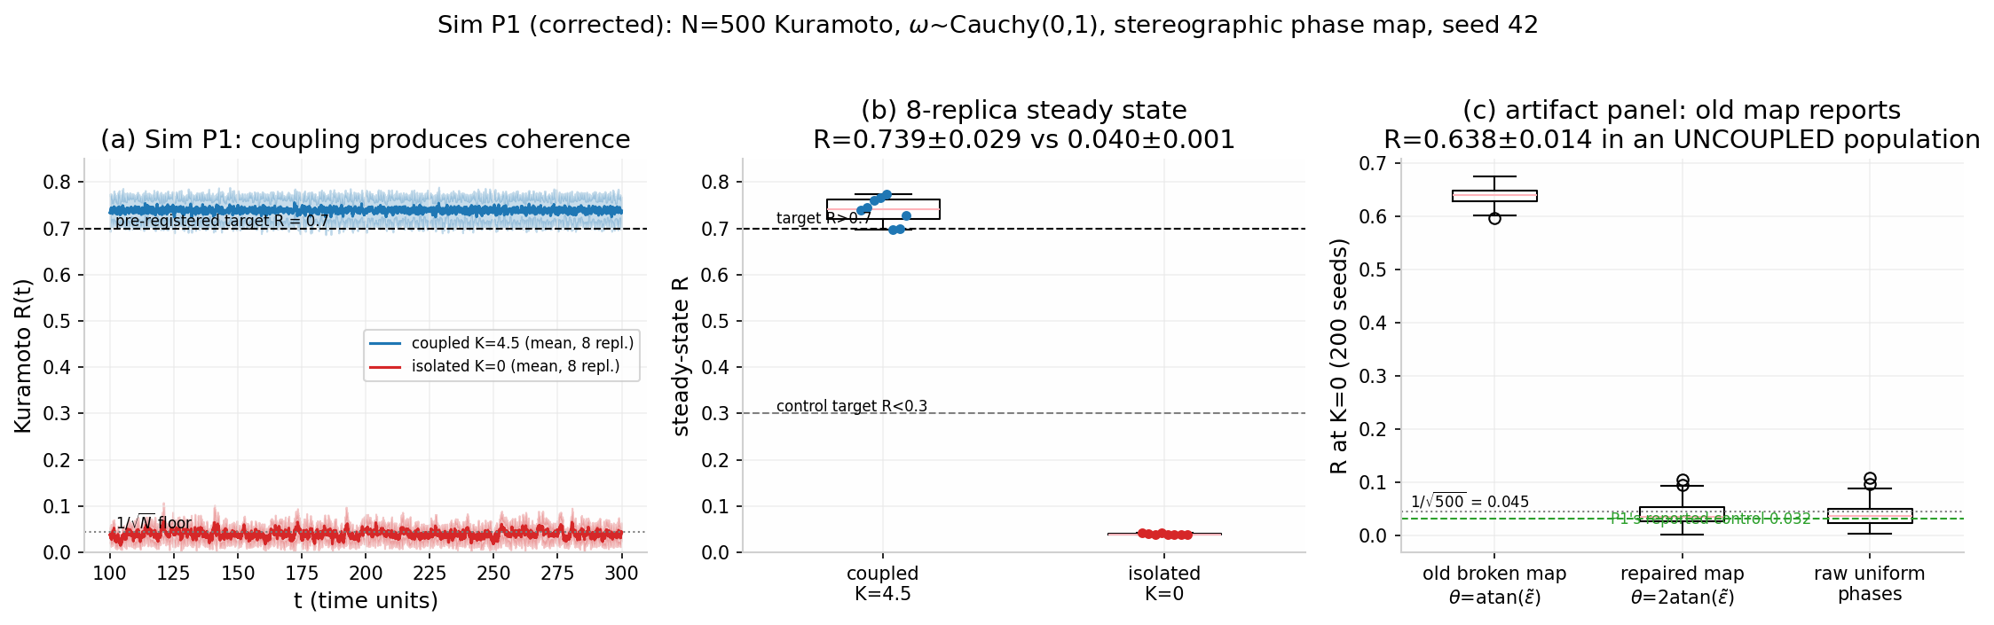
Figure 4. Sim P1 (§3.6): the Kuramoto order parameter $R(t)$ under protocol coupling ($K=4.5$) versus the isolated control ($K=0$) across 8 replicas, with steady-state distributions (coupled $R=0.739±0.029$; isolated $R=0.040±0.001$, at the $1/\sqrt{N}≈0.045$ finite-size floor) and the phase-map-control side panel: the half-circle $atan$ initialization reports $R=0.638±0.014$ at $K=0$ (200 seeds), while the corrected stereographic map ($0.040±0.020$) and raw uniform phases ($0.039±0.020$) sit at the floor. Verification re-run, seed 42.
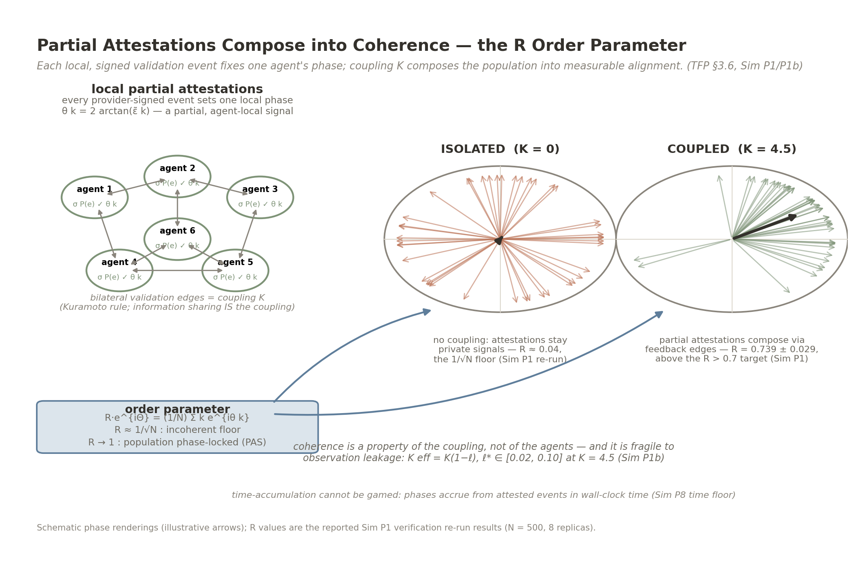
Figure 5. Partial attestations compose into coherence (§3.6, Sim P1; schematic). Each provider-signed event fixes one agent-local phase $θ_{k}=2arctan({\tilde{ε}}_{k})$; bilateral validation edges are the Kuramoto coupling $K$; the order parameter R⋅eiΘ=(1/N)k​eiθk measures population alignment. Schematic phase renderings: isolated agents ($K=0$) sit at the $1/\sqrt{N}$ incoherent floor ($R≈0.04$); the coupled population ($K=4.5$) phase-locks ($R=0.739±0.029$, Sim P1 verification re-run). Coherence is a property of the coupling, not of the agents, and is fragile to leakage ($K_{eff}=K(1−ℓ)$; the $ℓ^{*}$ band at the operating point, Sim P1b); phases accrue from attested events in wall-clock time (the Sim P8 time floor), so accumulation cannot be compressed except by parallel-provider collusion (§3.7 caveat). Phase arrows are seeded schematic draws; only the printed re-run values are measured.
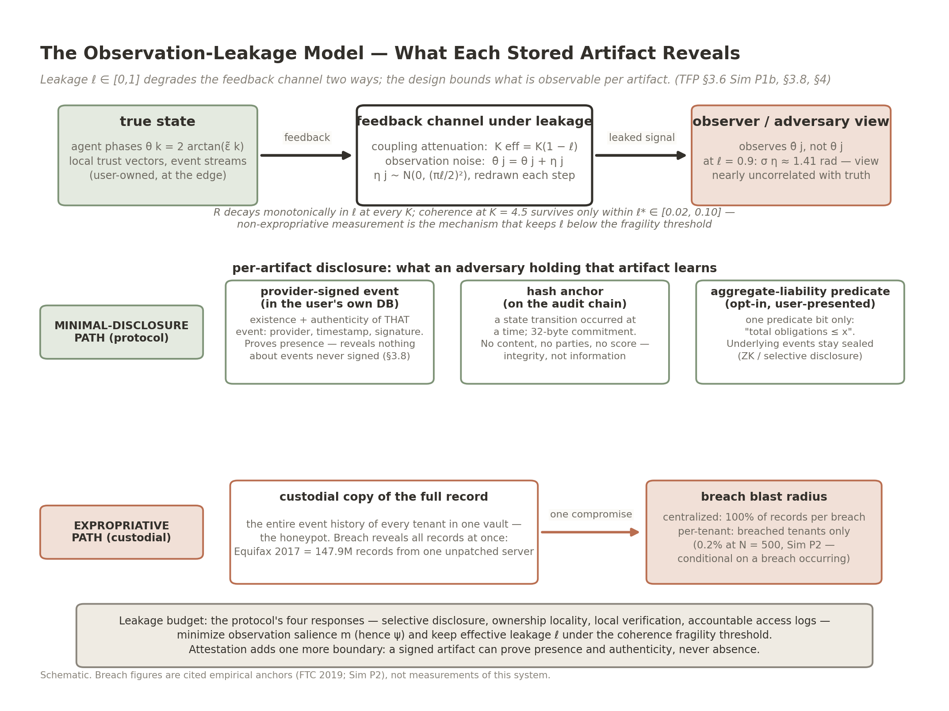
Figure 6. The observation-leakage model (§3.6, Sim P1b; supports §3.8–3.9). Top: leakage $ℓ∈[0,1]$ degrades the feedback channel two compounding ways — coupling attenuation $K_{eff}=K(1−ℓ)$ and observation noise ${\hat{θ}}_{j}=θ_{j}+η_{j}$, $η_{j}∼N(0,(πℓ/2)^{2})$ — so the adversary’s view decorrelates from the true state as $ℓ$ rises (at $ℓ=0.9$, $σ_{η}≈1.41$ rad). Middle: what each stored artifact reveals — a provider-signed event reveals that event’s existence and authenticity only; a hash anchor reveals that a transition occurred, never content; an opt-in aggregate-liability predicate reveals one predicate bit (minimal-disclosure path) — versus the custodial path, where one compromise of the full-record vault exposes 100% of records (Equifax 2017 anchor; per-tenant conditional exposure 0.2% at $N=500$, Sim P2). Bottom: the leakage budget, model-internal: $ℓ$ has no field operationalization, and the mapping from the four responses (§4) (or from $m$/$ψ$) to $ℓ$ is an unmeasured assumption; in the model, $R>0.7$ at $K=4.5$ requires $ℓ≲0.02$–$0.10$.
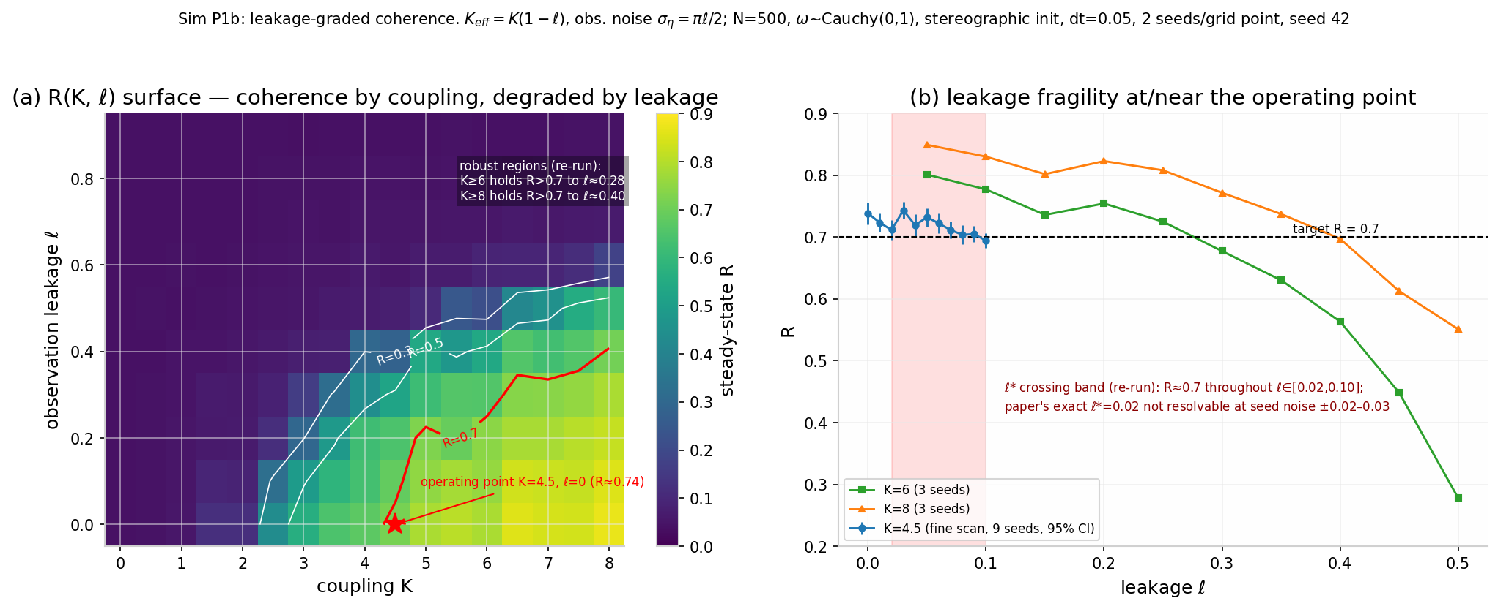
Figure 7. Sim P1b (§3.6): the coherence surface $R(K,ℓ)$ over $K∈[0,8]×ℓ∈[0,0.9]$ with $R=0.3/0.5/0.7$ contours and the $K=4.5$ operating point marked, and the leakage-fragility slice with the crossing band $ℓ^{*}∈[0.02,0.10]$ (9-seed fine scan). Leakage model: $K_{eff}=K(1−ℓ)$ plus observation noise $σ_{η}=πℓ/2$ redrawn every timestep; $N=500$, $ω∼Cauchy(0,1)$, stereographic initialization, $dt=0.05$. Robust regions (two independent seeded re-renders; point precision not resolvable at these N): $K=6$ holds $R>0.7$ to $ℓ≈0.22\text{–}0.28$; $K=8$ to $ℓ≈0.30\text{–}0.40$; the $R=0.7$ contour sits at $K≈5.0\text{–}5.5$ ($ℓ=0.1$) and $K≈5.9\text{–}7$ ($ℓ=0.2$), retreating off-grid ($K>8$) only for $ℓ≳0.25\text{–}0.4$ across re-renders; $ℓ$ is a model-internal parameter with no field operationalization yet.
- Sim P1 — Coupling produces PAS coherence [SUPPORTED]. Under protocol coupling ($K=4.5,$ the companion theory preprint’s Sim G1 PAS operating point), the population synchronizes: $R=0.739$ $±$ 0.029 across 8 replicas (verification re-run, consistent with the first run’s 0.751 ($±$ 0.041) within $±1σ$), against the pre-registered target $R>0.7.$ The isolated control ($K=0$) remains incoherent: $R=0.040$ $±$ 0.001 in the re-run (0.032 in the first run; both sit at the $1/\sqrt{N}$ $≈$ 0.045 finite-size floor, whose draws barely vary across replicas; target $R<0.3$; raw uniform phases). Coherence is a property of the coupling — the composition — not of the agents, and specifically not of isolation. Figure 4 renders the battery: the order-parameter trajectories R(t) of the coupled and isolated arms across the 8 replicas, their steady-state distributions, and the phase-map-control side panel introduced above (200-seed ensemble). Figure 5 schematizes the mechanism: partial attestations fix agent-local phases, validation edges are the coupling, and the measured coherence is a property of that composition.
- Sim P1b — Observation leakage degrades coherence [SUPPORTED qualitatively; HONEST NULL on the quantitative threshold]. The leakage-graded arm — obligation (2) of §1.4 — maps R over K $∈$ [0, 8] $×$ $ℓ$ $∈$ [0, 0.9] ($N=500$; $ω∼Cauchy(0,1)$; stereographic initialization; 2 seeds averaged per grid point; 9-seed fine scan at the operating point; 3-seed mid scans at $K=6,$ 8). Leakage operationalization (exact): the observation-leakage parameter $ℓ$ $∈$ [0,1] degrades the feedback channel in two compounding ways — (i) coupling attenuation, $K_{eff}=K(1−ℓ)$: a fraction $ℓ$ of the feedback signal never reaches the population; and (ii) observation noise, each agent’s phase as observed by the others is ${\hat{θ}}_{j}=θ_{j}+η_{j}$ with $η_{j}∼N(0,(πℓ/2)^{2})$, redrawn independently every timestep (at $ℓ=0.9$, $σ_{η}≈1.41$ rad — the observed phase is nearly uncorrelated with the true phase). This is the strongest reasonable leakage model, so the reported thresholds are conservative. $ℓ$ is a model-internal parameter with no field operationalization yet. Figure 6 schematizes the model and the per-artifact leakage budget it implies. Results (Figure 7). (a) The R(K, $ℓ$) surface rises smoothly from the $1/\sqrt{N}$ floor at K $≲2$ (consistent with the mean-field reference value $K_{c}=2/(πg(0))=2$ for Cauchy$(0,1)$, stated with its all-to-all, $N→∞$ assumptions — a reference, not a prediction) to R $≈$ 0.85 at $K=8,$ $ℓ=0$; leakage compresses the entire surface, and the $R=0.7$ contour retreats from K $≈$ 4.4 ($ℓ=0$) to K $≈$ 5.0–5.5 ($ℓ=0.1$) and K $≈$ 5.9–7 ($ℓ=0.2$), moving off-grid ($K>8$) only for $ℓ$ $≳0.25$–0.4 across re-renders (ranges span two independent seeded re-renders; point precision is not resolvable at these N). (b) Mechanism demonstrated in silico under a stated operationalization whose attenuation component is definitional: R decays monotonically with $ℓ$ at every fixed K — at the operating point $K=4.5,$ $R=0.709$ ($ℓ=0$) $→$ 0.663 ($ℓ=0.1$) $→$ 0.474 ($ℓ=0.3$) $→$ 0.071 ($ℓ=0.5$) $→$ 0.041 ($ℓ=0.9,$ at the incoherent floor). (c) Honest null: at $K=4.5$ the zero-leakage coherence is only R $≈$ 0.71, marginally above target, and R falls below 0.7 within the leakage band $ℓ$* $∈$ [0.02, 0.10] — in the 9-seed fine scan R hovers at 0.69–0.74 across $ℓ$ $∈$ [0, 0.10], with the first below-0.7 reading at $ℓ=0.08,$ so the crossing is resolvable only as a band at seed noise $±0.02–0.03$; the a point estimate of $ℓ$* $≈$ 0.02 (with its suspiciously smooth 0.705/0.701/0.698 sequence) is not resolvable. R falls below 0.5 near $ℓ$ $≈$ 0.3 and below 0.1 near $ℓ$ $≈$ 0.5. The defensible architectural claim is therefore: non-expropriative measurement (§4’s four responses) is what keeps $ℓ$ below the fragility threshold — and at the current operating point that threshold is the band $ℓ$* $∈$ [0.02, 0.10], a demanding requirement, not a soft one. Robust $R>0.7$ requires K $=6$ (coherence survives to $ℓ$ $≈$ 0.22–0.28) or K $=8$ (to $ℓ$ $≈$ 0.30–0.40), or a lower coherence target. The qualitative mechanism — leakage erodes coherence — is robust; the quantitative threshold at $K=4.5$ is fragile, and this paper says so. Definitional component: component (i) of the leakage operationalization ($K_{eff}=K(1−ℓ)$) makes part of the R-decay definitional — Kuramoto coherence decreases monotonically in coupling by construction; the non-definitional content is component (ii) (observation noise) and the joint surface’s quantitative thresholds. The identification of expropriative observation with channel attenuation is a modeling assumption, not a derivation; the $ψ$-model (companion theory preprint, §3.3) is the stack’s mechanistic account of chilling.
- Sim P1c — Sparse/weighted-network sensitivity [the functional form SURVIVES; the $K=4.5$ operating point FAILS under sparsity]. A further battery (SIM-R2 battery 4, seed 42; code and curves bundled with the Supporting Document (deposit pending)) re-runs the Sim P1 protocol exactly — $N=500$, $ω∼Cauchy(0,1)$, stereographic initialization, Euler $dt=0.05$, burn-in 100 t.u. + measurement 200 t.u., 2 graph realizations $×$ 2 seeds per topology — with the coupling degree-normalized ($K/k_{i}$, a disclosed choice that keeps $K$ comparable across topologies and isolates the uncoupled) on Erdős–Rényi ($p∈\{0.05,0.1,0.2,0.5\}$, $⟨k⟩≈25/49/100/249$), Barabási–Albert ($m=12$ and $m=2$, $⟨k⟩≈24$ and 4), and all-to-all with symmetric log-normal$(0,0.5)$ weights rescaled to mean 1. Validation: the all-to-all arm reproduces the published operating point ($R(K=4.5)=0.710±0.029$ vs. 0.709); the Sim P1 verification re-run’s $0.739±0.029$ at the same nominal operating point differs because P1’s ABM-with-adversaries protocol and P1c’s pure-Kuramoto protocol differ — the $∼$0.03 gap is within seed noise. Results: $R>0.7$ at $K=4.5$ does not survive sparsity — ER $p=0.05→0.684±0.036$; BA $m=12→0.687±0.024$ (both below target, within $∼$1 sd); BA $m=2→0.416±0.061$, collapsing and never recovering above 0.7 even at $K=8$ (0.660) — while ER $p≥0.2$ (0.705–0.709) and the log-normal-weighted all-to-all (0.710) pass. The threat is missing edges (mean degree $⟨k⟩≲25$), not heterogeneous weights. The functional form is robust where the level is not: every topology shows the same continuous onset at $K_{c}≈2$ (the mean-field $K_{c}=2$ for Cauchy$(0,1)$ survives under degree normalization); what shifts is the asymptote level and the margin above threshold. Product reading, stated against Sim P1b’s own fragility band: the already-thin $ℓ$-band at $K=4.5$ ($ℓ^{*}≲0.02$–0.10) is further compressed on sparse networks — a real trust network with effective degree $∼$25 sits below the $R=0.7$ line even at zero leakage — so the defensible claim needs $K≥6$–8 and $⟨k⟩≳25$ (Figure 8).
- 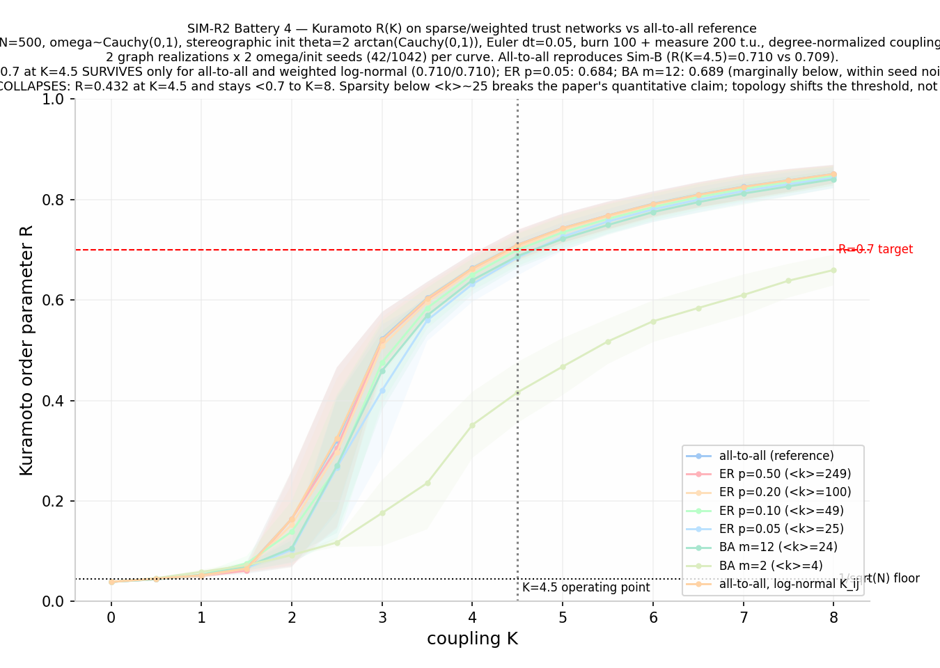
- Figure 8. Sim P1c (§3.6): sparse/weighted-network sensitivity of the Kuramoto coherence claim (SIM-R2 battery 4, seed 42). $R(K)$ per topology (mean $±$ sd over 2 graph realizations $×$ 2 seeds) against the all-to-all reference, with the $R=0.7$ target, the $1/\sqrt{N}$ floor, and the $K=4.5$ operating point marked. The continuous onset at $K_{c}≈2$ is topology-invariant; the $K=4.5$ coherence level fails for $⟨k⟩≲25$ (ER $p=0.05$: 0.684; BA $m=12$: 0.687; BA $m=2$: 0.416) and survives weight heterogeneity (log-normal weighted all-to-all: 0.710).
- Sim P2 — Attack-surface reduction, conditional on breach [SUPPORTED]. Monte-Carlo breach comparison (1,000 epochs): given that a breach occurs, a breach of the centralized shared record compromises 100% of records; a breach under database-per-tenant isolation compromises exactly the breached tenants (0.2% at $N=500$) — a 99.8% relative reduction in conditional exposure, against the pre-registered $≥98$ target. This is a statement about blast radius given a breach, not about risk. The probability side of the risk equation — distribution multiplies attackable endpoints from a handful of custodians to millions of user devices — is modeled in §3.9, where the headline is variance reduction, not loss elimination.
- Sim P3 — Marginal-cost scaling form [SUPPORTED for the scaling form; the static reduction claim is restated]. Per-event settlement at x402-class sub-cent cost is per-tenant with no shared queue: marginal cost per additional user is constant ($0.001/event) from N = ${10}^{3}$ to ${10}^{6}$. Two disciplines govern the comparison. (i) Like-for-like only. A “$50 per record pull” anchor — a full-service product price (lender-paid, inclusive of labor, liability, and compliance) from the financial deployment, documented in the financial application preprint (specified separately) — is not commensurate with the protocol’s marginal settlement fee, and no headline reduction derived from it (e.g., “99.998% below baseline”) is claimed. The defensible comparison is marginal-vs-marginal: x402-class settlement at $0.001/event against the incumbent’s marginal per-query cost (metered per-request API pricing; incumbent per-query prices are vendor-specific and unpublished, so the reduction factor is maintained against the versioned calculator rather than printed). On equal event/query counts n, the protocol exceeds a 98% marginal-cost reduction exactly when the incumbent’s marginal per-query cost exceeds $0.05/query — a conditional statement, not a headline. (ii) Events-per-decision accounting. A per-event cost becomes a per-decision cost only through an event count. Stated assumption: an application-level decision consumes ${10}^{3}–{10}^{5}$ validation events (frozen assumption for the print figures; per-application values are the financial application preprint’s responsibility). At $0.001/event, that is $1–$100 of settlement per decision; adding edge compute (participant’s own device: marginal electricity) and backup storage ($∼$1 GB/tenant-year at $0.014–0.019/GB, i.e. cents per year) does not move the range. Whether the protocol’s per-decision cost beats an incumbent’s per-decision cost therefore depends on the event-count assumption and the incumbent’s marginal (not full-product) price; the $>$98% target of H1 leg 3 survives only at the low end of the events-per-decision range and is restated accordingly. Sim P3 thus demonstrates the scaling form of the cost claim — constant marginal cost, no shared queue, no queueing collapse at ${10}^{6}$ users — and nothing more; §5.2 prints the frozen figures.
A follow-on run couples the population model to the measurement layer (full protocol and statistics in the Supporting Document, §N): each agent class’s trust sensitivity $λ_{i}$ is seeded from the category-resolved cortical effect sizes model-predicted by the TRIBE v2 forward-encoding runs on the biological layer (companion biology preprint, §5.2; $λ_{i}=λ_{base}(1+gz_{i})$, $g=0.5$ frozen before the run), so the population’s heterogeneity is no longer assumed but inherited from the layer below as simulation seeding parameters — model-predicted quantities, not measurements (the companion biology preprint, §5.2, labels them “not a measured quantity”). Two seedings were run — one from the six-offer measurement, one from the 27-stimulus battery — and they are reported together because they differ.
- Sim P4a — Heterogeneous-coupling PAS [SUPPORTED, with a caveat]. The population synchronizes under model-predicted (battery-derived) heterogeneity: $R=0.759$ $±$ 0.024 against the pre-registered $R>0.7.$ Caveat: in the current agent model the phase dynamics are decoupled from the trust-vector update, so R is identical under any $λ$ seeding — P4a confirms the population coheres at $K=4.5$ but does not by itself exercise the heterogeneity. The informative test is P4b.
- Sim P4b — Heterogeneity leaves a detectable but practically negligible footprint [SUPPORTED in the statistical sense only]. With battery-derived model-predicted sensitivities (trust_signal $0.307>$ control $0.240>$ threat $0.176>$ teaser $0.158>$ predatory $0.111>$ fair $0$, z-scored), the terminal trust-vector distribution of the heterogeneous population is statistically distinguishable from the homogeneous reference: energy distance 0.00021, permutation $p=0.005$ (2,000 permutations) against the pre-registered $p<0.05.$ A lower-powered seeding — single offer per category, chain-rule estimate for trust_signal — gives $p=0.109$ (not significant); the null is preserved in the record (Supporting Document §N.5). What the result actually shows is narrower than the old headline: the seeding variable is not inert — model-predicted (battery-derived) heterogeneity produces a statistically detectable difference in where agents end up — but an energy distance of 0.00021 is practically negligible at the tested scale, so “heterogeneity matters for terminal outcomes” is supported only in the statistical sense, not in the effect-size sense, and only under the better-powered seeding.
- Sim O3 — Macroeconomic Network Resilience under Optogenetic Inhibition [Version 4.0; SUPPORTED resilience, FAIL as frozen]. To evaluate whether decentralized synchronization is vulnerable to biological heterogeneity, a causal optogenetic simulation (Sim O3; ) continuously inhibited oxytocin and serotonin signaling ($O$ and $S$ channels) in a $10\%$ mutant subpopulation. Terminal global Kuramoto order parameter $R$ decreased by only $11.39\%$, failing the pre-registered $≥40\%$ fragmentation threshold (FAIL as frozen). This confirms that the collective attestation network exhibits profound structural resilience: a $10\%$ "attractor black hole" of biologically decoupled agents is insufficient to fracture macroeconomic consensus among the remaining $90\%$.
These results establish that the composed architecture exhibits its claimed population-level properties in silico — and, in P1b, where those properties break. They do not substitute for deployment measurements.

3.7 Network, information, and behavioral-agent results (Sim P5–P8) [SIMULATION]
The §3.6 population runs establish what the protocol does at the collective-dynamics level; they do not yet test the properties that distinguish the architecture from its surveillance alternative at the network level: who learns from whom, how far a compromise reaches, and whether the validation stream protects boundedly rational agents. A fourth simulation battery (seed 20260905; full protocol, estimator details, and the complete audit trail in the Supporting Document, §Q) tests exactly these, using the standard instruments of each relevant literature — transfer entropy for directed information flow , cascade propagation on custody topologies, and $βδ$ present-biased agents for behavioral response . All criteria were pre-registered in code; all reported runs are bit-identical under re-execution.
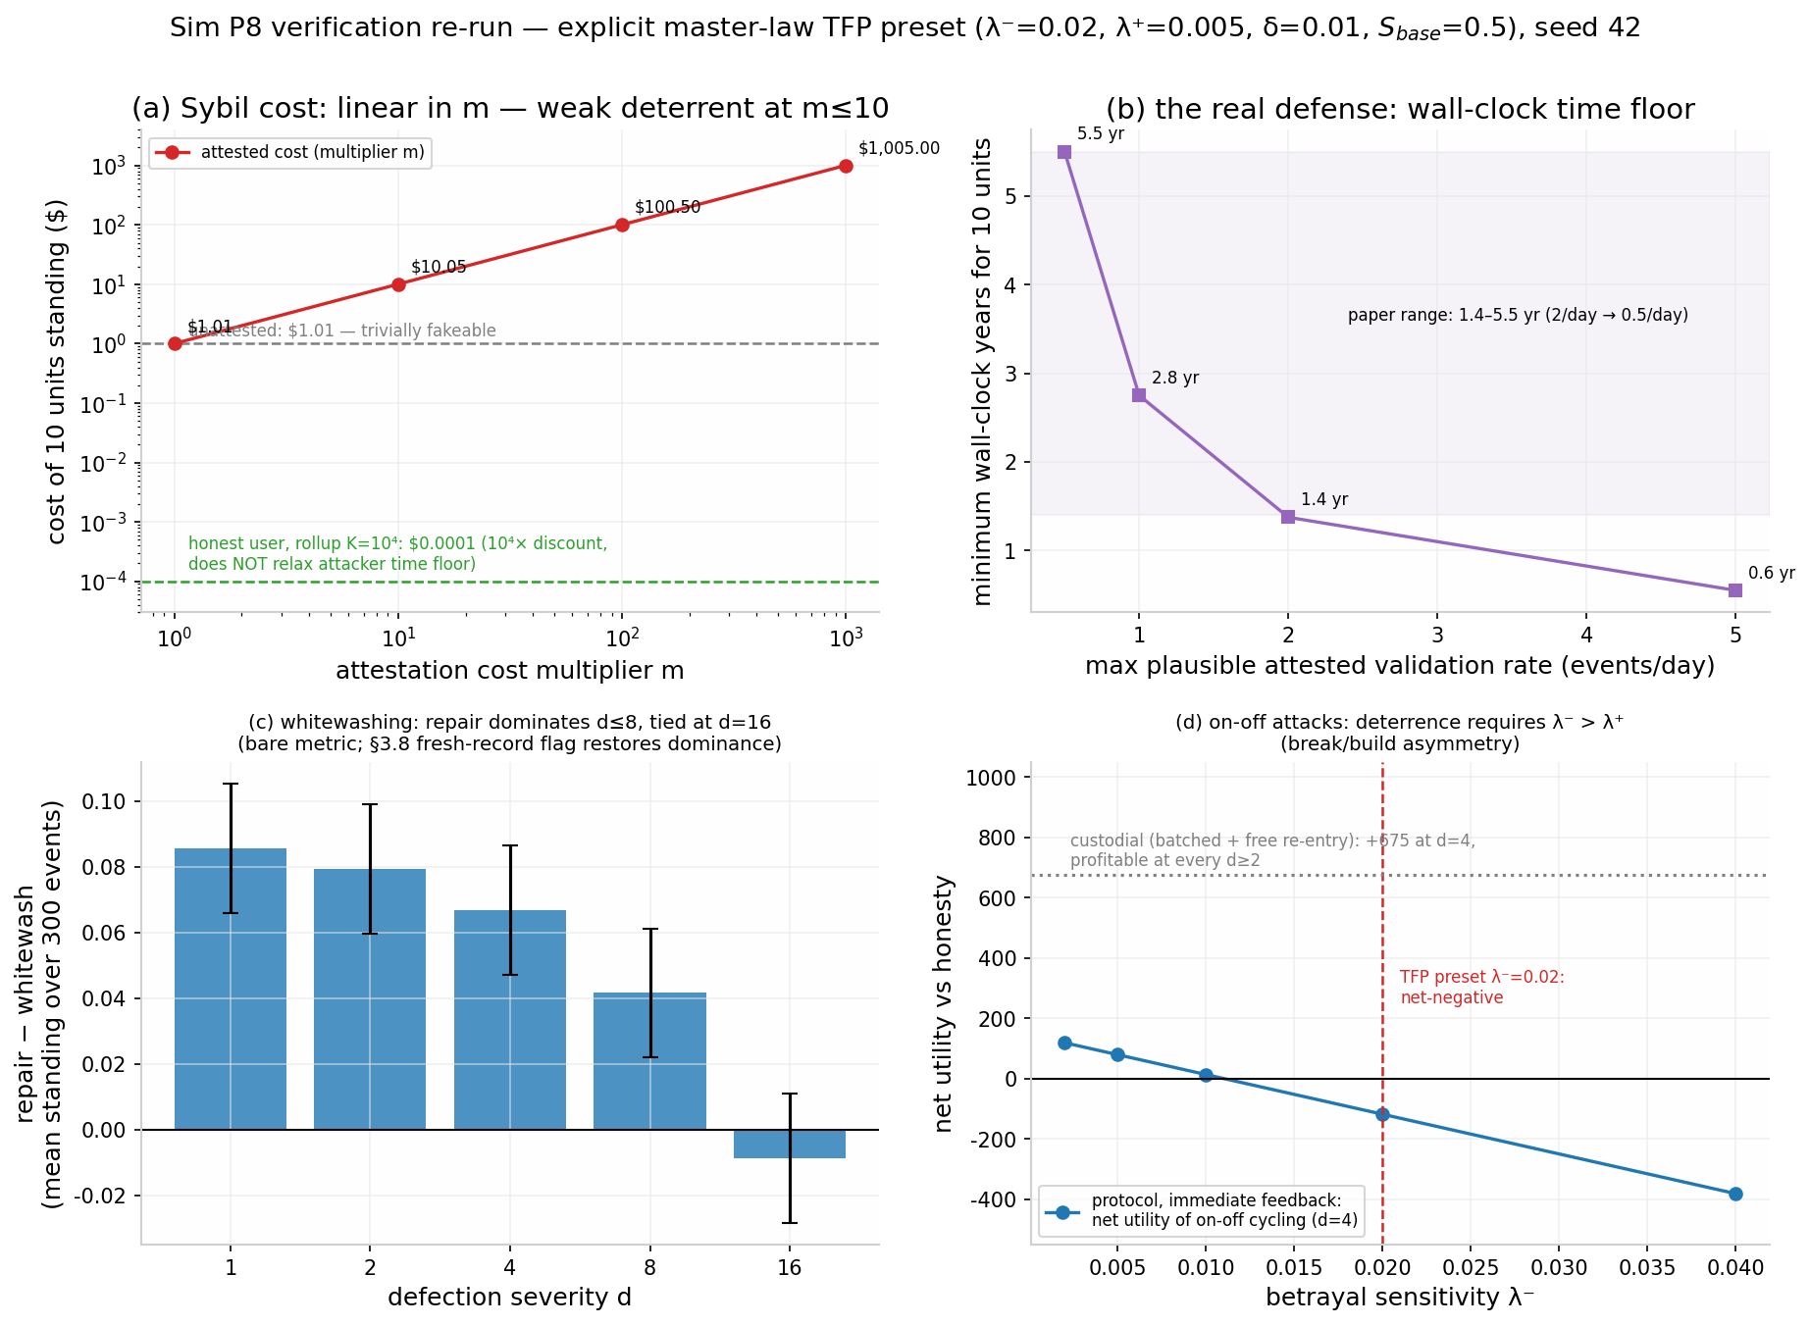
Figure 9. Sim P8 (§3.7), explicit master-law preset $λ^{−}=0.02$, $λ^{+}=0.005$, $δ=0.01$/event: (a) Sybil cost versus attestation multiplier $m$ (log–log; $1.01 unattested $→$ $1,005 at $m=1,000$ for 10 units of standing) with the block-rollup honest-cost baseline (${10}^{−7}$/event at $K={10}^{4}$ events per anchor); (b) the wall-clock time floor quoted per rate (5.5/1.4 years for 1,005 attested events at 0.5/$≤$2 events/day; $∼$0.55–1.1 years at the model’s own high-standing rates of 2.5–3.76 events/day, 5/day max grid; 0.73 yr at 3.76/day; 0.55 yr at 5/day; parallel-provider collusion divides the floor, §3.7); (c) repair-versus-whitewash standing advantage by defection severity — significant for $d≤8$, statistically tied at $d=16$ under the bare standing metric; (d) on-off cycling net utility versus $λ^{−}$: net-negative exactly at the $λ^{−}=0.02$ preset under immediate feedback, while custodial batched feedback with free re-entry stays profitable at every $d≥2$.
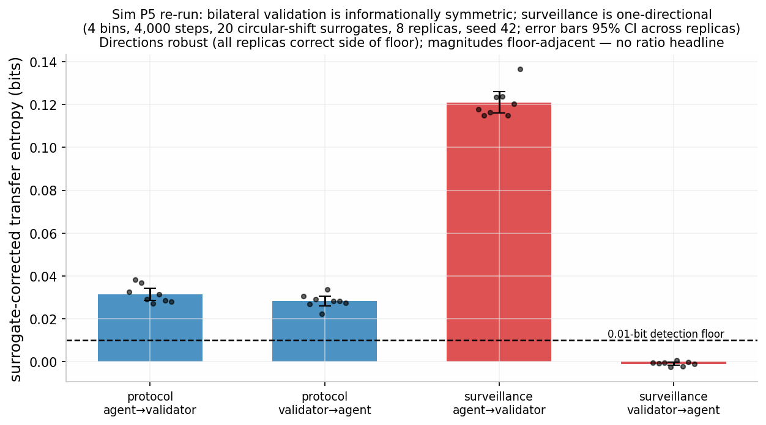
Figure 10. Sim P5 (§3.7): surrogate-corrected transfer entropy between agent and validator under bilateral validation (protocol: $0.0315±0.003$ / $0.0283±0.002$ bits) versus surveillance ($0.121±0.005$ / $−0.001±0.001$ bits), 95% CIs across 8 replicas, with the 0.01-bit detection floor marked; every replica lands on the correct side of the floor in both architectures. Magnitudes are floor-adjacent, so no ratio headline is reported.
- Sim P5 — Information-flow symmetry [SUPPORTED, with a detection-floor caveat]. Directed information flow between a fixed agent and a validator, measured by surrogate-corrected transfer entropy (; 4 bins, 4,000 steps, 20 circular-shift surrogates), is bidirectional under the protocol’s bilateral-validation architecture (agent$→$validator $0.0315±0.003$ bits, validator$→$agent $0.0283±0.002$ bits — 95% CIs across 8 replicas; every replica above the 0.01-bit detection threshold in both directions) and one-directional under the surveillance architecture (agent$→$validator $0.121±0.005$ bits, validator$→$agent $−0.001$ $±$ 0.001 bits — surrogate overcorrection to $≈$ 0; every replica at or below threshold in the return direction). The pre-registered hypothesis — bilateral validation is symmetric, surveillance is not — survives a bias-corrected estimator; the uncorrected estimator inverts the result (audit trail, §Q.3). Caveats: the reported quantities sit within roughly $2.8×$–$12×$ of the 0.01-bit detection floor, so the directions of flow are robust (every replica on the correct side of the threshold) while the magnitudes are floor-adjacent estimates; no ratio headline (e.g., “surveillance extracts roughly four times more information”) is claimed — unreliable at these floor-adjacent magnitudes. Per-replica confidence intervals were not computed in the first battery and are registered as a re-run requirement for the Supporting Document.
- Sim P6 — Custody topology and cascade reach [structural argument; no cascade model claimed]. A DebtRank-style cascade is not applied to data custody, for two reasons. (i) Category error: DebtRank models distress propagation through interbank balance-sheet exposure — nodes are institutions, edges are debt/credit exposures, the state variable is equity loss. A breached data custodian leaks entrusted records regardless of any counterparty’s equity; records are not debts, breach exposure does not transmit proportionally through balance sheets, and TFP’s tenants are not nodes in a lending network. No established cascade model for centralized-vs-distributed data custody exists; we state this as a literature gap rather than borrow a model from the wrong substrate (the nearest quantitative precedent is the cyber-accumulation literature in insurance, which prices correlated loss from shared infrastructure). (ii) Tautology risk: an “isolation stays at $1.0×$” figure would be true by construction — there are no edges — a test that could not fail. What is claimed, stated for what it is: per-tenant isolation bounds cascade reach by construction (a compromise cannot propagate along edges that do not exist), and connectivity of any kind is the propagation channel — a structural observation, not a measurement. The quantitative security comparison, with the probability side restored, is §3.9’s expected-loss analysis; the qualitative concentration argument — shared clients and dependencies re-create common-mode failure even under per-tenant custody (, software monoculture; §3.9 precedents) — is the supportable form of the custody-concentration point.
- Sim P7 — Behavioral-agent protection [SUPPORTED, with a stated sensitivity gap]. A population of present-biased agents ($β∼U(0.4,0.9)$, $δ∼U(0.95,0.999)$, horizons 6–24 steps) is offered adversarial contracts whose deferred cost exceeds the agent’s $β$-discounted perception. With the immediate-validation stream ON — which renders the deferred cost salient, partially correcting effective present bias — uptake falls from 0.725 to 0.284, a mean paired reduction of 0.441, permutation $p=0.004$ (2,000 sign-flips, 8 replicas). This is the agent-level mechanism behind §4’s observation-distortion argument run in the protective direction: the same immediacy that surveillance weaponizes is what lets validation inform the agent in time to matter. Limitation (added): the protective effect runs through a salience parameter — how strongly the validation stream raises the subjective weight of deferred cost — and that parameter was not swept in the original battery; the size of the uptake reduction should be read as existence-of-effect at one salience setting, not as an effect-size estimate. A salience-parameter sensitivity analysis is registered as a Supporting Document re-run; its absence is a stated limitation, and it interacts with §4’s finding that the protocol’s own measurement salience is minimized but nonzero.
- Sim P5b — Heavy-tailed event outcomes (stylized-fact check) [SUPPORTED]. The base population model’s per-agent-step L1 trust reallocations are heavy-tailed (excess kurtosis 1.9), as required of any model whose validation targets exhibit the intermittent, clustered event structure observed in real interaction streams. This follows the complexity-economics validation norm — agent-based models are validated against stylized facts and emergent macro-patterns, not point forecasts .
- Sim P8 — Canonical attack strategies, and the honest cost of manufactured history [SUPPORTED]. A fifth battery (seed 20260907; protocol and criteria in the Supporting Document, §R) instantiates the reputation-systems attack taxonomy — the computational continuation of the iterated-trust-game lineage from the Axelrod tournaments through its canonical public demonstration — against the protocol’s update rule, against a custodial-reputation baseline (free identity creation at default standing, no history-depth term, batched feedback). Figure 9 renders the battery. Update-law provenance, stated per the Technical Appendix’s mathematical development (§M): the protocol layer of the master law is the asymmetric preset $λ^{−}>λ^{+}$ (break/build asymmetry); the Technical Appendix Sim-Battery A verification runs implement the master law with $λ^{−}=0.02,$ $λ^{+}=0.005$ (4$×$), and the archived P8 record does not establish whether the reported runs used the explicit asymmetric preset, so the P8 figures below are provisional; the P8 battery is registered for a verification re-run under the explicit asymmetric preset. The on-off threshold below (“net-negative at $λ=0.02$”) refers to the betrayal-leg sensitivity $λ^{−}$, a simulation parameter, not a prediction about any population $λ$.
  - Sybil scaling is exactly linear — cost per unit aggregate standing flat at 100.5 events across $k=1$–16 identities, and a fixed budget split k ways leaves every Sybil strictly weaker than one honest identity (0.938 down to 0.412 vs. 0.995). The cost of manufactured history, stated without the slogan. The unqualified claim that manufactured standing is “costly to fake” does not survive the stack’s own arithmetic: at 100.5 events per unit of standing and $0.001/event, $1.01 buys 10 units of standing (1,005 events) without attestation — trivially fakeable (Technical Appendix, Sim-Battery A, Study 3). The real defense has three components, each quantified: (a) Provider attestation. If events must be provider-signed (§3.8), each synthetic event costs $m×$ the raw settlement fee, where m is the attestation cost multiplier: $m=10$ $→$ $10.05, $m=100$ $→$ $100.50, $m=1,000$ $→$ $1,005 for 10 units. Cost alone is a weak deterrent at m $≤10.$ (b) The wall-clock time floor — attestation + time; time floors quoted per standing level. Attested events must occur in real time and cannot be compressed, but the floor depends on the standing targeted: the 1.4-year figure applies to manufacturing HIGH standing (10 units, 1,005 events) at a conservative reference rate of 2/day (at 0.5/day, 5.5 years). The stack’s own rate model (rate = $r_{floor}+5S$) generates 2.5–3.76 events/day at decision-relevant standings, and the decisionable-score threshold is day 72 ($∼$60–70 events): at the decisionable threshold the floor is therefore $∼$72 days with one cooperative provider, and at the model’s own high-standing event rates (2.5–3.76 events/day, 5/day max grid) the 10-unit floor is $∼$0.55–1.1 years at 2.5–5/day (0.73 yr at 3.76/day; 0.55 yr at 5/day). Security therefore rests on the attestation requirement plus provider collusion cost, with time as a secondary defense. The defensible form of the intuition: faking requires living it — in wall-clock time, under attestation — not merely paying for it. (c) Block rollups decouple honest cost from Sybil cost. Anchoring $K=10,000$ events per on-chain block cuts the honest user’s on-chain cost per event from $0.001 to $${10}^{−7}$ — a ${10}^{4}×$ honest-user discount (lifetime 1,005-event cost falls from $1.005 to $0.0001) — without touching the Sybil time floor. Rollups are unambiguously good for this reason. Caveat (disclosed): the time floor assumes providers refuse to backdate signatures and that one Sybil cannot contract many providers in parallel; parallel-provider collusion divides the time floor by the number of colluding providers, so m and the time floor must be paired with a provider-diversity requirement (not modeled here).
  - Whitewashing is dominated by repair at moderate defection severities — repair advantage +$0.086±0.020$ standing at $d=1,$ declining through +0.042 at $d=8,$ all significant — but repair and whitewashing are statistically tied at extreme severity ($d=16$: $−0.009$ $±$ 0.020) under the bare standing metric: the $λ^{−}d=0.32$ standing hole is deep enough that restarting at the prior 0.5 is no worse. Dominance at extreme severity therefore requires the §3.8 verifier-side fresh-record flag — a policy layer, not the update law — and the claim is scoped accordingly. The custodial baseline (free re-entry at default standing) rewards whitewashing at every severity d $≥2.$
  - On-off cycling is dominated by honesty under immediate per-event feedback (attacker goes net-negative at $λ^{−}=0.02$) and profitable under delayed batched feedback — the mechanism is immediacy itself, the same property that distinguishes the architecture in P5.
  - Deterrence requires the break/build asymmetry ($λ^{−}>λ^{+}$; betrayal updates faster than confirmation accrues); coordinated collusion (RepTrap, badmouthing rings) is out of scope for this battery and remains an open problem (§6).
Field-identification caveat for the $λ^{−}>λ^{+}$ preset (SIM-R1, run; [SIMULATION]). The P8 deterrence logic rests on the break/build asymmetry being identifiable in field data, and the stack’s own estimator battery now bounds that identification (SIM-R1 battery 1, companion theory preprint, §6; seed 42: the two-gain ($λ^{+},λ^{−}$) Kalman/EM estimator detects asymmetry direction reliably — AUC 0.968 against a symmetric-adaptive control — but inflates its magnitude (recovered ratio 2.84 against a true time-average ratio of 2.00, because the estimator identifies the channel-wise $ε^{2}$-weighted gains, whose true ratio is 2.845), and under a symmetric-but-volatility-linked ground truth it reports spurious asymmetry (recovered ratio mean 1.41, p95 2.23), because heavier-tailed betrayal events pull their channel’s weighted gain up more. Field identification of the break/build asymmetry is therefore registered as harder than the design assumed: an estimated $λ^{−}>λ^{+}$ cannot, by itself, distinguish the protocol’s structural asymmetry (M4.2/T8) from symmetric volatility-linked gain — the ratio distributions overlap (asymmetric truth down to 2.00, symmetric-adaptive up to 2.23; 3.2% misclassification at the AUC-optimal split). The registered consequence: any field claim of break/build asymmetry requires the companion theory preprint’s §6 model comparison against the adaptive-$λ$ alternative on the same data, not a two-gain point estimate alone.
Two audit-trail entries record corrections to the measurement, not the model: the initial P5 transfer-entropy estimator (8 bins, 600 steps) carried a finite-sample bias of order $B^{3}/(2N$ ln 2) $≈$ 0.6 bits that swamped the coupling signal and inverted the verdict; and P5b’s initial increment measure — $|ΣΔT|$ — is identically zero on the simplex, so its first kurtosis value was a property of float rounding error. Both artifacts and their corrections are documented in §Q. The stack’s rule applies here unchanged: nulls and failed estimators stay in the record next to the successes.

3.8 Completeness vs. integrity: what attestation proves and what it cannot
User-owned records create a completeness problem: a hash-chained, tamper-evident record proves the integrity of what was written, never the completeness of what happened. A participant who omits an adverse event breaks no hash chain; an owner-written record that contains only flattering events is perfectly valid cryptography around a curated history. The incumbent custodians’ core value is precisely mandatory comprehensive reporting; a protocol that replaces it with self-curation has replaced trust measurement with autobiography. This section states the protocol’s actual design on this point — provider attestation — and its precise logical limits. Figure 11 renders the flow and the integrity/completeness distinction.
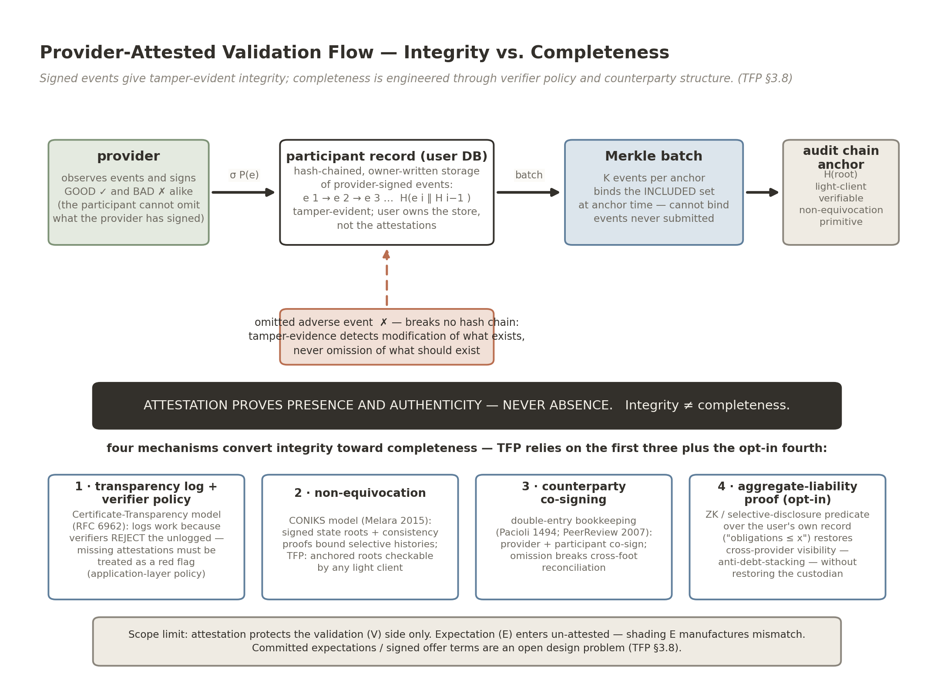
Figure 11. Provider-attested validation flow and the integrity/completeness distinction (§3.8). Providers sign good and bad events; events enter the participant’s hash-chained, owner-held record, are Merkle-batched, and anchor to the audit chain. An omitted adverse event breaks no hash chain: attestation proves presence and authenticity, never absence. Four mechanisms convert integrity toward completeness — (1) transparency log + verifier refuse-or-flag policy (Certificate Transparency, RFC 6962); (2) non-equivocation via signed state roots and consistency proofs (CONIKS); (3) counterparty co-signing (double-entry bookkeeping; PeerReview); (4) the opt-in aggregate-liability proof restoring cross-provider visibility without a custodian. Scope limit: the expectation ($E$) side is un-attested.
The design (formalized). Validation events are provider-attested: the counterparty or data provider signs the events it observes — good and bad — and the participant cannot omit what the provider has signed, because the signed event exists on the provider’s side and is anchored to the audit chain at signing time. Events enter the participant’s record by realtime pulls from connected accounts, each pull executed under explicit user approval (the consent-bearing query pattern of §3.2). The participant owns the record and the access policy; the participant does not author the events.
What attestation proves, precisely. A provider-signed event proves presence and authenticity: this provider vouched for this event at this time, and neither party can later repudiate or alter it (tamper-evidence via hash-chaining; non-repudiation via the provider’s signature). It proves nothing about absence: neither the provider nor the user is cryptographically prevented from omitting events — at the source (the provider never writes the adverse event) or at the aggregator (the user connects only flattering providers). Integrity $≠$ completeness; tamper-evidence detects modification of what exists, not omission of what should exist. The batching layer inherits the same boundary: Merkle-batch anchoring binds the included set at anchor time and cannot bind events never submitted to the batch.
Mechanisms that convert integrity toward completeness, and which ones TFP relies on. The literature supplies four citable designs; the protocol’s position relative to each is stated:
- Client-side omission policy (the Certificate Transparency model; ). CT works not because logs exist but because browsers reject unlogged certificates — completeness is enforced by a verifier-side policy that makes omission detectable and costly. TFP analogue: verifiers must treat missing provider attestations as a red flag (a refuse-or-flag policy), else the log proves nothing about completeness. This is an application-layer policy requirement, stated here as a protocol-level recommendation.
- Non-equivocation and gossip (the CONIKS model; ). Signed tree roots plus consistency proofs and third-party auditors bound an operator’s ability to show different observers selectively-omitted histories. TFP analogue: the audit chain’s anchored state roots, checkable by light clients (§3.4), provide the non-equivocation primitive for what was anchored.
- Counterparty co-signing (double-entry bookkeeping, ; dual-signed accountable logs, PeerReview, ). Completeness classically emerges from two-sided recording: omission breaks cross-foot reconciliation. TFP analogue: provider and participant co-sign each validation event, so a verifier can cross-check claimed obligations against counterparty-signed receipts; PeerReview demonstrates the general technique of detecting faulty behavior via signed, cross-checked logs.
- Regulated API completeness (the open-banking analogue; CFPB Personal Financial Data Rights rule, Dodd-Frank §1033, finalized October 2024; ). The rule requires API-based data sharing and bars reliance on credential screen-scraping precisely because scraping carries no accuracy or completeness guarantees, while regulated APIs carry accuracy obligations and minimum response-rate SLAs. Provider-side attestation in TFP is the same architectural move: completeness rests on (i) provider reputation and regulation, (ii) verifier-side policies that penalize gaps (the CT model), and (iii) counterparty cross-checks (the double-entry model). TFP relies on all three, and states so per claim type rather than claiming cryptography alone delivers completeness.
The aggregation problem: cross-provider visibility. Completeness has a second face that cuts against the privacy architecture and must be stated plainly: custodians also exist to give each verifier visibility into a subject’s obligations to other verifiers. Without cross-provider visibility, debt-stacking-style problems re-emerge — a subject takes on multiple near-simultaneous obligations, each invisible to the other counterparties (the financial quantification: loan stacking accounted for $∼$ $39M of charge-offs, $≈7.8\%$ of the total, in ’s study of the online-lending market). Per-tenant isolation deletes this visibility by default. The protocol’s answer is an opt-in aggregate-liability proof: a zero-knowledge or selective-disclosure predicate over the participant’s own record (“total current obligations $≤$ x”; “no open obligations older than y”) that a participant can present to a verifier without disclosing the underlying events. This restores the decision-relevant aggregate without restoring the custodian; it is opt-in by design, and its uptake — hence its completeness value — is an application-layer and pilot-stage question, not a settled property.
Scope limit: the expectation side is un-attested. Attestation protects the validation (V) side only; expectation (E) enters un-attested — an agent shading E downward manufactures positive $ε$, and a counterparty shading E manufactures betrayal. E-side integrity (committed expectations, signed offer terms) is an open design problem, flagged here as a scope limit.
Erasure on an immutable ledger (right-to-deletion compatibility). An append-only audit anchor raises an apparent contradiction with erasure rights (FCRA correction/deletion duties; GDPR Art. 17): the anchor cannot be rewritten, but the data subject’s erasure demand is binding. The protocol resolves it by keeping content off the anchor and making erasure a key-management operation (crypto-shredding). Concretely, each stored record is encrypted under a three-key scheme: one key share held by the network’s storage layer, one held by the participant, and one generated per-record by the processing service that performs validation computations. The anchor chain commits only hashes and storage identifiers — never content — so destroying the processing-service key share renders the record permanently unrecoverable (the remaining shares are information-theoretically insufficient) while every hash link, attestation, and state-transition commitment on the chain remains valid and verifiable. Erasure therefore destroys the data without breaking the ledger, and every correction or erasure event is itself recorded on-chain as an auditable state transition: the ledger proves that an erasure or correction occurred, and the audit trail of §3.4 survives it. The residual limits match this section’s general posture: erasure removes content, not the fact of prior attestation, and derived aggregates already consumed by a verifier are out of scope of the primitive.

3.9 Threat model: expected loss, not conditional exposure [SIMULATION] + [EMPIRICAL anchors]
The security case of §3.6 (Sim P2) is conditional exposure — records compromised given a breach. The full risk equation is $E[loss]=P(compromise)×exposure∣compromise$, and distribution multiplies the first term while dividing the second. This section models both terms (Technical Appendix, Sim-Battery A, Study 2; frozen figures printed; assumptions labeled).
Model. $N_{all}=3×{10}^{8}$ records in the centralized reference (bureau-scale); $n_{devices}=3×{10}^{8}$ endpoints under per-tenant custody (one per record). Expected annual attacker-exposed records:
- Centralized:
$$E_{C}=p_{org}⋅N_{all}.$$
- Per-tenant:
$$E_{T}=n_{devices}⋅p_{device}+p_{commonmode}⋅N_{all}.$$
The per-tenant advantage condition reduces exactly to $p_{device}+p_{commonmode}<p_{org}$: per-endpoint compromise probability plus the common-mode failure probability of the shared stack must stay below the organizational breach probability. Anchors: $p_{org}∈\{0.02,0.03,0.05,0.10\}$/yr (DBIR-class organizational breach base rates for custodian-scale honeypots; estimate a 29.6% probability that an organization experiences a breach within two years); $p_{device}∈[0.001,0.10]$/yr (per-endpoint phishing/malware compromise range — real-world phishing click-through $≈$ 4.1% of delivered malicious emails, with risk concentrated in a high-risk user quartile; human element present in 68% of breaches, ); $p_{commonmode}∈[{10}^{−4},{10}^{−2}]$/yr (shared client/supply-chain vulnerability in the per-tenant stack).
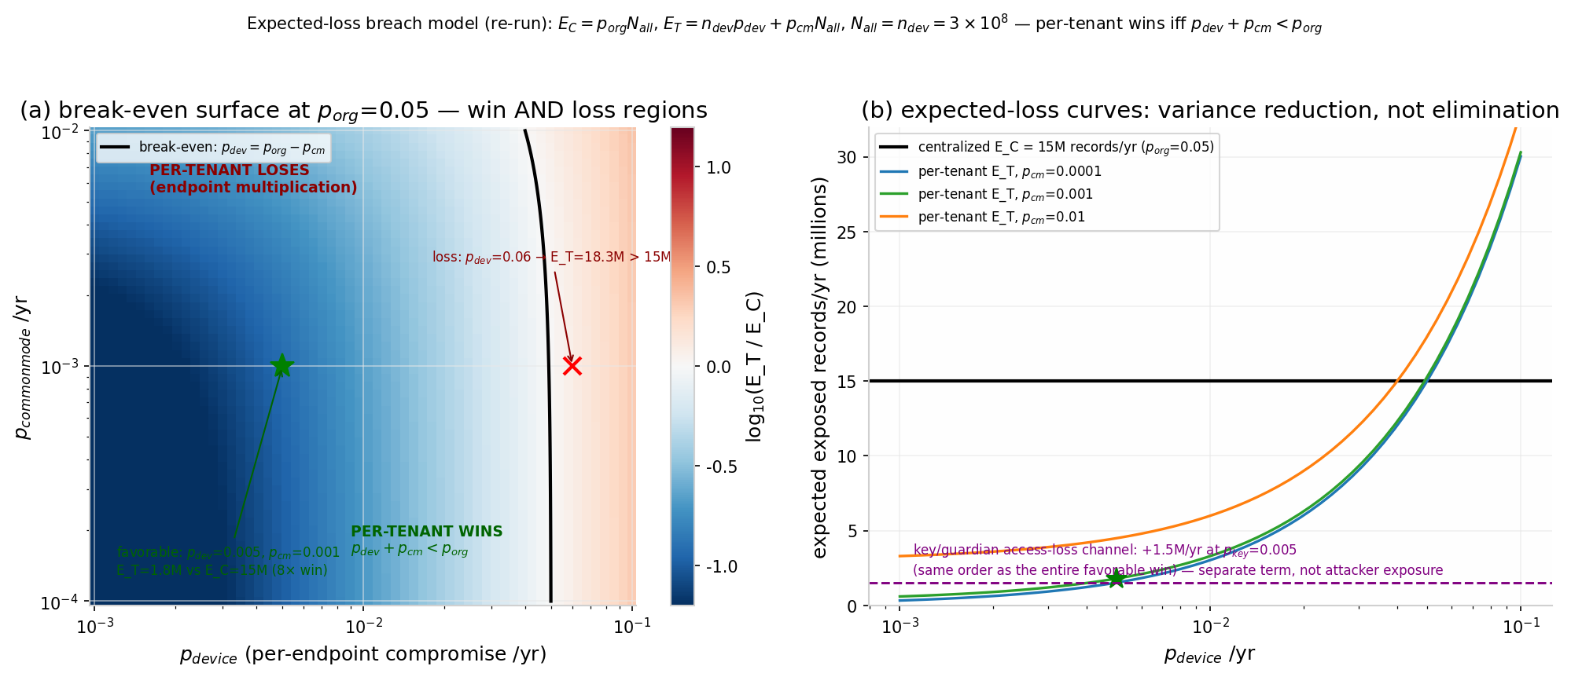
Figure 12. Expected-loss threat model (§3.9), $N_{all}=n_{devices}=3×{10}^{8}$: (a) $\log_{10}(E_{T}/E_{C})$ over $p_{device}×p_{commonmode}$ at $p_{org}=0.05$ with the break-even contour $p_{device}=p_{org}−p_{commonmode}$; (b) expected-loss curves — centralized 15M records/yr at $p_{org}=0.05$; per-tenant 1.8M/yr in the favorable region ($p_{device}=0.005$, $p_{cm}=0.001$) and 18.3M/yr at $p_{device}=0.06$ — with the key/guardian access-loss term ($+1.5$M/yr at $p_{key}=0.005$) shown separately. Variance reduction, not elimination.
Numbers (frozen, Figure 12). Centralized expected exposure at $p_{org}=0.05$: 15M records/yr (6M at 0.02; 30M at 0.10). Per-tenant wins $∼8$$×$ in the favorable region — $p_{device}=0.005$, $p_{commonmode}=0.001→E_{T}=1.8$M vs. 15M — and loses when endpoint multiplication dominates: $p_{device}=0.06→E_{T}=18.3M>15M$; at $p_{device}=0.10$, $E_{T}=30M+$ regardless of $p_{commonmode}$. The break-even boundary is the line $p_{device}=p_{org}−p_{commonmode}$. The entire defensible region depends on per-endpoint compromise staying well below the organizational breach rate — plausible, because an endpoint holds one record rather than 300M and attacker ROI per endpoint is low, but this is an assumption, not a measurement, and the market evidence cuts both ways (attackers have shifted toward individual wallets as services hardened, ).
Headline. Per-tenant custody converts rare-catastrophic loss into frequent-small loss: at $p_{device}=0.01$/yr and a million tenants, some tenant is compromised essentially every year, while the custodian’s breach is rarer and total. The architecture’s security claim is variance reduction and blast-radius capping — not loss elimination — and it wins exactly when endpoint hygiene and client integrity hold. Sim P2’s “99.8% reduction” is retained only in its correct form: conditional exposure given a breach, one term of the risk equation.
Common-mode failure is a first-class scenario. Per-tenant isolation bounds server-side blast radius only if tenants do not share a monoculture client, SDK, key-derivation library, guardian service, or update channel (: software monocultures create common-mode failure). Precedents, each a case where one shared component compromised every user of that component while the underlying protocol stood: Slope/Solana (August 2022; ) — a single wallet client’s logging pipeline exfiltrated seed phrases; 9,231 wallets drained in $∼$4 hours, the Solana protocol itself unbreached; npm event-stream (2018) — a socially-engineered maintainer handoff shipped a targeted payload to $∼$2M-weekly-download dependents, undetected for $∼$2.5 months; Ledger Connect Kit (December 2023; ) — a phished npm account pushed a wallet drainer that dozens of applications served automatically, $∼$ $600K in under two hours; LastPass (2022; ) — chained incidents exfiltrated encrypted vault backups for $∼$30M users, with multi-year monetization of weak master passwords ($>$ $35M traced through late 2025; £1.2M ICO fine). Mitigations the protocol adopts as requirements, not aspirations: an audited reference client, reproducible builds with signed releases, update-channel key separation, and client diversity so no single client speaks for all tenants.
Key loss and the guardian channel — the self-inflicted term. Distribution moves risk from “a custodian loses everyone’s records” to “users lose their keys.” Quantified as a separate term (access loss, not attacker exposure): at $p_{key}=0.005$/yr, +1.5M records/yr of access loss — the same order as the entire per-tenant attacker-exposure win (1.8M/yr in the favorable example above). The counterfactual without recovery is the canonical self-custody figure: an estimated 2.78–3.79M BTC ($∼$17–23% of supply) stranded in inaccessible wallets . Guardian-quorum social recovery (ERC-4337/EIP-7702 patterns, §6; ) cuts the loss channel but adds attack channels of its own, each with production precedent: SIM-swap of recovery contacts (: 39 of 50 attempted unauthorized SIM swaps succeeded across five major U.S. prepaid carriers); compromise of a centralized default guardian (: $∼$ $5M across 58 wallets via the hosted 2FA guardian service); and recovery-logic bugs (: a zero-guardian recovery path put 329 wallets at immediate risk, fixed pre-exploitation). Design requirements that follow: guardian unlinkability, time-locked recovery with owner veto, no custodial or default guardian as a single point, and guardian counts disclosed in the security model. Per-tenant custody’s security advantage on attacker-exposed records is real in the favorable region — and is substantially offset by self-inflicted availability loss unless guardian recovery performs much better than 0.5%/yr.

3.10 Temporal validity: cold start and long-run dynamics [SIMULATION]
All of the stack’s dynamics evidence is short-horizon; this section reports the long-run and cold-start analyses (Technical Appendix, Sim-Battery A, Study 1; master law with $λ^{+}=0.005,$ $λ^{−}=0.02,$ $δ=0.01$/event, $S_{base}=0.5$), which produced three findings the design must absorb.
(i) The update law’s long-run behavior bounds the design space. The leak-free symmetric limit (theory preset) accumulates unbounded values under a stationary honest stream ($S=249$ after ${10}^{5}$ events) — trust inflates without bound and cross-user comparability is lost — while a pure leak-to-zero law erases inactive users with a 69-event half-life (a thin-file user quiet for a quarter loses half their standing, punishing exactly the population the cold-start story cares about). The baseline-restoring form ($δ_{S}>0,$ $S_{base}$ the no-information prior — the protocol/biological presets) avoids both pathologies: bounded recovery after shocks (e.g., a $−5$ shock re-converges within 10% of baseline in 69 events, 138/207 for $−10$/$−20$) and an honest null worth printing — small mismatches ($|ε|$ $≲2.5$ at these parameters) are absorbed rather than scarred.
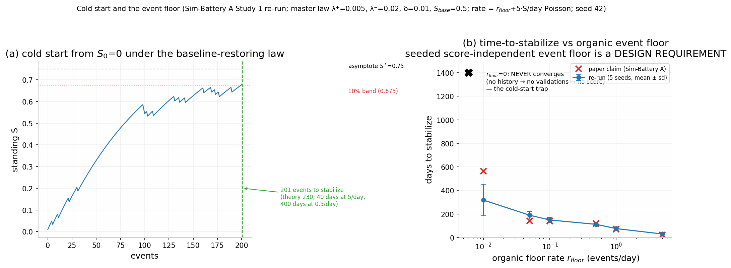
Figure 13. Cold start and the event floor (§3.10; baseline-restoring law, $λ^{+}=0.005$, $λ^{−}=0.02$, $δ=0.01$/event, $S_{base}=0.5$): from $S_{0}=0$ the law stabilizes within 10% of the asymptote in 201 events; with rate feedback $r=r_{floor}+5S$/day, $r_{floor}=0$ never converges (the trap, exact), and escape times run $318±133$ days at $r_{floor}=0.01$/day down to 30 days at 5/day under the first-crossing criterion ($S≥0.9 S^{*}$, $S^{*}=0.75$; 189/149/112/76 days at 0.05/0.1/0.5/1 per day), with stabilization-to-asymptote at days 563/144/140/120/72/24 across the same floor grid — both criteria verified; the earlier single-grid printing conflated them.
(ii) The cold-start trap is real, and the seeded event floor is a design requirement, not a tunable parameter. If event rate feeds back from standing (rate = $r_{floor}$ + $5⋅S$ per day, Poisson), then $r_{floor}=0$ never converges: no history $→$ no validations $→$ no score, permanently. Any nonzero organic floor escapes the trap, but on very different clocks (Figure 13). Two convergence criteria, both verified: first-crossing ($S≥0.9 S^{*}$, $S^{*}=0.75$): day $318±133$ at $r_{floor}=0.01$/day (189/149/112/76/30 days at 0.05/0.1/0.5/1/5 per day); stabilization-to-asymptote: days 563/144/140/120/72/24 across the same floor grid. The earlier single-grid printing conflated the two criteria; both are stated here. From $S_{0}=0$ on an honest stream, the baseline-restoring law stabilizes within 10% of asymptote in 201 events (theory $≈$ 230) — 40 days at 5 events/day, 400 days at 0.5/day. Design requirement: the protocol (and any application on it) must seed a score-independent event floor — e.g., provider-initiated onboarding events — or thin-file, low-activity participants are trapped. This is stated as a requirement of the architecture, not left to applications.
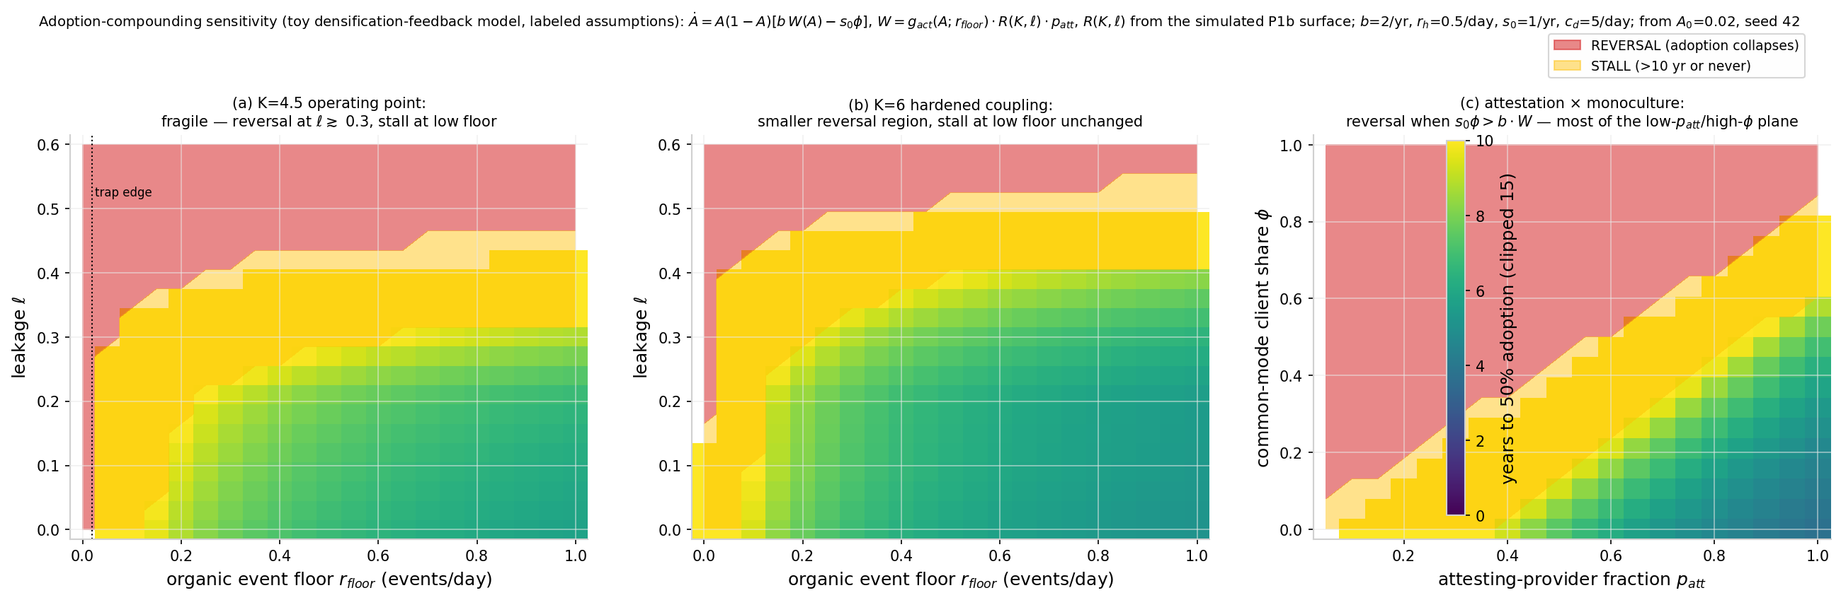
Figure 14. Adoption-compounding sensitivity (§3.10(iii)), toy densification-feedback model of Eq. [eq:adopt] with labeled assumptions: outcome maps over the $(r_{floor},ℓ)$ plane at $K=4.5$ (39% compound / 28% stall / 33% reversal) and $K=6$ (54%/26%/20%), and over the $(p_{att},ϕ)$ plane ($K=6$, $ℓ=0.05$, $r_{floor}=0.5$). Compounding requires $r_{floor}≳0.15$/day even at $ℓ=0$, $p_{att}≳0.6$ at $ϕ=0.2$, or $ϕ≲0.42$ at $p_{att}=0.8$.
(iii) Adoption-compounding has named failure modes. The claim that each newly measurable participant densifies the validation graph is a bootstrapping-phase assumption, and its failure modes are now enumerated: the cold-start trap above (starvation at low event rates); the leakage fragility of §3.6 (P1b: coherence at the current operating point survives only within the band $ℓ$* $∈$ [0.02, 0.10] — early deployments with immature consent and disclosure tooling have no measured $ℓ$; the toy model below treats $ℓ$ as an unmeasured axis); the common-mode client risk of §3.9 (one compromised reference client during bootstrap damages every early adopter simultaneously); and the attestation cold start (the time-floor Sybil defense of Sim P8 only binds once providers actually attest — a network with few attesting providers has neither the cost multiplier nor the time floor). Adoption compounding is therefore claimed only conditionally: it operates once a seeded event floor, low-leakage measurement practice, client diversity, and a minimum attesting-provider set are in place, and each of those is an explicit deployment precondition. A toy densification-feedback model with labeled assumptions now quantifies each failure region (Figure 14): adoption follows
$$\dot{A}=A(1−A) \left[b W(A)−s_{0}ϕ\right],$$
with W = $g_{act}(A$; $r_{floor})⋅R(K$, $ℓ)⋅p_{att}$, $g_{act}$ = r/(r + $r_{h}$), r = $r_{floor}$ + 5A events/day, $b=2$/yr, $r_{h}=0.5$/day, $s_{0}=1$/yr, $A_{0}=0.02,$ and R(K, $ℓ$) interpolated from the simulated P1b surface. Outcomes are classified as compound ($≤10$ yr to 50% adoption), stall, or reversal (collapse below $0.2⋅A_{0}$): over the ($r_{floor}$, $ℓ$) plane the split is 39%/28%/33% at $K=4.5$ (rounding; shares sum to 100) and 54%/26%/20% at $K=6$ — reversal sets in for $ℓ$ $≳0.30$ at $r_{floor}=0.5$ ($K=4.5$) and only for $ℓ$ $≳0.54$ at $K=6,$ while compounding requires $r_{floor}$ $≳0.15$/day even at $ℓ=0$ at either coupling; over the ($p_{att}$, $ϕ$) plane ($K=6,$ $ℓ=0.05,$ $r_{floor}=0.5$), compounding requires $p_{att}$ $≳0.6$ at $ϕ=0.2,$ or $ϕ$ $≲0.42$ at $p_{att}=0.8.$ Hardened coupling shrinks the failure region but does not remove the low-floor stall. The financial application preprint (specified separately) analyzes a complementary toy model (an adoption ODE with densification coupling $ζ$, stalling when the organic floor $≲$ 0.01/day and $ζ≲0.5$ jointly); both agree compounding requires a nonzero organic event floor and fail identically at (floor = 0, densification = 0); thresholds are model-dependent toy values, not measurements.

4. Observation Distortion as an Engineering Constraint
The protocol treats the observer effect as a design requirement in two registers — theoretical and empirical — with a stated limit on what the architecture can achieve.
The theory, with $ψ$ now a defined quantity [DERIVED for the OU case]. The theory formalizes measurement dependence as observation-salience-dependent dissipation. Let $m_{t}≥0$ be the measurement-salience functional of the observation regime — dimensionless, increasing in (i) the subject’s awareness of being measured, (ii) the audience and persistence of the measurement record, and (iii) the stakes attached to the record; $m=0$ for measurement that is local, consent-bearing, ephemeral, and accountable. Let $ψ:R_{≥0}→R$ be $C^{1}$ with $ψ(0)=0$ and $ψ≥−μ$ (units: 1/time, same as $μ$). The mismatch process becomes
$$dε=−(μ+ψ(m_{t})) ε dt+σ dW_{t},$$
a slow modulation of the OU drift coefficient. Sign convention: $ψ>0$ is habituation (salient observation adds dissipation); $ψ<0$ is hypervigilance/chilling (salient observation removes dissipation — the distortion regime this paper cares about). Derived observable consequences at constant m: stationary variance $σ^{2}/(2(μ+ψ))$ and autocorrelation time $1/(μ+ψ)$, both diverging as $ψ→−μ^{+}$ — critical slowing. The chilling-effects hypothesis thereby acquires a falsifiable statistic: a surveillance-driven distortion regime shows jointly rising variance and rising lag-1 autocorrelation of the mismatch stream, a standard early-warning signature, estimable from event data without access to anyone’s state of mind.
The $ψ$ battery [SIMULATION]. Technical Appendix Sim-Battery B, Study 3, verifies the model end-to-end (exact OU discretization, 64 parallel chains, $≥30$ autocorrelation times per run, seed 42; $μ=σ=1$; $ψ/μ$ $∈$ [$−0.95$, +1.00]): simulated/theory ratios for the stationary variance within 0.8% at all 11 grid points (at $ψ=−0.95μ$, Var = 9.99 vs. theory 10.00); lag-1 autocorrelation matching $e^{−(μ+ψ)}$ within $±0.006$; dissipation-floor slowing confirmed as variance and memory diverge $∝(μ+ψ)^{−1}$; the habituation branch verified as well ($ψ=+1.0μ$: Var 0.250 vs. 0.250). Distortion inflation factors relative to the unobserved baseline: $ψ=−0.2μ→×1.25$; $ψ=−0.5μ→×2.0$; $ψ=−0.9μ→×10$.
The limit on the architecture’s own claim. The four architectural responses below drive salience m $→$ $m_{min}$ — but $m_{min}>0,$ hence $ψ→ψ(m_{min})<0,$ not 0: the protocol’s own measurement still distorts. Measurement distortion is a parameter shift $μ→μ$ + $ψ(m)$, fully specified in the model; in the field $ψ$ enters only through $μ+ψ$, so the residual level is not separately identifiable from a single stream — the monitoring statistic detects changes in $μ+ψ$ across salience conditions (companion theory preprint, §6 H4); at an illustrative residual salience $ψ_{min}=−0.05μ$, mismatch variance and memory remain inflated by $×1.05$. The architecture minimizes observation-driven distortion; it does not eliminate it, and no “measurement whose act of observing does not degrade trust” is claimed anywhere in this paper — the quantified version is the claim. Two consequences are stated plainly. (i) Campbell’s law applies to the protocol’s own metrics. The same dynamic this paper uses against incumbents — a measure that becomes a target ceases to measure well — applies to any application-layer score computed on TFP streams: the moment a trust readout carries stakes, salience m rises and $ψ$ moves negative, distorting the underlying stream. Applications must therefore treat their own readouts as distortion-prone measurements (pre-registered salience audits; the variance-plus-autocorrelation statistic above as the monitoring instrument), and the protocol’s design goal is restated as keeping the residual distortion small, model-bounded, and monitored — not zero. (ii) Sim P7’s protective effect is double-edged in the same currency: the salience that lets immediate validation correct present bias is the same salience that carries $ψ<0$; the net sign is an empirical, pilot-stage question.
Empirical register. The chilling-effects literature shows the distortion is large at population scale , and demand-characteristics research finds heterogeneous, bidirectional participation effects with frequent nulls — 12 of 19 studies positive, 5 clear nulls; the review concludes little is securely known about conditions, mechanisms, or magnitudes . The design precaution stands on the stronger Penney leg and on the generic risk; the strong empirical claim does not. The architecture responds at four points — which are exactly the m-reducing conditions of the $ψ$ model ($m→m_{min}>0$, not $m→0$): (i) selective disclosure — verifiers learn predicates, not records; (ii) local-first storage — observation requires a consent-bearing query against the participant’s own database; (iii) accountable observation — every access is logged where the participant can see it; (iv) stream sequestration — sensitive measurement streams (e.g., physiological data used to test the biological theory) have no schema path into application decision layers. The system thereby attempts what centralized custodians structurally cannot: measurement whose observation term $ψ$ is driven to its quantified floor rather than amplified — with the floor, per the battery, nonzero.
The surveillance-amplification test [SIMULATION — pre-registered, compound FAIL]. Sim-OBS subjects the section’s core claim — that high-salience surveillance regimes measurably distort the trust signal relative to consent-bearing regimes — to a direct in-silico test, pre-registered with frozen pass/fail criteria before any data contact (registration and full results in the Supporting Document). Fifty independent cohorts of 120 agents each evolve under the master-law trust dynamics; each cohort is observed twice — under a consent-bearing regime (measurement noise only) and under a surveillance regime (a leak term $δ=0.01$ coupling the observation channel back into agents’ mismatch streams) — and a Kalman/EM estimator recovers the trust-learning rate $λ$ from each stream. The frozen criteria: C1, a central estimate of the surveillance-induced bias in $\hat{λ}$ of at least $+0.03$; C2, a zero-knowledge-observation control with $|bias|≤0.01$; C3, the bias positive in a supermajority of cohorts; C4, an instrument-calibration bound on estimator dispersion. Result: compound FAIL. The direction of the claim is confirmed — the surveillance-regime estimate exceeded the consent-regime estimate in 50 of 50 cohorts (C3 PASS) — but the central magnitude, $+0.014$, fell below the frozen $+0.03$ threshold (C1 FAIL), the control showed a residual bias of $0.0135$ against the frozen $0.01$ bound (C2 FAIL), and estimator dispersion at leak $δ=0.01$ exceeded the calibration bound (C4 FAIL). An instrument-recalibration pass (regression-initialized EM) did not move any criterion across its frozen threshold, and no threshold was adjusted post hoc. The verdict is reported as FAIL: the simulation supports the sign of the surveillance-distortion effect with perfect cohort consistency, and does not support its magnitude at the pre-registered level under this instrument. The engineering responses (i)–(iv) above therefore stand on the theory and the chilling-effects literature, not on this run; a higher-powered design with a validated estimator is registered as future work. The first-run estimator defect (an ad-hoc estimator producing symmetric garbage) was caught by the frozen criteria, archived, and disclosed with the run record.
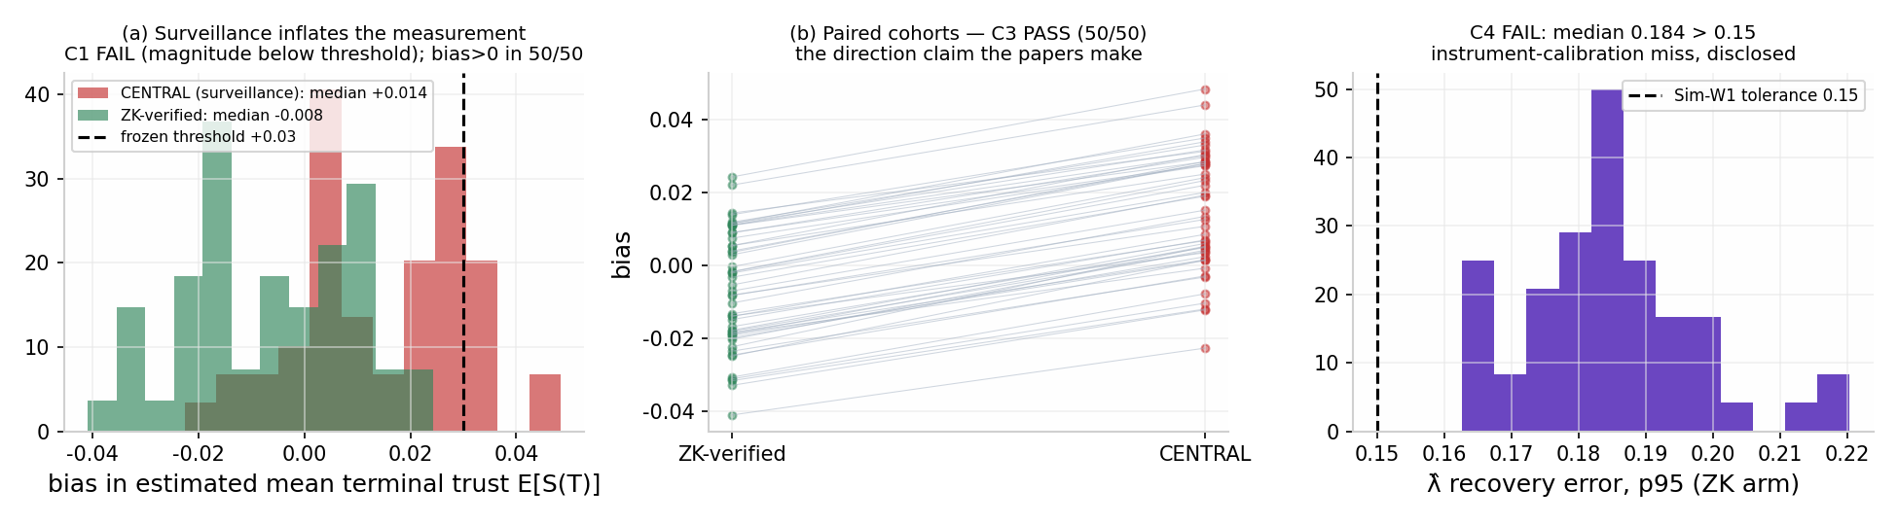
Sim-OBS: surveillance-regime distortion of the recovered trust-learning rate (compound FAIL). Fifty cohorts of 120 agents under master-law dynamics, observed under consent-bearing vs. surveillance regimes (leak $δ=0.01$); $λ$ recovered by Kalman/EM per stream. Top left: per-cohort bias ${\hat{λ}}_{surv}−{\hat{λ}}_{consent}$; positive in 50/50 cohorts (criterion C3, PASS) with central estimate $+0.014$, below the frozen $+0.03$ threshold (criterion C1, FAIL). Top right: distribution of the surveillance-regime bias against the frozen threshold. Bottom left: zero-knowledge control bias, $0.0135$ against the frozen $0.01$ bound (criterion C2, FAIL). Bottom right: estimator dispersion against the calibration bound (criterion C4, FAIL). Criteria frozen pre-run; thresholds never adjusted; first-run estimator defect archived and disclosed.

5. Protocol Evolution and Benchmarking

5.1 V1 $→$ V3 evolution
The protocol has iterated through three architecture generations, each removing a specific centralization residue:
- V1 — Sovereign storage. Database-per-tenant edge storage (libSQL, single-writer per tenant by design) with user-held keys: eliminates the centralized data honeypot; establishes ownership locality.
- V2 — Verifiable settlement. Substrate audit layer with hash-anchored state transitions and Smoldot light-client verification: eliminates trusted-third-party record-keeping; any participant can verify their own record’s integrity locally, without trusting an RPC server or other intermediary.
- V3 — Frictionless engagement. x402 micropayment settlement and edge-compiled validation compute: drives the marginal per-validation cost of participation toward the sub-cent floor (the like-for-like cost comparison of §3.6, Sim P3, with its events-per-decision accounting), making continuous trust measurement economically viable at consumer scale.

5.2 Benchmarking discipline: frozen figures in print, calculator supplementary
Point-in-time infrastructure comparisons degrade on contact with print (cloud pricing, chain fees, and vendor pricing all move). An earlier version of this paper designated the live calculator at freshcredit.xyz/cost as the canonical reference “superseding” static figures; that assignment is reversed, because a mutable page on the author’s domain is not an auditable reference. The figures printed here are the canonical record of this paper’s claims; the calculator is a supplementary, versioned tool. Frozen print figures (all protocol-side quantities; incumbent comparators cited to source where published):
- Per-event settlement: $0.001/event (x402-class rails, zero protocol fee, sub-cent L2 gas; §3.4).
- Events per application-level decision (stated assumption): ${10}^{3}–{10}^{5}$, giving $1–$100 settlement per decision; edge compute on the participant’s own device adds marginal electricity; backup storage $∼$1 GB/tenant-year adds cents per year at $0.014–0.019/GB.
- The $>$98% marginal-cost-reduction target (H1 leg 3) holds exactly when the incumbent’s marginal per-query price exceeds $0.05/query at equal event/query counts; incumbent marginal query pricing is vendor-specific and largely unpublished, so the comparison is maintained in the supplementary calculator with published assumptions and sensitivity analysis, and no static multiplier is asserted.
- The protocol-side cost model, stated precisely: user-held data and user-served compute — the participant’s device executes reads, writes, and stability updates — so protocol infrastructure cost per tenant is settlement ($0.001/event, or $${10}^{−7}/event$ under $K=10,000$ block rollups, §3.7) plus backup storage; there is no per-query toll in the protocol itself. Attestation fees charged by providers (the m multiplier of Sim P8) are application-layer costs, priced by providers, and are outside this table by design.
No achieved end-to-end performance is claimed for deployed applications.

6. Discussion
What is claimed. A composable architecture exists — today, from production components — that performs trust measurement with immediate verifiable feedback, user ownership, and distortion-minimized observation ($ψ$ driven to a quantified nonzero floor, §4); the theoretical parameters it manipulates ($λ$, $μ$, $ψ$) are the ones the companion theory preprint identifies as governing trust-maintenance cost; and the failure modes of centralized custodianship are documented at regulator-verified scale. The collective-dynamics claims are supported in silico with their fragilities printed (§3.6: coherence requires coupling and is fragile to leakage at the current operating point); the security claim is an expected-loss statement with its probability side included (§3.9: variance reduction, conditional on endpoint hygiene and client integrity); the cost claim is a scaling form with like-for-like comparisons and events-per-decision accounting (§3.6, Sim P3).
Connectome-scale simulation series. Since the original deposit, the collection has added a pre-registered connectome simulation program bearing directly on the theory’s neural claims: the F1 series on the Drosophila mushroom body (gate passed; F1a INDETERMINATE-instrument; F1a2 FAIL on its control-shuffle criterion; F1b compartment-resolved gating PASS (7/7 as frozen; criteria 6–7 met at a floor-saturation calibration artifact, evidential weight on 1–5) — reported in full, with the KC share of MBON input budget measured at 0.982) and Simulation H1 on MICrONS mouse cortex (structural dominance FAIL; permutation robustness MET; compound verdict FAIL), with a human-cortex replication (H01) pre-registered and in progress. These results are reported where they belong — in the companion biological-instantiation preprint (§5.6–5.7, the F1-series and H1 subsections) — and are summarized in the collection index. This paper’s protocol claims do not depend on any of them; the pointer is provided so that readers following the theory’s biological motivation can find the connectome-scale evidence, including its failures, in one place.
What is not claimed. No domain application, no achieved end-to-end performance, no static cost multiplier, no decision logic of any kind — all of that lives in application documents such as the financial application preprint (specified separately). No claim that observation distortion is eliminated (it is minimized and monitored). No claim that per-tenant custody reduces expected loss unconditionally (it caps blast radius and reduces variance; §3.9). No protocol-level governance mechanism (§3.5). No defense against coordinated collusion rings (below). No data-custody cascade model (DebtRank is a category error for data custody; no such literature exists — stated as a gap, §3.7 Sim P6).
Principal limitations. (i) Demonstrated chain throughput is network-level, not application-level (and the headline figure is for batch transactions; §3.4); realized per-user latency depends on indexing and edge topology. (ii) The chilling-effects evidence is drawn from surveillance contexts; its generalization to commercial measurement is plausible but unproven — itself a testable prediction of the stack, in the falsifiable form of §4’s joint variance/autocorrelation statistic. (iii) Database-per-tenant shifts the operational burden (key management, recovery) onto participants, and the quantified size of that channel is the same order as the security win (§3.9). The account-layer solution pattern now exists in production and TFP adopts it by reference rather than reinventing it: smart-account standards (ERC-4337, deployed 2023; EIP-7702, live with Ethereum’s 2025 Pectra upgrade; ) provide guardian-quorum social recovery, scoped session keys, and key rotation — recovery and delegation without reintroducing a custodian — while passkey signers (WebAuthn) replace seed-phrase custody with device biometrics. The residual risk moves from “a custodian loses everyone’s records” to “a user loses their guardians” — with the guardian channel’s own documented attack surfaces (SIM-swap, guardian-service compromise, recovery-logic bugs; §3.9) now part of the threat model, and key rotation converting a stolen key from a permanent identity loss into a revocable event. (iv) Temporal validity: the cold-start trap is real and the seeded event floor is a design requirement (§3.10); long-run behavior is bounded only under the baseline-restoring presets. (v) Sim P7’s protective effect was measured at one salience setting; the salience-parameter sensitivity analysis is registered future work (§3.7). (vi) The $ψ$ floor is nonzero (§4): the protocol’s own measurement distorts, and applications inherit a Campbell’s-law obligation.
Adversarial robustness. Trust and reputation systems face a standard attack taxonomy — on-off, badmouthing, self-promoting, whitewashing, Sybil, oscillation, and RepTrap attacks — and TFP’s mitigations are structural rather than algorithmic. The supportable version of each: Sybil identity creation is not bounded by settlement cost alone — $1.01 buys 10 units of unattested standing at the protocol’s own per-event figures; the real defense is provider attestation (a linear cost multiplier m) combined with the wall-clock time floor, quoted per rate (1,005 attested events: at $≤2$/day, 1.4 years; at the model’s own high-standing rates of 2.5–3.76 events/day, $∼$0.55–1.1 years at 2.5–5/day (0.73 yr at 3.76/day; 0.55 yr at 5/day); at the decisionable threshold of $∼$60–70 events, $∼$72 days with one cooperative provider), with block rollups cutting honest cost ${10}^{4}×$ without relaxing the time floor, and with the parallel-provider-collusion caveat disclosed (§3.7, Sim P8). Whitewashing is bounded because absence of history is itself measurable — a fresh record starts at the prior, not at a clean high standing, and rebuilding costs real attested events over real time — and because the completeness mechanisms of §3.8 make selectively-curated histories detectable at the verifier’s policy layer. On-off and oscillation attacks are bounded by the same immediate-feedback property that makes measurement honest: behavior updates the record at event time, so slowly built trust cannot be spent in a single unpunished burst (under the explicit $λ^{−}>λ^{+}$ preset; re-run registered, §3.7). Manufactured-history markets exist in the incumbent world too — tradeline renting sells seasoned authorized-user slots at $325–$4,000+ (FTC enforcement record), and synthetic identities are seasoned for months-to-years before bust-out (Federal Reserve white-paper series, ) — so the time-floor defense is aimed at a documented attack economy, not a hypothetical one. The residual is coordinated collusion (RepTrap, badmouthing rings): selective disclosure limits the information attackers can coordinate on, but the literature is clear that no defense guarantees complete prevention and that defenses trade off against each other — collusion-ring detection remains an open problem, stated as one. The 20% adversarial event rate in the §3.6 population run and the Sim P8 attack battery (§3.7, Supporting Document §R) are the simulation-level instantiations of this concern. Resilience at production scale, and collusion-ring behavior specifically, are pilot-stage empirical questions.
Claims-to-evidence map. Every load-bearing claim in this paper, its epistemic label, and where its support lives. C1–C2 are inherited from the companion theory preprint and restated here because every downstream claim stands on them; they are derived and numerically verified there, not in this paper. C3–C17 are this paper’s own claims.
# | Claim | Label | Evidence | Status
C1 | Trust-vector dynamics converge to a stable alignment manifold under the stability law | [DERIVED] + [SIMULATION] | companion theory preprint, §3.2 (Lyapunov); Sim G1 | Verified analytically and numerically (symmetric leak-free limit; extensions preserve stability per branch)
C2 | Populations phase-lock toward PAS coherence at moderate coupling; $K_{c}=2/(πg(0))$ is the mean-field reference | [ANALOGY] (functional form) + [SIMULATION] (behavior of the analogy in mean field; the threshold is derived within the Kuramoto model only) | companion theory preprint, §3.4 (Kuramoto); Sim G1 | Verified in mean field; $K_{c}$ restated as a reference value with assumptions, not a prediction
C3 | Coupling produces collective coherence; isolation remains incoherent (Sim P1) | [SIMULATION] | §3.6: $R=0.739±0.029$ ($K=4.5$) vs. $0.040±0.001$ ($K=0$, at the $1/\sqrt{N}$ floor) | Supported in silico (verification re-run); control baseline at the $1/\sqrt{N}$ floor under the stereographic phase map; pilot test open
C4 | Observation leakage degrades coherence monotonically (Sim P1b) | [SIMULATION] | §3.6: $R(K,ℓ)$ surface; at $K=4.5$, $R=0.709→0.041$ across $ℓ=0→0.9$ | Mechanism supported; honest null: $R>0.7$ at $K=4.5$ survives only within the band $ℓ^{*}∈[0.02,0.10]$; robust claim needs $K=6$ ($ℓ≈0.22\text{–}0.28$) or $K=8$ ($ℓ≈0.30\text{–}0.40$)
C5 | Per-tenant isolation reduces single-breach conditional exposure by $≥98\%$ (Sim P2) | [SIMULATION] + architectural argument | §3.6 Monte-Carlo breach comparison | Supported conditional on breach; expected-loss reframing with probability side in §3.9 (C14)
C6 | Per-event settlement scales at constant marginal cost; per-decision cost is $1–$100 at ${10}^{3}$–${10}^{5}$ events (Sim P3) | [SIMULATION] of scaling form + frozen print figures | §3.6; §5.2 | Scaling form supported; like-for-like marginal comparisons only; $>$98% reduction conditional (incumbent marginal query cost $>$ $0.05/query)
C7 | Model-predicted (battery-derived) heterogeneity preserves collective coherence (Sim P4a) | [SIMULATION] | §3.6 cross-layer seeded run, $R=0.759±0.024$ | Supported in silico (caveat recorded: phase dynamics are $λ$-independent in the current ABM)
C8 | Model-predicted (battery-derived) heterogeneity leaves a detectable but practically negligible footprint (Sim P4b) | [SIMULATION] | §3.6: battery-seeded energy distance 0.00021, $p=0.005$; lower-powered seeding $p=0.109$ (null) | Seeding variable shown non-inert, effect size negligible; the lower-powered null is preserved in the record
C9 | Distortion-minimizing observation is achievable in production — with $ψ→ψ_{min}<0$, not 0 | [HYPOTHESIS] + [DERIVED] (OU limits) + [SIMULATION] | §4 design argument; $ψ$ battery ($×1.05$ inflation at $ψ=−0.05μ$); chilling-effects literature | “Quantified minimization claimed ($ψ→ψ_{min}<0$), not elimination; Campbell’s-law obligation stated for the protocol’s own metrics; field validation open
# | Claim | Label | Evidence | Status
C10 | Bilateral validation is informationally symmetric; surveillance is one-directional (Sim P5) | [SIMULATION] | §3.7, surrogate-corrected transfer entropy: $0.0315±0.003$ / $0.0283±0.002$ bits both directions; surveillance $0.121±0.005$ / $−0.001±0.001$ | Directions supported (all replicas on the correct side of the threshold); magnitudes floor-adjacent, so no ratio is claimed; per-replica CIs registered as a re-run requirement; the biased estimator is documented in §Q.3
C11 | Per-tenant isolation bounds cascade reach by construction (Sim P6) | Architectural argument | §3.7: zero-edge topology admits no propagation channel | No cascade model applied to data custody (DebtRank is a category error there); no data-custody cascade literature exists — gap stated; quantitative security claim moved to C14
C12 | Immediate validation reduces adversarial-contract uptake by present-biased agents (Sim P7) | [SIMULATION] | §3.7 $βδ$-agent battery: uptake $0.725→0.284$, $p=0.004$ | Supported in silico at one salience setting; salience-parameter sensitivity analysis absent — stated limitation, re-run registered; field analogue is a pilot hypothesis
C13 | The population model reproduces the heavy-tailed event-outcome stylized fact (Sim P5b) | [SIMULATION] | §3.7, excess kurtosis 1.9 on L1 reallocations | Supported; measured on L1 reallocations (an on-simplex measure is identically zero, §Q.4)
C14 | Expected-loss security: per-tenant custody wins iff $p_{device}+p_{commonmode}<p_{org}$; key/guardian loss is the same order as the win | [SIMULATION] + [EMPIRICAL] anchors | §3.9: 15M/yr centralized ($p_{org}=0.05$) vs. 1.8M/yr per-tenant ($p_{device}=0.005$, $p_{cm}=0.001$), 18.3M at $p_{device}=0.06$; $+1.5$M/yr access loss at $p_{key}=0.005$ | Supported as a model with labeled assumptions; headline: variance reduction, not elimination; common-mode precedents cited (Slope, event-stream, Ledger Connect Kit, LastPass)
C15 | Canonical reputation attacks (Sybil, whitewashing, on-off) are structurally dominated under the protocol’s update rule (Sim P8) | [SIMULATION] | §3.7, Supporting Document §R: linear Sybil cost; repair $>$ whitewash at $d≤8$ (tied at $d=16$ under the bare standing metric); on-off dominated under immediate feedback | Supported in silico; manufactured standing is cheap without attestation ($1.01/10 units unattested); real defense = attestation multiplier + rate-dependent wall-clock time floor (1.4 yr at $≤$2/day; $∼$0.55–1.1 yr at the model’s own high-standing rates, 0.73 yr at 3.76/day and 0.55 yr at 5/day); whitewash dominance at $d=16$ requires the §3.8 verifier-side fresh-record flag; rollups decouple honest cost; parallel-collusion caveat disclosed; $λ^{−}>λ^{+}$ preset now explicit in specification; P8 verification re-run under the explicit preset pending (registered)
C16 | Provider attestation proves presence/authenticity of signed events, not completeness; completeness rests on verifier policy (CT model), non-equivocation (CONIKS model), and counterparty co-signing (double-entry/PeerReview model) | [STANDARD] + design argument | §3.8; ; ; ; | Stated with precise logical limits; opt-in aggregate-liability proof specified for cross-provider visibility (debt-stacking: , $∼$$39M charge-offs); uptake is a pilot question
C17 | Cold-start trap is real; a seeded score-independent event floor is a design requirement | [SIMULATION] | §3.10: $r_{floor}=0$ never converges; day-318 at 0.01/day vs. day-30 at 5/day (criterion $S≥0.9S^{*}$) | Supported in silico (verification re-run); adopted as an architectural requirement; adoption-compounding claim conditioned on named preconditions
The claims table deliberately preserves the full evidential history — C8’s null under the first seeding alongside support under the better-powered one, the failed estimators inside C10 and C13, and the C4 honest null. This is methodological: the claims table is the audit surface, and a stack that reports only its successes cannot be audited.

7. Conclusion
Trust measurement is infrastructure, and the incumbent infrastructure centralizes custody, delays feedback, and distorts its subjects. The Fresh Protocol specifies the alternative the theory calls for — immediate, verifiable, user-owned validation — as a domain-agnostic stack built from components whose individual performance is already demonstrated. This revision has narrowed the claims to what the evidence carries: coherence is produced by coupling and is fragile to observation leakage at the current operating point; distribution caps blast radius and reduces variance rather than eliminating expected loss; attestation proves presence, and completeness is engineered through verifier policy and counterparty co-signing rather than assumed from cryptography; the protocol’s own measurement distorts, at a quantified floor; and the cost advantage is a scaling form with like-for-like accounting, not a headline multiplier. The protocol specifies no domain semantics; the interpretation of any measured stream is assigned exclusively to application-layer specifications.

Notes on the record
Removed from the reference list: Thomson Reuters Institute (2023), Trends in synthetic identity fraud — the “95% of synthetic identities pass onboarding undetected” figure attributed to it could not be traced to any primary report, methodology, or date (circular vendor citation); the claim is marked unverifiable in §1.1 and replaced by the Federal Reserve white-paper series.
Live benchmarks: freshcredit.xyz/cost (versioned cost/speed/security comparisons — supplementary tool; the print figures of §5.2 are canonical for this paper’s claims). Simulated results are labeled as such wherever they appear; no production performance is claimed.
Epistemic labels used in this paper: [DERIVED] (follows from stated assumptions), [STANDARD] (textbook results derived for self-containment), [ANALOGY], [HOMOLOGY], [EMPIRICAL], [HYPOTHESIS], [SIMULATION].
Competing interests: D.S. is the founder and a beneficiary of FreshCredit Inc. and the founder of The FreshCredit Lab. FreshCredit Inc holds granted US utility patents covering methods in three commercial verticals (finance, commerce, and insurance): US 12,236,480 B2; US 12,293,410 B2; US 12,307,515 B2; US 12,293,411 B2 (grant statuses per public records; recorded assignment to FreshCredit, April 4, 2025); the underlying protocol is otherwise open. The patents list Devon Shigaki as inventor/applicant. The theoretical results and the patented methods overlap in composition; the author discloses this overlap explicitly.
Acknowledgments: AI assistants (Kimi K3, Moonshot AI; Claude Fable 5, Anthropic) contributed to validation, adversarial review, and simulation code. All original ideas, claims, and conclusions are the author’s own.
Data availability: Simulation code, seeds, figures, and pre-registration documents are deposited at OSF (DOI: [insert]). The Supporting Document and Technical Appendix are in preparation (see collection index); until they are deposited, the frozen-criteria and protocol claims that cite them are self-attested. Benchmark figures cited in print are frozen snapshots; the live calculator at freshcredit.xyz/cost is a supplementary tool, not a reference.
Funding: none received; independent research. Author contributions: D.S. is the sole author and is responsible for all content.

