**DOCUMENTATION**

**THE BRIEF:**

To create a CRUD application with utilisation of supporting tools, methodologies and technologies that encapsulate all core modules covered during training.

**THE IDEA:**

My idea was to create an Anime list application for users to keep track of Anime shows they are currently watching and Anime shows they have completed.

**Database:**

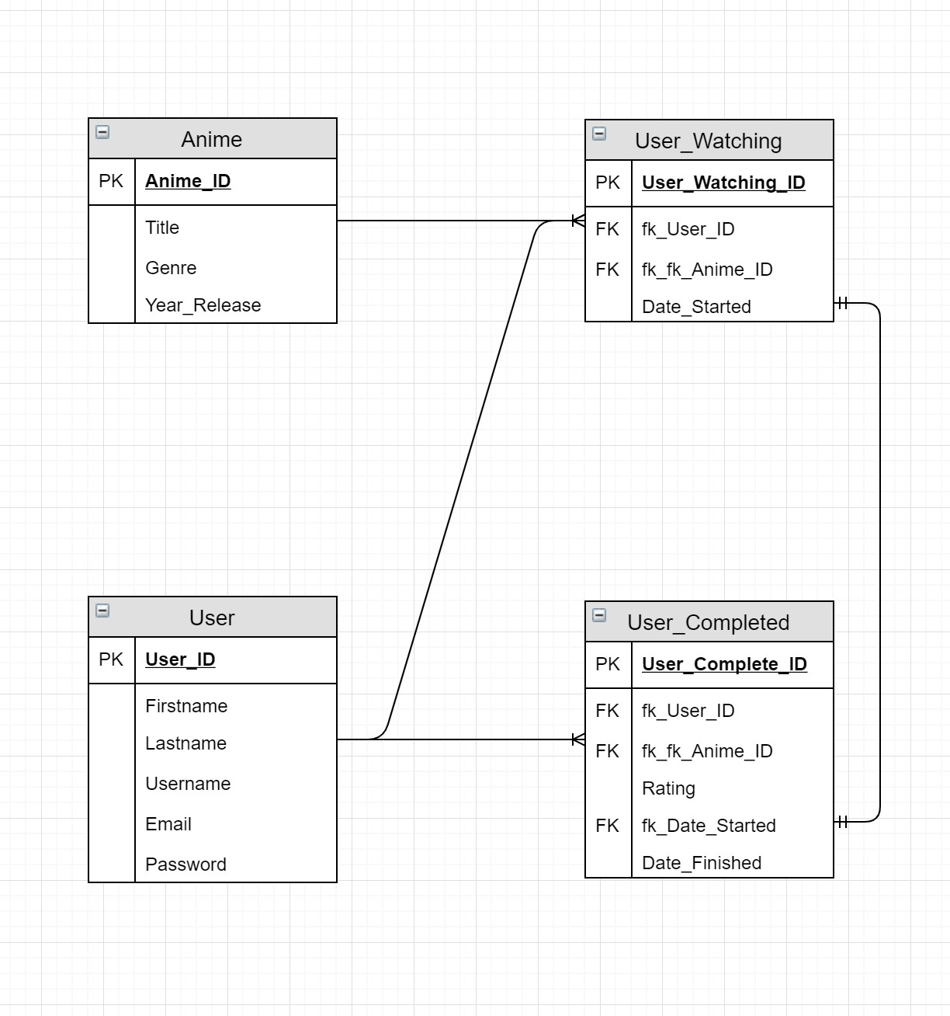With the design of the Database, I want to create a table for all anime series and all users. All users are expected to have two list separate lists which have all the anime series they are watching and all the anime series they have completed.

**DEPLOYMENT**



**TRELLO**

This project tracking tool was a good tool I used in order to keep track on the build of the application. Tracking what tasks have been done, tasks I’m currently doing and tasks I am yet to do.

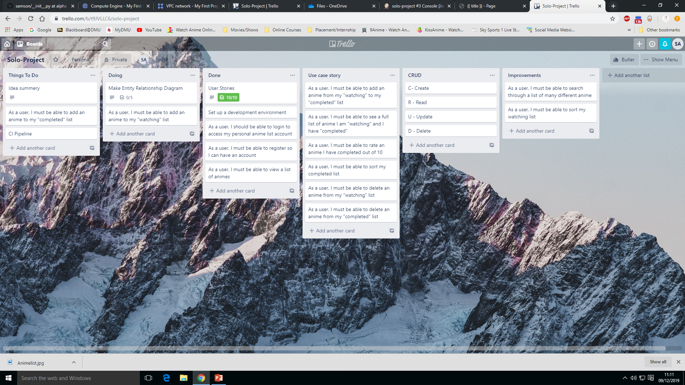

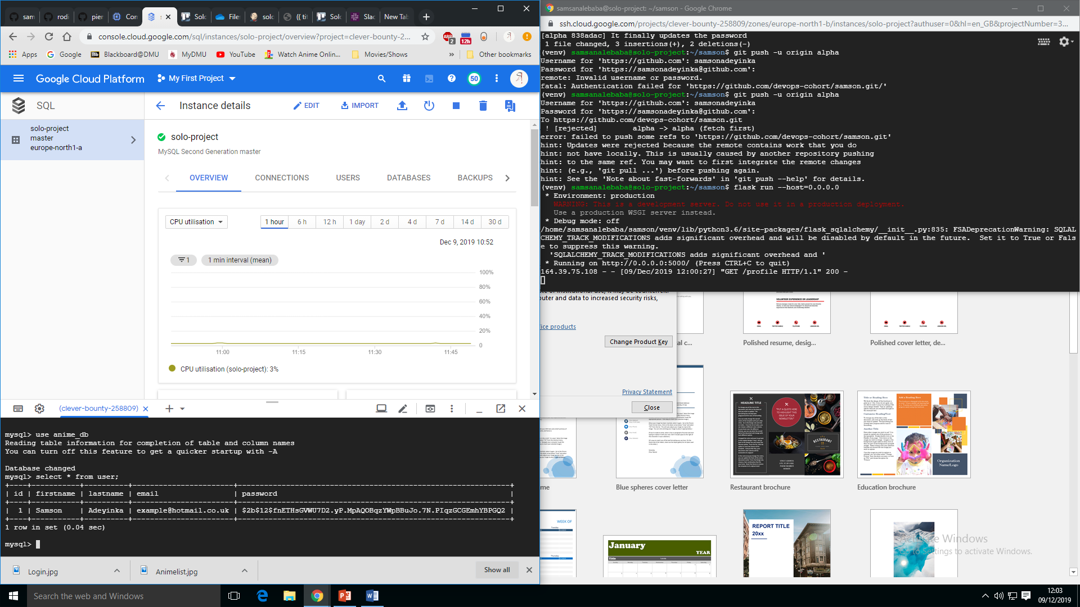

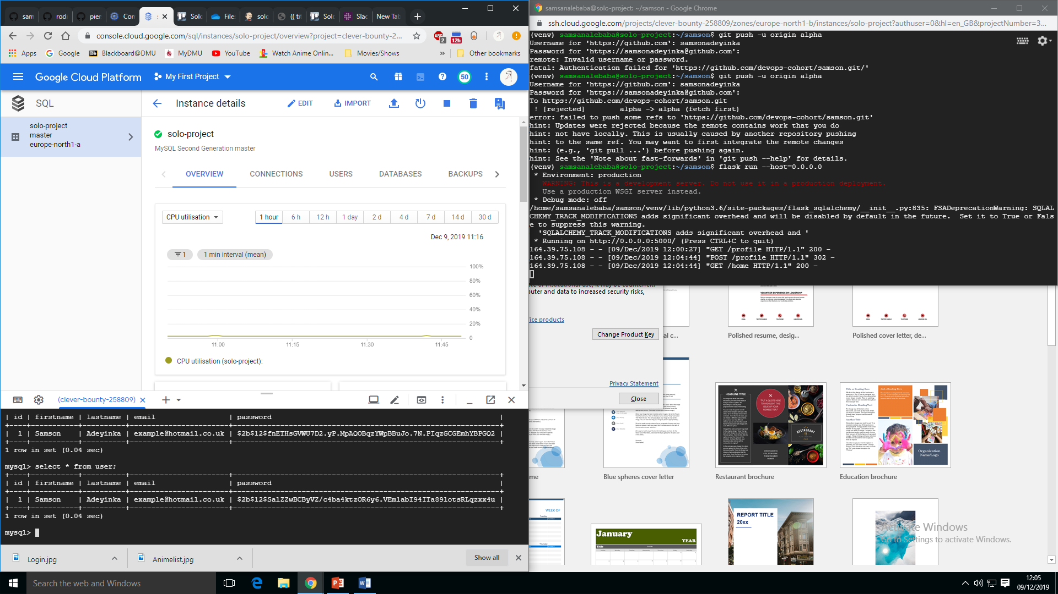

**Improvements**

For this application, there are many things which can be done to improve the experience, functionality and implementation of the app. There could also be an Admin user who can add

The first thing I will look at to improve will be to go back into the code of the application an improve the implementation and efficiency. The most obvious most noticeable thing about this app is the appearance and the design. This can clearly be improved using bootstrap or CSS. In terms of user experience, many things can be added in order to improve the whole app. One of the most important things that need to be improved is the functions, buttons with validation.

Deploying the app on Jenkins is very important as it will allow the app constantly be deployed without going down which is pretty important and less stress.