LOAD BALANCER ALGORITHEM – ROUND ROBIN USING NGINX
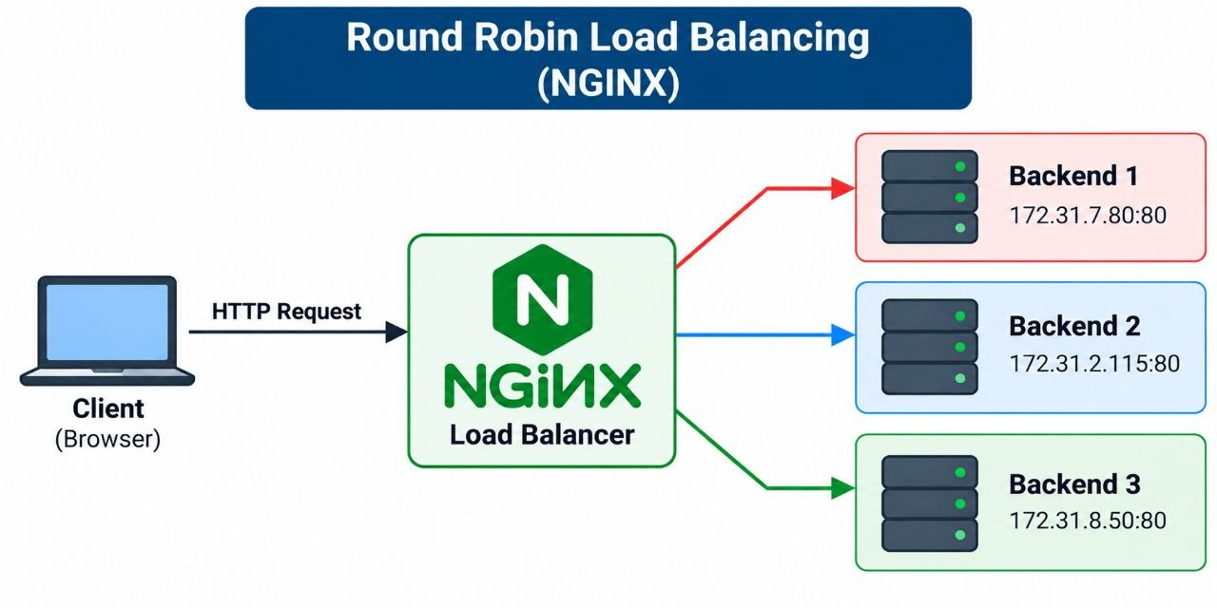
CREATE SECURITY GROUPS
1.create backend security group
- ssh - 22 (my-ip)
- http - 80 (loadbalancer-sg)
2.create loadbalancer security group
- ssh - 22
- http - 80
CREATE BACKEND SERVERS
1.create a backend server 1
- name - backend-server-1
- AMI - ubuntu
- sg - backend-sg
- user_data
sudo apt update
sudo apt install apache2 -y
echo '<h1>RESPONSE FROM BACKEND 1</h1>' \
| sudo tee /var/www/html/index.html
sudo systemctl enable --now apache2

2.create a backend server 2
- name - backend-server-2
- AMI - ubuntu
- sg - backend-sg
- user_data
sudo apt update
sudo apt install apache2 -y
echo '<h1>RESPONSE FROM BACKEND 2</h1>' \
| sudo tee /var/www/html/index.html
sudo systemctl enable --now apache2

CREATE LOAD-BALANCER SERVER
3.create a load balancer server
- name - lb-server
- ami - ubuntu
- sg - loadbalancer-sg
- launch instance

ACCESSING THE LOAD BALANCER
- sudo apt update
- sudo apt install nginx -y
- curl http://BACKEND_1_PRIVATE_IP
- curl http://BACKEND_2_PRIVATE_IP
- sudo vim /etc/nginx/sites-available/default
upstream backend_servers {
server BACKEND_1_PRIVATE_IP:80;
server BACKEND_2_PRIVATE_IP:80;
}
server {
listen 80 default_server;
server_name _;

location / {
proxy_pass http://backend_servers;

proxy_set_header Host $host;
proxy_set_header X-Real-IP $remote_addr;
proxy_set_header X-Forwarded-For $proxy_add_x_forwarded_for;
}
}
- sudo nginx -t
- sudo systemctl enable --now nginx
- sudo systemctl reload nginx
TEST THE LOAD BALANCER
- http://Your_Load_balancer_ip
YOU GET THE RESPONSE FROM
- backend-1
- backend-2

LOAD BALANCER ALGORITHEM - LEAST CONNECTION USING NGINX
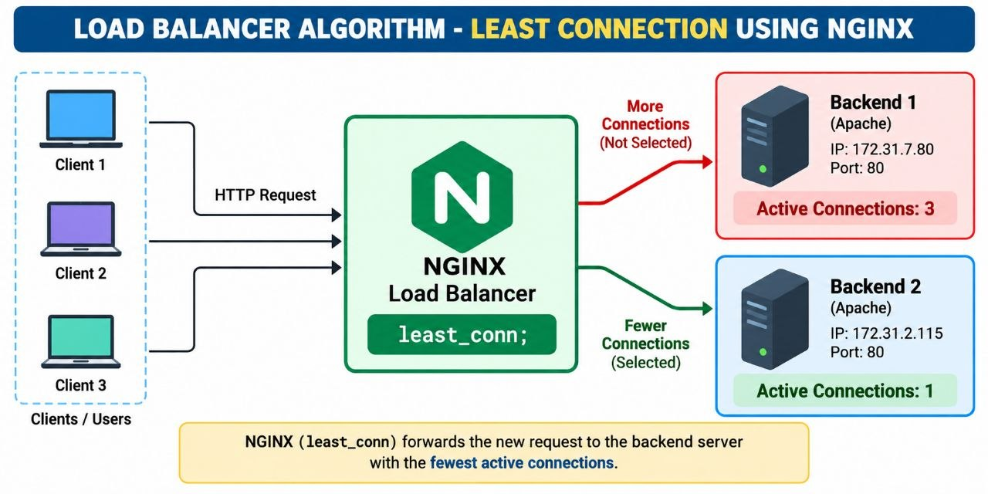
CREATE SECURITY GROUPS
1.create backend security group
- ssh - 22 (my-ip)
- http - 80 (loadbalancer-sg)
2.create loadbalancer security group
- ssh - 22
- http - 80
CREATE BACKEND SERVERS
1.create a backend server 1
- name - backend-server-1
- AMI - ubuntu
- sg - backend-sg
- user_data
sudo apt update
sudo apt install apache2 -y
echo '<h1>RESPONSE FROM BACKEND 1</h1>' \
| sudo tee /var/www/html/index.html
sudo systemctl enable --now apache2

2.create a backend server 2
- name - backend-server-2
- AMI - ubuntu
- sg - backend-sg
- user_data
sudo apt update
sudo apt install apache2 -y
echo '<h1>RESPONSE FROM BACKEND 2</h1>' \
| sudo tee /var/www/html/index.html
sudo systemctl enable --now apache2
CREATE LOAD-BALANCER SERVER
3.create a load balancer server
- name - lb-server
- ami - ubuntu
- sg - loadbalancer-sg
- launch instance
ACCESSING THE LOAD BALANCER
- sudo apt update
- sudo apt install nginx -y
- curl http://BACKEND_1_PRIVATE_IP
- curl http://BACKEND_2_PRIVATE_IP
- sudo vim /etc/nginx/sites-available/default
upstream backend_servers {
least_conn;
server BACKEND_1_PRIVATE_IP:80;
server BACKEND_2_PRIVATE_IP:80;
}
server {
listen 80 default_server;
server_name _;

location / {
proxy_pass http://backend_servers;

proxy_set_header Host $host;
proxy_set_header X-Real-IP $remote_addr;
proxy_set_header X-Forwarded-For $proxy_add_x_forwarded_for;
}
}
- sudo nginx -t
- sudo systemctl enable --now nginx
- sudo systemctl reload nginx
TEST THE LOAD BALANCER
- http://Your_Load_balancer_ip
YOU GET THE RESPONSE FROM
- backend-1
- backend-2

LOAD BALANCER ALGORITHEM – IP HASH
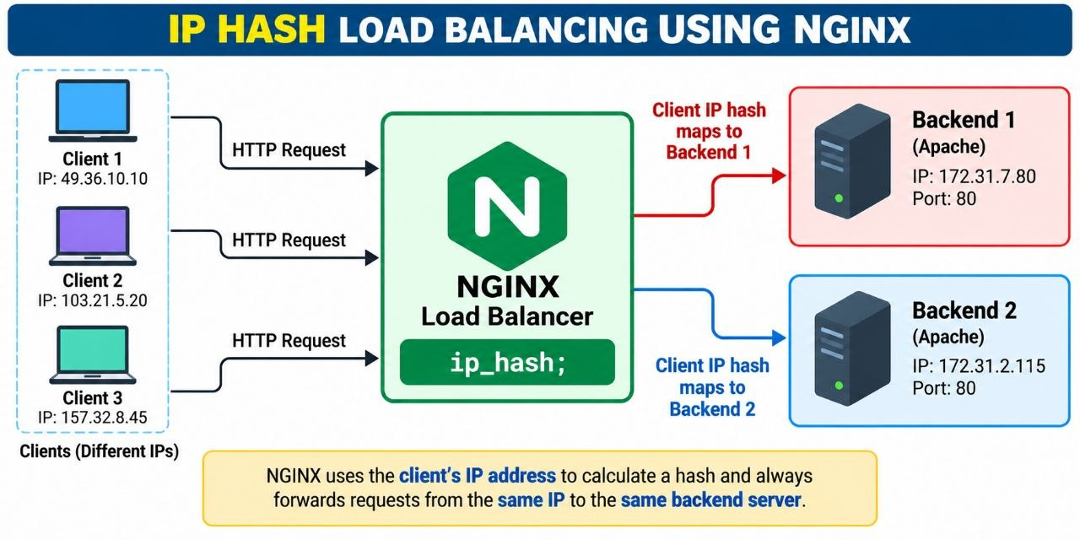

CREATE SECURITY GROUPS
1.create backend security group
- ssh - 22 (my-ip)
- http - 80 (loadbalancer-sg)
2.create loadbalancer security group
- ssh - 22
- http - 80
CREATE BACKEND SERVERS
1.create a backend server 1
- name - backend-server-1
- AMI - ubuntu
- sg - backend-sg
- user_data
sudo apt update
sudo apt install apache2 -y
echo '<h1>RESPONSE FROM BACKEND 1</h1>' \
| sudo tee /var/www/html/index.html
sudo systemctl enable --now apache2

2.create a backend server 2
- name - backend-server-2
- AMI - ubuntu
- sg - backend-sg
- user_data
sudo apt update
sudo apt install apache2 -y
echo '<h1>RESPONSE FROM BACKEND 2</h1>' \
| sudo tee /var/www/html/index.html
sudo systemctl enable --now apache2

CREATE LOAD-BALANCER SERVER
3.create a load balancer server
- 1.name - lb-server
- 2.ami - ubuntu
- 3.sg - loadbalancer-sg
- 4.launch instance

ACCESSING THE LOAD BALANCER
- sudo apt update
- sudo apt install nginx -y
- curl http://BACKEND_1_PRIVATE_IP
- curl http://BACKEND_2_PRIVATE_IP
- sudo vim /etc/nginx/sites-available/default
upstream backend_servers {
ip_hash;
server BACKEND_1_PRIVATE_IP:80;
server BACKEND_2_PRIVATE_IP:80;
}
server {
listen 80 default_server;
server_name _;

location / {
proxy_pass http://backend_servers;

proxy_set_header Host $host;
proxy_set_header X-Real-IP $remote_addr;
proxy_set_header X-Forwarded-For $proxy_add_x_forwarded_for;
}
}
- sudo nginx -t
- sudo systemctl enable --now nginx
- sudo systemctl reload nginx

TEST THE LOAD BALANCER
- http://Your_Load_balancer_ip
YOU SHOULD SEE EITHER…
- RESPONSE FROM BACKEND 1
- RESPONSE FROM BACKEND 2

EXPECTED RESULT:
- Requests from the same client IP should generally continue reaching the same backend, provided the backend configuration remains unchanged.
- The new network may produce a different client IP and therefore select a different backend.
- However, it can still select the same backend; IP Hash does not guarantee that different clients will reach different servers

LOAD BALANCER ALGORITHEM – LEAST-RESPONSE TIME
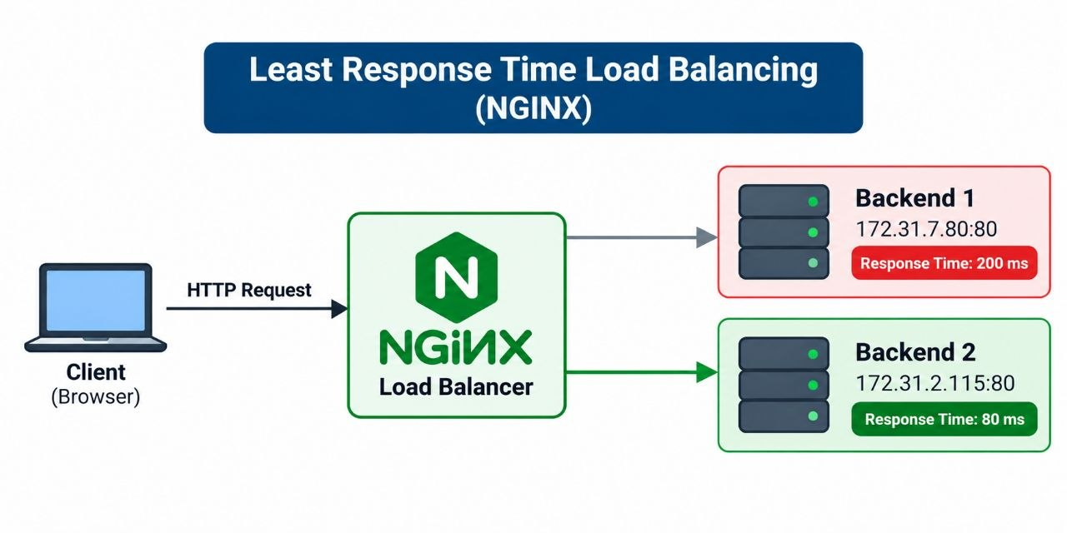
CREATE SECURITY GROUPS
1.create backend security group
- ssh - 22 (my-ip)
- http - 80 (loadbalancer-sg)
2.create loadbalancer security group
- ssh - 22
- http - 80
CREATE BACKEND SERVERS
1.create a backend server 1
- name - backend-server-1
- AMI - ubuntu
- sg - backend-sg
- user_data
sudo apt update
sudo apt install apache2 -y
echo '<h1>RESPONSE FROM BACKEND 1</h1>' \
| sudo tee /var/www/html/index.html
sudo systemctl enable --now apache2

2.create a backend server 2
- name - backend-server-2
- AMI - ubuntu
- sg - backend-sg
- user_data
sudo apt update
sudo apt install apache2 -y
echo '<h1>RESPONSE FROM BACKEND 2</h1>' \
| sudo tee /var/www/html/index.html
sudo systemctl enable --now apache2

CREATE LOAD-BALANCER SERVER
create a load balancer server
- name - lb-server
- ami - ubuntu
- sg - loadbalancer-sg
- launch instance

INSTALLATION OF NGINX ON LOAD-BALANCER SERVER
- sudo apt update
- sudo apt install -y curl gnupg2 ca-certificates lsb-release ubuntu-keyring
- curl -fsSL https://nginx.org/keys/nginx_signing.key \
| sudo gpg --dearmor --yes -o /usr/share/keyrings/nginx-archive-keyring.gpg
- gpg --show-keys /usr/share/keyrings/nginx-archive-keyring.gpg
- echo "deb [signed-by=/usr/share/keyrings/nginx-archive-keyring.gpg] https://nginx.org/packages/mainline/ubuntu resolute nginx" \
| sudo tee /etc/apt/sources.list.d/nginx.list
- apt update
- apt policy nginx
- sudo apt install nginx=1.31.8-1~resolute
- nginx -v
- curl http://BACKEND_1_PRIVATE_IP
- curl http://BACKEND_2_PRIVATE_IP
- vim /etc/nginx/conf.d/default.conf
upstream backend_servers {
least_time header;

server 172.31.7.80:80;
server 172.31.2.115:80;
}

server {
listen 80 default_server;
server_name _;

location / {
proxy_pass http://backend_servers;

proxy_set_header Host $host;
proxy_set_header X-Real-IP $remote_addr;
proxy_set_header X-Forwarded-For $proxy_add_x_forwarded_for;
}
}
- nginx -t
- systemctl enable nginx
- systemctl reload nginx
- systemctl status nginx --pager
TEST THE LOAD BALANCER
- http://Your_Load_balancer_ip
YOU SHOULD SEE EITHER…
- RESPONSE FROM BACKEND 1
- RESPONSE FROM BACKEND 2

EXPLANATION:
- Least Response Time Load Balancing is an algorithm that routes incoming requests to the backend server with the lowest average response time.
- NGINX considers the time taken to receive response headers and the number of active connections to help select a server.
- It helps improve application responsiveness by directing traffic toward faster-performing backend servers.

LOAD BALANCER ALGORITHEM – WEIGHTED ROUND ROBIN
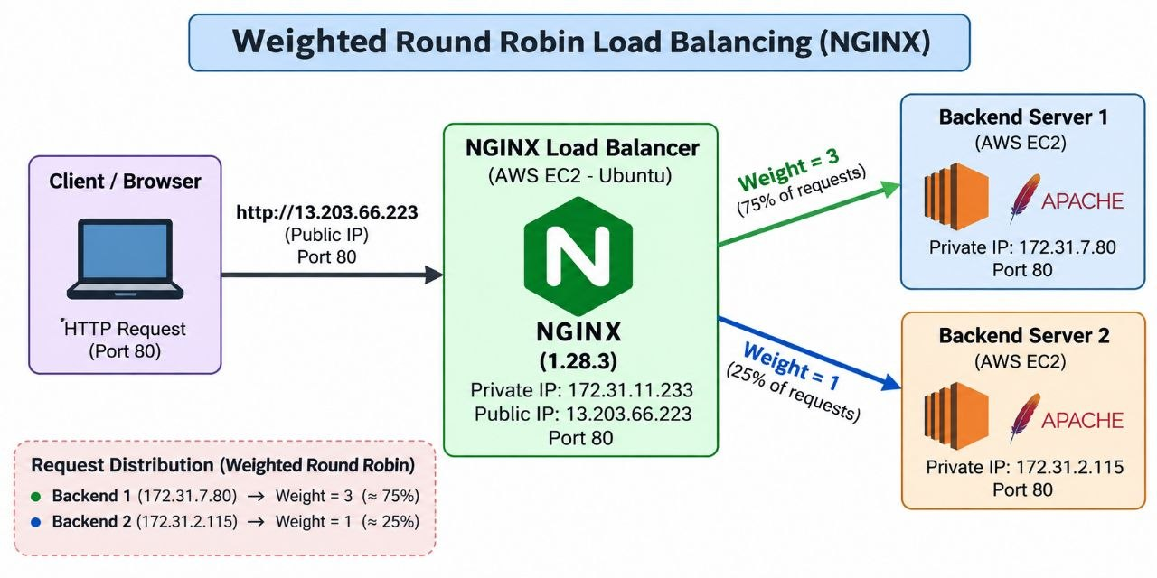

CREATE SECURITY GROUPS
1.create backend security group
- ssh - 22 (my-ip)
- http - 80 (loadbalancer-sg)
2.create loadbalancer security group
- ssh - 22
- http - 80
CREATE BACKEND SERVERS
1.create a backend server 1
- name - backend-server-1
- AMI - ubuntu
- sg - backend-sg
- user_data
sudo apt update
sudo apt install apache2 -y
echo '<h1>RESPONSE FROM BACKEND 1</h1>' \
| sudo tee /var/www/html/index.html
sudo systemctl enable --now apache2

2.create a backend server 2
- name - backend-server-2
- AMI - ubuntu
- sg - backend-sg
- user_data
sudo apt update
sudo apt install apache2 -y
echo '<h1>RESPONSE FROM BACKEND 2</h1>' \
| sudo tee /var/www/html/index.html
sudo systemctl enable --now apache2

CREATE LOAD-BALANCER SERVER
3.create a load balancer server
- name - lb-server
- ami - ubuntu
- sg - loadbalancer-sg
- launch instance

ACCESSING THE LOAD BALANCER
- sudo apt update
- sudo apt install nginx -y
- curl http://BACKEND_1_PRIVATE_IP
- curl http://BACKEND_2_PRIVATE_IP
- sudo vim /etc/nginx/sites-available/default
upstream backend_servers {
server 172.31.7.80:80 weight=3;
server 172.31.2.115:80 weight=1;
}

server {
listen 80 default_server;
listen [::]:80 default_server;

server_name _;

location / {
proxy_pass http://backend_servers;

proxy_set_header Host $host;
proxy_set_header X-Real-IP $remote_addr;
proxy_set_header X-Forwarded-For $proxy_add_x_forwarded_for;
}
}
- sudo nginx -t
- sudo systemctl enable --now nginx
- sudo systemctl reload nginx
TEST THE LOAD BALANCER
- http://Your_Load_balancer_ip
YOU GET THE RESPONSE FROM
- backend-1
- backend-2

IMPORTANT:
- The weights 3 and 1 mean Backend 1 receives approximately three times as many requests as Backend 2 over time. The distribution of a small number of requests may vary.
- Weighted Round Robin is useful when backend servers have different processing capacities.
- A server with a higher weight receives a larger share of requests, helping distribute traffic according to the capacity assigned to each backend.

