GITLAB-CICD

GITLAB-CICD
GitLab CI/CD is GitLab's built-in automation system.

What is .gitlab-ci.yaml
It is basically a file in the root directory of the project

When you push code, GitLab reads this file and understands:
"What jobs should I execute, in what order, and how?"

GITLAB RUNNER
GitLab itself does not execute your shell commands directly.

Gitlab says "I have a job that needs to run."

A GitLab Runner actually executes that job.

Think of it like these:
GitLab
│
│ "Run this job"
|
GitLab Runner
│
├── download source code
├── prepare environment
├── execute script
├── collect artifacts
└── send result to GitLab

TYPES OF GITLAB RUNNER
1. GitLab-hosted Runner
2. Self-managed Runner

- Gitlab-hosted Runner
- GitLab provides the Runner infrastructure.
- You don't install the Runner yourself.
- GitLab provides the execution environment.

- Self-managed Runner
- You install the GitLab Runner yourself.
Example (EC-2 / On-premises server)
- Then GitLab sends jobs to your Runner.

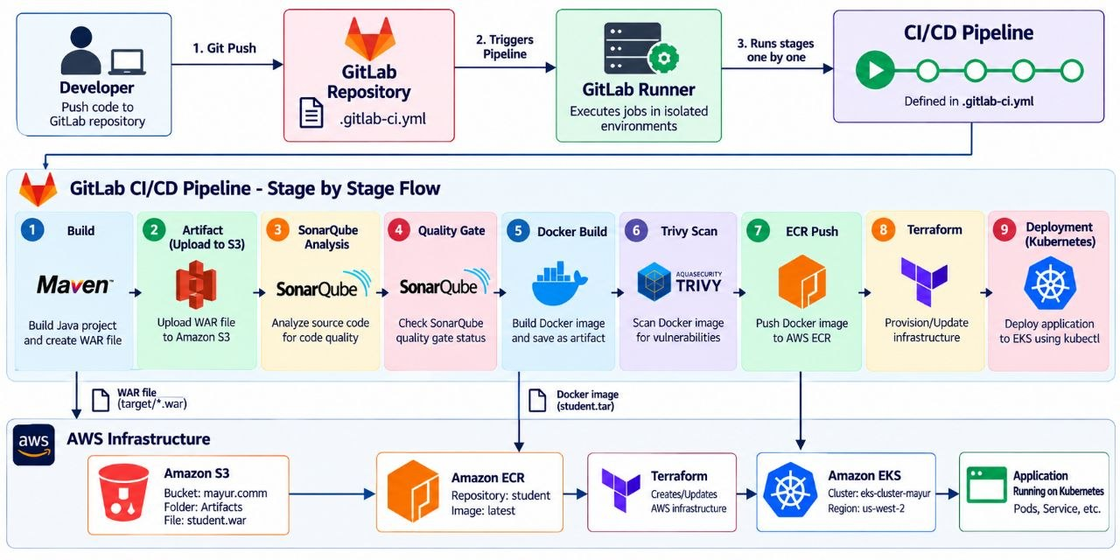

REPOSITORY LINK
https://gitlab.com/mayurpandit25/student-management.git

GITLAB END-TO-END PIPELINE

1.CREATE A FILE
.gitlab-ci.yaml

stages:
- build
- artifact
- sonar
- quality-gate
- docker-build
- trivy-scan
- ecr-push
- terraform
- deployment

# BUILD STAGE

build:
stage: build

image:
name: maven:3.9-eclipse-temurin-21

script:
- mvn clean package

artifacts:
paths:
- target/*.war
expire_in: 1 hour

# UPLOAD WAR TO S3

upload-to-s3:
stage: artifact

image:
name: alpine:latest

dependencies:
- build

before_script:
- apk add --no-cache aws-cli

script:
- aws s3 cp target/*.war s3://mayur.comm/Artifacts/student.war

# SONARQUBE ANALYSIS

sonarqube:
stage: sonar

image:
name: maven:3.9-eclipse-temurin-21

script:
- mvn clean compile
- mvn sonar:sonar
-Dsonar.token="$SONAR_TOKEN"
-Dsonar.host.url="$SONAR_HOST_URL"

# QUALITY GATES

quality-gate:
stage: quality-gate
image:
name: alpine:latest
before_script:
- apk add --no-cache curl jq
script:
- |
STATUS=$(curl -s -u "${SONAR_TOKEN}:" \
"${SONAR_HOST_URL}/api/qualitygates/project_status?projectKey=com.school:student-management" \
| jq -r '.projectStatus.status')

echo "SonarQube Quality Gate: $STATUS"

if [ "$STATUS" != "OK" ]; then
echo "Quality Gate failed!"
exit 1
fi

echo "Quality Gate passed!"

# DOCKER BUILD

docker-build:
stage: docker-build

image:
name: docker:latest

services:
- name: docker:dind

variables:
DOCKER_HOST: tcp://docker:2375
DOCKER_TLS_CERTDIR: ""

script:
- docker --version
- docker build --no-cache -t student:latest .
- docker images
- docker save student:latest -o student.tar

artifacts:
paths:
- student.tar
expire_in: 1 hour

# TRIVY IMAGE SCAN

trivy-scan:
stage: trivy-scan

image:
name: alpine:latest

services:
- name: docker:dind

variables:
DOCKER_HOST: tcp://docker:2375
DOCKER_TLS_CERTDIR: ""

dependencies:
- docker-build

before_script:
- apk add --no-cache docker-cli curl
- wget -qO- https://raw.githubusercontent.com/aquasecurity/trivy/main/contrib/install.sh | sh -s -- -b /usr/local/bin

script:
- docker --version
- trivy --version
- docker load -i student.tar
- docker images
- trivy image --scanners vuln --severity HIGH,CRITICAL --exit-code 0 student:latest

# PUSH IMAGE TO ECR

ecr-push:
stage: ecr-push

image:
name: alpine:latest

services:
- name: docker:dind

variables:
DOCKER_HOST: tcp://docker:2375
DOCKER_TLS_CERTDIR: ""

dependencies:
- docker-build

before_script:
- apk add --no-cache docker-cli aws-cli

script:
- docker --version
- aws --version

# Load image created in Docker Build stage
- docker load -i student.tar

#Push Image
- aws ecr get-login-password --region us-west-2 |
docker login --username AWS --password-stdin 822920903800.dkr.ecr.us-west-2.amazonaws.com
- docker tag student:latest 822920903800.dkr.ecr.us-west-2.amazonaws.com/student:latest
- docker push 822920903800.dkr.ecr.us-west-2.amazonaws.com/student:latest

# TERRAFORM

terraform:
stage: terraform

image:
name: hashicorp/terraform:latest
entrypoint: [""]

script:
- terraform --version
- terraform init
- terraform validate
- terraform apply -auto-approve

# KUBERNETES DEPLOYMENT

deployment:
stage: deployment

image:
name: alpine:latest

before_script:
- apk add --no-cache aws-cli curl kubectl

script:
- aws --version
- kubectl version --client

- aws eks update-kubeconfig --name eks-cluster-mayur --region us-west-2

- kubectl apply -f k8s/

- sleep 30

- kubectl get pods
- kubectl get svc -o wide

Where does AWS authentication come from

You don put cred inside the yaml
- AWS_ACCESS_KEY_ID: xxx
- AWS_SECRET_ACCESS_KEY: xxx

Instead, we configure these in
GitLab
→ Project (student-management)
→ Settings
→ CI/CD
→ Variables

Add these into the variables section
- AWS_ACCESS_KEY_ID
- AWS_SECRET_ACCESS_KEY
- AWS_DEFAULT_REGION
- SONAR_TOKEN
- SONAR_HOST_URL

