NGINX-WEBSERVER

NGINX is a high-performance web server that can be used for:
- Static web hosting
- Reverse proxy
- Load balancing
- SSL termination
- Virtual hosting — one NGINX server can host multiple websites

HOSTING STATIC WEBSITE ON NGINX
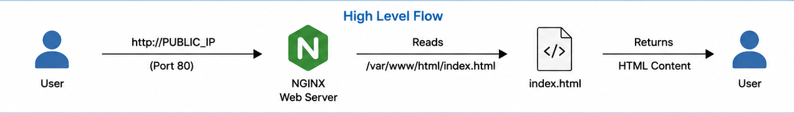
1. Install NGINX
- sudo apt update
- sudo apt install nginx -y
2. Start & Enable NGINX
- sudo systemctl start nginx
- sudo systemctl enable nginx
4. Check NGINX status
- sudo systemctl status nginx
5. Go to NGINX web directory & create index.html file
- cd /var/www/html/
- sudo vim index.html
<h1> Hello NGINX! </h1>
7. Restart NGINX
- sudo systemctl restart nginx
8. Test the website
- http://PUBLIC_IP

REVERSE PROXY ON NGINX
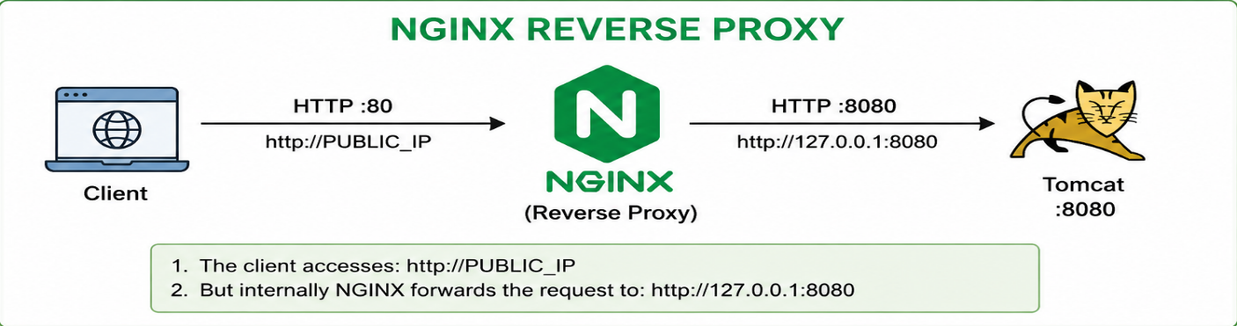

Install Java
- sudo apt update
- sudo apt install openjdk-17-jdk -y
- java -version

Download & Start Tomcat
- wget https://dlcdn.apache.org/tomcat/tomcat-9/v9.0.120/bin/apache-tomcat-9.0.120.tar.gz
- tar -xzf apache-tomcat-9.0.120.tar.gz
- cd apache-tomcat-9.0.120/bin/
- ./startup.sh
- Check Tomcat:
http://PUBLIC_IP:8080

So suppose Tomcat is running on: http://PUBLIC_IP:8080

Configure NGINX Reverse Proxy
- vim /etc/nginx/sites-available/reverse-proxy

server {
listen 80;
server_name _;

location / {
proxy_pass http://localhost:8080;

proxy_set_header Host $host;
proxy_set_header X-Real-IP $remote_addr;
proxy_set_header X-Forwarded-For $proxy_add_x_forwarded_for;
proxy_set_header X-Forwarded-Proto $scheme;
}
}

Enable the Configuration
- sudo ln -s /etc/nginx/sites-available/reverse-proxy /etc/nginx/sites-enabled/
- Remove the default configuration if required:
sudo rm /etc/nginx/sites-enabled/default
Test NGINX Configuration
- sudo nginx -t

Restart NGINX
- sudo systemctl restart nginx

Test Reverse Proxy
- http://PUBLIC_IP
NGINX will receive the request on port 80 and forward it to: http://127.0.0.1:8080

LOAD BALANCING ON NGINX
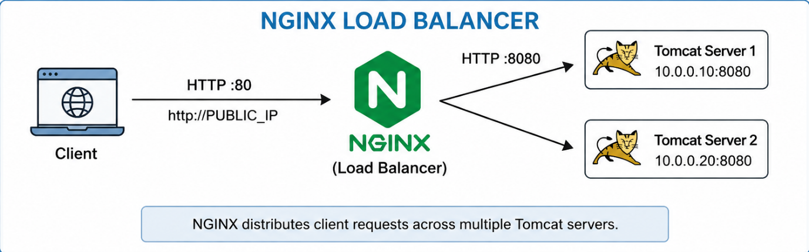
- Tomcat Server 1 (http://10.0.0.10:8080)
- Tomcat Server 2 (http://10.0.0.20:8080)
- NGINX Load Balancer (http://PUBLIC_IP)

Configure NGINX Load Balancer
- vim /etc/nginx/sites-available/load-balancer

upstream backend {
server 10.0.0.10:8080;
server 10.0.0.20:8080;
}

server {
listen 80;
server_name _;

location / {
proxy_pass http://backend;
include /etc/nginx/proxy_params;
}
}

Enable Configuration & Delete a default file
- sudo ln -s /etc/nginx/sites-available/load-balancer /etc/nginx/sites-enabled/
- sudo rm /etc/nginx/sites-enabled/default

Test Configuration
- sudo nginx -t

Restart NGINX
- sudo systemctl restart nginx

Test Load Balancing
- http://PUBLIC_IP

Note:
- NGINX distributes requests between:
Tomcat Server 1
Tomcat Server 2
- By default, NGINX uses a round-robin style distribution for an upstream with multiple servers.

LOAD BALANCER + DNS + SSL

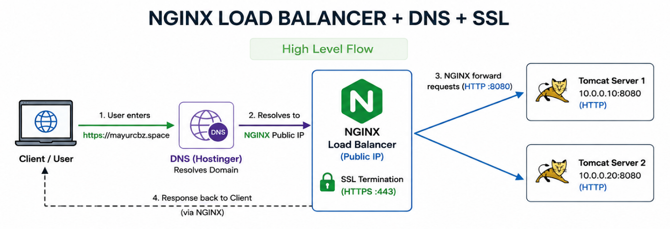

Configure NGINX Load Balancer
- vim /etc/nginx/sites-available/load-balancer

upstream backend {
server 10.0.0.10:8080;
server 10.0.0.20:8080;
}
server {
listen 80;
server_name mayurcbz.space www.mayurcbz.space;
location / {
proxy_pass http://backend;
include /etc/nginx/proxy_params;
}
}

Enable Configuration & Delete default file
- ln -s /etc/nginx/sites-available/load-balancer /etc/nginx/sites-enabled/
- rm -rf /etc/nginx/sites-enabled/default

Test NGINX
- sudo nginx -t

Restart NGINX
- sudo systemctl restart nginx

Test NGINX Load Balancer
- http://PUBLIC_IP

Configure DNS on Hostinger:
Add an A record:
- Type: A
- Name: @
- Value: NGINX-PUBLIC-IP
- TTL: 300

For www:
- Type: A
- Name: www
- Value: NGINX-PUBLIC-IP
- TTL: 300

Test Domain
- http://mayurcbz.space

CONFIGURE SSL CERTIFICATE ON NGINX
We can use Let’s Encrypt to get a free SSL certificate.

Install Certbot
- sudo apt update
- sudo apt install certbot python3-certbot-nginx -y

Generate SSL Certificate
- sudo certbot --nginx
Enter your email:
Accept the terms.
Redirect HTTP to HTTPS
Check Certificates
- certbot certificates
Restart NGINX
- sudo systemctl restart nginx

Check Port 80 & 443
- lsof -i :80
- lsof -i :443

Test HTTPS
- https://mayurcbz.space

CERTIFICATE RENEWAL
- sudo certbot renew --dry-run
If successful, Certbot's automatic renewal mechanism can renew the certificate when necessary.

VIRTUAL HOSTING ON NGINX
One NGINX server can host multiple websites using different domain names.

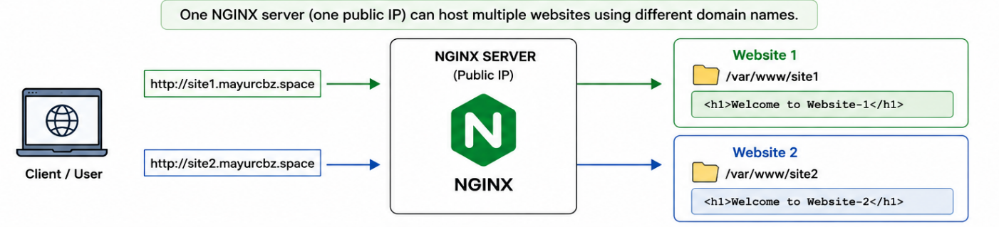

Install NGINX
- sudo apt update
- sudo apt install nginx -y

Start & Enable NGINX
- sudo systemctl start nginx
- sudo systemctl enable nginx

Check NGINX
- curl localhost

CREATE WEBSITE 1
- mkdir -p /var/www/site1
- vim /var/www/site1/index.html
<h1>Welcome to Website-1</h1>

CREATE WEBSITE 2
- mkdir -p /var/www/site2
- vim /var/www/site2/index.html
<h1>Welcome to Website-2</h1>

CREATE VIRTUAL HOST FOR WEBSITE 1
- vim /etc/nginx/sites-available/site1

server {
listen 80;

server_name site1.mayurcbz.space;
root /var/www/site1;
index index.html;

location / {
try_files $uri $uri/ =404;
}
}

CREATE VIRTUAL HOST FOR WEBSITE 2
- vim /etc/nginx/sites-available/site2
server {
listen 80;

server_name site2.mayurcbz.space;

root /var/www/site2;
index index.html;

location / {
try_files $uri $uri/ =404;
}
}

ENABLE WEBSITE 1
- ln -s /etc/nginx/sites-available/site1 /etc/nginx/sites-enabled/

ENABLE WEBSITE 2
- ln -s /etc/nginx/sites-available/site2 /etc/nginx/sites-enabled/

TEST NGINX CONFIGURATION
- sudo nginx -t

RESTART NGINX
- sudo systemctl restart nginx
DNS CONFIGURATION ON HOSTINGER
WEBSITE 1
Add an A record:
- Type: A
- Name: site1
- Value: NGINX-PUBLIC-IP
- TTL: 300

WEBSITE 2
Add an A record:
- Type: A
- Name: site2
- Value: NGINX-PUBLIC-IP
- TTL: 300

TEST THE WEBSITES
Website 1
- http://site1.mayurcbz.space

Website 2
- http://site2.mayurcbz.space

