5. User Management API – Express.js

A simple REST API built using Express.js to manage users. The data is fetched from a mock dataset generated using [Mockaroo](https://www.mockaroo.com/). The API supports listing users, retrieving a single user by ID, and adding, editing, or deleting users.

Features  
• Get all users in JSON format  
• Render users in HTML list format  
• Get individual user details by ID  
• Add a new user  
• Update an existing user (pending implementation)  
• Delete a user (pending implementation)  
• JSON file (MOCK_DATA.json) is used as a mock database

Project Link  
<https://github.com/devops-ktm/expressJs>

Tech Stack  
• Express.js  
• Node.js  
• JavaScript  
• Mockaroo (for mock data)  
• fs module (for file write operations)

How to Run  
Step 1: Prerequisites (Node.js installed)  
Step 2: Clone the Repository  
git clone https://github.com/devops-ktm/javascript-expressJs  
Step 3: Navigate to the project folder

cd javascript-expressJs  
Step 4: Install dependencies  
npm install

npm install express

Step 5: Start the server  
node index.js

Then open <http://localhost:8000>

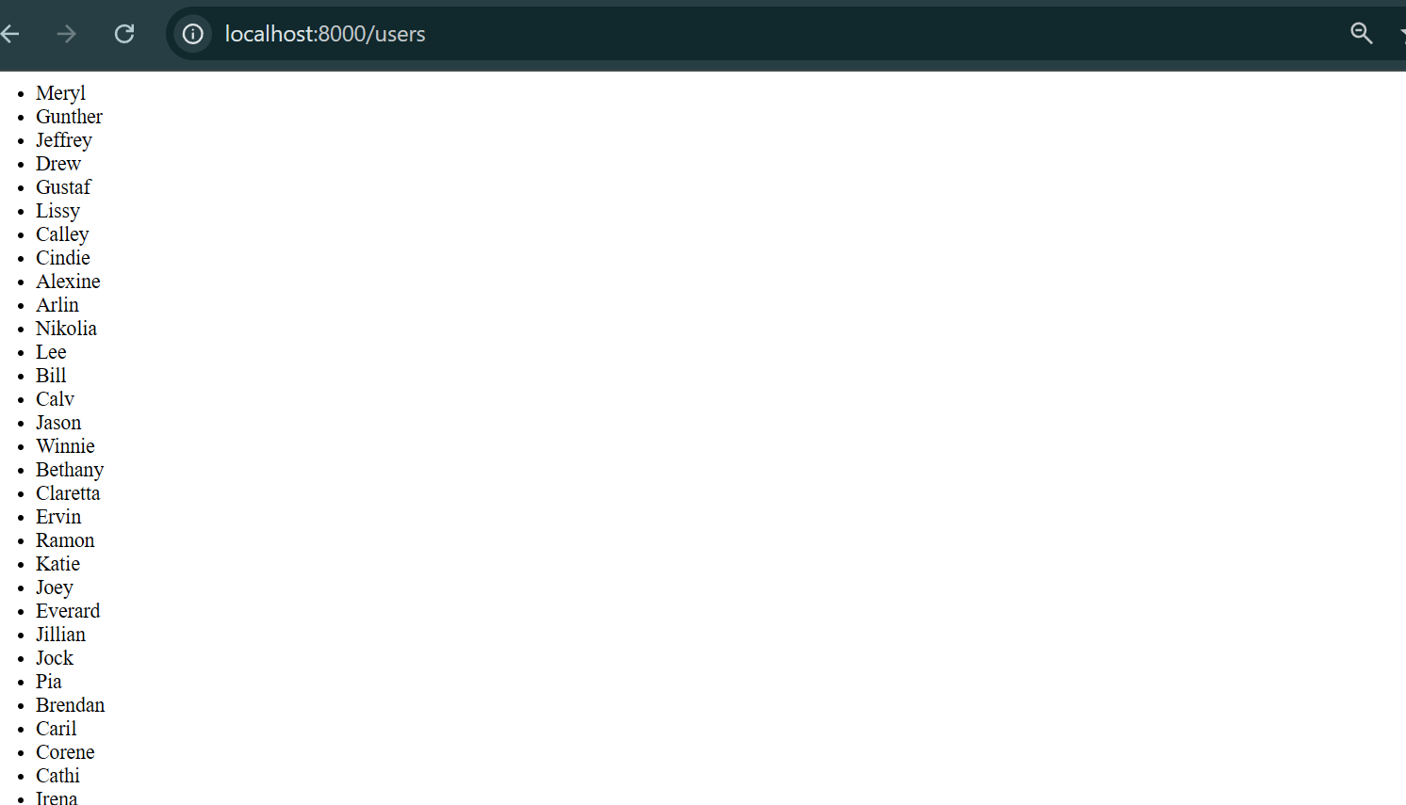

Tested with postman

