
NAME : AHMED FRAZ
REG : 2022065
FACULTY : DATA SCIENCE
LAB MID : SE-301L

TASK 01:
a: clone the repository
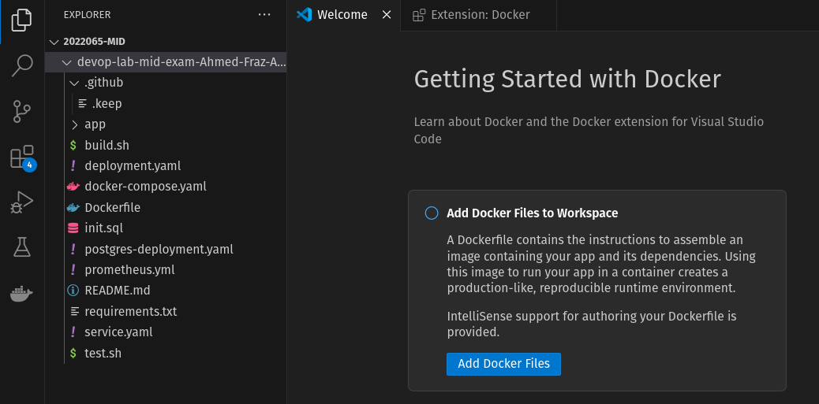
b:create a feature branch:
TASK 02:
a: modify field (phone)
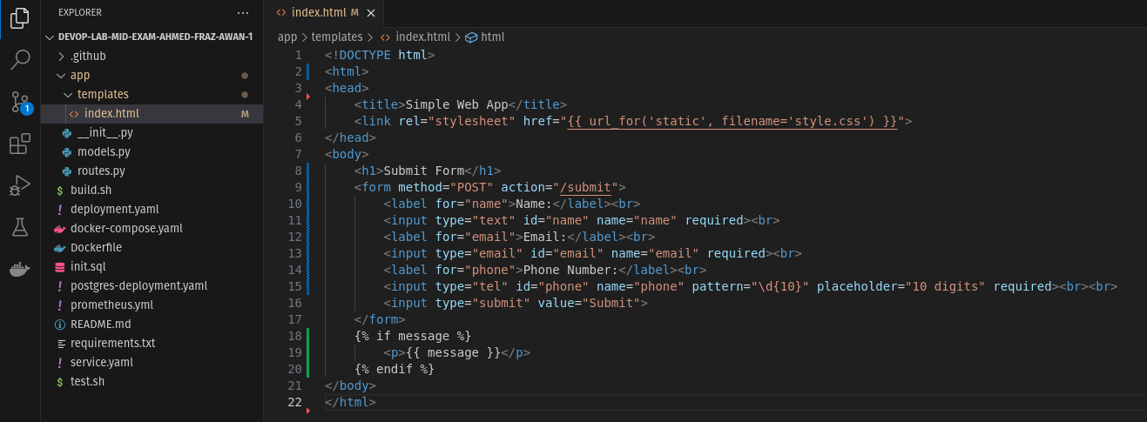
b: update backend to handle new field:
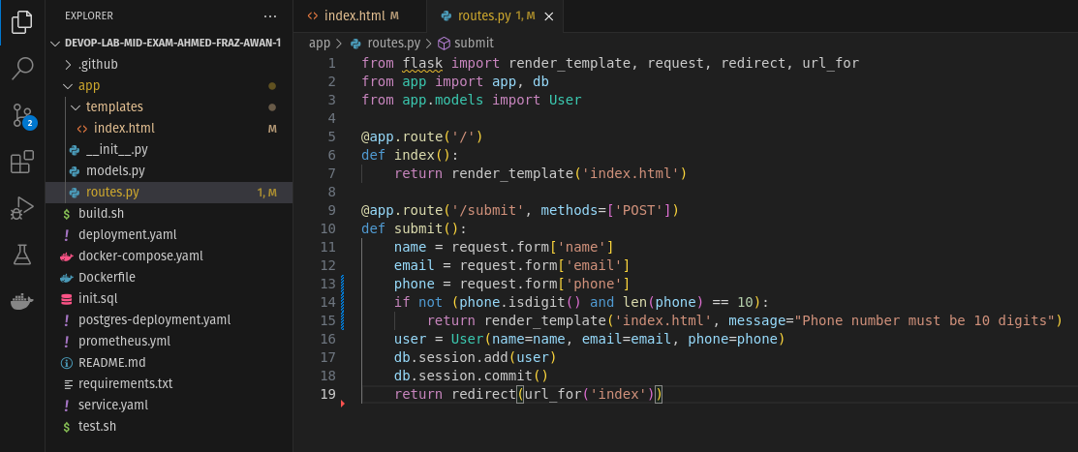
TASK 03:Analyze the issues
a:fix build.sh
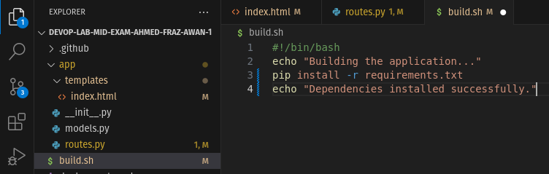
b:Requirments.txt file
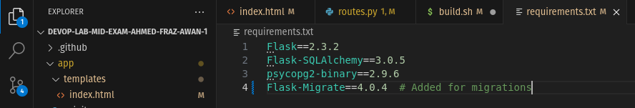
c:Run
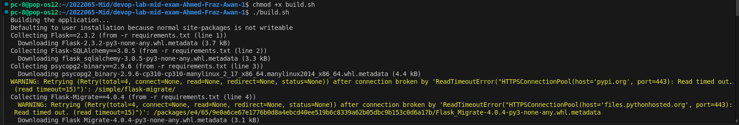
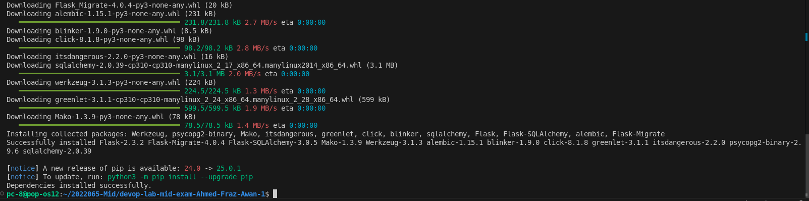
b: fix test.sh
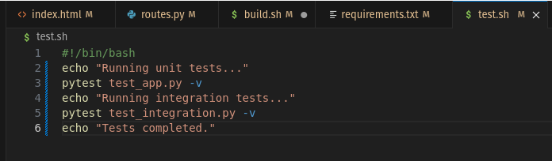
TASK 04:
a: update the docker
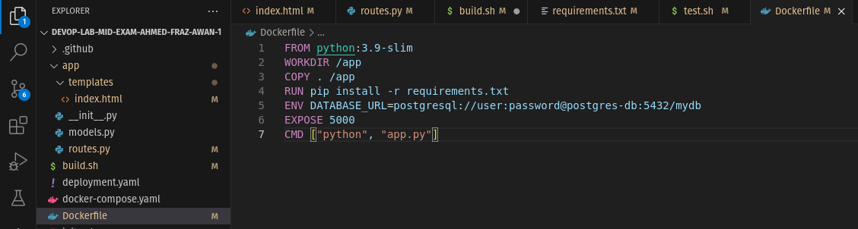
b. Build and push the container image:
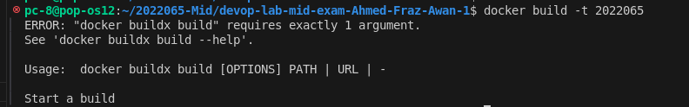
push:
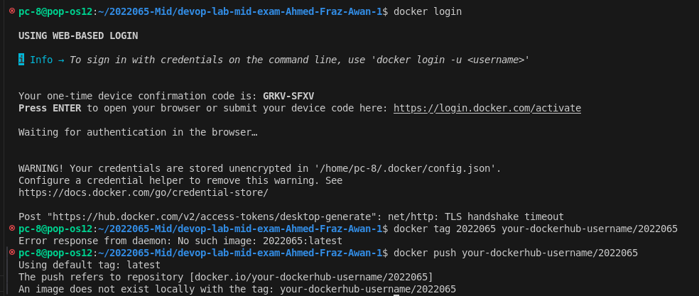
TASK 05:
a: Create Kubernetes files:
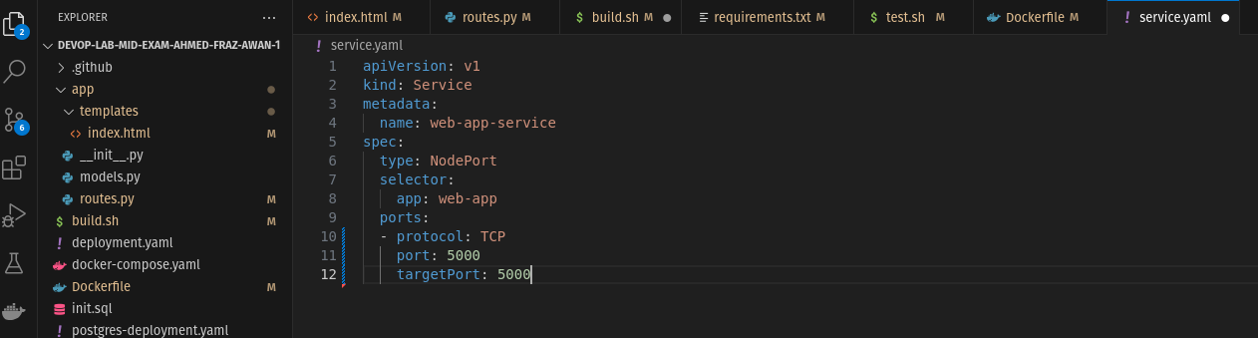
Use deployment.yaml (assuming it’s web-app-deployment.ya
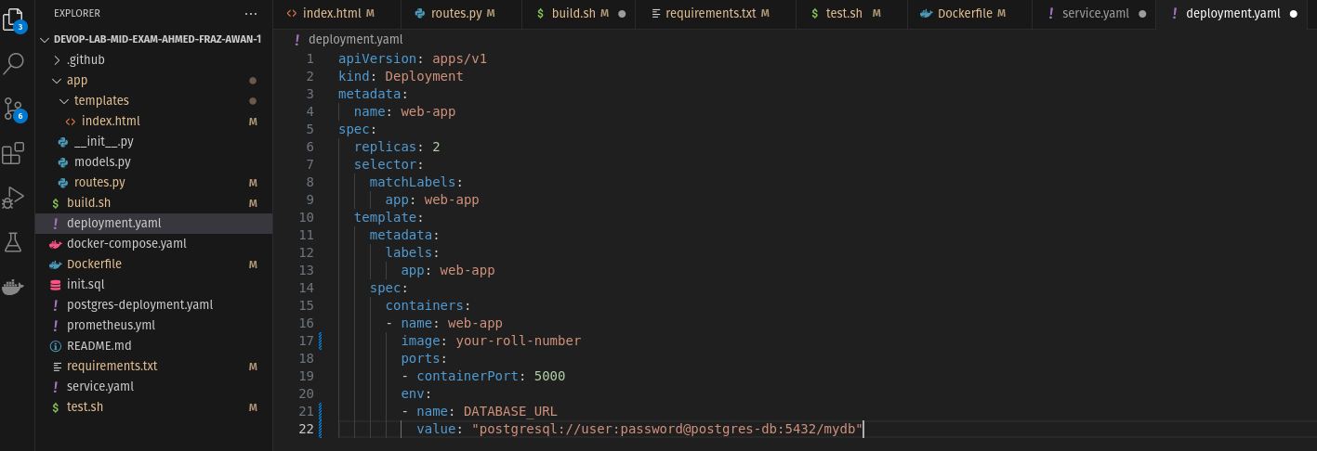
Use postgres-deployment.yaml:
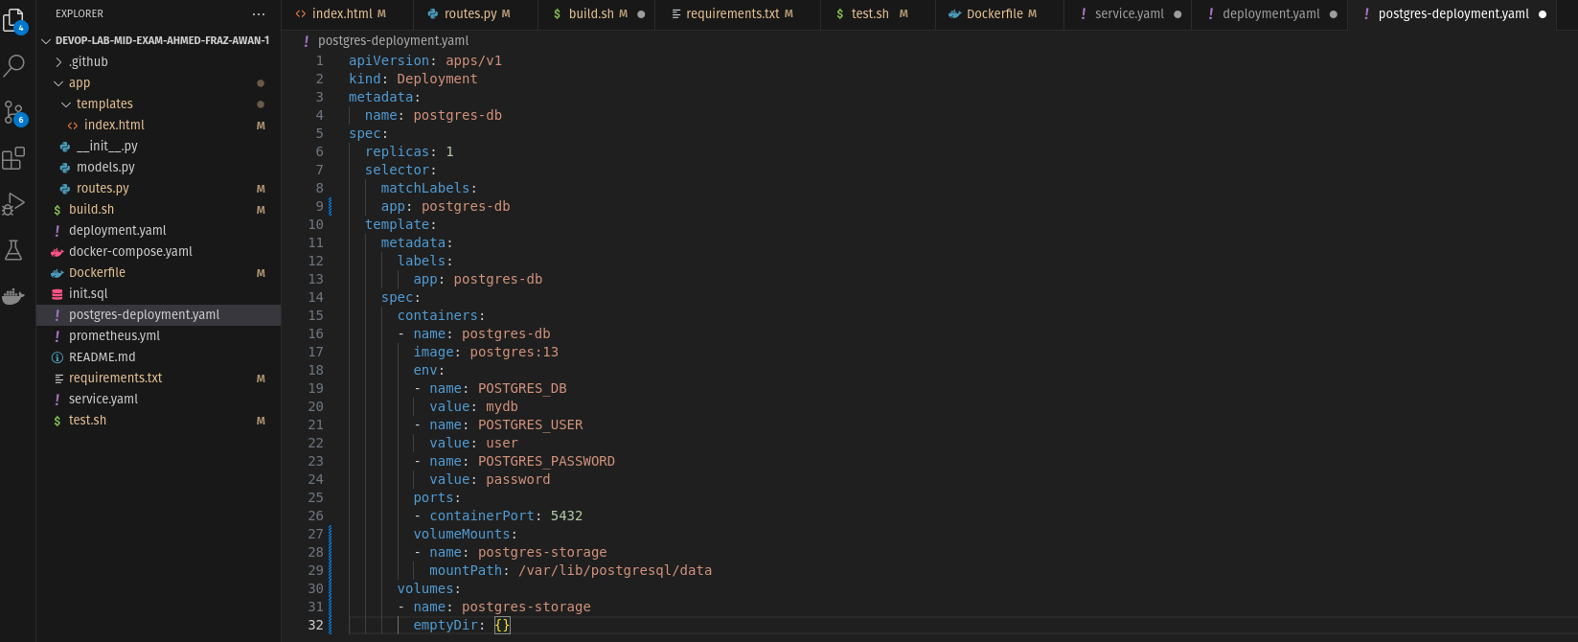
TASK 06:
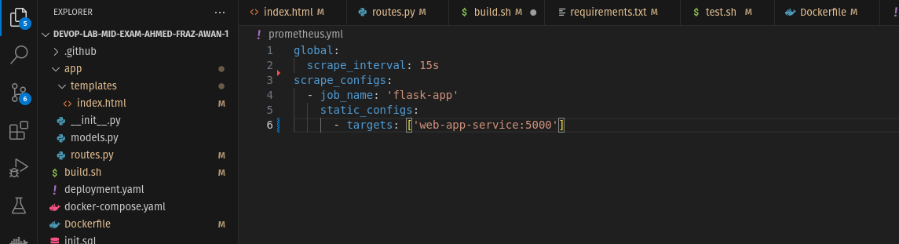
Create prometheus-deployment.yaml:
