Task1: Clone the repo
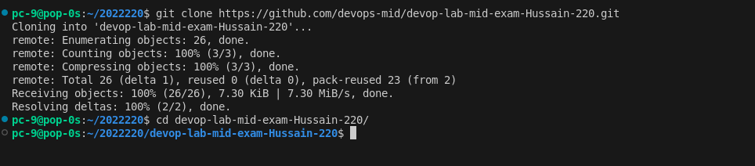
create a feature branch

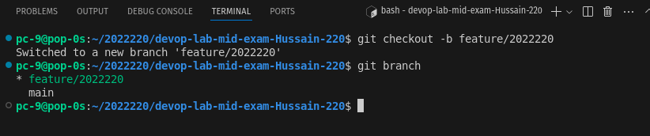

Task 2: Add features

Feature 1: Adding an Address field
updated index.html

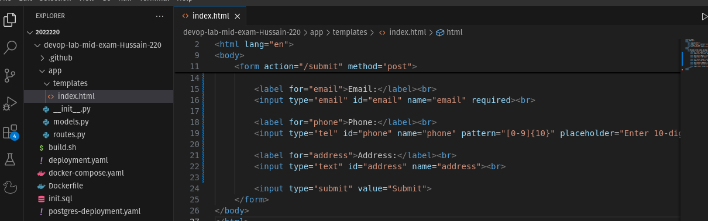
updated routes.py
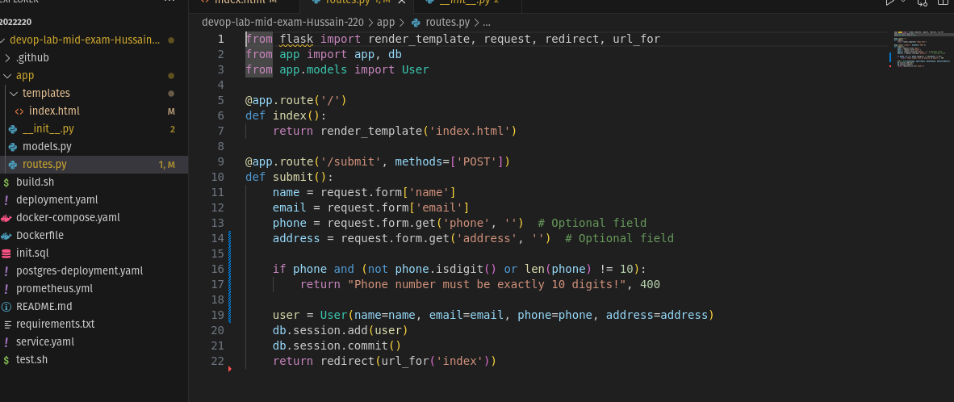

updated model.py
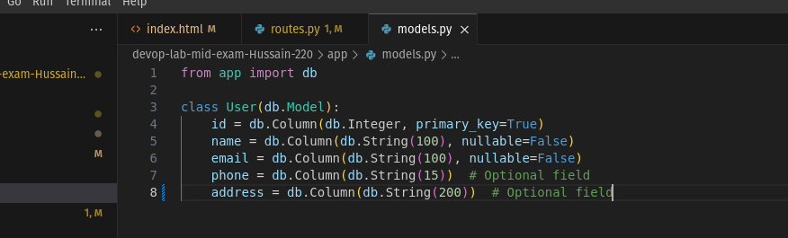
pushing the code to the feature branch
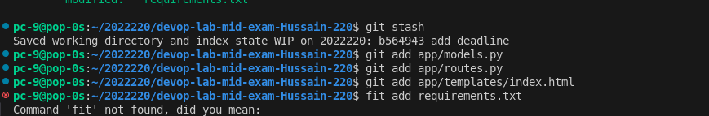
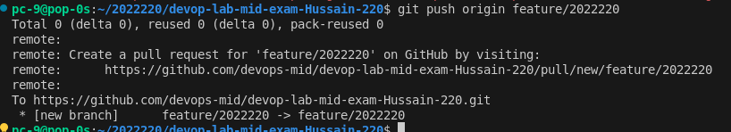

Feature 2:
client-side validation for email
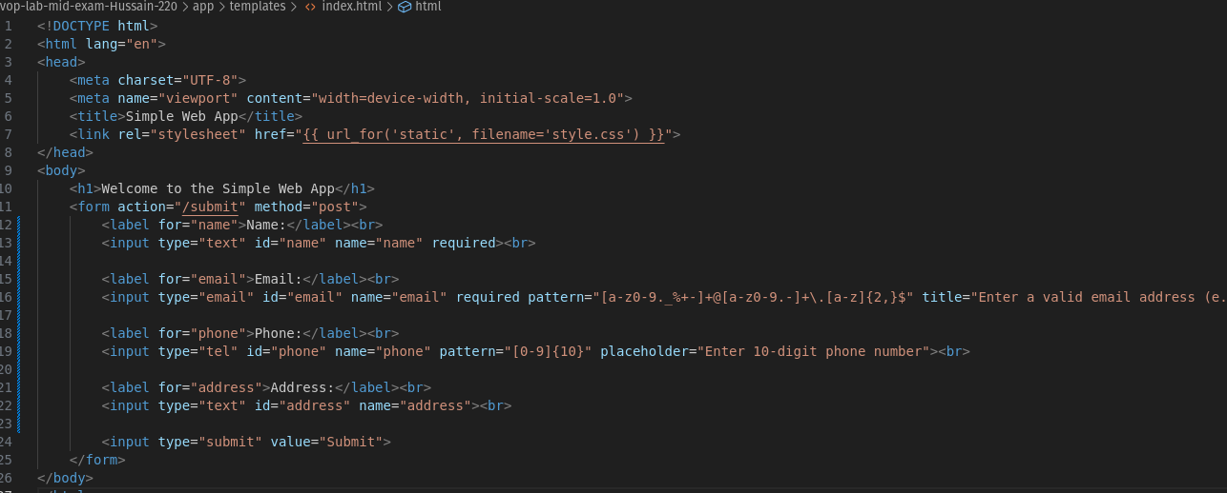

server-side validation for phone number: in routes.py
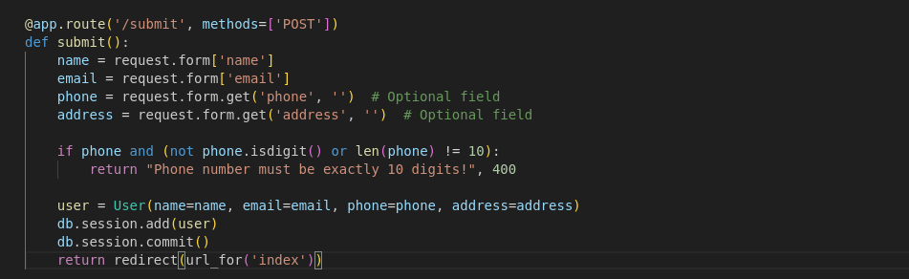
and enhanced feature of displaying error message
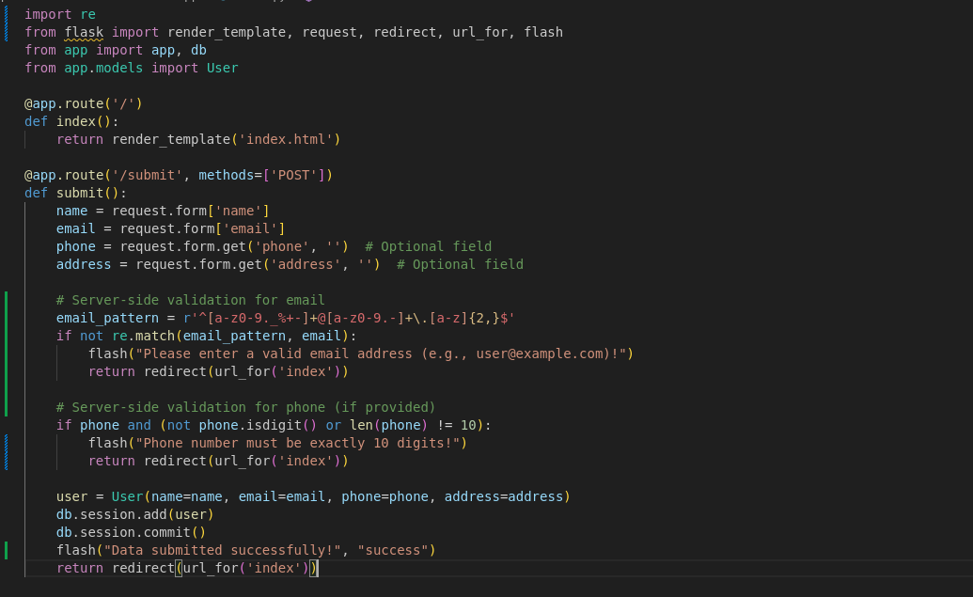

Task3:
updated build.sh
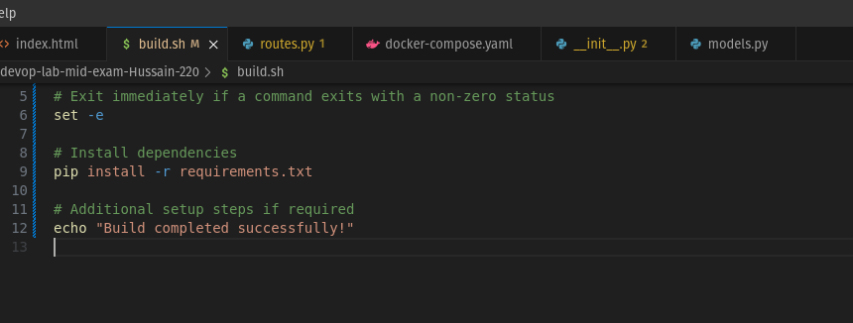

updated test.sh
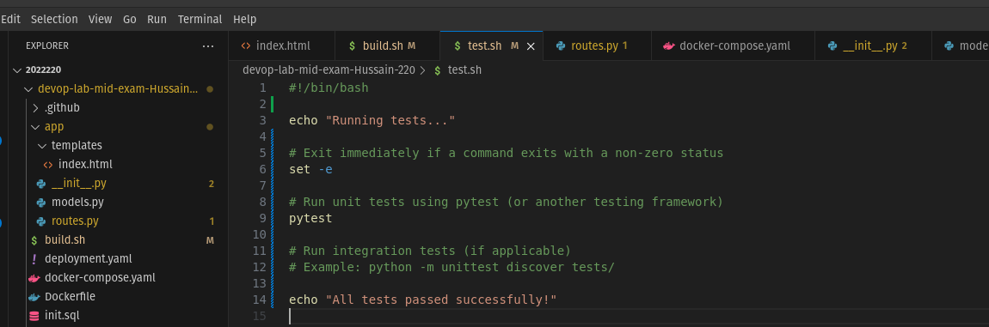

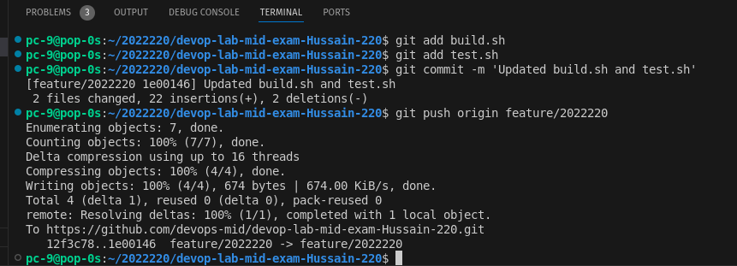

Task 4:

added docker file

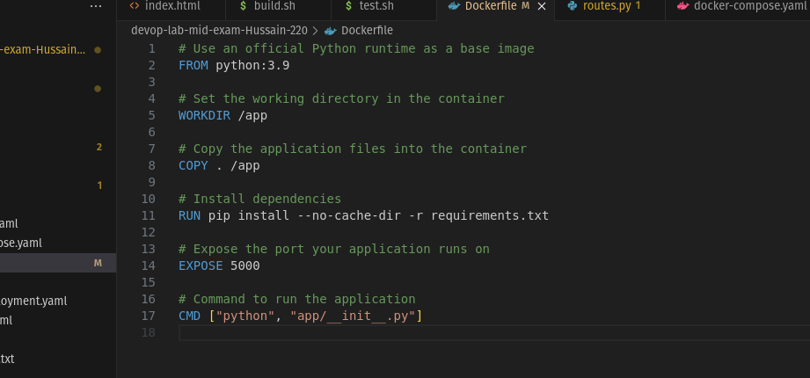

running the docker build command

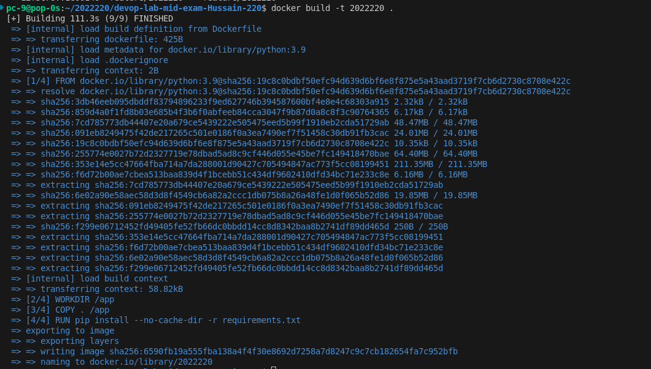

logged in the docker
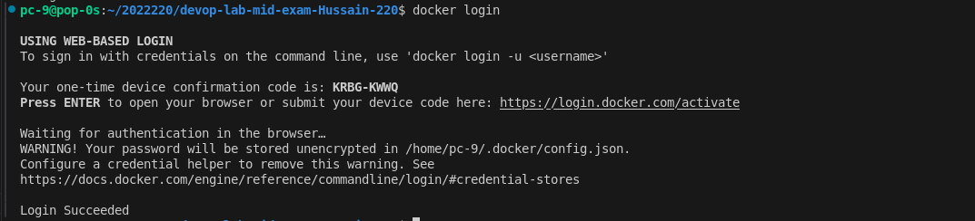
pushing the docker image

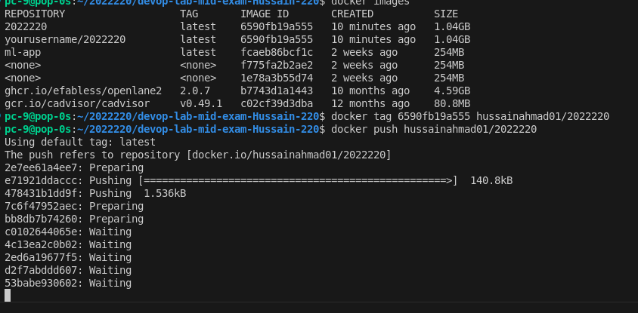

Task5: Updated deployement .yaml

