Task 1:
Apply clone and create feature branch:
a. create the repoo https://github.com/devops-mid/devop-lab-mid-exam-adeelkh21
b. create a feature branch feature/2022331

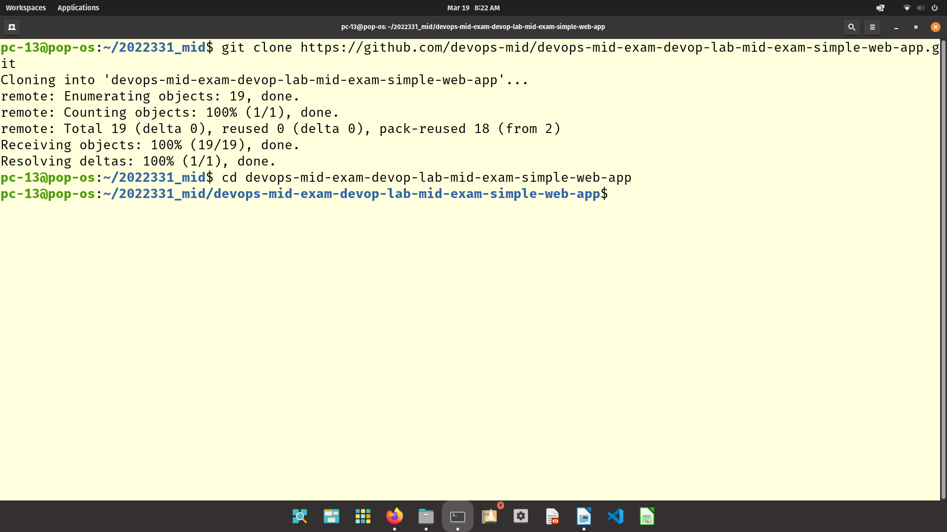
Task2: create new features:
a. feature 1
I. modify web app with another fields of your chouce fathername and phone)
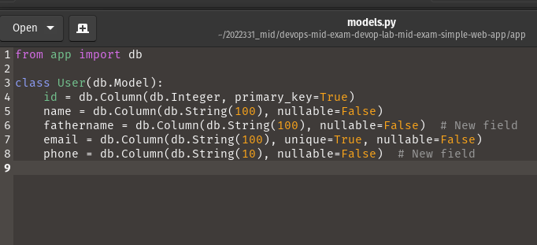

ii. update the backed to hadle the new fields and sotre it in database
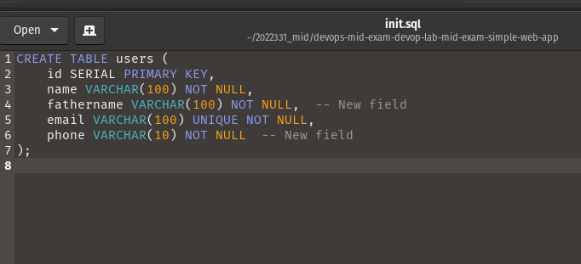
iii. Modify the database file to add new colimn to the table

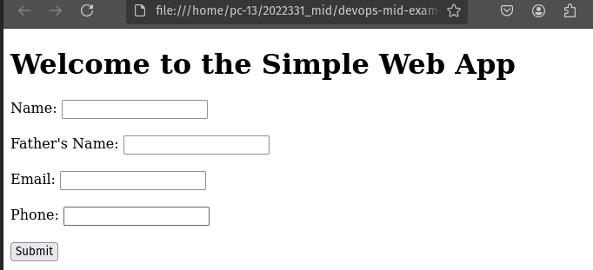

b. feature 2:
I. add client-side validation to ensure the email field contains a valid email address
ii. add server-side validation to ensure the phone number in numeric and has exactly 10 digits
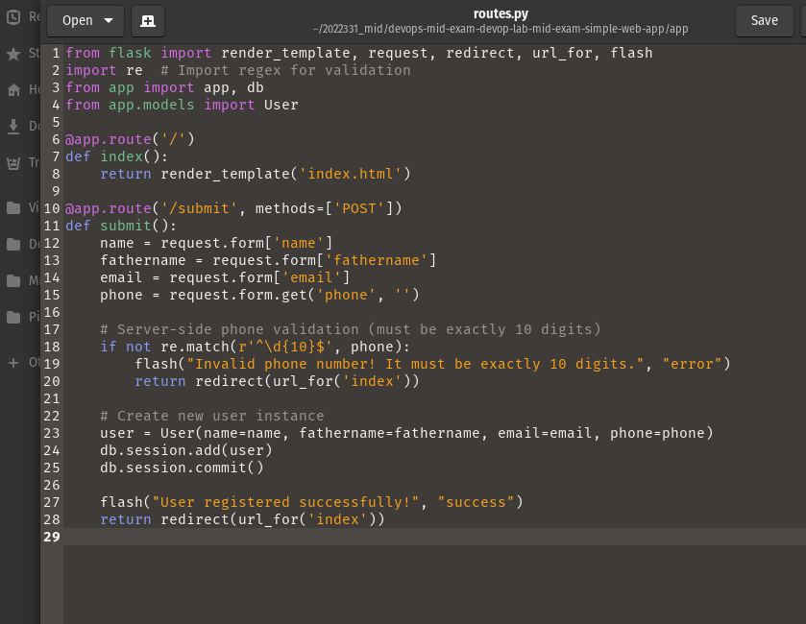

c. feature 3. ( make changes to style, appearance etc.)
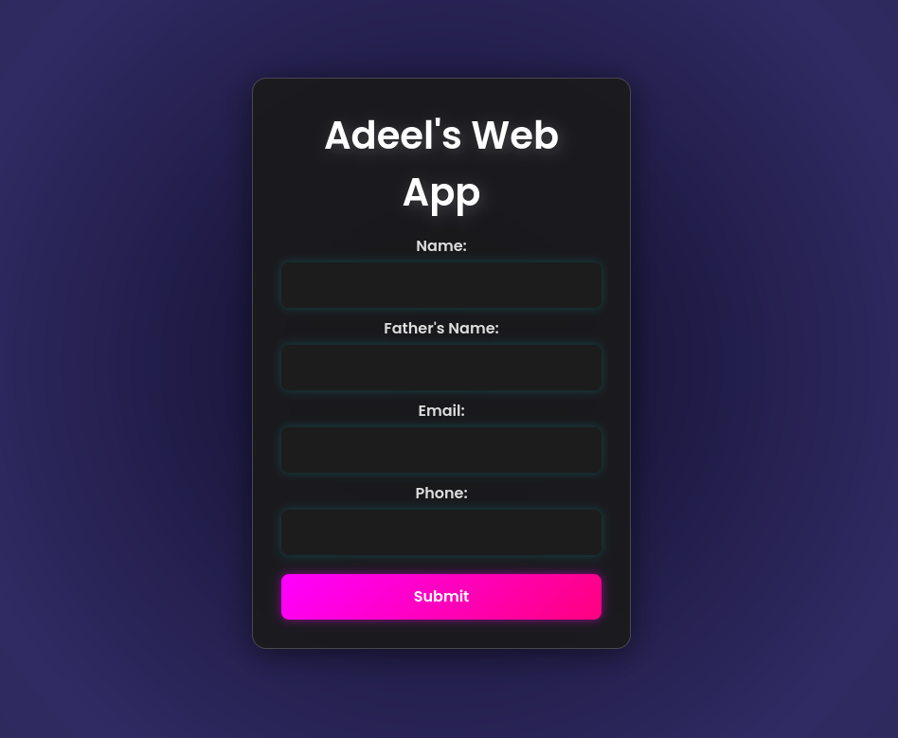

3. Analyze the issues:
a. the provided build.sh script is incomplete or contain errors, fix the script so that it installs dependecines of requirements.txt file

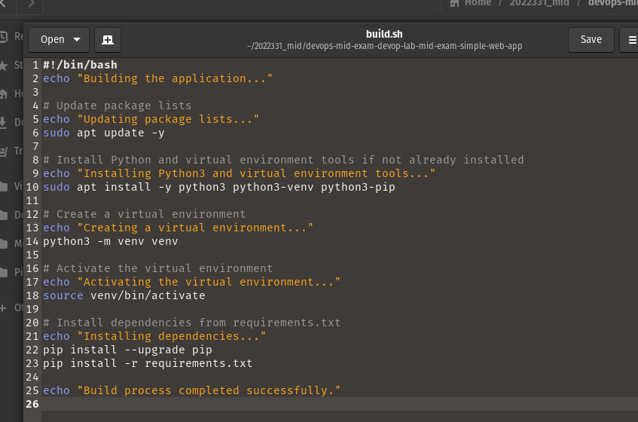
b. the provided test.sh script alos is incomplete or contains errors fix it to run unit tests and integration tests

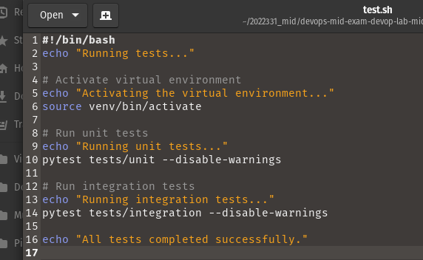

4. create container and containerizethe application:
a. update the container file to
I. User correct base image
ii. copy the application code into container
iii. intasll dependencis
iv. expose the correct port
v. set the correct entry point or command to run the applocation

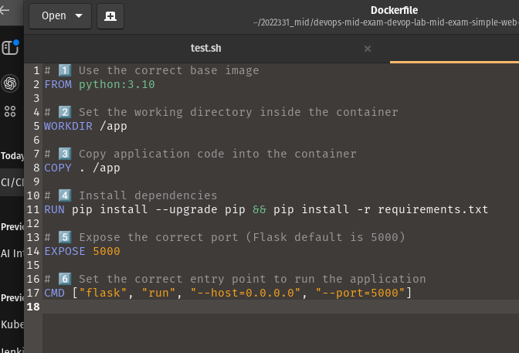
b. build and push the container image. Container name should be 2022331
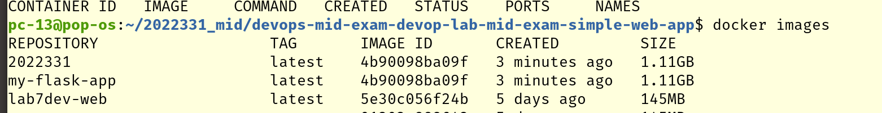

5. create instances and deploy application and database
a. create kyubernetes file for web application and database
I. file for depoloument of webapp and databas
ii. file for serviecs of web aplication and database
b. deploy the applocation and data base

the following files were created:

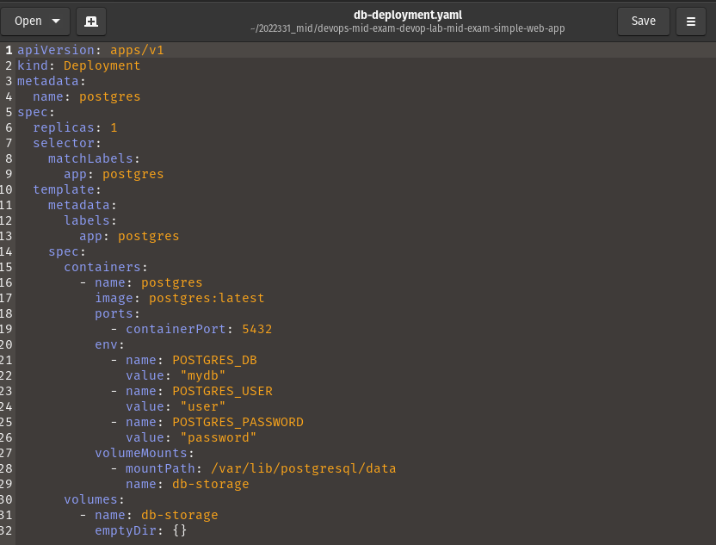

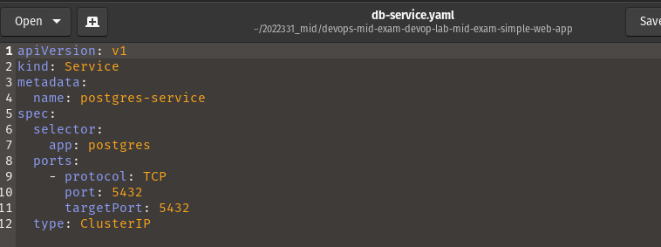

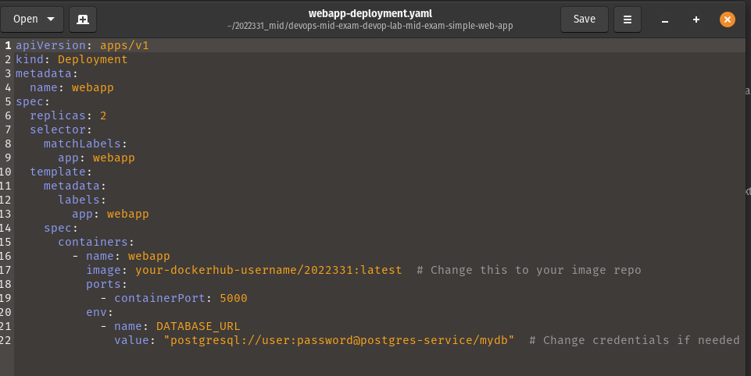
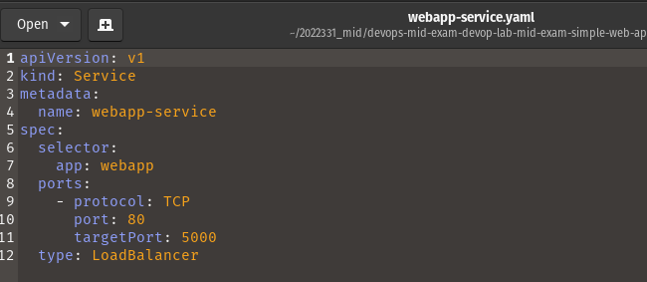

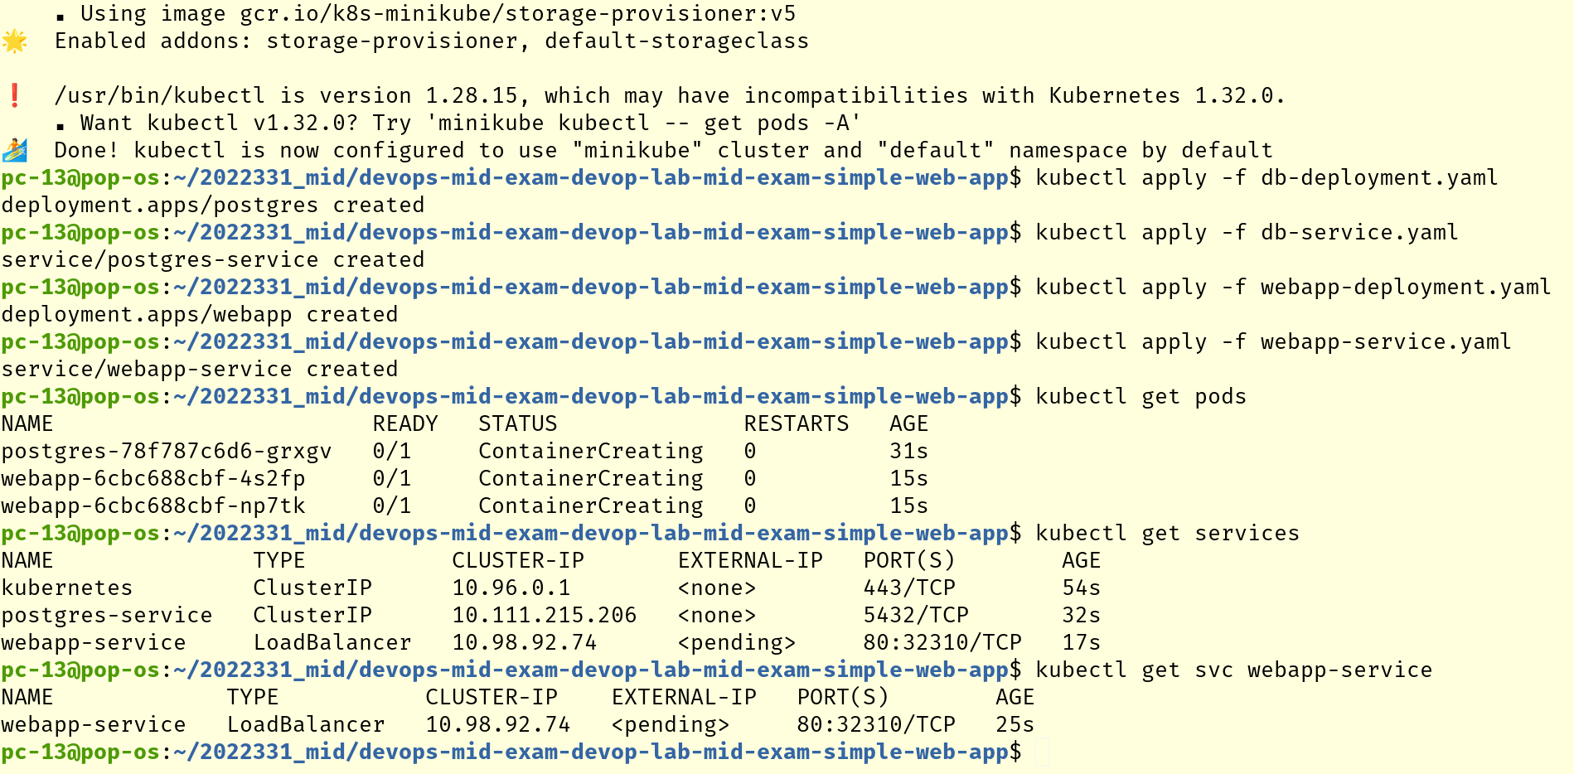

6. evaluate application and set up monitoring
a. setup monitoring of the application and database
I. create configuration file for prometheus
ii. deploy promethus using configuration

