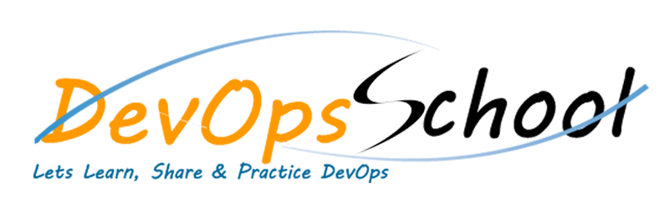

**DevOps Certified Professional**

|  |  |
| --- | --- |
| Trainer Name | Rajesh Kumar |
| No. of Hours | 75 Hours |
| Trainer CV | https://www.linkedin.com/in/rajeshkumarin/ |

|  |  |  |  |  |
| --- | --- | --- | --- | --- |
| Linux | Vagrant | AWS | DOCKER | JIRA |
| Confluence | Python | Git | Github | sonarqube |
| coverity | maven | gradle | package | artifactory |
| selenium | jmeter | ansible | kubernetes | helm |
| terraform | jenkins | datadog | splunk | newrelic |

**DevOps Certification Agenda**

* **SDLC Models & Architecture with Agile, DevOps, SRE & DevSecOps, SOA & Micro services** - Concept
* **Platform -** Operating Systems - Centos/Ubuntu & VirtualBox & Vagrant
* **Platform - Cloud** - AWS
* **Platform - Containers** - Docker
* **Planning and Designing** - Jira & Confulence
* **Backend Programming Language** - App Dev with Python/Flask with mysql DB
* **Source Code Versioning** - Git using Github
* **Code Analysis & Securing Code (SAST)** - SonarQube & Coverity Scan & Snyk
* **Build Management** - Maven and Gradle
* **Package Management** - Packer & Artifactory
* **Unit Testing & Acceptance Testing & Coverage** - Web applications - Junit & Selenium & Jacoco & Jmeter
* **Configuration & Deployment Management** - Ansible
* **Container Orchestration** - Kubernetes & Helm Introduction
* **Infrastructure Coding** - Terraform
* **Continuous Integration** - Jenkins
* **Infrastructure Monitoring Tool** - Datadog
* **Log Monitoring Tool** - Splunk
* **Application Performance Monitoring** – NewRelic

**Trainer Details**

**Name - Rajesh Kumar**

Linkedin - <https://www.linkedin.com/in/rajeshkumarin/>

Web CV - <https://www.rajeshkumar.xyz/cv/>

Training Clients - <https://www.rajeshkumar.xyz/clients/>

**Summary -**

Total, Over 18 years of extensive experience working with more than 10 software development companies for software development & maintenance of production environments involved in continuous improvement and automating entire life cycle using latest devops tools and techniques from design and architecture, through implementation, deployment, and successful operations. Also, helping more than 200 software organizations & 30000 engineers globally, providing coaching, mentoring and consulting in DevOps, CICD, Cloud, containers, SRE, DevSecOps, microservices and operations.

**DevOpsSchool Advantage**

DevOps: Basic Economics & Advantage & Summary

* Summary - 25 Tools.
* Fees - INR 19999 OR $300
* Duration - 80 Hours / 2 Months Program
* Economics - INR 800 /tool OR $10/tool for Lifetime
* Instructor Led Live training Session
* Lifetime access to LMS (<https://www.devopsschool.com/lms/>
* Trainer with 18+ real time exp from Top Prod based Company
* 1000+ real-time interview questions & Answer
* Interview Preparation Online KIT
* Assignment for each tools
* Real time based Project per courses
* 6 Months Free Internship Based on Merit by Cotocus Pvt Ltd IT Company (<https://www.cotocus.com/>)
* Course Syllabus Link - <https://devopsschool.com/certification/devops-certified-professional-dcp.html>