To set username to git

**git config –global user.name “Mukul”**

To set github email to git

**git config –global user.email “**[**myemail@gmail.com**](mailto:myemail@gmail.com)**”**

To check configured username and email id

**cat ~/.gitconfig**

To clone a repository

**git clone** [**https://github.com/devops021/java.git**](https://github.com/devops021/java.git)

To see the commit history

**git log**

To create a new git project

**git init**

To check the status of file we use

**git status**

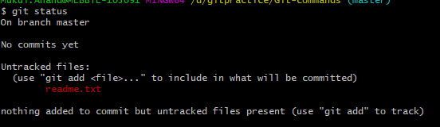

To add a file to git staging area

**git add readme.txt**

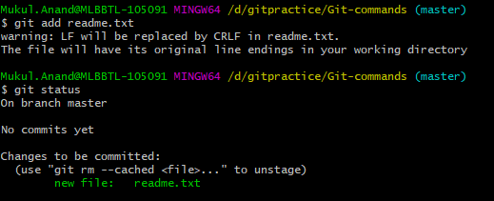

To commit

git commit -m “First commit”

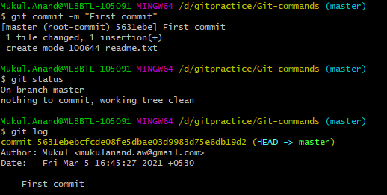

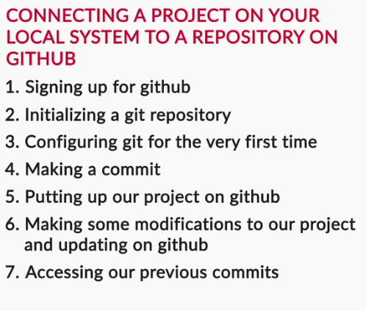

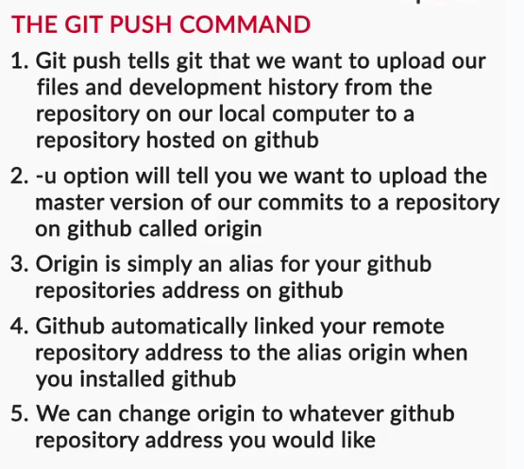

First-time Git setup:

For the first time Git configuration, you use the following commands:

**git config --global user.name "random”**

Using this, you will enter your GitHub username

**git config --global user.email “random@example.com”**

Using this, you will enter your GitHub username

Making a commit and pushing your changes to GitHub:

Commands to be executed are:

**git init**

**git add filename**

**(**git add readme.txt**)**

**git commit -m “commit message”**

**git remote add origin <url of the remote repository>**

**(**git remote add origin <https://github.com/devops021/git-repo.git>**)**

**git push -u origin master**

**or**

**git push**