Project URL

<https://github.com/devops021/spring-microservices-v2>

Debugging Guide

<https://github.com/in28minutes/spring-microservices-v2/blob/main/03.microservices/01-step-by-step-changes/microservices-v2-1.md#spring-cloud-config-server---steps-01-to-08>

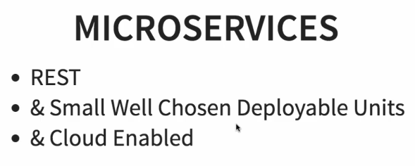

Spring cloud

<https://spring.io/projects/spring-cloud>

<https://spring.io/projects/spring-cloud-netflix>

3.0.3

# **Centralized Configuration**

Creating a hard coded limits service - V2

Getting hardcoded value

@GetMapping("/limits")

**public** Limits retrieveLimits() {

**return** **new** Limits(1,1000);

}

119. Step 01 - Setting up Limits Microservice - V2

To connect limit-service to spring-cloud-config-server we need below jar –

<dependency>

<groupId>org.springframework.cloud</groupId>

<artifactId>spring-cloud-starter-config</artifactId>

</dependency>

When we add in spring-cloud-starter-config what we would need to do is to configure how spring starter config needs to connect to spring cloud config server.

Application.properties

spring.config.import=optional:configserver:http://localhost:8888

122. Step 03 - Enhance limits service - Get configuration from application properties - V2

package com.in28minutes.microservices.limitsservice.controller;

import org.springframework.beans.factory.annotation.Autowired;

import org.springframework.web.bind.annotation.GetMapping;

import org.springframework.web.bind.annotation.RestController;

import com.in28minutes.microservices.limitsservice.bean.Limits;

import com.in28minutes.microservices.limitsservice.configuration.Configuration;

@RestController

public class LimitsController {

**@Autowired**

**private Configuration configuration;**

@GetMapping("/limits")

public Limits retrieveLimits() {

**return new Limits(configuration.getMinimum(),**

**configuration.getMaximum());**

// return new Limits(1,1000);

}

}

package com.in28minutes.microservices.limitsservice.configuration;

import org.springframework.boot.context.properties.ConfigurationProperties;

import org.springframework.stereotype.Component;

@Component

@ConfigurationProperties("limits-service")//limits-service is name in application.properties before .

public class Configuration {

private int minimum;

private int maximum;

public int getMinimum() {

return minimum;

}

public void setMinimum(int minimum) {

this.minimum = minimum;

}

public int getMaximum() {

return maximum;

}

public void setMaximum(int maximum) {

this.maximum = maximum;

}

}

**package** com.in28minutes.microservices.limitsservice.bean;

**public** **class** Limits {

**private** **int** minimum;

**private** **int** maximum;

**public** Limits() {

**super**();

}

**public** Limits(**int** minimum, **int** maximum) {

**super**();

**this**.minimum = minimum;

**this**.maximum = maximum;

}

**public** **int** getMinimum() {

**return** minimum;

}

**public** **void** setMinimum(**int** minimum) {

**this**.minimum = minimum;

}

**public** **int** getMaximum() {

**return** maximum;

}

**public** **void** setMaximum(**int** maximum) {

**this**.maximum = maximum;

}

}

**application.properties**

limits-service.minimum=3

limits-service.maximum=9972

123. Step 04 - Setting up Spring Cloud Config Server - V2

Spring Cloud Config provides server-side and client-side support for externalized configuration in a distributed system. With the Config Server, you have a central place to manage external properties for applications across all environments. We can use Git, SVN, or HashiCorp.

<dependency>

<groupId>org.springframework.cloud</groupId>

<artifactId>spring-cloud-config-server</artifactId>

</dependency>

Installing Git and Creating Local Git Repository

Create a folder **git-localconfig-repo** and initialize git

git init

**/git-localconfig-repo/limits-service.properties New**

limits-service.minimum=1

limits-service.maximum=111

open git bash

git add *

git commit -m "First commit"

Connect Spring Cloud Config Server to Local Git Repository –

#### application.properties Modified

spring.application.name=spring-cloud-config-server

server.port=8888

#spring.cloud.config.server.git.uri=file:///in28Minutes/git/spring-microservices-v2/03.microservices/git-localconfig-repo

spring.cloud.config.server.git.uri=D:\\NEW_D_DRIVE\\References\\RnD\\DevOps\\MicroServices\\spring-microservices-v2-main\\spring-microservices-v2-main\\03.microservices\\git-localconfig-repo

**SpringCloudConfigServerApplication.java**

**package** com.in28minutes.microservices.springcloudconfigserver;

**import** org.springframework.boot.SpringApplication;

**import** org.springframework.boot.autoconfigure.SpringBootApplication;

**import** org.springframework.cloud.config.server.EnableConfigServer;

@EnableConfigServer

@SpringBootApplication

**public** **class** SpringCloudConfigServerApplication {

**public** **static** **void** main(String[] args) {

SpringApplication.*run*(SpringCloudConfigServerApplication.**class**, args);

}

}

<http://localhost:8888/limits-service/default>

{

"name": "limits-service",

"profiles": [

"default"

],

"label": null,

"version": "6848d10ff4506852c1553ecc2baa6210b239563f",

"state": null,

"propertySources": [

{

"name": "D:\\NEW_D_DRIVE\\References\\RnD\\DevOps\\MicroServices\\spring-microservices-v2-main\\spring-microservices-v2-main\\03.microservices\\git-localconfig-repo/file:C:\\Users\\MUKUL~1.ANA\\AppData\\Local\\Temp\\config-repo-5847434452671414885\\limits-service.properties",

"source": {

"limits-service.minimum": "1",

"limits-service.maximum": "111"

}

}

]

}

127. Step 07 - Connect Limits Service to Spring Cloud Config Server - V2

In limit-service project add url of cloud config server and property file name which will be same as application name and jar spring-cloud-starter-config is already added in pom

application.properties

spring.application.name=limits-service

spring.config.import=optional:configserver:http://localhost:8888

<http://localhost:8080/limits>

{

"minimum": 1,

"maximum": 111

}

The above values are coming from cloud config server limits-server.properties default. The values in the application that properties have less priority compared

to the values which are present in your git repository.

Add few more properties file –

**limits-service-qa.properties**

limits-service.minimum=2

limits-service.maximum=222

**limits-service-dev.properties**

limits-service.minimum=3

limits-service.maximum=333

**limits-service-prod.properties**

limits-service.minimum=4

limits-service.maximum=444

<http://localhost:8888/limits-service/prod>

This would also return the default limits-service.properties file but the values which are configured in limits-service-dev will have higher priority than the values which are configured in limits-service.properties.

{

"name": "limits-service",

"profiles": [

"prod"

],

"label": null,

"version": "922d7418db15475287e82bc8aa519f135bedd6e4",

"state": null,

"propertySources": [

{

"name": "D:\\NEW_D_DRIVE\\References\\RnD\\DevOps\\MicroServices\\spring-microservices-v2-main\\spring-microservices-v2-main\\03.microservices\\git-localconfig-repo/file:C:\\Users\\MUKUL~1.ANA\\AppData\\Local\\Temp\\config-repo-4839353651740153921\\limits-service-prod.properties",

"source": {

"limits-service.minimum": "4",

"limits-service.maximum": "444"

}

},

{

"name": "D:\\NEW_D_DRIVE\\References\\RnD\\DevOps\\MicroServices\\spring-microservices-v2-main\\spring-microservices-v2-main\\03.microservices\\git-localconfig-repo/file:C:\\Users\\MUKUL~1.ANA\\AppData\\Local\\Temp\\config-repo-4839353651740153921\\limits-service.properties",

"source": {

"limits-service.minimum": "1",

"limits-service.maximum": "111"

}

}

]

}

**Note: We can pick different name of properties file from application name using below property in application.properties**

spring.cloud.config.name=limits-service-002

We can configure the name suffix of configuration file we want to pick and use in application.properties –

spring.profiles.active=qa

spring.cloud.config.profile=qa

<http://localhost:8080/limits>

{

"minimum": 2,

"maximum": 222

}

spring.profiles.active=prod

spring.cloud.config.profile=prod

<http://localhost:8080/limits>

{

"minimum": 4,

"maximum": 444

}

134. Step 12 - Setting up Dynamic Port in the the Response - V2

@Autowired

**private** Environment environment;

@GetMapping("/currency-exchange/from/{from}/to/{to}")

**public** CurrencyExchange retrieveExchangeValue(

@PathVariable String from,

@PathVariable String to) {

logger.info("retrieveExchangeValue called with {} to {}", from, to);

CurrencyExchange currencyExchange

= repository.findByFromAndTo(from, to);

**if**(currencyExchange ==**null**) {

**throw** **new** RuntimeException

("Unable to Find data for " + from + " to " + to);

}

String port = environment.getProperty("local.server.port");

currencyExchange.setEnvironment(port);

**return** currencyExchange;

}

Go to Run configuration

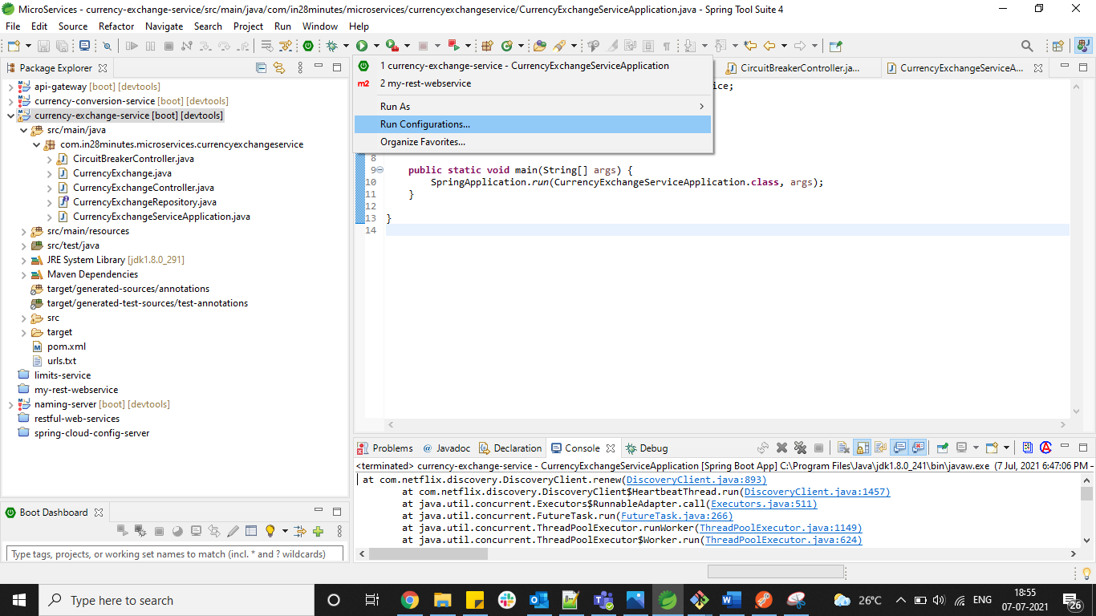

Make duplicate at Spring Boot App

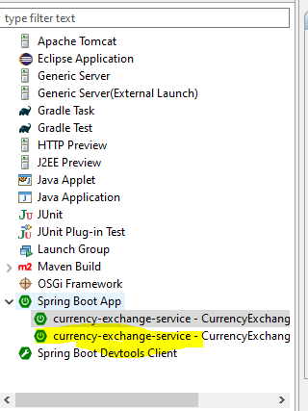

Rename with suffix 8000 and 8001

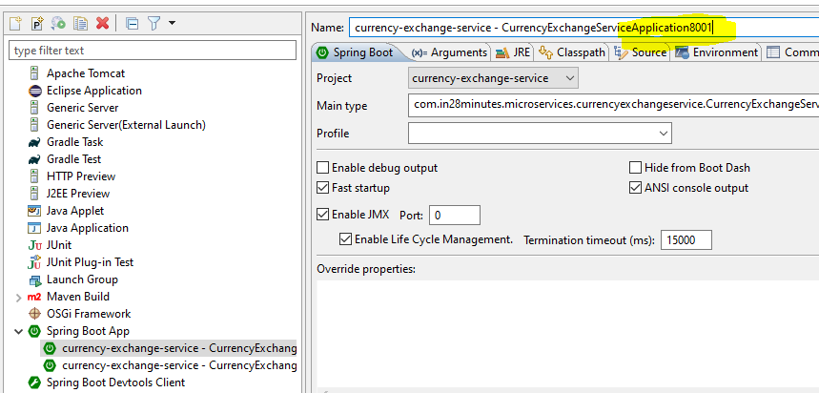

Apply

Provide Argument of port which will override 8000

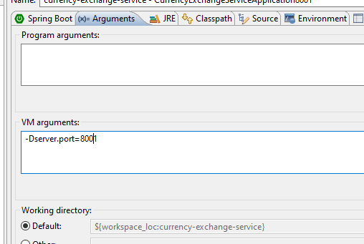

141. Step 17 - Invoking Currency Exchange from Currency Conversion Microservice - V2

@GetMapping("/currency-conversion/from/{from}/to/{to}/quantity/{quantity}")

**public** CurrencyConversion calculateCurrencyConversion(

@PathVariable String from,

@PathVariable String to,

@PathVariable BigDecimal quantity

) {

HashMap<String, String> uriVariables = **new** HashMap<>();

uriVariables.put("from",from);

uriVariables.put("to",to);

ResponseEntity<CurrencyConversion> responseEntity = **new** RestTemplate().getForEntity

("http://localhost:8000/currency-exchange/from/{from}/to/{to}",

CurrencyConversion.**class**, uriVariables);

CurrencyConversion currencyConversion = responseEntity.getBody();

**return** **new** CurrencyConversion(currencyConversion.getId(),

from, to, quantity,

currencyConversion.getConversionMultiple(),

quantity.multiply(currencyConversion.getConversionMultiple()),

currencyConversion.getEnvironment()+ " " + "rest template");

}

# **Feign (Client side load balencing)**

Feign uses eureka clients spring-cloud-load-balancer for client side load balancing.

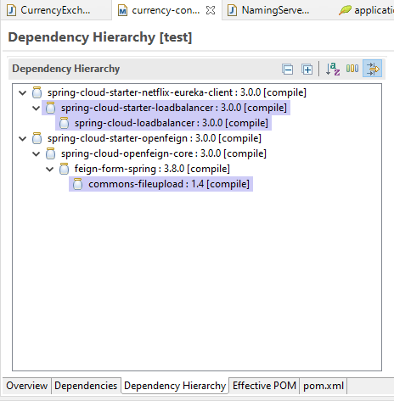

142. Step 18 - Using Feign REST Client for Service Invocation - V2

<dependency>

<groupId>org.springframework.cloud</groupId>

<artifactId>spring-cloud-starter-openfeign</artifactId>

</dependency>

Client currency-conversion-service will have a proxy –

package com.in28minutes.microservices.currencyconversionservice;

import org.springframework.cloud.openfeign.FeignClient;

import org.springframework.web.bind.annotation.GetMapping;

import org.springframework.web.bind.annotation.PathVariable;

@FeignClient(name="currency-exchange", url="localhost:8000")//name will be application name configured in application.properties and URL will be base URl

public interface CurrencyExchangeProxy {

@GetMapping("/currency-exchange/from/{from}/to/{to}")

public CurrencyConversion retrieveExchangeValue(

@PathVariable String from,

@PathVariable String to); //Only method defination

}

----------------------------------------------------------------------------------

Add an annotation in main class –

**package** com.in28minutes.microservices.currencyconversionservice;

**import** org.springframework.boot.SpringApplication;

**import** org.springframework.boot.autoconfigure.SpringBootApplication;

**import** org.springframework.cloud.openfeign.EnableFeignClients;

@SpringBootApplication

@EnableFeignClients

**public** **class** CurrencyConversionServiceApplication {

**public** **static** **void** main(String[] args) {

SpringApplication.*run*(CurrencyConversionServiceApplication.**class**, args);

}

}

---------------------------------------------

@Autowired

**private** CurrencyExchangeProxy proxy;

@GetMapping("/currency-conversion-feign/from/{from}/to/{to}/quantity/{quantity}")

**public** CurrencyConversion calculateCurrencyConversionFeign(

@PathVariable String from,

@PathVariable String to,

@PathVariable BigDecimal quantity

) {

CurrencyConversion currencyConversion = proxy.retrieveExchangeValue(from, to);

**return** **new** CurrencyConversion(currencyConversion.getId(),

from, to, quantity,

currencyConversion.getConversionMultiple(),

quantity.multiply(currencyConversion.getConversionMultiple()),

currencyConversion.getEnvironment() + " " + "feign");

}

# **Naming Server**

naming-server add –

<dependency>

<groupId>org.springframework.cloud</groupId>

<artifactId>spring-cloud-starter-netflix-eureka-server</artifactId>

</dependency>

package com.in28minutes.microservices.namingserver;

import org.springframework.boot.SpringApplication;

import org.springframework.boot.autoconfigure.SpringBootApplication;

import org.springframework.cloud.netflix.eureka.server.EnableEurekaServer;

@EnableEurekaServer

@SpringBootApplication

public class NamingServerApplication {

public static void main(String[] args) {

SpringApplication.run(NamingServerApplication.class, args);

}

}

Application.properties

spring.application.name=naming-server

server.port=8761

eureka.client.register-with-eureka=false

eureka.client.fetch-registry=false

<http://localhost:8761/>

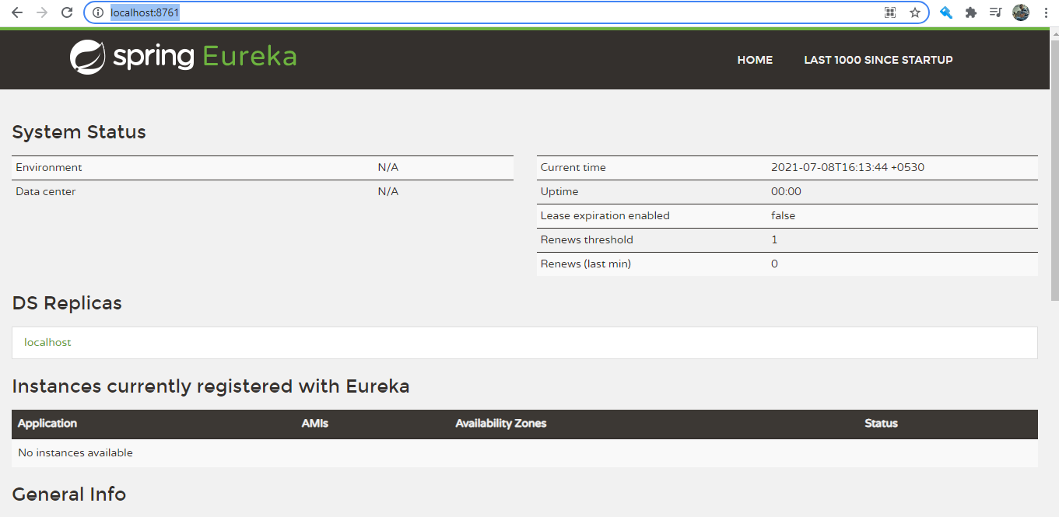

145. Step 20 - Connect Currency Conversion & Currency Exchange Microservices - V2

currency-conversion-service and currency-exchange-service add –

<dependency>

<groupId>org.springframework.cloud</groupId>

<artifactId>spring-cloud-starter-netflix-eureka-client</artifactId>

</dependency>

Add url of eureka server in all applications –

Application.properties

eureka.client.serviceUrl.defaultZone=http://localhost:8761/eureka

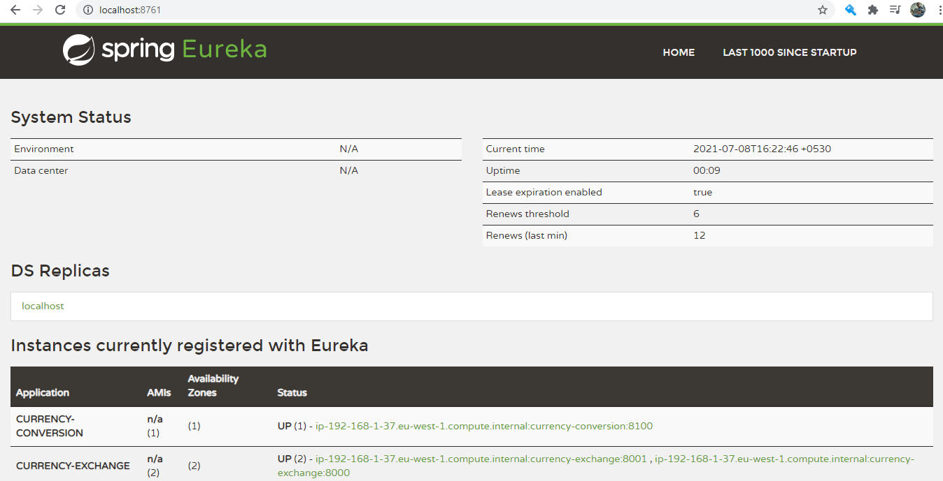

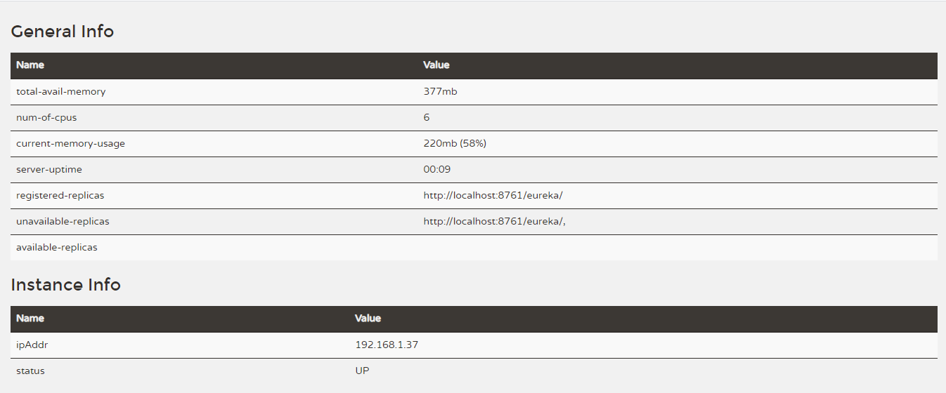

147. Step 22 - Load Balancing with Eureka, Feign & Spring Cloud LoadBalancer - V2

package com.in28minutes.microservices.currencyconversionservice;

import org.springframework.cloud.openfeign.FeignClient;

import org.springframework.web.bind.annotation.GetMapping;

import org.springframework.web.bind.annotation.PathVariable;

//@FeignClient(name="currency-exchange", url="localhost:8000")

@FeignClient(name="currency-exchange")

public interface CurrencyExchangeProxy {

@GetMapping("/currency-exchange/from/{from}/to/{to}")

public CurrencyConversion retrieveExchangeValue(

@PathVariable String from,

@PathVariable String to);

}

Use feign URL of currency conversion service to see load balancing –

<http://localhost:8100/currency-conversion-feign/from/USD/to/INR/quantity/10>

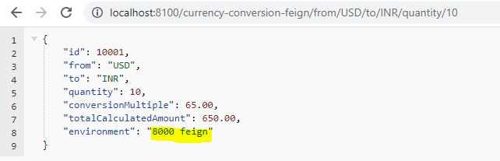

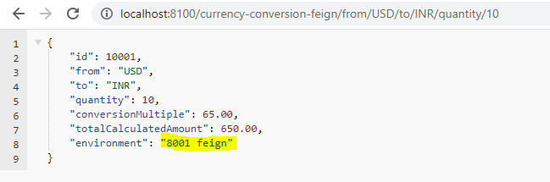

148. Step 22 - Setting up Spring Cloud API Gateway

<dependency>

<groupId>org.springframework.cloud</groupId>

<artifactId>spring-cloud-starter-gateway</artifactId>

</dependency>

Application.properties

spring.application.name=api-gateway

server.port=8765

eureka.client.serviceUrl.defaultZone=http://localhost:8761/eureka

#To Allow the api gateway to discover other applications configured in eureka

spring.cloud.gateway.discovery.locator.enabled=true

#To allow url in lower case also

#spring.cloud.gateway.discovery.locator.lowerCaseServiceId=true

spring.sleuth.sampler.probability=1.0

All the common logic like authentication, logging can be implemented using api-gateway.

<http://localhost:8765/CURRENCY-EXCHANGE/currency-exchange/from/USD/to/INR>

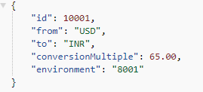

153. Step 25 - Implementing Spring Cloud Gateway Logging Filter

package com.in28minutes.microservices.apigateway;

import org.slf4j.Logger;

import org.slf4j.LoggerFactory;

import org.springframework.cloud.gateway.filter.GatewayFilterChain;

import org.springframework.cloud.gateway.filter.GlobalFilter;

import org.springframework.stereotype.Component;

import org.springframework.web.server.ServerWebExchange;

import reactor.core.publisher.Mono;

@Component

public class LoggingFilter implements GlobalFilter {

private Logger logger = LoggerFactory.getLogger(LoggingFilter.class);

@Override

public Mono<Void> filter(ServerWebExchange exchange,

GatewayFilterChain chain) {

logger.info("Path of the request received -> {}",

exchange.getRequest().getPath());

return chain.filter(exchange);

}

}

2021-07-08 17:12:23.259 INFO [api-gateway,,] 20788 --- [ctor-http-nio-3] c.i.m.apigateway.LoggingFilter : Path of the request received -> /currency-conversion-feign/from/USD/to/INR/quantity/10

# **Circuit Breaker (Fault tolerance)**

154. Step 26 - Getting started with Circuit Breaker - Resilience4j

currency-exchange-service add –

We need following dependencies –

<dependency>

<groupId>org.springframework.boot</groupId>

<artifactId>spring-boot-starter-actuator</artifactId>

</dependency>

<dependency>

<groupId>org.springframework.boot</groupId>

<artifactId>spring-boot-starter-aop</artifactId>

</dependency>

<dependency>

<groupId>io.github.resilience4j</groupId>

<artifactId>resilience4j-spring-boot2</artifactId>

</dependency>

Application.properties

resilience4j.retry.instances.sample-api.maxRetryAttempts=5

resilience4j.retry.instances.sample-api.waitDuration=1s

resilience4j.retry.instances.sample-api.enableExponentialBackoff=true

#resilience4j.circuitbreaker.instances.default.failureRateThreshold=90

-----------------------------------------------------------------------------

package com.in28minutes.microservices.currencyexchangeservice;

import org.slf4j.Logger;

import org.slf4j.LoggerFactory;

import org.springframework.http.ResponseEntity;

import org.springframework.web.bind.annotation.GetMapping;

import org.springframework.web.bind.annotation.RestController;

import org.springframework.web.client.RestTemplate;

import io.github.resilience4j.bulkhead.annotation.Bulkhead;

import io.github.resilience4j.circuitbreaker.annotation.CircuitBreaker;

import io.github.resilience4j.ratelimiter.annotation.RateLimiter;

@RestController

public class CircuitBreakerController {

private Logger logger =

LoggerFactory.getLogger(CircuitBreakerController.class);

@GetMapping("/sample-api")

//@Retry(name = "sample-api", fallbackMethod = "hardcodedResponse")

//@CircuitBreaker(name = "default", fallbackMethod = "hardcodedResponse")

//@RateLimiter(name="default")

@Bulkhead(name="sample-api")

//10s => 10000 calls to the sample api

public String sampleApi() {

logger.info("Sample api call received");

// ResponseEntity<String> forEntity = new RestTemplate().getForEntity("http://localhost:8080/some-dummy-url",

// String.class);

// return forEntity.getBody();

return "sample-api";

}

public String hardcodedResponse(Exception ex) {

return "fallback-response";

}

}