***Seller Restrictions***

*The data contained in this document shall not be disclosed and shall not be duplicated, used, or disclosed in whole or in part for any purpose. If a contract is awarded to chosen parties as a result of or in connection with the submission of this data, the client or prospective client shall have the right to duplicate, use, or disclose this data to the extent provided in the contract. This restriction does not limit the client’s or prospective client’s right to use the information contained in the data if it is obtained from another source without restriction. The data subject to this restriction is contained in all marked sheets.*

**MS SQL monitoring of services regular status**

***Version Control***

*All information given under this version over rides all and any kind of offers, assumptions, deliverables and contracts, given under any previous version. All previous versions of the subject Proposal stand null and void.*

|  |  |  |  |
| --- | --- | --- | --- |
| **Revision History** | | | |
| **Date** | **Who** | **Version** | **Description** |
| **07/03/2016** | Kanchan | 1.0 | Created Initial Draft Document |
|  |  |  |  |
|  |  |  |  |

TOYOTA FINANCIAL SERVICES

|  |  |
| --- | --- |
| **Version No.** | **Draft** |
| **Date** | **07/03/2016** |
| **Submitted by** | Kanchan |
| **Reviewed by** |  |
| **Approved by** | TEJINDER KAUR |

Table of Contents

|  |  |  |
| --- | --- | --- |
| 1. | Goals & Objectives | 3 |
| 2. | Environment & Prerequisites | 4 |
| 3. | How this script works (help) | 4 |
| 4. | Report | 5 |
| 5. | Script | 5 |

# Goals & Objectives

**Goal:**

Find SQL services instance information and mark services in ‘Red’ which are ‘Automatic’ and ‘start’. The output shall be in an HTML page.

Benefits:

1. If DBA admins need to know about services which are ‘automatic’ and ‘stopped’ then they have to manually login to each server and in “services.msc” they have to manually check. It consumes a lot of their time. This script gives all server names and respectively their SQL services information. Hence it saves time.

2. Environment & Pre-Requisites:

|  |
| --- |
| **Environment** |
| * PowerShell 2.0 * MSSQL server 2012 R2 |

3. How the script works:

Assumptions:

1. Script Should run from an account which have privilegde to access all servers.

Algorithm:

1. Make a folder where all required files should be kept i.e. "ServerList.csv","SQLServiceMonitoring.ps1","SQLServiceMonitoring.bat"

2. Make changes in batch file @line 3 and @line 4

3. Change path of folder in SQLServiceMonitoring.ps1 file

4. Script will execute and fetch MSSQL Services Monitoring report for all servers.

5. Result will be stored in a Html file SQLServiceMonitoring_report.html

4. Reports:

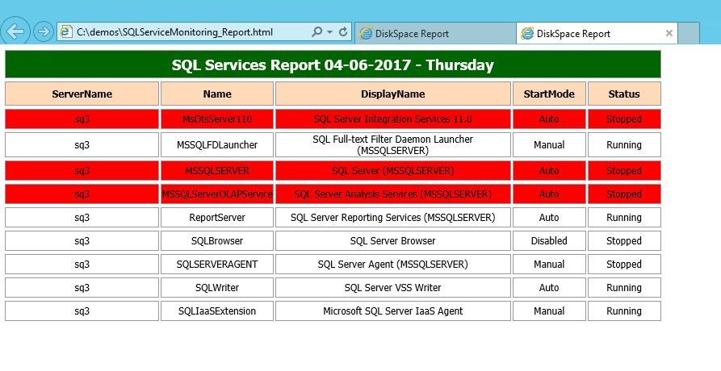

Errorlog file is generated in case of any error



**5**. Scripts:



