AICTE SECURITY DEPOSIT
& FDR LIFECYCLE MANAGEMENT PORTAL
PROJECT REPORT / TECHNICAL DOCUMENTATION
A centralized digital platform for institutional security deposits, Fixed Deposit Receipts (FDRs), scrutiny, maturity monitoring, renewals, releases, and statutory reporting.
Submitted by: ______________________________
Register Number: ___________________________
Department: _________________________________
Institution: __________________________________
Academic Year: 2026–2027

BONAFIDE CERTIFICATE
This is to certify that the project titled “AICTE Security Deposit & FDR Lifecycle Management Portal” is submitted as an academic project.
• The work is presented in partial fulfilment of the requirements of the programme.
• The project has been carried out under the guidance of the project supervisor.
• Student and institutional particulars must be completed before submission.

Detailed Discussion
The certificate page is intended for completion and signature by the authorized project guide, Head of Department, and institution. The project report documents the proposed system, its requirements, architecture, implementation approach, test plan, and user-interface evidence.
The portal is designed around traceability and controlled handling of institutional financial instruments. Each record should retain its relationship to the institution, mandate, submitted evidence, scrutiny decisions, lifecycle events, and reporting output. This relationship-driven design supports consistent review and makes it easier to reconstruct the history of a deposit without relying on disconnected spreadsheets or email trails.
At implementation time, each workflow transition should be validated on the server. The interface can guide users and display status, but it must not be the sole enforcement point for access, amount calculations, or approval rules. Events that materially change a record should be recorded with the acting user, timestamp, previous state, new state, and a short reason where appropriate.

DECLARATION
I declare that this project report is prepared for academic submission and reflects the project scope described in this document.
• The report should be reviewed against the actual implemented application.
• Any borrowed material must be cited in the final submission.
• Screenshots included are interface references supplied for this project.

Detailed Discussion
The declaration is a formal statement of authorship and academic integrity. Before printing, the student should confirm that the report accurately describes the completed work, replace all placeholders, and include only verified implementation and testing results.
The portal is designed around traceability and controlled handling of institutional financial instruments. Each record should retain its relationship to the institution, mandate, submitted evidence, scrutiny decisions, lifecycle events, and reporting output. This relationship-driven design supports consistent review and makes it easier to reconstruct the history of a deposit without relying on disconnected spreadsheets or email trails.
At implementation time, each workflow transition should be validated on the server. The interface can guide users and display status, but it must not be the sole enforcement point for access, amount calculations, or approval rules. Events that materially change a record should be recorded with the acting user, timestamp, previous state, new state, and a short reason where appropriate.

ACKNOWLEDGEMENT
The project team expresses gratitude to the guide, department, institution, and all individuals who supported the project.
• Guidance and feedback helped shape the project scope.
• The supplied UI screens provided a visual reference for the interface design.
• The report is prepared to support clear academic and technical review.

Detailed Discussion
The acknowledgement may be personalized with the names and roles of the project guide, Head of Department, institution, and other contributors. Avoid including personal information without permission.
The portal is designed around traceability and controlled handling of institutional financial instruments. Each record should retain its relationship to the institution, mandate, submitted evidence, scrutiny decisions, lifecycle events, and reporting output. This relationship-driven design supports consistent review and makes it easier to reconstruct the history of a deposit without relying on disconnected spreadsheets or email trails.
At implementation time, each workflow transition should be validated on the server. The interface can guide users and display status, but it must not be the sole enforcement point for access, amount calculations, or approval rules. Events that materially change a record should be recorded with the acting user, timestamp, previous state, new state, and a short reason where appropriate.

ABSTRACT
The AICTE Security Deposit & FDR Lifecycle Management Portal is proposed as a centralized system for managing institutional financial instruments and compliance activities.
• Institution directory and mandate management.
• FDR registry, document submission, officer scrutiny, and approval workflow.
• Maturity alerts, renewal lineage, release/refund tracking, and statutory reports.
• Role-based access, audit history, and dashboard analytics.

Detailed Discussion
The system aims to improve visibility, reduce manual reconciliation, and establish a traceable lifecycle for each deposit. A web-based interface presents institution profiles, deposit requirements, instrument details, verification checklists, maturity windows, and reporting views. A modular application architecture separates the user interface, API layer, business services, persistence layer, and document processing responsibilities. OCR may assist with extracting certificate fields, while final validation remains a controlled human review. The report describes the problem, requirements, design, workflow, implementation approach, validation plan, interface evidence, limitations, and future enhancements.
The portal is designed around traceability and controlled handling of institutional financial instruments. Each record should retain its relationship to the institution, mandate, submitted evidence, scrutiny decisions, lifecycle events, and reporting output. This relationship-driven design supports consistent review and makes it easier to reconstruct the history of a deposit without relying on disconnected spreadsheets or email trails.
At implementation time, each workflow transition should be validated on the server. The interface can guide users and display status, but it must not be the sole enforcement point for access, amount calculations, or approval rules. Events that materially change a record should be recorded with the acting user, timestamp, previous state, new state, and a short reason where appropriate.

TABLE OF CONTENTS
The following contents list provides the report's chapter structure. In Microsoft Word, update the table of contents field after final pagination.
• Preliminary pages: Certificate, Declaration, Acknowledgement, Abstract, Contents, Lists.
• Chapter 1 — Introduction
• Chapter 2 — Literature Survey and Existing System
• Chapter 3 — System Analysis and Requirements
• Chapter 4 — System Design
• Chapter 5 — Implementation
• Chapter 6 — Testing and Validation
• Chapter 7 — User Interface Screenshots and Discussion
• Chapter 8 — Results, Conclusion, and Future Enhancement
• Annexures — Data dictionary, sample API contracts, test cases, references.

Detailed Discussion
Page numbering depends on final Word layout, font, spacing, and screenshot sizing. This structured contents page is deliberately editable so the final page numbers can be generated by Word's automatic table-of-contents feature.
The portal is designed around traceability and controlled handling of institutional financial instruments. Each record should retain its relationship to the institution, mandate, submitted evidence, scrutiny decisions, lifecycle events, and reporting output. This relationship-driven design supports consistent review and makes it easier to reconstruct the history of a deposit without relying on disconnected spreadsheets or email trails.
At implementation time, each workflow transition should be validated on the server. The interface can guide users and display status, but it must not be the sole enforcement point for access, amount calculations, or approval rules. Events that materially change a record should be recorded with the acting user, timestamp, previous state, new state, and a short reason where appropriate.

LIST OF FIGURES AND TABLES
Figures are organized by the major system modules and screenshot evidence.
• Figure 7.1 Login screen
• Figure 7.2 Executive command dashboard
• Figure 7.3 Institution management
• Figure 7.4 Security deposit requirements
• Figure 7.5 Officer verification scrutiny
• Figure 7.6 Maturity monitoring and alerts
• Figure 7.7 Statutory reports and exports

Detailed Discussion
Tables include stakeholder roles, functional requirements, non-functional requirements, module descriptions, data entities, API examples, test cases, and risk analysis. Captions and numbering should be refreshed after any screenshots are moved or replaced.
The portal is designed around traceability and controlled handling of institutional financial instruments. Each record should retain its relationship to the institution, mandate, submitted evidence, scrutiny decisions, lifecycle events, and reporting output. This relationship-driven design supports consistent review and makes it easier to reconstruct the history of a deposit without relying on disconnected spreadsheets or email trails.
At implementation time, each workflow transition should be validated on the server. The interface can guide users and display status, but it must not be the sole enforcement point for access, amount calculations, or approval rules. Events that materially change a record should be recorded with the acting user, timestamp, previous state, new state, and a short reason where appropriate.

ABBREVIATIONS
The abbreviations below are used throughout the report.
• AICTE — All India Council for Technical Education
• FDR — Fixed Deposit Receipt
• RBAC — Role-Based Access Control
• API — Application Programming Interface
• OCR — Optical Character Recognition
• UI — User Interface; UX — User Experience
• SLA — Service Level Agreement; audit trail — chronological record of system events

Detailed Discussion
A shared vocabulary improves consistency between requirements, diagrams, screen labels, implementation code, and the user manual. Where institutional policy uses a specific term, that approved terminology should take precedence over generic technical wording.
The portal is designed around traceability and controlled handling of institutional financial instruments. Each record should retain its relationship to the institution, mandate, submitted evidence, scrutiny decisions, lifecycle events, and reporting output. This relationship-driven design supports consistent review and makes it easier to reconstruct the history of a deposit without relying on disconnected spreadsheets or email trails.
At implementation time, each workflow transition should be validated on the server. The interface can guide users and display status, but it must not be the sole enforcement point for access, amount calculations, or approval rules. Events that materially change a record should be recorded with the acting user, timestamp, previous state, new state, and a short reason where appropriate.

CHAPTER 1 — INTRODUCTION
Project context, motivation, problem statement, objectives, scope, and report organization

1.1 Background
Financial instruments such as fixed deposits are often submitted as evidence of financial commitment or compliance with an institutional mandate. Their value is not limited to the amount printed on a certificate: the institution must also know who issued the instrument, which requirement it satisfies, whether it is valid for the required period, and what action is necessary when it approaches maturity. These connected facts form the foundation of a lifecycle management system.
In a distributed institutional environment, records may be created by one user, reviewed by another, and approved by a third. A centralized portal therefore needs both a common data repository and a clear sequence of responsibility. A lifecycle view allows users to identify an instrument from initial submission through scrutiny, approval, monitoring, renewal, and eventual release.
Institutions may be required to maintain deposits or FDRs against approvals, mandates, or compliance obligations. Manual registers and disconnected files make it difficult to determine current status, verify supporting evidence, and identify upcoming maturities.

1.2 Problem Statement
The key problem is fragmented information. If the institution profile, mandate, FDR certificate, reviewer remarks, maturity date, and release evidence are stored separately, users must manually reconcile them. This increases the likelihood of incomplete submissions, inconsistent totals, repeated follow-up, and delayed action. The problem becomes more significant when many institutions submit multiple instruments over different periods.
The proposed solution addresses the information and workflow gaps by maintaining structured records, associating uploaded evidence with the relevant instrument, enforcing role-based transitions, and providing dashboard indicators. The system does not itself replace statutory policy or bank confirmation; rather, it makes the applicable process more transparent and easier to administer.
The absence of a unified lifecycle view can create delayed scrutiny, missed reminders, duplicated data, unclear ownership, and incomplete audit evidence.

1.3 Objectives
The objectives are translated into measurable system capabilities. A user should be able to locate an institution and its mandates, submit instrument details with evidence, view the current review status, respond to clarification, and identify the next expected action. Officers should be able to review a consistent checklist and record a decision with supporting remarks.
Administrative objectives include reducing duplicate data entry, improving retrieval, maintaining a reliable history, identifying upcoming maturity dates, and producing reports with consistent filters. During acceptance, these objectives can be assessed through scenario-based testing, user feedback, and comparison of report totals against source records.
Provide a single record for each institution and instrument; guide submission and verification; calculate compliance shortfall; alert users to maturity; preserve renewal and release history; produce filterable reports.

1.4 Scope
Within scope are user authentication, role and permission administration, institution profile management, security deposit requirement management, instrument registration, evidence upload, officer scrutiny, approval routing, maturity alerts, renewal lineage, release/refund tracking, dashboard analytics, statutory reporting, and audit history.
Items such as direct bank connectivity, legally binding digital signatures, automatic policy interpretation, and external statutory integrations are treated as future or integration-dependent capabilities unless they are explicitly implemented and approved. This boundary prevents the report from claiming integrations that are not part of the demonstrable build.
The scope covers institution directory, deposit mandates, FDR registry, verification desk, approval center, maturity radar, renewals, releases/refunds, analytics, user management, and audit activity.

1.5 Stakeholders
Central administrators configure portal-wide settings and manage access. Institution representatives maintain their profile and submit instruments. Scrutiny officers assess evidence against the checklist. Approving authorities make decisions within their delegated authority. Finance users monitor releases and amounts, while auditors review authorized records and event histories.
Each stakeholder requires a different level of detail. An institution user needs actionable submission feedback; an officer needs evidence and checklist controls; an administrator needs operational metrics and user management; and an auditor needs read-only access to a traceable record. Role design should reflect these distinct responsibilities and avoid granting broad permissions by default.
Central administrators, institution administrators, scrutiny officers, approving directors, finance users, and auditors interact with the system under distinct permissions.

1.6 Report Organization
Chapter 1 introduces the problem and objectives. Chapter 2 reviews the current process and related digital workflow concepts. Chapter 3 records functional and quality requirements. Chapter 4 explains architecture, data entities, and workflow design. Chapter 5 describes implementation responsibilities and technical patterns. Chapter 6 defines validation activities. Chapter 7 interprets the supplied interface screenshots. Chapter 8 presents outcomes, limitations, and future work.
The annexures provide compact reference material for data fields, API behavior, test scenarios, risk controls, and user operations. They are intended to support implementation and evaluation rather than replace the main explanation.
The report proceeds from problem context and requirements through architecture, implementation, testing, screen evidence, conclusions, and appendices.
Chapter note: The details in this chapter are a documented design baseline. The project team should reconcile each requirement with the implemented screens, API routes, database models, and institution-approved operating procedures.

CHAPTER 2 — LITERATURE SURVEY AND EXISTING SYSTEM
Review of manual processes, digital document workflows, and lifecycle management patterns

2.1 Manual Register Approach
Manual registers are familiar and require little initial technical setup. However, a register may not provide validation of certificate numbers, standardized status values, role-specific views, or automatic maturity reminders. Different departments may maintain separate versions, making it difficult to identify the authoritative record.
Digitization should preserve the useful parts of the manual process—such as clear ownership and review checkpoints—while adding searchable structured fields, controlled updates, and a shared history. Migration from a manual register should include data cleansing and reconciliation before the new records are treated as authoritative.
A paper or spreadsheet register can be simple to start but is difficult to keep synchronized across departments and institutions.

2.2 Email-Based Submission
Email can support document exchange, but an email thread is not a reliable workflow database. Attachments may be renamed, forwarded, duplicated, or separated from later decisions. Review comments may be buried in a thread, and staff may not know whether a submission is awaiting action or has already been processed.
A portal can still use email or another notification channel to inform users, but the instrument record should remain the source of truth. Notifications should direct recipients to the relevant authenticated page and should not expose confidential certificate content or sensitive information in the message body.
Email attachments provide a submission channel but may scatter evidence, comments, and decisions across inboxes.

2.3 Document Management Systems
A document repository is useful for file storage, metadata, access control, and retrieval. Yet a repository alone may not know whether a particular FDR satisfies a mandate, whether the amount is eligible, or whether a maturity action is overdue. Such decisions require domain-specific rules and linked business records.
The portal's document layer should therefore connect each file to an institution, instrument, and workflow event. Metadata should include the original filename, file type, size, uploader, upload time, and a storage reference. Access should be checked at download time rather than relying only on an obscure file URL.
Document repositories improve storage and retrieval, but do not necessarily implement mandate-specific rules, maturity tracking, or financial compliance calculations.

2.4 Workflow Management
Workflow management models work as states and permitted transitions. For example, a draft instrument may be submitted, scrutinized, returned for clarification, verified, and sent for approval. Each transition should specify the authorized role, required fields, and conditions that must be satisfied.
Explicit workflow states reduce ambiguity and support reporting. A pending queue can be derived from the current state and assigned responsibility. The design should also define exception handling, such as a withdrawn submission, an officer reassignment, or a rejected instrument that is resubmitted with corrected evidence.
A workflow engine represents each stage explicitly and makes responsibility and permitted transitions visible.

2.5 OCR-Assisted Review
OCR can help convert scanned certificates into candidate text fields. Its usefulness depends on scan quality, document orientation, font, language, stamps, and the layout used by the issuing bank. Extraction should be considered an assistive step, not an authoritative verification result.
A safe user experience displays extracted values alongside the source document and allows a reviewer to confirm or correct them. High-impact fields such as amount, certificate number, and maturity date should receive particular attention. The application should retain the original document and record whether a field was manually confirmed.
OCR can extract certificate number, bank, amount, issue date, and maturity date from scans. Extraction is probabilistic and must be confirmed by an authorized reviewer.

2.6 Comparative Summary
The proposed portal combines structured data, document association, role-controlled workflow, lifecycle reminders, and reporting. Its principal improvement is not simply moving a paper form onto a screen; it is connecting the record to its review history and future actions.
An effective comparison should be made using the same scenarios across the current and proposed processes. Useful criteria include time required to find an instrument, completeness of a submission, ability to identify pending work, correctness of maturity lists, and traceability of decisions. Actual improvements should be measured after a pilot.
The proposed portal combines structured records, controlled workflow, document evidence, alerts, and report generation in one application.
Chapter note: The details in this chapter are a documented design baseline. The project team should reconcile each requirement with the implemented screens, API routes, database models, and institution-approved operating procedures.

CHAPTER 3 — SYSTEM ANALYSIS AND REQUIREMENTS
Feasibility, stakeholder needs, functional requirements, and quality attributes

3.1 Feasibility Study
Technical feasibility includes availability of suitable development tools, secure database storage, file handling, authentication, and hosting. The chosen architecture should be supportable by the team and should allow separate testing of the user interface, business rules, and data access.
Operational feasibility depends on users understanding the process and accepting the portal as the working system. Training, data migration, clear responsibility, and a support mechanism are necessary. Economic feasibility should consider development effort, hosting, backup, storage, maintenance, and training rather than only initial software cost.
Technical feasibility depends on a browser-based frontend, API backend, database, secure file storage, and deployment environment. Operational feasibility depends on clear role ownership and training.

3.2 Functional Requirements
Functional requirements should be written in testable language. For example, an authorized institution representative shall be able to create a draft instrument and attach supporting evidence; an officer shall be able to record checklist outcomes; and an authorized approver shall be able to approve or reject a record only when required scrutiny conditions are met.
Each requirement should have an identifier, priority, owner, and acceptance criterion. Linking requirements to screens, API endpoints, data entities, and test cases creates traceability and makes it easier to determine whether a change affects other modules.
The application shall authenticate users, authorize module actions, manage institutions and mandates, register instruments, accept evidence, record scrutiny outcomes, track maturities, process renewals/releases, and generate reports.

3.3 Non-Functional Requirements
Security requires authentication, least-privilege authorization, safe document access, and protection of sensitive data. Performance requires efficient list queries, pagination, indexes, and controlled report aggregation. Availability and recovery require monitoring, backups, and a documented restoration procedure.
Usability requires understandable labels, consistent status meanings, useful validation messages, and responsive layouts. Maintainability requires modular code, shared validation, clear API contracts, and automated tests. Accessibility should include keyboard navigation, visible focus, sufficient contrast, and semantic form labels.
Security, availability, usability, performance, maintainability, scalability, accessibility, and auditability are primary quality attributes.

3.4 User Roles
Permissions should be defined at the action level, not merely at the page level. A user may be allowed to view an instrument but not edit its amount; an officer may record scrutiny but not approve their own submission; and an auditor may view history without changing records.
Role assignment and permission changes should be logged. Where separation of duties is required, the system should enforce that the same user cannot perform conflicting steps in one workflow. The precise conflict rules must be approved by the project owner.
Super Administrator manages configuration and users; Institution Admin manages submissions; Scrutiny Officer verifies evidence; Approver makes workflow decisions; Auditor accesses permitted history and reports.

3.5 Business Rules
Compliance values must be derived from eligible and verified instruments associated with the relevant mandate. An instrument that is expired, rejected, under clarification, or otherwise ineligible should not be counted as verified coverage unless an approved rule explicitly permits it.
All calculations should use a consistent currency representation and a defined rounding policy. Date comparisons should use the applicable institutional time zone and clearly distinguish calendar days from business days. Boundary cases—such as a maturity date today—must be covered by tests.
Shortfall is computed as max(0, required amount minus eligible verified deposit). Instrument status must follow approved lifecycle transitions.

3.6 Constraints and Assumptions
The portal's behavior depends on the applicable mandate rules, authoritative institution identifiers, accepted bank/instrument types, document retention policies, and approval authority. These details should be confirmed with the responsible organization before production use.
Sample values visible in prototype screenshots are illustrative. They should not be used as evidence of actual financial balances, institution status, or completed verification unless reconciled against approved source data.
Institutional policies, bank validation sources, retention requirements, and production deployment details must be confirmed by the project owner.

Requirement Summary
ID | Requirement | Priority
FR-01 | Authenticate users and enforce role permissions | High
FR-02 | Maintain institution and mandate records | High
FR-03 | Register FDR instruments and evidence | High
FR-04 | Record checklist scrutiny and discrepancies | High
FR-05 | Monitor maturity, renewal, and release lifecycle | High
FR-06 | Generate statutory reports and audit views | Medium
Chapter note: The details in this chapter are a documented design baseline. The project team should reconcile each requirement with the implemented screens, API routes, database models, and institution-approved operating procedures.

CHAPTER 4 — SYSTEM DESIGN
Architecture, module design, workflows, database design, security, and interface patterns

4.1 Architecture Overview
The presentation layer is responsible for rendering pages, collecting user input, and displaying API responses. It should not independently decide whether a user is authorized to approve a deposit or whether a financial amount is compliant. Those decisions belong in the server-side domain layer.
The API layer validates request shape and identity, then invokes services. Services coordinate business rules and transactions. The persistence layer stores structured records, while the file service handles private document storage and metadata. External services such as OCR or notifications should be isolated behind interfaces so they can be replaced or disabled safely.
A modular web architecture separates presentation, REST API, domain services, persistence, and document processing.

4.2 Module Decomposition
Module boundaries help organize development and reduce unintended coupling. Institution management owns institution identity and verification data; mandate management owns required amounts and deadlines; instrument management owns FDR facts; scrutiny owns checklist outcomes; and lifecycle modules own maturity, renewal, and release events.
Shared concerns include authentication, authorization, audit logging, validation, error handling, and notification delivery. These shared services should be implemented consistently and should not be duplicated separately in each module.
Modules include authentication, institution directory, mandates, FDR registry, scrutiny, approval, maturity, renewals, release/refund, reporting, and administration.

4.3 Data Model
Relationships should preserve the history of an instrument. An institution can have multiple requirements, and a requirement can be satisfied by one or more eligible instruments according to the approved rule. An instrument can have multiple document versions and multiple scrutiny actions over time.
Renewal should create a linked successor record or a well-defined renewal event rather than overwrite the original instrument's dates and certificate number. This lineage supports historical reports and prevents loss of evidence about the earlier deposit.
Core entities include User, Role, Institution, DepositRequirement, Instrument, Document, ScrutinyChecklist, WorkflowAction, MaturityAlert, Renewal, Release, and AuditEvent.

4.4 Workflow Design
Every workflow transition should have a defined source state, destination state, permitted role, and validation condition. A transition should be rejected if the current state has changed since the page was loaded, preventing stale clients from overwriting newer decisions.
Workflow history should be append-oriented. The current status may be stored for efficient querying, but each decision should also create a history event containing actor, timestamp, action, and relevant remarks. This approach supports audit review and troubleshooting.
Submission progresses through draft, submitted, under scrutiny, clarification/rejected, verified, approval pending, approved, active, maturity due, renewed/matured, and released states as applicable.

4.5 Security Design
Authentication verifies the user identity, while authorization checks whether the identity may perform the requested action on the specific record. Both checks are required on every protected server endpoint. Hiding a button in the interface is not an access-control mechanism.
Uploaded documents should be restricted by file size and type, checked for unsafe content, stored outside public web paths, and served only after permission checks. Secrets should be managed through environment configuration and never committed to source control. Logs must avoid credentials and tokens.
Use strong password hashing, short-lived access tokens, refresh-token rotation, RBAC, server-side validation, safe uploads, and auditable privileged actions.

4.6 UI Design Principles
The provided screenshots use a left navigation rail, top search and user area, clear page titles, metric cards, tables, filters, and status indicators. Reusing these patterns helps users learn the portal and recognize where actions are located.
Color should reinforce rather than replace meaning. For example, a status should include readable text in addition to a colored badge. Tables should support responsive behavior, pagination, empty states, loading states, and clear action labels. Long forms should group related fields and explain validation errors near the relevant input.
The interface uses a consistent sidebar, top navigation, dashboard cards, data tables, filters, status badges, and action menus. Purple/indigo accents and white surfaces match the provided screenshots.
Chapter note: The details in this chapter are a documented design baseline. The project team should reconcile each requirement with the implemented screens, API routes, database models, and institution-approved operating procedures.

CHAPTER 5 — IMPLEMENTATION
Implementation approach, technologies, module behavior, API patterns, and data handling

5.1 Technology Stack
React with TypeScript can provide reusable, typed interface components. Node.js and Express can expose REST endpoints and coordinate application services. MongoDB with Mongoose can persist institution, mandate, instrument, and workflow documents. The exact versions and deployment choices should be recorded from the actual project environment.
Technology selection does not by itself guarantee security or performance. The implementation should use supported versions, lock dependencies, configure environment variables, validate inputs, define indexes, and establish a repeatable build and deployment process.
The proposed stack uses React and TypeScript for the client, Node.js with Express for APIs, and MongoDB with Mongoose for persistence. Confirm this stack against the actual repository.

5.2 Frontend Implementation
Frontend modules should be organized around features while shared UI elements remain in a common component layer. Forms should use consistent field labels, required indicators, validation messages, and submission feedback. Table views should preserve filter and pagination state when users navigate between records where appropriate.
Network states require explicit handling: loading, success, empty result, validation failure, authorization failure, and server error. A successful UI action should be shown only after the server confirms the operation. Destructive actions should provide confirmation and explain the consequence.
Reusable components handle navigation, metrics, forms, tables, filters, file uploads, status indicators, and responsive layout.

5.3 Backend Implementation
A layered backend keeps HTTP concerns separate from domain rules and persistence. Routes define endpoints and middleware; controllers translate request and response data; services enforce business rules; and repositories or model functions perform database operations.
Centralized validation and error handling make API behavior predictable. Services should avoid trusting client-supplied user IDs, status values, calculated totals, or approval decisions. The authenticated identity and current database state should determine what is allowed.
Routes map to controllers; controllers validate requests and invoke services; services enforce business rules; repositories/data models perform persistence.

5.4 Authentication and Authorization
Login should validate credentials and return a controlled session result. Passwords must be stored using a modern password-hashing algorithm, never as plaintext. Token/session expiration, refresh behavior, logout, and account recovery should be documented and tested.
Role checks should be supplemented by record-level rules. For example, an institution representative may be limited to their own institution's records. Failed authentication and sensitive administrative actions should be logged in a way that supports security monitoring without exposing secrets.
Login establishes a session/token flow. Each protected operation checks the authenticated identity and required permission on the server.

5.5 Instrument Registration
The registration process should capture the instrument type, issuing bank and branch, certificate identifier, amount, issue date, maturity date, institution, linked mandate, and supporting proof. Validation should check required fields, sensible date order, positive amounts, and duplicate identifiers according to the business rule.
After submission, the system should display a reference number and status. If clarification is requested, the institution user should see the officer's remarks, upload corrected evidence, and resubmit without losing the earlier submission history.
The user selects an institution and mandate, enters instrument data, attaches evidence, and submits the record for scrutiny.

5.6 OCR and Evidence Processing
An OCR pipeline typically receives a document, validates the upload, stores the original, creates a processing job, extracts text, maps candidate fields, and presents the result for review. Long-running OCR should not block the main request; a job status can communicate queued, processing, completed, or failed.
Extraction results should be traceable to the source file and processing version. If OCR fails, manual entry must remain possible. A reviewer should not treat OCR output as proof of authenticity; authenticity requires the approved verification procedure.
OCR may prefill candidate fields; field-level confidence and manual correction should be presented. The source file remains linked to the instrument.

5.7 Analytics and Reports
Dashboard metrics need precise definitions. Active instruments, pending scrutiny, approaching maturity, matured instruments, renewal requests, release petitions, pledged value, and compliance ratio should each specify which statuses and dates are included.
Reports should support consistent filtering by institution, bank, status, date range, and mandate where relevant. Exported records should match the on-screen filters and the user's permissions. For large data volumes, generation can be asynchronous with a controlled download link.
Aggregations summarize pledged amount, active instruments, pending scrutiny, shortfall, maturities, and bank distribution.

5.8 Error Handling and Audit
Errors should be expressed with a stable code, a safe user-facing message, and diagnostic details available only to authorized operators. Validation errors should identify the affected field; unexpected failures should not expose stack traces or database internals.
Audit events should be recorded for authentication-related actions, record creation, material edits, document replacement, scrutiny decisions, approvals, renewals, releases, role changes, and report exports. Retention and access to audit history should follow the organization's approved policy.
Standardized errors avoid exposing secrets. Significant changes append audit events with actor, action, entity, timestamp, and context.
Chapter note: The details in this chapter are a documented design baseline. The project team should reconcile each requirement with the implemented screens, API routes, database models, and institution-approved operating procedures.

CHAPTER 6 — TESTING AND VALIDATION
Test strategy, test cases, acceptance criteria, and quality review

6.1 Testing Objectives
Testing should verify both expected behavior and prohibited behavior. It is not enough to demonstrate that an authorized user can submit a record; the test plan must also show that an unauthorized user cannot view or change that record.
Test data should include normal values, boundary dates, duplicate identifiers, missing fields, invalid documents, and conflicting workflow updates. Test results should identify the build version, environment, input, expected outcome, observed outcome, and pass/fail status.
Confirm correct calculations, permitted transitions, access restrictions, file handling, usability, and reporting consistency.

6.2 Unit Testing
Unit tests should isolate business logic from network and database dependencies. Suitable targets include shortfall calculation, eligible deposit aggregation, maturity-window categorization, permission checks, state transition rules, and renewal relationship creation.
Boundary-focused tests are particularly important for financial and date logic. For example, required amount equal to verified amount should produce zero shortfall; a verified amount greater than the requirement should not produce a negative shortfall; and maturity-window edges should be handled consistently.
Test business services such as shortfall calculation, maturity-window classification, role checks, and renewal lineage.

6.3 Integration Testing
Integration tests verify that routes, middleware, services, database operations, and file metadata work together. A test may create an institution, add a mandate, submit an instrument, record scrutiny, and confirm that the status and aggregate values are updated correctly.
External dependencies such as OCR and email should be tested with controlled stubs or test environments. The test report should distinguish integration behavior verified locally from behavior that requires external credentials or a production integration.
Test API-to-database operations, upload metadata, workflow updates, and report aggregation.

6.4 System Testing
System testing follows complete user journeys across roles. A representative journey begins with institution registration, continues through mandate setup and FDR submission, and proceeds through scrutiny, approval, maturity notification, renewal or release, and report generation.
System tests should also include exception journeys: clarification, rejection, corrected resubmission, missing evidence, expired instrument, and an attempted action by a user with insufficient permission. Screenshots or logs can be attached as test evidence.
Validate end-to-end scenarios from institution setup through FDR submission, scrutiny, approval, maturity alert, and release.

6.5 Security Testing
Security review should include direct API access, object-level authorization, token expiry, brute-force protections, injection resistance, upload restrictions, and sensitive information in logs or exports. Testing should use non-production data and approved environments.
Security findings should be prioritized by severity and tracked to resolution. A final academic report should describe the testing method and observed findings honestly; it should not claim a formal security certification unless one was actually obtained.
Test unauthorized access, role escalation, invalid tokens, injection attempts, unsafe file uploads, and sensitive-data exposure.

6.6 Acceptance Testing
Acceptance testing should involve representative users who understand the institution's workflow. They should confirm that the portal's terminology, checklist, statuses, required documents, and approval sequence align with the approved process.
Acceptance criteria should be agreed before testing. Feedback should be recorded, classified as defect or enhancement, assigned, and retested after changes. Sign-off should identify the tested build and the scope accepted.
Representative users should confirm that task labels, decision points, reminders, and report outputs match approved requirements.

6.7 Test Reporting
A test summary should include total test cases, passed, failed, blocked, and not executed. Defects should include severity, steps to reproduce, expected behavior, actual behavior, and resolution status.
Since this report describes a project design and supplied interface evidence, actual test outcomes must be inserted from the team's execution. Planned test cases in this document are not evidence that the tests have already passed.
Populate actual pass/fail results from the executed build; do not present proposed tests as completed execution.
Chapter note: The details in this chapter are a documented design baseline. The project team should reconcile each requirement with the implemented screens, API routes, database models, and institution-approved operating procedures.

CHAPTER 7 — SCREENSHOTS AND USER INTERFACE DISCUSSION
Screen-by-screen explanation of the supplied application interface references

7.1 Login Screen
The screen establishes the product identity and separates the sign-in form from a visual security panel. The email and password fields, password visibility control, remember-me option, and recovery link provide the standard authentication entry points.
The demo credential cards shown in the screenshot are suitable only for a controlled demonstration. In a deployed environment, demo accounts should be disabled or protected, password recovery should use a verified channel, and error messages should avoid confirming whether an account exists.
The login page presents AICTE Portal branding, security messaging, demo role shortcuts, email/password fields, remember-me option, password recovery, and sign-in action.

7.2 Executive Dashboard
The dashboard groups high-level indicators into a quick operational summary. A user can identify pending scrutiny, instruments nearing maturity, matured deposits, renewal activity, release requests, and the overall compliance position without opening each record individually.
Metric cards should link to their underlying filtered lists so users can investigate a value. Each chart should state its time range, data definition, and unit. Refresh behavior should indicate whether data is current and should handle empty or unavailable analytics gracefully.
Dashboard cards summarize pledged deposits, active instruments, pending scrutiny, approaching maturity, matured deposits, renewals, releases, and compliance ratio.

7.3 Institution Management
The institution directory is a master-data module. It should maintain a unique institution identifier, name, category, location, contact details, administrator, verification status, and active/inactive state. Search and filters help users locate records across a large directory.
Duplicate prevention and profile verification are important because institution identity is referenced by mandates and instruments. Updates to key identifiers should be controlled, validated, and included in the audit history.
The directory provides institution totals, verification status, search and filters, profile data, location, contact, and actions.

7.4 Deposit Requirements
A requirement represents a mandate or obligation associated with an institution. It defines the required amount, title or purpose, reference, deadline, and applicable status. Instruments are associated with requirements to determine coverage.
The shortfall shown in the interface should be calculated from eligible verified instruments only. The page should clarify whether multiple instruments can satisfy one mandate, whether partial coverage is permitted, and how expired or disputed instruments are excluded.
Mandates display required amount, eligible verified deposit, shortfall, deadlines, and compliance status.

7.5 Officer Verification Scrutiny
The scrutiny workspace is designed to support a consistent officer review. Checklist items can cover institution identity, issuing bank, certificate number, amount, dates, joint mandate, legibility, and supporting confirmation, as applicable to the approved procedure.
Each checklist item should allow a pass, fail, or not-applicable result only where the rule permits it. A failed item should support a reason and may create a discrepancy or clarification request. The final action should be disabled until mandatory checklist items are complete.
The scrutiny workspace displays instrument details, checklist items, attached proofs, discrepancy handling, and final workflow actions.

7.6 Maturity Monitoring
Maturity monitoring uses instrument maturity dates to create actionable windows, such as 90 days, 30 days, 7 days, and overdue. These windows allow the organization to prioritize reminders and escalation before an instrument expires.
The system should record alert generation and delivery attempts, avoid duplicate notifications where possible, and allow authorized users to see why an instrument appears in a window. Renewal should preserve the relationship between the original instrument and its successor.
Maturity radar groups instruments by time windows and highlights overdue/matured records with renewal actions.

7.7 Statutory Reports
The report interface provides access to registry data, maturity proximity, renewal lineage, releases and refunds, compliance shortfall, discrepancies, and audit activity. Filters should be consistent across tabs and should be reflected in exported files.
Reports may contain financial and institutional data, so export permissions should be restricted. Exported files should include generation time, selected filters, and appropriate report title or version so that the result can be interpreted later.
Reporting tabs support registry, maturity proximity, renewal lineage, releases/refunds, shortfall, discrepancy log, and audit trail exports.
Chapter note: The details in this chapter are a documented design baseline. The project team should reconcile each requirement with the implemented screens, API routes, database models, and institution-approved operating procedures.

CHAPTER 8 — RESULTS, CONCLUSION, AND FUTURE ENHANCEMENTS
Expected outcomes, limitations, conclusion, and next steps

8.1 Expected Results
Expected results include a consolidated view of institutions and instruments, more visible review queues, structured evidence association, and maturity-related reminders. The system can also support consistent report generation from shared records.
These are intended outcomes, not measured claims. A pilot evaluation can compare baseline and portal-assisted processes using retrieval time, submission completeness, pending-case age, missed maturity actions, and reconciliation differences.
The design consolidates instrument information and makes lifecycle status visible across roles. Actual operational gains must be measured after deployment.

8.2 Discussion
The interface demonstrates how complex lifecycle data can be summarized without removing access to detail. Dashboard indicators help prioritize work, while table filters and record-level views support investigation. The scrutiny checklist gives officers a repeatable structure for assessment.
Effectiveness depends on the accuracy of master data, clarity of business rules, adoption by users, and operational reliability. A well-designed interface cannot compensate for missing source evidence or unclear institutional policy; governance and training remain essential.
Dashboards can support prioritization; checklist-driven scrutiny can improve consistency; audit history can help reconstruct decisions.

8.3 Limitations
The portal relies on the completeness and authenticity of submitted documents and on users entering accurate dates and amounts. OCR extraction can be incorrect, external bank verification may not be available, and notification delivery can be affected by service outages.
Policy changes may require updates to mandate configuration and validation rules. Data migration may introduce duplicates or incomplete historical records. These limitations should be managed through review procedures, monitoring, reconciliation, and a clearly assigned system owner.
The system depends on reliable source documents, validated policy rules, timely user updates, and approved integrations. OCR may misread scanned certificates.

8.4 Conclusion
The project presents a centralized approach to managing security deposits and FDRs from submission through scrutiny, approval, monitoring, renewal, and release. Structured records and explicit workflow states provide a foundation for transparency and accountability.
The most important design principle is that every instrument should remain connected to its institution, mandate, evidence, decisions, and lifecycle events. With validated requirements, secure implementation, and user acceptance, the portal can reduce dependence on fragmented manual tracking.
A structured portal can replace fragmented tracking with a controlled and auditable workflow for institutional security deposits and FDRs.

8.5 Future Enhancements
Future enhancements may include secure bank integrations for certificate validation, configurable rules for different mandate categories, digital signatures, and automated notifications through approved channels. Such integrations require governance, credentials, service agreements, and exception handling.
Additional possibilities include anomaly detection for duplicate certificates or unusual values, richer audit analytics, mobile-first workflows, and configurable dashboards. Each enhancement should be prioritized by user need, risk, and measurable benefit rather than added solely for technical novelty.
Potential extensions include bank API verification, digital signatures, configurable policy rules, secure notification channels, advanced anomaly detection, and mobile-friendly workflows.
Chapter note: The details in this chapter are a documented design baseline. The project team should reconcile each requirement with the implemented screens, API routes, database models, and institution-approved operating procedures.

SCREENSHOT EVIDENCE
Figure 7.1 — Login and Authentication Screen
The screen establishes the portal identity and provides an entry point for authenticated users. Demo role cards are useful for demonstration environments only and should not be enabled in a production deployment. Password visibility, recovery, and remember-me controls should follow the application's security policy.
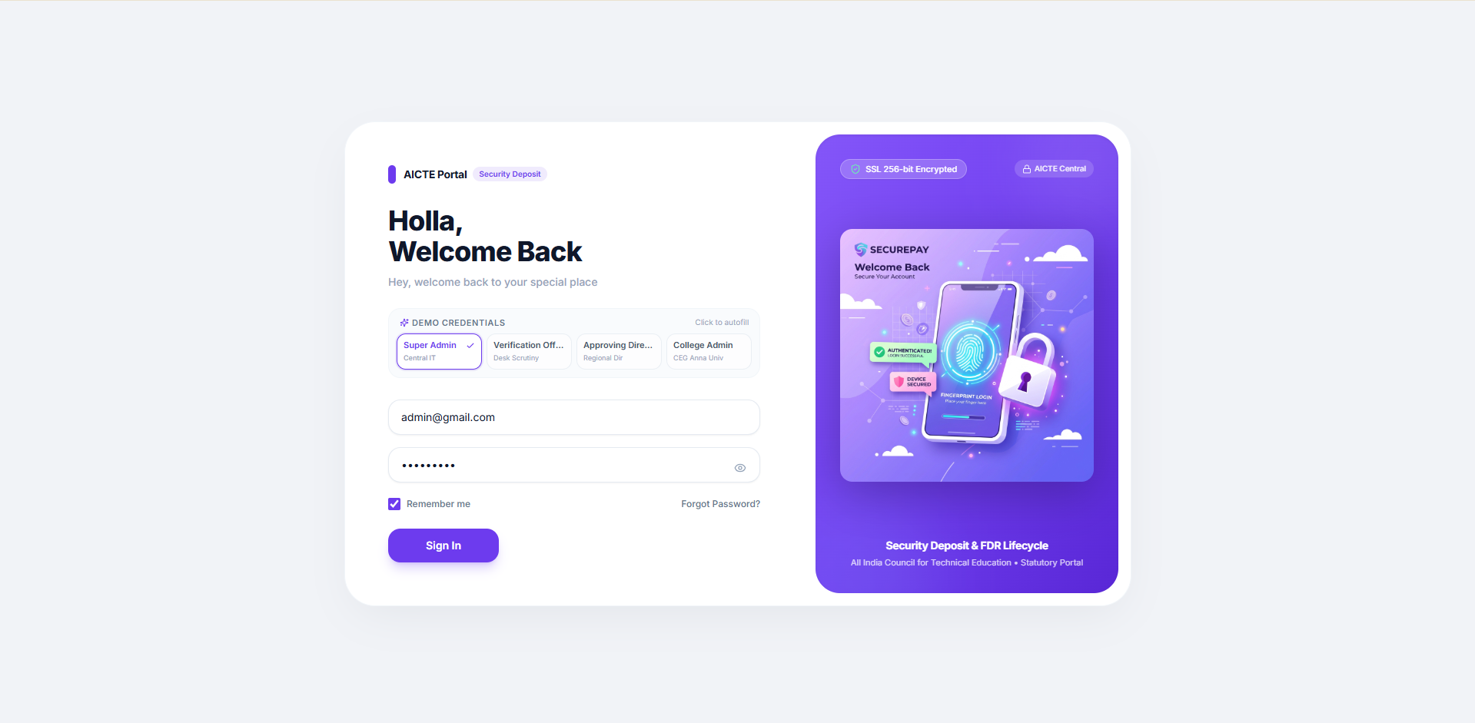
Interface interpretation and implementation note
This figure is included as supplied visual evidence. Replace demo values with validated project data before final academic submission. Any visible sample institution, amount, account identifier, or date should be treated as illustrative unless independently confirmed. The corresponding feature should be tested for keyboard accessibility, responsive behavior, validation feedback, and server-side authorization.

SCREENSHOT EVIDENCE
Figure 7.2 — Executive Command Dashboard
The dashboard provides a high-level snapshot of deposits, instruments, scrutiny backlog, maturity exposure, renewal requests, release disbursements, and compliance ratio. Each metric should be computed from authoritative records and include a clear definition.
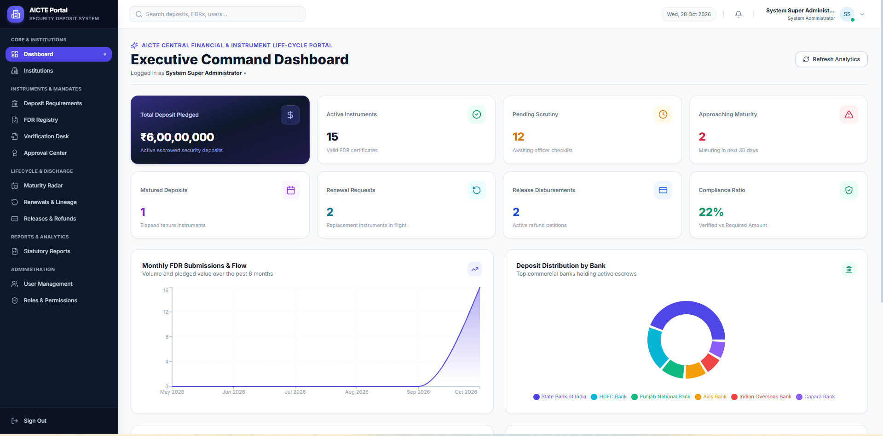
Interface interpretation and implementation note
This figure is included as supplied visual evidence. Replace demo values with validated project data before final academic submission. Any visible sample institution, amount, account identifier, or date should be treated as illustrative unless independently confirmed. The corresponding feature should be tested for keyboard accessibility, responsive behavior, validation feedback, and server-side authorization.

SCREENSHOT EVIDENCE
Figure 7.3 — Institution Management Directory
The institution directory supports search, category and verification filters, and a structured view of institution identity, category, location, contact/admin, verification, and status. Record actions should be permission-controlled.
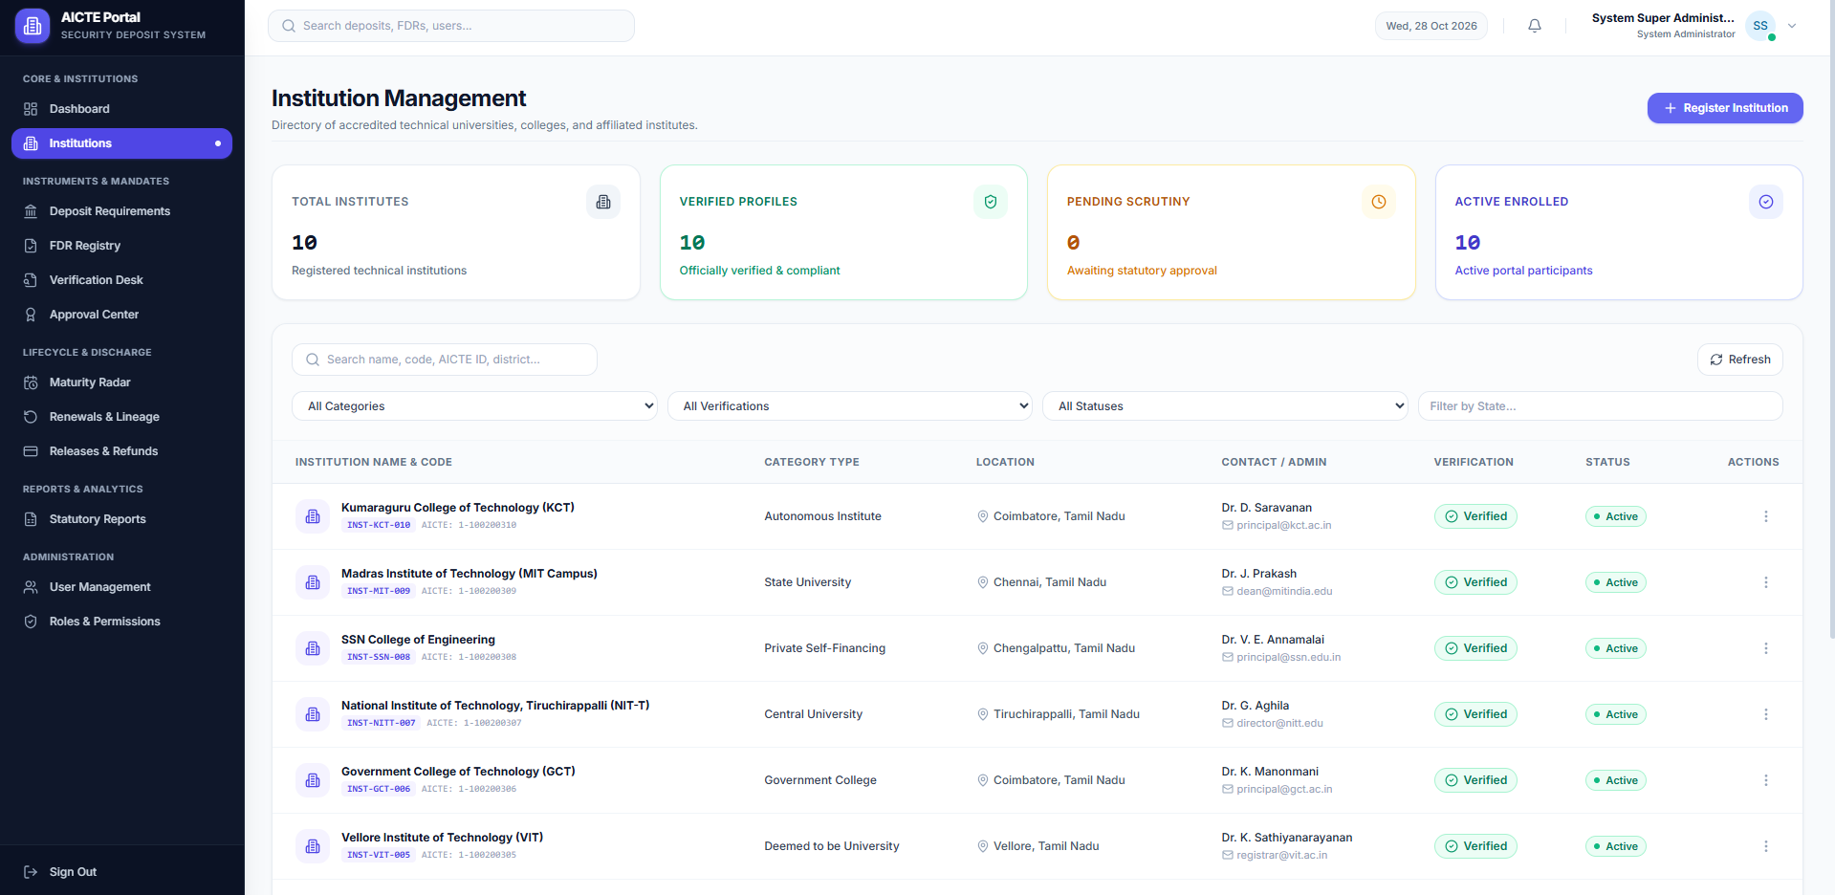
Interface interpretation and implementation note
This figure is included as supplied visual evidence. Replace demo values with validated project data before final academic submission. Any visible sample institution, amount, account identifier, or date should be treated as illustrative unless independently confirmed. The corresponding feature should be tested for keyboard accessibility, responsive behavior, validation feedback, and server-side authorization.

SCREENSHOT EVIDENCE
Figure 7.4 — Security Deposit Requirements
Mandate records compare the required amount with eligible verified deposits and calculate outstanding shortfall. The rule shown in the interface should be consistently applied in the service layer.
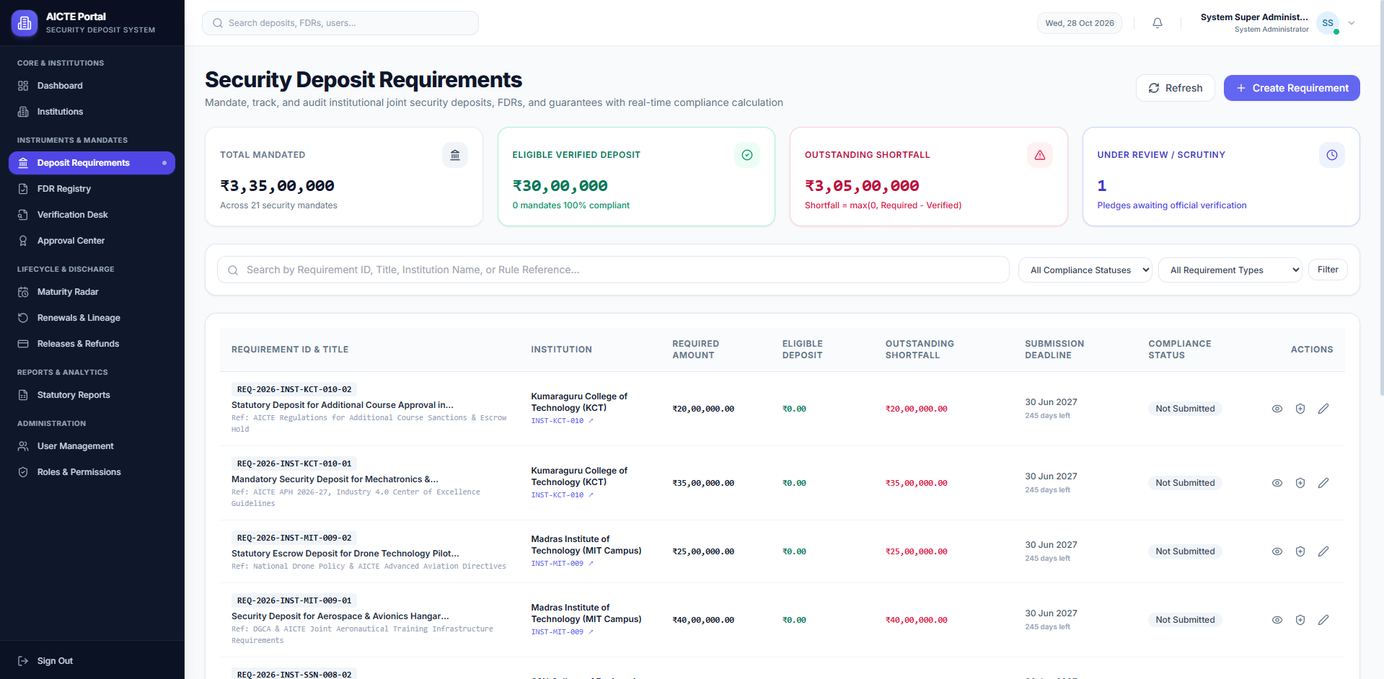
Interface interpretation and implementation note
This figure is included as supplied visual evidence. Replace demo values with validated project data before final academic submission. Any visible sample institution, amount, account identifier, or date should be treated as illustrative unless independently confirmed. The corresponding feature should be tested for keyboard accessibility, responsive behavior, validation feedback, and server-side authorization.

SCREENSHOT EVIDENCE
Figure 7.5 — Officer Verification Scrutiny
The scrutiny page combines instrument metadata, a statutory checklist, supporting proofs, discrepancy management, and workflow decisions. Each checklist result should be stored with reviewer identity and timestamp.
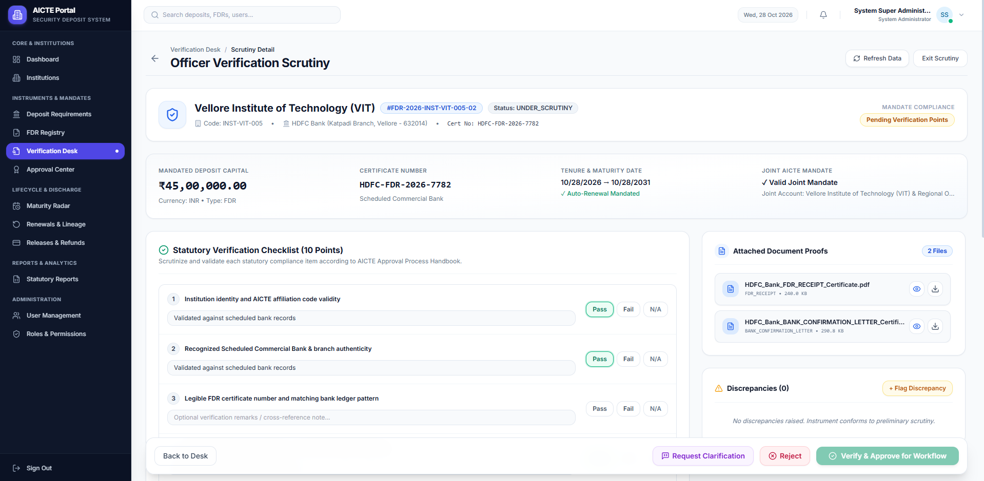
Interface interpretation and implementation note
This figure is included as supplied visual evidence. Replace demo values with validated project data before final academic submission. Any visible sample institution, amount, account identifier, or date should be treated as illustrative unless independently confirmed. The corresponding feature should be tested for keyboard accessibility, responsive behavior, validation feedback, and server-side authorization.

SCREENSHOT EVIDENCE
Figure 7.6 — Maturity Monitoring and Alerts
The maturity radar groups instruments into time windows and supports a maturity scan. Alerts should be generated from reliable maturity dates, with configurable escalation rules and recorded delivery status.
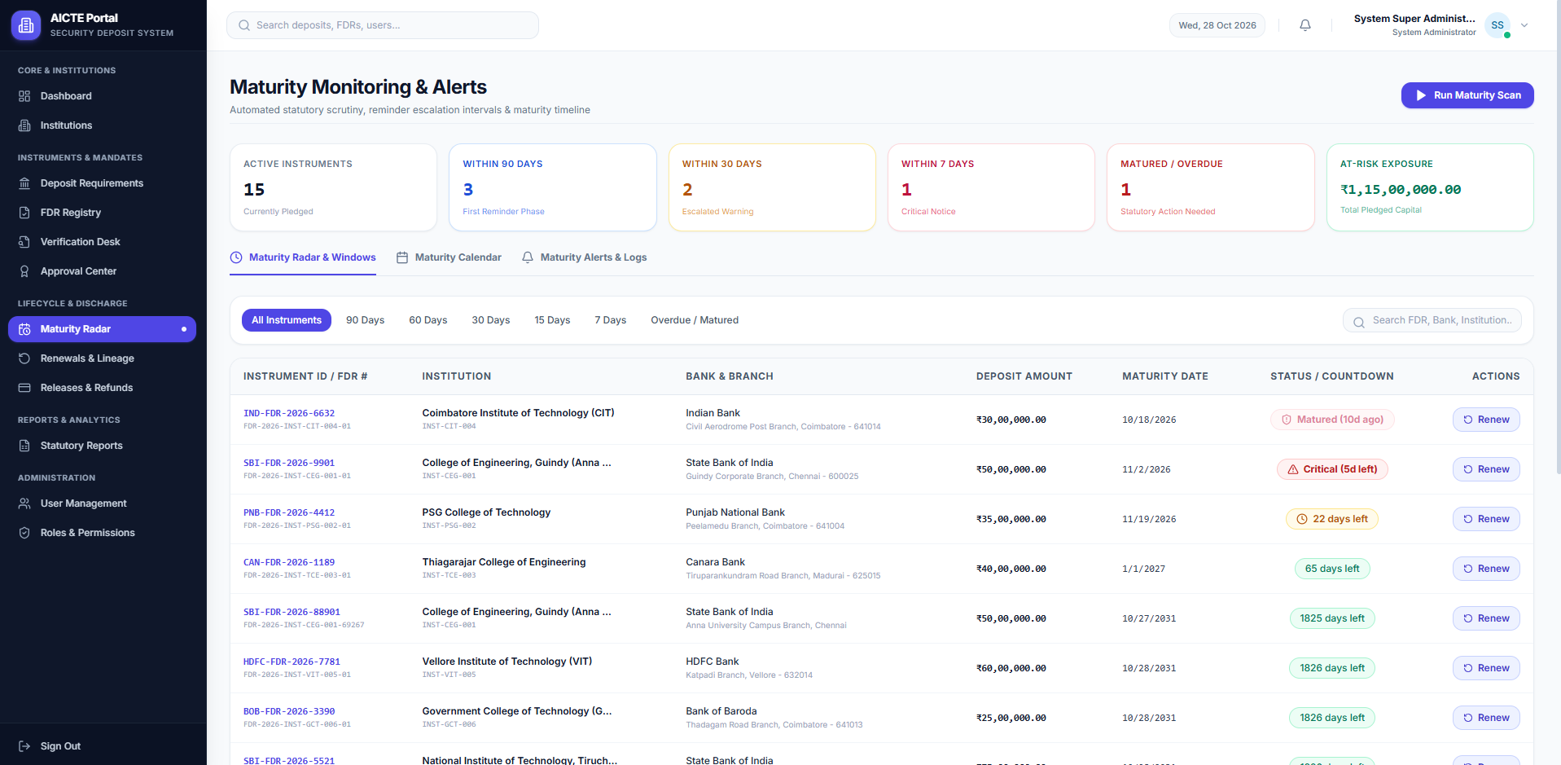
Interface interpretation and implementation note
This figure is included as supplied visual evidence. Replace demo values with validated project data before final academic submission. Any visible sample institution, amount, account identifier, or date should be treated as illustrative unless independently confirmed. The corresponding feature should be tested for keyboard accessibility, responsive behavior, validation feedback, and server-side authorization.

SCREENSHOT EVIDENCE
Figure 7.7 — Statutory Reports and Exports
The reporting interface presents report categories, filters, record counts, aggregate pledged values, and export options. Export permissions and report generation events should be audited.
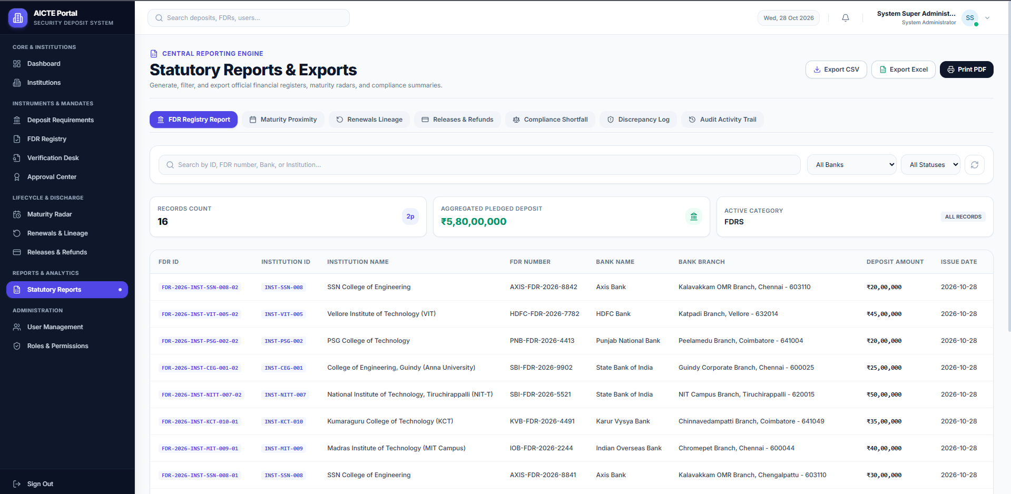
Interface interpretation and implementation note
This figure is included as supplied visual evidence. Replace demo values with validated project data before final academic submission. Any visible sample institution, amount, account identifier, or date should be treated as illustrative unless independently confirmed. The corresponding feature should be tested for keyboard accessibility, responsive behavior, validation feedback, and server-side authorization.

ANNEXURE A — SAMPLE DATA DICTIONARY
Entity | Suggested fields
User | userId, name, email, passwordHash, roleId, status, createdAt
Institution | institutionId, name, AICTECode, category, address, contact, verificationStatus
DepositRequirement | requirementId, institutionId, title, requiredAmount, deadline, status
Instrument | instrumentId, institutionId, requirementId, instrumentType, bank, branch, certificateNo, amount, issueDate, maturityDate, status
Document | documentId, instrumentId, storageKey, fileName, mimeType, checksum, uploadedBy, uploadedAt
Scrutiny | scrutinyId, instrumentId, reviewerId, checklist, remarks, decision, reviewedAt
AuditEvent | eventId, actorId, entityType, entityId, action, oldValue, newValue, timestamp
These annexures provide a baseline and should be adapted to the actual source code, final database schema, approved institutional process, and tested deployment.

ANNEXURE B — SAMPLE API CONTRACTS
Endpoint | Purpose
POST /api/auth/login | Accepts email and password; returns authenticated session/token result.
GET /api/institutions | Returns permitted institution records with paging and filters.
POST /api/instruments | Creates a draft instrument after request validation.
POST /api/instruments/:id/submit | Submits an instrument and initiates scrutiny workflow.
POST /api/scrutiny/:id/decision | Stores checklist results and authorized decision.
GET /api/reports/maturity | Returns maturity records filtered by window and status.
These annexures provide a baseline and should be adapted to the actual source code, final database schema, approved institutional process, and tested deployment.

ANNEXURE C — SAMPLE TEST CASES
Test ID | Expected validation
TC-01 | Valid credentials authenticate the correct user role.
TC-02 | A user without permission cannot access an administrative endpoint.
TC-03 | Shortfall calculation returns max(0, required − eligible verified).
TC-04 | An invalid or unsupported upload is rejected safely.
TC-05 | A maturity record is categorized in the correct time window.
TC-06 | Scrutiny decision records reviewer, time, and decision history.
TC-07 | Report filters and totals match the underlying permitted records.
These annexures provide a baseline and should be adapted to the actual source code, final database schema, approved institutional process, and tested deployment.

ANNEXURE D — SECURITY AND RISK REGISTER
Risk / Item | Control / Description
Risk | Mitigation
Unauthorized access | Server-side RBAC checks and least privilege.
Document leakage | Private storage, short-lived signed links, access logging.
OCR field error | Confidence indicators and human verification.
Maturity alert failure | Retry queue, delivery tracking, and dashboard fallback.
Incorrect shortfall | Centralized calculation service and automated tests.
Audit tampering | Append-only event strategy and restricted administrative access.
These annexures provide a baseline and should be adapted to the actual source code, final database schema, approved institutional process, and tested deployment.

ANNEXURE E — USER GUIDE
Task | User procedure
Institution setup | Create institution profile, confirm code and contact, submit verification evidence.
Mandate setup | Create mandate, enter required amount and deadline, associate institution.
FDR submission | Enter bank/instrument details and upload certificate evidence.
Scrutiny | Review checklist, add remarks, flag discrepancy or submit decision.
Maturity action | Review upcoming maturity, initiate renewal or release process as authorized.
Reports | Choose report type, apply filters, verify totals, export permitted results.
These annexures provide a baseline and should be adapted to the actual source code, final database schema, approved institutional process, and tested deployment.

REFERENCES AND BIBLIOGRAPHY
Source | Reference
React Documentation | https://react.dev/
Node.js Documentation | https://nodejs.org/docs/
Express Documentation | https://expressjs.com/
MongoDB Manual | https://www.mongodb.com/docs/
OWASP Application Security Verification Standard | https://owasp.org/www-project-application-security-verification-standard/
OWASP File Upload Cheat Sheet | https://cheatsheetseries.owasp.org/
AICTE | Use the applicable official AICTE regulations, approval process handbooks, and institutional circulars verified for the submission date.
These annexures provide a baseline and should be adapted to the actual source code, final database schema, approved institutional process, and tested deployment.

SUPPLEMENTARY TECHNICAL NOTE 01

Data integrity and transaction boundaries
This supplementary note expands the implementation considerations for the AICTE Security Deposit & FDR Lifecycle Management Portal. It is intended to be reviewed alongside the main chapters and adapted to the actual implementation.
Data consistency is maintained by validating input at the API boundary and enforcing domain rules in a dedicated service layer. Multi-step changes should be executed within database transactions where supported. The system should avoid accepting a client-provided aggregate as authoritative when the value can be calculated from source records.
Operationally, each module should define its owner, access permissions, expected inputs, resulting state, and failure behavior. Logs should capture enough context for troubleshooting without recording passwords, access tokens, or unnecessary sensitive document content.
For academic accuracy, the team should distinguish design proposals from implemented functions. The final report should include evidence from the running application, actual test outputs, and institution-approved requirements. Performance or compliance claims should only be stated when measured or formally verified.

SUPPLEMENTARY TECHNICAL NOTE 02

Role and permission matrix
This supplementary note expands the implementation considerations for the AICTE Security Deposit & FDR Lifecycle Management Portal. It is intended to be reviewed alongside the main chapters and adapted to the actual implementation.
Data consistency is maintained by validating input at the API boundary and enforcing domain rules in a dedicated service layer. Multi-step changes should be executed within database transactions where supported. The system should avoid accepting a client-provided aggregate as authoritative when the value can be calculated from source records.
Operationally, each module should define its owner, access permissions, expected inputs, resulting state, and failure behavior. Logs should capture enough context for troubleshooting without recording passwords, access tokens, or unnecessary sensitive document content.
For academic accuracy, the team should distinguish design proposals from implemented functions. The final report should include evidence from the running application, actual test outputs, and institution-approved requirements. Performance or compliance claims should only be stated when measured or formally verified.

SUPPLEMENTARY TECHNICAL NOTE 03

Document evidence lifecycle
This supplementary note expands the implementation considerations for the AICTE Security Deposit & FDR Lifecycle Management Portal. It is intended to be reviewed alongside the main chapters and adapted to the actual implementation.
Data consistency is maintained by validating input at the API boundary and enforcing domain rules in a dedicated service layer. Multi-step changes should be executed within database transactions where supported. The system should avoid accepting a client-provided aggregate as authoritative when the value can be calculated from source records.
Operationally, each module should define its owner, access permissions, expected inputs, resulting state, and failure behavior. Logs should capture enough context for troubleshooting without recording passwords, access tokens, or unnecessary sensitive document content.
For academic accuracy, the team should distinguish design proposals from implemented functions. The final report should include evidence from the running application, actual test outputs, and institution-approved requirements. Performance or compliance claims should only be stated when measured or formally verified.

SUPPLEMENTARY TECHNICAL NOTE 04

Workflow state transitions
This supplementary note expands the implementation considerations for the AICTE Security Deposit & FDR Lifecycle Management Portal. It is intended to be reviewed alongside the main chapters and adapted to the actual implementation.
Data consistency is maintained by validating input at the API boundary and enforcing domain rules in a dedicated service layer. Multi-step changes should be executed within database transactions where supported. The system should avoid accepting a client-provided aggregate as authoritative when the value can be calculated from source records.
Operationally, each module should define its owner, access permissions, expected inputs, resulting state, and failure behavior. Logs should capture enough context for troubleshooting without recording passwords, access tokens, or unnecessary sensitive document content.
For academic accuracy, the team should distinguish design proposals from implemented functions. The final report should include evidence from the running application, actual test outputs, and institution-approved requirements. Performance or compliance claims should only be stated when measured or formally verified.

SUPPLEMENTARY TECHNICAL NOTE 05

Maturity notification strategy
This supplementary note expands the implementation considerations for the AICTE Security Deposit & FDR Lifecycle Management Portal. It is intended to be reviewed alongside the main chapters and adapted to the actual implementation.
Data consistency is maintained by validating input at the API boundary and enforcing domain rules in a dedicated service layer. Multi-step changes should be executed within database transactions where supported. The system should avoid accepting a client-provided aggregate as authoritative when the value can be calculated from source records.
Operationally, each module should define its owner, access permissions, expected inputs, resulting state, and failure behavior. Logs should capture enough context for troubleshooting without recording passwords, access tokens, or unnecessary sensitive document content.
For academic accuracy, the team should distinguish design proposals from implemented functions. The final report should include evidence from the running application, actual test outputs, and institution-approved requirements. Performance or compliance claims should only be stated when measured or formally verified.

SUPPLEMENTARY TECHNICAL NOTE 06

Reporting definitions
This supplementary note expands the implementation considerations for the AICTE Security Deposit & FDR Lifecycle Management Portal. It is intended to be reviewed alongside the main chapters and adapted to the actual implementation.
Data consistency is maintained by validating input at the API boundary and enforcing domain rules in a dedicated service layer. Multi-step changes should be executed within database transactions where supported. The system should avoid accepting a client-provided aggregate as authoritative when the value can be calculated from source records.
Operationally, each module should define its owner, access permissions, expected inputs, resulting state, and failure behavior. Logs should capture enough context for troubleshooting without recording passwords, access tokens, or unnecessary sensitive document content.
For academic accuracy, the team should distinguish design proposals from implemented functions. The final report should include evidence from the running application, actual test outputs, and institution-approved requirements. Performance or compliance claims should only be stated when measured or formally verified.

SUPPLEMENTARY TECHNICAL NOTE 07

Accessibility and responsive behavior
This supplementary note expands the implementation considerations for the AICTE Security Deposit & FDR Lifecycle Management Portal. It is intended to be reviewed alongside the main chapters and adapted to the actual implementation.
Data consistency is maintained by validating input at the API boundary and enforcing domain rules in a dedicated service layer. Multi-step changes should be executed within database transactions where supported. The system should avoid accepting a client-provided aggregate as authoritative when the value can be calculated from source records.
Operationally, each module should define its owner, access permissions, expected inputs, resulting state, and failure behavior. Logs should capture enough context for troubleshooting without recording passwords, access tokens, or unnecessary sensitive document content.
For academic accuracy, the team should distinguish design proposals from implemented functions. The final report should include evidence from the running application, actual test outputs, and institution-approved requirements. Performance or compliance claims should only be stated when measured or formally verified.

SUPPLEMENTARY TECHNICAL NOTE 08

Deployment and environment configuration
This supplementary note expands the implementation considerations for the AICTE Security Deposit & FDR Lifecycle Management Portal. It is intended to be reviewed alongside the main chapters and adapted to the actual implementation.
Data consistency is maintained by validating input at the API boundary and enforcing domain rules in a dedicated service layer. Multi-step changes should be executed within database transactions where supported. The system should avoid accepting a client-provided aggregate as authoritative when the value can be calculated from source records.
Operationally, each module should define its owner, access permissions, expected inputs, resulting state, and failure behavior. Logs should capture enough context for troubleshooting without recording passwords, access tokens, or unnecessary sensitive document content.
For academic accuracy, the team should distinguish design proposals from implemented functions. The final report should include evidence from the running application, actual test outputs, and institution-approved requirements. Performance or compliance claims should only be stated when measured or formally verified.

SUPPLEMENTARY TECHNICAL NOTE 09

Backup, recovery, and retention
This supplementary note expands the implementation considerations for the AICTE Security Deposit & FDR Lifecycle Management Portal. It is intended to be reviewed alongside the main chapters and adapted to the actual implementation.
Data consistency is maintained by validating input at the API boundary and enforcing domain rules in a dedicated service layer. Multi-step changes should be executed within database transactions where supported. The system should avoid accepting a client-provided aggregate as authoritative when the value can be calculated from source records.
Operationally, each module should define its owner, access permissions, expected inputs, resulting state, and failure behavior. Logs should capture enough context for troubleshooting without recording passwords, access tokens, or unnecessary sensitive document content.
For academic accuracy, the team should distinguish design proposals from implemented functions. The final report should include evidence from the running application, actual test outputs, and institution-approved requirements. Performance or compliance claims should only be stated when measured or formally verified.

SUPPLEMENTARY TECHNICAL NOTE 10

Operational monitoring and support
This supplementary note expands the implementation considerations for the AICTE Security Deposit & FDR Lifecycle Management Portal. It is intended to be reviewed alongside the main chapters and adapted to the actual implementation.
Data consistency is maintained by validating input at the API boundary and enforcing domain rules in a dedicated service layer. Multi-step changes should be executed within database transactions where supported. The system should avoid accepting a client-provided aggregate as authoritative when the value can be calculated from source records.
Operationally, each module should define its owner, access permissions, expected inputs, resulting state, and failure behavior. Logs should capture enough context for troubleshooting without recording passwords, access tokens, or unnecessary sensitive document content.
For academic accuracy, the team should distinguish design proposals from implemented functions. The final report should include evidence from the running application, actual test outputs, and institution-approved requirements. Performance or compliance claims should only be stated when measured or formally verified.

SUPPLEMENTARY DETAIL — REQUIREMENT TRACEABILITY
A traceability matrix connects stakeholder needs to functional requirements, modules, and validation evidence. Maintaining this matrix during development makes it possible to identify requirements that have not been implemented or tested.
Requirement ID | Requirement summary | Related module | Verification evidence
FR-01 | Authenticate users and authorize operations | Authentication / RBAC | Login and permission tests
FR-02 | Maintain institution profiles and verification | Institution Management | Create, edit, search, and verify scenarios
FR-03 | Create and maintain deposit mandates | Deposit Requirements | Amount, deadline, and status validation
FR-04 | Register instruments and supporting files | FDR Registry | Instrument submission and upload tests
FR-05 | Record scrutiny checklist and discrepancy | Verification Desk | Checklist decision and clarification tests
FR-06 | Approve eligible instruments | Approval Center | Role and workflow transition tests
FR-07 | Monitor maturity and renewal lineage | Maturity Radar / Renewals | Date-window and successor record tests
FR-08 | Track release and refund activity | Releases & Refunds | Authorization and release history tests
FR-09 | Generate statutory reports and exports | Reports & Analytics | Filter and aggregate reconciliation
FR-10 | Preserve auditable activity | Audit Trail | Event completeness and access tests
The final project team should update this matrix to reflect the actual modules, implemented endpoints, and test evidence. It is a control document for the project, not a claim that every item has already been delivered.

SUPPLEMENTARY DETAIL — DATA VALIDATION AND EXCEPTION HANDLING

Field-level validation
Required fields should be checked before submission, and the API should repeat all critical checks. Amounts must be numeric and positive; dates must be valid; and the maturity date should follow the issue date. Certificate identifiers should be normalized consistently before duplicate checks.

Cross-record validation
An instrument should reference an existing institution and an applicable mandate. The institution must be active, and the submitting user must have permission to act for that institution. Eligibility calculations should use the current verified state of linked instruments.

Concurrency control
Two reviewers may open the same record at nearly the same time. The server should detect stale updates using a version field, timestamp, or equivalent concurrency strategy. If the record changed, the client should refresh and explain that another action was recorded.

Exception response
The application should provide a recoverable response when a file upload fails, OCR is unavailable, a notification cannot be delivered, or a database operation is rejected. Users should be able to retry safe operations without creating duplicate instruments or duplicate alerts.

Data quality review
Periodic reconciliation should compare totals and key identifiers with approved source registers. Potential duplicates, missing maturity dates, incomplete evidence, and instruments linked to inactive institutions should be placed in a review queue.

SUPPLEMENTARY DETAIL — DEPLOYMENT AND MAINTENANCE

Environment separation
Development, testing, staging, and production environments should use separate configuration and credentials. Production data should not be copied into development unless it has been appropriately anonymized and approved.

Configuration and secrets
Database connection strings, token secrets, file-storage credentials, and notification keys should be injected through a secure configuration mechanism. The repository should contain an example configuration file with placeholder values, not real secrets.

Database indexes
Indexes should be considered for institution identifiers, certificate numbers, status fields, institution references, maturity dates, and common report filters. Indexes must be selected based on observed query patterns and reviewed for write overhead.

Backup and restoration
Backups should be scheduled and monitored. A restoration test should be performed periodically to establish that data can be recovered within the expected recovery objectives. Backup files should be access-restricted and encrypted where appropriate.

Monitoring and support
Operational monitoring should cover API errors, database health, storage capacity, background job status, and notification failures. A support process should define how users report issues, how incidents are prioritized, and how fixes are deployed.

