PEERBRIDGE
CONNECT. LEARN. GROW.
ACADEMIC DOUBT FEED & PEER DISCUSSION
PROJECT DESIGN, IMPLEMENTATION AND TECHNICAL DOCUMENTATION
A comprehensive project report with UI evidence, system design,
functional specifications, implementation and testing documentation.
Submitted by: [Student Name]
Register Number: [Register Number]
Department: [Department]
Institution: [College / University]
Academic Year: [Year]

CERTIFICATE
This is to certify that the project entitled “PeerBridge – Academic Doubt Feed and Peer Discussion Platform” is a bona fide work carried out by [Student Name], bearing [Register Number], under the guidance and supervision of [Guide Name]. The project documentation records the proposed application, its user-facing workflows, design decisions, implementation plan, validation approach and future scope. The submitted screenshots are included as visual evidence of the interface shared for documentation.

DECLARATION
I hereby declare that the project report titled “PeerBridge – Academic Doubt Feed and Peer Discussion Platform” is prepared for academic submission. The description is based on the project concept, supplied interface screenshots and stated technology direction. Any institution-specific declarations, signatures, implementation metrics, source citations and test execution evidence must be verified and completed by the project team before final submission.

ACKNOWLEDGEMENT
I express sincere gratitude to the project guide, department faculty, institution and peers for their support and encouragement. Their feedback helped shape the academic collaboration concept and the design of a platform where learners can ask questions, exchange explanations and build a supportive peer-learning community. I also acknowledge the use of the supplied screen captures as the visual reference for the UI analysis in this report.

ABSTRACT
PeerBridge is a student-oriented academic collaboration application designed to connect learners through a structured doubt feed, peer discussion, direct messaging and profile-based academic identity. Students can publish a question with a title, description, subject tags, hashtags, code snippets and optional media; browse community doubts; indicate willingness to help; interact through likes and comments; and communicate with connected peers. The interface direction uses a clean light surface, green primary actions, rounded cards, readable labels and a persistent bottom navigation bar. This report describes the problem context, objectives, stakeholder needs, functional requirements, architecture, data design, screen-level workflows, security, quality assurance, deployment considerations and future enhancements. Where the supplied screenshots show interface behavior, the report describes that evidence; backend behavior and production metrics are framed as design requirements rather than falsely claimed as completed implementation.

CONTENTS
1. Introduction and Project Context
2. Problem Definition and Objectives
3. Feasibility and Stakeholder Analysis
4. Requirements Specification
5. System Architecture and Design
6. Data Model and API Design
7. UI/UX Design and Screen Analysis
8. Implementation Approach
9. Security, Privacy and Governance
10. Testing and Quality Assurance
11. Deployment and Maintenance
12. Results, Limitations and Future Scope
13. Conclusion
14. References and Appendices

CHAPTER 1 — INTRODUCTION

1.1 Background
Higher education increasingly depends on collaborative learning, online resources and rapid peer exchange. A learner who encounters a difficult programming concept or an unclear lecture topic may need help outside classroom hours. Traditional support channels—asking a nearby friend, sending a message to a class group or waiting for the next faculty session—can be fragmented and difficult to search later. PeerBridge proposes a focused academic environment in which questions remain organized and students can contribute explanations at a time convenient to them.
Implementation note: The requirement should be translated into a clearly testable user story, supported by validation rules, an explicit permission boundary and a consistent interface state. The team should document assumptions, error handling and data ownership before treating the feature as complete.
User value: A predictable workflow reduces confusion and supports learners who may be using the application between classes or on a mobile connection. The design should make the next action visible while keeping secondary actions available without cluttering the screen.

1.2 Project Overview
PeerBridge combines a community doubt feed with student identity, peer presence and messaging. The supplied screens show a login interface, a doubt listing with personal and community tabs, search and status filters, a home feed containing image/code content, a peer discussion screen, and a profile with skills and campus information. These visible elements provide a coherent application concept: academic questions are discoverable, help is socially connected, and learner profiles communicate relevant skills.
Implementation note: The requirement should be translated into a clearly testable user story, supported by validation rules, an explicit permission boundary and a consistent interface state. The team should document assumptions, error handling and data ownership before treating the feature as complete.
User value: A predictable workflow reduces confusion and supports learners who may be using the application between classes or on a mobile connection. The design should make the next action visible while keeping secondary actions available without cluttering the screen.

1.3 Need for the System
A general-purpose chat group often mixes announcements, casual conversation and academic questions. Important answers can disappear in the message history. A dedicated doubt feed gives each question a title, description, topic, status and interaction summary. It also supports later discovery through tags and search. PeerBridge therefore emphasizes contextual organization rather than replacing classroom instruction or institutional learning management systems.
Implementation note: The requirement should be translated into a clearly testable user story, supported by validation rules, an explicit permission boundary and a consistent interface state. The team should document assumptions, error handling and data ownership before treating the feature as complete.
User value: A predictable workflow reduces confusion and supports learners who may be using the application between classes or on a mobile connection. The design should make the next action visible while keeping secondary actions available without cluttering the screen.

1.4 Scope
The report covers account access, profile creation, doubt creation and browsing, topic tags, code attachment, help requests, likes, comments, peer discussion messaging, connected-peer presentation and profile skill management. The exact production implementation and integrations must be confirmed by the development team. Institutional administration, moderation workflows, notification delivery and analytics are described as recommended supporting capabilities.
Implementation note: The requirement should be translated into a clearly testable user story, supported by validation rules, an explicit permission boundary and a consistent interface state. The team should document assumptions, error handling and data ownership before treating the feature as complete.
User value: A predictable workflow reduces confusion and supports learners who may be using the application between classes or on a mobile connection. The design should make the next action visible while keeping secondary actions available without cluttering the screen.

1.5 Intended Audience
The primary users are college students seeking or offering academic help. Secondary stakeholders include faculty mentors, project administrators and institution coordinators who may oversee safety, content quality and platform adoption. Developers, testers and evaluators can use this report to understand user journeys, system boundaries and acceptance expectations.
Implementation note: The requirement should be translated into a clearly testable user story, supported by validation rules, an explicit permission boundary and a consistent interface state. The team should document assumptions, error handling and data ownership before treating the feature as complete.
User value: A predictable workflow reduces confusion and supports learners who may be using the application between classes or on a mobile connection. The design should make the next action visible while keeping secondary actions available without cluttering the screen.

CHAPTER 2 — PROBLEM, AIM AND OBJECTIVES

2.1 Problem Statement
Students often lack a consistent, searchable and peer-friendly space to post academic doubts, receive answers and continue discussions. Questions can be lost across separate messaging groups; students may hesitate to ask publicly; and helpful peers may be difficult to identify. PeerBridge addresses these challenges through a topic-based feed, visible response signals and peer communication.
Implementation note: The requirement should be translated into a clearly testable user story, supported by validation rules, an explicit permission boundary and a consistent interface state. The team should document assumptions, error handling and data ownership before treating the feature as complete.
User value: A predictable workflow reduces confusion and supports learners who may be using the application between classes or on a mobile connection. The design should make the next action visible while keeping secondary actions available without cluttering the screen.

2.2 Aim
The aim is to design a mobile-first academic collaboration application that helps students share doubts, discover questions, contribute solutions and communicate with peers through a simple, accessible interface.
Implementation note: The requirement should be translated into a clearly testable user story, supported by validation rules, an explicit permission boundary and a consistent interface state. The team should document assumptions, error handling and data ownership before treating the feature as complete.
User value: A predictable workflow reduces confusion and supports learners who may be using the application between classes or on a mobile connection. The design should make the next action visible while keeping secondary actions available without cluttering the screen.

2.3 Objectives
The core objectives are to provide a secure sign-in experience; allow students to publish clear academic doubts; enable topic, keyword and status discovery; support likes and comments; make help intent visible; provide peer discussion messaging; maintain academic profiles and skills; and create a consistent UI across the main application areas.
Implementation note: The requirement should be translated into a clearly testable user story, supported by validation rules, an explicit permission boundary and a consistent interface state. The team should document assumptions, error handling and data ownership before treating the feature as complete.
User value: A predictable workflow reduces confusion and supports learners who may be using the application between classes or on a mobile connection. The design should make the next action visible while keeping secondary actions available without cluttering the screen.

2.4 Measurable Outcomes
Suggested evaluation indicators include successful completion of core user journeys, time required to create a doubt, search relevance, message delivery behavior, accessibility checks, error rate during validation and user satisfaction. These should be measured during testing; no numerical results are asserted in this report without test evidence.
Implementation note: The requirement should be translated into a clearly testable user story, supported by validation rules, an explicit permission boundary and a consistent interface state. The team should document assumptions, error handling and data ownership before treating the feature as complete.
User value: A predictable workflow reduces confusion and supports learners who may be using the application between classes or on a mobile connection. The design should make the next action visible while keeping secondary actions available without cluttering the screen.

2.5 Constraints and Assumptions
The supplied screens establish visual direction but do not independently confirm database schema, server framework, hosting provider, authentication protocol or completed real-time infrastructure. These are documented as implementation choices or requirements to validate. Internet connectivity is assumed for synchronized community content and peer messaging.
Implementation note: The requirement should be translated into a clearly testable user story, supported by validation rules, an explicit permission boundary and a consistent interface state. The team should document assumptions, error handling and data ownership before treating the feature as complete.
User value: A predictable workflow reduces confusion and supports learners who may be using the application between classes or on a mobile connection. The design should make the next action visible while keeping secondary actions available without cluttering the screen.

CHAPTER 3 — FEASIBILITY AND STAKEHOLDERS

3.1 Technical Feasibility
The platform can be implemented using a conventional client-server architecture. A responsive web or mobile client communicates with an API for authentication, doubts, comments, reactions, profiles and conversations. A database stores persistent records; file storage handles uploaded images and code attachments. Real-time messaging may use WebSocket technology or a managed messaging service.
Implementation note: The requirement should be translated into a clearly testable user story, supported by validation rules, an explicit permission boundary and a consistent interface state. The team should document assumptions, error handling and data ownership before treating the feature as complete.
User value: A predictable workflow reduces confusion and supports learners who may be using the application between classes or on a mobile connection. The design should make the next action visible while keeping secondary actions available without cluttering the screen.

3.2 Operational Feasibility
The interaction model follows familiar social application patterns: a feed, search, filters, profile, chat and a prominent add action. Students can learn the basic workflow quickly. Clear empty states, simple labels and an accessible help action reduce onboarding friction.
Implementation note: The requirement should be translated into a clearly testable user story, supported by validation rules, an explicit permission boundary and a consistent interface state. The team should document assumptions, error handling and data ownership before treating the feature as complete.
User value: A predictable workflow reduces confusion and supports learners who may be using the application between classes or on a mobile connection. The design should make the next action visible while keeping secondary actions available without cluttering the screen.

3.3 Economic Feasibility
A student project can begin with open-source libraries and low-cost development infrastructure. Costs may arise from managed database capacity, object storage, email or push notifications, domain registration, observability and production hosting. Cost estimation should be based on expected users, data volume and message frequency.
Implementation note: The requirement should be translated into a clearly testable user story, supported by validation rules, an explicit permission boundary and a consistent interface state. The team should document assumptions, error handling and data ownership before treating the feature as complete.
User value: A predictable workflow reduces confusion and supports learners who may be using the application between classes or on a mobile connection. The design should make the next action visible while keeping secondary actions available without cluttering the screen.

3.4 Stakeholder Analysis
Students create questions and answer peers; faculty or mentors may provide guidance; administrators oversee misuse and platform configuration; developers maintain the application; testers verify expected behavior. Each stakeholder requires clear permissions and transparent handling of content.
Implementation note: The requirement should be translated into a clearly testable user story, supported by validation rules, an explicit permission boundary and a consistent interface state. The team should document assumptions, error handling and data ownership before treating the feature as complete.
User value: A predictable workflow reduces confusion and supports learners who may be using the application between classes or on a mobile connection. The design should make the next action visible while keeping secondary actions available without cluttering the screen.

3.5 Risk Analysis
Key risks include spam, abusive messages, low answer participation, incorrect advice, privacy leakage, unsafe uploads and inconsistent network access. Controls include reporting, moderation, rate limits, secure access checks, content disclaimers, input validation and monitoring.
Implementation note: The requirement should be translated into a clearly testable user story, supported by validation rules, an explicit permission boundary and a consistent interface state. The team should document assumptions, error handling and data ownership before treating the feature as complete.
User value: A predictable workflow reduces confusion and supports learners who may be using the application between classes or on a mobile connection. The design should make the next action visible while keeping secondary actions available without cluttering the screen.

CHAPTER 4 — REQUIREMENTS SPECIFICATION

4.1 Functional Requirements
The system should support registration/sign-in, session management, profile editing, doubt creation, feed retrieval, keyword search, topic filtering, status filtering, likes, comments, helper intent, peer connections and direct conversations. Each feature should return understandable success or error feedback.
Implementation note: The requirement should be translated into a clearly testable user story, supported by validation rules, an explicit permission boundary and a consistent interface state. The team should document assumptions, error handling and data ownership before treating the feature as complete.
User value: A predictable workflow reduces confusion and supports learners who may be using the application between classes or on a mobile connection. The design should make the next action visible while keeping secondary actions available without cluttering the screen.

4.2 Authentication Requirements
Users should enter a valid email and password. The interface includes a remember-me option, password visibility control, sign-up navigation and forgot-password link. The server must validate credentials, protect password material with a suitable password hashing algorithm and issue secure session credentials.
Implementation note: The requirement should be translated into a clearly testable user story, supported by validation rules, an explicit permission boundary and a consistent interface state. The team should document assumptions, error handling and data ownership before treating the feature as complete.
User value: A predictable workflow reduces confusion and supports learners who may be using the application between classes or on a mobile connection. The design should make the next action visible while keeping secondary actions available without cluttering the screen.

4.3 Doubt Feed Requirements
Each doubt card should show author identity, creation time, title, body preview, topic labels and available interaction counts. Status filters shown in the screenshots include All Doubts, Open for Help, Unanswered and Resolved. Search should support topic, keyword or tag discovery.
Implementation note: The requirement should be translated into a clearly testable user story, supported by validation rules, an explicit permission boundary and a consistent interface state. The team should document assumptions, error handling and data ownership before treating the feature as complete.
User value: A predictable workflow reduces confusion and supports learners who may be using the application between classes or on a mobile connection. The design should make the next action visible while keeping secondary actions available without cluttering the screen.

4.4 Content Creation Requirements
A creation workflow should collect a concise title, detailed question, subject or topic, optional hashtags and optional code or media. The form should explain required fields, validate length and type, and preserve user input if validation fails.
Implementation note: The requirement should be translated into a clearly testable user story, supported by validation rules, an explicit permission boundary and a consistent interface state. The team should document assumptions, error handling and data ownership before treating the feature as complete.
User value: A predictable workflow reduces confusion and supports learners who may be using the application between classes or on a mobile connection. The design should make the next action visible while keeping secondary actions available without cluttering the screen.

4.5 Chat Requirements
Peer discussion lists connected peers and recent messages. Each conversation preview can display the peer name, message excerpt, time and unread count. The conversation view should preserve message order, identify sender and receiver, and handle sending, retry and empty states.
Implementation note: The requirement should be translated into a clearly testable user story, supported by validation rules, an explicit permission boundary and a consistent interface state. The team should document assumptions, error handling and data ownership before treating the feature as complete.
User value: A predictable workflow reduces confusion and supports learners who may be using the application between classes or on a mobile connection. The design should make the next action visible while keeping secondary actions available without cluttering the screen.

4.6 Non-Functional Requirements
The application should be responsive, accessible, maintainable, secure and performant. Requirements include predictable navigation, readable contrast, keyboard support, validated data, controlled file uploads, reliable persistence and graceful handling of offline or failed requests.
Implementation note: The requirement should be translated into a clearly testable user story, supported by validation rules, an explicit permission boundary and a consistent interface state. The team should document assumptions, error handling and data ownership before treating the feature as complete.
User value: A predictable workflow reduces confusion and supports learners who may be using the application between classes or on a mobile connection. The design should make the next action visible while keeping secondary actions available without cluttering the screen.

CHAPTER 5 — SYSTEM ARCHITECTURE AND DESIGN

5.1 Architecture Overview
A layered design separates presentation, API routing, authentication and authorization, business logic, data access and persistence. The client renders screens and validates simple form constraints; the API enforces authoritative rules; repositories or data-access modules encapsulate database operations.
Implementation note: The requirement should be translated into a clearly testable user story, supported by validation rules, an explicit permission boundary and a consistent interface state. The team should document assumptions, error handling and data ownership before treating the feature as complete.
User value: A predictable workflow reduces confusion and supports learners who may be using the application between classes or on a mobile connection. The design should make the next action visible while keeping secondary actions available without cluttering the screen.

5.2 Logical Components
The principal components are Authentication, Student Profile, Doubt Management, Feed and Search, Reactions and Comments, Peer Connections, Messaging, Notifications, Moderation and Administration. Components should communicate through explicit interfaces to reduce coupling.
Implementation note: The requirement should be translated into a clearly testable user story, supported by validation rules, an explicit permission boundary and a consistent interface state. The team should document assumptions, error handling and data ownership before treating the feature as complete.
User value: A predictable workflow reduces confusion and supports learners who may be using the application between classes or on a mobile connection. The design should make the next action visible while keeping secondary actions available without cluttering the screen.

5.3 Request Lifecycle
A typical request begins with a user action, passes client-side validation, is sent over HTTPS, is authenticated by middleware, validated against a schema, processed by a service and persisted through a repository. The response is normalized and rendered with clear loading, success or failure state.
Implementation note: The requirement should be translated into a clearly testable user story, supported by validation rules, an explicit permission boundary and a consistent interface state. The team should document assumptions, error handling and data ownership before treating the feature as complete.
User value: A predictable workflow reduces confusion and supports learners who may be using the application between classes or on a mobile connection. The design should make the next action visible while keeping secondary actions available without cluttering the screen.

5.4 Architecture Decisions
A modular monolith is a practical initial deployment for a college project because it simplifies development and operations. Messaging or notifications can be extracted later if traffic or reliability requirements justify service separation. Avoid premature microservice complexity.
Implementation note: The requirement should be translated into a clearly testable user story, supported by validation rules, an explicit permission boundary and a consistent interface state. The team should document assumptions, error handling and data ownership before treating the feature as complete.
User value: A predictable workflow reduces confusion and supports learners who may be using the application between classes or on a mobile connection. The design should make the next action visible while keeping secondary actions available without cluttering the screen.

5.5 Data Flow
Doubt creation sends user-authored content and tags to the API. The server validates identity and payload, stores the record, and returns the canonical resource. Feed retrieval applies pagination and filters. Chat retrieves authorized conversation history and posts new messages while enforcing participant membership.
Implementation note: The requirement should be translated into a clearly testable user story, supported by validation rules, an explicit permission boundary and a consistent interface state. The team should document assumptions, error handling and data ownership before treating the feature as complete.
User value: A predictable workflow reduces confusion and supports learners who may be using the application between classes or on a mobile connection. The design should make the next action visible while keeping secondary actions available without cluttering the screen.

CHAPTER 6 — DATA MODEL AND API DESIGN

6.1 Entity Model
Core entities include User, Profile, Doubt, TopicTag, DoubtTag, Comment, Reaction, HelpOffer, PeerConnection, Conversation, ConversationParticipant, Message, Notification and Report. Relations should enforce referential integrity and prevent duplicate reactions or invalid conversation membership.
Implementation note: The requirement should be translated into a clearly testable user story, supported by validation rules, an explicit permission boundary and a consistent interface state. The team should document assumptions, error handling and data ownership before treating the feature as complete.
User value: A predictable workflow reduces confusion and supports learners who may be using the application between classes or on a mobile connection. The design should make the next action visible while keeping secondary actions available without cluttering the screen.

6.2 User and Profile
User records represent authentication identity and account status. Profile records contain public academic details such as display name, institution, department, academic level, skills, bio and avatar reference. Private fields should not be returned in public profile responses.
Implementation note: The requirement should be translated into a clearly testable user story, supported by validation rules, an explicit permission boundary and a consistent interface state. The team should document assumptions, error handling and data ownership before treating the feature as complete.
User value: A predictable workflow reduces confusion and supports learners who may be using the application between classes or on a mobile connection. The design should make the next action visible while keeping secondary actions available without cluttering the screen.

6.3 Doubt Record
A doubt may contain an identifier, author identifier, title, description, topic, status, attachment references, created/updated timestamps and optional resolution metadata. Status transitions should be explicit and auditable.
Implementation note: The requirement should be translated into a clearly testable user story, supported by validation rules, an explicit permission boundary and a consistent interface state. The team should document assumptions, error handling and data ownership before treating the feature as complete.
User value: A predictable workflow reduces confusion and supports learners who may be using the application between classes or on a mobile connection. The design should make the next action visible while keeping secondary actions available without cluttering the screen.

6.4 Comment and Reaction
Comments reference the doubt and author. Reactions should be unique per user and target where the product uses a single like per user. Counts should be computed or maintained consistently; clients must not be trusted to submit authoritative counts.
Implementation note: The requirement should be translated into a clearly testable user story, supported by validation rules, an explicit permission boundary and a consistent interface state. The team should document assumptions, error handling and data ownership before treating the feature as complete.
User value: A predictable workflow reduces confusion and supports learners who may be using the application between classes or on a mobile connection. The design should make the next action visible while keeping secondary actions available without cluttering the screen.

6.5 Conversation and Message
Conversation participants define access. Message records include conversation ID, sender ID, body or attachment reference, sent time, delivery/read metadata where supported. Access checks must verify that the requesting user is a participant.
Implementation note: The requirement should be translated into a clearly testable user story, supported by validation rules, an explicit permission boundary and a consistent interface state. The team should document assumptions, error handling and data ownership before treating the feature as complete.
User value: A predictable workflow reduces confusion and supports learners who may be using the application between classes or on a mobile connection. The design should make the next action visible while keeping secondary actions available without cluttering the screen.

6.6 API Conventions
Use resource-oriented endpoints, consistent JSON responses, stable identifiers, pagination and validation errors. Version the API when incompatible changes are introduced. Do not expose stack traces or internal database errors to clients.
Implementation note: The requirement should be translated into a clearly testable user story, supported by validation rules, an explicit permission boundary and a consistent interface state. The team should document assumptions, error handling and data ownership before treating the feature as complete.
User value: A predictable workflow reduces confusion and supports learners who may be using the application between classes or on a mobile connection. The design should make the next action visible while keeping secondary actions available without cluttering the screen.

CHAPTER 7 — UI/UX DESIGN AND SCREEN ANALYSIS

7.1 Visual Design Language
The screenshots use a light background, deep charcoal text, green as the main action color, pale green status surfaces, rounded cards and outlined controls. A persistent bottom navigation provides Home, Doubts, Add, Chat and Profile. The interface uses friendly typography and generous touch targets.
Implementation note: The requirement should be translated into a clearly testable user story, supported by validation rules, an explicit permission boundary and a consistent interface state. The team should document assumptions, error handling and data ownership before treating the feature as complete.
User value: A predictable workflow reduces confusion and supports learners who may be using the application between classes or on a mobile connection. The design should make the next action visible while keeping secondary actions available without cluttering the screen.

7.2 Login Screen
The login screen presents a green hero area with supportive copy and an illustration, followed by a white rounded panel. Email and password fields include icons; password visibility, remember-me, forgot-password and sign-up affordances are visible. Validation should be placed close to the corresponding field.
Implementation note: The requirement should be translated into a clearly testable user story, supported by validation rules, an explicit permission boundary and a consistent interface state. The team should document assumptions, error handling and data ownership before treating the feature as complete.
User value: A predictable workflow reduces confusion and supports learners who may be using the application between classes or on a mobile connection. The design should make the next action visible while keeping secondary actions available without cluttering the screen.

7.3 Doubt Listing Screen
The listing screen presents PeerBridge branding, an Ask Doubt action, My Doubts and Community Doubts tabs, a search field, status filters and cards. Cards communicate author, time, status, topic labels, code attachment and engagement counts. The screenshot shows two sample doubts and pagination information.
Implementation note: The requirement should be translated into a clearly testable user story, supported by validation rules, an explicit permission boundary and a consistent interface state. The team should document assumptions, error handling and data ownership before treating the feature as complete.
User value: A predictable workflow reduces confusion and supports learners who may be using the application between classes or on a mobile connection. The design should make the next action visible while keeping secondary actions available without cluttering the screen.

7.4 Home Feed
The home feed includes brand identity, quick actions, notifications and chat entry points. A post can display author details, a topic badge, media carousel, title, description and code block. Like, comment, share and “I Can Help” actions create a compact interaction row.
Implementation note: The requirement should be translated into a clearly testable user story, supported by validation rules, an explicit permission boundary and a consistent interface state. The team should document assumptions, error handling and data ownership before treating the feature as complete.
User value: A predictable workflow reduces confusion and supports learners who may be using the application between classes or on a mobile connection. The design should make the next action visible while keeping secondary actions available without cluttering the screen.

7.5 Peer Discussion Screen
The discussion screen contains a back action, title, refresh control, connected peers and recent message cards. Peer presence is shown with a small status marker. Message preview includes peer identity, role label, timestamp and unread indicator.
Implementation note: The requirement should be translated into a clearly testable user story, supported by validation rules, an explicit permission boundary and a consistent interface state. The team should document assumptions, error handling and data ownership before treating the feature as complete.
User value: A predictable workflow reduces confusion and supports learners who may be using the application between classes or on a mobile connection. The design should make the next action visible while keeping secondary actions available without cluttering the screen.

7.6 Profile Screen
The profile view displays a green identity header, student name, department/institution, peer rating, role and counts for doubts, solutions, followers and following. The lower section contains bio, edit profile, skill chips, campus details and academic information. Sensitive identifiers should be restricted or masked in public views.
Implementation note: The requirement should be translated into a clearly testable user story, supported by validation rules, an explicit permission boundary and a consistent interface state. The team should document assumptions, error handling and data ownership before treating the feature as complete.
User value: A predictable workflow reduces confusion and supports learners who may be using the application between classes or on a mobile connection. The design should make the next action visible while keeping secondary actions available without cluttering the screen.

7.7 Responsive and Accessible Behavior
At narrow widths, cards should stack, text should wrap naturally and bottom navigation should avoid obscuring content. Controls need accessible names, focus indicators and sufficient contrast. Avoid relying only on color to communicate status.
Implementation note: The requirement should be translated into a clearly testable user story, supported by validation rules, an explicit permission boundary and a consistent interface state. The team should document assumptions, error handling and data ownership before treating the feature as complete.
User value: A predictable workflow reduces confusion and supports learners who may be using the application between classes or on a mobile connection. The design should make the next action visible while keeping secondary actions available without cluttering the screen.

CHAPTER 8 — IMPLEMENTATION APPROACH

8.1 Development Strategy
Implement incrementally: establish repository conventions and design tokens; build authentication; create profile; implement doubt CRUD; add feed/search/filter; add comments and reactions; build peer connections and chat; then add moderation, notifications and analytics.
Implementation note: The requirement should be translated into a clearly testable user story, supported by validation rules, an explicit permission boundary and a consistent interface state. The team should document assumptions, error handling and data ownership before treating the feature as complete.
User value: A predictable workflow reduces confusion and supports learners who may be using the application between classes or on a mobile connection. The design should make the next action visible while keeping secondary actions available without cluttering the screen.

8.2 Frontend Organization
Group features by domain rather than placing all components in one folder. Shared UI elements include buttons, text fields, badges, cards, avatar, loading states, dialogs and navigation. Feature modules own API hooks, schemas, screens and local state.
Implementation note: The requirement should be translated into a clearly testable user story, supported by validation rules, an explicit permission boundary and a consistent interface state. The team should document assumptions, error handling and data ownership before treating the feature as complete.
User value: A predictable workflow reduces confusion and supports learners who may be using the application between classes or on a mobile connection. The design should make the next action visible while keeping secondary actions available without cluttering the screen.

8.3 Backend Organization
Separate routes, middleware, validation, controllers, services and repositories. Controllers should translate HTTP concerns; services enforce business rules; repositories perform persistence. Centralize errors and structured logging.
Implementation note: The requirement should be translated into a clearly testable user story, supported by validation rules, an explicit permission boundary and a consistent interface state. The team should document assumptions, error handling and data ownership before treating the feature as complete.
User value: A predictable workflow reduces confusion and supports learners who may be using the application between classes or on a mobile connection. The design should make the next action visible while keeping secondary actions available without cluttering the screen.

8.4 State and Data Synchronization
Use server-state caching for feeds, profiles and messages, with controlled invalidation after create/update actions. Avoid stale counts by refreshing or updating cache consistently. For chat, optimistic display should support failure recovery.
Implementation note: The requirement should be translated into a clearly testable user story, supported by validation rules, an explicit permission boundary and a consistent interface state. The team should document assumptions, error handling and data ownership before treating the feature as complete.
User value: A predictable workflow reduces confusion and supports learners who may be using the application between classes or on a mobile connection. The design should make the next action visible while keeping secondary actions available without cluttering the screen.

8.5 File and Code Attachments
Validate file extension, MIME type and size; use safe storage keys; scan uploads where feasible; and serve files through authorized URLs. Code snippets should be rendered as text, not executed. Syntax highlighting must not create an injection path.
Implementation note: The requirement should be translated into a clearly testable user story, supported by validation rules, an explicit permission boundary and a consistent interface state. The team should document assumptions, error handling and data ownership before treating the feature as complete.
User value: A predictable workflow reduces confusion and supports learners who may be using the application between classes or on a mobile connection. The design should make the next action visible while keeping secondary actions available without cluttering the screen.

8.6 Configuration and Environments
Keep secrets outside source control. Use separate development, test and production configurations. Document required environment variables and verify deployment configuration before release.
Implementation note: The requirement should be translated into a clearly testable user story, supported by validation rules, an explicit permission boundary and a consistent interface state. The team should document assumptions, error handling and data ownership before treating the feature as complete.
User value: A predictable workflow reduces confusion and supports learners who may be using the application between classes or on a mobile connection. The design should make the next action visible while keeping secondary actions available without cluttering the screen.

CHAPTER 9 — SECURITY, PRIVACY AND GOVERNANCE

9.1 Authentication and Sessions
Use secure password hashing, HTTPS, session expiration, revocation and appropriate cookie or token handling. Remember-me must be implemented as a controlled persistent-session choice, not as plaintext password storage.
Implementation note: The requirement should be translated into a clearly testable user story, supported by validation rules, an explicit permission boundary and a consistent interface state. The team should document assumptions, error handling and data ownership before treating the feature as complete.
User value: A predictable workflow reduces confusion and supports learners who may be using the application between classes or on a mobile connection. The design should make the next action visible while keeping secondary actions available without cluttering the screen.

9.2 Authorization
Every private resource requires server-side authorization. A user may edit or delete their own doubt; conversation content is available only to participants; administrative actions require explicit elevated permission.
Implementation note: The requirement should be translated into a clearly testable user story, supported by validation rules, an explicit permission boundary and a consistent interface state. The team should document assumptions, error handling and data ownership before treating the feature as complete.
User value: A predictable workflow reduces confusion and supports learners who may be using the application between classes or on a mobile connection. The design should make the next action visible while keeping secondary actions available without cluttering the screen.

9.3 Input and Output Safety
Validate schemas, constrain lengths, normalize appropriate fields and encode output. Protect against injection, cross-site scripting, CSRF where applicable, mass assignment and unsafe file handling.
Implementation note: The requirement should be translated into a clearly testable user story, supported by validation rules, an explicit permission boundary and a consistent interface state. The team should document assumptions, error handling and data ownership before treating the feature as complete.
User value: A predictable workflow reduces confusion and supports learners who may be using the application between classes or on a mobile connection. The design should make the next action visible while keeping secondary actions available without cluttering the screen.

9.4 Privacy by Design
Collect only necessary academic data. Explain what is visible publicly, offer account controls, avoid exposing student IDs in feed cards, and establish retention/deletion rules. Profile screenshots may contain illustrative personal data and should be anonymized before public release.
Implementation note: The requirement should be translated into a clearly testable user story, supported by validation rules, an explicit permission boundary and a consistent interface state. The team should document assumptions, error handling and data ownership before treating the feature as complete.
User value: A predictable workflow reduces confusion and supports learners who may be using the application between classes or on a mobile connection. The design should make the next action visible while keeping secondary actions available without cluttering the screen.

9.5 Moderation and Reporting
Provide a report action for inappropriate content and user behavior. A moderation workflow should capture report category, target, status, reviewer and decision. Include appeal or correction mechanisms appropriate to the institution.
Implementation note: The requirement should be translated into a clearly testable user story, supported by validation rules, an explicit permission boundary and a consistent interface state. The team should document assumptions, error handling and data ownership before treating the feature as complete.
User value: A predictable workflow reduces confusion and supports learners who may be using the application between classes or on a mobile connection. The design should make the next action visible while keeping secondary actions available without cluttering the screen.

9.6 Audit and Monitoring
Record security-relevant events such as sign-in failures, account changes, moderation actions and administrative updates. Logs should avoid passwords, access tokens and unnecessary message content.
Implementation note: The requirement should be translated into a clearly testable user story, supported by validation rules, an explicit permission boundary and a consistent interface state. The team should document assumptions, error handling and data ownership before treating the feature as complete.
User value: A predictable workflow reduces confusion and supports learners who may be using the application between classes or on a mobile connection. The design should make the next action visible while keeping secondary actions available without cluttering the screen.

CHAPTER 10 — TESTING AND QUALITY ASSURANCE

10.1 Testing Strategy
Testing should cover unit, integration, API, UI, accessibility, security and end-to-end flows. Test cases must identify preconditions, input, expected result, actual result and execution status.
Implementation note: The requirement should be translated into a clearly testable user story, supported by validation rules, an explicit permission boundary and a consistent interface state. The team should document assumptions, error handling and data ownership before treating the feature as complete.
User value: A predictable workflow reduces confusion and supports learners who may be using the application between classes or on a mobile connection. The design should make the next action visible while keeping secondary actions available without cluttering the screen.

10.2 Authentication Test Scenarios
Verify valid and invalid credentials, empty fields, malformed email, password visibility, remember-me behavior, sign-up navigation, reset flow, expired session and logout. Verify rate limits and generic failure messaging.
Implementation note: The requirement should be translated into a clearly testable user story, supported by validation rules, an explicit permission boundary and a consistent interface state. The team should document assumptions, error handling and data ownership before treating the feature as complete.
User value: A predictable workflow reduces confusion and supports learners who may be using the application between classes or on a mobile connection. The design should make the next action visible while keeping secondary actions available without cluttering the screen.

10.3 Doubt Feed Test Scenarios
Create a doubt with valid data; reject missing title or body; search by keyword and tag; verify each status filter; ensure pagination does not duplicate records; and check that resolved status is reflected correctly.
Implementation note: The requirement should be translated into a clearly testable user story, supported by validation rules, an explicit permission boundary and a consistent interface state. The team should document assumptions, error handling and data ownership before treating the feature as complete.
User value: A predictable workflow reduces confusion and supports learners who may be using the application between classes or on a mobile connection. The design should make the next action visible while keeping secondary actions available without cluttering the screen.

10.4 Interaction Test Scenarios
Verify like toggling, comment creation, helper intent, duplicate reaction prevention and updated counts. Confirm that only authorized users can modify or remove their own content.
Implementation note: The requirement should be translated into a clearly testable user story, supported by validation rules, an explicit permission boundary and a consistent interface state. The team should document assumptions, error handling and data ownership before treating the feature as complete.
User value: A predictable workflow reduces confusion and supports learners who may be using the application between classes or on a mobile connection. The design should make the next action visible while keeping secondary actions available without cluttering the screen.

10.5 Messaging Test Scenarios
Verify conversation access, sending and receiving, ordering, unread count, empty state, network retry, long message wrapping and participant-only visibility.
Implementation note: The requirement should be translated into a clearly testable user story, supported by validation rules, an explicit permission boundary and a consistent interface state. The team should document assumptions, error handling and data ownership before treating the feature as complete.
User value: A predictable workflow reduces confusion and supports learners who may be using the application between classes or on a mobile connection. The design should make the next action visible while keeping secondary actions available without cluttering the screen.

10.6 Quality and Accessibility
Test layouts at common mobile widths and desktop sizes, keyboard navigation, accessible labels, color contrast, focus order, screen-reader announcements and reduced-motion preferences. Document actual results rather than inventing pass rates.
Implementation note: The requirement should be translated into a clearly testable user story, supported by validation rules, an explicit permission boundary and a consistent interface state. The team should document assumptions, error handling and data ownership before treating the feature as complete.
User value: A predictable workflow reduces confusion and supports learners who may be using the application between classes or on a mobile connection. The design should make the next action visible while keeping secondary actions available without cluttering the screen.

CHAPTER 11 — DEPLOYMENT AND MAINTENANCE

11.1 Deployment Model
Deploy the frontend and API using a managed hosting or container-based environment. Configure database access through private networking or restricted credentials. Use HTTPS and a production domain.
Implementation note: The requirement should be translated into a clearly testable user story, supported by validation rules, an explicit permission boundary and a consistent interface state. The team should document assumptions, error handling and data ownership before treating the feature as complete.
User value: A predictable workflow reduces confusion and supports learners who may be using the application between classes or on a mobile connection. The design should make the next action visible while keeping secondary actions available without cluttering the screen.

11.2 Release Pipeline
A standard pipeline should install dependencies, run lint and type checks, execute tests, build artifacts and deploy only after required checks pass. Keep rollback instructions and release notes.
Implementation note: The requirement should be translated into a clearly testable user story, supported by validation rules, an explicit permission boundary and a consistent interface state. The team should document assumptions, error handling and data ownership before treating the feature as complete.
User value: A predictable workflow reduces confusion and supports learners who may be using the application between classes or on a mobile connection. The design should make the next action visible while keeping secondary actions available without cluttering the screen.

11.3 Database Operations
Use migration scripts, backups, restore testing and least-privilege credentials. Avoid manual production schema changes without a documented migration. Monitor slow queries and index frequently filtered fields.
Implementation note: The requirement should be translated into a clearly testable user story, supported by validation rules, an explicit permission boundary and a consistent interface state. The team should document assumptions, error handling and data ownership before treating the feature as complete.
User value: A predictable workflow reduces confusion and supports learners who may be using the application between classes or on a mobile connection. The design should make the next action visible while keeping secondary actions available without cluttering the screen.

11.4 Observability
Track request latency, error rates, API availability, database health, message processing and upload failures. Logs should be structured and correlated with request identifiers while preserving privacy.
Implementation note: The requirement should be translated into a clearly testable user story, supported by validation rules, an explicit permission boundary and a consistent interface state. The team should document assumptions, error handling and data ownership before treating the feature as complete.
User value: A predictable workflow reduces confusion and supports learners who may be using the application between classes or on a mobile connection. The design should make the next action visible while keeping secondary actions available without cluttering the screen.

11.5 Maintenance
Maintenance includes dependency updates, security patching, moderation policy review, backup verification, accessibility review and user feedback analysis. Prioritize fixes based on severity and impact.
Implementation note: The requirement should be translated into a clearly testable user story, supported by validation rules, an explicit permission boundary and a consistent interface state. The team should document assumptions, error handling and data ownership before treating the feature as complete.
User value: A predictable workflow reduces confusion and supports learners who may be using the application between classes or on a mobile connection. The design should make the next action visible while keeping secondary actions available without cluttering the screen.

CHAPTER 12 — RESULTS, LIMITATIONS AND FUTURE SCOPE

12.1 Interface Evidence
The supplied screenshots provide visual evidence for the login, doubt list, home feed, peer discussion and profile concepts. They demonstrate the intended visual language and key navigation areas. They do not by themselves prove backend persistence, real-time delivery or deployed service availability.
Implementation note: The requirement should be translated into a clearly testable user story, supported by validation rules, an explicit permission boundary and a consistent interface state. The team should document assumptions, error handling and data ownership before treating the feature as complete.
User value: A predictable workflow reduces confusion and supports learners who may be using the application between classes or on a mobile connection. The design should make the next action visible while keeping secondary actions available without cluttering the screen.

12.2 Expected Benefits
The proposed system can make academic questions more organized, encourage peer-to-peer support, help learners discover relevant discussions and provide a reusable record of explanations. Benefits should be evaluated through a pilot rather than assumed as measured outcomes.
Implementation note: The requirement should be translated into a clearly testable user story, supported by validation rules, an explicit permission boundary and a consistent interface state. The team should document assumptions, error handling and data ownership before treating the feature as complete.
User value: A predictable workflow reduces confusion and supports learners who may be using the application between classes or on a mobile connection. The design should make the next action visible while keeping secondary actions available without cluttering the screen.

12.3 Current Limitations
The report is based on the screenshots and project context available. Actual source code, deployed URL, database definitions, measured performance, completed test logs and institutional policy were not supplied here. These items are marked for project-team verification.
Implementation note: The requirement should be translated into a clearly testable user story, supported by validation rules, an explicit permission boundary and a consistent interface state. The team should document assumptions, error handling and data ownership before treating the feature as complete.
User value: A predictable workflow reduces confusion and supports learners who may be using the application between classes or on a mobile connection. The design should make the next action visible while keeping secondary actions available without cluttering the screen.

12.4 Future Enhancements
Potential additions include AI-assisted question categorization, duplicate-doubt suggestions, answer summarization, semantic search, faculty moderation dashboard, push notifications, reputation signals, multilingual interface, accessibility improvements and learning analytics. AI-generated content should be labeled and reviewed.
Implementation note: The requirement should be translated into a clearly testable user story, supported by validation rules, an explicit permission boundary and a consistent interface state. The team should document assumptions, error handling and data ownership before treating the feature as complete.
User value: A predictable workflow reduces confusion and supports learners who may be using the application between classes or on a mobile connection. The design should make the next action visible while keeping secondary actions available without cluttering the screen.

12.5 Conclusion
PeerBridge presents a focused academic collaboration concept that brings doubt sharing, peer discovery, messaging and student profiles into one experience. A modular architecture, security-first implementation and evidence-based testing plan can support a reliable student project and provide a foundation for future campus deployment.
Implementation note: The requirement should be translated into a clearly testable user story, supported by validation rules, an explicit permission boundary and a consistent interface state. The team should document assumptions, error handling and data ownership before treating the feature as complete.
User value: A predictable workflow reduces confusion and supports learners who may be using the application between classes or on a mobile connection. The design should make the next action visible while keeping secondary actions available without cluttering the screen.

SCREENSHOT EVIDENCE AND UI WALKTHROUGH
The following screen captures were supplied as the visual reference. They are inserted in the relevant order and described without claiming functionality that cannot be confirmed from a static image.

Figure 1. PeerBridge interface reference
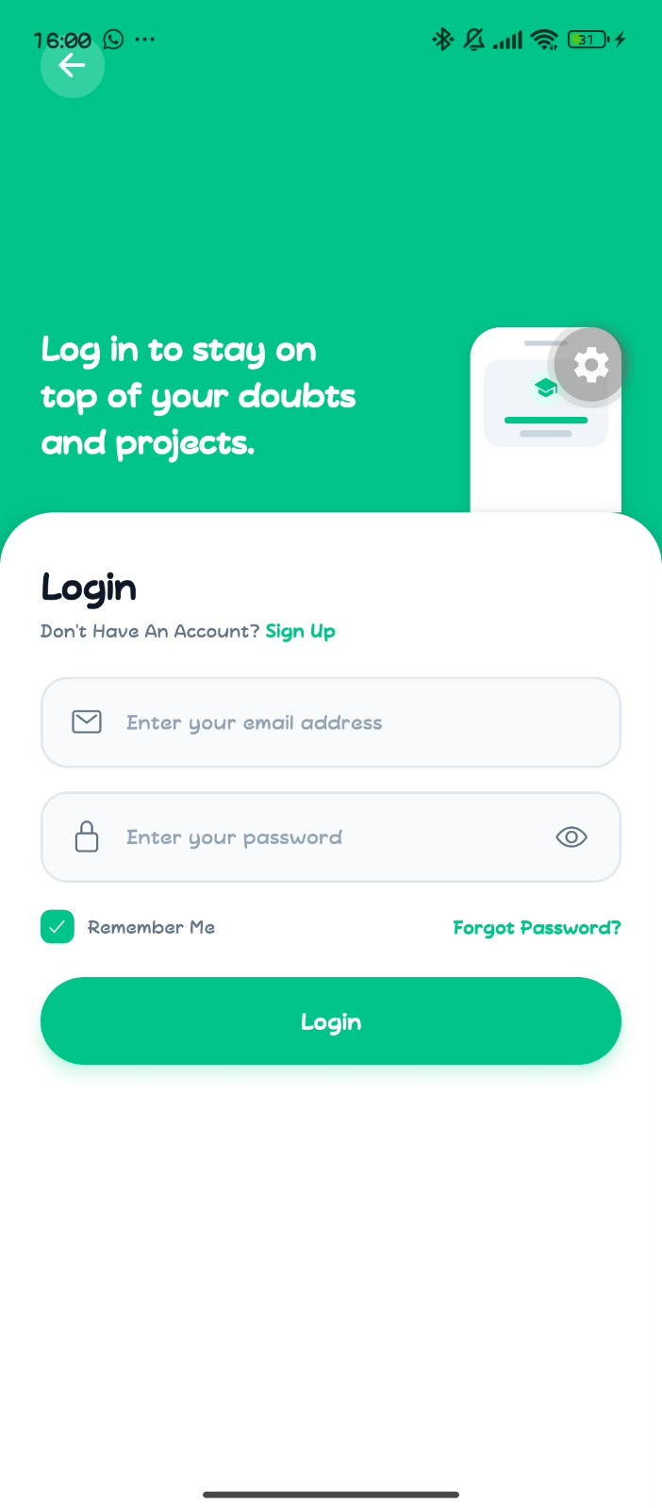
Figure 1: Supplied screen capture illustrating the PeerBridge UI. Review the associated chapter for screen-level requirements and interaction details.

Figure 2. PeerBridge interface reference
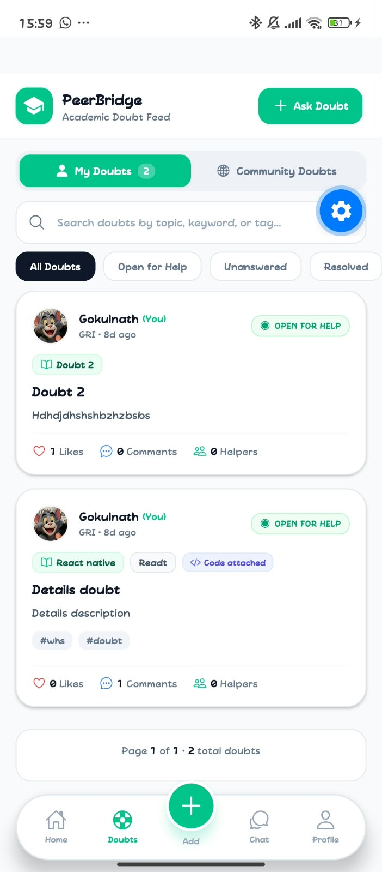
Figure 2: Supplied screen capture illustrating the PeerBridge UI. Review the associated chapter for screen-level requirements and interaction details.

Figure 3. PeerBridge interface reference
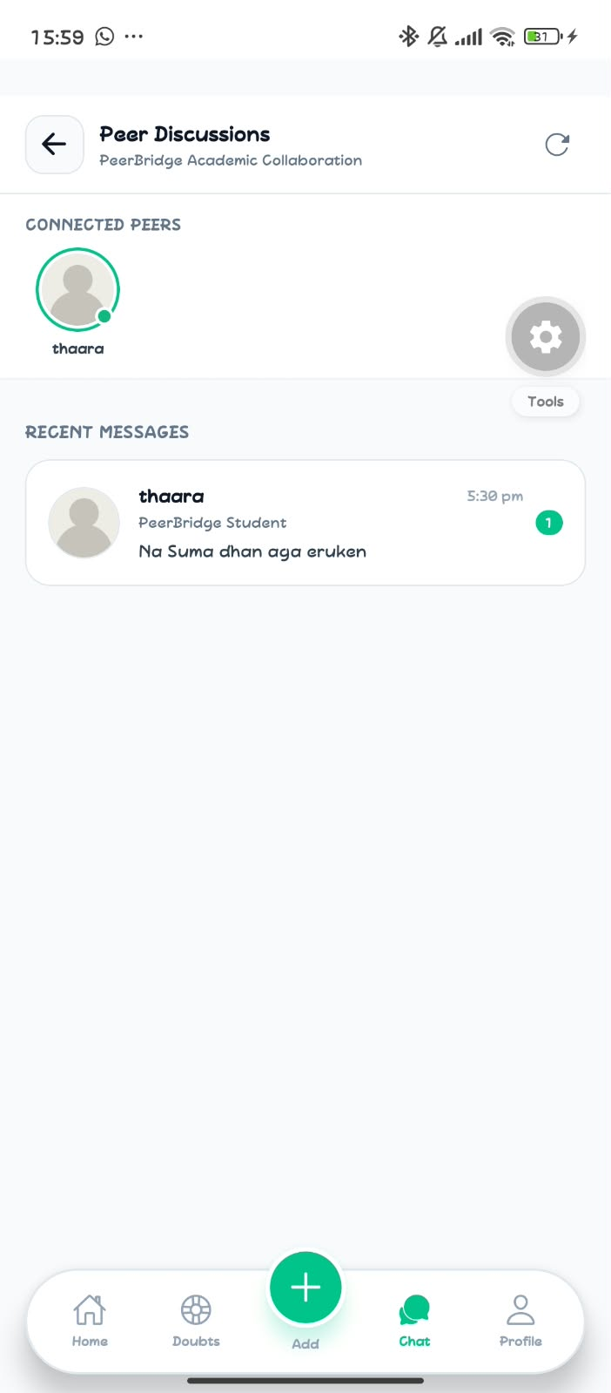
Figure 3: Supplied screen capture illustrating the PeerBridge UI. Review the associated chapter for screen-level requirements and interaction details.

Figure 4. PeerBridge interface reference
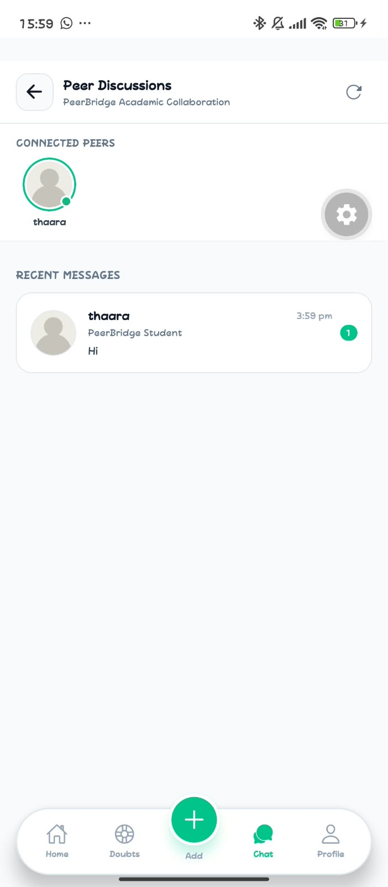
Figure 4: Supplied screen capture illustrating the PeerBridge UI. Review the associated chapter for screen-level requirements and interaction details.

Figure 5. PeerBridge interface reference
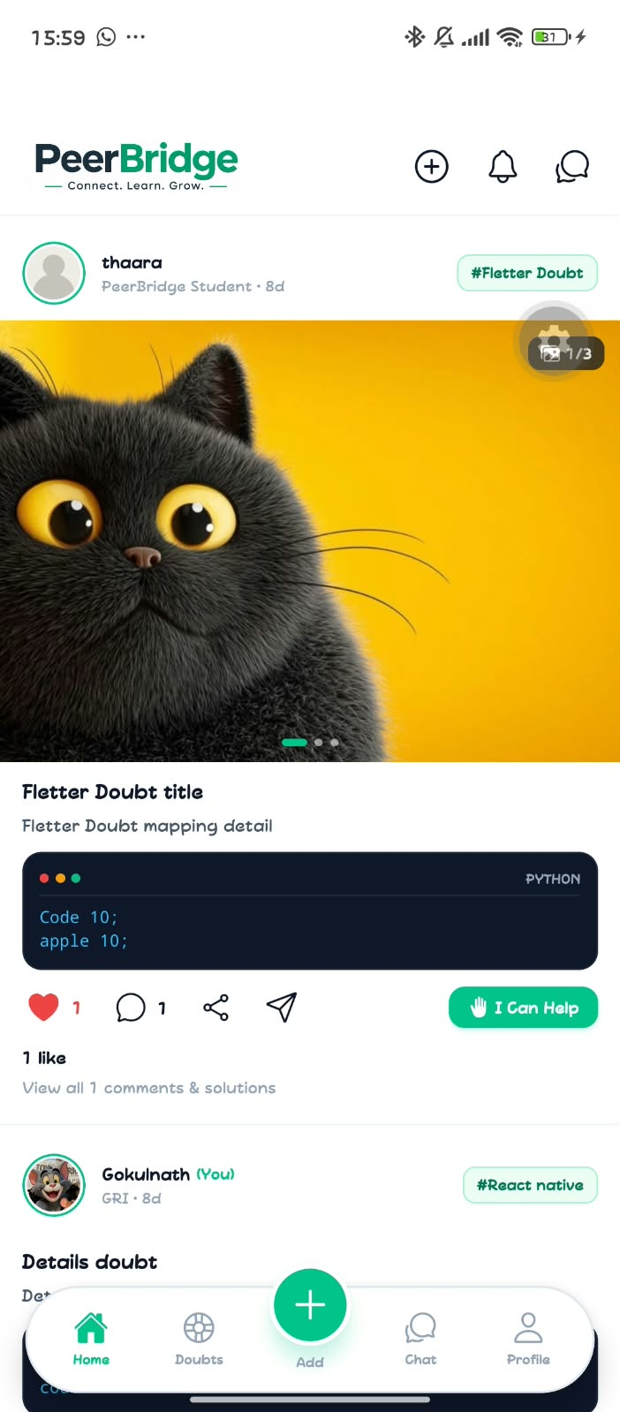
Figure 5: Supplied screen capture illustrating the PeerBridge UI. Review the associated chapter for screen-level requirements and interaction details.

Figure 6. PeerBridge interface reference

Figure 6: Supplied screen capture illustrating the PeerBridge UI. Review the associated chapter for screen-level requirements and interaction details.

APPENDIX A — ROLE AND PERMISSION MATRIX
Role | Profile | Doubts | Interactions | Conversations
Student | Create/update own profile | Create and manage own doubts | Comment and react | Access own conversations
Moderator | View reported content | Review reports | Apply permitted moderation actions | Access moderation audit
Administrator | Manage platform configuration | Manage roles and account state | Review platform-level reports | Access administrative audit
These appendix items are implementation and evaluation aids. Confirm them against the final deployed application and institutional assessment requirements.

APPENDIX B — SAMPLE API CATALOG
Endpoint | Purpose | Expected behavior
POST /api/auth/login | Authenticate user | Validated credentials; session/token response
POST /api/auth/forgot-password | Start recovery flow | Generic response; avoid account enumeration
GET /api/doubts | Retrieve feed | Pagination, search, topic and status filters
POST /api/doubts | Create doubt | Authenticated author; validated title/body/tags
GET /api/doubts/:id | Retrieve doubt details | Public or authenticated policy as configured
POST /api/doubts/:id/comments | Add comment | Authenticated user; content validation
PUT /api/doubts/:id/reaction | Toggle reaction | One reaction per user/target
GET /api/conversations | List authorized conversations | Participant-only results
POST /api/conversations/:id/messages | Send message | Conversation participant validation
GET /api/profile/:id | Read profile | Public-safe fields only
These appendix items are implementation and evaluation aids. Confirm them against the final deployed application and institutional assessment requirements.

APPENDIX C — SAMPLE ACCEPTANCE CRITERIA
Feature | Acceptance criteria
Login | Valid credentials proceed to the authenticated area; invalid credentials show a generic message; password visibility does not change stored credential security.
Create Doubt | A signed-in user can submit a valid title and description; invalid fields show inline feedback; successful creation returns a canonical doubt record.
Search | Search query is applied to supported fields and empty results display a useful message.
Chat | Only conversation participants can load history or send messages; failed sends provide retry feedback.
Profile | The owner can edit allowed profile fields; public viewers see only fields approved for display.
These appendix items are implementation and evaluation aids. Confirm them against the final deployed application and institutional assessment requirements.

APPENDIX D — PROJECT COMPLETION CHECKLIST
Area | Checklist item
Requirements | Confirm feature list and institution-specific requirements.
Screenshots | Replace illustrative captures with final build screenshots and figure labels.
Implementation | Verify actual stack, repository structure, API paths and database schema.
Testing | Attach executed test cases, evidence and defect resolution status.
Security | Review authentication, authorization, uploads, privacy and logs.
Submission | Fill student/guide/institution details, signatures, dates and references.
These appendix items are implementation and evaluation aids. Confirm them against the final deployed application and institutional assessment requirements.

REFERENCES AND DOCUMENTATION NOTES
- Project-specific UI screenshots supplied by the project owner (PeerBridge interface reference set, November 2026).
- Official documentation for the selected frontend, backend, database, authentication, hosting and testing technologies should be cited in the final academic submission.
- Add the institution's prescribed project-report guidelines, bibliography format and any approved research sources before submission.
Documentation integrity note: This report intentionally distinguishes screenshot-visible design from implementation claims. Add exact stack versions, source-code references, deployment evidence, test outputs and verified citations where applicable.

