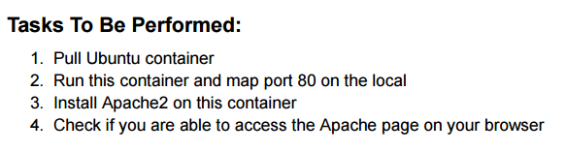

Screenshot 2025-10-09 195047

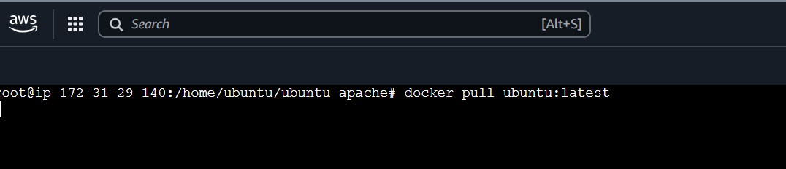

Screenshot 2025-10-09 195121

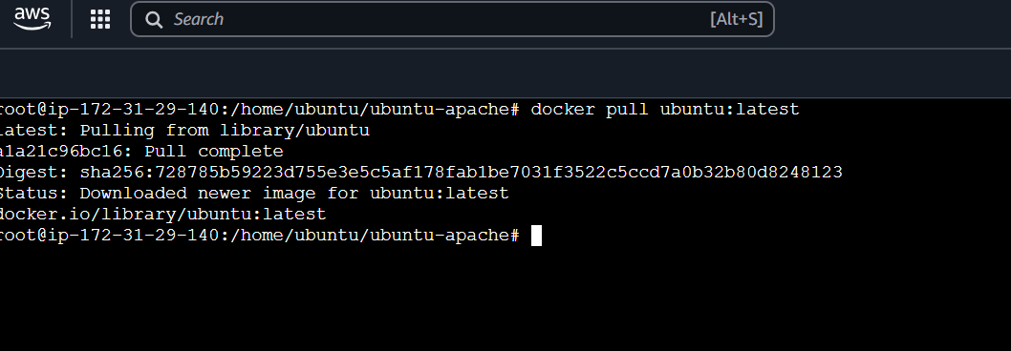



Screenshot 2025-10-09 195157

Screenshot 2025-10-09 114341

Screenshot 2025-10-09 114427

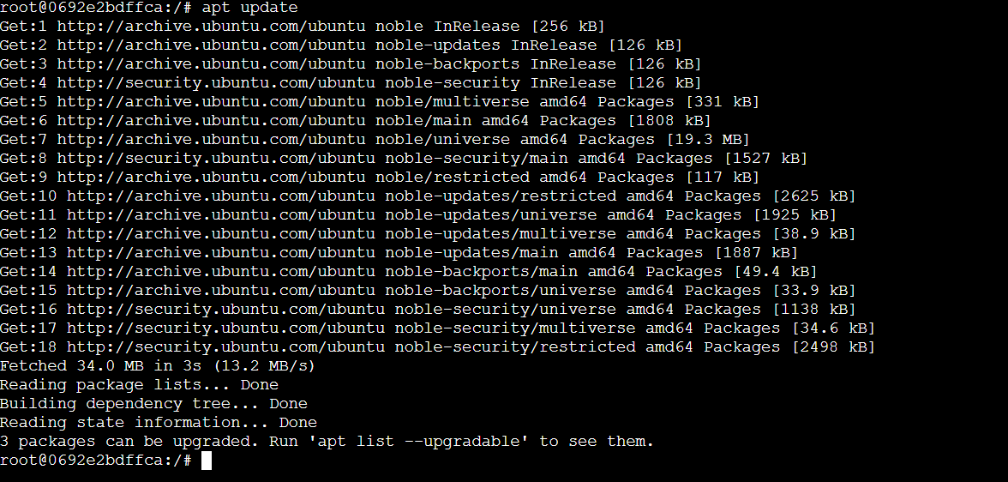

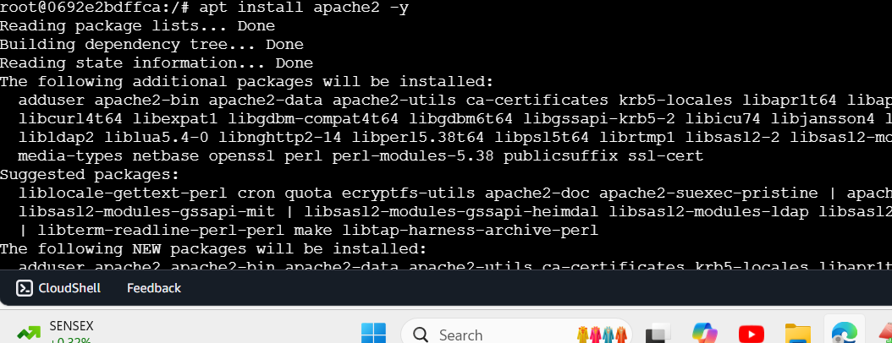

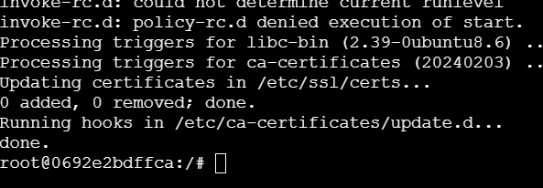

Screenshot 2025-10-09 195216

