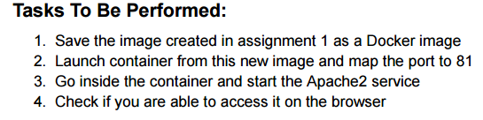

Screenshot 2025-10-09 195429

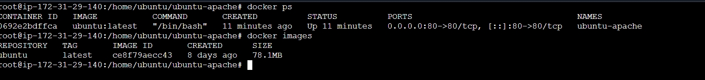

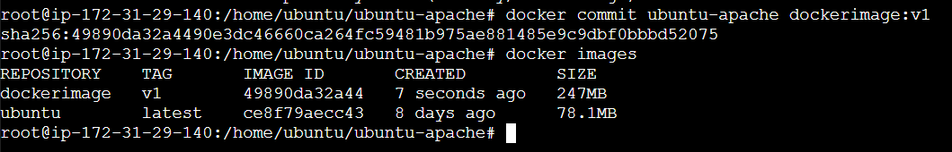

Screenshot 2025-10-09 195441





Screenshot 2025-10-09 195450

Screenshot 2025-10-09 120708



Screenshot 2025-10-09 195502

