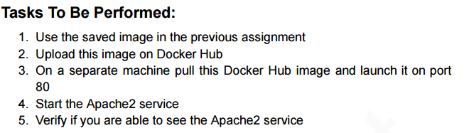

================================================================================

Screenshot 2025-10-09 195612

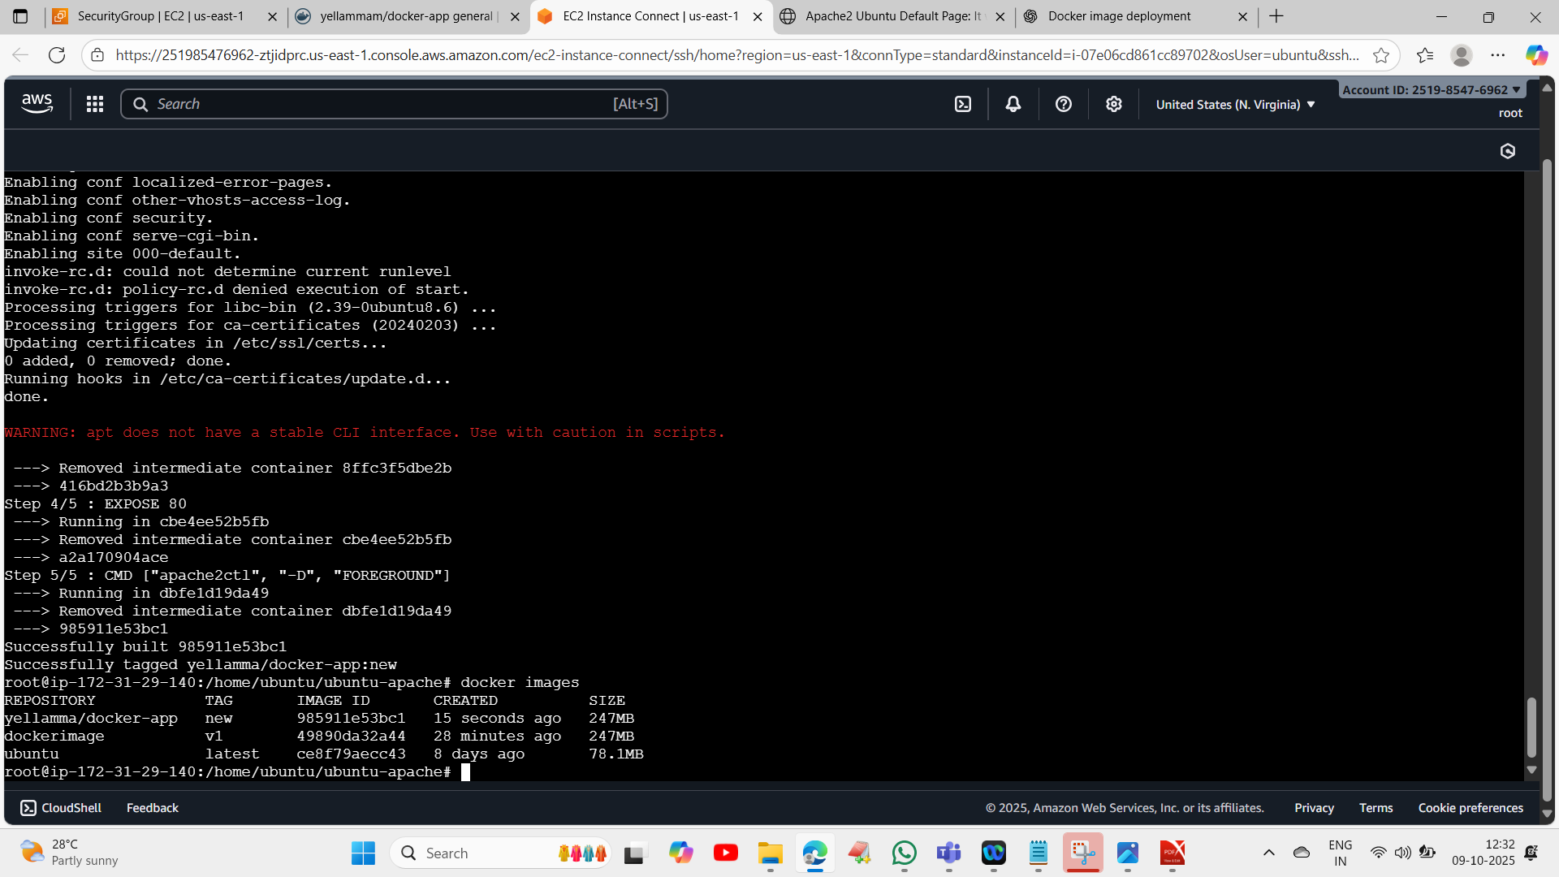

Screenshot 2025-10-09 195620

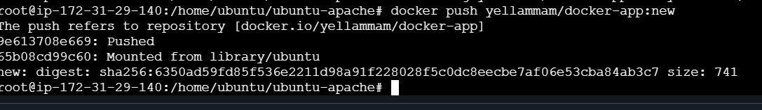

Screenshot 2025-10-09 195646

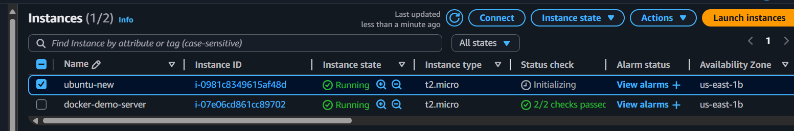

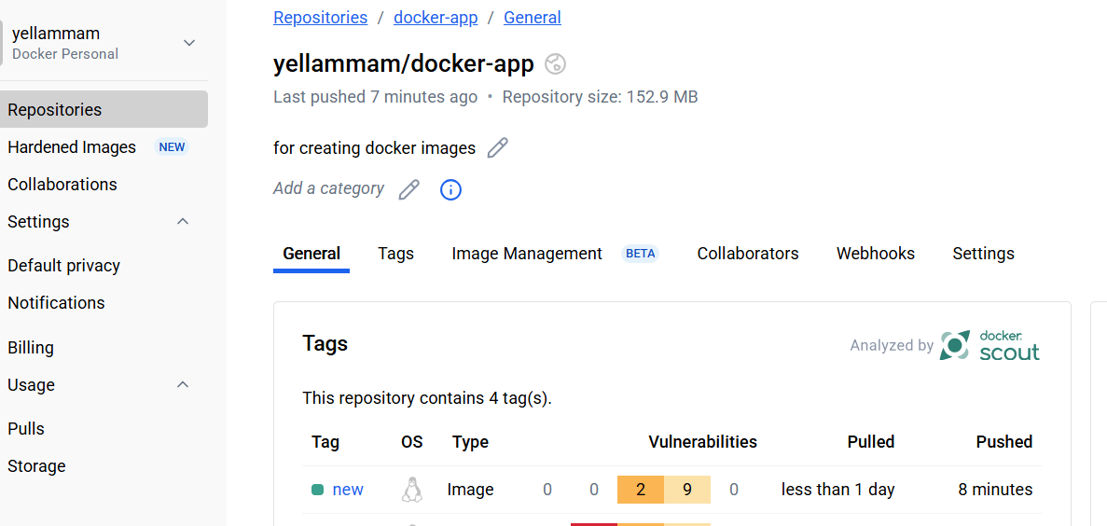

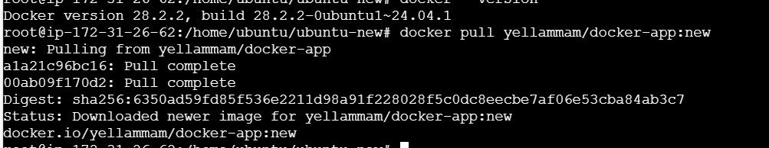

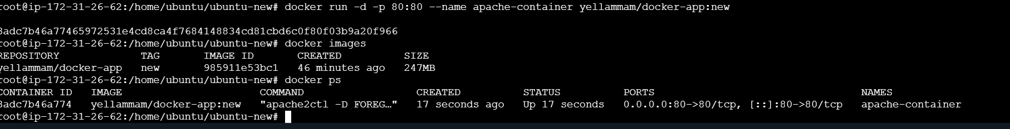

Screenshot 2025-10-09 195654

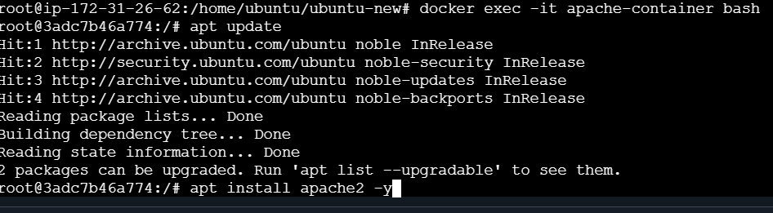

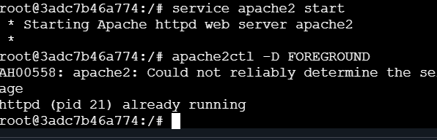

Screenshot 2025-10-09 195709

