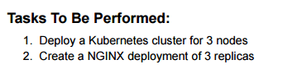

Screenshot 2025-10-11 072626

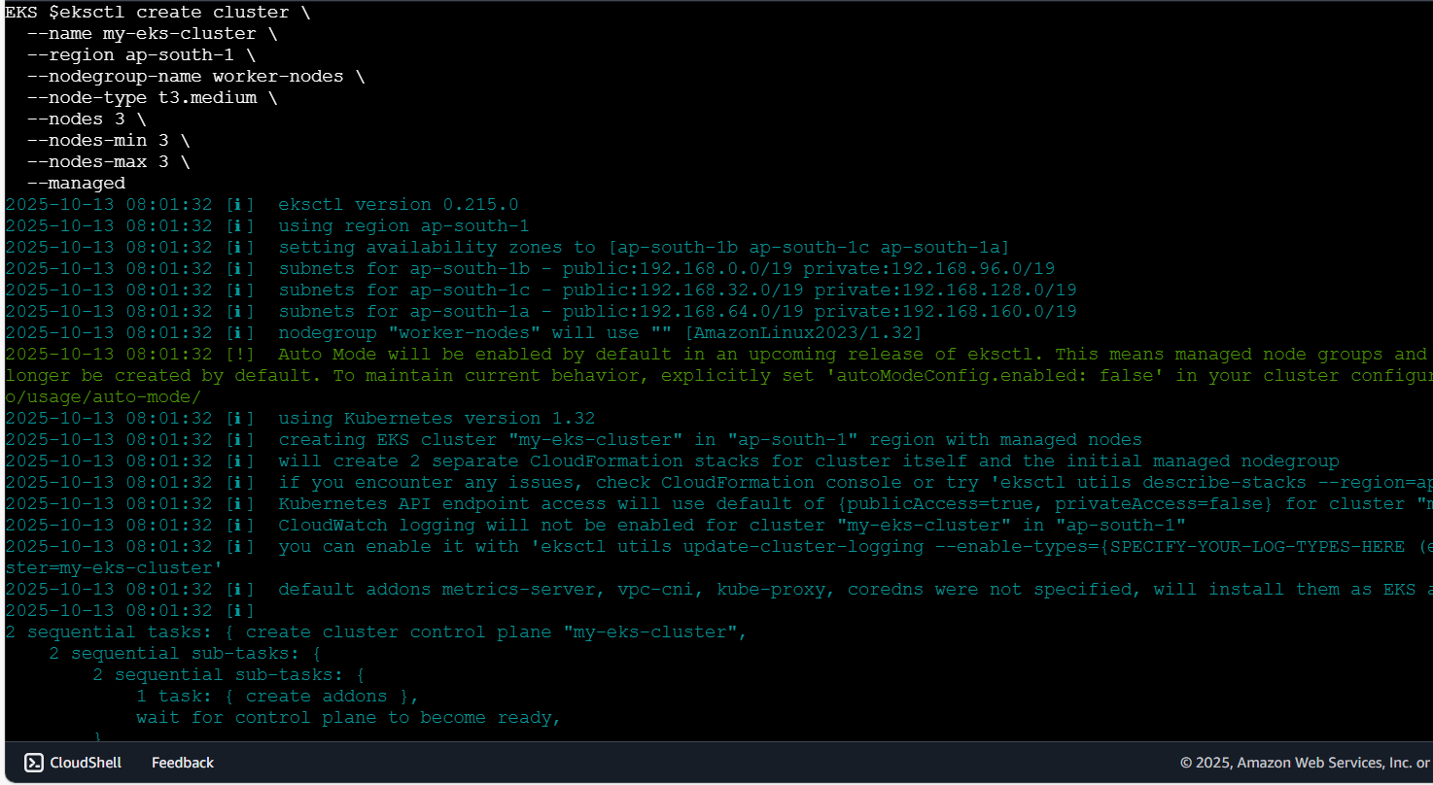

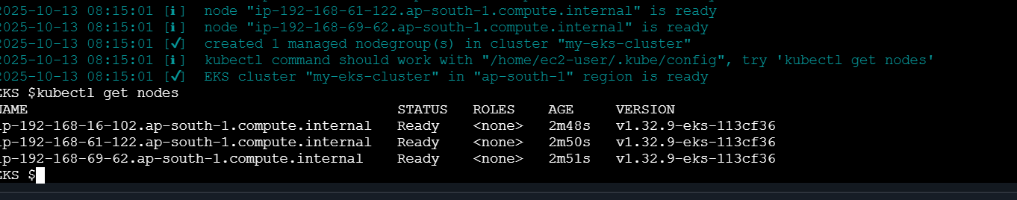

Screenshot 2025-10-11 072651

