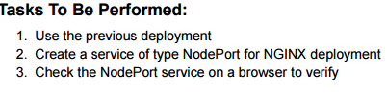

Screenshot 2025-10-11 072855

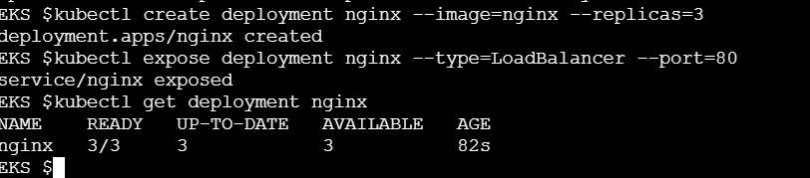

Screenshot 2025-10-11 072909

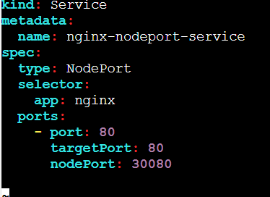

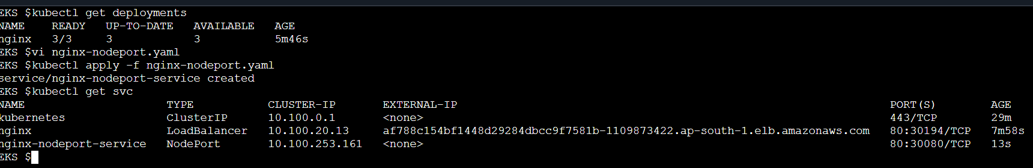

Screenshot 2025-10-11 072917

