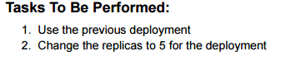

Screenshot 2025-10-11 073035

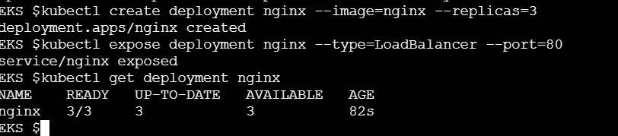

Screenshot 2025-10-11 073114

