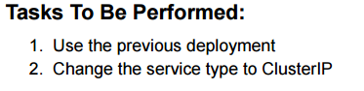

Screenshot 2025-10-11 073252

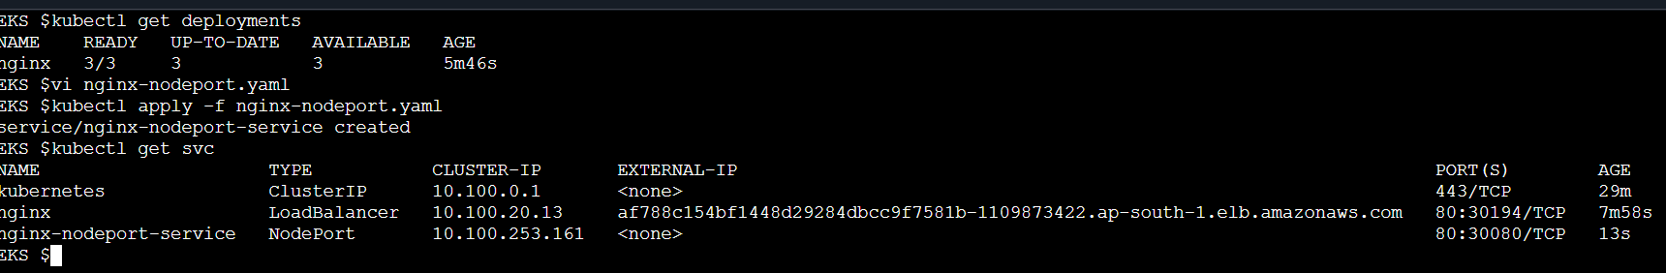

Screenshot 2025-10-11 073302

