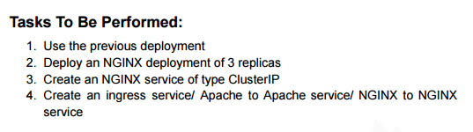

Screenshot 2025-10-11 073414

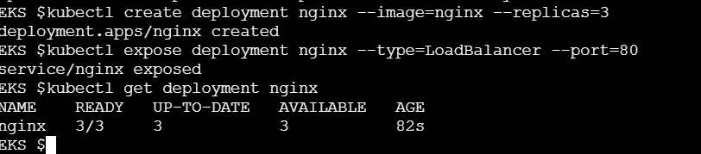

Screenshot 2025-10-11 073511

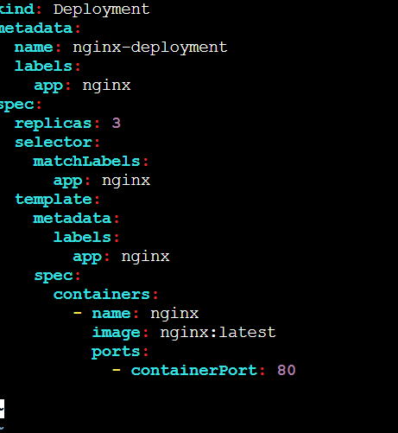

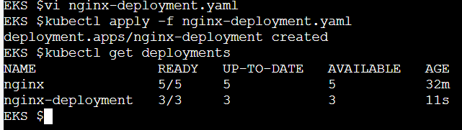

Screenshot 2025-10-11 073527

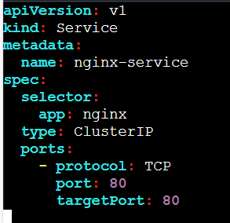

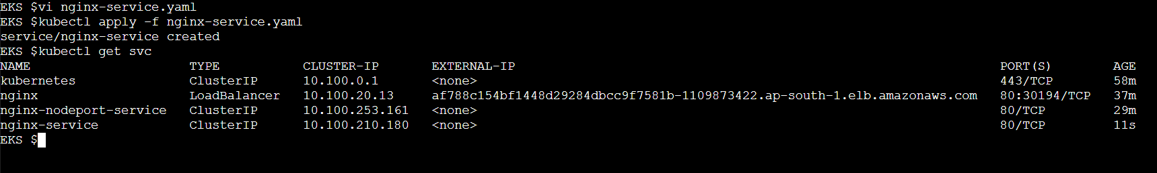

Screenshot 2025-10-11 073558

