This poc It will covered first 2 tasks using ci/cd pipeline
I am using ci cd pieline for jenkins blue ocean
pipleline as code for ci/cd stages

React application is running on docker container and deploy the react application into kubernetes cluster

I am using onpremise server and set up docker and kubernetes on that server

docker verison and kubernetes versions are

docker login
username: suryabezawada
passwd: Surya@3366

you can find the react docker image there

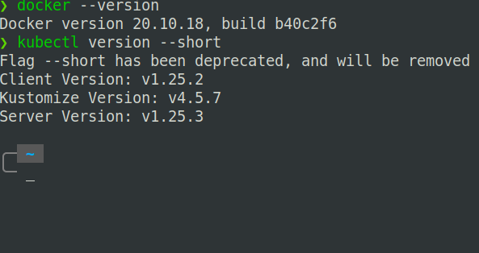

my jenkins server also set up in my onpremises server

Below jenkins file configured through declartive pipeline

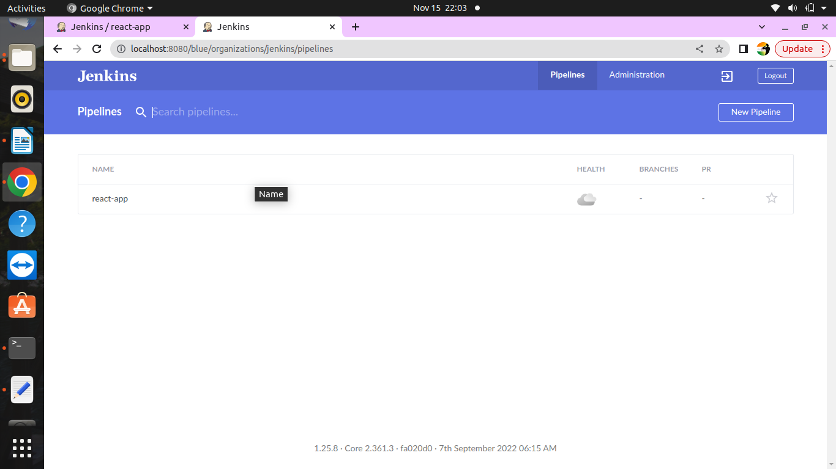
p

pipeline name is react-app

below the jenkins file for ci/cd

pipeline {
agent any

tools {
dockerTool 'Docker'
}

stages {

stage('git'){
steps {
git branch: 'feature', url: 'https://github.com/devopsclouds/${repo}.git'
}
}

stage('Docker '){
when {
expression { params.BUILD == 'YES' }
}
steps{
sh 'sudo docker login --username=${dockerusername} --password=${dockerpasswd}'
sh 'sudo docker build -t ${dockerusername}/angularapp:${BUILD_NUMBER} . '
sh 'docker tag ${dockerusername}/angularapp:${BUILD_NUMBER} ${dockerusername}/angularapp:latest'
sh 'docker push ${dockerusername}/angularapp:latest'

}
}
stage('Deploy to react App') {
steps {

withCredentials([file(credentialsId: 'mykubeconfig', variable: 'KUBECONFIG')]) {
sh 'kubectl apply -f deployment.local.yaml'

}
}
}
}
}

stage 1 – cloing the code from git hub to jenkins server

stage 2- 1. to connect to docker registry
2. create the docker image with dockerusername ,application name and build number
3. tag the docker image build number to latest docker image tag
4. push the docker image to docker registry

stage 3 – in oder to connect kubernetes cluster to jenkins user. Save kubeconfig file in secret file in jenkins .

I have already configured deployment yaml file and it will the container deploy into kubernetes cluster

Dockerfile

FROM node:14.17.1-alpine3.13 as node
WORKDIR /app
COPY . .

RUN npm install --save-dev @angular-devkit/build-angular
RUN npm run build --prod

# stage 2
FROM nginx:alpine
COPY --from=node /app/dist/angular-app /usr/share/nginx/html

explaination:using mutistage docker image and first download the node base image

and install the dependencies ,build the application

download another image nginx for deploy the react application

copies the react html from base image and copies to nginx html page

This container will be deploy on kubernetes

deployment-local.yaml

apiVersion: apps/v1 # for versions before 1.9.0 use apps/v1beta2
kind: Deployment
metadata:
name: angular-deployment
spec:
selector:
matchLabels:
app: angular
replicas: 1 # tells deployment to run 2 pods matching the template
template:
metadata:
labels:
app: angular
spec:
containers:
- name: angular
image: suryabezawada/angularapp:latest
ports:
- containerPort: 80
---
# https://kubernetes.io/docs/concepts/services-networking/service/#defining-a-service
kind: Service
apiVersion: v1
metadata:
name: angular-service
spec:
selector:
app: angular
ports:
- protocol: TCP
port: 8082
targetPort: 80

type: ClusterIP
---
apiVersion: networking.k8s.io/v1
kind: Ingress
metadata:
name: ingress-resource-1
spec:
ingressClassName: nginx
rules:
- host: nginx.react.com
http:
paths:
- path: /
pathType: Prefix
backend:
service:
name: angular-service
port:
number: 80

in the deployment yaml we call docker image and put in the pod spec and maintain replicas 1

it will create one pod

how he pod will be access to create a service

I have used ingress load balancer to route the traffic . Define the rules like if the request comes in nginx.react.com it will map to angular service

then nginx.react.com will be accessing the browser

demo:

go to ci pipleline

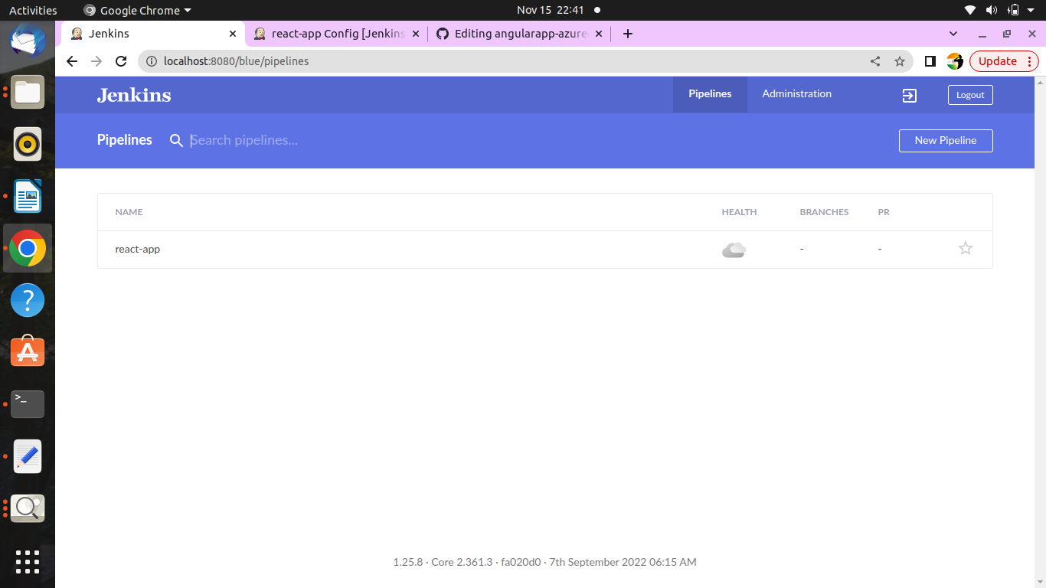

add docker user name and paaword in parameters

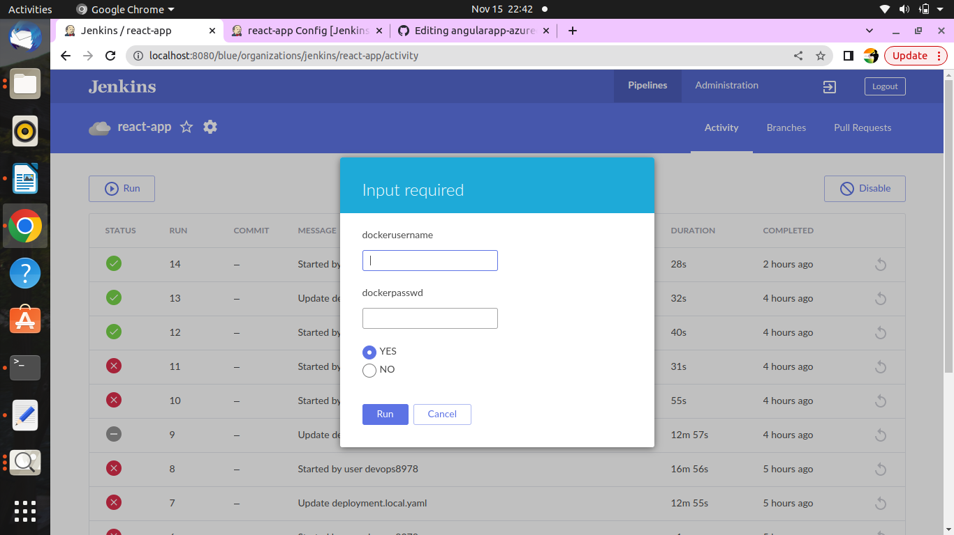

here ci stages in diagram flow

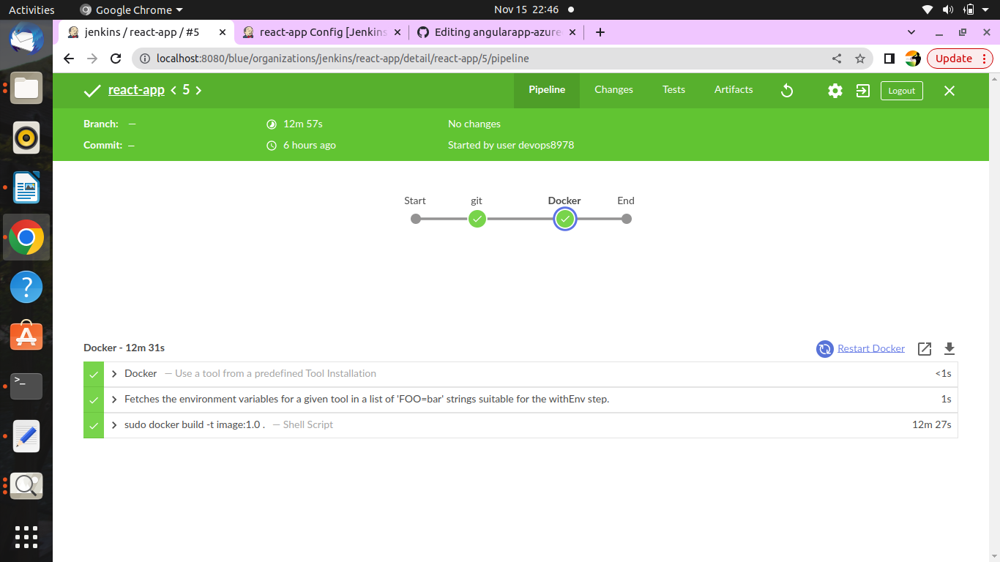

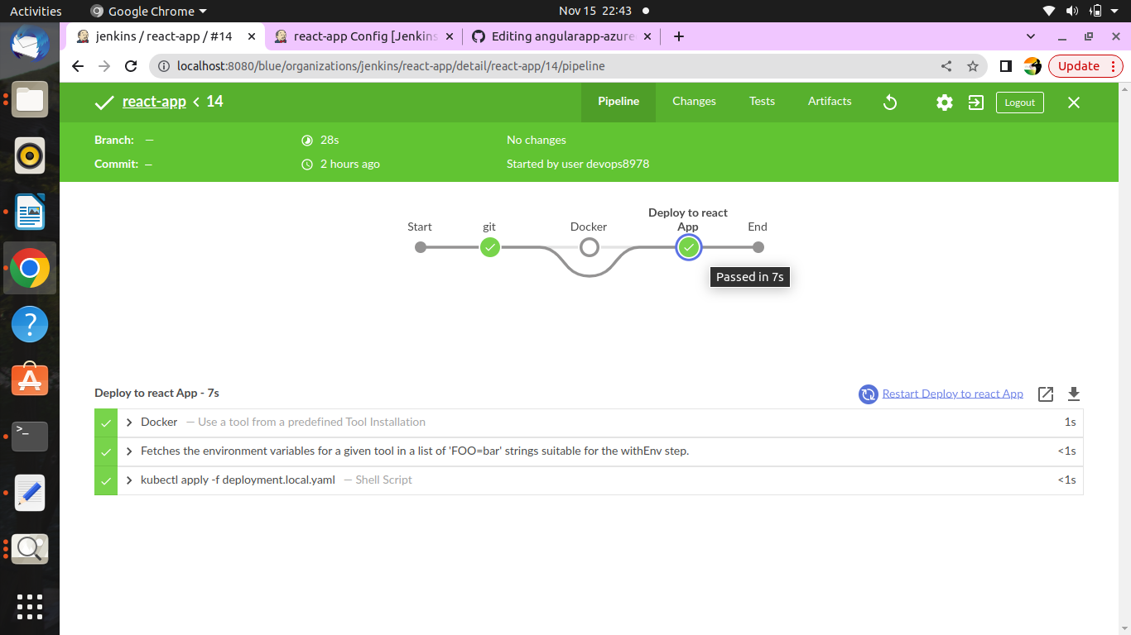
above one is cd diagram flow

Then browse the application in browser using domain name nginx.react.com

I added on the /etc folder

nginx.react.com it will reverse or redirect to loadbalancer ip of ingress

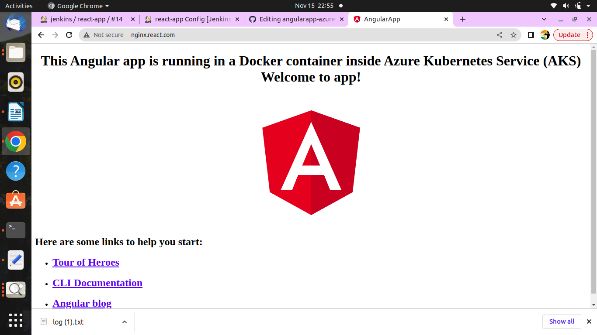
to connect mysql
download mysql/mysql-server image

--detach \
--name=hsoft_mysql-server \
--env="MYSQL_ROOT_PASSWORD="{you choose" \
--publish 6603:3306 \
--volume=/home/nofa/mysql/conf/my.cnf:/etc/my.cnf \
--volume=/home/nofa/mysql/data:/var/lib/mysql \
--volume=/home/nofa/mysql/logs:/var/log \

add above configuration on pod spec in containers

add mysql server script extension in package.json

