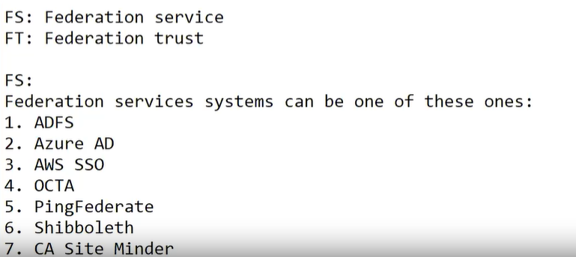

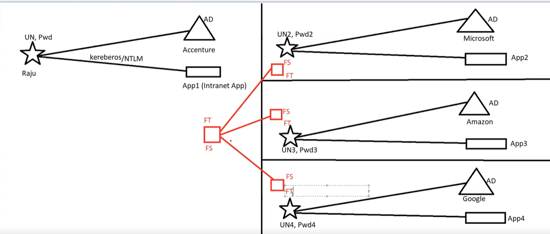

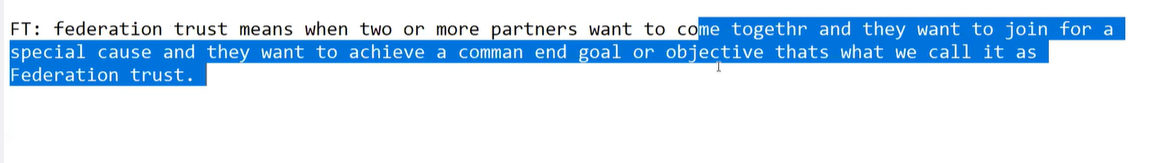

In FT partners exchange information called metadata

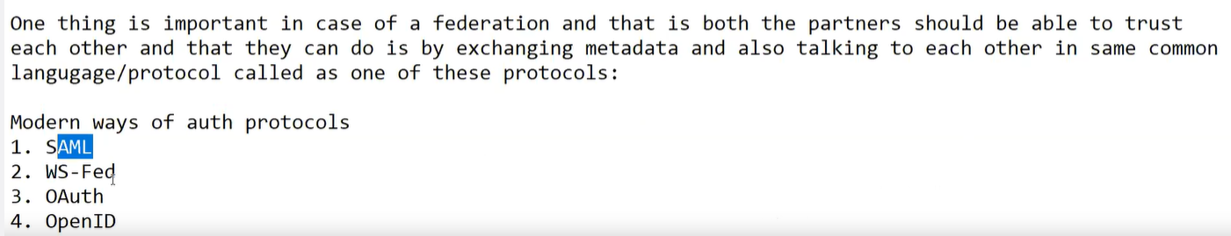

Once federation is done you can allow partners in idp to access app in SP using single user id and password

IDP – someone who provide user identities

SP: someone who provides app url to be accessed b other IDP

AzureAD will be our IDP

Pagerduty will be SP

