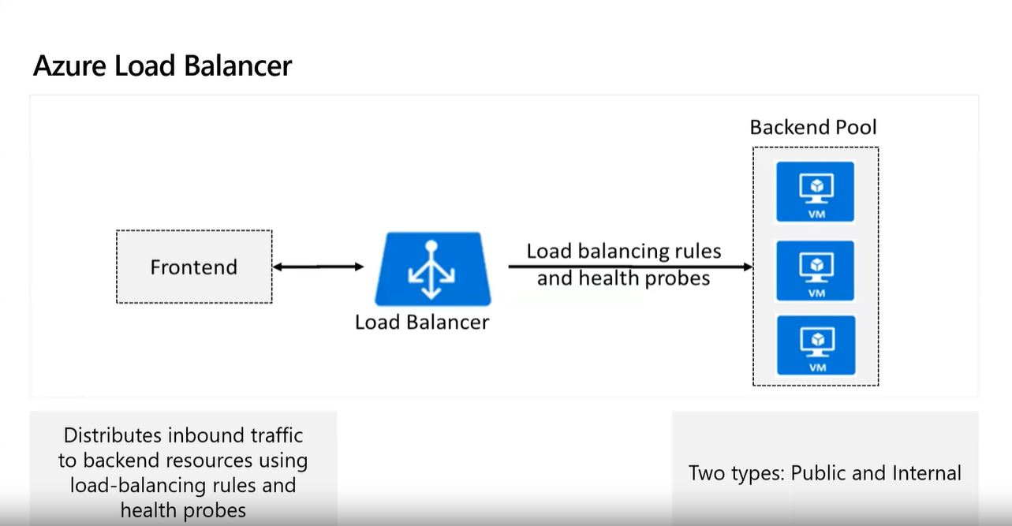

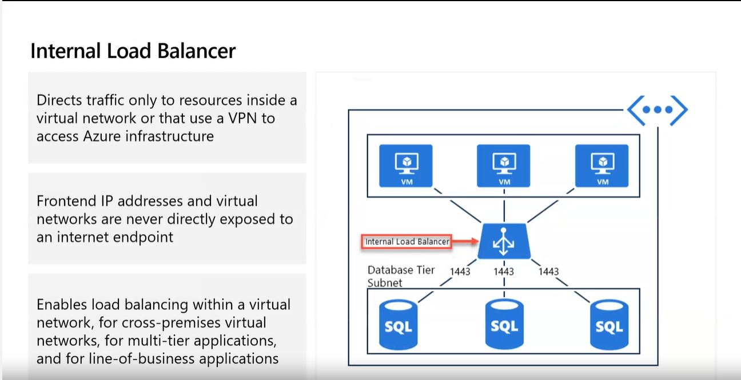

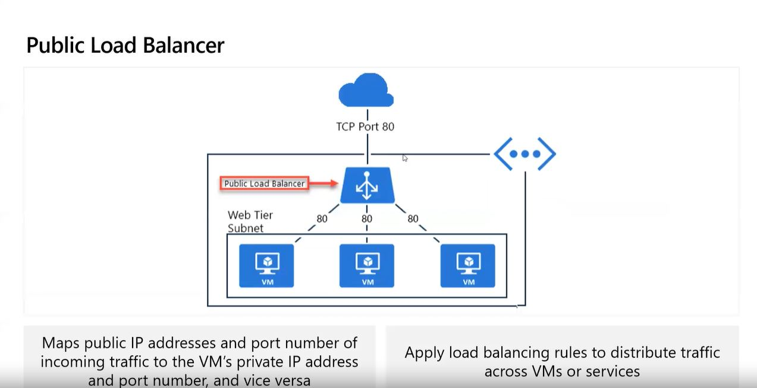

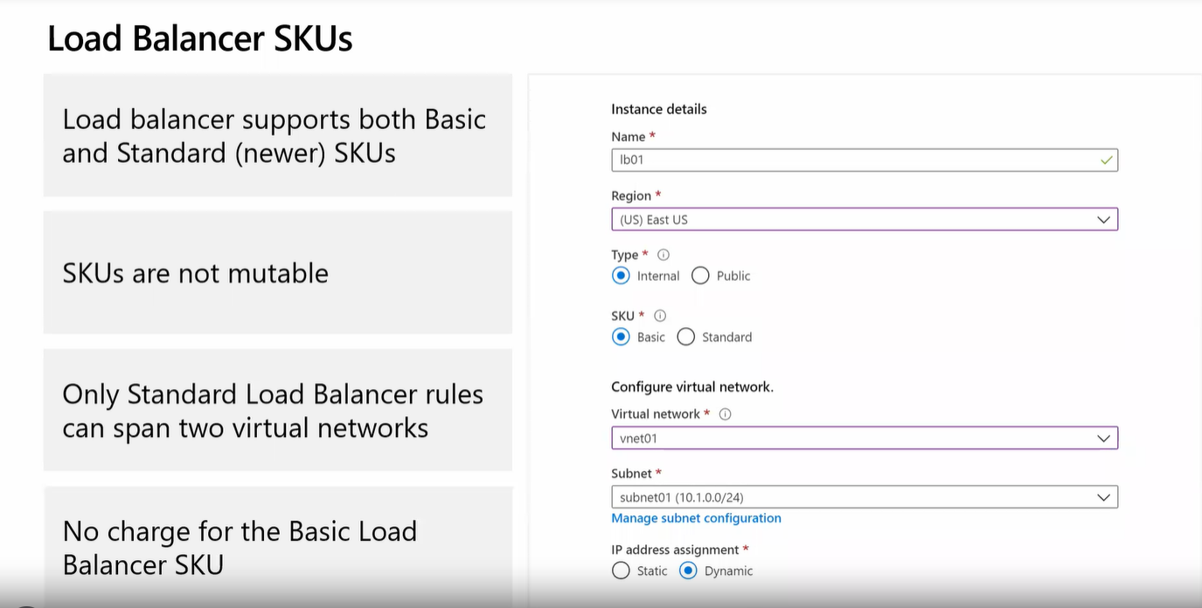

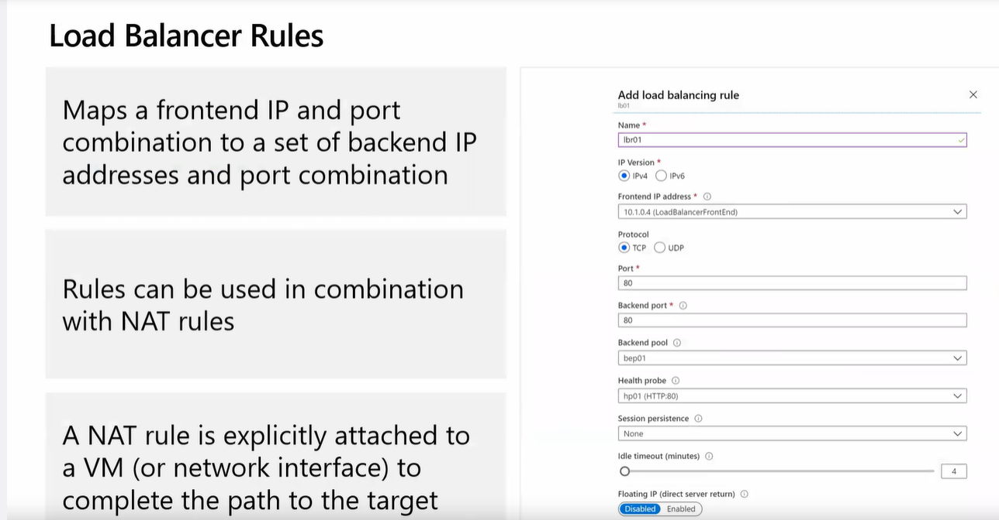

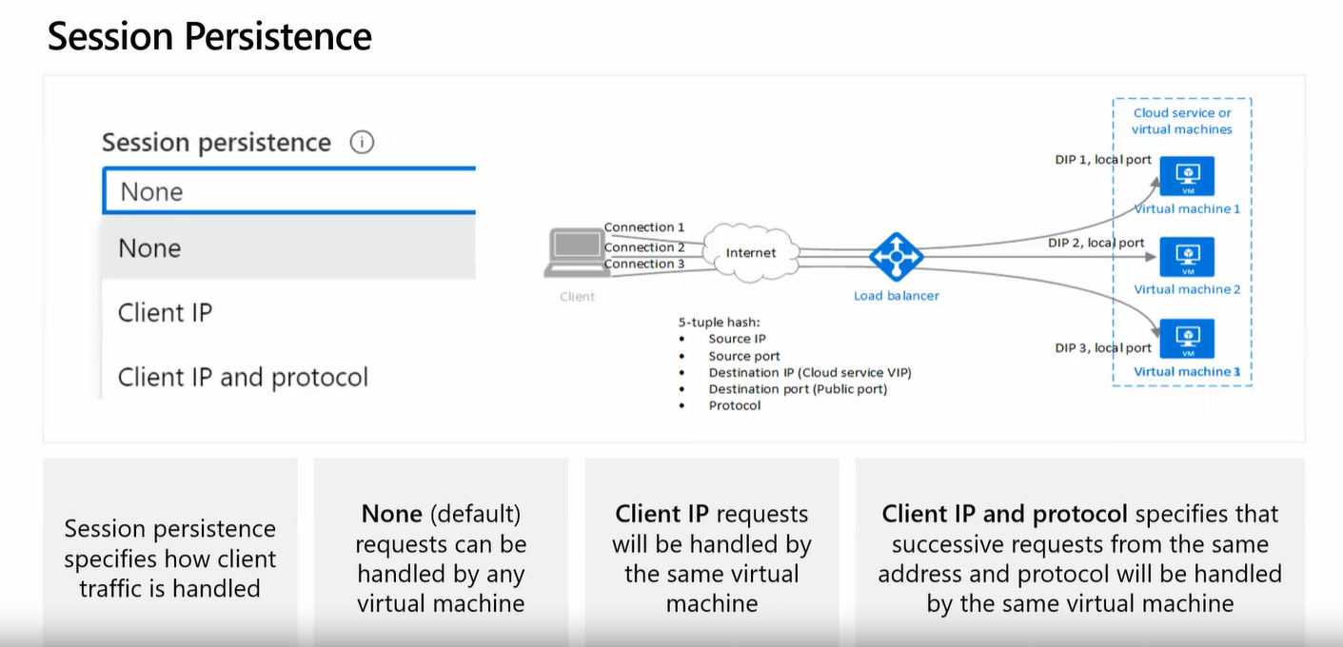

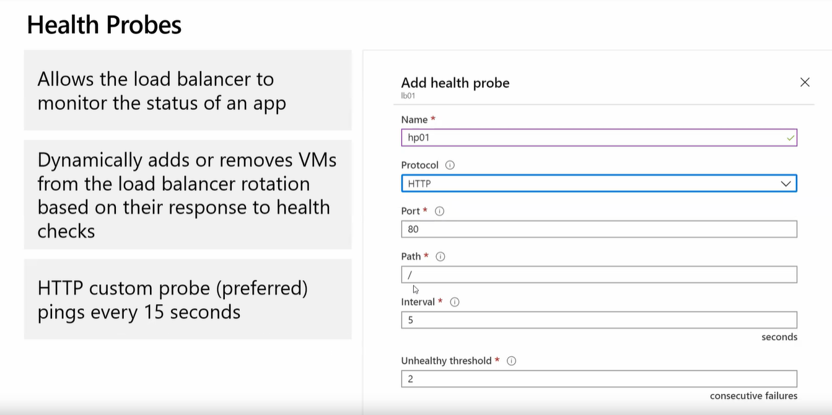

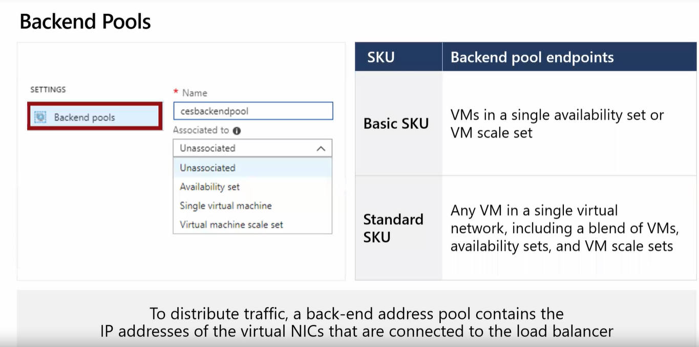

# Ensure the script is running with Administrator privileges

if (-not ([Security.Principal.WindowsPrincipal] [Security.Principal.WindowsIdentity]::GetCurrent()).IsInRole([Security.Principal.WindowsBuiltInRole] "Administrator")) {

Write-Warning "You need to run this script as an Administrator."

exit

}

# Install the Web Server (IIS) role

Install-WindowsFeature -Name Web-Server -IncludeManagementTools

# Check if the installation was successful

if ((Get-WindowsFeature -Name Web-Server).InstallState -eq 'Installed') {

Write-Host "Web Server (IIS) installation successful."

} else {

Write-Host "Web Server (IIS) installation failed."

exit

}

# Start the IIS service if not already running

Start-Service W3SVC

# Confirm the IIS service is running

if ((Get-Service W3SVC).Status -eq 'Running') {

Write-Host "IIS service is running."

} else {

Write-Host "IIS service is not running. Please check the service status."

exit

}

# Define the path to the default IIS webpage

$defaultPagePath = "C:\inetpub\wwwroot\index.html"

# Create some random content for the default webpage

$randomContent = @"

<html>

<head>

<title>Welcome to My IIS Server</title>

</head>

<body>

<h1>Hi from Amit</h1>

<p>This page was automatically created by a PowerShell script on $(Get-Date).</p>

<p>Random Fact: The random number of the day is $(Get-Random).</p>

</body>

</html>

"@

# Write the content to the default webpage

$randomContent | Out-File -FilePath $defaultPagePath -Encoding UTF8

# Confirm the content was added

if (Test-Path $defaultPagePath) {

Write-Host "Default webpage created successfully at $defaultPagePath"

} else {

Write-Host "Failed to create the default webpage."

}

