INDEX

| Sr.No | Topic | Date | Sign |
| --- | --- | --- | --- |
| 1. | Practical No :- 1. Write A Program For Tokenization Of Given Input. |  |  |
| 2. | Practical No :- 2. Write A Program For Generating Regular Expressions For Regular Grammar. |  |  |
| 3. | Practical No :- 3. Write A Program For Generating Derivation Sequence / Language For The Given Sequence Of Productions In Python. |  |  |
| 4. | Practical No :- 4. Design A Program For Creating A Machine That Accepts Three Consecutive One In Python. |  |  |
| 5. | Practical No :- 5. Design A Program For Creating Machine That Accepts The String Always Ending With 101 In Python |  |  |
| 6. | Practical No :- 6. Design A Program For Accepting Decimal Number Divisible By 2 In Python. |  |  |
| 7. | Practical No :- 7. Design A Program For Creating A Machine Which Accepts String Having Equal No Of 1’s And 0’s In Python. |  |  |
| 8. | Practical No :- 8. Design A Program For Creating A Machine Which Count The Number Of 1’s And 0’s In A Given String In Python. |  |  |
| 9. | Practical No 9. Design A PDA To Accept WCWR Here W Is Any String And Wr Is Reverse Of That String And C Is A Special Symbol. |  |  |
| 10. | Practical No :- 10 . Design A Turing Machine That’s Accepts The Following Language b n c n Where N>0. |  |  |

Practical No :- 1. Write A Program For Tokenization Of Given Input.

Ans.

import re

def tokenize(input_string):

tokens = re.findall(r'\w+|[^\w\s]', input_string, re.UNICODE) return tokens

if name == " main ":

input_string = input("Enter a string to tokenize: ") tokens = tokenize(input_string)

print("Tokens:", tokens)

OUTPUT :-



Practical No :- 2. Write A Program For Generating Regular Expressions For Regular Grammar.

Ans.

import re

line = "horses are taller than dogs"

searchObj = re.search(r'(.*) are (.*?) .*', line, re.M|re.I)

if searchObj:

print("searchObj.group() : ", searchObj.group()) print("searchObj.group(1) : ", searchObj.group(1)) print("searchObj.group(2) : ", searchObj.group(2))

else:

print("Nothing found!!")

Output :-

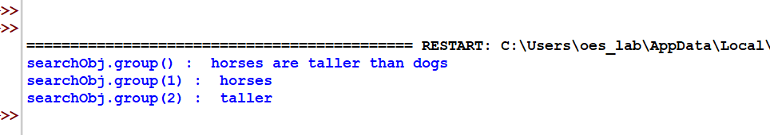

Practical No :- 3. Write A Program For Generating Derivation Sequence /

Language For The Given Sequence Of Productions In Python.

Ans.

def printArray(arr, k):

print(" ".join(map(str, arr)))

def getSuccessor(arr, k, n):

for i in range(k - 1, -1, -1): if arr[i] < n:

arr[i] += 1

for j in range(i + 1, k): arr[j] = 1

return 1

return 0

def printSequences(n, k): arr = [0] * k

for i in range(k): arr[i] = 1

while True:

printArray(arr, k)

if getSuccessor(arr, k, n) == 0: break

n = 3

k = 2 printSequences(n, k)

Output :-

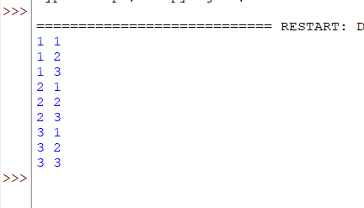

Practical No :- 4. Design A Program For Creating A Machine That Accepts

Three Consecutive One In Python.

Ans.

def stateA(n):

if len(n) == 0:

print("String Not Accepted") elif n[0] == '1':

stateB(n[1:]) else:

stateA(n[1:])

def stateB(n):

if len(n) == 0:

print("String Not Accepted") elif n[0] == '1':

stateC(n[1:]) else:

stateA(n[1:])

def stateC(n):

if len(n) == 0:

print("String Not Accepted") elif n[0] == '1':

stateD(n[1:]) else:

stateA(n[1:])

def stateD(n):

print("String Accepted")

input_string = "11101" # Example input string stateA(input_string)

Output :-

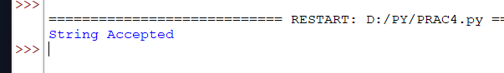

Practical No :- 5. Design A Program For Creating Machine That Accepts The

String Always Ending With 101 In Python Ans.

def q1(s, i):

print("q1->", end="") if i == len(s):

print("NO") return

if s[i] == '0': q1(s, i + 1)

else:

q3(s, i + 1)

def q2(s, i):

print("q2->", end="") if i == len(s):

print("NO") return

if s[i] == '0': q1(s, i + 1)

else:

q3(s, i + 1)

def q3(s, i):

print("q3->", end="") if i == len(s):

print("YES") return

if s[i] == '0': q1(s, i + 1)

else:

q2(s, i + 1)

def q0(s, i):

print("q0->", end="") if i == len(s):

print("NO") return

if s[i] == '0':

q1(s, i + 1) else:

q2(s, i + 1)

if name == " main ": s = "010101"

print("State transitions are", end=" ") q0(s, 0)

Output :-

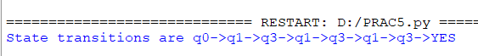

Practical No :- 6. Design A Program For Accepting Decimal Number Divisible

By 2 In Python. Ans.

def stateq0(n):

print(f"stateq0 called with {n}") if len(n) == 0:

print("Input processed in stateq0") elif n[0] == '0':

stateq0(n[1:])

elif n[0] == '1':

stateq1(n[1:])

def stateq1(n):

print(f"stateq1 called with {n}") if len(n) == 0:

print("Input processed in stateq1") elif n[0] == '0':

stateq0(n[1:])

elif n[0] == '1':

stateq1(n[1:])

n = int(input("Enter a number: ")) n = bin(n).replace("0b", "") stateq0(n)

Output :-

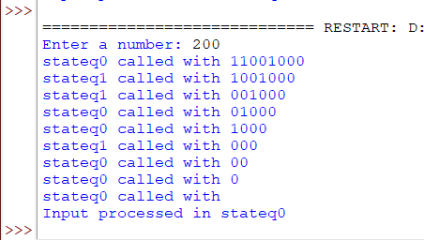

Practical No :- 7. Design A Program For Creating A Machine Which Accepts

String Having Equal No Of 1’s And 0’s In Python.

Ans.

# Function to count substrings with equal numbers of 0's, 1's, and 2's

def getSubStringWithEqual012(Str):

count = 0 # Counter for valid substrings

# Traverse all possible substrings for i in range(len(Str)):

countZero = 0

countOnes = 0

countTwo = 0

# Check for every substring starting from index i for j in range(i, len(Str)):

if Str[j] == '0': countZero += 1

elif Str[j] == '1': countOnes += 1

elif Str[j] == '2': countTwo += 1

# If counts of 0's, 1's, and 2's are equal

if countZero == countOnes and countOnes == countTwo: count += 1

return count # Driver code

Str = input("Enter the string: ") # Take input from the user at runtime

print("Number of substrings with equal 0's, 1's, and 2's:", getSubStringWithEqual012(Str))

Output :-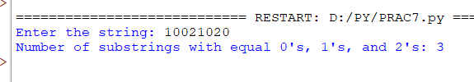

Practical No :- 8. Design A Program For Creating A Machine Which Count The

Number Of 1’s And 0’s In A Given String In Python. Ans.

def countSubstring(S, n): ans = 0

i = 0

while i < n:

cnt0 = 0

cnt1 = 0

# Count consecutive 0's while i < n and S[i] == '0':

cnt0 += 1

i += 1

# Count consecutive 1's after consecutive 0's while i < n and S[i] == '1':

cnt1 += 1

i += 1

# Update the total count of substrings with the minimum of cnt0 and cnt1

ans += min(cnt0, cnt1) return ans

# Driver code

if name == " main ":

S = "0001110010" # Input string

n = len(S) # Length of the string

# Function call to count and print the result print("Total substrings:", countSubstring(S, n))

Output :-

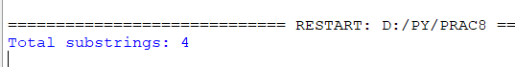

Practical No 9. Design A PDA To Accept WCWR Here W Is Any String And Wr

Is Reverse Of That String And C Is A Special Symbol. Ans.

class DPDA:

def init (self, trf, input, state):

self.head = 0 # Tracks the position in the input string self.trf = trf # Transition function

self.state = state # Initial state self.input = input # Input string

self.stack = ['Z'] # Initial stack with 'Z' as the stack bottom marker

def step(self):

if self.head < len(self.input): a = self.input[self.head]

s = self.stack.pop() if self.stack else 'ε'

if (self.state, a, s) in self.trf:

state, ss = self.trf.get((self.state, a, s))

if ss != 'ε': # Push symbols onto the stack in

reverse order

self.state))

for symbol in reversed(ss): self.stack.append(symbol)

self.state = state

print('{:20s} [{:10s}] {:5s}'.format(

self.input[self.head:], ''.join(self.stack),

self.head += 1

else:

print("No transition available!")

else:

print("Input fully processed!")

def run(self):

print('{:20s} [{:10s}] {:5s}'.format(

self.input[self.head:], ''.join(self.stack), self.state))

while self.head < len(self.input): self.step()

s = self.stack.pop() if self.stack else 'ε' if (self.state, 'ε', s) in self.trf:

self.state, _ = self.trf.get((self.state, 'ε', s)) print("Final state:", self.state)

if self.state == 'q_accept': print("Accepted!")

else:

print("Rejected!")

# Transition function for DPDA accepting L = {a^n b^n | n >= 0} trf = {

('q0', 'a', 'Z'): ('q0', 'AZ'),

('q0', 'a', 'A'): ('q0', 'AA'),

('q0', 'b', 'A'): ('q1', 'ε'),

('q1', 'b', 'A'): ('q1', 'ε'),

('q1', 'ε', 'Z'): ('q_accept', 'ε') # Epsilon transition for stack-empty check

}

# Driver code

if name == " main ":

input_string = input("Enter a string (e.g., aaabbb): ") dpda = DPDA(trf, input_string, "q0")

dpda.run()

Output :-

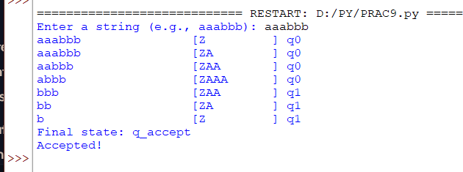

Practical No :- 10. Design A Turing Machine That’s Accepts The Following

Language b n c n Where N>0. Ans.

# Function to perform actions for states def action(inp, rep, move):

global tapehead

if tape[tapehead] == inp: tape[tapehead] = rep

if move == 'L': # Move the tape head left tapehead -= 1

elif move == 'R': # Move the tape head right tapehead += 1

return True return False

# Initialize the tape

tape = ['B'] * 50 # 'B' represents blank spaces on the tape string = input("Enter a string (e.g., aaabbbccc): ")

i = 5 # Start placing input at position 5 on the tape tapehead = 5 # Initial position of the tape head

# Place the input string on the tape for s in string:

tape[i] = s i += 1

# Variables for the Turing Machine state = 0

a, b, c, X, Z, U, V, R, L, B = 'a', 'b', 'c', 'X', 'Z', 'U', 'V', 'R', 'L', 'B'

oldtapehead = -1 accept = False

# Turing Machine logic

while oldtapehead != tapehead: # If tape head does not move, terminate

oldtapehead = tapehead

if state == 0: # Initial state

right

if action(a, X, R): # Replace 'a' with 'X' and move

state = 1

elif action(B, B, R): # Blank detected, transition to

final state

state = 10

elif action(Z, Z, R): # Marker detected, move right state = 7

elif action(b, U, R): # Handle 'b', move right state = 4

elif state == 1:

if action(a, a, R): # Skip over 'a' state = 1

elif action(b, b, R): # Transition to handle 'b' state = 2

elif state == 2:

if action(b, U, R): # Replace 'b' with 'U' and move

right

state = 3

elif action(c, c, R): # Skip over 'c' state = 5

elif state == 3:

if action(c, V, L): # Replace 'c' with 'V' and move

left

state = 4

elif action(B, B, R): # Transition to accept state if

all symbols processed

state = 10

elif state == 4:

if action(b, b, L): # Handle 'b' by moving left state = 4

elif action(U, U, R): # Skip 'U', transition back state = 5

elif state == 5:

if action(X, X, R): # Skip over 'X', return to state 0 state = 0

elif state == 7:

if action(Z, Z, R): # Keep moving right over 'Z' state = 7

elif action(b, U, R): # Replace 'b' with 'U' state = 8

elif state == 8:

if action(c, V, R): # Replace 'c' with 'V' state = 9

elif action(B, B, R): # Transition to accept state state = 10

elif state == 10: # Accept state accept = True

break

# Output results if accept:

print("String accepted on state =", state) else:

print("String not accepted on state =", state)

Output :-

