ONDC Registry
Technical Design Document
Version 1.0
TABLE OF CONTENTS
1 PREFACE
1.1 PURPOSE OF THIS DOCUMENT
1.2 USE OF THIS DOCUMENT
2 INTRODUCTIONS
3 PURPOSE
4 SEQUENCE DIAGRAM
5 SYSTEM ARCHITECTURE
6 DESIGN METHODOLOGY AND STANDARDS
7 SYSTEM CHARACTERISTICS
8 FEATURE LISTS
9 NAMING CONVENTIONS
10 PROGRAMMING STANDARDS
11 SOFTWARE DEVELOPMENT TOOLS
12 COMPONENT DESCRIPTION
13 SOFTWARE REQUIREMENTS TRACEABILITY MATRIX

Preface

Purpose of this document
This document provides brier technical overview of ONDC Registry and it design.

Use of this document
- This Preface is addressed to the users of this generic document and is not meant to be retained in any project-specific Technical Design Document documents based on it.

a. “Summary” Properties
 | Title | ONDC Registry - Technical Design Document
 | Author | Manish G. Bendre
b. “Custom” Properties
 | Version | Version 1.0
 | Date | 07 December 2022

INTRODUCTION
Open Network for Digital Commerce(ONDC) Registry maintains a Repository for storing the details of the Network Particpants. ONDC Gateway provides the routing infrastructure of the Transaction Layer between the Buyer and Gateway. Registry is extremely lean and stateless routing servers. The purpose of the infrastructure is to maintain a repository of the Network Participants (Sellers and Buyers). The Gateway takes a request from the Buyer, determines to which Sellers the message needs to be sent to (by looking up the registry) and multicasts the message only to them.

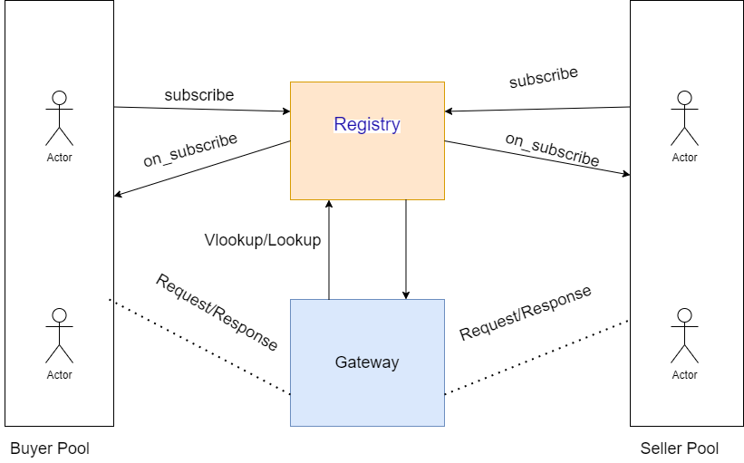

PURPOSE
The purpose of the Registry is to maintain a repository of all the Network Participants in ONDC network i.e. Buyers, Sellers and the Gateway. The Registry provides facility for the Network Participant to be Registered on the Registry under the ONDC ecosystem.

SEQUENCE DIAGRAM

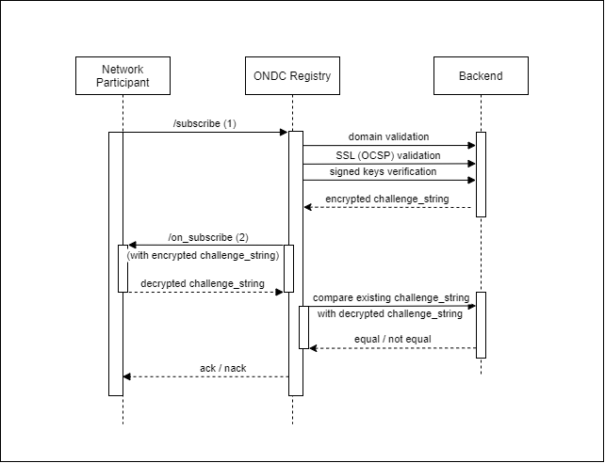

The diagram above explains the details of the flow and the end points exposed by the Registry. The Network Participant registers with the ONDC eco-system by the subscriber API exposed by the Registry. The Registry calls the on_subscribe API by the Network Participant for verification.
The Registry also provides the details of the repository by the /lookup and /vlookup API. The /vlookup API provides similar details as the /lookup but performs authentication against subscribed Network Participants.
The Network Participants are categorised as given in Table Below:
Sr. No. | Entity Registration Scenarios | Description
1 | Buyer | Network Participants registers as a Buyer
2 | Seller (Non-MSN) | Network Participants registers as a Non – MSN Seller
3 | Seller (MSN) | Network Participants registers as a MSN Seller
4 | Buyer + Seller (Non-Seller) | Network Participants registers as a Buyer and Non – MSN Seller
5 | Buyer + Seller (Seller) | Network Participants registers as a Buyer and MSN Seller

System ARCHITECTURE

Registry is a spring boot jar which exposes 3 rest endpoints named lookup, vlookup and subscribe. The gateway internally makes a lookup call to the registry portal, caches the data and then authenticate the incoming request against the signature with the help of public key. It also audits all the event in the database. This audit is asynchronous where all the request body, headers, ip address of the host, transaction id, etc. is captured.

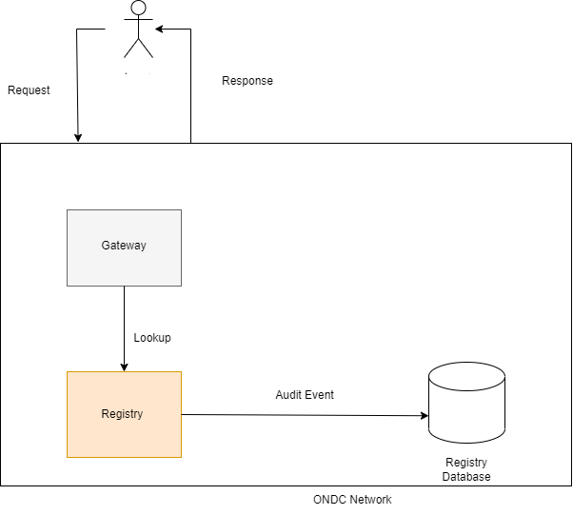

DESIGN METHODOLOGY AND STANDARDS

The registry is based on microservice design pattern. It’s a runnable jar file which stateless and can be easily hosted in any cloud environment and can be quickly scaled on demand. All the below standard of microservice architecture is available:

distributed tracing

externalised configuration

profiling based on environment

circuit breaker

retry mechanism

backoff in case of service unavailability

executor services

caching

zipkin

System Characteristics
Registry is a serverless jar file that provides below characteristic:
- It ensures that the specification is followed for each request response that takes place between Gateway or Network Participant.
- Can handle multiple requests at the same time.
- Highly scalable, configurable and customizable.
- Cloud ready with low latency and high throughput.
- It has inbuilt logging and auditing feature.

FEATURE LISTS
Services are provided by the gateway which includes below points/topics:
          - Security
          - Audit
          - Performance monitoring and reporting
          - Error Handling
          - Debugging
          - Logging.

NAMING CONVENTIONS
- Config file names are as per spring boot standard and this ensures possibility for profiling.
- Java class name and packages are as per client standard.
- Class name starts with the uppercase letter. It is a noun and appropriate words, instead of acronyms.
- Interface name start with the uppercase letter. It is an adjective such as Runnable, Remote, ActionListener. Used appropriate words, instead of acronyms.
- Variable starts with a lowercase letter. It should not start with the special characters like & (ampersand), $ (dollar), _ (underscore). If the name contains multiple words, start it with the lowercase letter followed by an uppercase letter.
- Package should be a lowercase letter. If the name contains multiple words, it should be separated by dots (.)
- Constant should be in uppercase letters. If the name contains multiple words, it should be separated by an underscore (_). It may contain digits but not as the first letter.

PROGRAMMING STANDARDS
- Naming Conventions: Camel case convention is followed in this java project. It means that all the classes and interfaces should be nouns, in mixed cases with the first letter of each internal word capitalized. All the methods should be verbs, in mixed case with the first letter lowercase and with the first letter of each internal word capitalized. The variables should be meaningful and one character variable names must be avoided. A constant variable is defined in the capital case.
- Class Members must be accessed privately: It is considered a java best practice to keep the accessibility of class fields as inaccessible as possible. It is done to protect the fields. To achieve that, private access modifier is the ideal choice. This practice is recommended to maintain the encapsulation, one of the fundamental concepts of OOP
- Never leave a Catch Blocks empty: It is a java best practice to write a proper and meaningful message in the catch block while exception handling. If catch block empty and when the exception is caught by the empty catch block, when the program gets an exception, it does not show anything, making debugging harder and time-consuming.
- Use StringBuilder instead of StringBuffer for String Concatenation: The java best practice, in that case, would be using “StringBuilder” instead of “StringBuffer”. These built-in functions modify a String without creating intermediate String objects saving processing time and unnecessary memory usage.
- Avoid Redundant Initializations: Although it is very common practice, it is not encouraged to initialize member variables with the values: like 0, false and null. These values are already the default initialization values of member variables in Java. Therefore, a java best practice is to be aware of the default initialization values of member variables and avoid initializing the variables explicitly.
- Curly Braces: Curly braces are used to define the bodies of classes, methods, and loops. No blank lines should be present after the opening brace or before the closing brace. A curly brace is applied at the end of the line that starts the class, method, loop, etc., and the closing brace is on a line by itself, lined up vertically with the start of the first line.
- Indentation: The unit of indentation is 4 spaces. Tab-stops should be set exactly every 8 spaces. All indentation must be achieved by the space character and tab characters must not exist in the resultant source file.
- In general, the programming standard should define a consistent and uniform programming style.

SOFTWARE DEVELOPMENT TOOLS
The project run on below mentioned tools:
- Eclipse
- IntelliJ IDEA
- VS Code

COMPONENT DESCRIPTION
- beckn-gateway:
- gateway is a spring boot java application with below configuration:
<parent>
<groupId>org.springframework.boot</groupId>
<artifactId>spring-boot-starter-parent</artifactId>
<version>2.7.0</version>
</parent>

<groupId>com.nsdl</groupId>
<artifactId>beckn-gateway</artifactId>
<version>0.0.11</version>

- It exposed 2 rest endpoint for /search and /on_search as per ondc api. All the related configuration is present in the externalised file application-{profile}.yml and config-gateway-{profile}.json.
- It uses spring profile passed in the jvm parameter to configure itself for dev, uat, pre-prod and prod environment.

- beckn-common:
It is maven-based java project where all the core logic of gateway component resides. It takes care of header validation, body validation, lookup call, caching, exception handling, auditing and other http calls

- beckn-model:
It is a java project where all the model class as per latest ONDC schema is maintained and used across by different projects like gateway and common. Below link is used to maintain the model classes:
https://app.swaggerhub.com/apis/ONDC/ONDC-Protocol-Retail/1.0.16#/ONDC%20Gateway

Software Requirements Traceability Matrix
- This section should contain a table that summarises how each software requirement has been met in this document. The tabular format permits one-to-one and one-to-many relationships to be shown.

System Req. Number | System Ref. Item | Component Identifier | Component Item
Document Signoff
Nature of Signoff | Person | Signature | Date | Role
Authors | Ganesh Khedkar |  | 07/12/2022
Reviewers | Ramakrishna |  | 07/12/2022 | Senior Manager
Document Change Record
Date | Version | Author | Change Details
07-12-2022 | 1.0 | Manish G. Bendre

